Supporting Information

Photothermal seleno-polysaccharide polymer nanocomposites mediating mitochondria function to anti-tumor therapy
Xiaotong Yang^{1, a}, Dandan Ma^{1, a}, Enze Sheng ^{1, a,} *, Yingying Tang ª, Yuyin Tang ª, Linyu Hu ª, Su Li ª, and Dong Zhu ^{a,} *
ª School of Pharmacy, Nanjing University of Chinese Medicine, Nanjing, Jiangsu 210023, P. R. China
¹ Xiaotong Yang, Dandan Ma and Enze Sheng contributed equally to this work.
*Address correspondence to Dong Zhu, dongzhu@njucm.edu.cn; Enze Sheng, 300563@njucm.edu.cn.

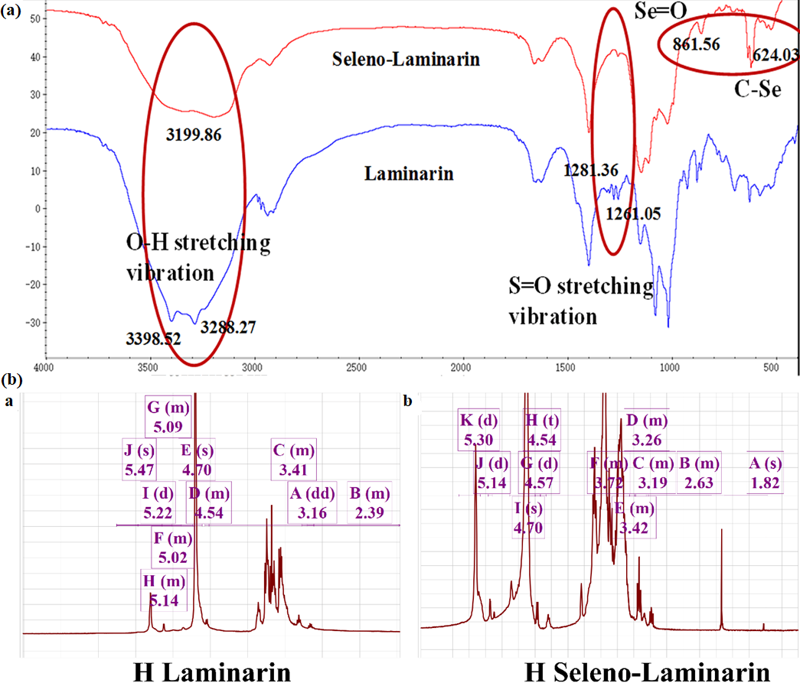

Figure S1. Characterization of Seleno-Laminarin.

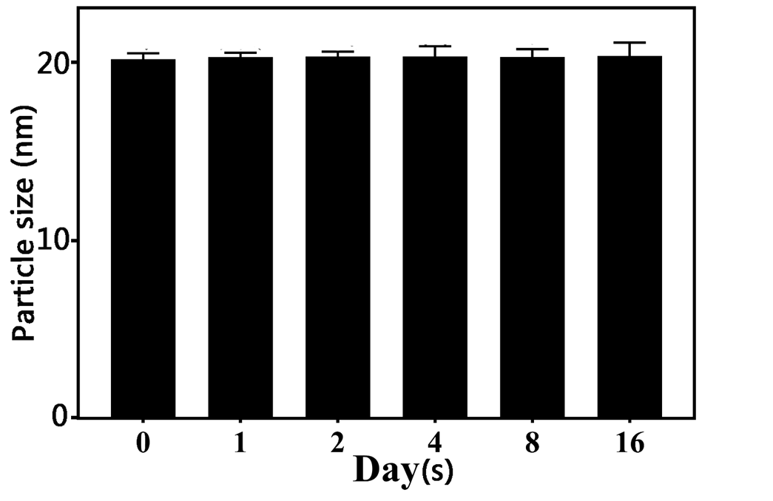
Figure S2. Changes in particle size of SPPNs.

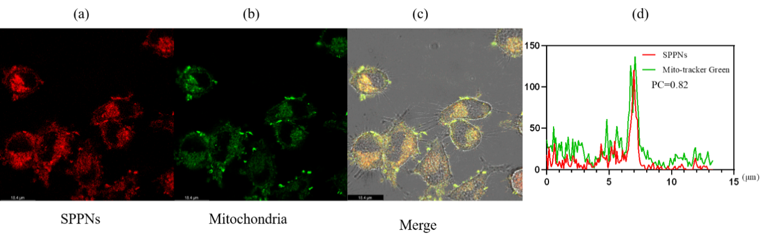
Figure S3. Mitochondrial colocalizaiton test of SPPNs in HeLa cells.

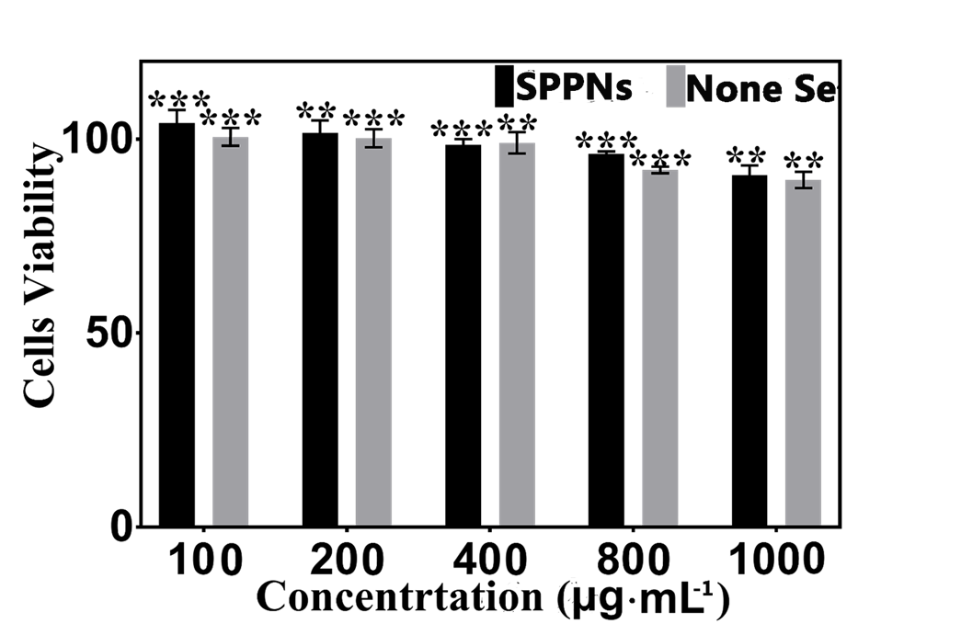
Figure S4. Biocompatibility of SPPNs with or without Se in 24 h on HUVEC

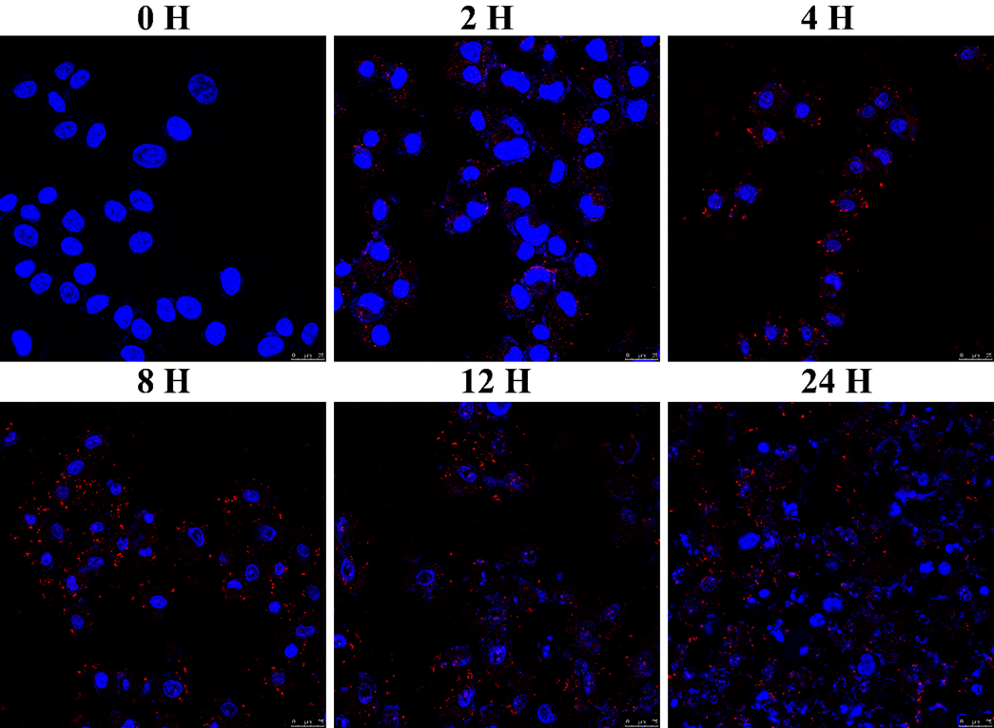

Figure S5. Fluorescence imaging for uptake of SPPNs in Hela cells at different times.
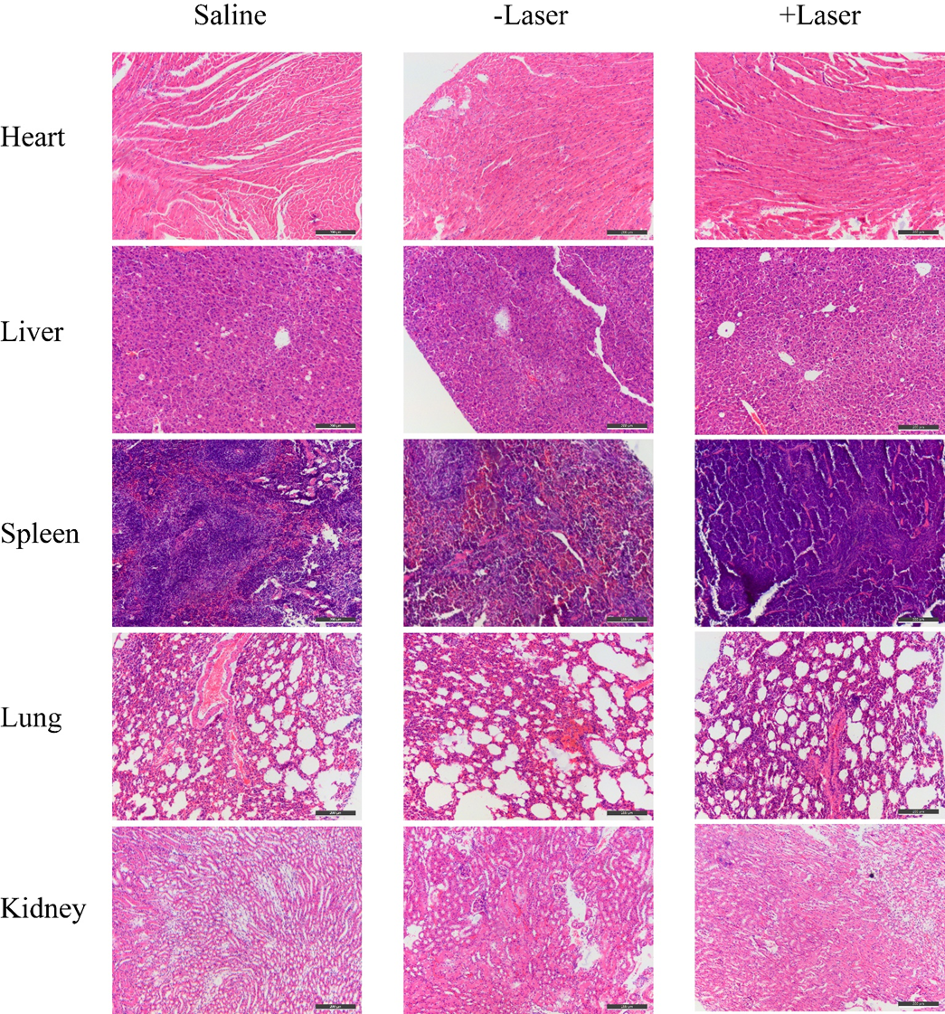
Figure S6. Images of H&E stained heart, liver, spleen, lung and kidney obtained from the nude mice after s tail vein injection with saline, SPPNs with laser irradiation and SPPNs without laser irradiation.

