Electronic Optimization and Modification of Efficient Ir Clusters Embedded onto Ni-Mo-P for Electrocatalytic Oxygen Evolution Reaction
Hehe Wei¹, Jing Li², Peng Du³, Longtao Zhang¹, Zixiang Su¹, Hui Li¹, Ming Lei³, Kai Huang^{3*}, Xueqing Gong^{1*}
¹ Key Laboratory for Advanced Materials, Center for Computational Chemistry and Research Institute of Industrial Catalysis, East China University of Science and Technology, 130 Meilong Road, Shanghai 200237, China
² Engineering Technology Center of Department of Education of Anhui Province and College of Chemistry and Materials Engineering, Chaohu University, 238024, Chaohu, Anhui, China
³ State Key Laboratory of Information Photonics and Optical Communications &, School of Science, Beijing University of Posts and Telecommunications, Beijing 100876, China

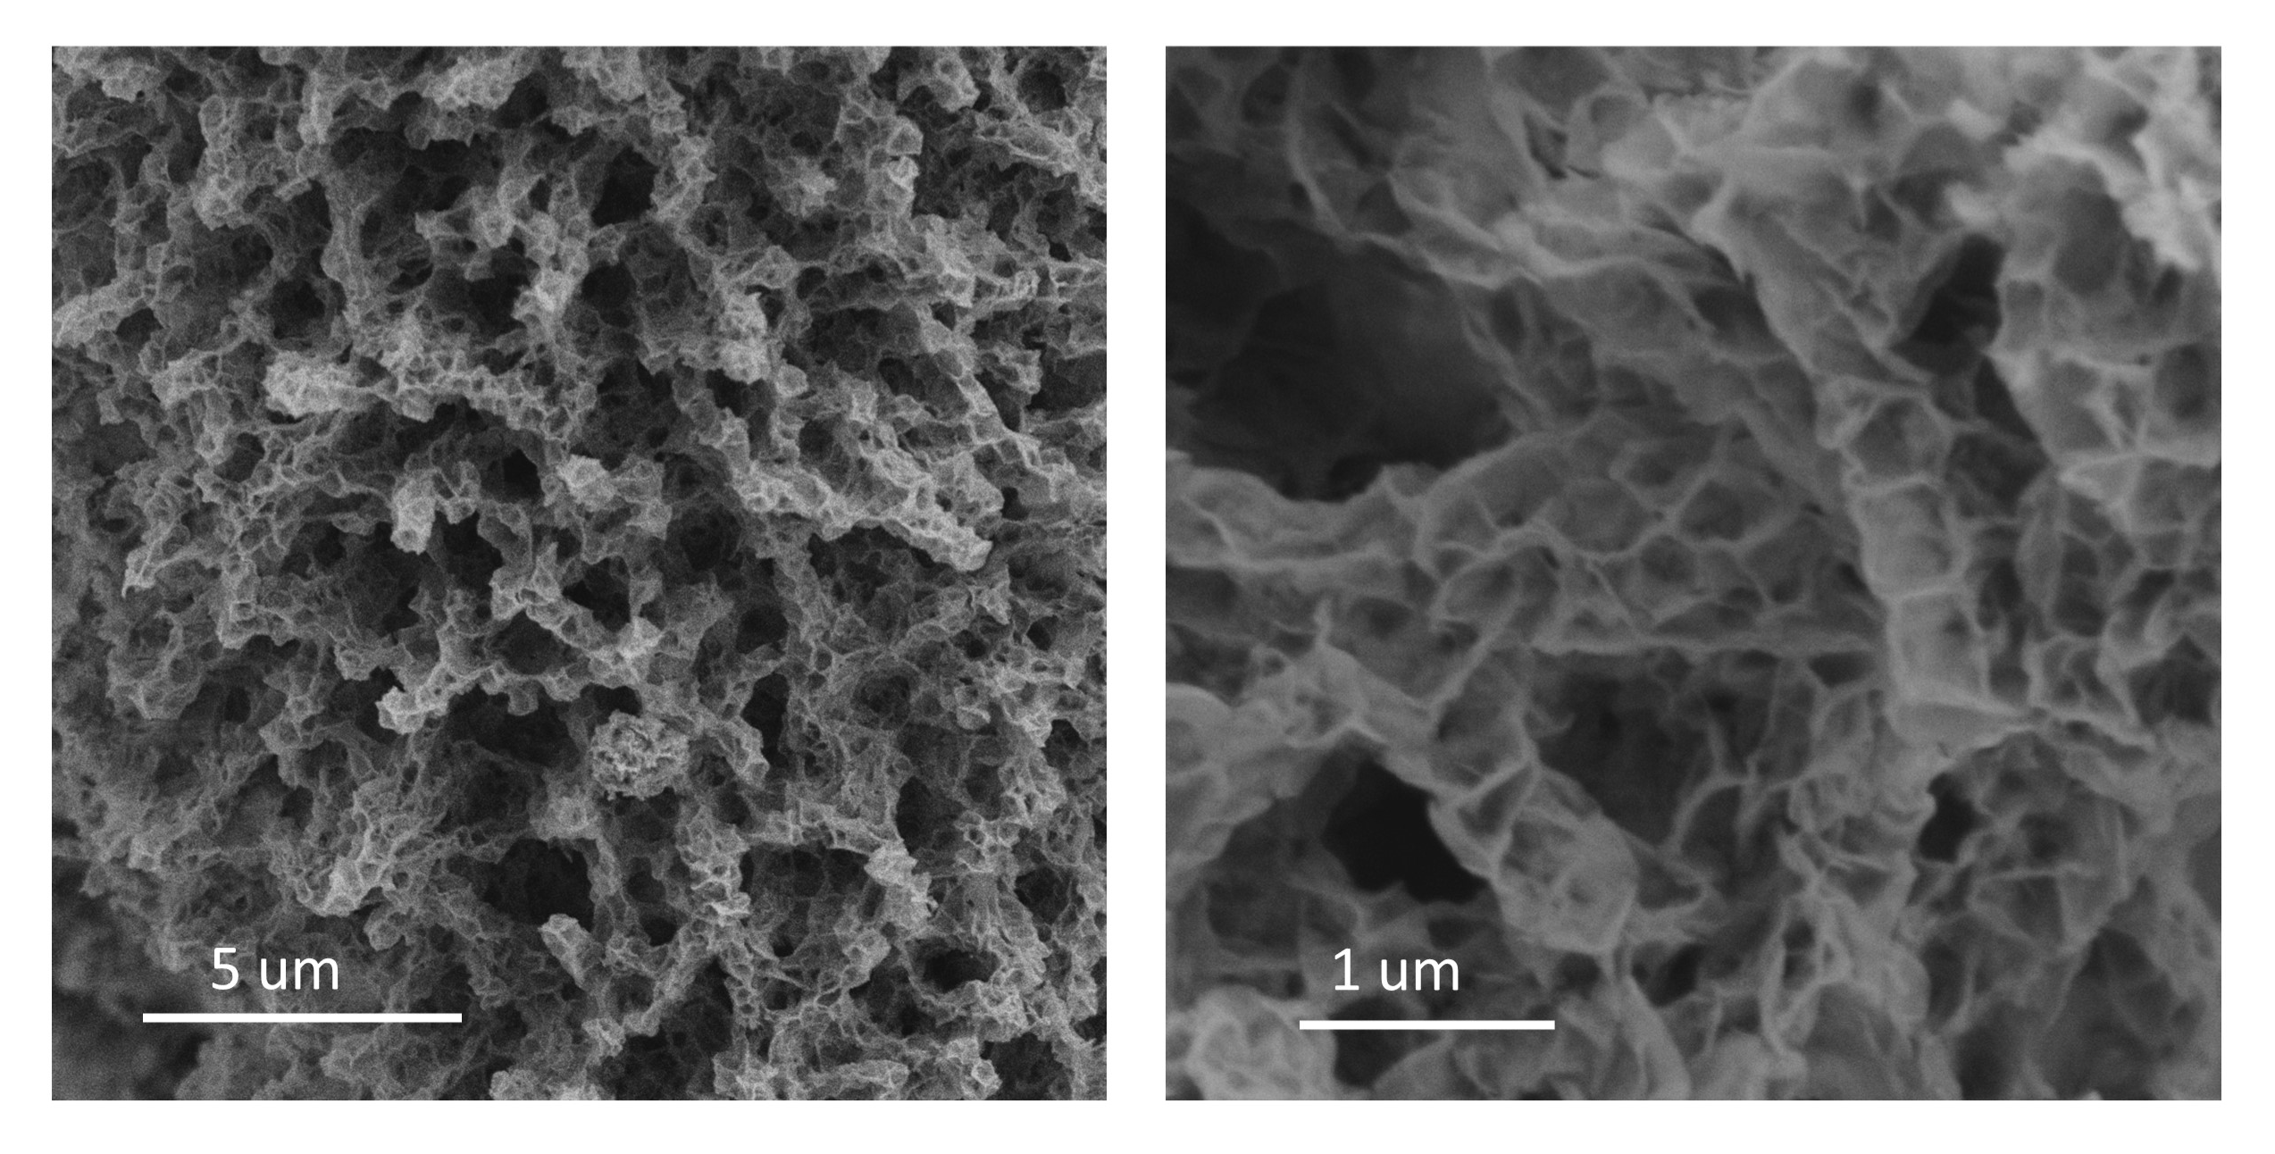
Fig. S1 SEM images of nickel-molybdenum precursors.

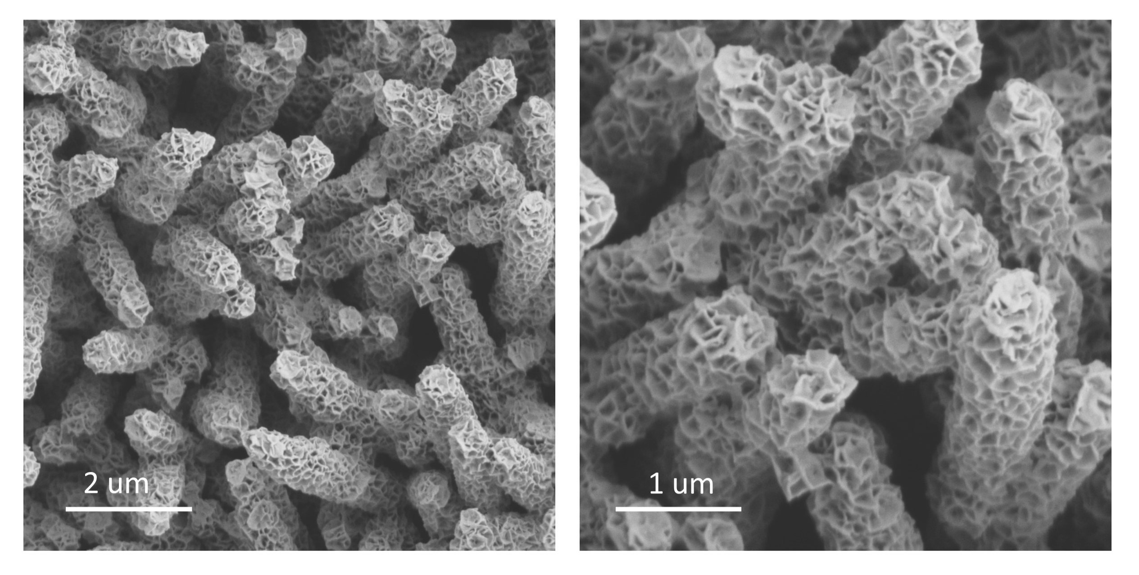
Fig. S2 SEM images of Ni-Mo-P.

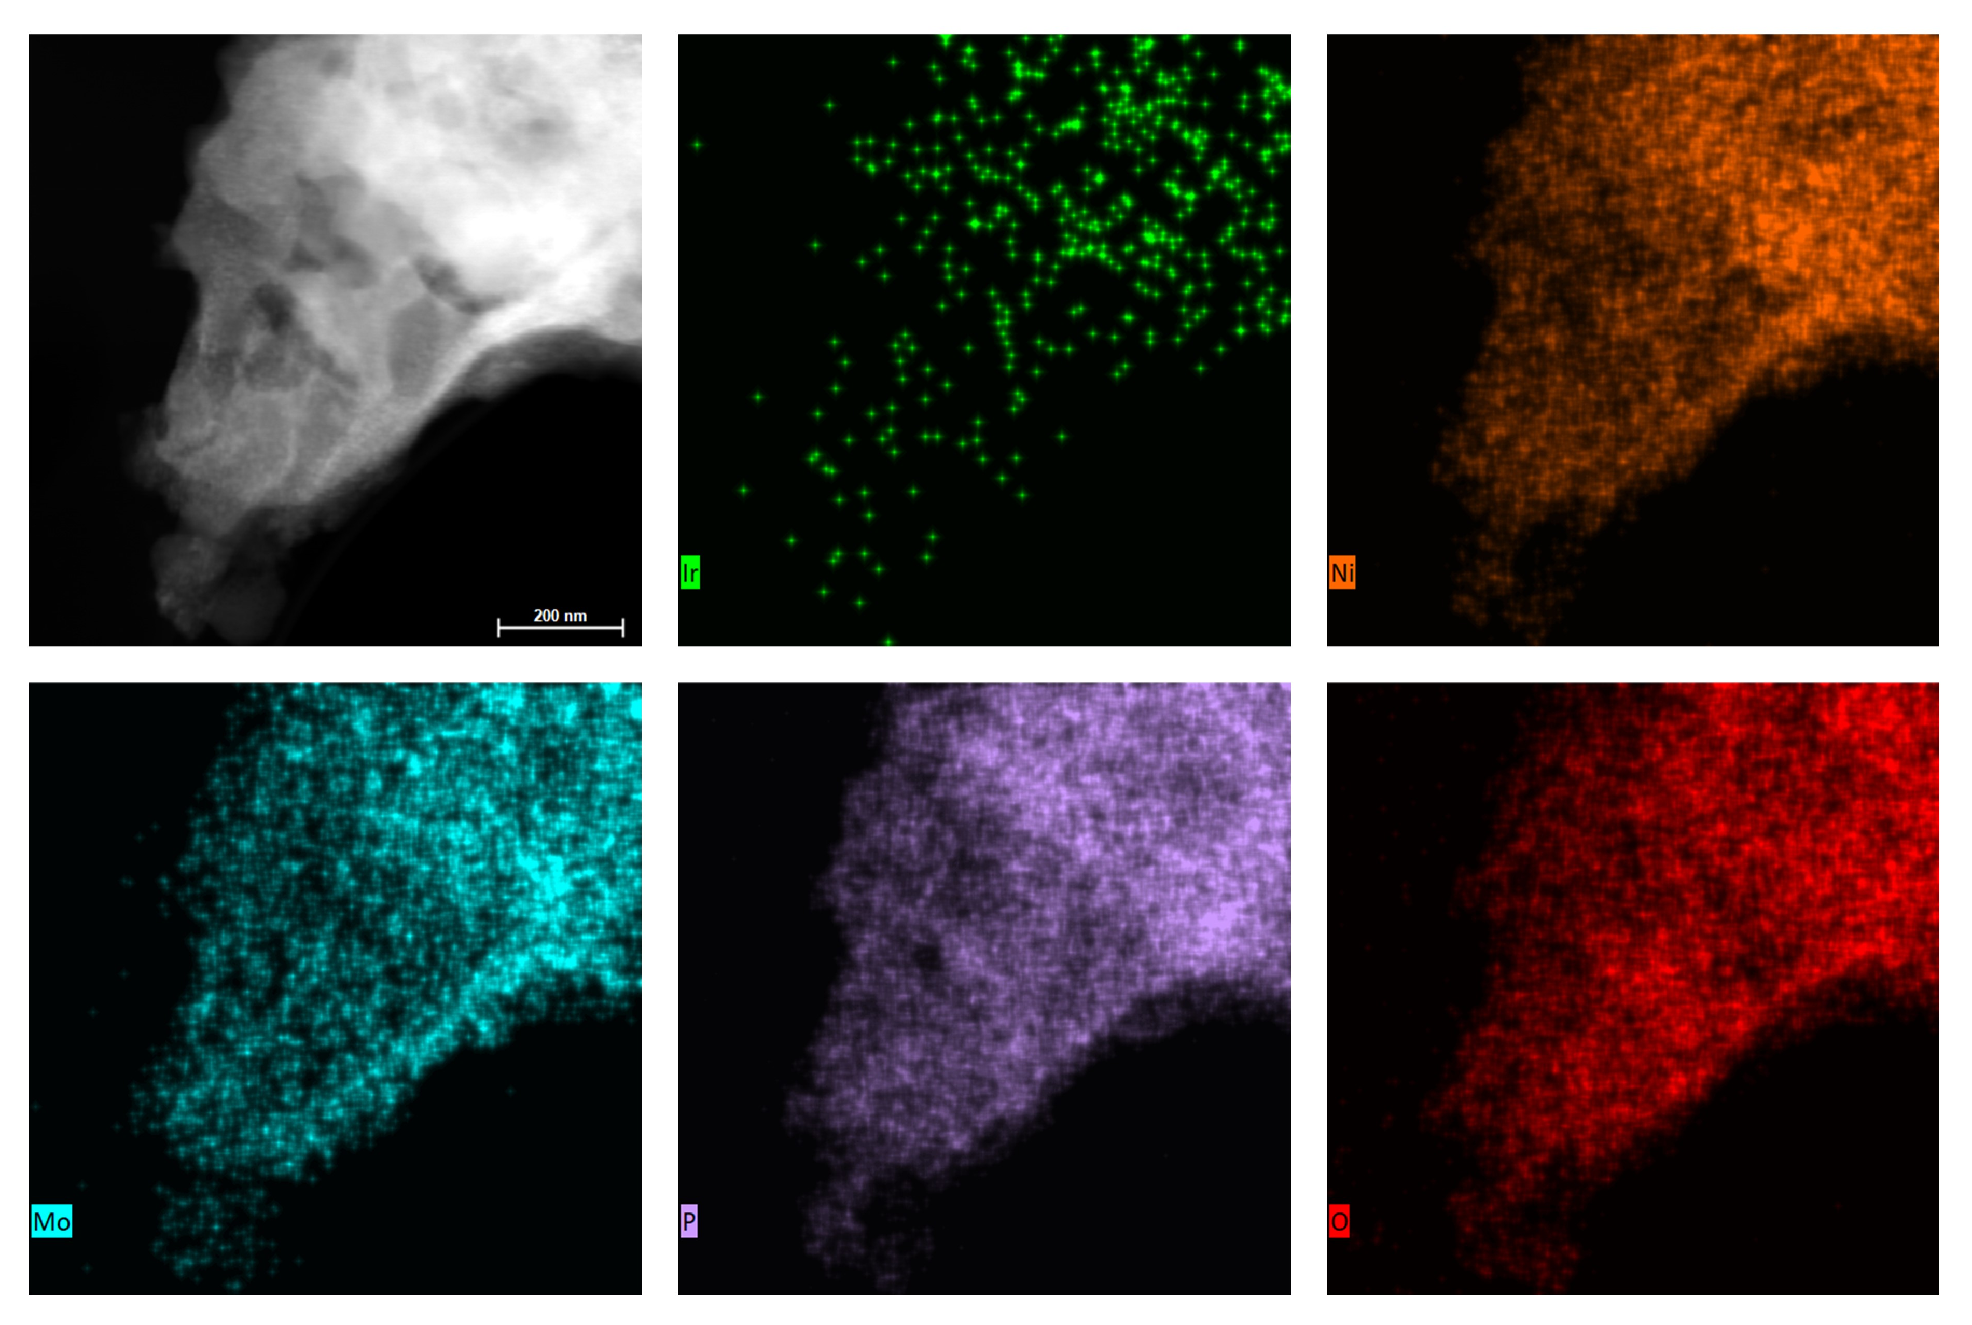
Fig. S3 TEM element mapping images of the Ir-NMP catalyst.
Fig. S4 EDS image of the Ir-NMP catalyst.

Fig. S5 Size distribution of Ir clusters in the Ir-NMP catalyst.

Fig. S6 XRD patterns of carbon paper, NMP and Ir-NMP supported on the surface of carbon paper.

