Extended Data Figures
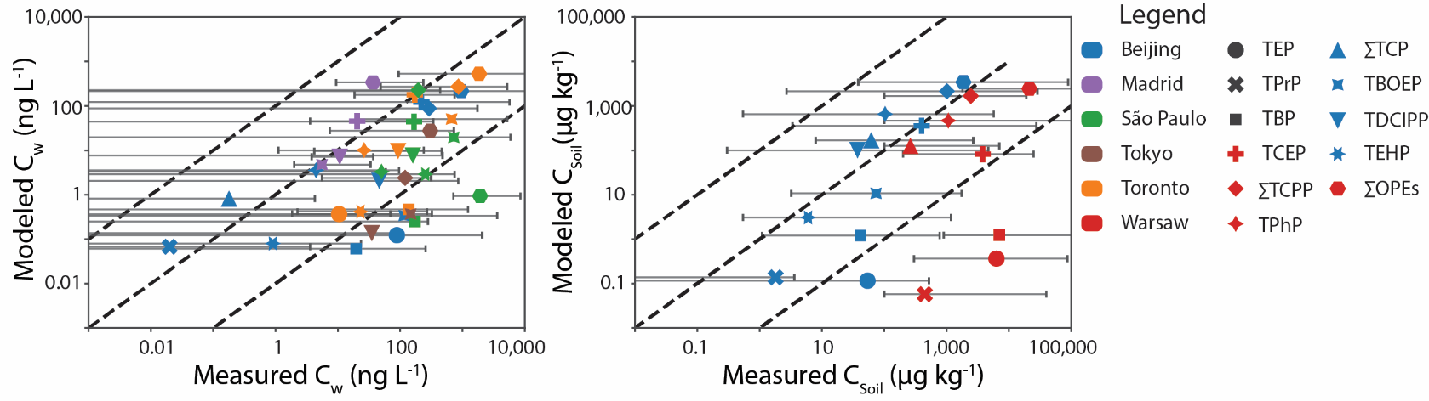
Figure ED 1: Literature measured vs model-predicted water (C_{W}, ng L⁻¹) and soil (C_{soil}, ug kg⁻¹) concentrations. Colors represent the city where the literature measurements were taken; shapes represent the concentration of each OPE. Error bars indicate the range of measured values; minimum values that were below the limit of detection are shown with the error bar extending to the left-hand side of the x-axis. Dashed lines indicate a 1:1 fit and modeled values 100 times larger or smaller than the literature values.
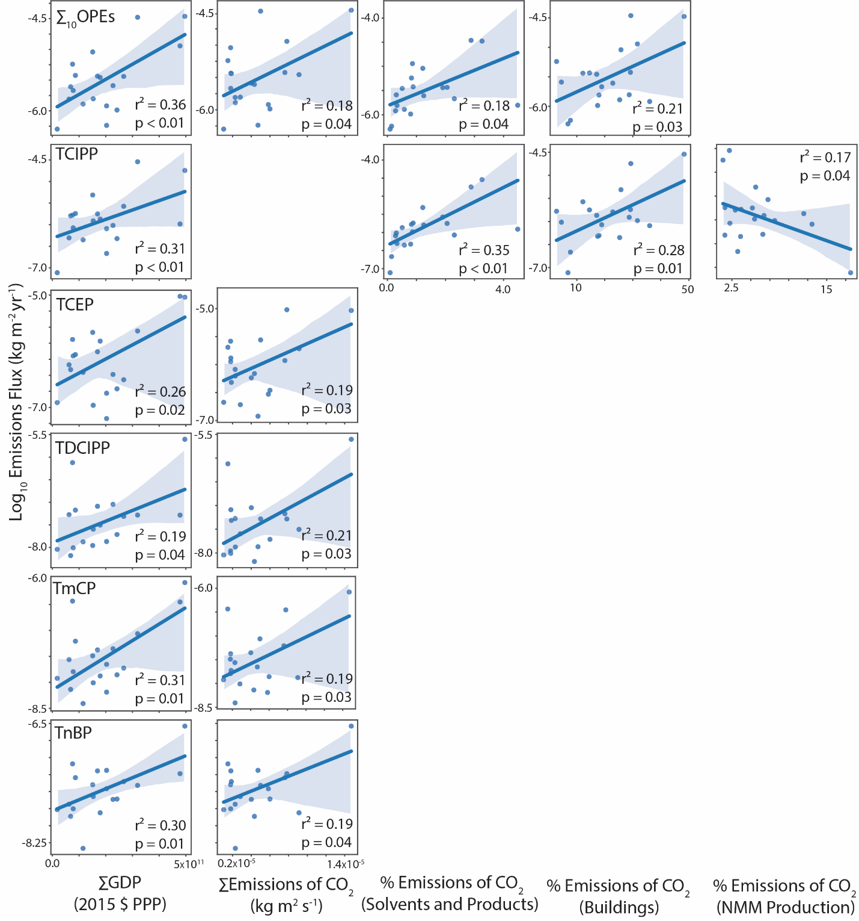
Figure ED 2: Regressions between emissions proxies (Gross Domestic Product (GDP) at 2015 purchasing power parity, anthropogenic emissions of greenhouse gases as CO₂ equivalents, and the proportion of anthropogenic CO₂ equivalent emissions from the Solvents and Products, Buildings and Non-Metallic Minerals Production sectors, as described by EDGAR³³) and the log₁₀ transformed emissions flux (kg m⁻² yr⁻¹). Selected regressions with p<0.05 are shown, r² is the adjusted correlation coefficient. Table S3 shows all regressions with p<0.05.
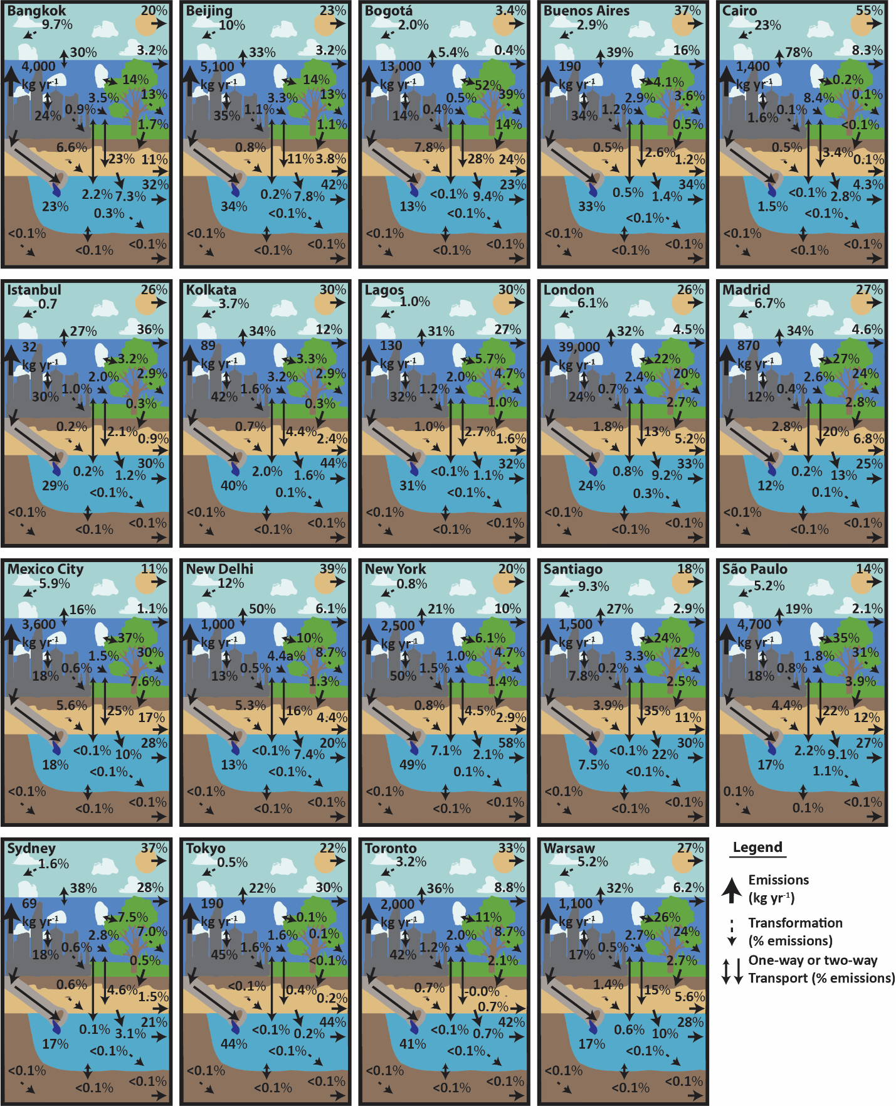
Figure ED 3: Schematic diagrams showing the ∑₁₀OPEs emissions and fate for each of the modeled cities using the 2018 annual average administrative area baseline model fate parameterization. Advective processes leaving the city’s modeled boundary are shown with one-way transport arrows at the right-hand side of the figure for the upper air, lower air, soil (to groundwater), water, and sediment (burial) compartments. Figures may not sum exactly to 100 due to rounding. Figures S2-S11 show the fates of each individual compound across the 19 cities.
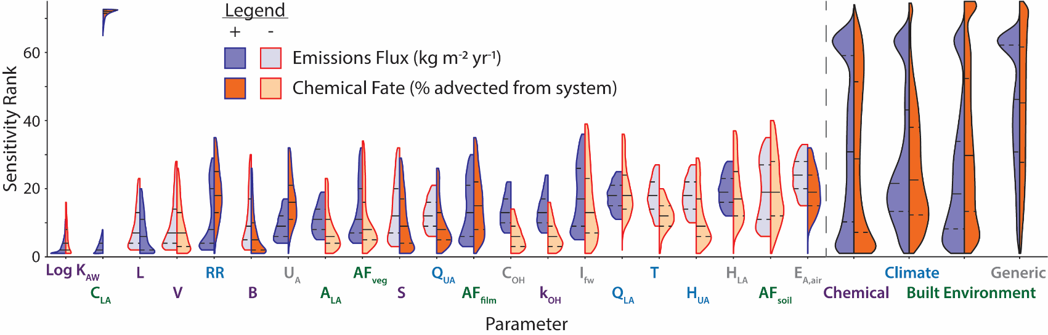
Figure ED 4: Violinplots showing the rank-transformed sensitivity of the modeled emissions flux (purple) and chemical fate (orange) to the input parameters. The font color represents the parameter groupings, with purple font representing chemical-specific parameters; blue font, climate; green font, built-environment; and grey font, generic parameters. Red outlines with a lighter shade and blue outlines with a darker shade indicate that a higher parameter value lowered or raised the output magnitude, respectively. Horizontal lines in each violinplot represent quartiles, and label colors represent the parameter category (as shown on the right-hand side). The middle 80% distribution for each parameter is shown, from a run of 10,000 random trials. The overall distribution for all parameters in each category is shown on the right. Abbreviations are as follows: concentration in the lower air (C_{LA}), air-water partition coefficient (log K_{AW}), Abraham’s solvation parameters (L, V, B, S), upper-lower air mixing rate (U_{A),} area of lower air (A_{LA}), rain rate (RR), flow in compartment j (Q_{j}), concentration I and reaction rate (k) of hydroxyl, ratio of area in compartment j to lower air (AF_{j}), height of compartment j (H_{J}), temperature (T), wet interception fraction (I_{fw}), and activation energy in the air (E_{A,air}).

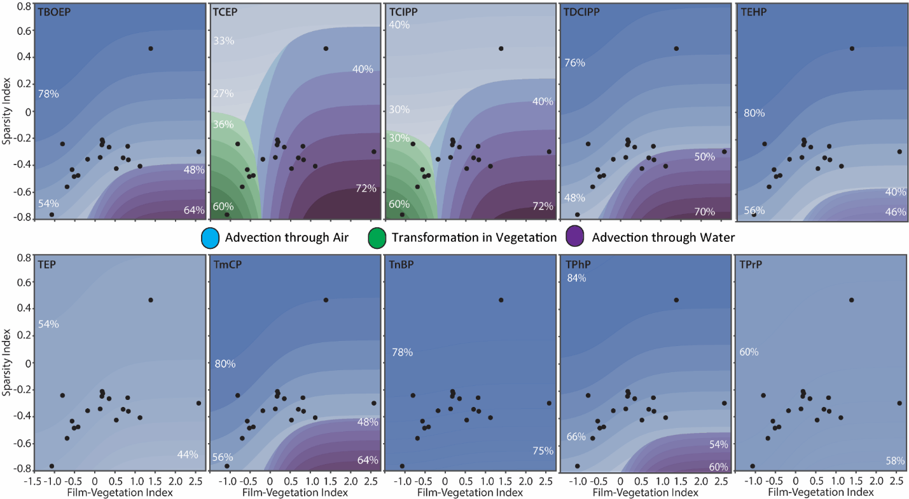
Figure ED 5: City-space diagrams showing the fate of each OPE across the built-environment “sparsity” and “film-vegetation” indices. Models were parameterized using the “average” city, as explained in the main text. The color of the contour lines shows the dominant fate processes, with the intensity of the color showing the percentage of total emissions represented by the dominant fate (as shown by the percentage values in white text

