SUPPLEMENTARY INFORMATION

1. SUPPLEMENTARY RESULTS

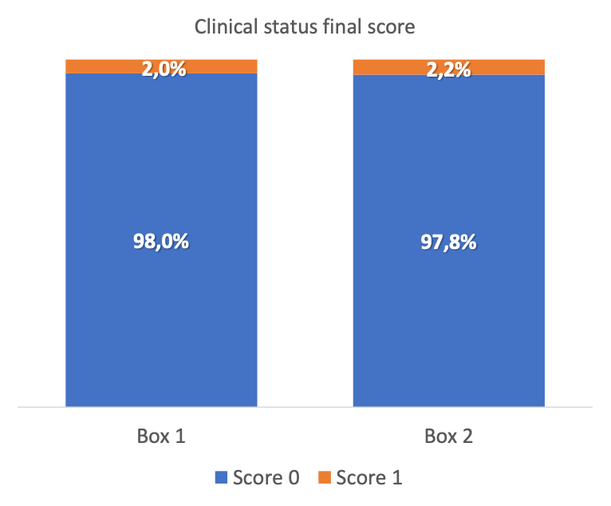
Supplementary Figure 1: Proportion of the initial and final clinical score of all subjects in the FNC group and the placebo group. The p value represents the significant difference between groups by the Wilcoxon test (BOX1: FNC; BOX 2: CONTROL).

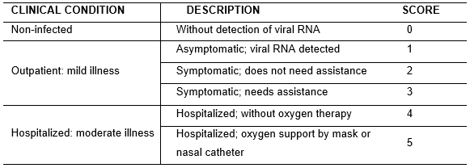
Supplementary Figure 2: scores of the study related to clinical picture.

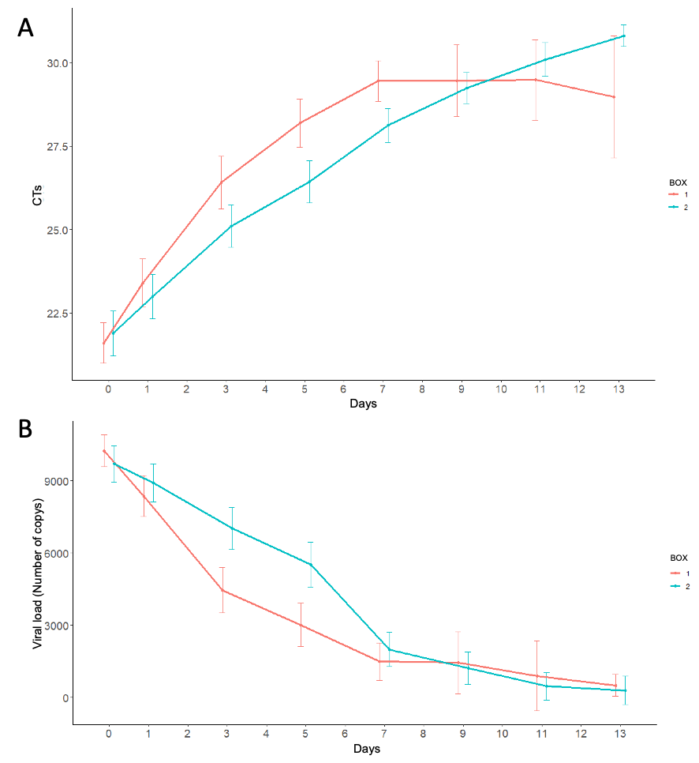
Supplementary Figure 3: Ciral load (B) analysis measured by RT-PCR of all participants in the FNC group and the placebo group. Data are median (SD).

Supplementary Table 1: Demographic and baseline characteristics of participants.
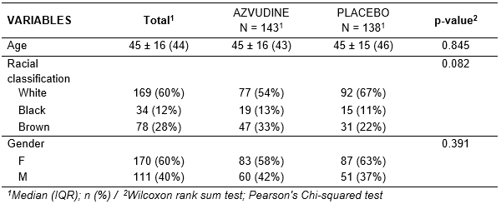

Supplementary Table 2: Mean score index (WHO Clinical Improvement Ordinal Scale) of participants at the beginning and final of the clinical research.
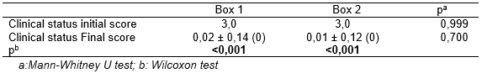

Supplementary Table 3:
VARIABLES | Total¹ | AZVUDINE  N = 143¹ | PLACEBO  N = 138¹ | p-value²
Viral load (D0) | 9.971 ± 4.257 (11.553) | 10.239 ± 3.985 (11.593) | 9.694 ± 4.519 (11.394) |  | 0.543
Viral load (D1) | 8.631 ± 4.897 (10.756) | 8.359 ± 5.083 (10.834) | 8.909 ± 4.702 (10.717) |  | 0.634
Viral load l(D3) | 5.733 ± 5.503 (1.037) | 4.452 ± 5.564 (969) | 7.023 ± 5.146 (10.000) |  | <0.001
Viral load l(D5) | 4.285 ± 5.189 (971) | 3.016 ± 4.897 (0) | 5.513 ± 5.187 (9.642) |  | <0.001
Viral load (D7) | 1.773 ± 3.613 (63) | 1.483 ± 3.516 (0) | 1.987 ± 3.684 (967) |  | <0.001
Viral load D9) | 1.276 ± 3.282 (0) | 1.439 ± 3.653 (0) | 1.214 ± 3.149 (29) |  | 0.064
Viral load (D11) | 556 ± 2.230 (0) | 902 ± 2.637 (0) | 462 ± 2.124 (0) |  | 0.712
Viral load (D13) | 334 ± 1.526 (0) | 501 ± 536 (491) | 294 ± 1.685 (0) |  | 0.002
CTs(D0) | 21.3 (18.9 - 24.8) | 21.1 (19.0 - 24.4) | 21.6 (18.5 - 25.2) |  | 0.490
CTs(D1) | 23.0 (20.0 - 26.4) | 23.0 (20.0 - 26.6) | 23.0 (20.0 - 25.9) |  | 0.523
CTs(D3) | 26.1 (23.1 - 29.8) | 28.0 (23.0 - 31.0) | 25.1 (23.1 - 27.8) |  | <0.001
CTs(D5) | 27.9 (25.0 - 31.0) | 31.0 (25.8 - 31.0) | 26.0 (24.6 - 29.6) |  | <0.001
CTs(D7) | 29.80 (26.83 - 31.00) | 31.00 (27.65 - 31.00) | 28.00 (26.80 - 31.00) |  | <0.001
CTs(D9) | 31.00 (28.50 - 31.00) | 31.00 (30.10 - 31.00) | 29.80 (28.50 - 31.00) |  | 0.062
CTs(D11) | 31.00 (29.92 - 31.00) | 31.00 (28.25 - 31.00) | 31.00 (30.15 - 31.00) |  | 0.708
CTs(D13) | 31.00 (31.00 - 31.00) | 29.20 (27.18 - 31.00) | 31.00 (31.00 - 31.00) |  | 0.002
¹n (%); Median (IQR) / ² Mann-Whitney test; Wilcoxon rank sum exact test

Supplementary Table 4: Time for improvement of symptoms.
VARIABLES | Total¹ | AZVUDINE  N = 143¹ | PLACEBO  N = 138¹ | p-value²
Myalgia (Qty.days) | 2.07 ± 1.42 (1.00) | 2.00 ± 1.30 (1.50) | 2.13 ± 1.53 (1.00) | 0.959
Lost olphate (Qty.days) | 2.67 ± 1.84 (2.00) | 2.17 ± 1.37 (2.00) | 3.07 ± 2.09 (3.00) | 0.107
Lost palate (Qty.days) | 2.48 ± 1.78 (2.00) | 1.96 ± 1.10 (2.00) | 2.94 ± 2.12 (2.50) | 0.050
Diarrhea (Qty.days) | 2.08 ± 1.51 (1.50) | 2.18 ± 1.59 (1.50) | 1.98 ± 1.44 (1.50) | 0.706
Dizziness (Qty.days) | 1.97 ± 1.31 (1.00) | 1.69 ± 1.17 (1.00) | 2.23 ± 1.41 (2.00) | 0.095
Fever (Qty.days) | 1.26 ± 0.60 (1.00) | 1.29 ± 0.64 (1.00) | 1.24 ± 0.56 (1.00) | 0.896
Chill (Qty.days) | 1.78 ± 1.04 (1.00) | 1.61 ± 0.86 (1.00) | 2.00 ± 1.20 (2.00) | 0.213
Sore throat (Qty.days) | 2.08 ± 1.39 (2.00) | 1.88 ± 1.18 (2.00) | 2.26 ± 1.55 (2.00) | 0.367
Coryza (Qty.days) | 2.54 ± 1.97 (2.00) | 2.24 ± 1.66 (2.00) | 2.80 ± 2.19 (2.00) | 0.207
Dyspnea (Qty.days) | 2.52 ± 1.80 (2.00) | 2.18 ± 1.17 (2.00) | 2.89 ± 2.26 (2.00) | 0.328
Tachypnea (Qty.days) | 1.60 ± 0.85 (1.00) | 1.50 ± 0.92 (1.00) | 1.71 ± 0.77 (2.00) | 0.251
Nausea (Qty.days) | 1.89 ± 1.43 (1.00) | 1.84 ± 1.14 (1.00) | 1.94 ± 1.70 (1.00) | 0.639
Vomit (Qty.days) | 1.60 ± 1.44 (1.00) | 1.40 ± 0.63 (1.00) | 1.90 ± 2.18 (1.00) | 0.973
Abdominal pain (Qty.days) | 2.32 ± 2.09 (1.00) | 2.22 ± 1.53 (2.00) | 2.40 ± 2.45 (1.00) | 0.413
Disability march (Qty.days) | 2.00 ± 1.73 (1.00) | 2.67 ± 2.89 (1.00) | 1.67 ± 1.03 (1.00) | 0.877
¹n (%); Median (IQR) / ²Mann-Whitney test Wilcoxon rank sum test

Supplementary Table 5: Comorbidities

VARIABLES | N |  |  | Total¹ | Azvudine  N = 143¹ | Placebo  N = 138¹ | p-value²
Insomnia |  | 281 | 99 (35%) |  | 55 (38%) | 44 (32%) | 0.249
Arterial hypertension |  | 281 | 83 (30%) |  | 44 (31%) | 39 (28%) | 0.645
Constipation |  | 281 | 44 (16%) |  | 18 (13%) | 26 (19%) | 0.149
Gastritis |  | 281 | 38 (14%) |  | 22 (15%) | 16 (12%) | 0.353
Labyrinthitis |  | 281 | 35 (12%) |  | 21 (15%) | 14 (10%) | 0.249
Obesity |  | 281 | 31 (11%) |  | 18 (13%) | 13 (9.4%) | 0.397
Hepatic steatosis |  | 281 | 23 (8.2%) |  | 14 (9.8%) | 9 (6.5%) | 0.318
Smoker |  | 281 | 22 (7.8%) |  | 12 (8.4%) | 10 (7.2%) | 0.721
Type 2 diabetes (non-insulin dependent) |  | 281 | 20 (7.1%) |  | 8 (5.6%) | 12 (8.7%) | 0.312
Irritable bowel syndrome |  | 281 | 17 (6.0%) |  | 12 (8.4%) | 5 (3.6%) | 0.094
Alcoholic |  | 281 | 18 (6.4%) |  | 8 (5.6%) | 10 (7.2%) | 0.572
Rheumatic disease |  | 281 | 18 (6.4%) |  | 9 (6.3%) | 9 (6.5%) | 0.938
Bronchitis |  | 281 | 15 (5.3%) |  | 10 (7.0%) | 5 (3.6%) | 0.209
Cardiac arrhythmia |  | 281 | 14 (5.0%) |  | 8 (5.6%) | 6 (4.3%) | 0.631
Kidney stone |  | 281 | 14 (5.0%) |  | 7 (4.9%) | 7 (5.1%) | 0.946
Osteoporosis |  | 281 | 13 (4.6%) |  | 4 (2.8%) | 9 (6.5%) | 0.137
Asthma |  | 281 | 7 (2.5%) |  | 4 (2.8%) | 3 (2.2%) | >0.999
Type 1 diabetes (insulin dependent) |  | 281 | 7 (2.5%) |  | 4 (2.8%) | 3 (2.2%) | >0.999
Cardiac arrhythmia |  | 281 | 6 (2.1%) |  | 5 (3.5%) | 1 (0.7%) | 0.214
Endometriosis |  | 281 | 4 (1.4%) |  | 4 (2.8%) | 0 (0%) | 0.123
Coronary angioplasty (stent) |  | 281 | 4 (1.4%) |  | 1 (0.7%) | 3 (2.2%) | 0.364
Angina |  | 281 | 3 (1.1%) |  | 1 (0.7%) | 2 (1.4%) | 0.617
Cardiac revascularization |  | 281 | 2 (0.7%) |  | 1 (0.7%) | 1 (0.7%) | >0.999
Stroke |  | 281 | 1 (0.4%) |  | 1 (0.7%) | 0 (0%) | >0.999

Supplementary Table 6: Total values of urea, creatinine and uric acid.
VARIÁVEIS | N | Total¹ | AZVUDINE  N = 143¹ | PLACEBO  N = 138¹ | p-value²
Urea (D1) | 270 | 28 ± 9 (28) | 27 ± 9 (27) | 28 ± 10 (29) | 0.356
Urea (D3) | 218 | 31 ± 10 (29) | 31 ± 9 (31) | 31 ± 11 (29) | 0.437
Urea (D5) | 203 | 31 ± 11 (28) | 30 ± 10 (28) | 31 ± 12 (30) | 0.800
Urea (D7) | 149 | 31 ± 11 (30) | 31 ± 10 (30) | 31 ± 12 (30) | 0.888
Urea (D9) | 94 | 31 ± 11 (29) | 30 ± 9 (29) | 32 ± 11 (30) | 0.494
Urea (D11) | 56 | 31 ± 10 (30) | 30 ± 11 (28) | 31 ± 10 (30) | 0.570
Urea (D13) | 33 | 30 ± 9 (31) | 30 ± 9 (31) | 30 ± 10 (31) | 0.981
Urea (D15) | 251 | 31 ± 10 (29) | 31 ± 10 (30) | 30 ± 11 (29) | 0.402
Urea (D28) | 275 | 28 ± 9 (27) | 28 ± 8 (27) | 28 ± 10 (27) | 0.594
Creatinine (D0) | 281 | 0.84 (0.72 - 1.05) | 0.84 (0.75 - 1.06) | 0.85 (0.70 - 1.05) | 0.712
Creatinine (D1) | 281 | 0.89 ± 0.25 (0.84) | 0.89 ± 0.24 (0.84) | 0.88 ± 0.26 (0.85) | 0.712
Creatinine (D3) | 270 | 0.92 ± 0.60 (0.87) | 0.89 ± 0.25 (0.85) | 0.96 ± 0.82 (0.87) | 0.747
Creatinine (D5) | 219 | 0.82 ± 0.19 (0.82) | 0.83 ± 0.22 (0.82) | 0.81 ± 0.17 (0.81) | 0.754
Creatinine (D7) | 203 | 0.85 ± 0.23 (0.83) | 0.84 ± 0.24 (0.81) | 0.86 ± 0.23 (0.84) | 0.493
Creatinine (D9) | 149 | 1.07 ± 2.72 (0.84) | 1.50 ± 4.60 (0.84) | 0.84 ± 0.20 (0.85) | 0.911
Creatinine (D11) | 94 | 0.85 ± 0.24 (0.82) | 0.83 ± 0.24 (0.78) | 0.86 ± 0.24 (0.83) | 0.584
Creatinine (D13) | 56 | 0.81 ± 0.25 (0.81) | 0.85 ± 0.18 (0.84) | 0.81 ± 0.26 (0.80) | 0.489
Creatinine (D15) | 33 | 0.84 ± 0.27 (0.85) | 0.79 ± 0.25 (0.89) | 0.85 ± 0.28 (0.82) | >0.999
Creatinine (D28) | 252 | 0.85 ± 0.21 (0.84) | 0.86 ± 0.21 (0.84) | 0.84 ± 0.20 (0.84) | 0.917
Uric acid (D1) | 270 | 4.02 ± 1.49 (3.90) | 4.12 ± 1.35 (4.00) | 3.92 ± 1.62 (3.79) | 0.183
Uric acid (D3) | 218 | 3.90 ± 1.31 (3.80) | 4.01 ± 1.29 (3.90) | 3.80 ± 1.33 (3.80) | 0.283
Uric acid (D5) | 203 | 4.00 ± 1.41 (3.97) | 4.07 ± 1.36 (4.00) | 3.94 ± 1.44 (3.90) | 0.590
Uric acid (D7) | 149 | 4.15 ± 1.41 (4.10) | 4.20 ± 1.34 (4.05) | 4.13 ± 1.45 (4.10) | 0.858
Uric acid (D9) | 94 | 4.45 ± 1.57 (4.41) | 4.38 ± 1.50 (4.20) | 4.48 ± 1.60 (4.50) | 0.555
Uric acid D11) | 56 | 4.71 ± 1.67 (4.44) | 4.16 ± 0.88 (3.90) | 4.84 ± 1.79 (4.60) | 0.132
Uric acid (D13) | 33 | 4.76 ± 1.83 (4.70) | 3.95 ± 0.64 (3.95) | 4.94 ± 1.96 (5.00) | 0.168
Uric acid (D15) | 251 | 4.47 ± 1.49 (4.43) | 4.62 ± 1.41 (4.48) | 4.31 ± 1.57 (4.40) | 0.153
Uric acid (D28) | 275 | 4.73 ± 1.50 (4.70) | 4.88 ± 1.40 (5.00) | 4.57 ± 1.59 (4.60) | 0.032
Uric acid (D1) | 270 | 4.02 ± 1.49 (3.90) | 4.12 ± 1.35 (4.00) | 3.92 ± 1.62 (3.79) | 0.183
Uric acid (D3) | 218 | 3.90 ± 1.31 (3.80) | 4.01 ± 1.29 (3.90) | 3.80 ± 1.33 (3.80) | 0.283
Uric acid (D5) | 203 | 4.00 ± 1.41 (3.97) | 4.07 ± 1.36 (4.00) | 3.94 ± 1.44 (3.90) | 0.590
Uric acid (D7) | 149 | 4.15 ± 1.41 (4.10) | 4.20 ± 1.34 (4.05) | 4.13 ± 1.45 (4.10) | 0.858
Uric acid (D9) | 94 | 4.45 ± 1.57 (4.41) | 4.38 ± 1.50 (4.20) | 4.48 ± 1.60 (4.50) | 0.555
¹Median (IQR); ² Mann-Whitney test

Supplementary Table 7: values of AST/TGO, ALT/TGP, GGT and BT.
VARIABLES | N | Total¹ | AZVUDINE  N = 143¹ | PLACEBO  N = 138¹ | p-value²
AST/TGO(D0) | 281 | 34 ± 21 (31) | 34 ± 14 (32) | 34 ± 26 (29) | 0.015
AST/TGO(D1) | 271 | 33 ± 15 (31) | 33 ± 13 (32) | 32 ± 17 (30) | 0.232
AST/TGO (D3) | 219 | 34 ± 20 (30) | 34 ± 20 (31) | 33 ± 20 (30) | 0.345
AST/TGO (D5) | 204 | 34 ± 20 (30) | 35 ± 22 (31) | 32 ± 17 (28) | 0.057
AST/TGO (D7) | 149 | 31 ± 10 (29) | 34 ± 9 (32) | 29 ± 10 (28) | <0.001
AST/TGO (D9) | 95 | 34 ± 30 (28) | 37 ± 26 (32) | 33 ± 31 (27) | 0.039
AST/TGO (D11) | 56 | 31 ± 13 (28) | 34 ± 10 (31) | 31 ± 14 (27) | 0.131
AST/TGO (D13) | 33 | 30 ± 15 (28) | 40 ± 20 (34) | 28 ± 14 (28) | 0.141
AST/TGO (D15) | 252 | 32 ± 16 (29) | 31 ± 15 (29) | 32 ± 18 (28) | 0.846
AST/TGO (D28) | 275 | 31 ± 16 (29) | 31 ± 14 (29) | 30 ± 17 (28) | 0.062
ALT/TGP(D0) | 281 | 27 ± 20 (22) | 28 ± 18 (23) | 26 ± 23 (21) | 0.052
ALT/TGP(D1) | 271 | 27 ± 17 (23) | 27 ± 17 (23) | 26 ± 18 (22) | 0.567
ALT/TGP (D3) | 219 | 31 ± 21 (24) | 30 ± 19 (23) | 32 ± 23 (24) | 0.693
ALT/TGP (D5) | 204 | 33 ± 30 (24) | 34 ± 33 (26) | 32 ± 26 (23) | 0.218
ALT/TGP (D7) | 149 | 32 ± 21 (26) | 34 ± 25 (28) | 30 ± 19 (24) | 0.320
ALT/TGP (D9) | 95 | 36 ± 60 (24) | 32 ± 20 (27) | 38 ± 69 (24) | 0.434
ALT/TGP (D11) | 56 | 31 ± 37 (21) | 29 ± 20 (22) | 32 ± 40 (21) | 0.726
ALT/TGP (D13) | 33 | 27 ± 18 (22) | 35 ± 36 (22) | 25 ± 13 (23) | 0.944
ALT/TGP (D15) | 252 | 29 ± 19 (24) | 30 ± 21 (24) | 28 ± 17 (23) | 0.344
ALT/TGP (D28) | 275 | 26 ± 19 (21) | 27 ± 19 (21) | 25 ± 18 (21) | 0.508
GGT(D1) | 271 | 43 ± 37 (29) | 47 ± 41 (32) | 38 ± 33 (28) | 0.027
GGT(D3) | 219 | 47 ± 43 (32) | 51 ± 46 (37) | 43 ± 39 (29) | 0.059
GGT(D5) | 204 | 46 ± 39 (34) | 50 ± 42 (37) | 42 ± 35 (30) | 0.054
GGT(D7) | 149 | 43 ± 34 (32) | 50 ± 39 (40) | 39 ± 30 (30) | 0.059
GGT(D9) | 95 | 48 ± 61 (32) | 51 ± 40 (42) | 46 ± 68 (30) | 0.285
GGT(D11) | 65 | 41 ± 58 (28) | 47 ± 51 (32) | 39 ± 60 (25) | 0.384
GGT(D13) | 33 | 42 ± 39 (31) | 67 ± 70 (32) | 37 ± 28 (31) | 0.315
GGT(D15) | 252 | 41 ± 31 (32) | 44 ± 32 (34) | 37 ± 29 (31) | 0.029
GGT(D28) | 275 | 39 ± 32 (29) | 43 ± 35 (32) | 35 ± 28 (26) | 0.011
BT(D0) | 281 | 0.59 ± 0.28 (0.54) | 0.60 ± 0.31 (0.55) | 0.58 ± 0.25 (0.54) | 0.716
BT(D1) | 270 | 0.63 ± 0.30 (0.57) | 0.63 ± 0.30 (0.59) | 0.64 ± 0.31 (0.55) | 0.985
BT(D3) | 219 | 0.61 ± 0.28 (0.56) | 0.62 ± 0.27 (0.58) | 0.60 ± 0.30 (0.55) | 0.292
BT(D5) | 203 | 0.65 ± 0.30 (0.61) | 0.71 ± 0.32 (0.66) | 0.60 ± 0.26 (0.57) | 0.005
BT(D7) | 149 | 0.65 ± 0.25 (0.61) | 0.66 ± 0.23 (0.63) | 0.64 ± 0.26 (0.59) | 0.530
BT(D9) | 95 | 0.64 ± 0.24 (0.61) | 0.68 ± 0.25 (0.65) | 0.63 ± 0.23 (0.61) | 0.407
BT(D11) | 56 | 0.67 ± 0.21 (0.65) | 0.66 ± 0.22 (0.57) | 0.68 ± 0.21 (0.67) | 0.536
BT(D15) | 33 | 0.63 ± 0.25 (0.58) | 0.62 ± 0.17 (0.56) | 0.63 ± 0.27 (0.58) | 0.981
BT(D28) | 251 | 0.96 ± 4.64 (0.63) | 0.67 ± 0.31 (0.62) | 1.27 ± 6.62 (0.63) | 0.834
¹Median (IQR); ² Mann-Whitney test

Supplementary Table 8: Biochemical analysis of blood.

VARIABLES | N | Total¹ | AZVUDINE  N = 143¹ | PLACEBO  N = 138¹ | p-value²
HGT(D0) | 281 | 99 (88 - 105) | 100 (92 - 108) | 98 (87 - 103) | 0.014
HGT(D1) | 281 | 106 (93 - 123) | 110 (96 - 124) | 102 (93 - 121) | 0.27
HGT(D2) | 281 | 106 (95 - 131) | 107 (95 - 132) | 106 (95 - 131) | 0.961
HGT(D3) | 281 | 106 (97 - 131) | 105 (98 - 130) | 108 (97 - 134) | 0.983
HGT(D4) | 281 | 105 (97 - 132) | 105 (97 - 130) | 106 (97 - 133) | 0.917
HGT(D5) | 281 | 106 (95 - 130) | 103 (95 - 126) | 108 (96 - 131) | 0.574
HGT(D6) | 281 | 107 (97 - 126) | 106 (97 - 126) | 107 (96 - 126) | 0.973
HGT(D7) | 281 | 106 (98 - 137) | 102 (97 - 134) | 108 (98 - 138) | 0.526
HGT(D8) | 281 | 107 (97 - 132) | 103 (93 - 132) | 111 (98 - 129) | 0.307
HGT(D9) | 281 | 108 (97 - 136) | 106 (98 - 136) | 110 (97 - 135) | 0.706
HGT(D10) | 281 | 103 (95 - 120) | 101 (94 - 143) | 104 (95 - 118) | 0.917
HGT(D11) | 281 | 103 (97 - 129) | 104 (101 - 128) | 102 (94 - 128) | 0.209
HGT(D12) | 281 | 119 (101 - 138) | 124 (116 - 164) | 114 (100 - 135) | 0.139
HGT(D13) | 281 | 126 (112 - 150) | 144 (130 - 188) | 120 (106 - 142) | 0.029
HGT(D14) | 281 | 117 (102 - 136) | 124 (102 - 138) | 117 (100 - 136) | 0.954
Hemoglobin (D0) | 280 | 13.52 ± 1.38 (13.40) | 13.64 ± 1.41 (13.45) | 13.39 ± 1.34 (13.30) | 0.134
Hemoglobin (D1) | 273 | 13.48 ± 1.75 (13.30) | 13.60 ± 2.04 (13.30) | 13.36 ± 1.39 (13.30) | 0.414
Hemoglobin (D3) | 218 | 13.64 ± 2.15 (13.40) | 13.60 ± 1.49 (13.55) | 13.67 ± 2.62 (13.40) | 0.295
Hemoglobin (D5) | 206 | 13.44 ± 1.37 (13.40) | 13.70 ± 1.39 (13.70) | 13.22 ± 1.32 (13.10) | 0.016
Hemoglobin (D7) | 149 | 13.44 ± 1.39 (13.30) | 13.64 ± 1.45 (13.75) | 13.34 ± 1.36 (13.00) | 0.223
Hemoglobin (D9) | 90 | 13.37 ± 1.36 (13.10) | 13.79 ± 1.36 (13.55) | 13.24 ± 1.34 (13.00) | 0.116
Hemoglobin (D11) | 56 | 13.35 ± 2.75 (13.20) | 14.75 ± 5.50 (13.20) | 13.01 ± 1.39 (13.20) | 0.620
Hemoglobin (D13) | 33 | 12.64 ± 1.50 (12.60) | 12.85 ± 0.70 (12.75) | 12.59 ± 1.64 (12.30) | 0.674
Hemoglobin (D15) | 251 | 13.20 ± 1.92 (13.20) | 13.37 ± 1.69 (13.50) | 13.02 ± 2.13 (13.00) | 0.141
Hemoglobin (D28 | 275 | 13.01 ± 1.78 (13.00) | 13.15 ± 1.85 (13.10) | 12.86 ± 1.69 (12.80) | 0.094
Hematocrite (D0) | 280 | 40.8 ± 3.9 (40.8) | 41.2 ± 4.0 (41.1) | 40.4 ± 3.8 (40.4) | 0.081
Hematocrite (D1) | 273 | 40.4 ± 4.0 (40.3) | 40.5 ± 4.0 (40.3) | 40.4 ± 4.0 (40.3) | 0.788
Hematocrite (D3) | 218 | 40.7 ± 4.5 (40.8) | 40.8 ± 5.5 (41.2) | 40.6 ± 3.4 (40.2) | 0.171
Hematocrite (D5) | 206 | 40.6 ± 3.9 (40.5) | 41.5 ± 3.9 (41.3) | 40.0 ± 3.8 (39.7) | 0.006
Hematocrite (D7) | 149 | 40.5 ± 4.0 (39.7) | 41.0 ± 3.9 (40.9) | 40.3 ± 4.0 (39.3) | 0.224
Hematocrite (D9) | 90 | 40.4 ± 3.9 (39.7) | 41.3 ± 3.5 (40.9) | 40.1 ± 4.0 (39.4) | 0.195
Hematocrite (D11) | 56 | 39.6 ± 3.8 (39.7) | 39.6 ± 3.1 (39.4) | 39.6 ± 4.0 (40.1) | 0.820
Hematocrite (D13) | 33 | 38.6 ± 4.3 (38.0) | 38.0 ± 2.3 (37.7) | 38.7 ± 4.7 (38.0) | 0.640
Hematocrite (D15) | 251 | 40.1 ± 4.6 (40.0) | 40.6 ± 3.8 (40.6) | 39.6 ± 5.3 (39.6) | 0.117
Hematocrite (D28) | 275 | 39.3 ± 5.2 (39.4) | 39.8 ± 5.3 (40.1) | 38.9 ± 4.9 (39.0) | 0.068
Total Protein (D1) | 261 | 6.73 ± 1.90 (7.20) | 6.70 ± 1.88 (7.20) | 6.75 ± 1.93 (7.20) | 0.420
Total Protein (D15) | 234 | 9.68 ± 45.81 (7.00) | 6.72 ± 1.65 (7.00) | 12.68 ± 65.05 (7.00) | 0.500
Total Protein (D28) | 272 | 6.87 ± 1.30 (7.00) | 6.93 ± 1.13 (7.00) | 6.82 ± 1.45 (7.00) | 0.585
Globulin (D1) | 261 | 2.76 ± 0.86 (2.90) | 2.75 ± 0.85 (2.90) | 2.77 ± 0.87 (2.90) | 0.840
Globulin (D15) | 234 | 3.88 ± 17.82 (2.80) | 2.76 ± 0.76 (2.80) | 5.02 ± 25.30 (2.80) | 0.297
Globulin (D28) | 272 | 2.75 ± 0.61 (2.80) | 2.79 ± 0.56 (2.80) | 2.71 ± 0.65 (2.80) | 0.555
Albumin (D1) | 261 | 3.94 ± 1.14 (4.20) | 3.91 ± 1.14 (4.20) | 3.98 ± 1.14 (4.20) | 0.234
Albumin (D15) | 234 | 3.97 ± 0.98 (4.10) | 3.96 ± 0.99 (4.12) | 3.98 ± 0.99 (4.10) | 0.753
Albumin (D28) | 272 | 4.14 ± 0.76 (4.20) | 4.17 ± 0.62 (4.20) | 4.11 ± 0.89 (4.20) | 0.872
¹Median (IQR); ²Mann-Whitney test

Despite having significant data, the values are within the normal range. Total protein and globulin increased in D15 justifying an increase in antibody production in infectious diseases. However, no changes was observed for uric acid.

Supplementary Table 9: Analysis of blood electrolytes.
VARIABLES | N | Total¹ | AZVUDINE  N = 143¹ | PLACEBO  N = 138¹ | p-value²
Sodium (D1) | 270 | 136.78 ± 14.76 (138.00) | 138.23 ± 2.73 (138.00) | 135.29 ± 20.78 (138.00) | 0.585
Sodium (D3) | 217 | 135.60 ± 18.83 (138.00) | 133.78 ± 23.34 (138.00) | 137.27 ± 13.31 (138.67) | 0.051
Sodium (D5) | 203 | 135.5 ± 18.3 (138.2) | 134.6 ± 20.5 (138.0) | 136.3 ± 16.3 (138.9) | 0.043
Sodium (D7) | 149 | 136.2 ± 16.2 (138.0) | 137.4 ± 2.9 (138.0) | 135.5 ± 20.0 (138.0) | 0.264
Sodium (D9) | 93 | 135.5 ± 14.5 (137.0) | 136.4 ± 3.6 (136.7) | 135.2 ± 16.9 (137.1) | 0.373
Sodium (D11) | 56 | 137.16 ± 3.32 (137.52) | 137.03 ± 3.99 (138.43) | 137.19 ± 3.19 (137.00) | 0.509
Sodium (D13) | 33 | 129 ± 33 (138) | 138 ± 3 (138) | 127 ± 37 (137) | 0.451
Sodium (D15) | 251 | 135.5 ± 17.5 (138.0) | 136.3 ± 12.5 (137.7) | 134.6 ± 21.6 (138.0) | 0.165
Sodium (D28) | 274 | 133.2 ± 24.5 (138.0) | 132.8 ± 25.7 (138.0) | 133.7 ± 23.1 (138.0) | 0.976
Potassium (D1) | 267 | 4.05 ± 1.48 (4.30) | 4.02 ± 1.61 (4.30) | 4.09 ± 1.33 (4.28) | 0.752
Potassium (D3) | 217 | 3.95 ± 1.53 (4.27) | 3.83 ± 1.63 (4.24) | 4.05 ± 1.42 (4.29) | 0.556
Potassium (D5) | 203 | 4.04 ± 1.26 (4.25) | 4.13 ± 1.09 (4.40) | 3.96 ± 1.39 (4.12) | 0.027
Potassium (D7) | 149 | 4.13 ± 1.08 (4.30) | 4.33 ± 0.77 (4.50) | 4.02 ± 1.21 (4.29) | 0.085
Potassium (D9) | 93 | 4.42 ± 1.67 (4.50) | 5.00 ± 1.90 (4.50) | 4.20 ± 1.54 (4.46) | 0.386
Potassium (D11) | 56 | 4.27 ± 1.35 (4.47) | 4.03 ± 1.40 (4.40) | 4.33 ± 1.35 (4.60) | 0.433
Potassium (D13) | 33 | 4.26 ± 1.65 (4.60) | 4.38 ± 0.47 (4.37) | 4.23 ± 1.82 (4.63) | 0.575
Potassium (D15) | 251 | 4.03 ± 1.67 (4.35) | 4.00 ± 1.88 (4.32) | 4.06 ± 1.44 (4.39) | 0.386
Potassium (D28) | 272 | 4.11 ± 1.65 (4.30) | 4.02 ± 1.78 (4.30) | 4.22 ± 1.51 (4.30) | 0.854
Chlorine (D1) | 265 | 105.7 ± 73.1 (102.0) | 107.2 ± 71.5 (102.0) | 104.3 ± 75.0 (102.0) | 0.292
Chlorine (D3) | 217 | 99.6 ± 10.6 (101.5) | 98.7 ± 14.5 (101.8) | 100.4 ± 4.8 (101.0) | 0.811
Chlorine (D5) | 203 | 99.9 ± 4.1 (100.4) | 99.5 ± 4.1 (100.0) | 100.2 ± 4.1 (101.5) | 0.122
Chlorine (D7) | 149 | 99.7 ± 4.4 (100.0) | 99.5 ± 4.5 (100.0) | 99.9 ± 4.5 (100.0) | 0.658
Chlorine (D9) | 93 | 100.4 ± 4.2 (101.0) | 101.0 ± 4.1 (102.0) | 100.2 ± 4.3 (101.0) | 0.402
Chlorine (D11) | 56 | 100.6 ± 4.2 (101.4) | 101.5 ± 3.9 (103.7) | 100.4 ± 4.3 (101.1) | 0.368
Chlorine (D13) | 33 | 101.6 ± 3.6 (102.0) | 100.9 ± 3.0 (101.0) | 101.8 ± 3.7 (102.0) | 0.574
Chlorine (D15) | 251 | 99.9 ± 7.6 (101.0) | 100.4 ± 4.2 (101.4) | 99.4 ± 10.1 (101.0) | 0.830
Chlorine (D28) | 274 | 100.8 ± 9.6 (102.0) | 100.7 ± 9.4 (102.0) | 100.8 ± 9.9 (102.0) | 0.985
Calcium (D1) | 268 | 9.20 ± 1.18 (9.25) | 9.31 ± 0.75 (9.30) | 9.09 ± 1.49 (9.21) | 0.500
Calcium (D3) | 217 | 9.73 ± 5.91 (9.33) | 9.41 ± 0.48 (9.40) | 10.02 ± 8.19 (9.21) | 0.049
Calcium (D5) | 203 | 9.21 ± 0.85 (9.24) | 9.29 ± 0.58 (9.30) | 9.14 ± 1.01 (9.20) | 0.135
Calcium (D7) | 149 | 9.28 ± 0.51 (9.30) | 9.35 ± 0.57 (9.35) | 9.24 ± 0.48 (9.28) | 0.268
Calcium (D9) | 93 | 9.26 ± 0.52 (9.20) | 9.38 ± 0.65 (9.30) | 9.21 ± 0.46 (9.20) | 0.186
Calcium (D11) | 56 | 9.33 ± 0.52 (9.30) | 9.20 ± 0.32 (9.14) | 9.37 ± 0.56 (9.30) | 0.438
Calcium (D13) | 33 | 9.29 ± 0.60 (9.30) | 9.03 ± 0.48 (9.05) | 9.35 ± 0.62 (9.30) | 0.242
Calcium (D15) | 251 | 9.18 ± 0.98 (9.20) | 9.31 ± 0.55 (9.27) | 9.04 ± 1.27 (9.17) | 0.042
Calcium (D28) | 273 | 9.27 ± 0.94 (9.30) | 9.34 ± 0.94 (9.40) | 9.19 ± 0.94 (9.20) | 0.021
¹Median (IQR); ²Mann-Whitney test

The electrolyte values fluctuate, but within the normal range, demonstrating good safety.

Supplementary Table 10: Demonstration of inflammatory marker values during the study days.

VARIABLES | N | Total¹ | AZVUDINE  N = 143¹ | PLACEBO  N = 138¹ | p-value²
US PCR(D1) | 263 | 4.6 ± 8.1 (2.0) | 3.6 ± 5.3 (1.6) | 5.6 ± 10.2 (3.3) | 0.161
US PCR (D15) | 238 | 3.2 ± 4.6 (0.9) | 2.6 ± 3.6 (0.5) | 3.7 ± 5.3 (1.4) | 0.024
US PCR (D28) | 274 | 2.51 ± 3.14 (0.68) | 2.43 ± 3.16 (0.75) | 2.60 ± 3.13 (0.55) | 0.996
D Dimero(D1) | 281 | 300 ± 298 (270) | 289 ± 285 (270) | 311 ± 312 (270) | 0.696
CPK-MB(D1) | 270 | 7 ± 9 (2) | 7 ± 10 (1) | 7 ± 9 (2) | 0.815
CPK-MB(D15) | 239 | 6 ± 9 (0) | 5 ± 8 (0) | 7 ± 10 (0) | 0.451
CPK-MB(D28) | 274 | 5 ± 11 (0) | 5 ± 10 (0) | 5 ± 12 (0) | 0.868
Troponin I(D1) | 257 | 1.67 ± 3.80 (0.40) | 1.69 ± 3.52 (0.40) | 1.65 ± 4.07 (0.35) | 0.501
Troponin I (D15) | 228 | 1.63 ± 3.17 (0.65) | 1.58 ± 2.67 (0.90) | 1.67 ± 3.63 (0.50) | 0.370
Troponin I (D28) | 271 | 1.94 ± 3.35 (1.10) | 2.15 ± 3.83 (1.20) | 1.71 ± 2.74 (0.90) | 0.159
TTPA (D1) | 273 | 29 ± 10 (33) | 29 ± 10 (33) | 29 ± 10 (33) | 0.859
TTPA (D15) | 252 | 28 ± 10 (31) | 27 ± 11 (32) | 29 ± 9 (31) | 0.919
TTPA (D28) | 275 | 32.2 ± 16.7 (33.0) | 31.7 ± 6.6 (33.0) | 32.7 ± 22.9 (33.0) | 0.467
TAP (D1) | 273 | 18.2 ± 100.2 (13.0) | 12.2 ± 3.5 (13.0) | 24.4 ± 142.5 (13.0) | 0.782
TAP (D15) | 252 | 16.4 ± 71.1 (13.0) | 20.5 ± 99.4 (13.0) | 12.2 ± 3.6 (13.0) | 0.599
TAP (D28) | 275 | 13.03 ± 2.24 (13.00) | 13.20 ± 1.71 (13.00) | 12.86 ± 2.68 (13.00) | 0.032
ESR (D1) | 260 | 20 ± 19 (11) | 20 ± 20 (10) | 20 ± 17 (13) | 0.357
ESR (D15) | 244 | 17 ± 19 (6) | 15 ± 17 (5) | 19 ± 20 (7) | 0.168
ESR (D28) | 273 | 19 ± 18 (9) | 19 ± 19 (9) | 19 ± 18 (11) | 0.784
Platelets (D0) | 280 | 228,165 ± 63,844 (225,000) | 232,710 ± 66,141 (234,500) | 223,488 ± 61,279 (215,500) | 0.190
Platelets (D1) | 273 | 238,097 ± 65,987 (230,000) | 244,578 ± 67,834 (241,000) | 231,471 ± 63,612 (219,000) | 0.055
Platelets (D3) | 218 | 257,088 ± 71,750 (251,500) | 265,273 ± 80,414 (263,500) | 249,621 ± 62,241 (242,000) | 0.099
Platelets (D5) | 206 | 264,124 ± 70,517 (264,350) | 272,075 ± 76,534 (269,500) | 257,707 ± 64,893 (258,000) | 0.142
Platelets (D7) | 149 | 272,596 ± 74,070 (268,000) | 285,212 ± 81,139 (281,500) | 265,833 ± 69,485 (262,000) | 0.144
Platelets (D9) | 90 | 268,528 ± 72,885 (269,500) | 246,750 ± 84,726 (249,250) | 275,574 ± 67,827 (273,000) | 0.112
Platelets (D11) | 56 | 270,971 ± 70,057 (258,500) | 265,273 ± 78,216 (253,000) | 272,364 ± 68,808 (278,000) | 0.657
Platelets (D13) | 33 | 276,394 ± 107,343 (266,000) | 255,167 ± 74,516 (265,500) | 281,111 ± 113,959 (266,000) | 0.762
Platelets (D15) | 251 | 266,719 ± 71,390 (263,000) | 277,832 ± 74,732 (275,000) | 254,968 ± 65,964 (251,000) | 0.016
Platelets (D28) | 275 | 238,632 ± 61,406 (235,000) | 243,174 ± 63,990 (240,000) | 233,853 ± 58,421 (230,000) | 0.195
¹Median (IQR); ²Mann-Whitney test

Supplementary Table 11: Demonstration of white series values and immunological markers during the study days
VARIABLES | N | Total¹ | AZVUDINE  N = 143¹ | PLACEBO  N = 138¹ | p-value²
Leukocytes (D0) | 280 | 6,574 ± 4,055 (6,100) | 6,361 ± 2,380 (5,900) | 6,792 ± 5,249 (6,400) | 0.672
Leukocytes (D1) | 273 | 6,837 ± 5,904 (6,000) | 6,441 ± 2,247 (6,100) | 7,243 ± 8,079 (6,000) | 0.637
Leukocytes (D3) | 218 | 8,224 ± 3,213 (8,100) | 8,541 ± 3,221 (8,250) | 7,935 ± 3,193 (8,000) | 0.177
Leukocytes (D5) | 206 | 8,536 ± 5,871 (7,950) | 8,174 ± 2,926 (8,400) | 8,829 ± 7,447 (7,550) | 0.971
Leukocytes (D7) | 149 | 8,462 ± 4,344 (8,200) | 7,905 ± 2,877 (7,950) | 8,761 ± 4,944 (8,300) | 0.302
Leukocytes (D9) | 90 | 8,207 ± 2,968 (7,800) | 7,161 ± 2,895 (7,200) | 8,546 ± 2,932 (7,950) | 0.089
Leukocytes (D11) | 56 | 8,681 ± 7,709 (7,550) | 6,555 ± 2,476 (6,400) | 9,201 ± 8,455 (7,600) | 0.051
Leukocytes (D13) | 33 | 7,064 ± 1,655 (7,200) | 6,350 ± 1,540 (6,550) | 7,222 ± 1,665 (7,600) | 0.199
Leukocytes (D15) | 251 | 8,062 ± 5,663 (7,600) | 8,092 ± 2,901 (7,900) | 8,030 ± 7,573 (7,400) | 0.130
Leukocytes (D28) | 275 | 6,702 ± 5,942 (6,000) | 7,275 ± 8,096 (6,200) | 6,099 ± 1,742 (5,800) | 0.280
Neutrophils (D0)cells/mm3 | 280 | 3,843 ± 1,881 (3,460) | 3,775 ± 1,925 (3,368) | 3,914 ± 1,839 (3,624) | 0.469
Neutrophils (D1)cells/mm3 | 273 | 3,750 ± 1,976 (3,245) | 3,753 ± 1,808 (3,504) | 3,747 ± 2,141 (3,082) | 0.476
Neutrophils (D3)cells/mm3 | 218 | 5,651 ± 2,930 (5,621) | 5,804 ± 2,962 (5,818) | 5,510 ± 2,907 (5,504) | 0.428
Neutrophils (D5)cells/mm3 | 206 | 4,885 ± 2,422 (4,561) | 4,904 ± 2,395 (4,916) | 4,871 ± 2,454 (4,294) | 0.833
Neutrophils (D7)cells/mm3 | 149 | 5,151 ± 2,210 (4,708) | 4,867 ± 2,110 (4,214) | 5,303 ± 2,258 (4,897) | 0.315
Neutrophils (D9)cells/mm3 | 90 | 4,837 ± 2,633 (4,359) | 4,196 ± 2,526 (4,054) | 5,044 ± 2,651 (4,430) | 0.124
Neutrophils (D11)cells/mm3 | 56 | 4,567 ± 2,354 (4,580) | 3,842 ± 2,254 (3,219) | 4,744 ± 2,368 (4,585) | 0.232
Neutrophils (D13)cells/mm3 | 33 | 4,176 ± 1,475 (4,339) | 4,037 ± 1,660 (4,206) | 4,207 ± 1,464 (4,339) | 0.838
Neutrophils (D15)cells/mm3 | 251 | 4,652 ± 2,145 (4,293) | 4,861 ± 2,317 (4,361) | 4,431 ± 1,931 (4,256) | 0.293
Neutrophils (D28)cells/mm3 | 275 | 3,525 ± 1,575 (3,300) | 3,648 ± 1,759 (3,342) | 3,395 ± 1,350 (3,226) | 0.391
Neutrophils (D0)% | 280 | 58 ± 12 (59) | 57 ± 12 (59) | 59 ± 12 (59) | 0.196
Neutrophils (D1)% | 273 | 56 ± 12 (57) | 56 ± 11 (57) | 56 ± 13 (56) | 0.870
Neutrophils (D3)% | 218 | 65 ± 15 (68) | 65 ± 15 (68) | 65 ± 16 (67) | 0.956
Neutrophils (D5)% | 206 | 58 ± 13 (59) | 57 ± 13 (57) | 58 ± 13 (59) | 0.452
Neutrophils (D7)% | 149 | 60 ± 12 (60) | 59 ± 12 (58) | 61 ± 11 (60) | 0.186
Neutrophils (D9)% | 90 | 56 ± 13 (56) | 55 ± 15 (55) | 57 ± 12 (56) | 0.725
Neutrophils (D11)% | 56 | 57 ± 12 (58) | 54 ± 16 (53) | 58 ± 11 (58) | 0.688
Neutrophils (D13)% | 33 | 58 ± 14 (60) | 61 ± 18 (63) | 57 ± 13 (59) | 0.560
Neutrophils (D15)% | 251 | 58 ± 12 (59) | 58 ± 12 (59) | 58 ± 12 (59) | 0.872
Neutrophils (D28)% | 275 | 54 ± 12 (55) | 55 ± 12 (55) | 54 ± 12 (55) | 0.507
Lymphocytes %(D0) | 280 | 1,827 ± 692 (1,725) | 1,861 ± 745 (1,732) | 1,792 ± 634 (1,706) | 0.400
Lymphocytes %(D1) | 273 | 2,026 ± 706 (1,974) | 2,042 ± 705 (2,012) | 2,010 ± 709 (1,924) | 0.497
Lymphocytes %(D3) | 218 | 2,062 ± 895 (1,902) | 2,116 ± 875 (2,044) | 2,012 ± 914 (1,842) | 0.196
Lymphocytes %(D5) | 206 | 2,583 ± 970 (2,377) | 2,600 ± 1,015 (2,458) | 2,569 ± 937 (2,348) | 0.870
Lymphocytes %(D7) | 149 | 2,493 ± 906 (2,331) | 2,595 ± 1,048 (2,400) | 2,438 ± 821 (2,287) | 0.495
Lymphocytes %(D9) | 90 | 2,812 ± 2,425 (2,486) | 3,204 ± 4,693 (2,316) | 2,686 ± 918 (2,559) | 0.132
Lymphocytes %(D11) | 56 | 2,388 ± 860 (2,236) | 2,338 ± 1,371 (1,931) | 2,401 ± 704 (2,340) | 0.119
Lymphocytes %(D13) | 33 | 2,100 ± 687 (2,117) | 1,740 ± 741 (1,686) | 2,180 ± 662 (2,323) | 0.189
Lymphocytes %(D15) | 251 | 2,451 ± 1,081 (2,304) | 2,528 ± 1,020 (2,394) | 2,370 ± 1,140 (2,253) | 0.183
Lymphocytes %(D28) | 275 | 2,045 ± 626 (2,001) | 2,046 ± 622 (2,005) | 2,044 ± 632 (1,999) | 0.997
¹Median (IQR); ²Mann-Whitney test

Supplementary Table 12: Objectives and outcomes

OBJECTIVE AND OUTCOMES | p-value
Score Reduction | >0,999
Cure time/absence of viral RNA | <0.001
Viral load negative time | <0.001
Days 1st Negative Conversion | <0.001
Days 2st Negative Conversion | <0.001
Medication use time | <0.001
Moment of viral load reduction | D3, D5, D9, D11
Participants who did not become viral load negative within 14 days | 1,77%

