Table 1: Compilation of results of contrasts between FNC and Placebo treatments on study outcomes.
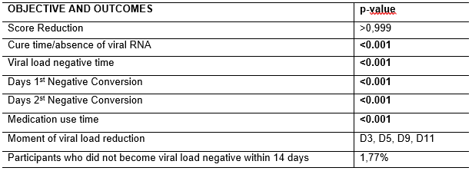

Table 2: Absolute Viral load Analysis by RT-PCR and DDPCR during the treatment days.
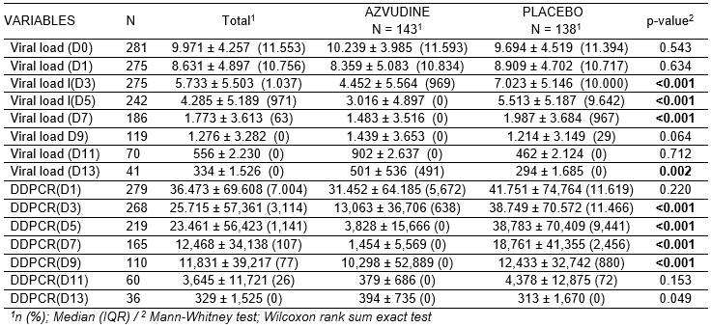

Table 3: Quantification of vaccinated and unvaccinated participants included in the study.
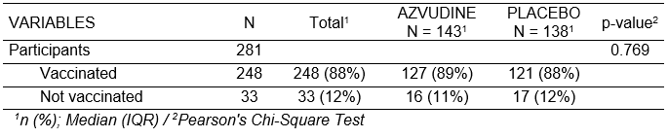

Table 4: Global quantification of Adverse Events
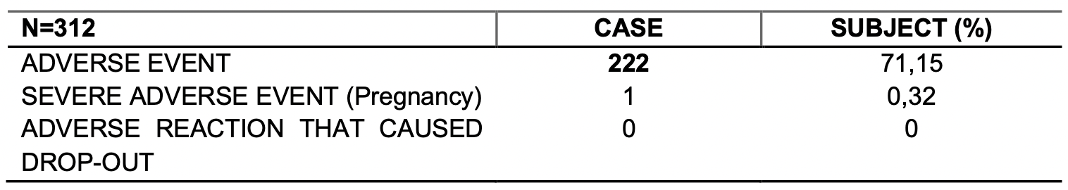

Table 5: Consolidated report of adverse events.

