Table 1: Compilation of results of contrasts between FNC and Placebo treatments on study outcomes.
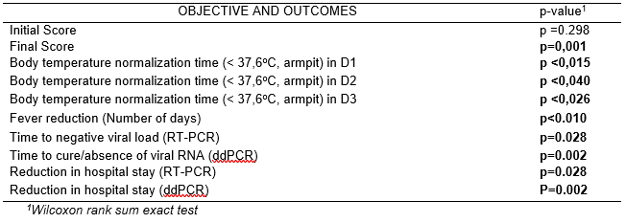

Table 2: Estimated (RT-PCR) and absolute (ddPCR) viral load values during the treatment days.

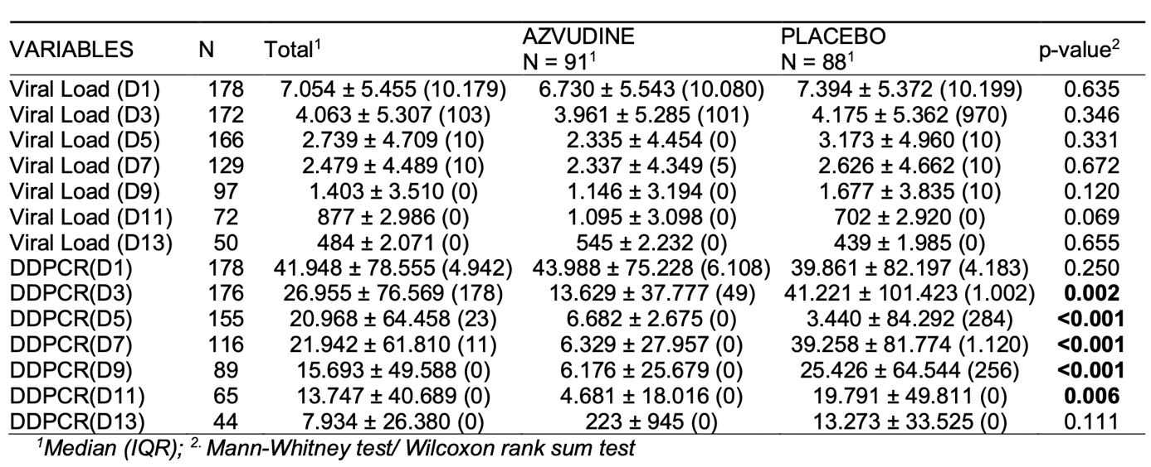

Table 3: Scorpio Call and Lineage of the SARS-COV-2 strains distributed among the treatments.
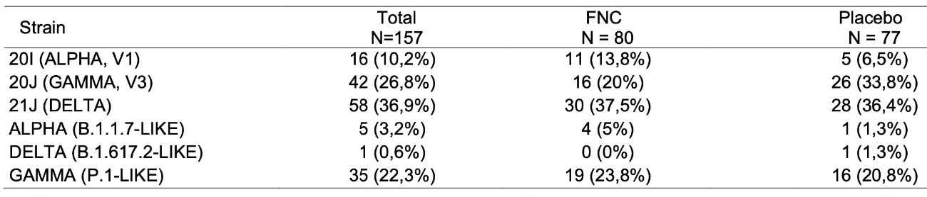

Table 4: Consolidated report of adverse events.
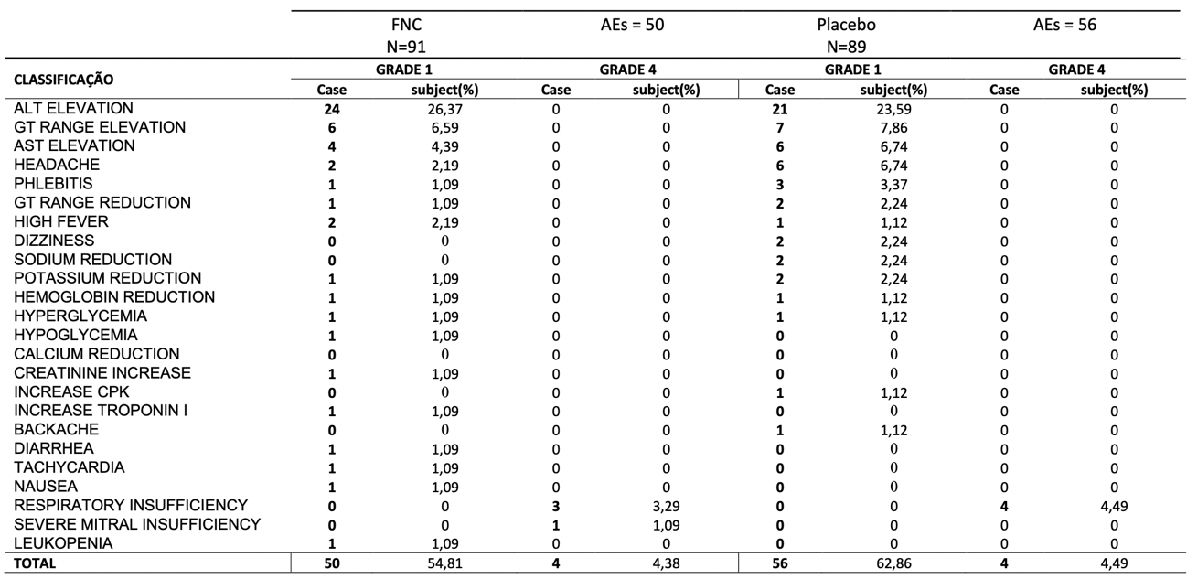

Table 5: Global quantification of Adverse Events.

