SUPPLEMENTARY INFORMATION

1. SUPPLEMENTARY RESULTS

1.1 CLINICAL IMPROVIMENT

The data indicate that the initial clinical score of the participants who used the FNC was 4.42 ± 0.50 and for those in the control group it was 4.50 ± 0.50, with no significant difference in the clinical score at which the participants entered the treatment (p=0.298) (Supplementary Figure 1).

1.2 TIME TO IMPROVEMENT OF SYMPTOMS
The time of improvement of the symptoms evaluated during the study was measured through the number of days that the participants remained with the symptom. The characteristic symptoms of patients infected with the SARS-CoV-2 virus were evaluated (Table 1 and Supplementary Table 2). It was not possible to identify statistical differences in the time to improvement of arctic all symptoms between the two groups, FNC and placebo, of participants. These results corroborate the previously published FNC pilot study treating COVID-19, where Ren and colleagues² also showed no difference in symptoms and laboratory test results during screening between the FNC group and the control group. However, it was possible to observe significant differences in the time of improvement of fever (p<0.01) and Chill (p=0.08) symptoms. The chill feeling in the initial stages of a fever could be explained by the vasoconstriction and consequent fall in the skin temperature³, thus, chill and fever are correlated. Since fever attenuation was observed in the FNC group, this may be a consequence of the decline in the infection⁴, which in turn is related to a possible reduction of the patient viral load.
In the analysis of curing time, it was observed that the AZVUDINE group had a shorter cure time/absence of viral RNA (6.5 days, p = 0.028) in relation to the PLACEBO group (8 days). There was a significant reduction in the length of hospital stay for the AZVUDINE group, reducing the time of exposure to the virus action and the possibility of greater sequelae. 09 participants took more than 14 days for the 1st negative conversion.
In the analysis of curing time, it was observed that the AZVUDINE group had a shorter cure time/absence of viral RNA (6.5 days, p = 0.028) in relation to the PLACEBO group (8 days). There was a significant reduction in the length of hospital stay for the AZVUDINE group, reducing the time of exposure to the virus action and the possibility of greater sequelae. 09 participants took more than 14 days for the 1st negative conversion.

1.3 TIME AND PROPORTION OF LUNG IMAGING IMPROVEMENT

It was not possible to observe significant differences regarding the improvement of lung images during the treatment days (Table 1 and Supplementary Table 3). All participants started the study with a clinical picture of 25 to 50% of pulmonary involvement, however, despite the clinical improvement that was observed, the improvement of the lung occurred slowly, so it was possibly not possible to observe a difference in relation to this parameter due to the short treatment period (14 days) and clinical follow-up D28 and D60.

Table 1: Demographic and baseline characteristics of participants.
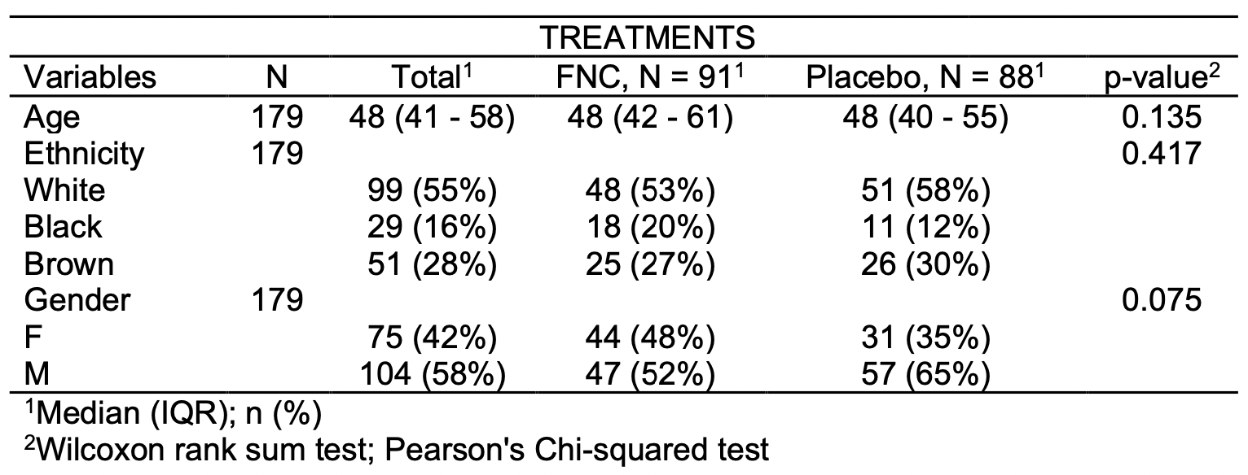

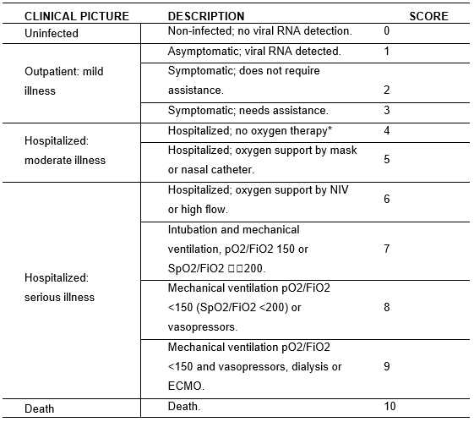
Supplementary Figure 1: scores of the study related to clinical picture. Table 4: WHO Clinical Progression Scale (Jun 2020)

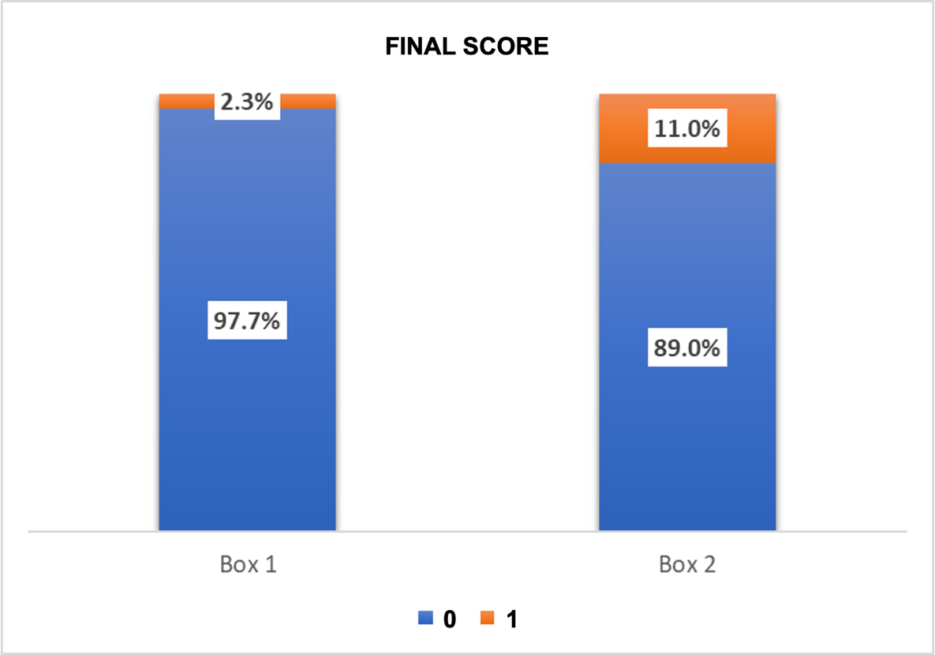

Supplementary Figure 2: Proportion of the initial and final clinical score of all subjects in the FNC group and the placebo group. The p value represents the significant difference between groups by the Wilcoxon test (Left bar: FNC; Right bar: PLACEBO).

Supplementary Table 02: Time for improvement of symptoms.
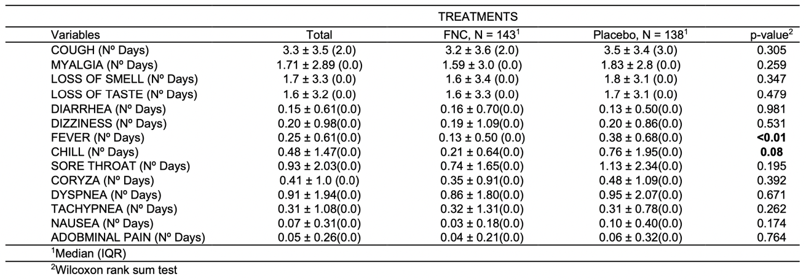

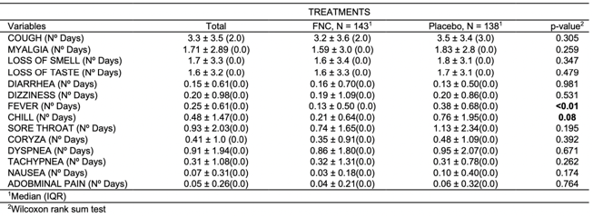
Supplementary Table 3: Time to improve lung image enhancement.
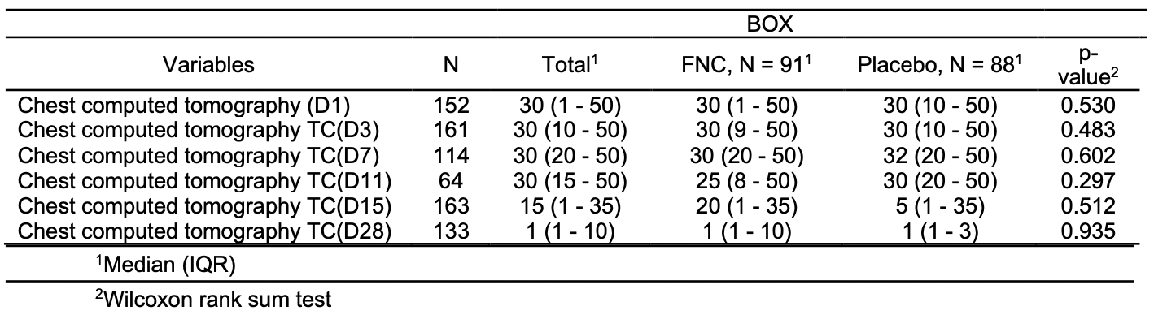

Supplementary Table 4: Viral load and CTs values during the treatment days.
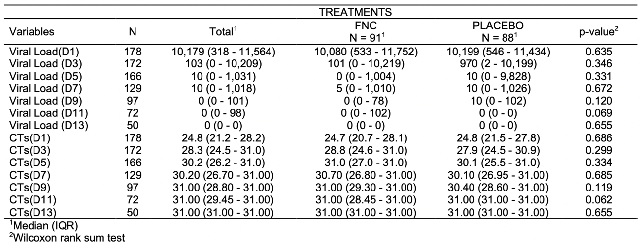

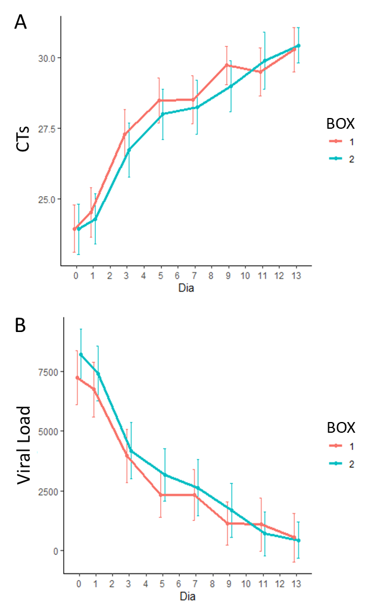

RT-PCR

Supplementary Figure 3: CTs (A) and viral load (B) analysis measured by RT-PCR of all participants in the FNC group and the placebo group. Data are median (SD). (Red line: FNC; Blue line: PLACEBO).
In this study, the FNC group showed a more accentuated increase in TCs/day, however without showing significant differences in relation to the control group (Supplementary Table 4; Supplementary Figure 3A). It was not possible to observe significant differences between the 2 groups on any of the treatment days. Since it was not possible to notice differences in the results of CTs, the same occurred for the viral load of the participants analyzed by the RT-PCR technique (Table 2, Supplementary Table 4, Figure 3A). Although it was not possible to observe differences between the groups, it is notable that there is a trend towards a more pronounced reduction in viral load in the group treated with FNC (Table 2, Supplementary Table 4, Figure 3A).
Supplementary Table 5: Comorbidities
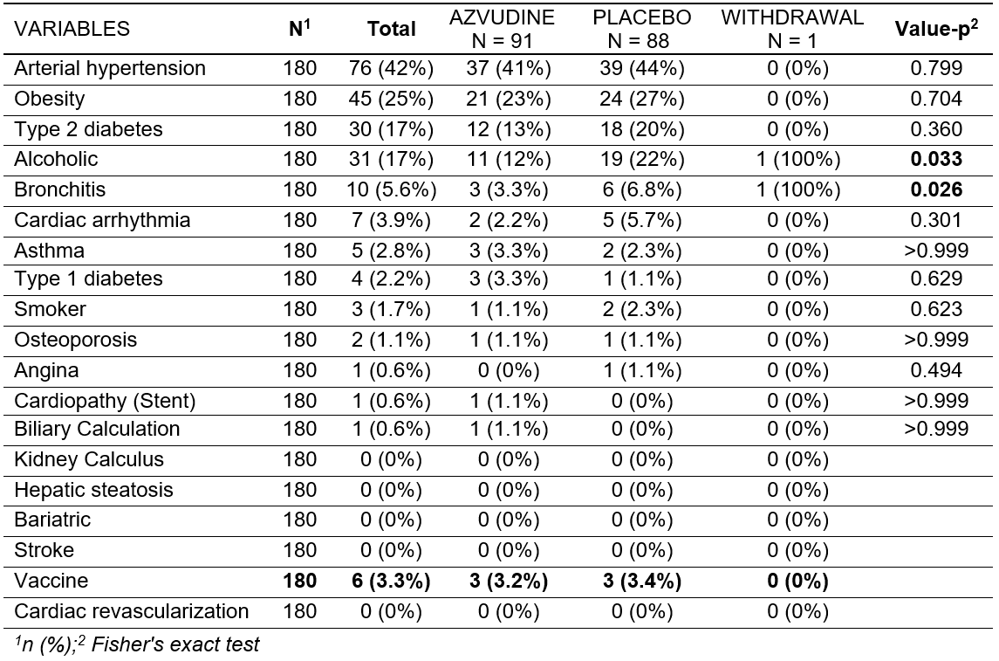
There was the presence of comorbidities among the participants, among them the most common were: arterial hypertension and obesity, Type 2 Diabetes and alcohol consumption.

Supplementary Table 6: Demonstration of values for other variables during the days of study.
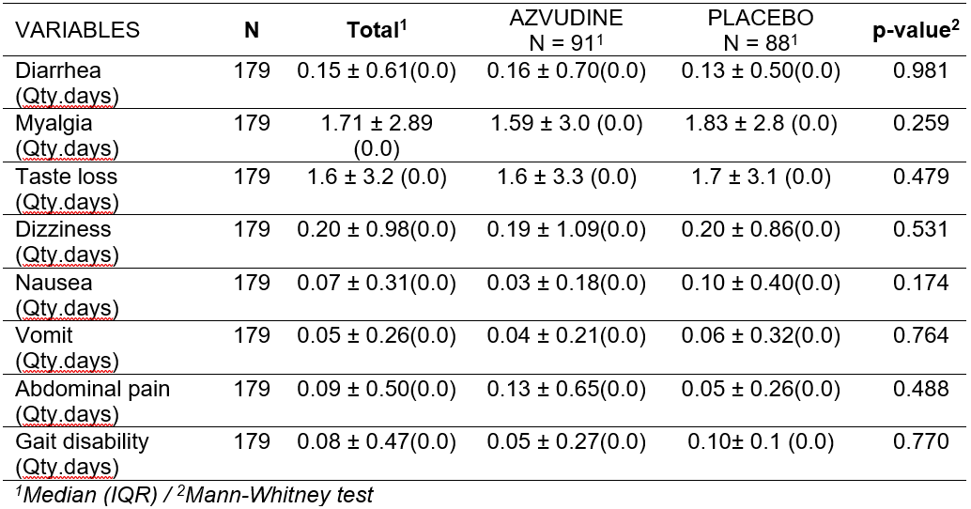

Time for improvement of diarrhea, myalgia, fatigue, malaise, cough and headache [Period: until D15, D21 and D28, approximately 14-30 days]
Analysis method: Student's t test/Mann-Whitney test

Supplementary Table 7: Analysis of urinary phosphorus excretion in 24 hours.
Despite the clinical improvement, the data were not significant. As for Headache, there were 8 cases in this study that were reported in adverse events.

There was also no significant change in urinary phosphorus as reported in adverse events of special interest.
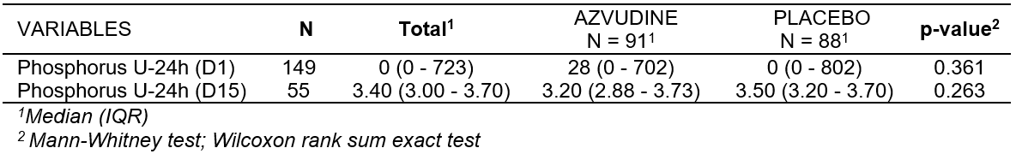
Supplementary Table 8: Demonstration of serum cholinesterase values during the study days.
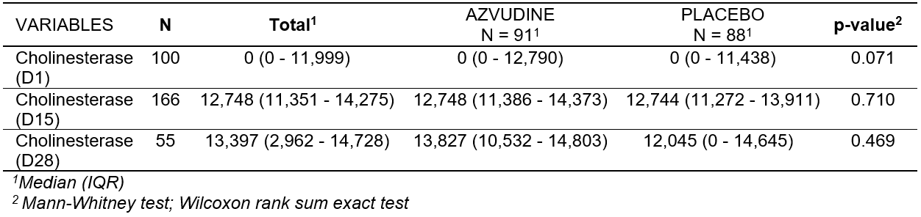
Serum cholinesterase is decreased in hepatic parenchymal diseases (viral hepatitis, cirrhosis), congestive heart failure, abscesses, neoplasms, malnutrition, acute infections, anemia, myocardial infarction and dermatomyositis. It may be increased in obese patients, in diabetics and in nephrotic syndrome. We observed that the values evaluated were not significant and that the participants did not have other debilitating conditions.

Supplementary Table 9: Demonstration of inflammatory marker values during the study days.
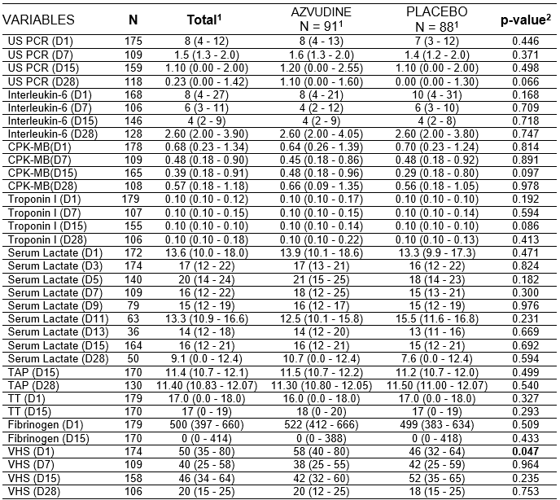
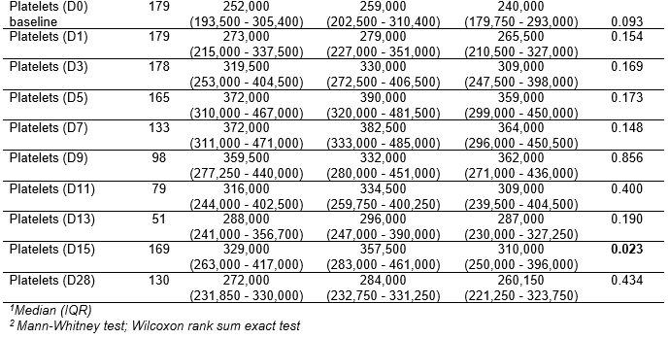

IMMUNOLOGICAL MARKERS
There was a reduction of leukocytes and neutrophils, within the normal range, but significant on D1 and compatible with an initial stage of infection. Procalcitonin that has good sensitivity and specificity for the diagnosis of secondary bacterial infections in patients with viral disease and was not significant at D1, which meets the protocol's inclusion criteria, becoming significant at D7, for 102 participants, reducing up to D15 (high) and D28 (accompaniment).

Supplementary Table 10: Demonstration of white series values and immunological markers during the study days
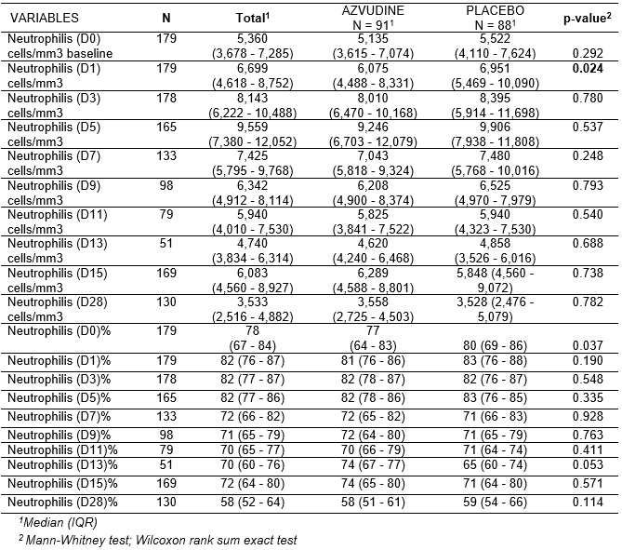
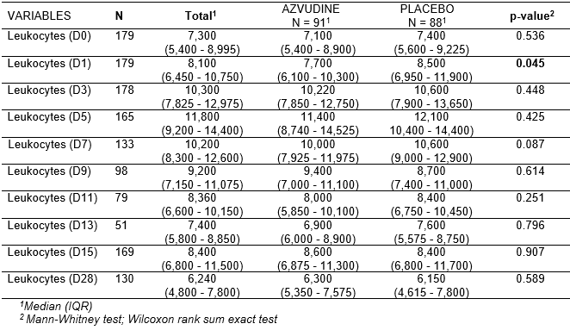

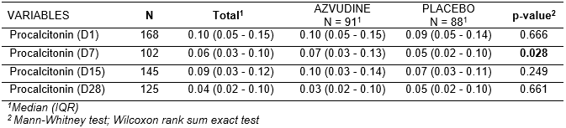

Supplementary Table 11: Demonstration of immunological marker values during the study days.
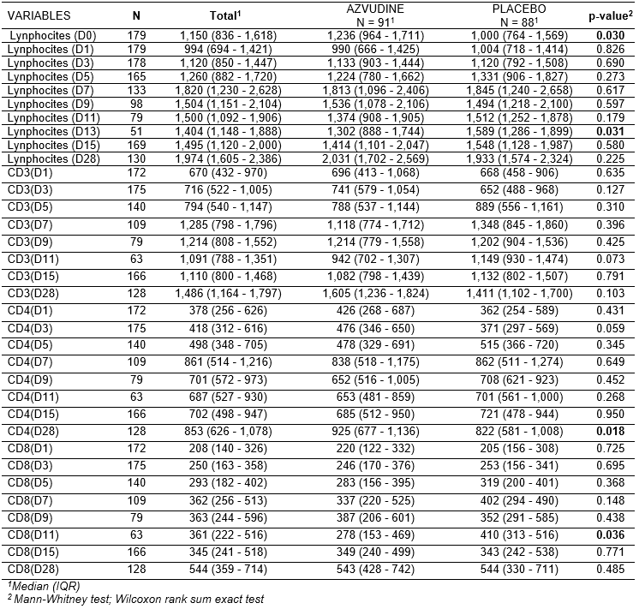

There was a significant increase in lymphocytes at D13, for 51 participants, but within the normal range.
There was significance of CD8 on D11 (elimination of infectious cells) for 63 participants.
There was CD4 significance at D28 (specific for opportunistic infections) for 128 participants, which may explain post-covid symptoms.

Supplementary Table 12: Demonstration of lung imaging values during the study days

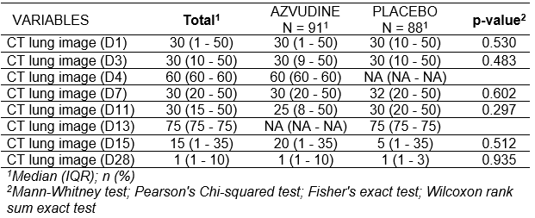

Time and proportion of lung imaging improvement during treatment (Ground-glass opacity pattern, mosaic paving, alveolar consolidation, reticular pattern/septal thickening, inverted halo opacity, pleural/pericardial effusion, fibrosis and/or lymphadenomegaly) [Period: up to D15, D21 and D28, approximately 14-30 days]
Analysis method: Student's t test/Mann-Whitney test/Pearson's chi-square test

There was no significance in lung computed tomography imaging, since the assessment time during treatment is aimed at the perception of disease progression. A short time of 14 days of treatment is not enough for an improvement to happen, since the organism is dynamic and a decompensation causes defense mechanisms and unwanted responses.

Supplementary Table 13: Demonstration of respiratory symptoms values during the study days
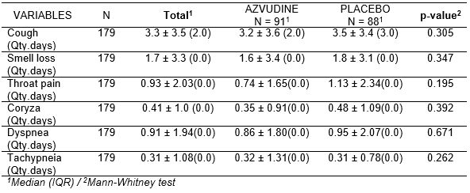

Time of improvement and proportion of respiratory symptoms and signs during treatment (lung rales, cough, sputum, sore throat); [Period: up to D15, D21 and D28, approximately 14-30 days]
Analysis method: Student's t test/Mann-Whitney test/Pearson's chi-square test

Although there was an improvement in respiratory symptoms leading participants to hospital discharge, this improvement was not observed in the statistical analysis.

Supplementary Table 14: Demonstration of O2 saturation values during the study days.
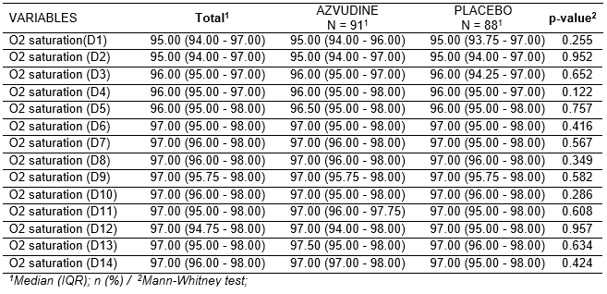

Time for normalization of O2 saturation (above 95%); [Period: up to D15, D21 and D28, approximately 14-30 days]
Analysis method: Student's t test/Mann-Whitney test

Although there was an improvement in O2 saturation, this was not observed in the statistical analysis. We can see an improvement in O2 saturation in the 2 groups from D2 onwards.

Supplementary Table 15: Demonstration of O2 saturation values during the study days
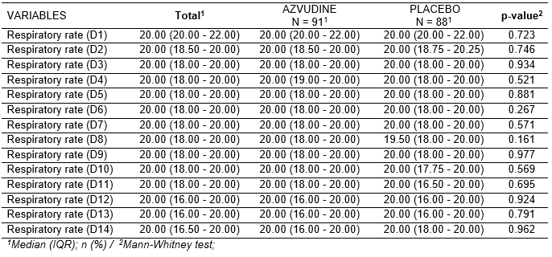

Time for normalization of respiratory rate to levels ≤ 24rpm, in ambient air; [Period: up to D15, D21 and D28, approximately 14-30 days]
Analysis method: Student's t test/Mann-Whitney test
The improvement in respiratory rate was not significant and ventilatory support makes this parameter questionable.

Supplementary Table 16: Demonstration of the distribution of participants in the type of ventilatory support during the study days.
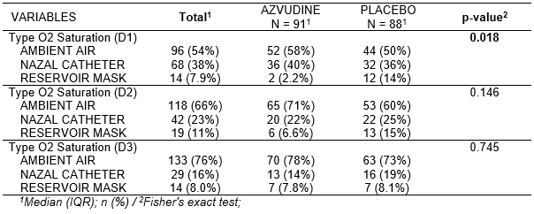

This data shows the number of participants who entered the study in room air, nasal catheter and reservoir mask, with significance between groups, in D1. It also shows that the number of these participants who moved to room air practically doubled in D2 in the AZVUDINE group. The predominance of recovery to room air continued until D6, which coincides with the time when viral load decreases with AZVUDINE on D3, D5 and D7. Also, the number of participants using a catheter or reservoir mask from D2 onwards is lower in the AZVUDINE group than in the PLACEBO group.

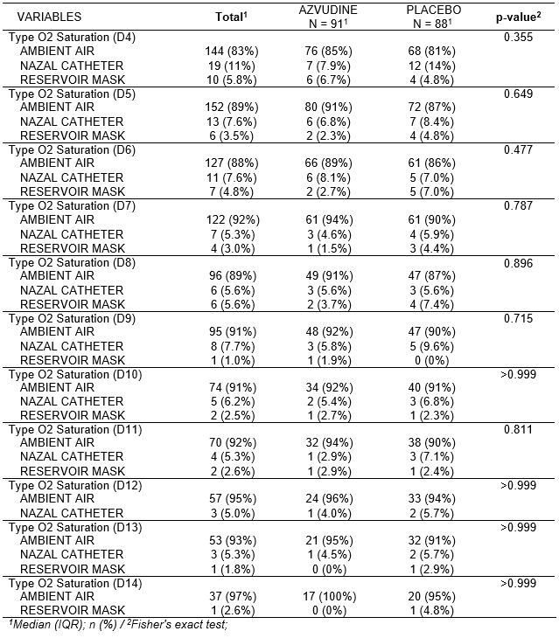
Frequency of supplemental oxygenation or non-invasive ventilation; [Period: up to D15, D21 and D28, approximately 14-30 days]
Analysis method: Student's t test/Mann-Whitney test/Pearson's chi-square test.

Supplementary Table 17: Demonstration of O2 consumption during ventilatory support on the study days.

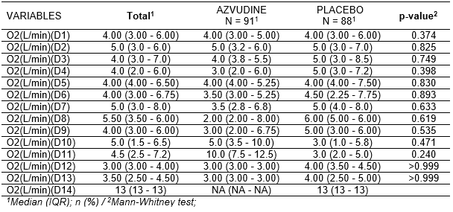Also related to the frequency of supplemental oxygenation or non-invasive ventilation, we have the amount of liters of O2/minute that tended to decrease in the AZVUDINE group.
Although there was no significance, the O2 consumption of the AZVUDINE group was lower than the PLACEBO group.
Note that in D11 the O2 consumption increased due to the worsening of participant R41 in the AZVUDINE group, as well as in D14 there was a worsening of R161 in the PLACEBO group. Both were transferred to ICU care.

Supplementary Table 18: Demonstration of the use of mechanical ventilation during the study days.
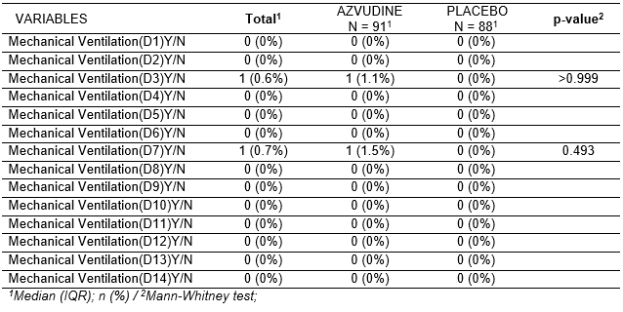

Frequency of invasive mechanical ventilation or extracorporeal membrane oxygenation (ECMO); [Period: up to D15, D21 and D28, approximately 14-30 days]
Analysis method: Student's t test/Mann-Whitney test

There was no significance between the groups in the use of mechanical ventilation, although there was a predominance of worsened conditions in the Placebo group. Another factor is the worsening without clinical, which justifies entry into the study and worsening afterwards.

REFERENCES

¹Chow S. C., Shao, J., Wang, H., Lokhnygina, Y. Eds. Sample Size Calculations in Clinical Research: Third Edition. 2017, Chapman and Hall/CRC.) utilizando a fórmula 4.2.2 (test for non-inferiority /superiority

2 Ren Z., Luo H., Yu Z., Song J., Liang L., Wang L., et al. A Randomized, Open-label, Controlled Clinical Trial of AZVUDINE Tablets in the Treatment of Mild and Common COVID-19, A Pilot Study. Adv Sci (Weinh). 2020 Jul 14,7(19):2001435. doi: 10.1002/advs.202001435. Epub ahead of print. PMID: 32837847, PMCID: PMC7404576.

³ Guieu J. D. and Hellon R. F., 1980. The Chill Sensation in Fever. Pflugers Arch. 384, 103- i04 (1980)
⁴ Kluger M J, Kozak W, Conn C A, Leon L R, Soszynski D., 1998. Ann N Y Acad Sci;856:224-33. doi: 10.1111/j.1749-6632.1998.tb08329.x.

