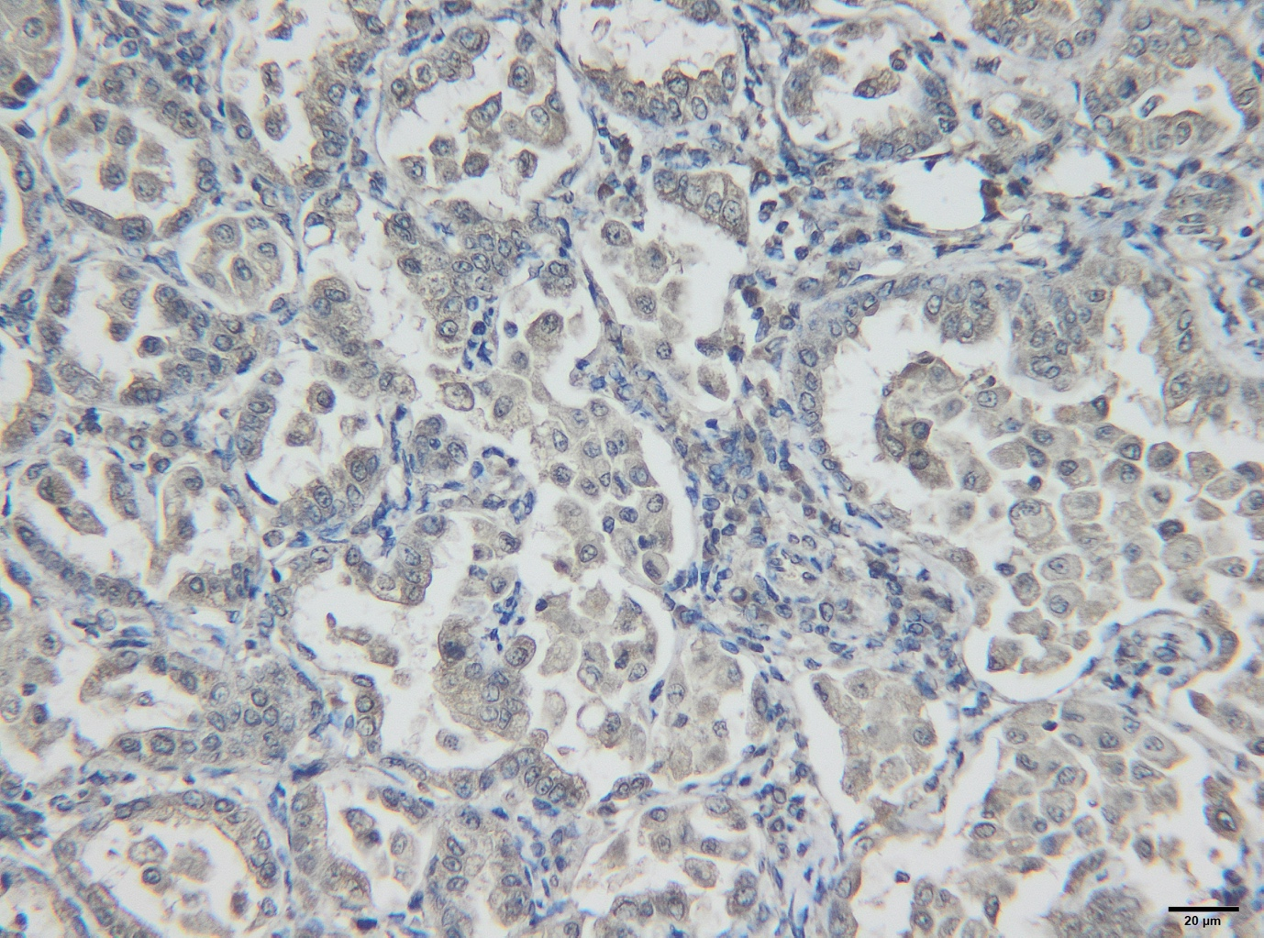

Figure S1: OPA, sheep, immunohistochemistry for JSRV-MA;

