Supplementary Material

Photodegradation of 17α-ethinylestradiol on Ag₃PO₄ crystals treated at different temperatures
Luis F. G. Noletoª, Vitória E. M. Vieiraª, Francisco H. P. Lopes^{b}, Lara K. Ribeiro^{c}, Taisa C. M. Dantas^{b}, Gustavo O. M. Gusmão^{b}, Geraldo E. Luz Jr.^{a,b,*}
ª Departamento of Chemistry (DQ), Federal University of Piauí – UFPI, Teresina, PI 64049-550, Brazil
^{b} PPGQ-GrEEnTec-DQ, State University of Piauí – UESPI, 2231 João Cabral Street, P.O. Box 381, Teresina, PI 64002-150, Brazil
^{c} LIEC/CDMF, Departamento of Chemistry, Federal University of São Carlos, São Carlos-SP, Brazil

* Corresponding author.
Email address: geraldoeduardo@ccn.uespi.br (G. E. Luz Jr.)
Tel: +55 86 99983-9932.
Figure S1 – Schematic representation of the precipitation synthesis at room temperature of Ag₃PO₄.

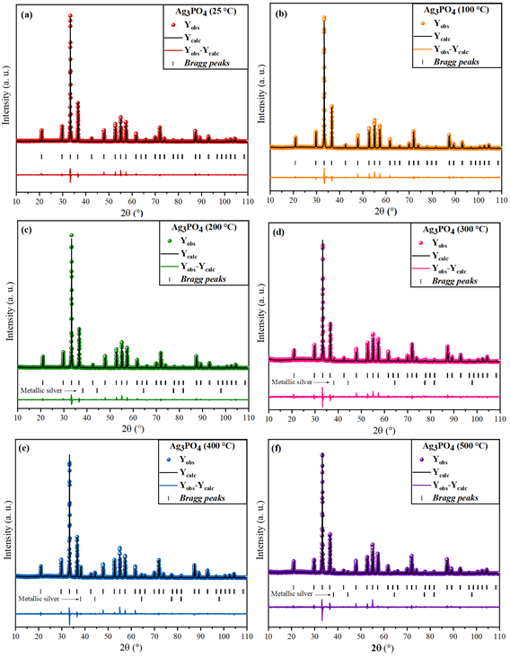
Figure S2 – Rietveld refinement plots of the Ag₃PO₄ crystals obtained at room temperature (a) and thermally treated at 100 °C (b), 200 °C (c), 300 °C (d), 400 °C (e), and 500 °C (f).

Table S1 – Atomic coordinates and network parameters obtained by Rietveld refinement of the Ag₃PO₄ crystals at room temperature (a) and thermally treated at 100 °C (b), 200 °C (c), 300 °C (d), 400 °C (e), and 500 °C (f) comparing to ICSD card no. 14000 (g).
Atoms | Wyckoff | Sites | X | Y | Z
a) Ag₃PO₄ (25°C)
Ag | 6d | -4.. | 0.25000 | 0.00000 | 0.50000
P | 2a | 23. | 0.00000 | 0.00000 | 0.00000
O | 8e | .3. | 0.14767 | 0.14767 | 0.14767
Density = 6.511 g/cm³; *R_{p}: 17.7%; *R_{wp}: 16.7%; *R_{exp}: 10.96%; *R_{bragg}: 4.499%; *χ²: 2.33; *D-W_{(stat.)}: 1.0432; *D-W_{(esp.)}: 1.9443; Volume (Å)³: 217.24; Cell parameters a=b=c: 6.01151(3) Å e α=β=γ: 90°
b) Ag₃PO₄ (100°C)
Ag | 6d | -4.. | 0.25000 | 0.00000 | 0.50000
P | 2a | 23. | 0.00000 | 0.00000 | 0.00000
O | 8e | .3. | 0.14210 | 0.14210 | 0.14210
Density = 6.520 g/cm³; R_{p}: 21.1%; R_{wp}: 19.1%; R_{exp}: 12.44%; R_{bragg}: 4.045%; χ²: 2.35; D-W_{(stat.)}: 0.9841; D-W_{(esp.)}: 1.9427; Volume (Å)³: 217.29; Cell parameters a=b=c: 6.0118(7) Å e α=β=γ: 90°
c) Ag₃PO₄ (200°C)
Ag | 6d | -4.. | 0.25000 | 0.00000 | 0.50000
P | 2a | 23. | 0.00000 | 0.00000 | 0.00000
O | 8e | .3. | 0.14662 | 0.14662 | 0.14662
Density = 6.514 g/cm³; R_{p}: 17.2%; R_{wp}: 16.9%; R_{exp}: 10.90%; R_{bragg}: 3.246%; χ²: 2.40; D-W_{(stat.)}: 1.0369; D-W_{(esp.)}: 1.9443; Volume (Å)³: 217.25; Cell parameters a=b=c: 6.01158(3) Å e α=β=γ: 90°
d) Ag₃PO₄ (300°C)
Ag | 6d | -4.. | 0.25000 | 0.00000 | 0.50000
P | 2a | 23. | 0.00000 | 0.00000 | 0.00000
O | 8e | .3. | 0.14492 | 0.14492 | 0.14492
Density = 6.409 g/cm³; R_{p}: 29.5%; R_{wp}: 23.7%; R_{exp}: 18.44%; R_{bragg}: 2.520%; χ²: 1.59; D-W_{(stat.)}: 1.3504; D-W_{(esp.)}: 1.9439; Volume (Å)³: 217.56; Cell parameters a=b=c: 6.01441(4) Å e α=β=γ: 90°
e) Ag₃PO₄ (400°C)
Ag | 6d | -4.. | 0.25000 | 0.00000 | 0.50000
P | 2a | 23. | 0.00000 | 0.00000 | 0.00000
O | 8e | .3. | 0.13989 | 0.13989 | 0.13989
Density = 6.427 g/cm³; R_{p}: 23.3%; R_{wp}: 20.2%; R_{exp}: 13.46%; R_{bragg}: 3.974%; χ²: 2.25; *D-W_{(stat.)}:1.1056; D-W_{(esp.)}: 1.9439; Volume (Å)³: 217.40; Cell parameters a=b=c: 6.01294(3) Å e α=β=γ: 90°
f) Ag₃PO₄ (500°C)
Ag | 6d | 4.. | 0.25000 | 0.00000 | 0.50000
P | 2a | 23. | 0.00000 | 0.00000 | 0.00000
O | 8e | 3. | 0.15031 | 0.15031 | 0.15031
Density = 6.577 g/cm³; R_{p}: 25.3%; R_{wp}: 21.7%; R_{exp}: 15.60%; R_{bragg}: 3.127%; χ²: 1.93; D-W_{(stat.)}: 1.2029; D-W_{(esp.)}: 1.9439; Volume (Å)³: 217.40; Cell parameters a=b=c: 6.01298(4) Å e α=β=γ: 90°
g) ICSD: 14000
Ag | 6d | 4.. | 0.25000 | 0.00000 | 0.50000
P | 2a | 23. | 0.00000 | 0.00000 | 0.00000
O | 8e | 3. | 0.14860 | 0.14860 | 0.14860
Density = 6.405 g/cm³; Volume (Å)³: 218.82; Cell parameters a=b=c: 6.026000 Å e α=β=γ: 90°
*R_{p} = profile factor; *R_{wp} = weighted profile factor; *R_{exp} = expected weighted profile factor; *R_{braag} = Bragg factor; χ² = fit factor); *D-W_{(stat)} = Durbin-Watsom statistical parameter and *D-W_{(esp)} = expected Durbin-Watsom parameter.

Table S2 – Length and bond angles of [AgO₄] and [PO₄] clusters.

Ag₃PO₄ | Bond length (Å) |  |  | Bond angles (°)
Ag₃PO₄ | Ag−O | P−O | O−P−O |  | O−Ag−O |  | Ag−O−Ag | Ag−O−P
Ag₃PO₄ |  |  | δ |  | α | β | γ | ε
25 °C | 2.373 | 1.547 | 109.5 |  | 150.23 | 150.2 | 101.72 | 116.42
100 °C | 2.373 | 1.547 | 109.5 |  | 150.23 | 150.2 | 101.72 | 116.4
200 °C | 2.373 | 1.547 | 109.5 |  | 150.23 | 150.2 | 101.72 | 116.4
300 °C | 2.374 | 1.548 | 109.47 |  | 150.23 | 150.2 | 101.72 | 116.4
400 °C | 2.374 | 1.548 | 109.5 |  | 150.23 | 150.2 | 101.72 | 116.4
500 °C | 2.374 | 1.548 | 109.5 |  | 150.23 | 150.2 | 101.72 | 116.4
14000* | 2.379 | 1.551 | 109.47 |  | 150.23 | 150.2 | 101.72 | 116.4
*Values obtained by ICSD card no. 14000 used in the Rietveld refinement

Figure S3 – TG (a) and DSC (b) curves of Ag₃PO₄ crystals.

Table S3 – Kinetic constants, correlation factor and Turnover frequency of the samples Ag₃PO₃ used in photodegradation of the EE2.6
Ag₃PO₄ (ºC) | k ª (min⁻¹) | R ^{b} | TOF ^{c} (min⁻¹)
25 | 3.87x10⁻³ | 0.95280 | 1.62x10⁻⁴
100 | 2.66x10⁻³ | 0.90825 | 1.11x10⁻⁴
200 | 7.42x10⁻³ | 0.98479 | 3.11x10⁻⁴
300 | 5.04x10⁻³ | 0.99350 | 2.12x10⁻⁴
400 | 1.24x10⁻³ | 0.98046 | 5.19x10⁻⁵
500 | 6.64x10⁻³ | 0.80347 | 2.78x10⁻⁴
a- kinetic rate constants; b- correlation factor; c- turnover frequency

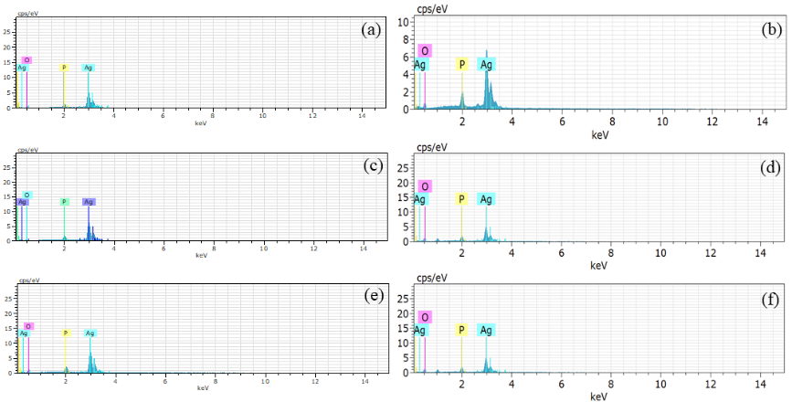
Figure S4 – EDX spectra for Ag₃PO₄ crystals at room temperature (a) and treated at 100 (b), 200 (c), 300 (d), 400 (e), and 500 °C (f).

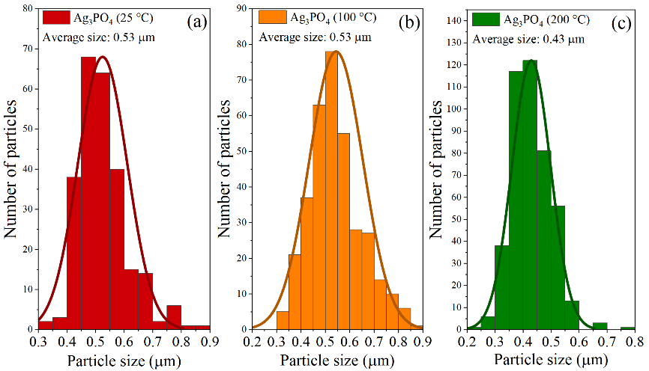
Figure S5 – Particles distribution diagrams for Ag₃PO₄ crystals at room temperature (a) and treated at 100 (b) and 200 °C (c).

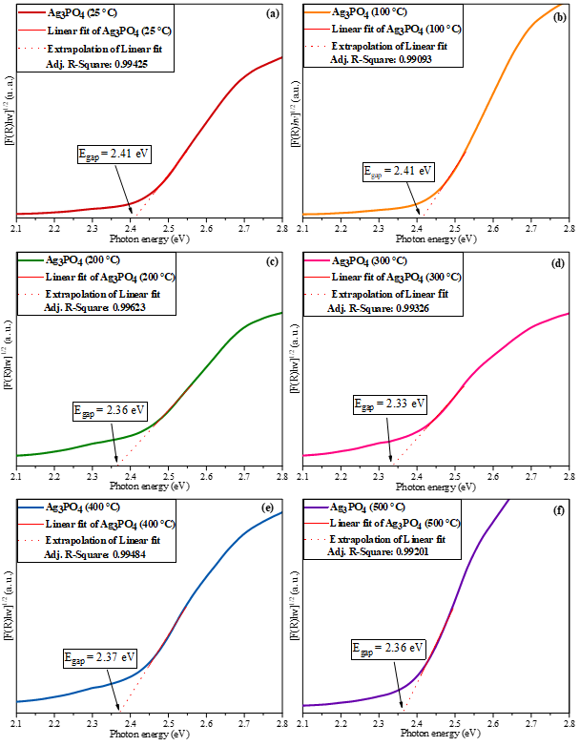
Figure S6 – Indirect band gap energy (E_{gap}) of Ag₃PO₄ samples at room temperature (a) and treated at 100 °C (b), 200 °C (c), 300 °C (d), 400 °C (e), and 500 °C (f).

