Appendix
Figure A1: Kaplan Meier Failure estimates of age at First Cohabitation in India by background characteristics
A1.  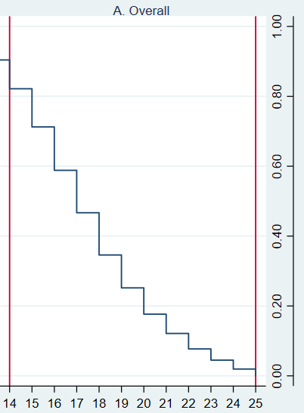 | A2  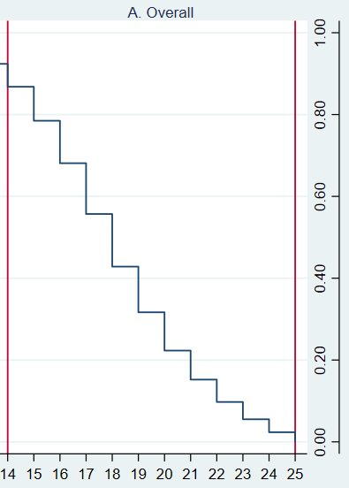 | A3  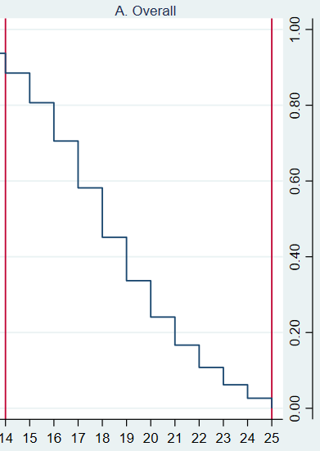
B1  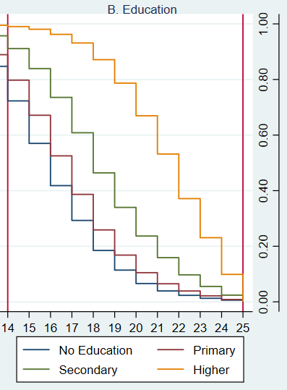 | B2  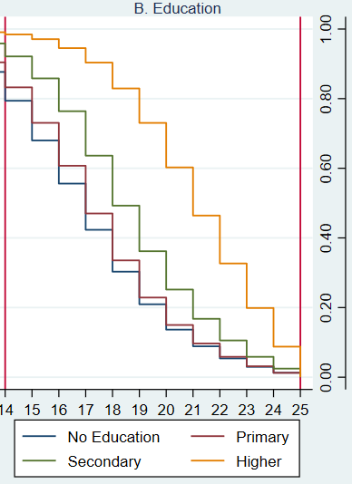 | B3  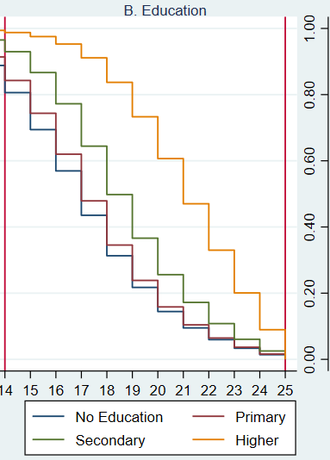
C1  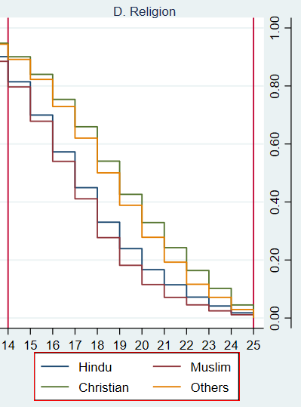 | C2  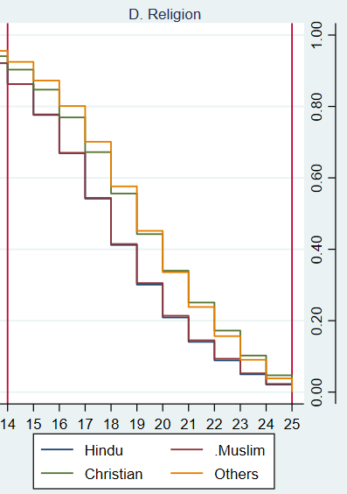 | C3  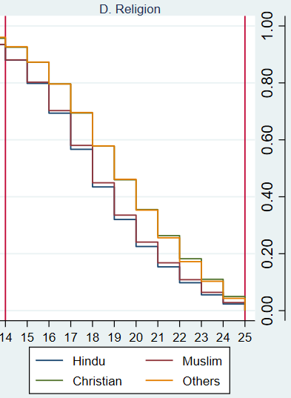
D1  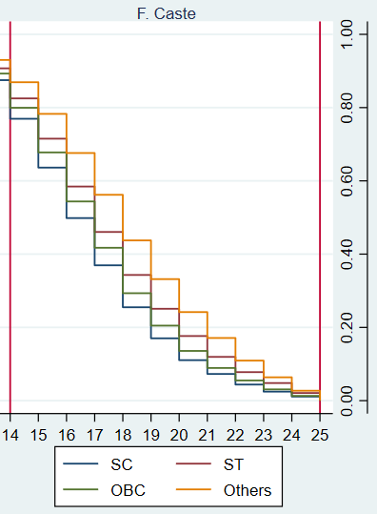 | D2  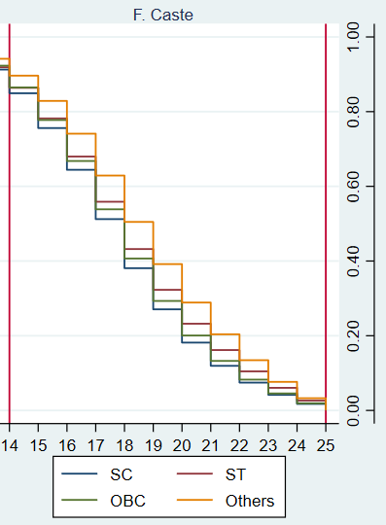 | D3  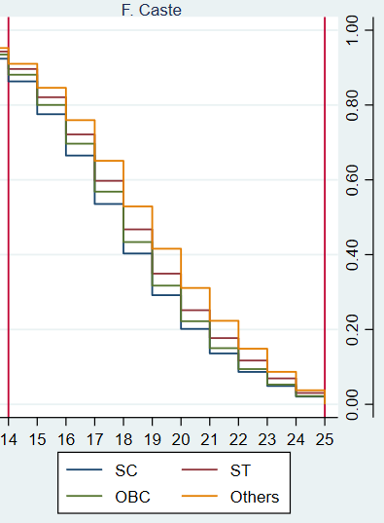
E1  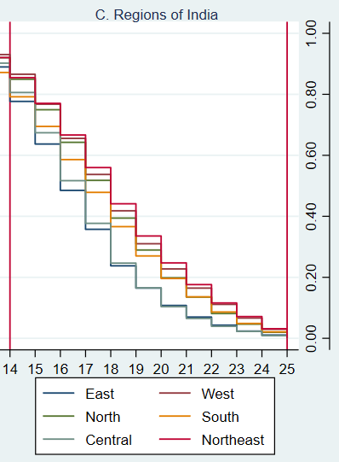 | E2  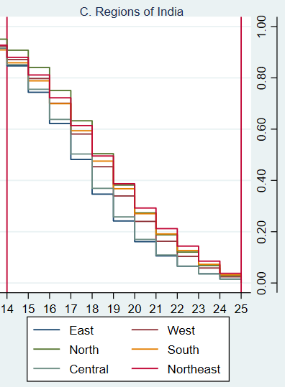 | E3  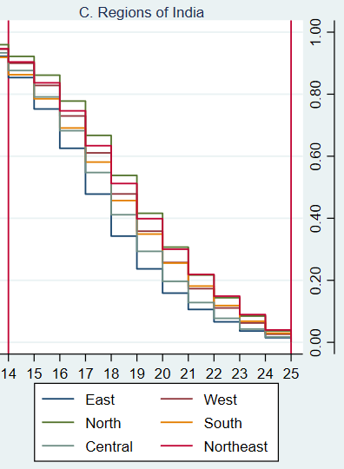
F1  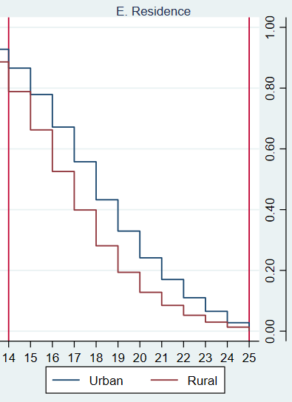 | F2  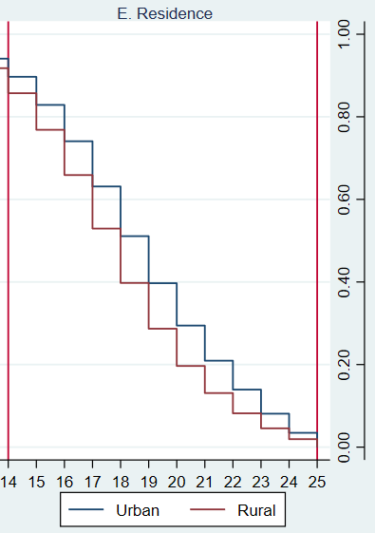 | F3  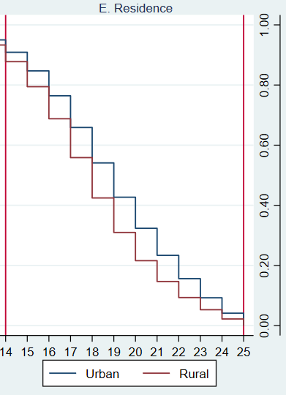

Figure A2: Kaplan Meier Failure estimates of age at First Sex in India by background characteristics
A1  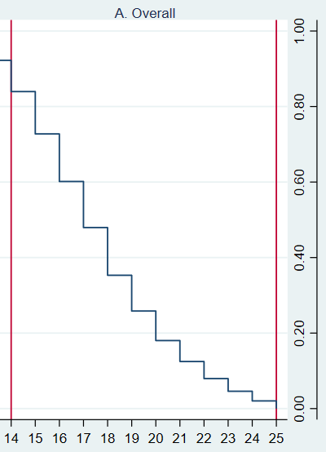 | A2  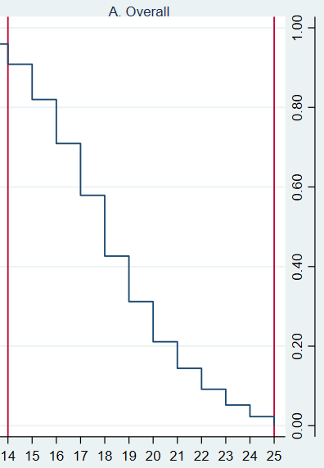 | A3  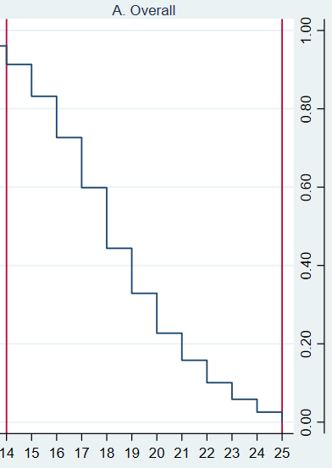
B1  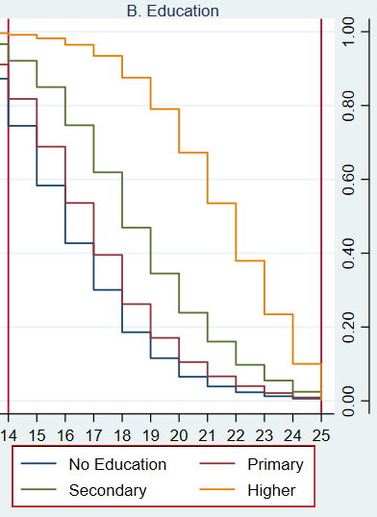 | B2  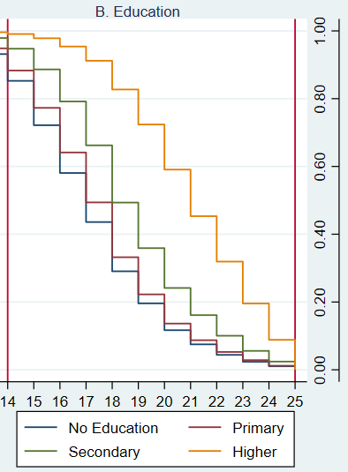 | B3  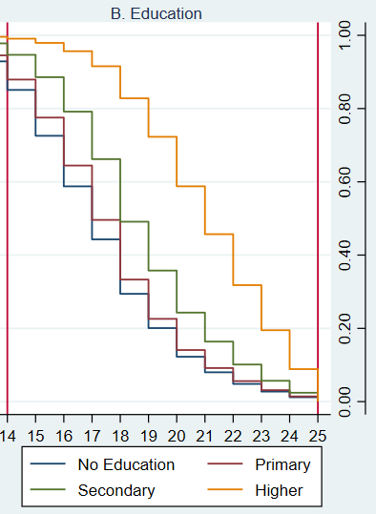
C1  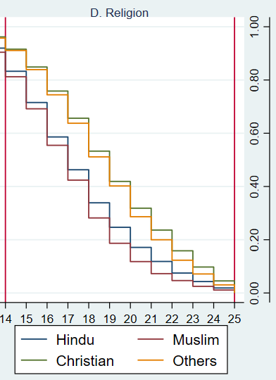 | C2  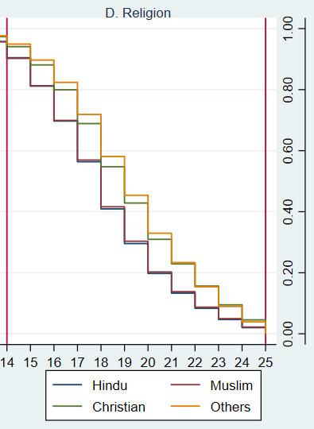 | C3  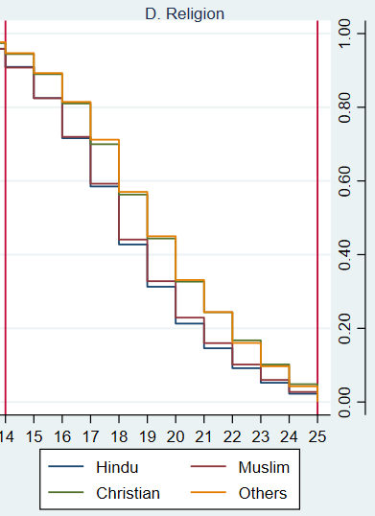
D1  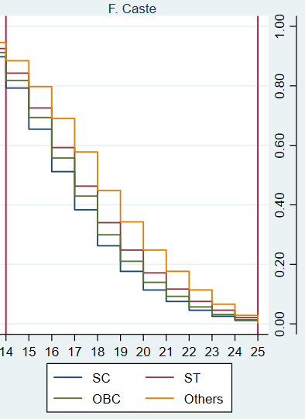 | D2  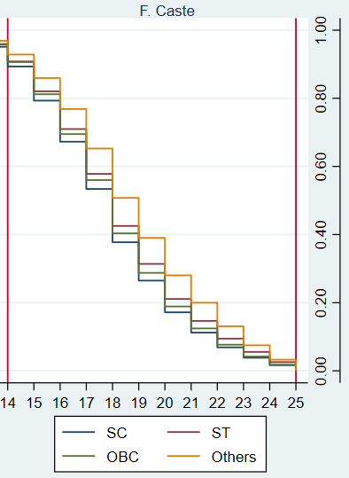 | D3  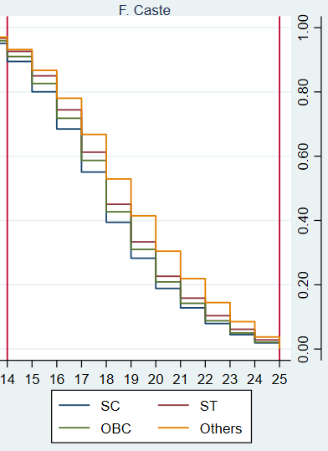
E1  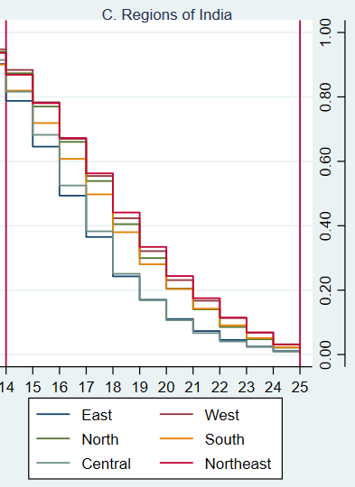 | E2  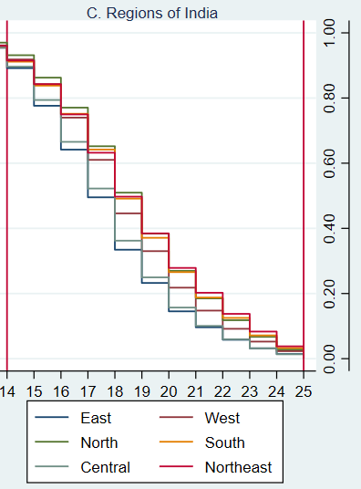 | E3  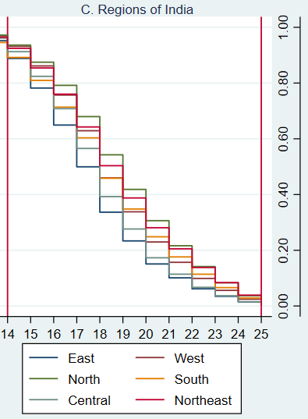
F1  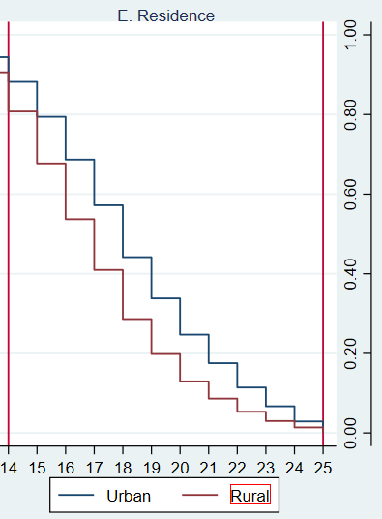 | F2  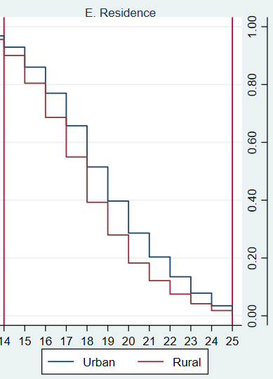 | F3  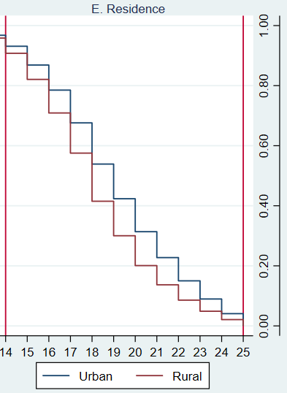

Figure A3: Kaplan Meier Failure estimates of age at First Birth in India by background characteristics
A1  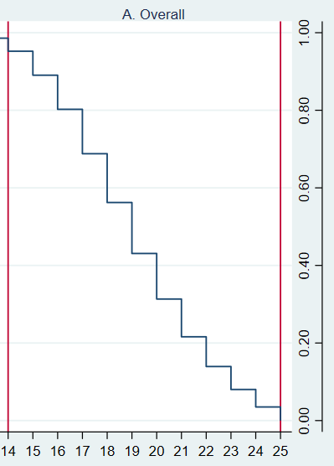 | A2  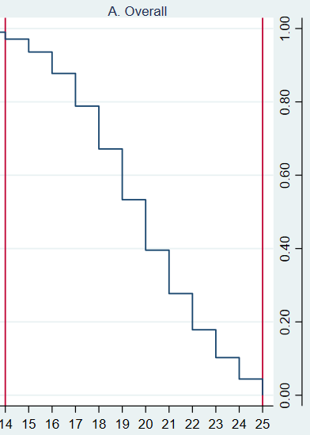 | A3  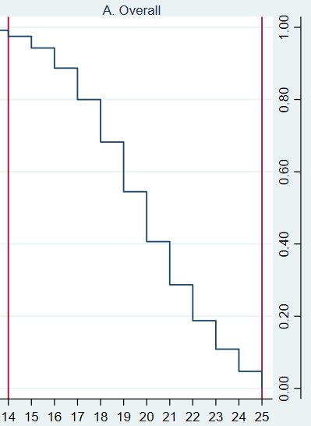
B1  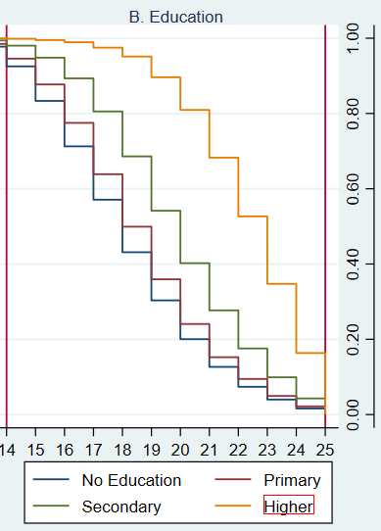 | B2  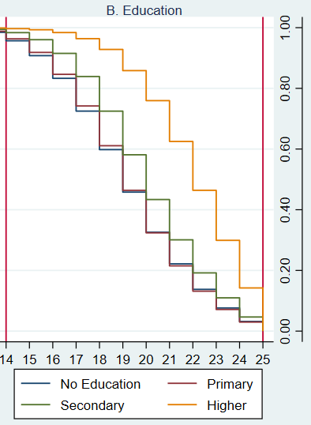 | B3  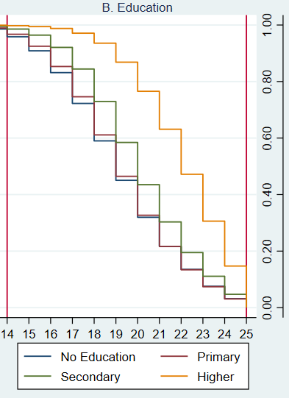
C1  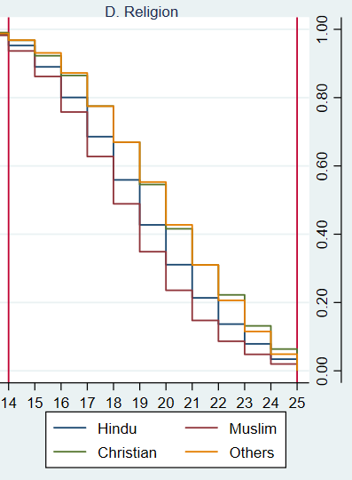 | C2  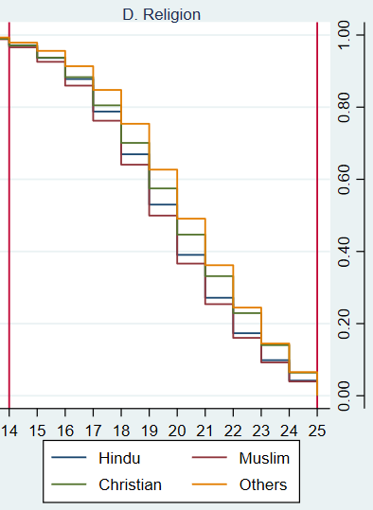 | C3  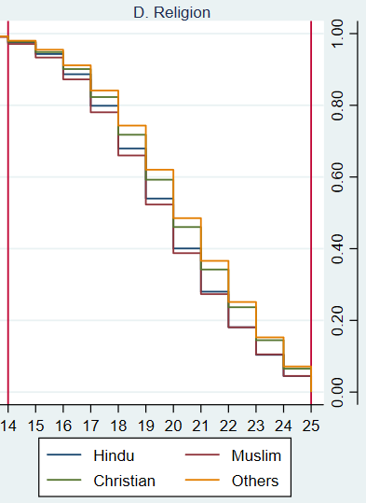
D1  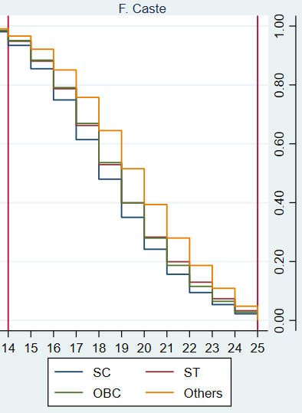 | D2  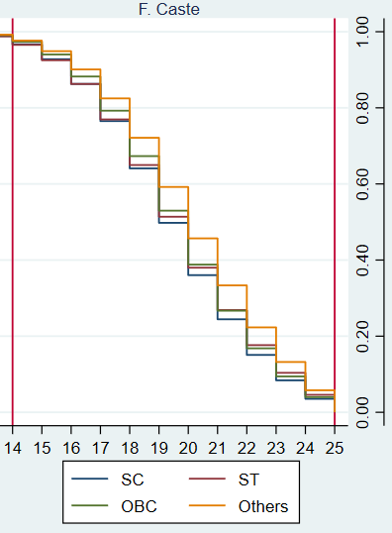 | D3  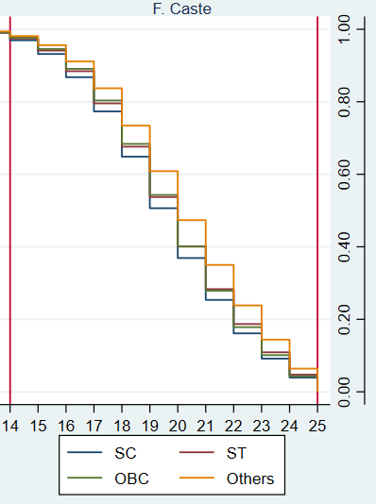
E1  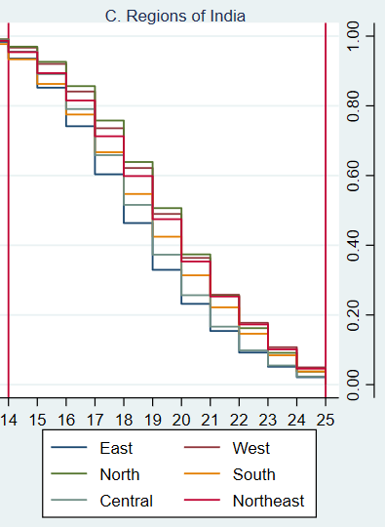 | E2  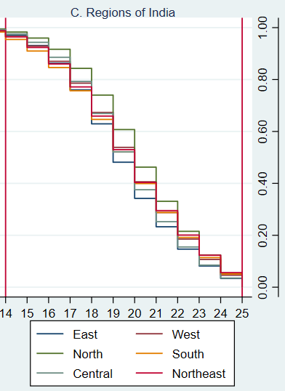 | E3  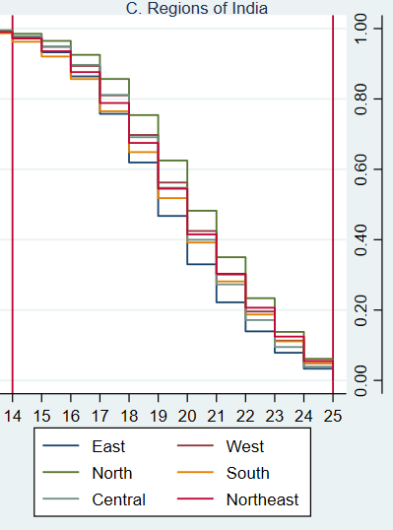
F1  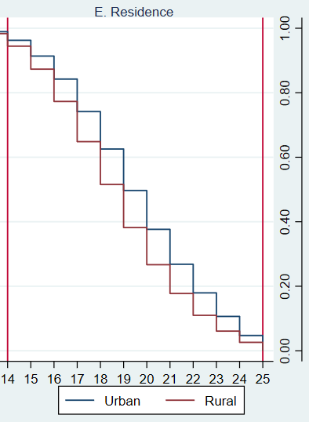 | F2  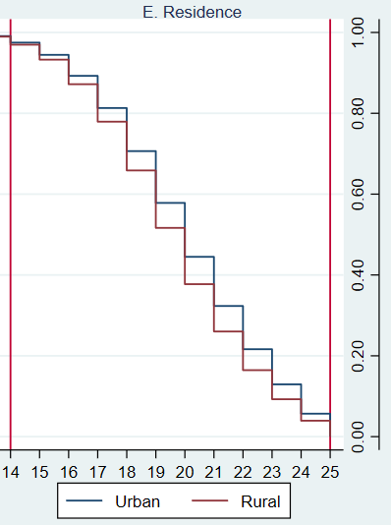 | F3  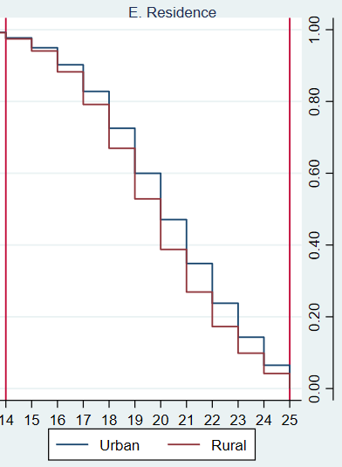

Figure A4: State specific hierarchical clustered heat map showing the probability of First Cohabitation, First Sex and First Birth not yet happened by exact age among women aged 15-49 years for the last 3 survey rounds.
I. 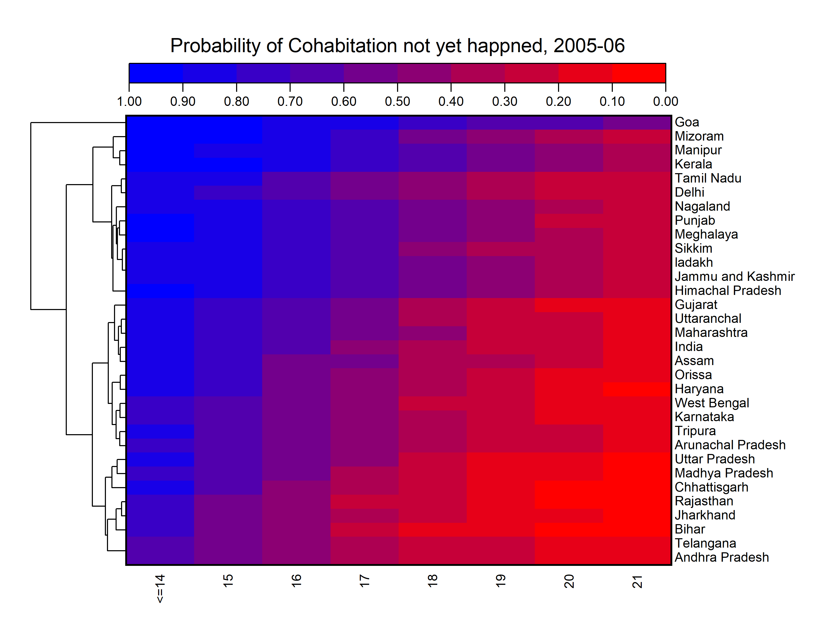
II. 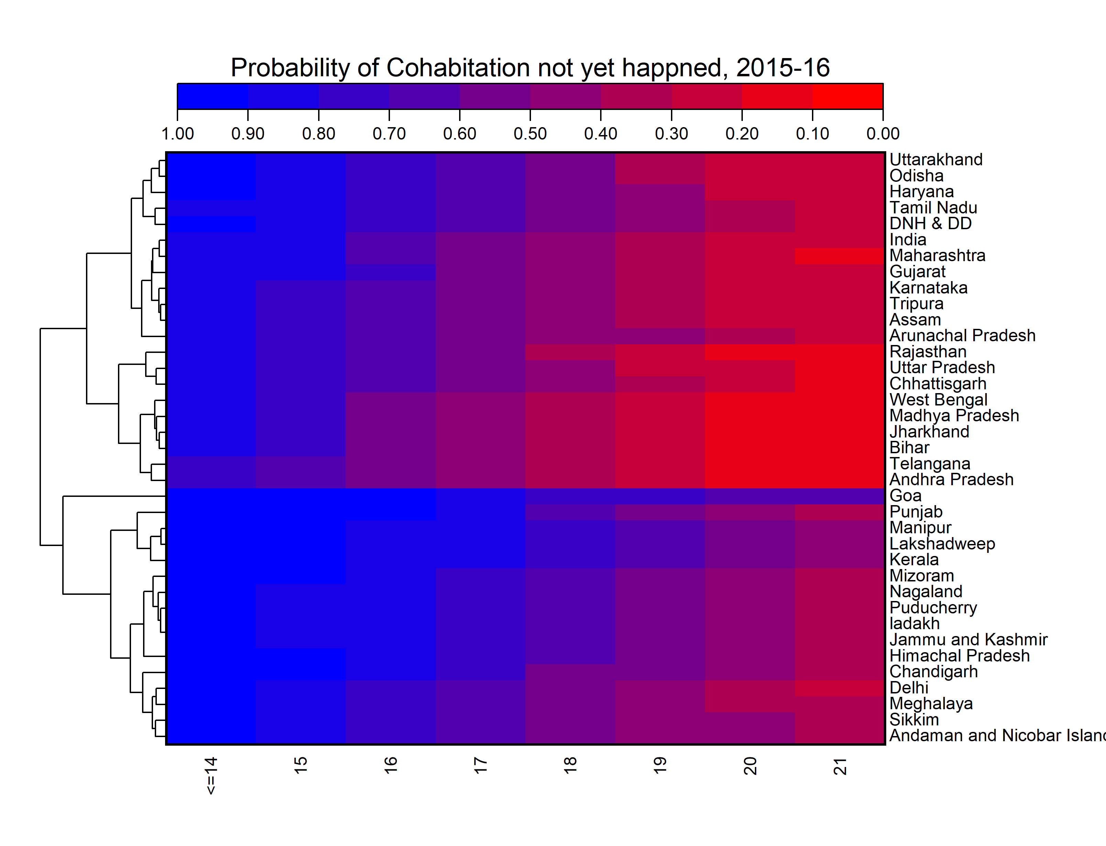
III. 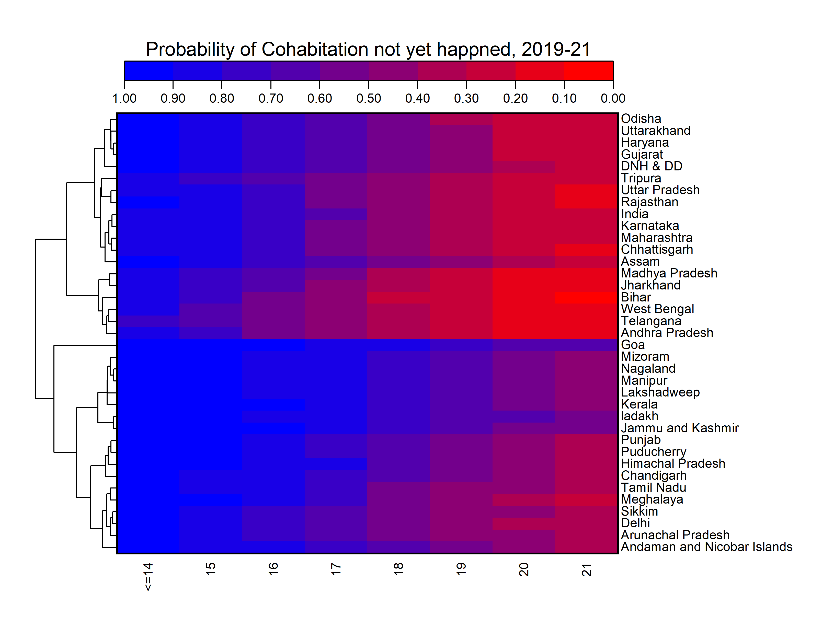
IV. 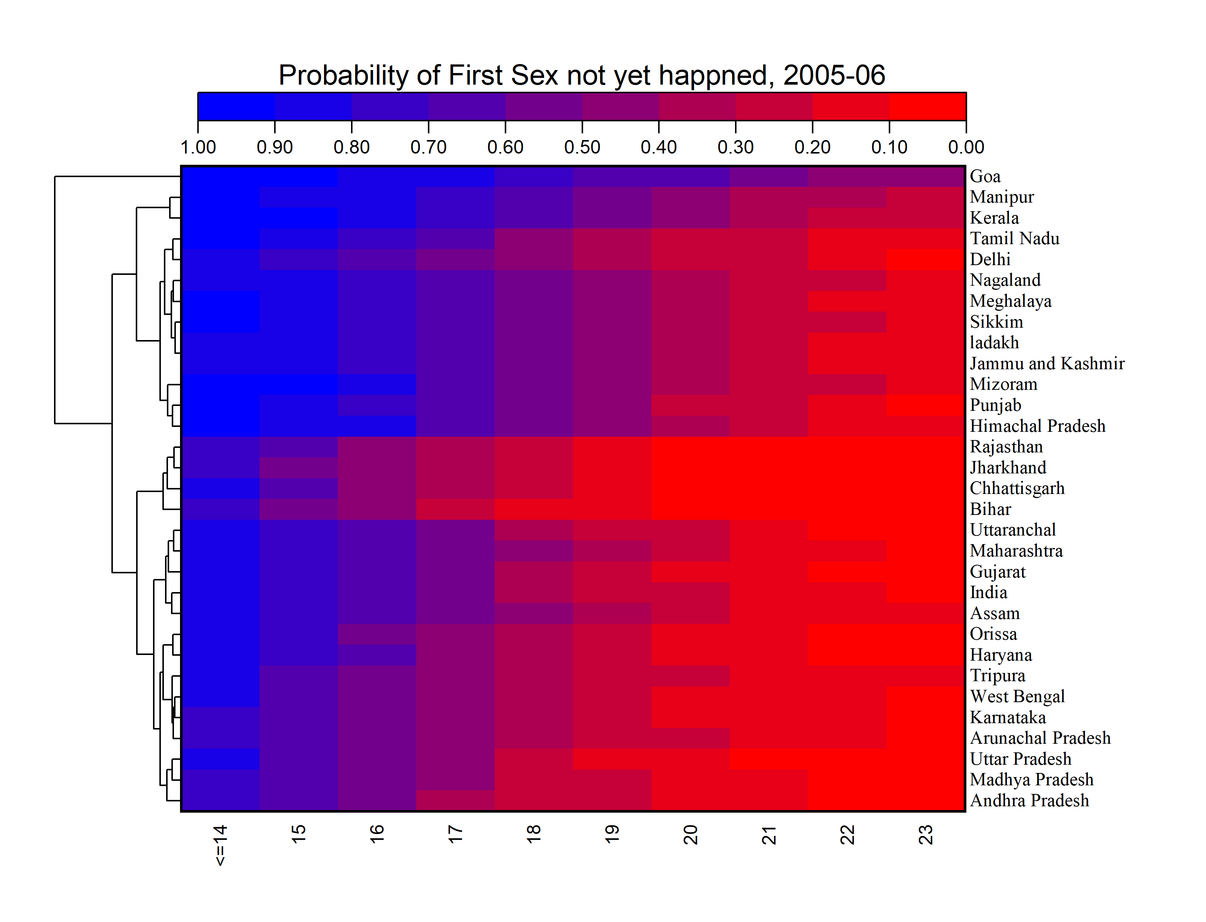
V. 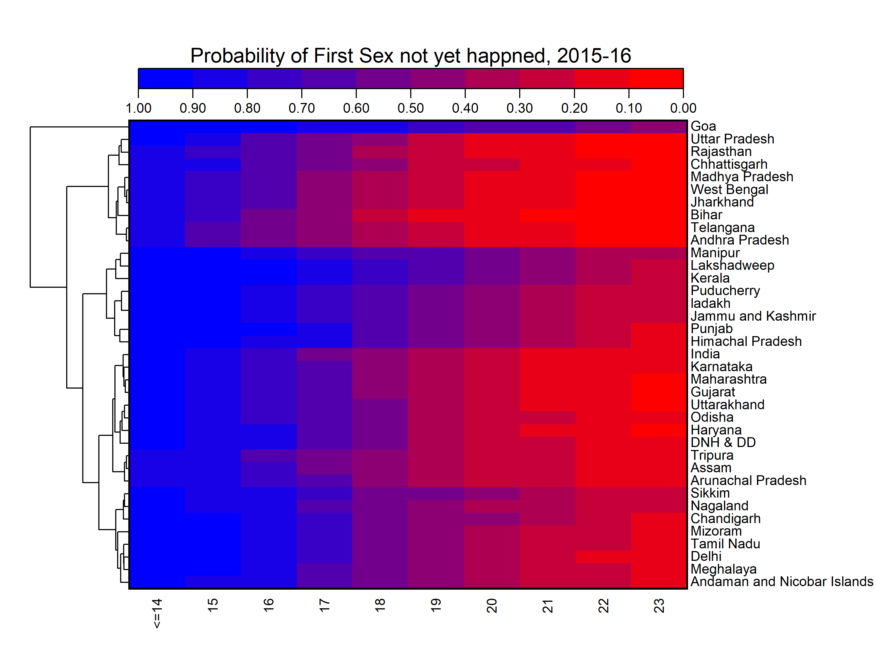
VI. 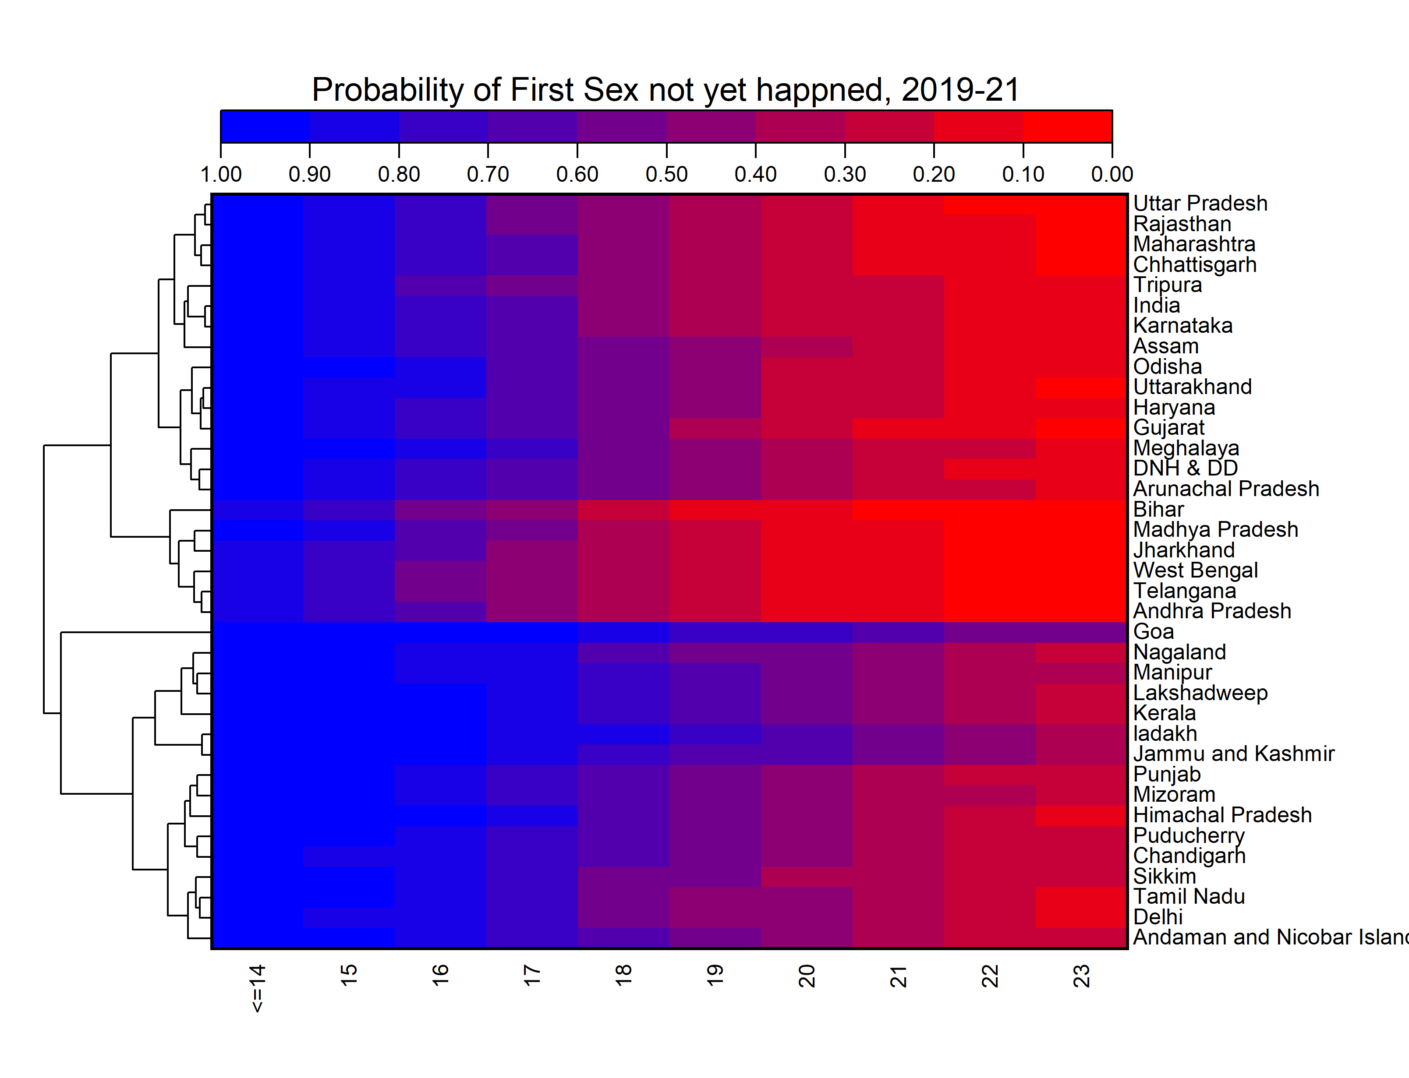
VII. 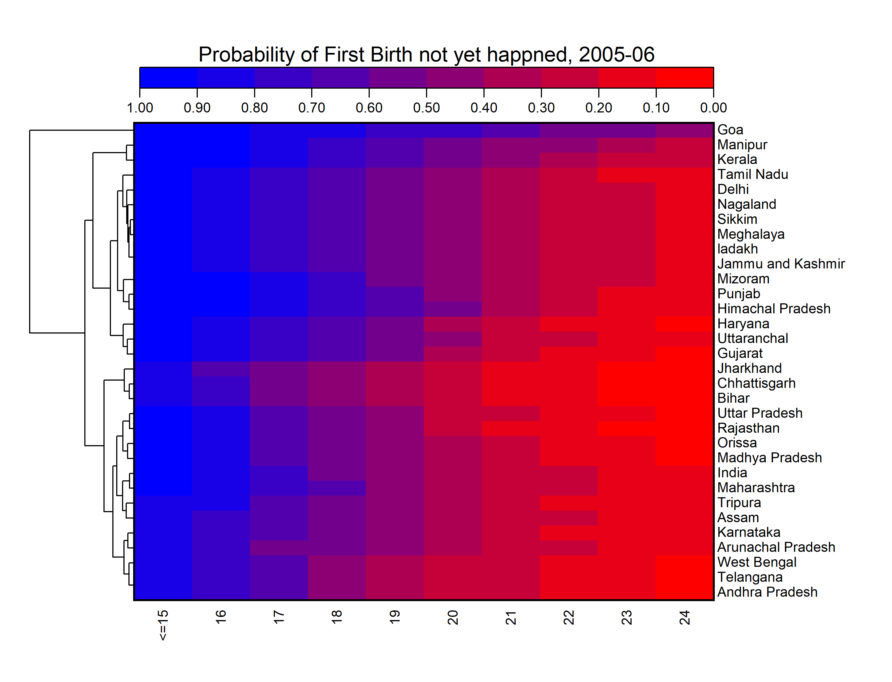
VIII. 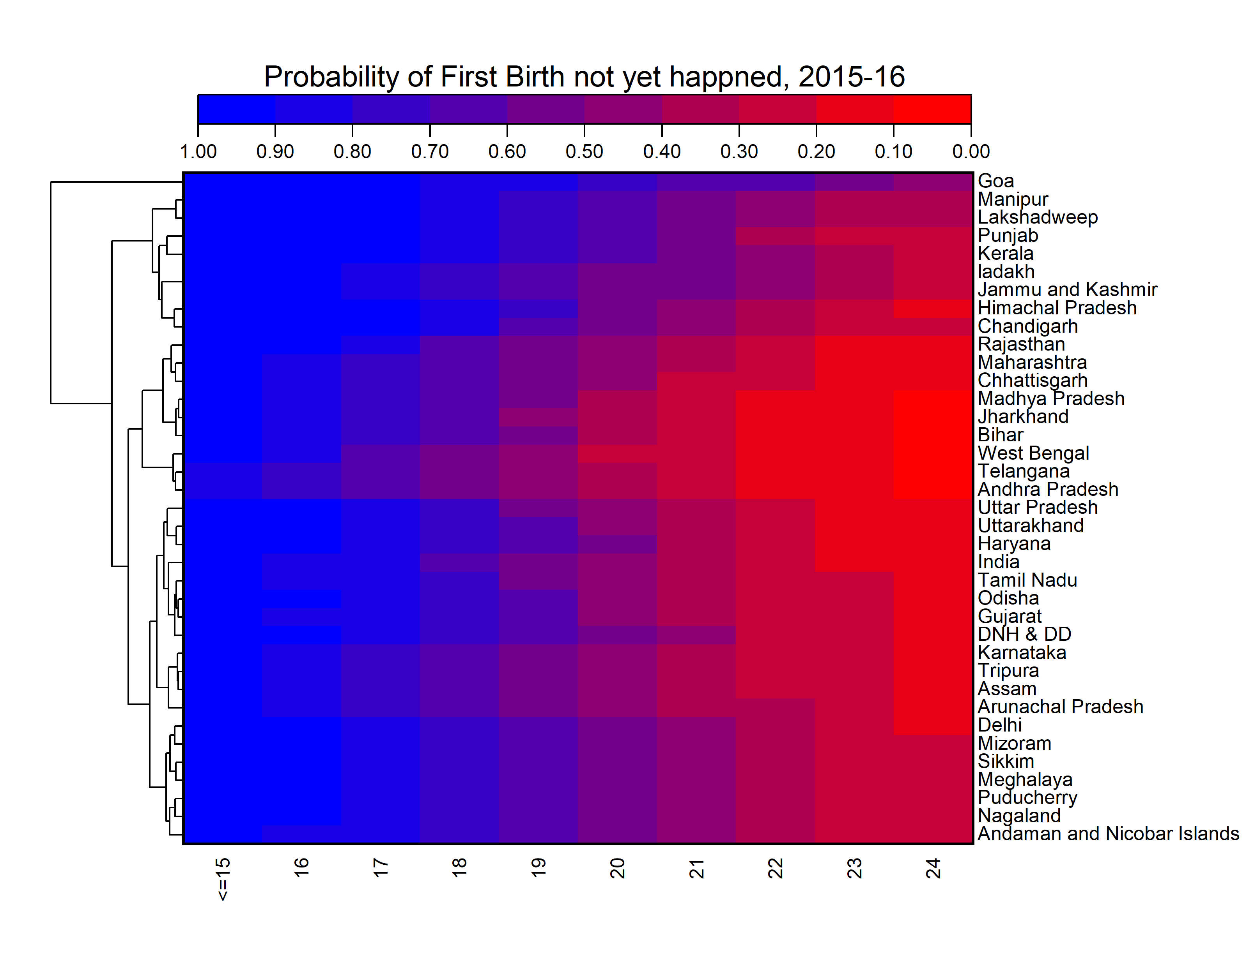
IX. 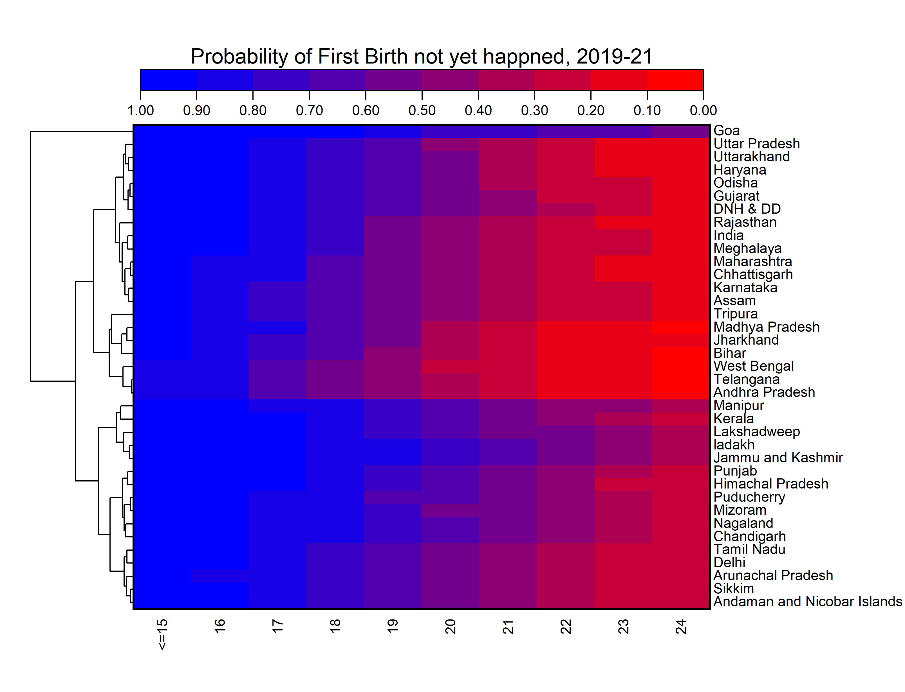

Table B1: Cox Proportional Hazard Model predicting women risk of first cohabitation, first sex and first birth by various demographic characteristics, 2019-21.
Characteristics | First Cohabitation |  | First Sex |  | First Birth
Characteristics | NFHS-V |  | NFHS-V |  | NFHS-V
State Region | CHR | AHR | CHR | AHR | CHR | AHR
East(Ref)
West | 0.76*** [0.76,0.77] | 0.85*** [0.84,0.86] | 0.78*** [0.77,0.78] | 0.89*** [0.87,0.89] | 0.81*** [0.80,0.82] | 0.99* [0.98,1.00]
North | 0.67*** [0.66,0.68] | 0.78*** [0.77,0.79] | 0.66*** [0.65,0.66] | 0.77*** [0.77,0.78] | 0.73*** [0.73,0.74] | 0.95*** [0.94,0.96]
South | 0.76*** [0.75,0.77] | 0.87*** [0.86,0.88] | 0.75*** [0.74,0.76] | 0.87*** [0.87,0.88] | 0.83*** [0.82,0.84] | 1 [0.99,1.01]
Central | 0.91*** [0.90,0.92] | 0.93*** [0.93,0.94] | 0.93*** [0.92,0.94] | 0.97*** [0.96,0.98] | 0.91*** [0.90,0.91] | 0.93*** [0.92,0.94]
Northeast | 0.61*** [0.60,0.61] | 0.67*** [0.67,0.68] | 0.63*** [0.62,0.63] | 0.68*** [0.67,0.69] | 0.72*** [0.71,0.73] | 0.96*** [0.94,0.97]
Residence
Urban
Rural | 1.30*** [1.30,1.31] | 1.07*** [1.06,1.08] | 1.33*** [1.32,1.33] | 1.07*** [1.06,1.08] | 1.26*** [1.25,1.26] | 1.04*** [1.03,1.05]
Highest Education
No Education(Ref)
Primary | 0.94*** [0.93,0.95] | 0.97*** [0.96,0.98] | 0.92*** [0.91,0.92] | 0.94*** [0.93,0.95] | 1.01 [1.00,1.01] | 1.12*** [1.11,1.13]
Secondary | 0.70*** [0.70,0.71] | 0.74*** [0.74,0.75] | 0.67*** [0.66,0.67] | 0.71*** [0.70,0.71] | 0.80*** [0.80,0.81] | 1.11*** [1.10,1.12]
Higher | 0.40*** [0.40,0.41] | 0.43*** [0.43,0.44] | 0.38*** [0.37,0.38] | 0.40*** [0.40,0.41] | 0.46*** [0.46,0.47] | 0.77*** [0.76,0.78]
Caste
SC (Ref)
ST | 0.81*** [0.80,0.81] | 0.88*** [0.88,0.89] | 0.83*** [0.82,0.84] | 0.89*** [0.88,0.89] | 0.86*** [0.85,0.87] | 1.02** [1.01,1.03]
OBC | 0.95*** [0.95,0.96] | 0.99*** [0.98,0.99] | 0.95*** [0.94,0.96] | 0.99*** [0.98,0.99] | 0.95*** [0.94,0.95] | 0.97*** [0.96,0.97]
Others | 0.76*** [0.76,0.77] | 0.93*** [0.92,0.94] | 0.75*** [0.74,0.75] | 0.92*** [0.91,0.93] | 0.78*** [0.78,0.79] | 0.95*** [0.94,0.95]
Religion
Hindu(Ref)
Muslim | 0.92*** [0.91,0.92] | 0.84*** [0.83,0.85] | 0.92*** [0.91,0.92] | 0.83*** [0.82,0.84] | 0.97*** [0.96,0.98] | 1.04*** [1.03,1.05]
Christian | 0.66*** [0.65,0.66] | 0.81*** [0.80,0.82] | 0.68*** [0.67,0.69] | 0.83*** [0.82,0.84] | 0.76*** [0.75,0.77] | 0.91*** [0.90,0.92]
Others | 0.73*** [0.72,0.73] | 0.83*** [0.82,0.84] | 0.73*** [0.72,0.74] | 0.85*** [0.83,0.86] | 0.79*** [0.77,0.80] | 0.95*** [0.93,0.96]
Wealth Index
Poorest(Ref)
Poor | 0.93*** [0.93,0.94] | 1.04*** [1.03,1.05] | 0.91*** [0.91,0.92] | 1.04*** [1.03,1.04] | 0.98*** [0.97,0.99] | 1.04*** [1.03,1.05]
Middle | 0.85*** [0.84,0.86] | 1.02*** [1.01,1.03] | 0.82*** [0.81,0.83] | 1.01 [1.00,1.02] | 0.91*** [0.91,0.92] | 1.04*** [1.03,1.05]
Richer | 0.74*** [0.73,0.74] | 0.97*** [0.96,0.98] | 0.70*** [0.70,0.71] | 0.96*** [0.95,0.97] | 0.81*** [0.80,0.82] | 1.03*** [1.01,1.04]
Richest | 0.59*** [0.59,0.60] | 0.92*** [0.91,0.93] | 0.56*** [0.55,0.56] | 0.91*** [0.89,0.92] | 0.65*** [0.65,0.66] | 1.01 [0.99,1.02]
Mass Media Exposure
No(Ref)
Any | 0.77*** [0.76,0.77] | 0.99*** [0.98,0.99] | 0.73*** [0.73,0.74] | 0.97*** [0.96,0.98] | 0.83*** [0.82,0.84] | 1.05*** [1.04,1.06]
Family Structure
Nuclear
Non-Nuclear | 0.93*** [0.92,0.93] | 0.99** [0.99,1.00] | 0.91*** [0.91,0.92] | 0.98*** [0.98,0.99] | 0.99*** [0.98,0.99] | 1.07*** [1.06,1.07]
Prior Relationship with husband
No
Yes | 1.11*** [1.10,1.12] | 1.09*** [1.08,1.10] | 1.12*** [1.11,1.12] | 1.10*** [1.09,1.11] | 1.11*** [1.10,1.12] | 1.05*** [1.04,1.06]
Notes: CHR: Crude hazard ratio, AHR: Adjusted hazard ratio, CI: Confidence Interval

Figure A5: State specific predicted mean age at First Cohabitation, First Sex and First Birth among women aged 15-49 years by survey rounds.
A1  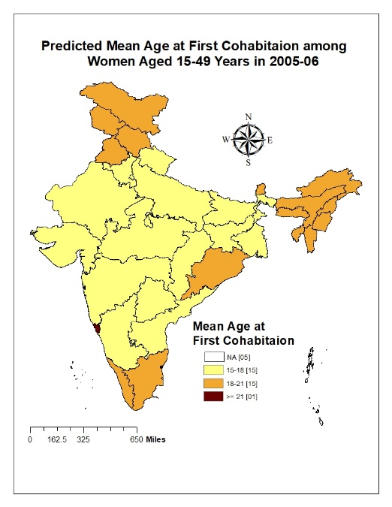 | A2  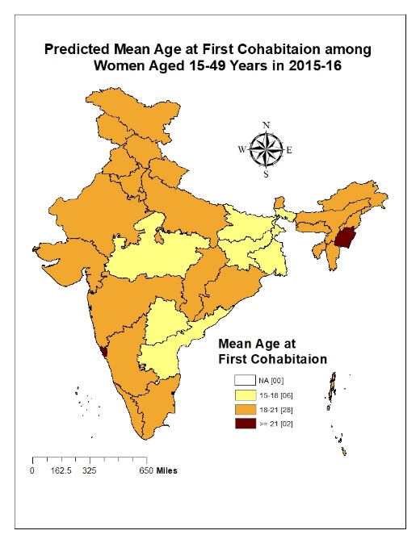 | A3  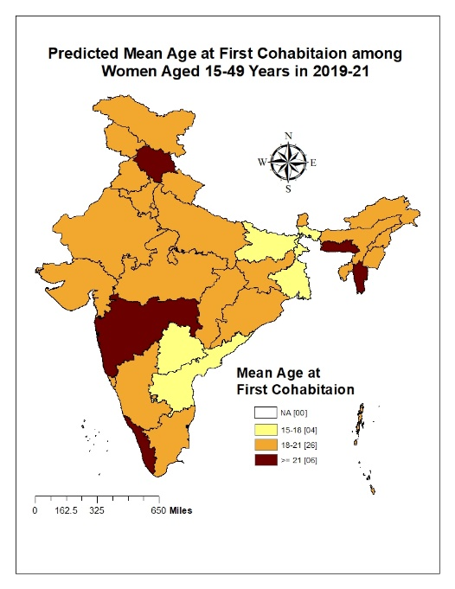
B1  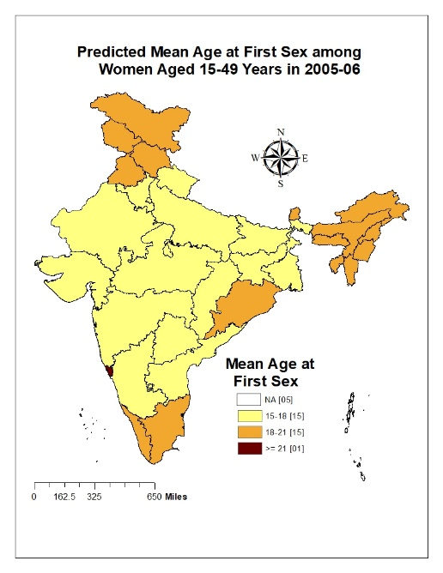 | B2  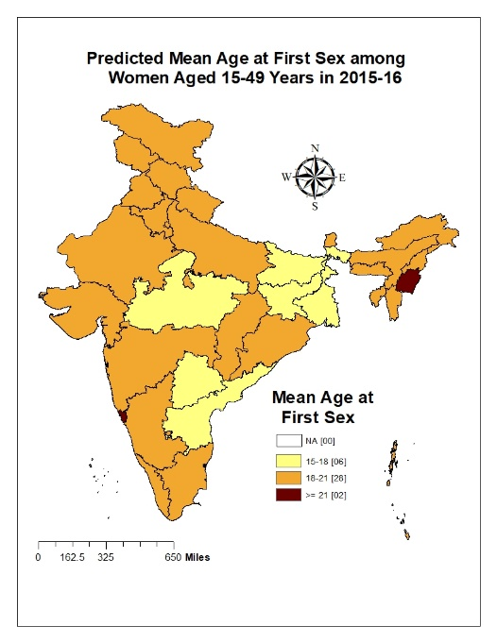 | B3  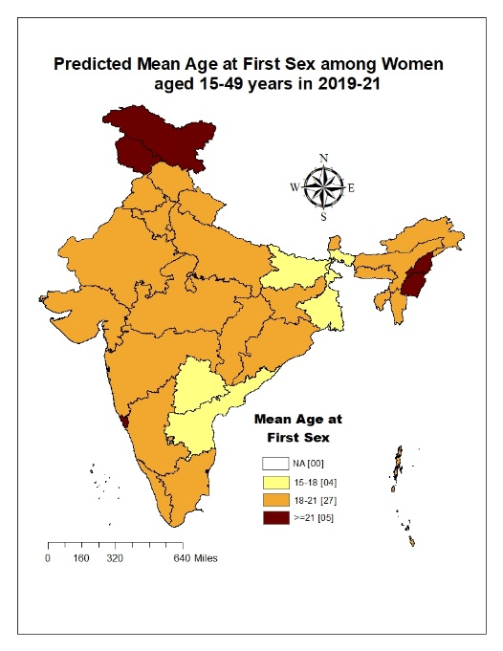
C1  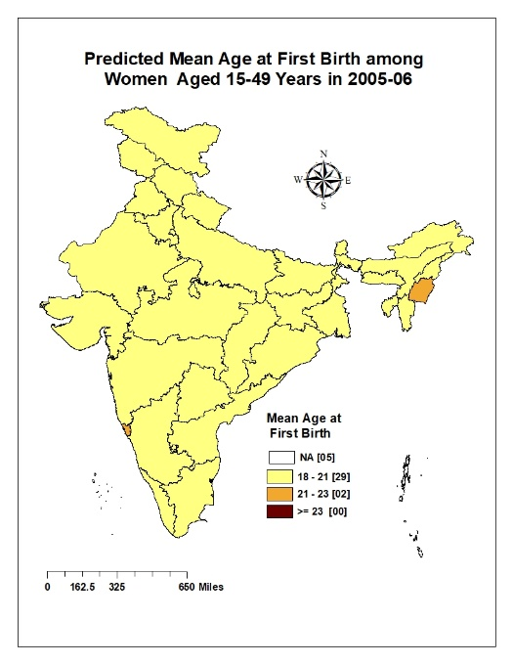 | C2  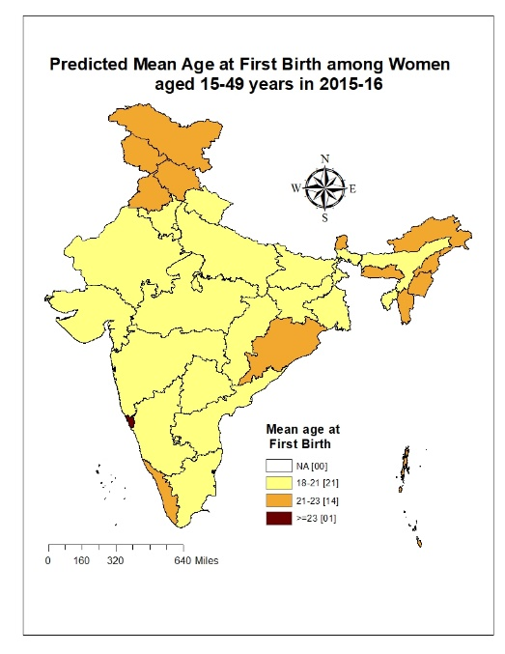 | C3  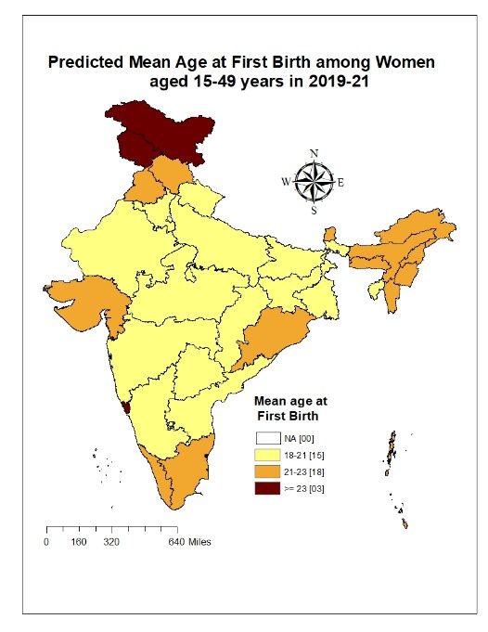
Note: State specific estimates are adjusted for education, caste, residence, religion and wealth.

