Supplementary Material

Instruction given to the participant
“Imagine yourself in the building represented by the tactile map, standing at the starting point. Now imagine that someone comes to you and asks you how he/she can get to a specific location (destination). Your job is to explain them the route in a way that if this person follows your instructions, he/she can reach this specific location without making any errors and/or getting lost. Please add as much information as possible.”

Instruction given to orientation and mobility specialists
As an orientation and mobility specialist, you can evaluate the abilities of our participants to reach destinations in an environment learned with a tactile map. Please rate the routes by judging vocabulary and strategies used by blind participants to reflect the individual’s functioning.
Rating system in %. Here are some guidelines, but you can use intermediate gradation.
- 0%: the route is false, incomplete, or not even attempted.
- 25%: the participant is going in the good direction but does not complete half of the route.
- 50%: half of the route is completed successfully, but the participant does not reach the destination
- 75%: the route is generally good, but missing information leaves possibilities for someone to make errors and get lost if the instructions are followed.
- 100%: the route is complete and contains all necessary information and instructions to reach the destination without any possibilities to make errors.

Instruction given to the research assistant
Please listen to the audio recording containing the answers given by the participant. On the map, please draw the route you are listening to. If the participant does not reach the destination, please draw the “good route” from the starting point to the destination. Then count the steps for the good route, then the attempted route. For the attempted route, from where the participants make an error, subtract steps. Where the participant reaches the destination, but does not say all information (ex: turn right vs turn right at the third intersection), all steps in the “error-prone” zone have half values.
- Tile = 1 point
- Tile with decision point (2 possible paths) = 2 points
- Tile with decision point (3 possible paths) = 3 points

Contextual maze and route elaboration protocol
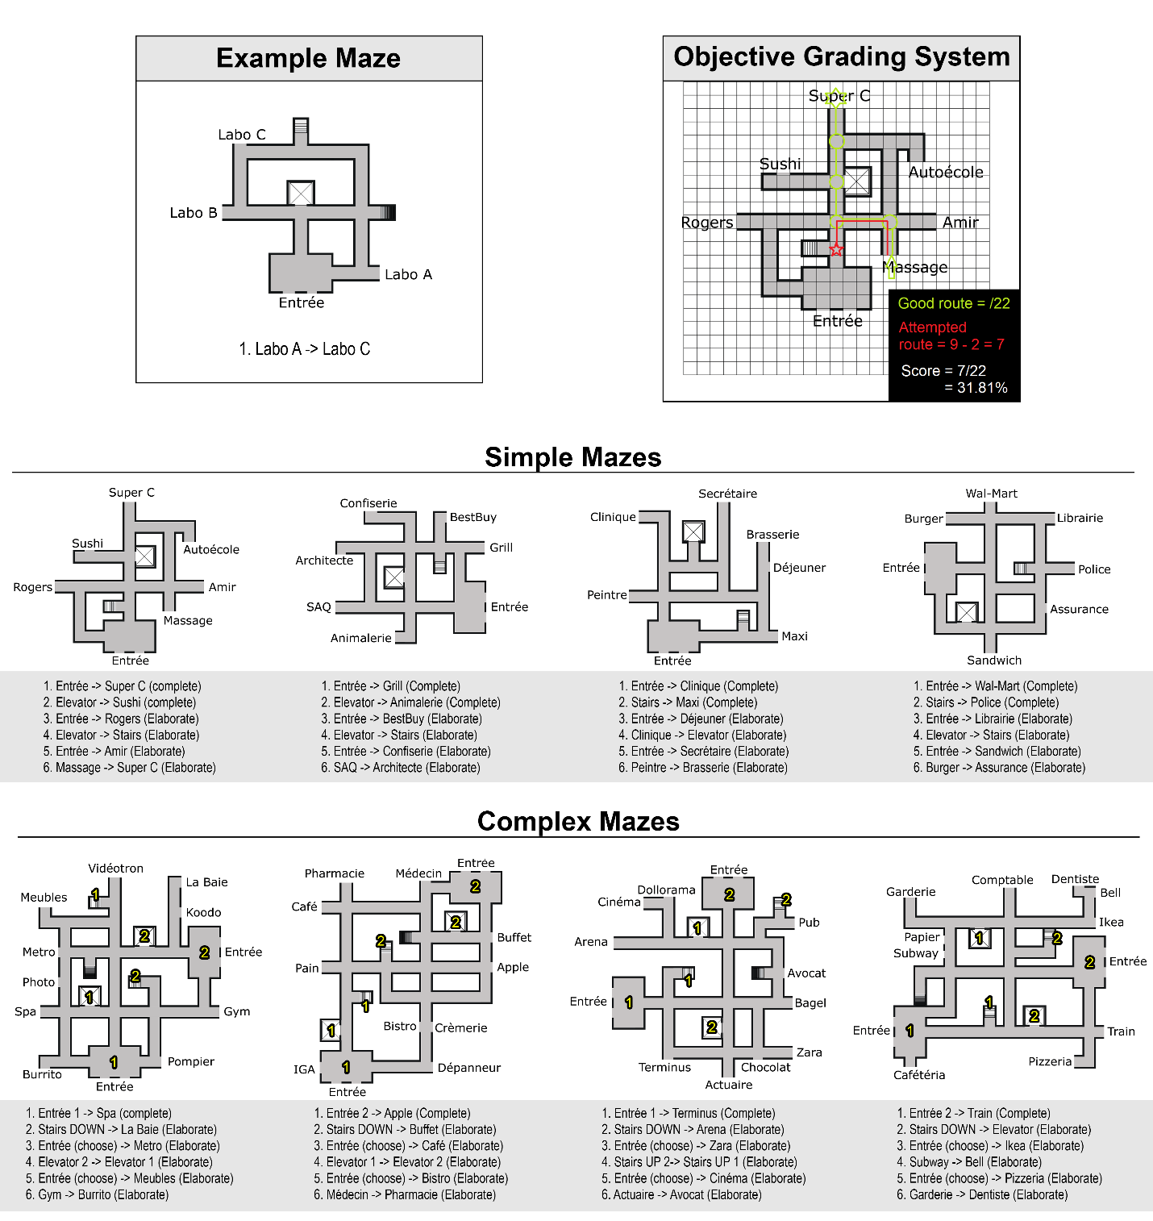
Supplementary figure 1. The contextual maze and route elaboration protocol. On the upper left is displayed the example maze used during familiarization. On the upper right, an example of the objective grading system used by the research assistant. The rest of the figure displays all the mazes and the route elaboration questions. Questions marked as “complete” were routes given by the experimenter, the participant had to name the ending point of the route. Questions marked as “elaborate” are route that needed to be elaborated in entirety by the participant who was given the starting point and destination.

