Table 1 Top 10 CpGs in sex-stratified analysis. Shown are CpGs that are highly significant in one sex (FDR < 0.05), but not significant (P-value > 0.05) in the other sex. For each CpG, annotations include the location of the CpG based on hg19/GRCh37 genomic annotation (chr, position), Illumina gene annotations, nearby genes based on GREAT, and chromatin state. The inverse-variance weighted meta-analysis regression models results include estimated effect size (estimate) where CpGs that are hyper-methylated in AD have positive values, and its associated standard error (se), P-value, and false discovery rate (FDR) for multiple comparison corrections. Bold indicates significant association at 5% FDR.
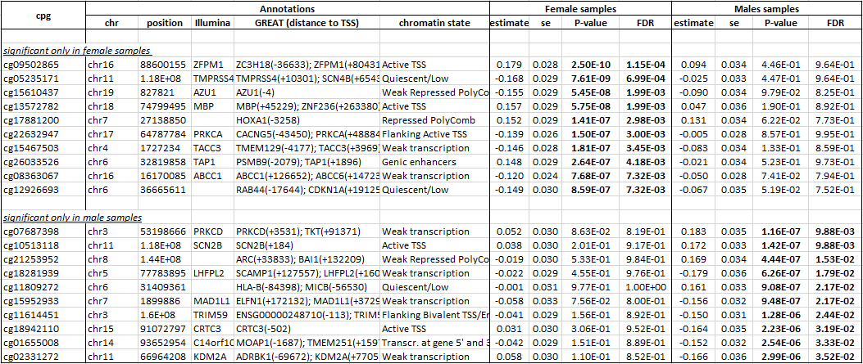

Table 2 Top 10 and 6 DMRs in sex-stratified analysis. Shown are DMRs that are highly significant in one sex (FDR < 0.05), but not significant (P-value > 0.05) in another sex. Only 6 DMRs satisfied these criteria in male samples. For each DMR, annotations include location of the DMR based on hg19/GRCh37 genomic annotation (DMR), Illumina gene annotations, nearby genes based on GREAT, and chromatin state. The inverse-variance weighted meta-analysis regression models results based on coMethDMR include estimated effect size (estimate) where DMRs that are hyper-methylated in AD have positive values, its associated standard error (se), P-value, and false discovery rate (FDR) for multiple comparison corrections. Shown in bold are significant results with FDR < 0.05.
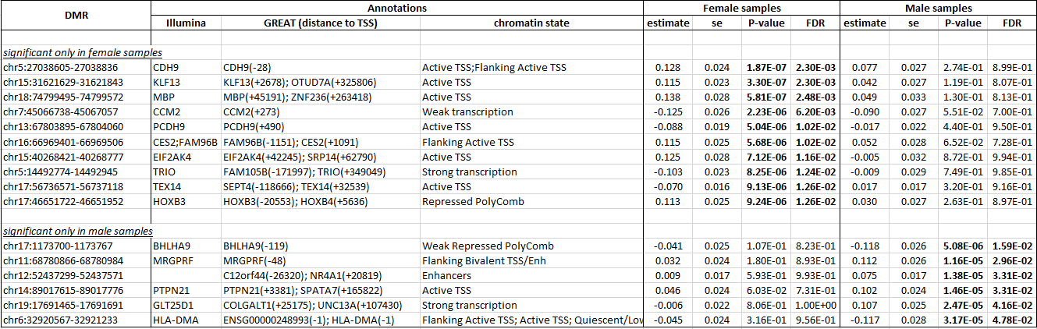

Table 3 Results from sex-by-Braak stage interaction analysis. For each CpG, annotations include the location of the CpG based on hg19/GRCh37 genomic annotation (chr, position), Illumina gene annotations, nearby genes based on GREAT, and chromatin state. The inverse-variance weighted meta-analysis regression models results include estimated effect size (estimate) where CpGs that are hyper-methylated in AD have positive values, its associated standard error (se), and P-value. Adj.pval is adjusted P-value from stageR analysis. Shown in bold are significant results (adj.pval < 0.05 for interaction or P-value < 0.05 for one sex). * indicates these CpGs also reached 5% FDR significance in sex-stratified analysis.
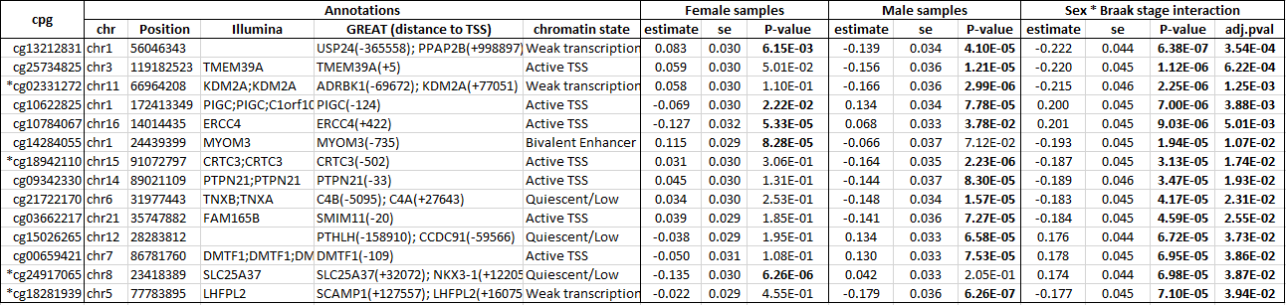

Table 4 Top 10 GO Biological processes enriched with sex-specific DNA methylation changes associated with AD Braak stage in females and males. Shown are GSEA results including number of genes in the gene set (SIZE), normalized enrichment score (NES), P-value, FDR and relevant AD literature for the gene set.
Gene Set | SIZE | NES | P-value | FDR | Relevance to AD
Top 10 GO Biological Process terms in females
INTEGRIN_ACTIVATION | 24 | 2.105 | 0 | 9.53E-02 | Wennstrome et al. (2012)[92]
RESPONSE_TO_PLATELET_DERIVED_GROWTH_FACTOR | 19 | 2.116 | 0 | 1.07E-01 | Sil et al. (2018)[93]
I_KAPPAB_PHOSPHORYLATION | 19 | 2.081 | 0 | 1.13E-01 | Jha et al. (2019)[94]
NEGATIVE_REGULATION_OF_INTERLEUKIN_8_PRODUCTION | 18 | 2.133 | 0 | 1.21E-01 | Qin et al. (2016)[95]
POSITIVE_REGULATION_OF_MACROPHAGE_MIGRATION | 25 | 2.048 | 0 | 1.46E-01 | Bacher et al. (2010) [96]
TOLL_LIKE_RECEPTOR_SIGNALING_PATHWAY | 142 | 2.031 | 0 | 1.61E-01 | Fiebich et al. (2018)[97]
NEGATIVE_REGULATION_OF_TUMOR_NECROSIS_FACTOR_SUPERFAMILY_CYTOKINE_PRODUCTION | 57 | 2.007 | 0 | 1.90E-01 | Chang et al. (2017) [98]
REGULATION_OF_SYNCYTIUM_FORMATION_BY_PLASMA_MEMBRANE_FUSION | 28 | 1.944 | 0 | 1.98E-01 | Armoto et al. (2013)[99]
RESPONSE_TO_VITAMIN_A | 19 | 1.945 | 0 | 2.08E-01 | Ono et al. (2012)[100]
POSITIVE_REGULATION_OF_AXON_EXTENSION | 42 | 1.931 | 0 | 2.08E-01 | Kanaan et al. (2013)[101]
Top 10 Biological Process terms in males
REGULATION_OF_T_CELL_ACTIVATION_VIA_T_CELL_RECEPTOR_CONTACT_WITH_ANTIGEN_BOUND_TO_MHC_MOLECULE_ON_ANTIGEN_PRESENTING_CELL | 6 | 1.869 | 0 | 5.98E-01 | Schetters et al. (2017)[102]
REGULATION_OF_SYSTEMIC_ARTERIAL_BLOOD_PRESSURE_BY_CIRCULATORY_RENIN_ANGIOTENSIN | 18 | 1.964 | 0 | 6.11E-01 | Cosarderelioglu et al. (2020)[42]
NEGATIVE_REGULATION_OF_REACTIVE_OXYGEN_SPECIES_BIOSYNTHETIC_PROCESS | 29 | 1.745 | 0 | 6.12E-01 | Manoharan et al. (2016)[44]
COMPLEMENT_ACTIVATION | 68 | 1.741 | 0 | 6.26E-01 | Morgan (2018)[80]
RESPONSE_TO_ANGIOTENSIN | 26 | 1.746 | 0 | 6.36E-01 | Benigni et al. (2010)[43]
CELL_REDOX_HOMEOSTASIS | 55 | 1.721 | 0 | 6.49E-01 | Chen et al. (2020)[45]
PROTEIN_DEMETHYLATION | 28 | 1.832 | 0 | 6.77E-01 | Esposito et al. (2019)[103]
IMMUNE_RESPONSE_INHIBITING_CELL_SURFACE_RECEPTOR_SIGNALING_PATHWAY | 6 | 1.781 | 0 | 7.02E-01 | Schetters et al. (2017)[102]
DICARBOXYLIC_ACID_CATABOLIC_PROCESS | 17 | 2.052 | 0 | 7.57E-01 | Griffin et al. (2017)[104]
GLUTAMINE_FAMILY_AMINO_ACID_METABOLIC_PROCESS | 70 | 1.657 | 0 | 7.75E-01 | Conway et al. (2020)[105]

