Supplementary Information
Morphological and organic spectroscopic studies of a 44-million-year-old leaf beetle (Coleoptera: Chrysomelidae) with preserved α-chitin
Jerit L. Mitchell^{1,*}, Ryan C. McKellar^{2,3,4}, Mauricio Barbi¹, Ian M. Coulson⁵, and Andris
Bukejs⁶
¹Department of Physics, University of Regina, Regina, SK, S4S 0A2, Canada.
²Royal Saskatchewan Museum, 2445 Albert St., Regina, SK, S4P 4W7, Canada.
³Department of Biology, University of Regina, Regina, SK, S4S 0A2, Canada.
⁴Department of Ecology & Evolutionary Biology, University of Kansas, Lawrence, Kansas, 66045, USA.
⁵Department of Geology, University of Regina, Regina, Saskatchewan, S4S 0A2, Canada.
⁶Institute of Life Sciences and Technologies, Daugavpils University, Vienîbas 13, Daugavpils, LV-5401, Latvia.
*Corresponding Author: jlm696@uregina.ca
Supplementary Methods and Results
FTIR
2nd Derivative Analysis
2nd derivative analysis can be used to determine the precise positions of peaks, and deconvolute the sub-bands of the fingerprint region of the mid infrared spectrum. An 11-point Savitzky–Golay filter was applied to the raw spectra. The three flake spectra can be overlain with their corresponding 2nd derivative spectrum (Fig. S2). Tables S1 and S2 list the 2nd derivative peaks for the pronotum and sternite sections, band assignments, as well as comparison to human protein and α-chitin references, respectively.
Reference Comparison
Possible organic contributions/contaminants for the cuticle flake spectra were examined in detail (Fig. S3). Inorganic contributions are expected to be minimal for amber inclusions. There are three protein references: Bovine Serum Albumin¹ (BSA, a standard protein reference), human collagen², and extant insect cuticle protein³. Other non-proteinaceous references include Baltic amber⁴, α-chitin⁵ (the other main component of cuticle), and Type 1 kerogen⁶ (an aliphatic structure that can be derived from diagenesis of chitin). Normalization of the spectra for comparison was performed using the rubber band method over the region 1800-1000 cm⁻¹. Amide-rich references were compared by linearly scaling the top of the Amide I peak of both to the same value of unity. The others had their largest normalized peak to unity.
The pronotum spectrum resembles the BSA spectrum nearly identically, with proper Amide peaks. The human collagen spectrum also matches very well. The spectrum is clearly heavily dominated by protein. The extant insect cuticle contains the same main Amide I and II peaks, but they are redshifted by about ~20 cm⁻¹. This is because the β-sheet secondary structure dominates the Amide peaks in insect cuticle³. The small redshift of the Amide I α-helix band on the pronotum spectrum with respect to the BSA and Human collagen spectra (1656 cm⁻¹) could be explained by the presence of the broad peak at ~1600 cm⁻¹. The Amide III shoulder at (1236 cm⁻¹) is most similar to the BSA spectrum, rather than the human collagen or insect cuticle. The main Baltic amber peaks are not represented in the spectrum. The largest peaks are outside the frequency range of the Amide I range, even though the other main peak is located at the exact position of the first lipid peak (1451 cm⁻¹). The kerogen spectrum features a broad peak at roughly (1450 cm⁻¹), but the absence of the other peaks means there is likely no contribution. The α-chitin spectrum features numerous sharp peaks, including ones located on the Amide I and Amide II α-helix bands, although again the non-appearance of the low frequency bands rules out α-chitin contribution. As a result, the pronotum spectrum matches best to the α-helix amide structure to confirm the likelihood of human protein over beetle protein or other organics.
The elytron and sternite spectra are nearly identical and will be discussed in the same context. Protein may possibly contribute to the Amide peaks seen in the spectrum. The absence of the low frequency Amide II peak from the beetle cuticle rules out beetle protein. Possible human protein contamination can be expected to be low as Amide I β-sheet is not seen in human protein. No contribution due to kerogen is evident. Peaks at 1450 cm⁻¹, 1380 cm⁻¹, and 1160 cm⁻¹ are realized but the absence of the largest peak at 1738 cm⁻¹ discredits the hypothesis. As discussed in the main body of the manuscript, the α-chitin accounts for all peaks seen in the spectrum and is thus is sufficient for predominately describing both the sternite and elytron spectra.

SEM-EDS
Quantitative Analysis
Since chitin has the chemical formula C₈H₁₃O₅N, it is expected to have a carbon-to-oxygen ratio of C/O = 1.6 in elemental analysis. From the quantitative analysis (Table S3, S4), the calculated atomic carbon-to-oxygen ratio is C/O = 1.44 and C/O = 1.49 for the sternite and elytron cuticle, respectively, close to the theoretical ratio. For the amber spectrum, the calculated value is C/O = 6.33, clearly distinguishing this from the cuticle. Due to the high uncertainty in the statistics, no claim of chitin preservation can be made from the EDS analysis. We can find support, however, for the idea that no proteins have survived in the original chitin-protein matrix of the cuticle. For example, a low nitrogen content (~7%) is indicative of this⁷, and as well the C/O value would be much lower in a protein containing matrix⁸. These features also make possible modern or human contamination unlikely.

References
[1] Sukumaran, S. Protein secondary structure elucidation using FTIR spectroscopy (Application Note No. AN52985). Retrieved from Thermo Fisher website: AN52985-protein-secondary-structure-elucidation-using-ftir-spectroscopy.pdf (thermofisher.com) (2022).
[2] Sandt, C. Liver Spectroscopy (Collagen) [Data Set]. Quasar 0.9 (2017).
[3] Iconomidou, V. A., Chryssikos, G. D., Gionis, V., Willis, J. H. & Hamodrakas, S. J. "Soft"-cuticle protein secondary structure as revealed by FT-Raman, ATR FT-IR and CD spectroscopy. Insect Biochem. Mol. Biol. 31, 877–885, DOI: 10.1016/S0965-1748(01)00033-9 (2001).
[4] Causey, F. Ancient Carved Ambers in the J. Paul Getty Museum. Getty Publications (2020).
[5] Hassainia, A., Satha, H. & Boufi, S. Chitin from Agaricus bisporus: Extraction and characterization. Int. J. Biol. Macromol. 117, 1334–1342, DOI: 10.1016/j.ijbiomac.2017.11.172 (2018).
[6] Mroczkowska-Szersze ́n, M. & Jankowski, L. S. The organic matter type in the shale rock samples assessed by FTIR-ATR analyses fossil resins view project application of spectroscopic techniques in several aspects of rock analysis view project. NAFTA-GAZ 6, 361–369, DOI: 10.17632/rx8jp7chkv.2 (2015).
[7] Cárdenas, G., Cabrera, G., Taboada, E. & Miranda, S. P. Chitin characterization by SEM, FTIR, XRD, and 13C cross polarization/mass angle spinning NMR. J. Appl. Polym. Sci. 93, 1876–1885, DOI: 10.1002/app.20647 (2004).
[8] Godigamuwa, K., Nakashima, K., Tsujitani, S. & Kawasaki, S. Fabrication of silica on chitin in ambient conditions using silicatein fused with a chitin-binding domain. Bioprocess Biosyst. Eng. 44, 1883–1890, DOI: 10.1007/s00449-021-02568-w (2021).
[9] Bobroff, V., Chen, H. H., Javerzat, S. & Petibois, C. What can infrared spectroscopy do for characterizing organic remnant in fossils? TrAC - Trends Anal. Chem. 82, 443–456, DOI: 10.1016/j.trac.2016.07.005 (2016).

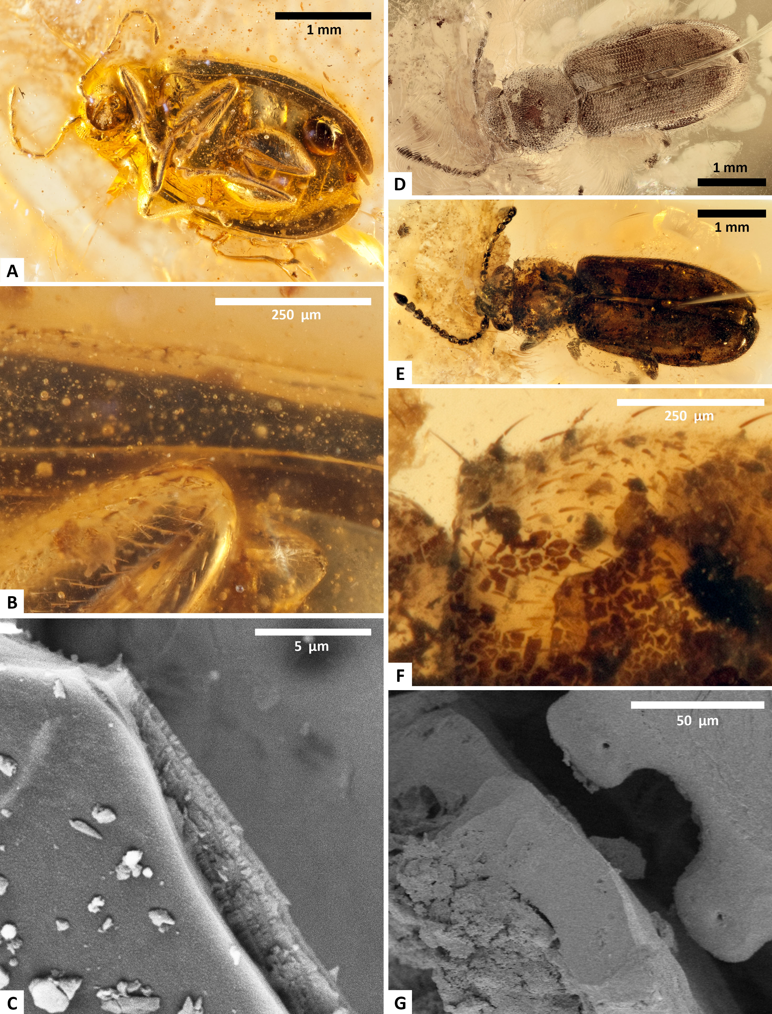

Figure S1: (A,B,C) (left column): RSKM_P3300.144 (Baltic 145), an example of excellent cuticle preservation in Baltic amber. Figures (D,E,F,G) (right column): RSKM_P3300.83, an example of poor cuticle preservation in Baltic amber. (A,D,E): overview images of the insects. (B,F): close up of the upper thorax of the insects. (C,G): SEM SE images of the cuticle.
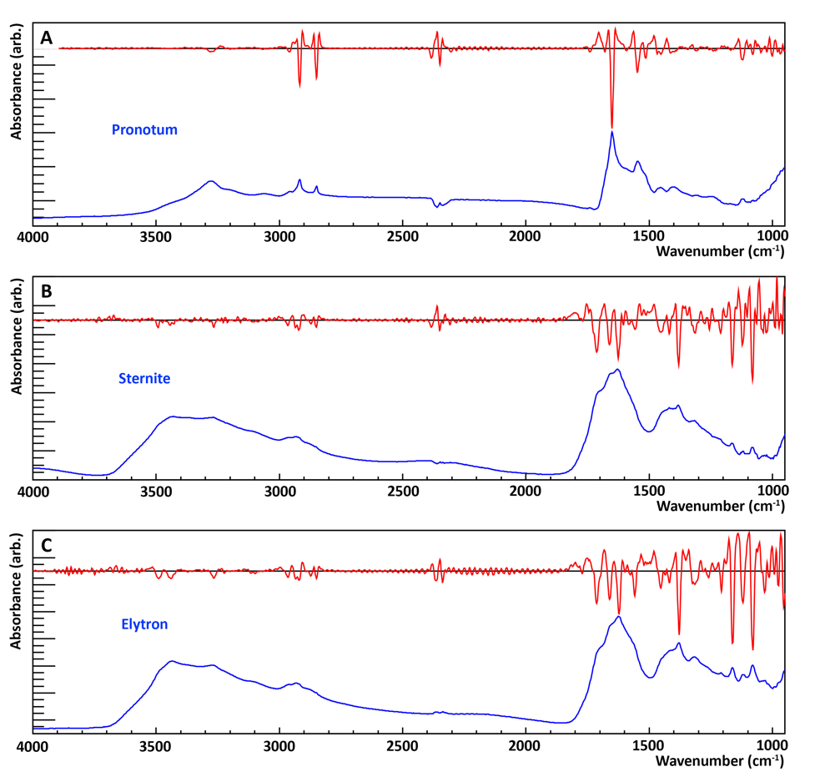
Figure S2: Pronotum (A), sternite (B) and elytron (C) flake spectrum with overlayed 2nd derivative. The 2nd derivative spectrum is produced from an 11-point Savitzky–Golay Filter and scaled to fit into the graphing window.
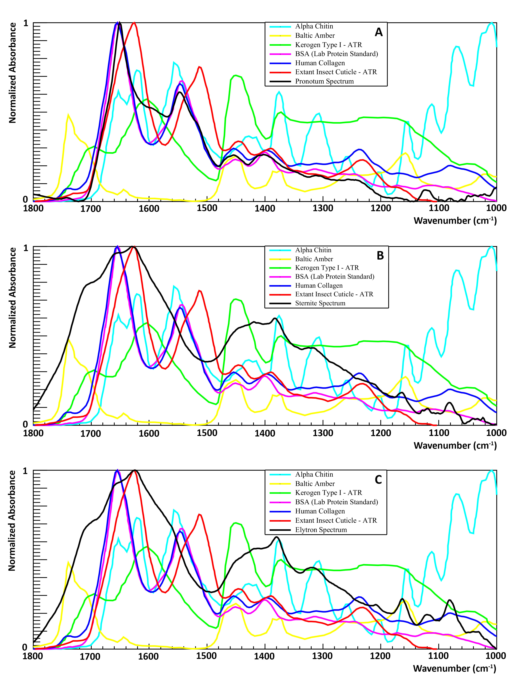
Figure S3: Low wavenumber region reference comparison – cuticle flakes spectra superimposed on spectra of potential organic contributions. (A) Pronotum (B) Sternite (C) Elytron. All spectra are normalized to their largest peak over the entire mid IR spectrum.
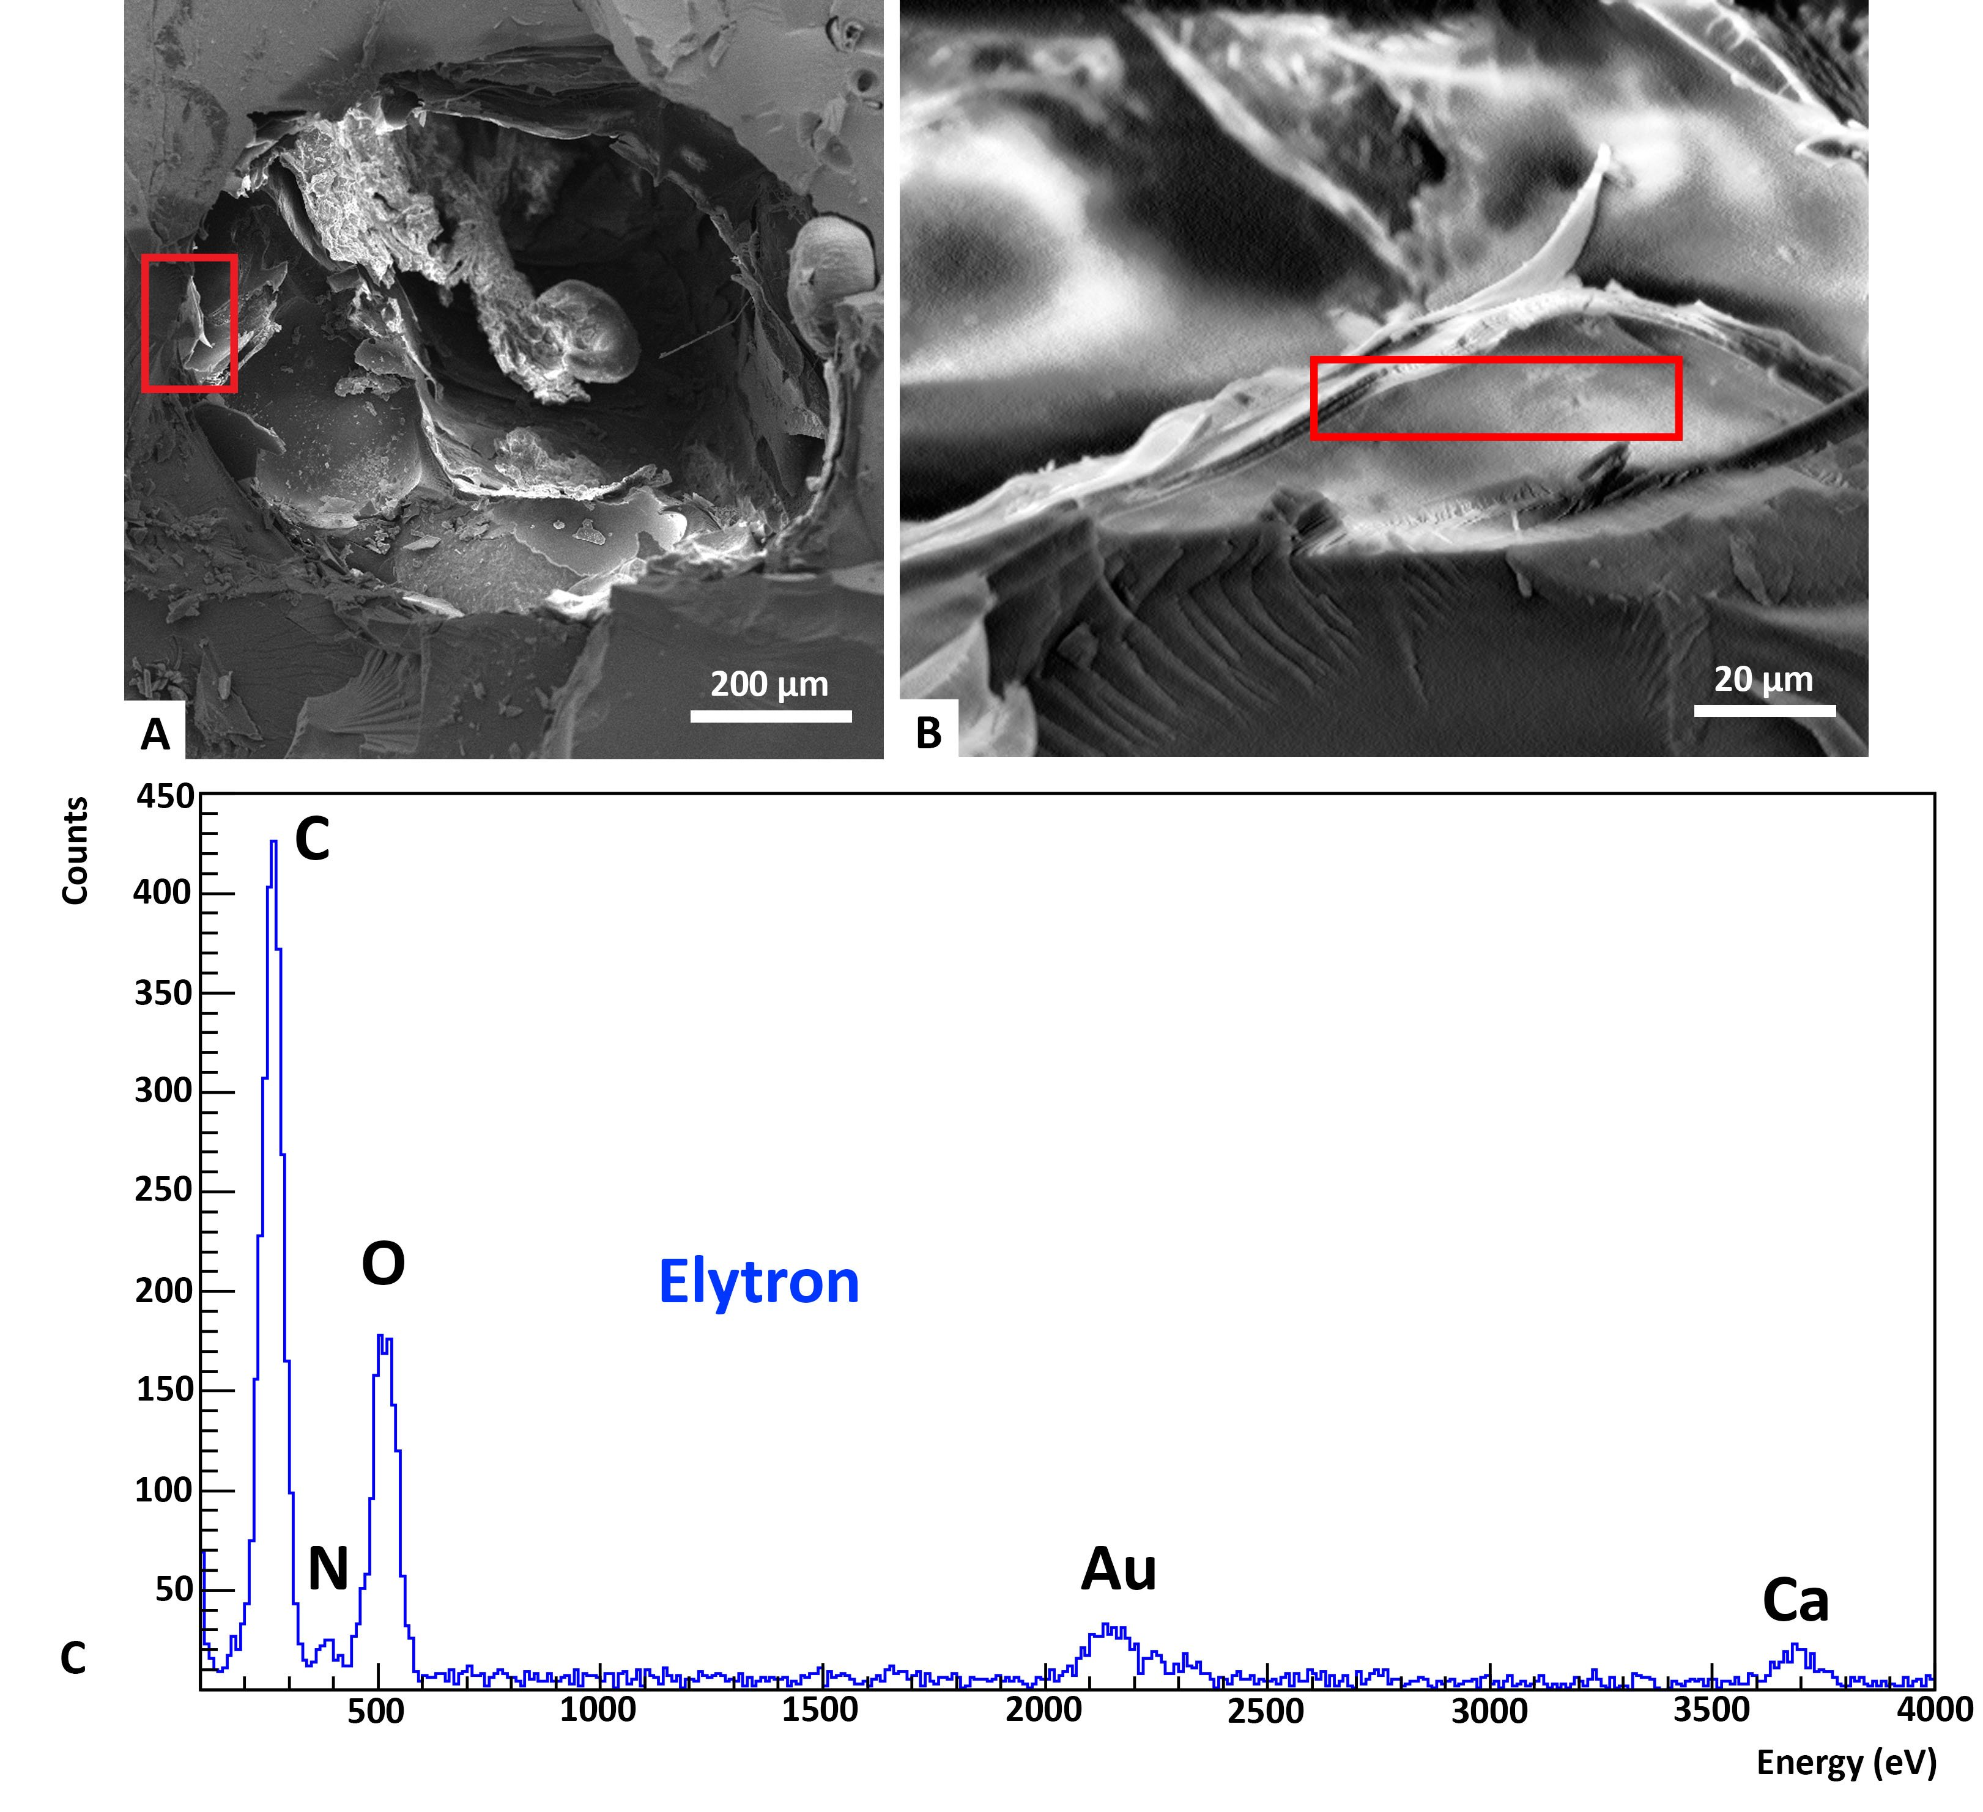
Figure S4: SEM-EDS analysis of Baltic 83. (A) SE image of crack-out section of Baltic 83B, post removal of flakes for FTIR analysis. (B) Piece of exposed elytron cuticle with location for EDS probing. (C) EDS spectrum of the elytron cuticle. The cuticle contains carbon, oxygen and trace amounts of nitrogen and calcium.

Frequency (cm⁻¹) | Protein Reference (Human Collagen²) (cm⁻¹) | Band Assignment | Organic Component
3278 |  | ν(N-H) | Amide A
3061 |  | ν(N-H) | Amide B
2918 |  | ν_{as}(CH₂) | Lipid
2850 |  | ν_{s}(CH₂) | Lipid
1741 | 1743 | ν(C=O) | Acid
1651 | 1659 | ν(C=O) | Amide I
1593 | - | ν(C=O) | ?
1547 | 1549 | ν(C-N), δ(N-H) | Amide II
1460 | 1454 | δ_{as}(CH₂) | Lipid
1405 | 1396 | δ_{s}(CH₂) | Lipid
1236 | 1238 | ν(C-N), δ(N-H) | Amide III
1122 |  | ? | ?
1081 | 1080 | ν(C-O) | Sugar
Table S1: Selected main peaks of the pronotum spectrum. Assignments from⁹.

Sternite Peak Frequency (cm⁻¹) | α-chitin Reference⁵ Peak Frequency (cm⁻¹) | α-chitin Reference⁷ Peak Frequency (cm⁻¹) | Band Assignment | Organic Component
3492 | 3483 | 3479 | ν(O-H)
- | 3428 | 3448 | ν(O-H)
3267 | 3254 | 3268 | ν_{as}(N-H) | Amide A
3099 | 3100 | 3102 | ν_{s}(N-H) | Amide B
2966 | 2960 | 2965 | ν_{as}(CH₃) | Lipid
2928 | 2932 | 2927 | ν_{s}(CH₂) | Lipid
2872 | 2876 | 2883 | ν_{as}(CH₃) | Lipid
2851 | - | - | ν_{s}(CH₂) | Lipid
- | - | - | ?
1713 | - | - | ν(C=0) | Oxidation
1661 | 1652 | 1660 | ν(C=0) | Amide I
1625 | 1621 | 1627 | ν(C=0) | Amide I
1558 | 1556 | 1558 | ν(C-N) + 8(N-H) | Amide II
1453 | - | - | δ(CH₂) | Lipid
1419 | 1428 | 1422 | δ(CH₂) | Lipid
1381 | 1376 | 1376 | δ(CH) + δ(C-CH₃) | Lipid
1315 | 1308 | 1312 | ν(C-N) + δ(N-H) | Amide III
1256 | 1260 | 1255 | δ(N-H) | Amide III
1211 | 1207 | - | δ(N-H) | Amide III
1164 | 1156 | 1157 | ν_{as}(C-O-C, ring)
1122 | 1114 | 1113 | ν(C-O) | Sugar
1081 | 1069 | 1072 | ν(C-O) | Sugar
- | 1029* | - | ν(C-O) | Sugar
- | 1008 | 1021 | ν(C-O) | Sugar
- | 995* | - | ?
- | 952 | 957 | γ(CH₃)
Table S2: Selected peaks of the sternite spectrum, with comparisons to two α-chitin references from shrimp. Band assignments are indicative of ⁷. Frequency bands labeled with “*” are missing from the articles data table, but are found from our own analysis of the given spectra.

 | Element | Weight % | Atomic % | Error %
Amber | C | 82.61 | 86.36 | 43.91
Amber | O | 17.39 | 13.64 | 69.57
Sternite | C | 44.93 | 52.83 | 9.61
Sternite | N | 8.80 | 8.87 | 24.76
Sternite | O | 41.54 | 36.64 | 13.26
Sternite | Ca | 4.74 | 1.67 | 25.30
Table S3: EDS statistics table for the amber and sternite section.

 | Element | Weight % | Atomic % | Error %
Elytron | C | 42.34 | 53.14 | 8.45
Elytron | N | 5.41 | 5.81 | 39.30
Elytron | O | 37.84 | 35.62 | 13.96
Elytron | Ca | 14.41 | 5.43 | 14.41
Table S4: EDS statistics table for an elytron section.

