Supplementary Table 1. De novo extracted mutational signatures
De novo extracted signatures | Global NMF Signatures | L1 Error % | L2 Error % | Cosine Similarity
Signature 96-A | Signature SBS1 (3.06%) & Signature SBS4 (76.16%) & Signature SBS5 (20.78%) | 0.39 | 0.41 | 0.92
Signature 96-B | Signature SBS1 (10.82%) & Signature SBS5 (24.16%) & Signature SBS6 (35.04%) & Signature SBS7a (6.82%) & Signature SBS7b (8.66%) & Signature SBS18 (14.50%) | 0.36 | 0.26 | 0.97
Signature DINUC-A | Signature DBS2 (48.80%) & Signature DBS6 (14.52%) & Signature DBS9 (24.96%) & Signature DBS10 (11.72%) | 0.86 | 0.47 | 0.91
Signature INDEL-A | Signature INDEL-A | 0 | 0 | 1

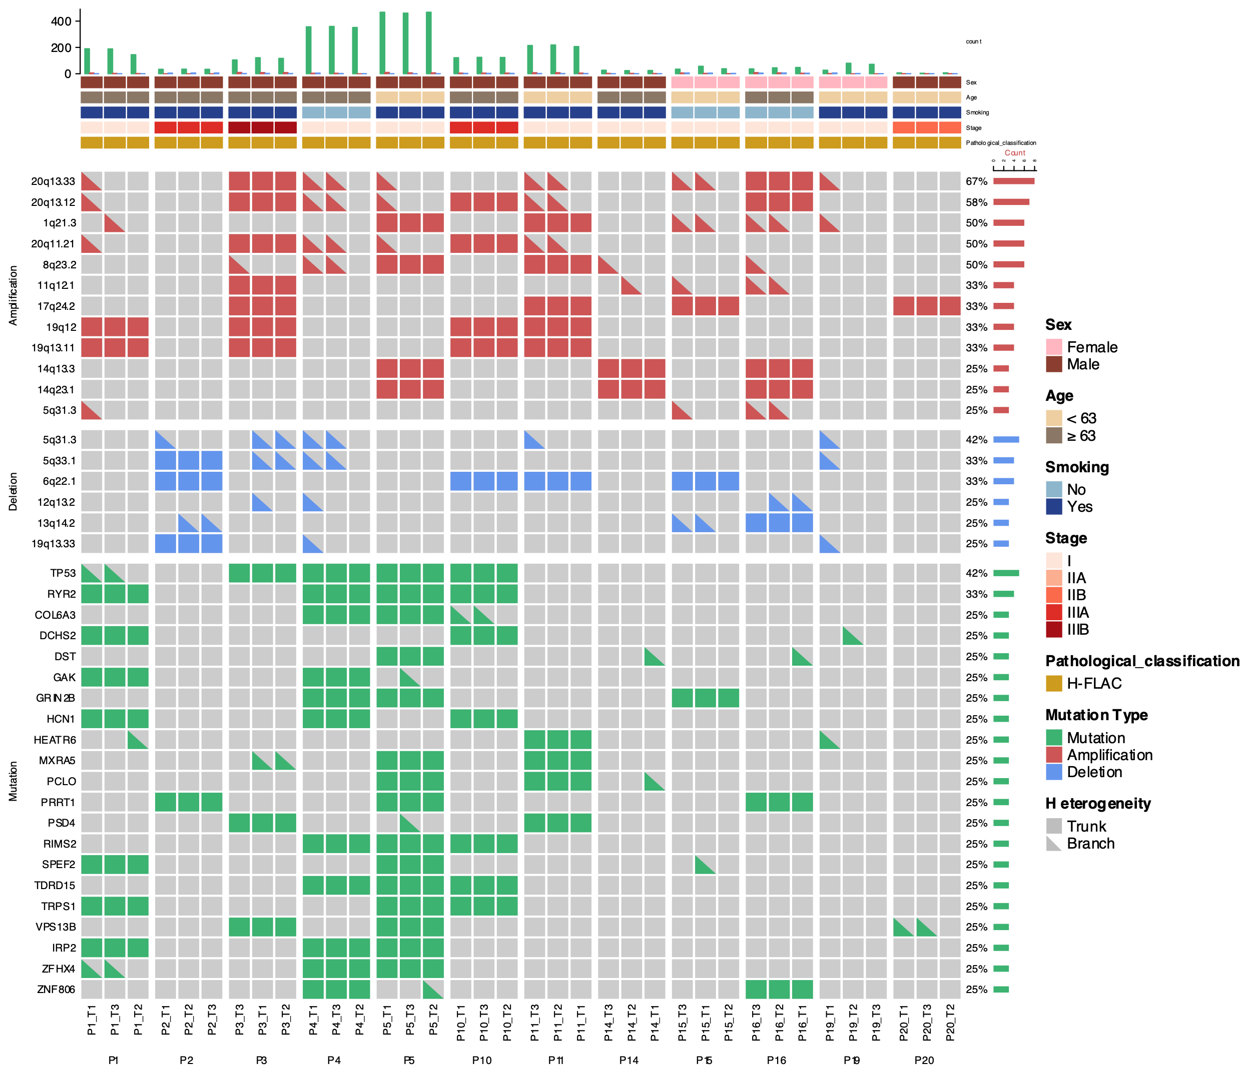
Supplementary Fig 1a Mutational landscape of H-FLAC (n=12). Alteration frequencies are calculated per patient.

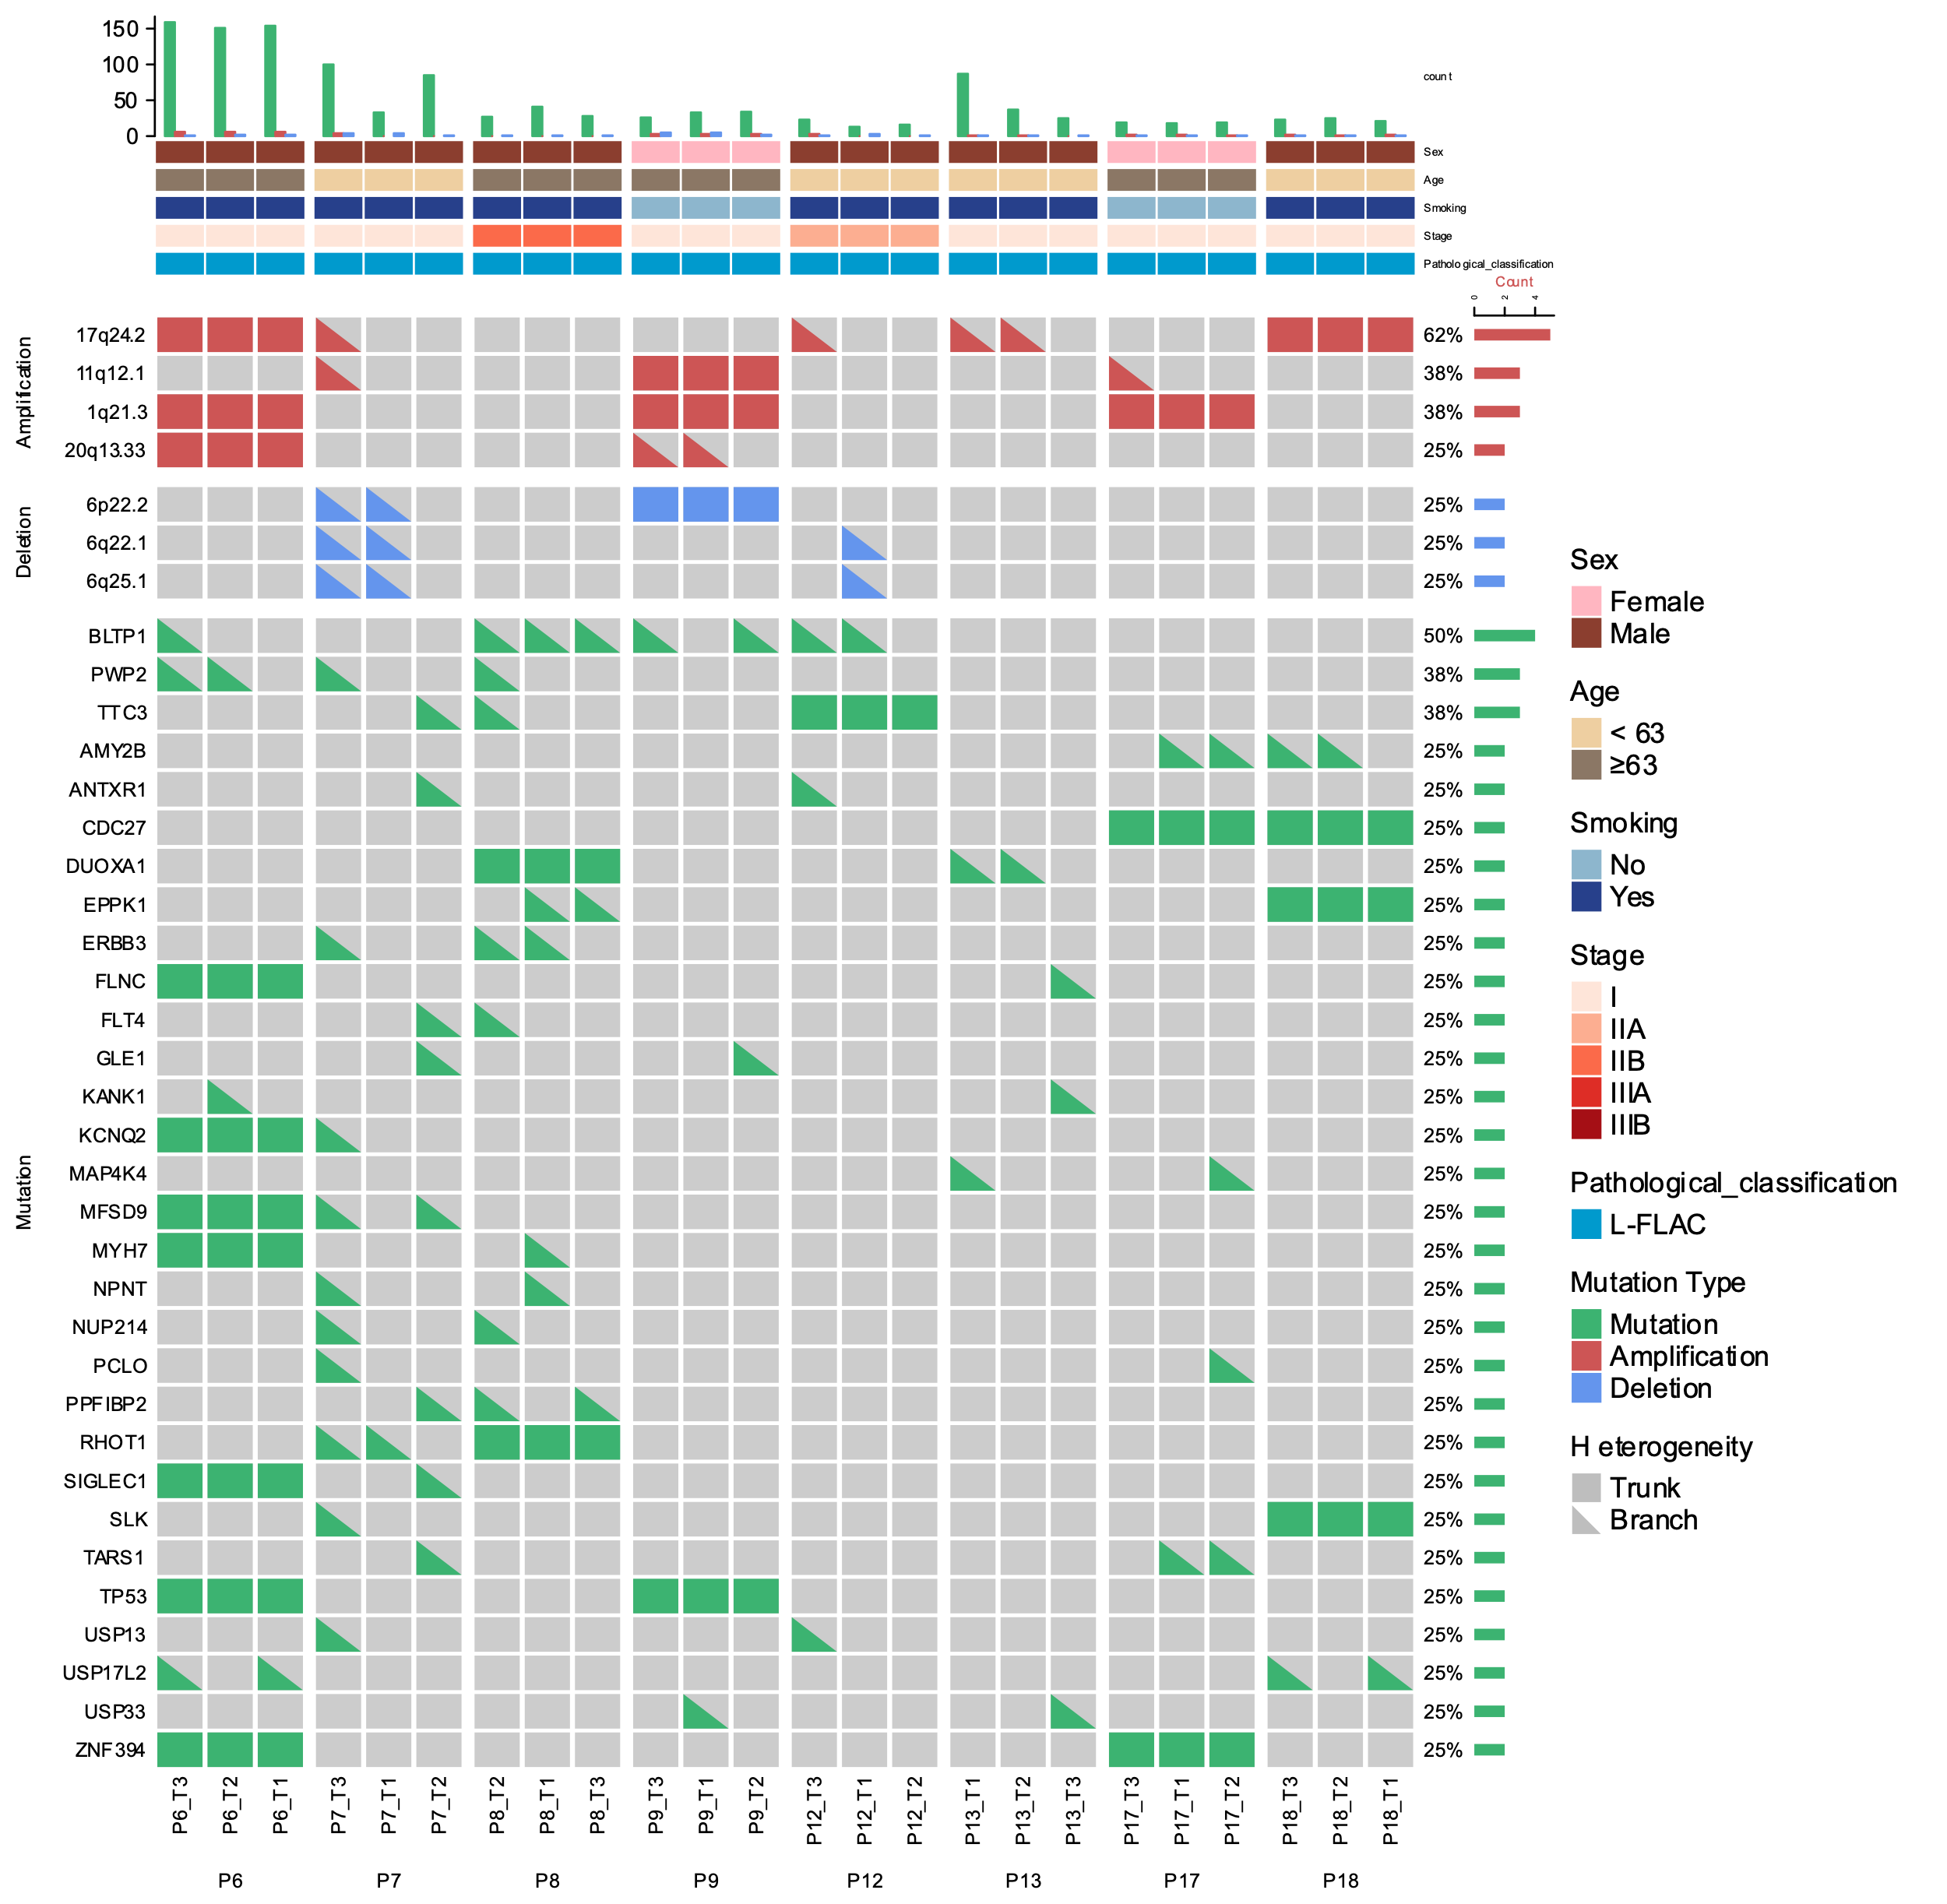
Supplementary Fig 1b Mutational landscape of L-FLAC (n=8). Alteration frequencies are calculated per patient.

Supplementary Fig 2 COSMIC signatures that the de novo mutational signatures are composed of.

Supplementary Fig 3 Recurrent somatic copy-number variations in FLAC. Amplifications and deletions are plotted in red and blue, respectively.

A
B
Supplementary Fig 4 Hierarchical clustering plot showing the extent of epigenomic (a) and transcriptomic (b) variation within and across tumor and non-malignant tissue regions from the patients.
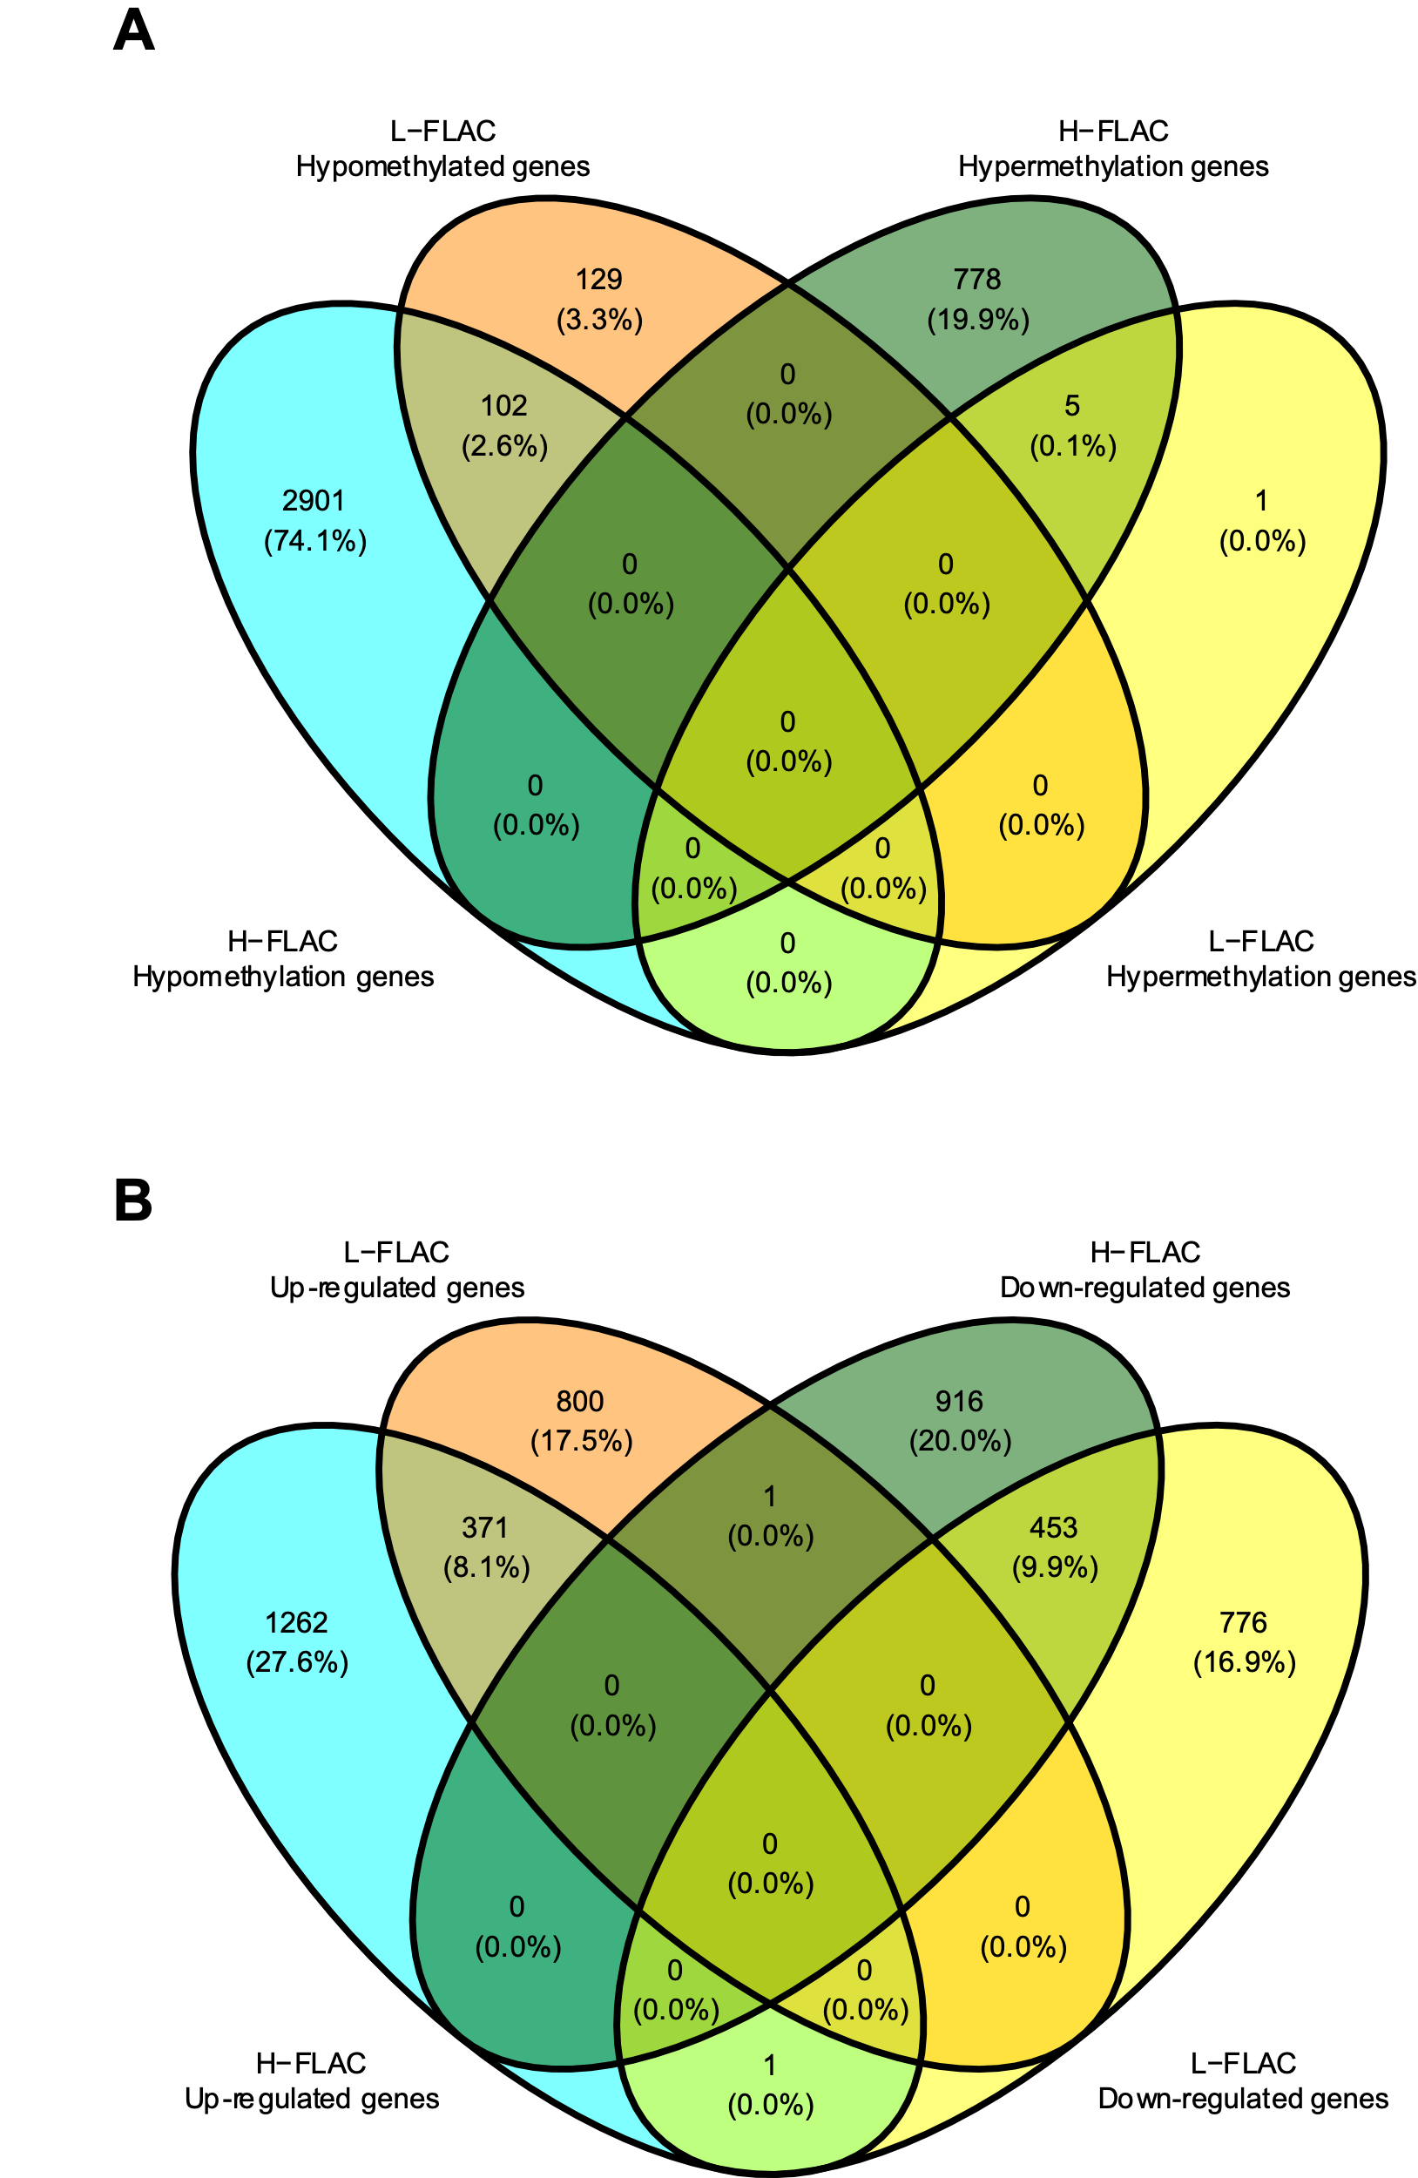

Supplementary Fig 5 Venn diagram of the differentially expressed genes.: The number in each circle represents the amount of differentially expressed genes between the different comparisons (test versus control). The overlapping number stands for the mutual differentially expressed genes between the different comparisons and the non-overlapping numbers specify the genes unique to each condition

Supplementary Fig 6 Proportions of trunk mutations in H-FLAC tend to be higher than those in L-FLAC. The p value is calculated using Wilcoxon signed rank test. Center line, median; box limits, upper and lower quartiles; whiskers, 1.5x interquartile range.

A
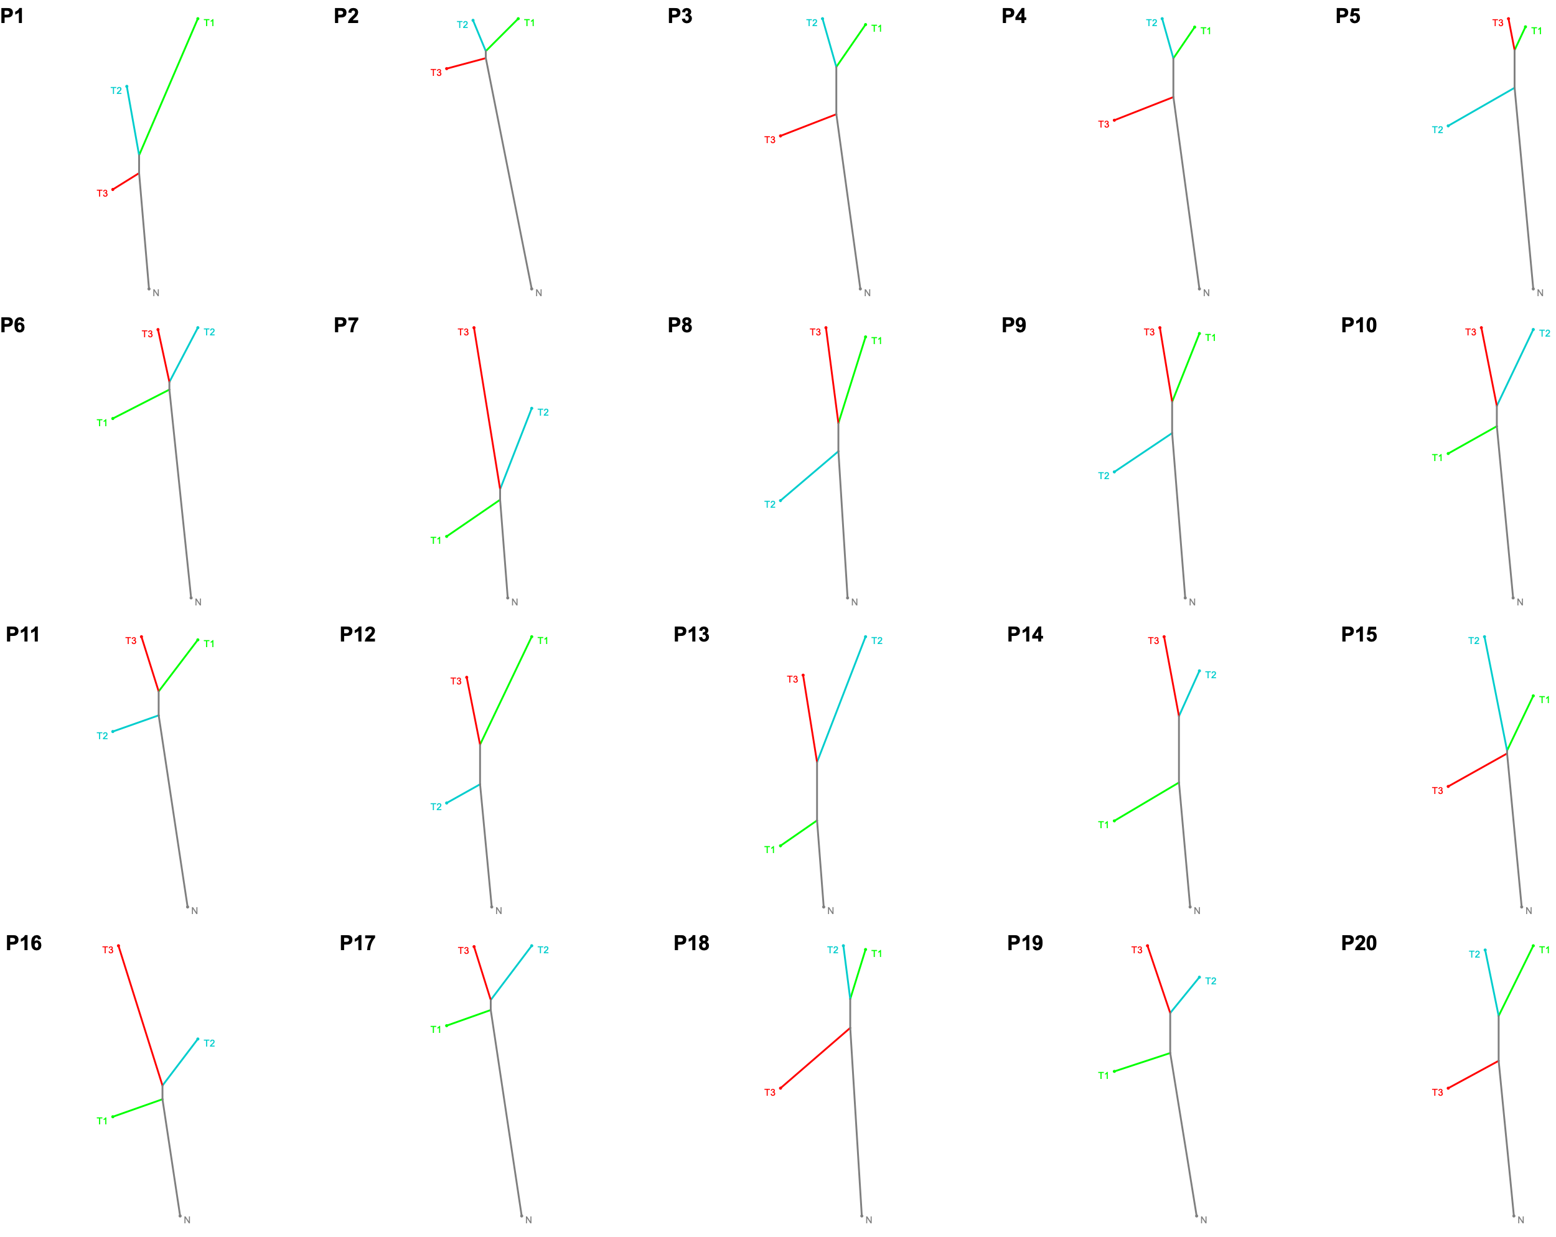
B

Supplementary Fig 7 Phylogenetic trees of FLAC based on copy number variants (a) and gene expression profiles (b).

Supplementary Fig 8 Correlations between pairwise mutational, CNV, methylation and transcriptional ITH in all FLAC patients, assessed by two-tailed Spearman’s correlation analysis. Each dot represents each pairwise comparison of regions within each tumor. ns: not significant; •: p<0.1; *: p<0.05; **: p<0.01; ***: p<0.001

A
B
Supplementary Fig 9 Kaplan–Meier curve of recurrence-free survival (a) and overall survival (b) in patients stratified by subgroups.

Supplementary Fig 10 Kaplan–Meier curve of recurrence-free survival (DFS) and overall survival (OS) in H-FLAC patients (n=12) stratified by median mutational ITH (a), CNV ITH (v) and methylation ITH (c).

Supplementary Fig 11 Kaplan–Meier curve of recurrence-free survival (DFS) and overall survival (OS) in all FLAC patients (n=20) stratified by median mutational methylation ITH.

Supplementary Fig 12 Morphologic features of H-FLAC (a-c) and L-FLAC (d-f) revealed by H&E staining. a-c Three regions from tumor specimen of P5 (H-FLAC). Complex glandular structures composed of columnar cells with clear cytoplasm and pseudostratified nuclei resembling fetal lung tubules (a), multifocal necrosis (b) and miscellaneous histological components (c). d-f Three regions from tumor specimen of P18 (L-FLAC). Complex glandular structures lined with glycogen-rich columnar cells resembling the developing fetal lung (d-e), with low nuclear atypia, and morule formation (f).

