Supplemental data:
Supplemental material & methods:
Samples & ethics:
Blood samples were collected on EDTA tubes for leucocytes DNA analysis and on PAXgene-Blood RNA Tubes for RNAseq. DNA extractions were performed using QIAsymphony SPTM device (Qiagen, Hilden, Germany) according to the manufacturer’s instructions. RNA was extracted from PAXgene blood samples with the Maxwell device from Promega (Promega Corporation, Madison, Wisconsin, United States), according to the manufacturer’s instructions.
Written informed consent for genetic analysis was obtained from the parents for clinical testing and research use.
Sanger sequencing:
PCR duplex was performed on the proband and her healthy parents. The mane select transcript NM_001282531.3 was consider as reference. Template sequences were obtained using the Alamut software (Interactive Biosoftware, Rouen, France) and primers were designated using NCBI tool Primer-BLAST (https://www.ncbi.nlm.nih.gov/tools/primer-blast/). The primers were designated on the area of the breakpoint g.49525309 (hg19) with one primer common to the WT and post-inversion sequence (primer F), another one specific of the wildtype sequence (primer R1) and a last one specific of the inverted sequence (primer R2). The expected size of the product post-inversion is 441 bp and 596 bp for the WT product.
Amplification products were visualized using the Agilent (Agilent Technologies Inc., Santa Clara, California, United States) TapeStation 4200 system (figure S1). PCR products were sequenced by Sanger sequencing using Big Dye Terminator chemistry and an ABI3500XL Capillary Array Sequencer (Applied Biosystems, Waltham, Massachusetts, United States). Primers specific to the inverted (Primer R2) and WT sequence (Primer R1) were used and sequences were analyzed with the SnapGene Viewer software (figure S2).
RNAseq:
The study was performed on the proband and five controls to research splicing abnormalities and to realize a quantification analysis of ADNP blood expression. After extraction RNA integrity (RIN) is evaluated with the TapeStation 4200 device. If RNA achieved RIN score > 6, it was considered utilizable. RNA is diluted to obtain 25µl à 12µM. Then the Illumina Stranded mRNA Prep protocol (Illumina, San Diego, CA), which converts mRNA in dual-indexed libraries, is followed. Briefly, Oligo(dT) magnetic beads purify and capture RNA with poly-A tails. Then the purified mRNA is fragmented and a first strand complementary DNA (cDNA) is synthetized. During second-strand cDNA synthesis dUTP replaces dTTP. The final step ligate adapters to fragment ends. The resulting products are purified and selectively amplified for the sequencing realized with a nextseq 500 using 75 bp paired-end reads.
Raw data from the Illumina NextSeq 500 sequencer (Illumina) is converted to FASTQ and demultiplexed with bcl2fastq. Reads from each sample are aligned to the human hg38 reference genome using the STAR tool. The quality metrics of the two previous software are supplemented by those of FastQC, Picard RnaSeqMetrics and RNA-SeQC and brought together in an HTML file thanks to MultiQC.
The analysis of aberrant transcripts is carried out on the one hand without a priori with the DROP pipeline (Detection of RNA Outlier Pipeline) and on the other hand manually with Sashimi plots in IGV (Integrative Genome Browser) on the regions of interest previously identified after DNA sequencing. For quantification analysis, data of the five controls sequenced with the proband and those of 33 others without ADNP mutation, previously analyzed with the same protocol, were used. After recuperation of the number of reads mapped on ADNP we make a normalization with the total number of read mapped of each sample.

Supplemental figures:
Figure S1: Profile achieved after migration of PCR products with the TapeStation 4200 system
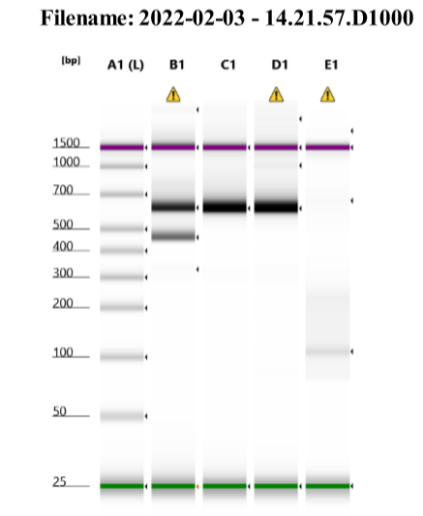

Proband
Mother
Father
Blank

Legend: Lane A1 corresponds to the ladder, B1 to the proband products, C1 mother, D1 father and E1 negative control. Expected presence of the chimeric and WT product on the proband and only the WT product on the parents were obtained, thus confirming the de novo inheritance
Figure S2: Sequences achieved after Sanger sequencing for the patient
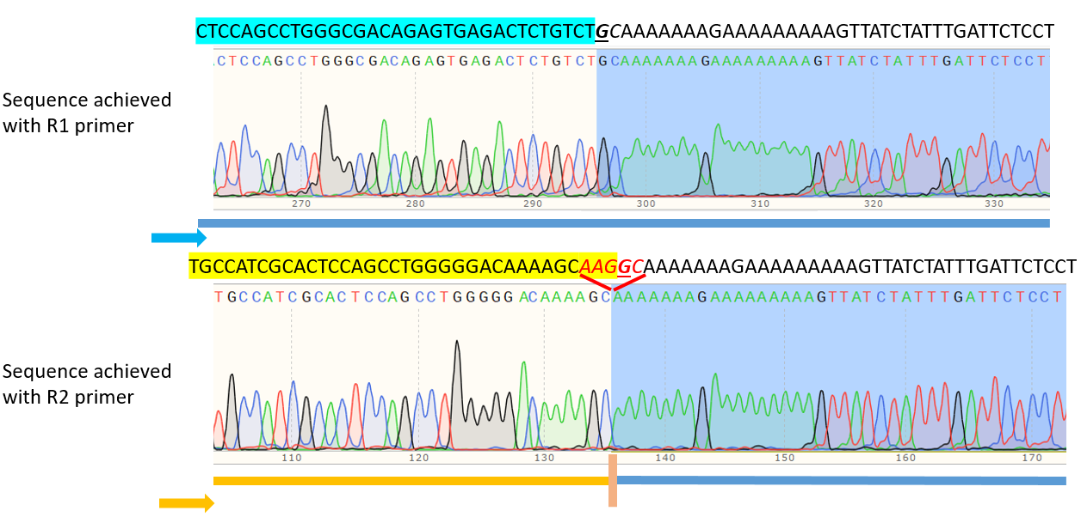
Legend: Sequence achieved with R1 primer (specific of the WT allele) upside and with R2 primer specific of the inverted allele (downside). Upside both chromatograms is mentioned the expected sequence. Part inside the rearrangement are highlighted in blue and yellow respectively for the WT and the inverted alleles. The first nucleotide after the expected breakpoint is underlined. We obtained the expected rearranged sequence for the patient and WT sequence for both patient and her parents (parents not shown). We also noticed near the breakpoint a small deletion of five nucleotides marked in red, which after verification was also noticeable on the soft-clip of the WGS reads (data not shown).
Figure S3: Regulation elements located in the ADNP gene
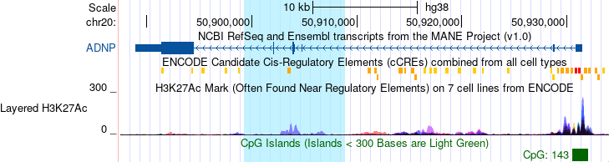
Legend: UCSC tracks encode regulation and Candidate Cis-Regulatory Elements (cCREs) are displayed. Reversed region highlighted in blue. Most regulatory element are located outside the reverse region.
Figure S4: Region of homozygosity located in chromosome 20 of our patient
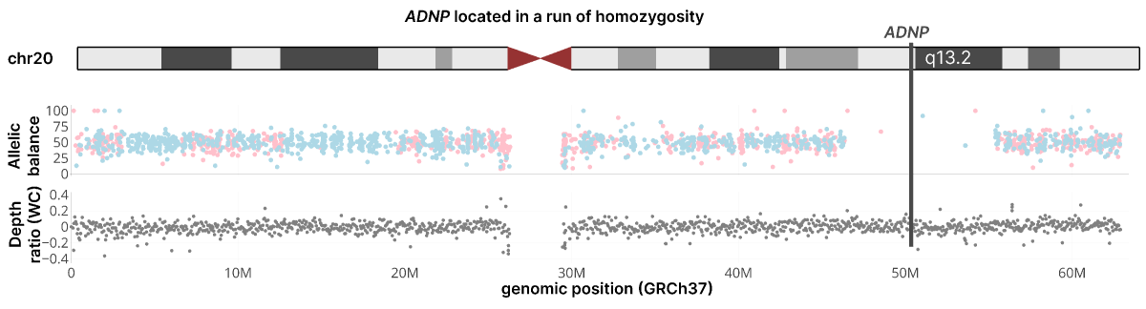
Legend: ADNP locus is pointed with the black arrow. As ADNP is in a region of homozygosity bi-allelic expression could not be confirmed.

