Supplementary Material
Antineuroinflammatory effects of dl-3-n-butylphthalide conferred by stimulation of Foxp3 and Ki-67 in an ischemic stroke model
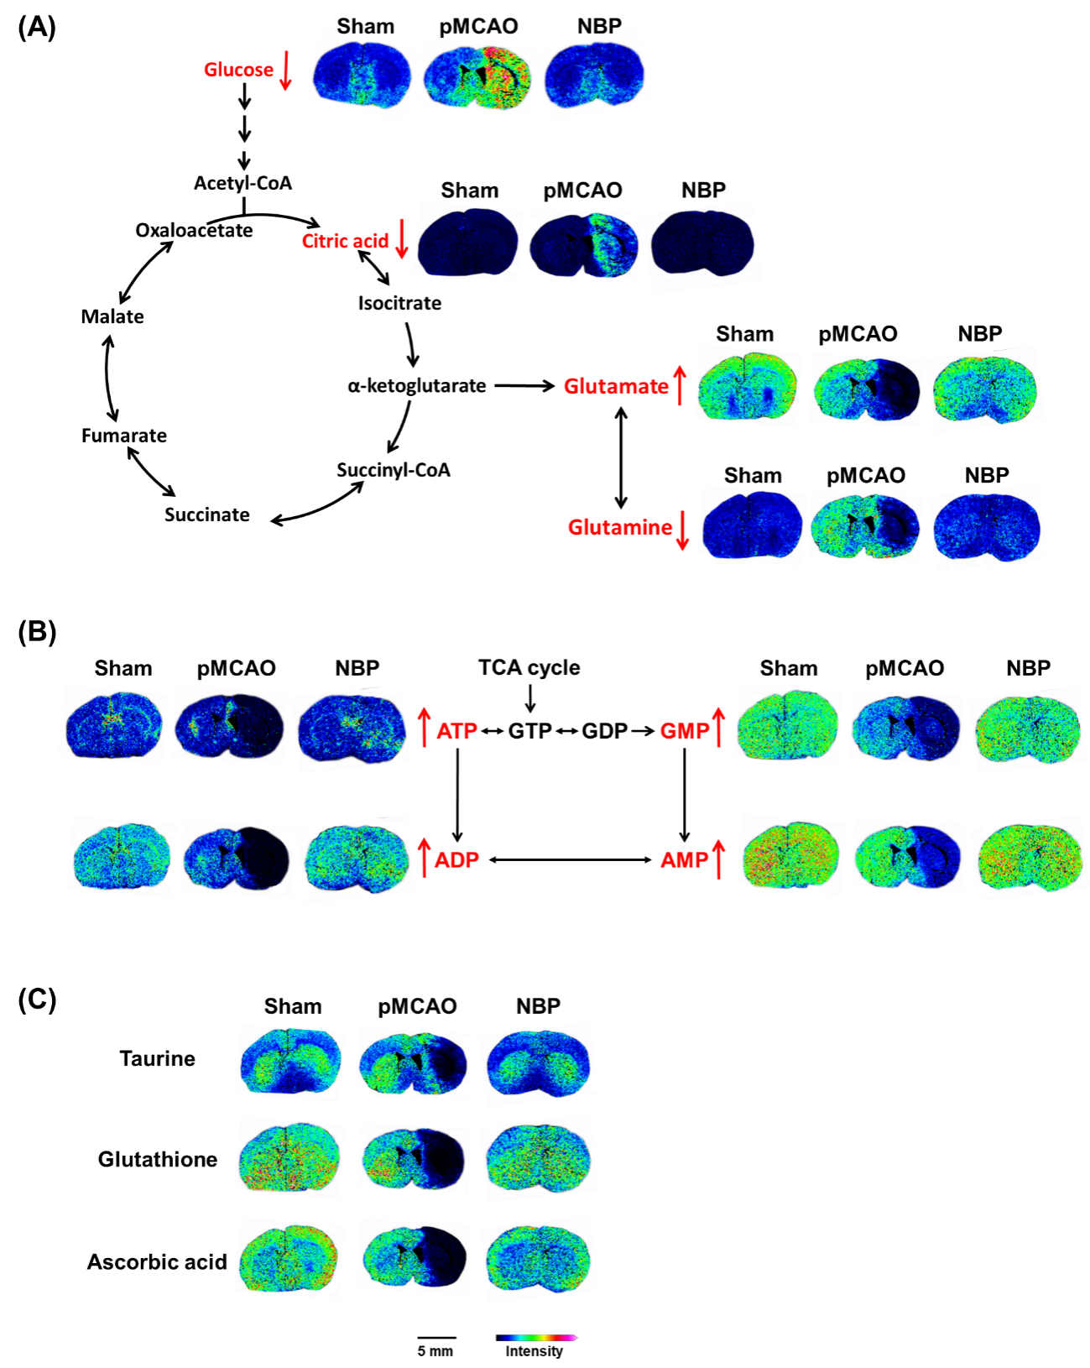
Figure S1. NBP alleviated the abnormal accumulation of glucose and citric acid, improved the levels of metabolites involved in the glutamate-glutamine cycle (A), enhanced ATP metabolism (B), and increased the levels of antioxidants (C) in a rat model of pMCAO. MALDI-TOF-MS imaging of glucose (215 ± 0.2 Da), citric acid (191.05 ± 0.1 Da), glutamate (146.07 ± 0.1 Da), glutamine (145.07 ± 0.1 Da), ATP (505.85 ± 0.1 Da), ADP (425.97 ± 0.1 Da), AMP (346.01 ± 0.1 Da), GMP (362.01 ± 0.1 Da), taurine (124.05 ± 0.1 Da), glutathione (306.05 ± 0.1 Da), and ascorbic acid (175.05 ± 0.1 Da). The spatial resolution was set to 100 μm. Scale bar = 5 mm. Sham: sham surgery group; pMCAO: permanent middle cerebral artery occlusion group; NBP: dl-3-n-butylphthalide-treated group.

