Supplementary Information

Topologically protected phase singularities in TMDCs monolayers

Guoteng Ma^{1#}, Wanfu Shen^{1,2#*}, Soy Daniel Sanchez¹, Yu Yu¹, Han Wang¹, Lidong Sun,³ Xinran Wang⁴, Chunguang Hu^{1*}
1 State Key Laboratory of Precision Measuring Technology and Instruments, School of Precision Instrument and Opto-Electronics Engineering, Tianjin University, Tianjin 300072, China
2 Nanchang Institute for Microtechnology of Tianjin University, Tianjin 300072, China
3 Institut für Experimentalphysik, Johannes Kepler Universität Linz, Altenbergerstr. 69, A-4040 Linz, Austria
4 National Laboratory of Solid State Microstructures, School of Electronic Science and Engineering and Collaborative Innovation Center of Advanced Microstructures, Nanjing University, Nanjing, China

# These authors contributed equally to this work
*Corresponding author: swf2014@tju.edu.cn; cghu@tju.edu.cn

Supplementary Note 1. Optical model and predictions of topological phase singularities 3
Supplementary Note 2. Conditions for the evolution of single to multiple phase singularities 6
Supplementary Note 3. Synthesis and characterizations of MoS₂ monolayer 10
Supplementary Note 4. Homogeneities of the TMDCs monolayers 12
Supplementary Note 5. Spectroscopic ellipsometry measurements of TMDCs monolayers and parameterization of dielectric functions 13
Supplementary Note 6. Experimental and theoretical results of phase singularities 16
Supplementary Note 7. Topologically protected phase singularities of MoS₂ monolayer with varied CRs 19
Supplementary Note 8. Characterizations of MoS₂ monolayers with varied CRs 22
Supplementary Note 9. Experimentally data of biosensors and possible sensitivity analysis 24
Supplementary Note 10. Theoretical calculations of gas sensor and sensitivity 28

Figure S1. Optical model and predictions of phase singularities. 7
Figure S2. Evolutions of phase singularities by substrates. 11
Figure S3. Evolutions of phase singularities by thickness of TMDCs layers.. 12
Figure S4. Schematic drawing of the controllable CVD system. 13
Figure S5. Optical images of TMDCs monolayers. 14
Figure S6. Ellipsometric measurements of TMDCs monolayers. 17
Figure S7. Experimental and simulated Ψ and ∆ of MoS₂ monolayer. 19
Figure S8. Behaviors of Ψ and ∆ near the phase singularities of TMDCs monolayers 20
Figure S9. Additional experimental data for Fig. 3. 21
Figure S10. Experiments and simulations for phase singularities of MoS2 monolayers with varied coverage ratios. 23
Figure S11. Optical characterizations of MoS2 with varied coverage ratios. 26
Figure S12. Additional experimental data for Fig. 5. 27
Figure S13. Spectral and slope sensitivity of biosensors. 29
Figure S14. Theoretical sensitivity of gas sensors. 31

Table S1. Fitting parameters of the dielectric functions of TMDCs monolayers. 16

Supplementary Note 1. Optical model and predictions of topological phase singularities
To visualize the phase singularities (PSs) of atomically thick films coated on transparent substrates, polarized zero-reflection points were predicted employed by optical transmission matrix method modeling as Fig. S1a. The model is made of three layers, which are stratified structures made by smooth, parallel media layers in a non-absorbing ambient. The thickness of the atomically thick layer is estimated at 0.62 nm, which is acceptable value for TMDCs monolayer. The transparent substrate layer is backside roughed, which is considered as an ideal non-reflection semi-infinite substrate.
The rigorous equation derivation of the model is presented using conventional compound optical response of the interface between two layers as extensively used in fundamental literature and reports^{1,2}. First, the complex refractive index N_{m} of each finite layer m is defined by
(1)
where the λ is the wavelength of the incident light, i is the imaginary unit and m = 0 is air, m = 1 is TMDCs, and m = 2 is sapphire. If ϕ is the angle of incidence, the refraction angle between two adjacent layers is defined by Snell’s law:
(2)
And the polarized amplitude ratios for the reflected waves through the interface between two adjacent layers is defined by Fresnel’s law:
(3)
where the r and t are the reflection and transmission amplitude ratios for each interface, the superscript p and s is the polarized components which parallel and perpendicular to the plane of incidence, respectively. Assuming the thickness of the atomically thick layer is d, and the phase difference thickness β is defined by
(4)
Then, the total polarized reflection ratios for the whole stack are:
(5)
The ellipsometric ratio is then be extracted by the definition:
(6)
where the ρ is the ellipsometric ratio, Ψ and Δ are the amplitude ratio and the phase difference of the polarized reflection p and s, respectively. The inverse definitions of the Ψ and Δ derived by ρ are:
(7)
where, -π/2 ≤ Δ ≤ +3π/2 is defaulted under normal SE instrumental data process, values beyond 3π/2 are subtracted by 2π due to the periodic of the arctangent function. For better visualization of the singularities, partial calculated and measured data of Δ in this paper (main text and supplementary notes) are not subtracted from periods.
So far, if the permittivity of the atomically thick layer (N₁ = n₁ - ik₁) and the transparent substrate (N₂) are determined (structure parameters: d, N₁, N₂), the Ψ and Δ can be directly numerical calculated by given the input parameter conditions consisting of ϕ and λ. The topological darkness points could be determined by checking the calculated spectra of Ψ and Δ, and the input parameters of a PS are described as a combination of ϕ_{s} and λ_{s}. But if the permittivity of atomically thick layer is not previously determined, we can use a two-dimensions arrays consisting of the real and imaginary part of complex refractive indices (n₁, k₁) as substituted input parameter space to calculate Ψ and Δ under a given parameter condition (ϕ, λ). Then, all possible PSs could be found in the Δ mapping from the RI plane shown as Fig. S1b, and each PS corresponds to a unique combination of the complex refractive index (n_{s}, k_{s}). A real PS can be determined if the combination (n_{s}, k_{s}) could be found in the dispersion coefficients (N₁) of true materials.
Fig. S1b shows the simulated Δ mapped from n₁ and k₁ (RI plane) under the given input parameters (ϕ = 65°, λ = 450 nm). Notably, the map is divided into two discontinuous regions, where a monotonic π-jump in phase occurs when one region crosses the boundary to the other. The phase points located at the boundary are undefined and the corresponding Ψ is 0, which represent singular phase and topological darkness. All possible combinations of RI (n_{s}, k_{s}) to determine singularities are concentrated on this boundary and named as ‘singular line’. These combinations are characterized by high n accompanied with high k, where could be found in the energies of excitons in semiconductor materials. Thus, TMDCs monolayers with strong excitons meet all these requirements. Conveniently, we can direct plot the dispersion curves of TMDCs monolayers on the RI plane to find their intersections (Fig. 1c, d). It is noted that the RI of the choosing substrate should be completely known, when the parameter condition of λ is specified, the RI of substrate is determined accordingly. Another necessary note is that the singular line will change slightly depending on the wavelength λ (Fig. S1c) while barely change with the angle of incidence ϕ (Fig. S1d), the singular line affected by the input wavelength is shown using the gray visible band. The ϕ determines the magnitude of phase in the RI plane but not obviously affect the position of singular line. Thus, the singular line in RI plane is mainly determined by λ and corresponding RI of substrates when the thickness of the TMDCs film is specified.
Figure S1. Optical model and predictions of phase singularities. (a) Schematic drawing of the optical structure for prediction of topological darkness, which is generated by monolayer film (0.62nm) overlaid on transparent substrate. (b) Phase difference Δ constructed by the real and imaginary parts (n₁, k₁) of the complex refractive index (RI) of monolayer film as parameter space using sapphire substrate. (c) Extracted singular line from (b) under different input wavelength λ at a fixed incident angle ϕ = 65°. (d) Extracted singular line from (b) under different input incident angle ϕ at a fixed wavelength λ = 450 nm.

Supplementary Note 2. Conditions for the evolution of single to multiple phase singularities
In this note, we focused on how the singular line in RI plane are shifted by potential input parameters and the evolution of PSs when it moves. This will help us understand the intrinsic conditions and controllable construct the singularities effectively. First, let us consider the phase of the light reflected from a surface of TMDCs monolayer without supporting substrate, the upper and lower medium are infinite air. According to Eq. 1 – Eq. 4, the reflected phase in completely determined by the permittivity and thickness of the monolayer. Then, we can predict the singular line in visible spectral band based on such structure in the RI plane (Fig. S2a). We can see that the dispersion curves of four TMDCs monolayers (from Note. 4) all have intersections with the singular line, MoS₂, WSe₂, and WS₂ may even have multiple intersections if the appropriate wavelength is selected. Namely, the reflected PSs are widespread thanks to the dielectric properties of the TMDCs monolayer characterized by strong excitons.
However, the suspended monolayers without supporting substrates are hardly measured and applied. We expect that the movement of the singular line by introducing a substrate (N2 = n₂ - ik₂) will not change substantially, and the still intersect with the dispersion curves. On purpose, we examined the substrates proved to have growth ability of high-quality and large-scale monolayer, which are divided into two types: absorptive (e.g., copper, silicon) and non-absorptive (e.g., sapphire, mica). Luckily, non-absorptive substrate (k₂ is close to zero) moves the singular line to the center of dispersion curves (Fig. S2b), where there is a unique intersection for each TMDCs monolayer. Moreover, the singular line just divides the RI plane into two regions, and the dispersion curves start in one of these two regions and finish in the other, which implies they will always intersect with the singular line and topologically protected as a result of Jordan theorem^{3,4}. While, for the absorptive substrates, as SiO₂/Si discussed in Fig. 1c, the singular line is far away from the distribution region of the dispersion curves of TMDCs monolayer, hardly to have intersections. Therefore, we focus on the non-absorptive substrates and use sapphire for the CVD growth in our study. Generally, these non-absorptive substrates are transparent medium and their dispersion curves could be described by Cauchy’s dispersion formula universally⁵, n₂ increases significantly below ~ 400 nm, gradually tends to constant with increasing wavelength in visible and infrared bands, and k₂ in the visible band is close to zero. The visible band is mainly considered since n₂ does not change dramatically and sensors or optoelectronic devices sensitive to visible light could be widely used.
The n₂ of commonly used non-absorptive substrates (sapphire, mica, quartz, PET) is 1.4 - 1.8 in the visible band. As we have discussed in Fig. 1c, each TMDCs monolayer has only one PS in this range. This is mainly because of the similar prominent electron transition in their dielectric functions (Lorentz oscillator C, details in Note. 5). The dispersion curves located in the spectral range of oscillator C have high n₁ and k₁ synchronously, and decrease rapidly in the neighborhood, which appears as a circular arc far away from the coordinate zero and with a large radius in the RI plane. In fact, each distinct oscillator in the dielectric function of TMDCs monolayer is mapped to an arc in the RI plane: A and B oscillators caused by direct transition possess high amplitude and small damping, appear as closed rings in the regions of high n and low k; C oscillator, which has the highest amplitude and wide energy range among all oscillators, exhibit a largest half-open arc in the region of high n and high k; the inconspicuous D oscillator whose amplitude is close to A and B but with larger damping, appears as a closed ring in the region of low n and high k; and those higher energy oscillators with strong damping, behave as open arcs in small radius in the in the region of low n and high k. As shown in Fig. S2b, these arcs on the dispersion curves divide the RI plane into regions, where closed rings appear on both sides of arc C. The singular line of substrate n₂ ranging from 1.40 to 2.49 only intersects the arc C and separate the dispersion curves unclosed, as one topological protected PS observed in our measurements, and the spectral positions (λ_{s}) of the PSs are red shifted as increasing substrate n₂. We next calculated the variation of the singular line as the n₂ continues to increase. Obviously, the singular line moves up gradually, and the second PS appears when the singular line of critical n₂ (labelled values in Fig. S2b) is tangent to ring B. After exceeding the critical value, the singular passes through rings A and B, showing multiple PSs in the spectral range of 500 – 800 nm. As n₂ increases further, the PSs move to the infrared and wear off. We can conclude that these PSs are not stationary and evolve with the n₂ of substrates. Another interesting phenomenon is that the points when singular line is tangent to ring B correspond to topological charges C = 0, where two singularities belong to opposite charges (C = +1 or -1) meet in the parameter space and annihilate leaving no PS (similarly, as recently mentioned by G. Ermolaev et al. in their singular phase study of controlling thickness of PdSe₂⁶). The closed rings of dispersion curves can exist only one side of the segment regions by the singular line in the RI plane, but they do not always intersect with the singular line, therefore such PSs appear or disappear in pairs with the total topological charge preserved at zero.
However, the hypothetical increasing n₂ of substrate used for calculation cannot be physically achieved easily. Even the natural transparent crystal with largest n (diamond, n = 2.42) fails to exceed the minimum critical value (n₂ = 2.49) of WS₂. To feasibly assist the design of PSs, the evolution of singular line by adjusting extinction coefficient k₂ of substrate were further studied. As shown in Fig. S2c, by introducing a small k₂ of the sapphire substrate, the singular line moves up significantly, reaching the same effect as a large increase in n₂ but quite physically easy. Transparent substrate with small k₂ can be constructed by the equivalent medium complex refractive index method, which is specifically realized by adding absorption layers, modifying metal microstructures, synthesizing compound crystal, etc. When k₂ exceeds 0.47, the singular line will not intersect with the dispersion curves of any TMDCs monolayer, which also indicates that the absorptive substrates are difficult to induce the PSs in general (it invariably needs to be carefully designed and selected from size, structure, and materials). In a more complicated case, the substrates with both high n₂ and k₂, such as silicon covered with oxide layer, the singular line appears in the regions far from the coordinate zero and close to the n-axis or k-axis in the RI plane, where the dispersion curves cannot reach. As a summary, by increasing n₂ or k₂ of the substrate, the spectral positions of the singularities are red shifted, and even more PSs appear at red or infrared bands. This theoretically prediction can significantly assist the design of alternative non-unitary charged PSs and shifting their spectral positions without destroying the monolayer features of TMDCs.
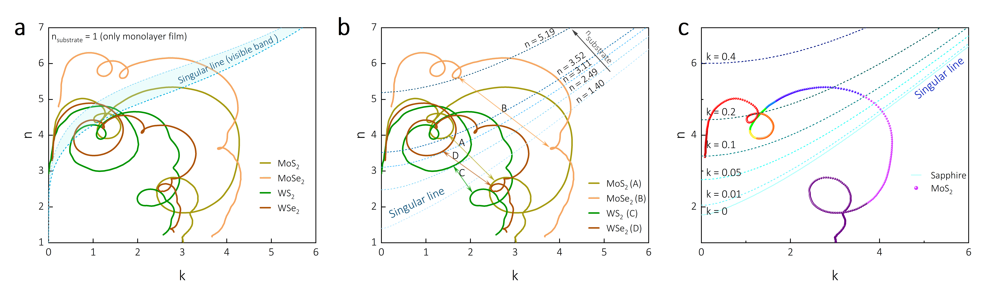
Figure S2. Evolutions of phase singularities by substrates. (a) PSs of monolayer TMDCs arise when the singular line (zero-reflection line) intersects with the dispersion curve of TMDCs, the visible band represent the variation of singular line caused by spectral wavelength λ (380-800 nm). (b) PSs of monolayer TMDCs on hypothetical transparent substrate with varied refractive index n₂. (c) PSs of monolayer TMDCs on sapphire with hypothetical varied absorption coefficient k₂.

Another choice to shift the PSs or induce more PSs is to sacrifice the monolayer features and switch from monolayer to multilayer. Such thickness controlling method is commonly used to change the strength of plasma resonance or shift the PSs^{7–9}. However, for two-dimensional films, homogeneous multilayers are difficult to prepare in large-scale. Here, we demonstrate the possibility of this approach using only calculations. As shown in Fig. S3a, with the increase of the number of layers, the singular line will clearly approach the n-axis around the starting point (0, 1.78) and the slope will also gradually increase, which lead to the red shift of PSs. More non-unitary charged PSs appear in the red or infrared bands, similar as increasing the n₂ or k₂ of substrate. Fig. S3b shows the spectral shift of the unique PS of TMDCs on sapphire, the spectral position shifts of the PSs increase linearly with the number of layers, which are obvious for less than 10 layers (e.g., ~1 nm/L for MoS₂) but accelerate after 10 layers. The shifting rate of each TMDCs monolayer is different, which is closely related to the oscillators C of the dielectric functions (see Note. 5 for more details). It is worth noting that the dielectric functions of TMDCs are proved to have layer-dependent properties, the peaks amplitude decrease and small spectral shift as the number of layers increases. In the calculations, we used dielectric functions of monolayer instead of multilayer, which results in bias but not fatal, a small change in the dielectric functions will only bring spectra deviations of the PSs. This calculation of few layers is still of interest, which can help us to understand the direction and extent of PSs evolution with thickness, and how to deal with PSs in the face of multilayer mixed or bulk materials.
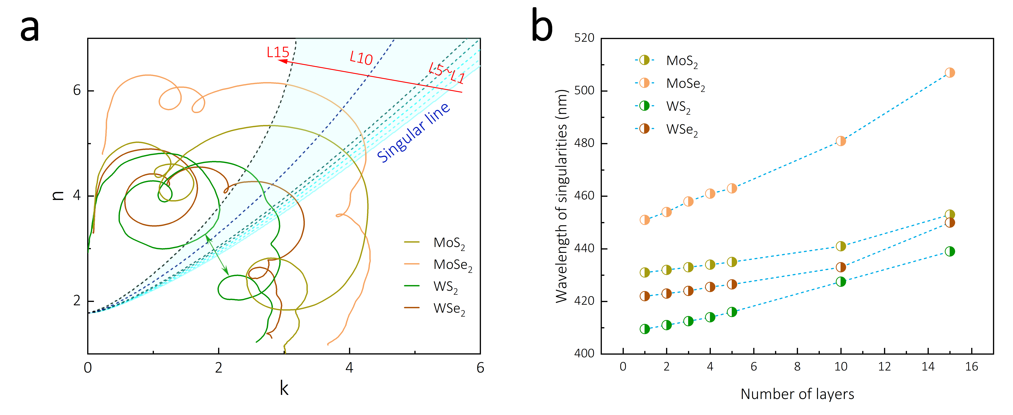
Figure S3. Evolutions of phase singularities by thickness of TMDCs layers. (a) PSs of multilayer TMDCs (1L~15L) on sapphire substrate arise when the singular line (zero-reflection line) intersects with the dispersion curve of TMDCs. (b) Wavelength points of the PSs of multilayer TMDCs.

Supplementary Note 3. Synthesis and characterizations of MoS₂ monolayer
To control the CRs of large-scale MoS₂ monolayer on sapphire, a home-designed CVD furnace system with high precision controls of the locations of precursor sources, temperatures, and carrier gas, were developed. The schematic design of the CVD system was shown in Fig. S4, which is composed of a main three temperature zone CVD furnace and three independent movable small sub-quartz tubes (I1, I2, I3) driven by electrical motors separately. The precursors of sulfur crystals (S) and molybdenum trioxide (MoO₃) powder were individually placed in the two sub-quartz tubes (I1 and I2). Each precursor sub-quartz tube is independently driven by a motor for axial scalable motion. Thus, the reaction time could be deliberately controlled by simply moving the precursor sources into or out of heating zones. The relative distances between the S, MoO₃, and substrate can be precisely adjusted during CVD growth, which is vital to obtain the optimized ratio of vaporized S and MoO₃ for high-quality MoS₂ monolayer as revealed by previous reports^{10,11}. The movable precursors in our experiment are also designed to suppress the heating hysteresis by importing the S and MoO₃ sources into their heating zones after the setting temperature is steady by waiting enough time. On the other hand, the transportation field of carrier gas is also a crucial factor in growing high-quality MoS₂ monolayer film^{12,13}. A mechanical pump mounted at end of the chamber was used to produce steadily pressure difference guiding the flow of carrier gas. The extreme vacuum pressure is around 10⁻² Torr and keeps at 10⁻¹ Torr during growth. The argon (Ar) carrier gas was purged from the three sub-quartz tubes with different flow rates, and I3 was used to provide background flow, which is called background sub-quartz tube for clarity. In a typical growth, the Ar flow rate in the background sub-quartz tube is 100 sccm and lasts for 2 hours to obtain a steady laminar flow before growth. The Ar flow rate in the S and MoO₃ precursor sub-tubes are 20 sccm and 10 sccm, respectively, where were used to carry vaporized (sublimed) precursors to the substrate.
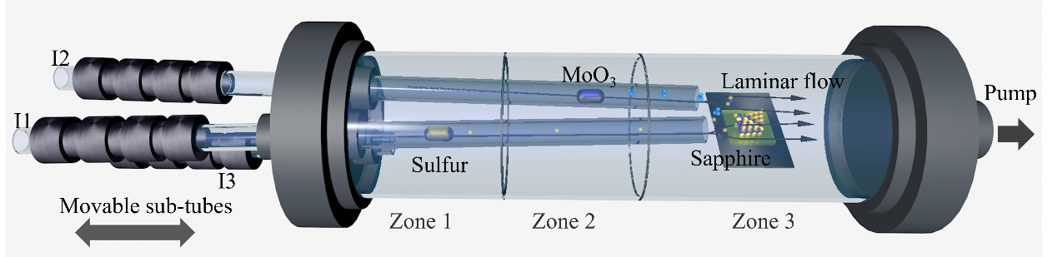
Figure S4. Schematic drawing of the controllable CVD system. The purple and yellow particles represent Mo and S atoms, respectively.

Supplementary Note 4. Homogeneities of the TMDCs monolayers
The ellipsometry has relatively large light spot (>100 μm) in the magnitude order of millimeter, which is much larger than the crystal grains of TMDCs. Thus, the high spatial homogeneity in large-scale is required to obtain reliable determinations of the PSs. Although the homogeneity (CRs) is confirmed to have no influence on the λ (wavelength) of the PSs due to topological protection, the ϕ (angle of incidence) is still affected. To obtain reliable parameters (λ_{s}, ϕ_{s}) of the PSs, it is necessary to maintain high homogeneities among all the samples. Here, the OM and SEM images taken from four points of the measured samples (Fig. S5) are shown to demonstrate the homogeneity. The spanning distances between the measured points are 0.75 cm, far exceeding the spot diameter. The continuous TMDCs monolayer show large-scale morphological consistency (Fig. S5a, b), and crystal grains show uniform size and density over the whole substrate (Fig. S5c, d).
Figure S5. Optical images of TMDCs monolayers. (a) Optical images of TMDCs monolayer on 1 cm² square c-sapphire substrate. The four images of MoS₂ are taken from tagged positions of the samples. The scale bars are uniformly 50 µm. (b) SEM images of the TMDCs monolayer. The scale bars are uniformly 40 µm. (c) Optical images of the crystal grains of MoS₂ monolayers. The four images are taken from the tagged positions of the samples. The scale bars are uniformly 10 µm. (d) SEM images of the crystal grains of the MoS₂ monolayer sample (discontinuous sub-monolayer used for topological verification in Fig. 4). The scale bars are uniformly 50 µm.

Supplementary Note 5. Spectroscopic ellipsometry measurements of TMDCs monolayers and parameterization of dielectric functions
The systemically broadband permittivity of the four TMDCs monolayers are rough data or not open source to the best of our knowledge. The reported data of serval groups remains certain differences as the permittivity easily suffers from lots of factors such as crystal quality, defects, and measurement accuracy^{14–17}. However, the deviations of the permittivity will only result in a shift of the singularities in the parameter space, but will not lead to its disappearance due to the zero-reflection points are topologically protected. Here, the dielectric response of TMDCs monolayers were carefully refined by ellipsometric method to minimize their influence to the parameter space.
To physical retrieve the dielectric response of TMDCs monolayer, the optical dispersion of each TMDCs, expressed by a Kramers-Kronig consistent dielectric function, was modeled with a superposition of classical Lorentz oscillators and baseline constant¹⁸:
(8)
where, E is the photon energy, ε∞ is the high-energy baseline dielectric constant and C_{n}, A_{n}, Г_{n} are the central energy, amplitude and damping of n-th Lorentz oscillator, respectively.
The optical stacked model consistent with Fig. S1a was established to calculate ellipsometric parameters (Ψ, ∆). The thickness of the TMDCs monolayer is treated as a homogeneous medium with an effective thickness given by the interlayer spacing of the respective bulk material (dMoS₂ = dWS₂ = 0.62 nm, dMoSe₂ = dWSe₂ = 0.65 nm)¹⁹. The complex dielectric functions of the four TMDCs monolayer were then extracted using least-squares regression analysis and weighted root-mean-square error to fit the measured data at three incident angles (60°, 65°, 70°). In the infrared, the TMDCs monolayer behave as non-absorbing transparent medium with low reflectance, the measured reflective data contains large uncertainty, and the fitting spectral range was consequently reduced to 210-900 nm. The dielectric response term arising from polar phonons and free carriers in the infrared is neglected due to the weak contribution to the visible response (in the optical frequency range is estimated to be less than 0.1). The fitting results of Ψ and ∆ at 65° are shown in Fig. S6, which are in well accordance with the reported experimental data and density functional theory (DFT) predications^{14,19}, and the best fitting parameters are listed in Table. S1.
For TMDCs monolayers, the most prominent signatures in the dielectric functions are a series of sharp peaks in the lower energy range and a series of broad and low oscillators at higher photon energies, and these peaks are labeled with uppercase in Table. S1. The lowest energy structural feature is denoted by direct-gap transitions from the valence band maximum to the conduction band minimum at K-point in the Brillouin zone (BZ), and followed by a spin-orbital splitting peak of the valence band at the same K-point. The two direct-gap transitions are designated as A and B excitons by PL spectra²⁰. The C oscillator corresponds to the complex many-body effects (mostly contributions from the nonlocalized p orbitals character of the S and Se atoms) that occur between the K- and Г- points of the BZ as pointed by the DFT calculations of Song et. al^{15,21}. The followed D of the same type as C is transited from Г- point. High energy oscillators (E-H) could be formed by electron transitions to higher conduction bands. Oscillators A-D are focused in our study due to their closely relevance to the formation of the singularities. The optical dispersion of TMDCs near 2 eV dominated by A and B oscillators possess highest refractive index (n) and lower extinction coefficient (k ~ 1) than C, which could form multiple singularities by special conditions (see Note 2). The C oscillator assisted by D provides the highest extinction coefficient and larger refractive index, which contributes mostly to the formation of the single singularity of TMDCs on transparent substrates. However, high energy oscillators with larger damping all contribute to the numerical values of RI. To this end, the oscillators within the measurement window are considered carefully. Rarely reported higher-energy electronic transitions beyond 5.9 eV are not considered in this study because the undetermined higher oscillators have been concealed by the superimposition of the highest energy oscillators F (H).
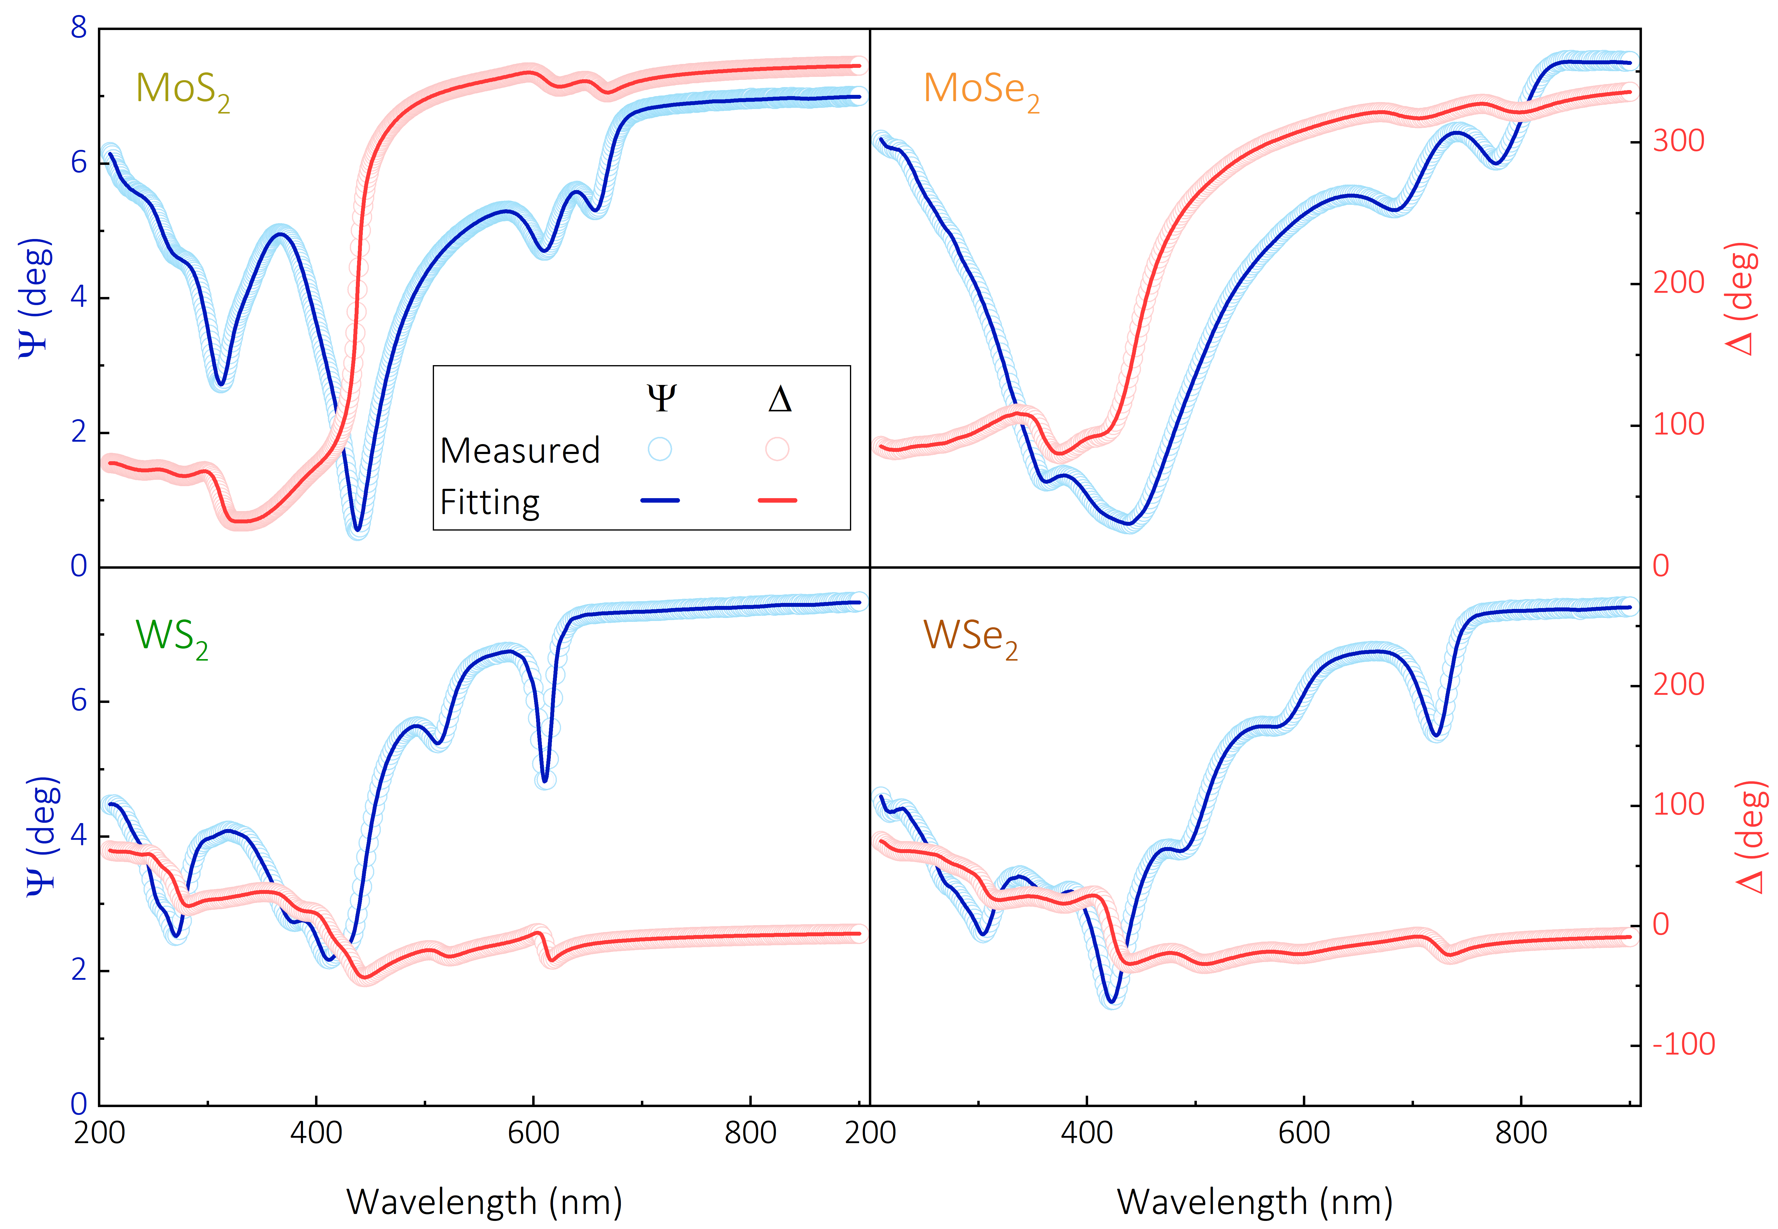
Figure S6. Ellipsometric measurements of TMDCs monolayers. Experimental (solid line) and fitting (dot line) results of ellipsometric parameters (Ψ, ∆) of TMDCs monolayers. The angles of incidence are uniformly 65°.

Table S1. Fitting parameters of the dielectric functions of TMDCs monolayers.
TMDCs | Lorentz oscillators | Parameters
TMDCs | Lorentz oscillators | C_{n} | A_{in} | Г_{n} | ε∞
MoS₂ | 1 (A) | 1.878 | 0.793 | 0.046 | 0.714
MoS₂ | 2 (B) | 2.029 | 1.773 | 0.163 | 0.714
MoS₂ | 3 (C) | 2.891 | 7.797 | 0.580 | 0.714
MoS₂ | 4 (D) | 3.689 | 0.875 | 0.226 | 0.714
MoS₂ | 5 (E) | 4.079 | 5.691 | 0.659 | 0.714
MoS₂ | 6 (F) | 4.755 | 5.280 | 0.934 | 0.714
MoS₂ | 7 (G) | 5.715 | 5.954 | 1.361 | 0.714
MoSe₂ | 1 (A) | 1.583 | 0.921 | 0.058 | 0.820
MoSe₂ | 2 (B) | 1.786 | 1.947 | 0.210 | 0.820
MoSe₂ | 3 (C) | 2.612 | 8.886 | 0.823 | 0.820
MoSe₂ | 4 (D) | 3.100 | 2.617 | 0.492 | 0.820
MoSe₂ | 5 (E) | 3.773 | 10.390 | 1.349 | 0.820
MoSe₂ | 6 (F) | 4.862 | 6.571 | 1.415 | 0.820
MoSe₂ | 7 (G) | 5.998 | 7.063 | 1.838 | 0.820
WS₂ | 1 (A) | 2.028 | 1.150 | 0.048 | 0.463
WS₂ | 2 (B) | 2.405 | 1.492 | 0.162 | 0.463
WS₂ | 3 (C) | 2.834 | 3.613 | 0.321 | 0.463
WS₂ | 4 (D) | 3.030 | 2.178 | 0.258 | 0.463
WS₂ | 5 (E) | 3.341 | 5.612 | 0.758 | 0.463
WS₂ | 6 (F) | 4.050 | 3.144 | 0.810 | 0.463
WS₂ | 7 (G) | 4.590 | 2.280 | 0.392 | 0.463
WS₂ | 8 (H) | 4.911 | 2.762 | 0.477 | 0.463
WS₂ | 9 (I) | 5.407 | 8.253 | 1.805 | 0.463
WSe₂ | 1 (A) | 1.719 | 1.168 | 0.063 | 0.527
WSe₂ | 2 (B) | 2.136 | 1.675 | 0.228 | 0.527
WSe₂ | 3 (C) | 2.498 | 3.180 | 0.350 | 0.527
WSe₂ | 4 (D) | 2.924 | 4.927 | 0.438 | 0.527
WSe₂ | 5 (E) | 3.430 | 4.186 | 0.646 | 0.527
WSe₂ | 6 (F) | 4.101 | 4.080 | 0.680 | 0.527
WSe₂ | 7 (G) | 4.368 | 3.233 | 1.055 | 0.527
WSe₂ | 8 (H) | 4.816 | 6.735 | 1.379 | 0.527
WSe₂ | 9 (I) | 6.093 | 7.124 | 1.623 | 0.527

Supplementary Note 6. Experimental and theoretical results of phase singularities
The observed PSs in Fig. 3 in the main text should be reproduced by complete theoretical calculations to validate our studies. Taking MoS₂ monolayer as an example, the ellipsometric maps of Ψ, ∆ are simulated based on the optical model in Note 1 and dielectric function in Note 4. The comparison results between the measured and simulated maps are shown in Fig. S7. Evidently, they are in close agreement in the parameter space of the PS (λ_{s} = 431 nm, ϕ_{s} = 65.4°), which demonstrates authenticity of the measured PSs and effectively theoretical modeling.
The measured Ψ and ∆ spectra extracted from Fig. 3a are shown in Fig. S8. The parameters (λ_{s}, ϕ_{s}) of the PSs of TMDCs monolayer on sapphire substrates are clearly presented: MoS₂ (431 nm, 65.4°), MoSe₂ (452 nm, 65.3°), WS₂ (409 nm, 63.6°), and WSe₂ (422 nm, 64.0°). Another interesting fact is that the amplitude (Ψ) and phase (∆) response of these four materials near the zero-reflections exhibit intensity differences due to their characteristic excitons. It is notable that MoS₂ monolayer shows the strongest phase deviations and amplitude gradient, which means it is the best choice to apply in sensors.
The measured Ψ and ∆ maps of WS₂ and WSe₂ monolayer on flexible PET substrates are shown in Fig. S9.
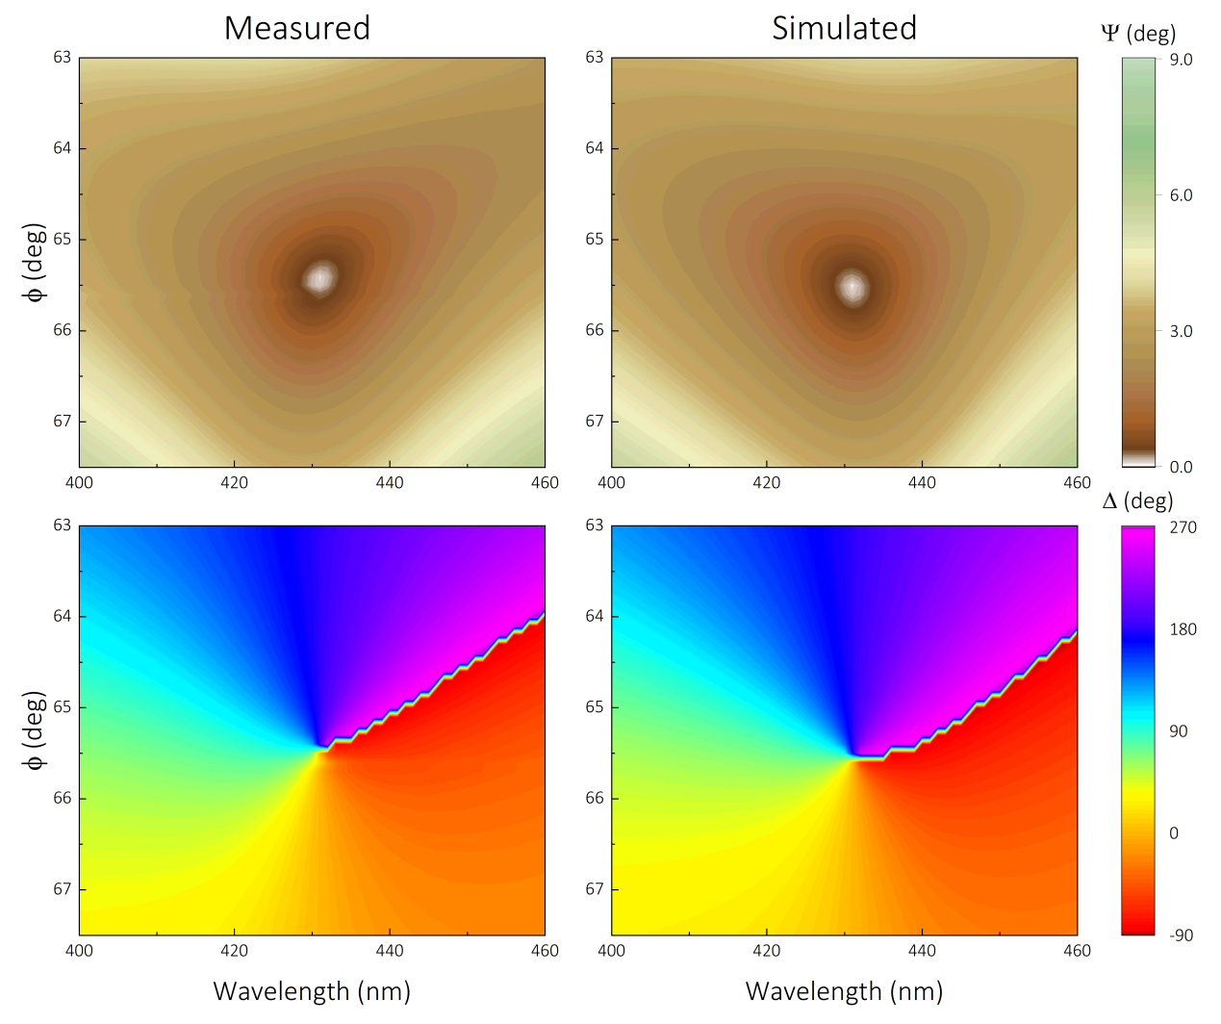
Figure S7. Experimental and simulated Ψ and ∆ of MoS₂ monolayer. Ellipsometric parameters Ψ and ∆ are mapped by the parameter space consisting of wavelength λ and angle of incidence ϕ.

Figure S8. Behaviors of Ψ and ∆ near the phase singularities of TMDCs monolayers. Extracted Ψ spectra at the incident angle (ϕ_{s}) of PSs of the four TMDCs monolayers from experimental maps in Fig. 3a, and extracted ∆ spectra at the incident angles (ϕ_{s} ± 0.2°). The inset is the extracted ∆ versus incident angles at the wavelength (λ_{s}) of PSs.

Figure S9. Additional experimental data for Fig. 3. Ellipsometric parameters (Ψ, ∆) maps of WS₂ and WSe₂ monolayers on PET substrates.

Supplementary Note 7. Topologically protected phase singularities of MoS₂ monolayer with varied CRs
For MoS₂ monolayer with varied coverage, the three-layer model shown in Fig. S1a was converted to an island form described as Fig. S10a. The partial covered MoS₂ monolayer (0.62 nm) with clearly crystal grains contains two kinds of medium including MoS₂ island S₁ and blank area S₂ (air). The mixed MoS₂ layer is superimposed using CRs as relative weights²²,
(9)
Then, the total polarized reflection ratios for the whole MoS₂/air-substrate stack change to:
(10)
where, the polarized amplitude ratios r₃^{p,s} represent the reflected waves through air and substrate.
To validate the effects of CRs on the parameter space of the PSs, ellipsometric maps of Ψ, ∆ are simulated based on the above deformation optical model. Fig. S10b shows the measured and simulated maps of two CRs, which are close in the parameter space of PSs (λ_{s_35.5%} = 431 nm, ϕ_{s_35.5%} = 62.6°, λ_{s_49.7%} = 431 nm, ϕ_{s_49.7%} = 63.2°). A 0.2° deviation of ϕ_{s_35.5%} and 0.1° deviation of ϕ_{s_49.7%} between the measured and calculated PSs could be attributed to the instrumental angular resolution (0.1°) and binarization errors for CRs. The comparisons between λ_{s} and ϕ_{s} show that the displacement of CRs will only result in a shift of the angle of incidence, but will not change the spectral position (λ) as topological nature discussed in the main text. The default CRs of monolayers in the aforementioned notes is 100%, the parameter space of singularities is simplified to include only λ_{s} and ϕ_{s}. However, we can focus on the parameter space of CRs and ϕ on the study of discontinuous monolayers, because the λ is always topological protected. To theoretical confirm the correlations between CRs and ϕ, ellipsometric maps of Ψ, ∆ consisting of parameter space of CRs and λ at incidence angle of 62° and 65° are simulated as Fig. S8c. Obviously, CRs and ϕ are complementary for the conditions of singularities. Small ϕ is required for the MoS₂ monolayer with low CRs and vice versa. As mentioned in Fig. 1, the absolute Brewster angle of bare sapphire is ~ 60.7° at 431 nm, and the CRs of monolayer on the sapphire affects the degree of deviation of ϕ_{s}. The synthesis of faultlessly TMDCs monolayers remain huge challenging and most films are mixtures of single crystals, multilayers, bulk, and residual sources, while this result show us that even defectively monolayers can also display PSs by flexible selection of the parameter space (CRs, ϕ).
However, the PSs obtained by sacrificing CRs have a notable disadvantage. The low CRs means that the local electric field of the monolayer film to the substrate modification is smaller, and local electric field of the monolayer itself is rather small limited by thickness, the enhanced phase sensitivity near the PSs will be reduced deeply. As shown in Fig. S10d, the Ψ and ∆ spectra are extracted from Fig. S10c at parameter conditions (CRs = 87.7%, ϕ_{s} = 65°, and CRs = 24.3%, ϕ_{s} = 62°) for singularities. Clearly, the Ψ spectra of low CRs exhibit low amplitude and slope near the spectral singular point (λ_{s} = 431 nm). Sharp and narrow Ψ peak near the zero-reflection point (Ψ = 0, r_{p} = 0) represent high phase sensitivity (details will be discussed in Note 9). The ∆ spectra with 0.5% shift to the CRs of singularities show the adjacent phase difference caused by CRs. The maximum phase near singularity increases significantly by ~ 82 degrees when the CRs increases from 24.3% to 87.7%. Therefore, considering the phase sensitivity, fully covered monolayers are still the best choice for sensor applications.
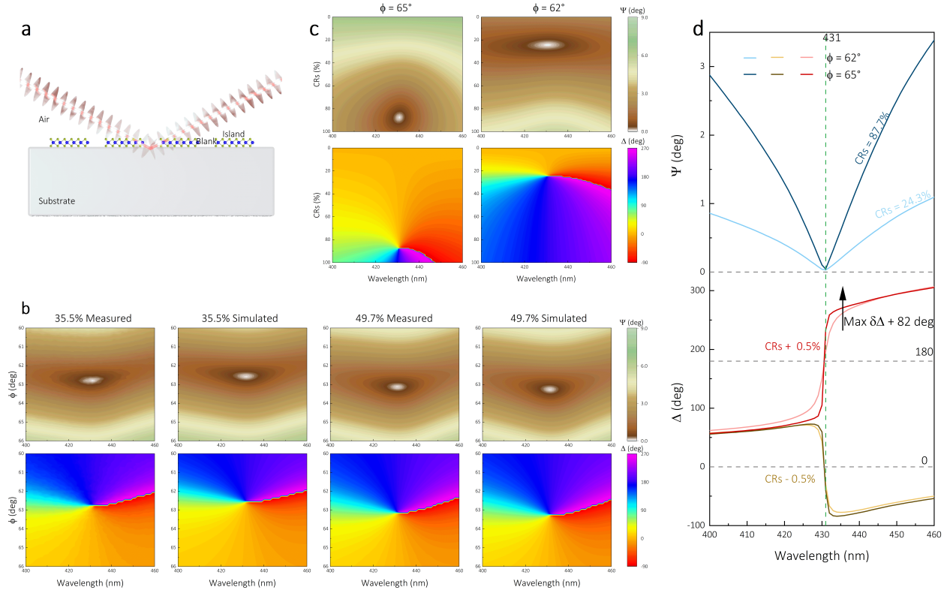
Figure S10. Experiments and simulations for phase singularities of MoS₂ monolayers with varied coverage ratios. (a) Schematic drawing of the optical structure for calculating the topological darkness of discontinuous MoS₂ monolayer. (b) Measured and simulated ellipsometric parameters (Ψ, ∆) of discontinuous MoS₂ monolayer for the observation of PSs. Ψ and ∆ are mapped by parameter space consisting of wavelength λ and angle of incidence ϕ. Ψ or ∆ shares uniformly scale bar on the left side. (c) Calculated Ψ and ∆ of MoS₂ monolayer are mapped by parameter space consisting of wavelength λ and CRs under angle of incidence at 65° and 62°. (d) Calculated spectra of Ψ and ∆ of discontinuous MoS₂ monolayer at specified angle of incidence (65° and 62°) and CRs (24.3%, 87.7% for Ψ, and a difference of 0.5% for ∆) conditions under which PSs occur.

Due to the PSs being generated at the condition of incident angle is close the Brewster angle of the bare substrates, we demonstrate that ideal zero-reflection is not easily obtained on absorptive materials at Brewster incident angle. However, it is almost impossible to rigorously derive the equations from a three-layer model. Take the simplest structure as example, a two-layer model composed of air (N₀) and a semi-infinite layer (N₁) is considered. The p-polarized reflectance r^{p}₁ is determined only by the reflection of the incident light at the interface between the two media (Eq. 3). Assume that the r^{p}₁ is zero, one can get:
(11)
where, cosϕ₁ is eliminated by substituting Eq. 2. Then, the Eq. 11 is formulated to a standard quadratic equation:
(12)
The discriminant of this quadratic equation is:
(13)
that is to say N₁ can only be real or purely imaginary, which obviously contradicts to the complex reflective index of the absorptive layer. This result proves the zero-reflection cannot be found in the pseudo-Brewster angle on a semi-infinite layer. But if the layer is finite (Fig. S2a) or a three layers structure, the zero-reflection could be found due to the phase delay (β) caused by the thickness and reflectance from the inferior interface (r^{p}₂). The relationship between them should be such that:
(14)

Supplementary Note 8. Characterizations of MoS₂ monolayers with varied CRs
Using the designed CVD system shown in Note. 3, large-scale and homogeneous MoS₂ monolayer can be directly synthesized with high repeatability. The growth process starts from nucleation, gradually epitaxy to form single crystals, and then the single crystals are connected to form a continuous film, corresponding to the CRs from 0 to 100%. By changing the growth time only, eight MoS₂ monolayer on sapphire with CRs ranging from 8.6% to 100% were obtained, and consecutively characterized by optical microscope, Raman, and PL shown as Fig. S11. The triangular crystal grains distributed uniformly on the substrate were clearly visualized shown as Fig. S10a. To previously calculate the CRs, the OM images were converted into grayscale binarization map with a threshold chromaticity coefficient of 0.57. Raman and photoluminescence (PL) spectra are also utilized to confirm the monolayer nature of these samples. Two characteristic Raman peaks located at 386.3 cm⁻¹ and 406.2 cm⁻¹ are clearly observed (Fig. S10b), which are attributed to E1 2g and A_{1g} mode, respectively^{20,23}. The frequency difference (∆ω) between the two modes of the 8 samples are evenly ~20 cm⁻¹, which confirms the monolayer nature of the CVD-grown MoS₂ film (18.5-21.0 cm⁻¹). The Raman peak of sapphire located at 418.3 cm⁻¹ was also observed due to the thin atomic layer of MoS₂. The full widths at half-maximum (FWHM) of the Raman peaks are ~3.8 cm⁻¹ demonstrating the high crystal structural quality of the samples²⁴. The dominate peak at of PL spectra at 1.85 eV (Fig. S10c) is related to the direct excitonic transition at the K-points in the Brillouin zone, which is in good agreement with previously reported high-quality MoS₂ monolayer^{24–26}. The charged A⁻ trion peak was fitted at 1.81 eV using Pseudo-Voigt curves. The characteristic peak of sapphire around 1.78 eV appears sharply due to the high-power excitation and the use of wide-field microscope, which the CRs can be represented by the peak intensity ratio of MoS₂ (I_{A}) to sapphire (I_{S}). Fig. S10d shows the peak intensity ratio I_{A}/I_{S} varied with CRs, the ratios increase linearly with CRs approximately, indicating the exciton enhancement due to the CRs.
Figure S11. Optical characterizations of MoS₂ with varied coverage ratios. (a) Optical images of eight MoS₂ monolayer samples with varied CRs labeled as top left corner. The scale bar is uniformly 10 µm. (b) Raman spectra of the eight MoS₂ monolayer samples shown in (a). (c) PL spectra of the eight MoS₂ monolayer samples shown in (a), the inset is the charged A⁻ trion peak fitted by Pseudo-Voigt curves with exciton of sapphire eliminated. (d) PL intensity ratios of MoS₂ monolayers (I_{A}) to substrates (I_{S}) as a function of CRs.

Supplementary Note 9. Experimentally data of biosensors and possible sensitivity analysis
Accessory measured ellipsometric data of ∆ for Fig. 5 are provided in Fig. S12. Three stacks (100% MoS₂ on sapphire, 87.4% MoS₂ on sapphire, 100% MoSe₂ on PET) were measured in liquid to determine the capability of biosensor at the vicinity of PSs. The complete zero-reflection point and undefined phase cannot be directly used for metrology, hence the adjacent phase on the one side of the spectral position of PSs with high sensitivity were used for sensing. By controlling the angle of incidence ϕ, the ∆ spectra exhibit two opposite directions of Heaviside-like jump of phase, one goes up through π (ϕ < ϕ_{s}), and the other down through 0 (ϕ > ϕ_{s}). Here, the ascending one was selected due to its larger phase changes near the PSs.
MoS₂ monolayers of two CRs on sapphire were used for verifying the reduction in phase sensitivity caused by low CRs as theoretical mentioned in Note 7. Besides, MoSe₂ monolayer on PET shows the universal sensor potential of TMDCs on flexible substrates. To obtain reliable phase sensitivity with confidence, we use the original measured data without smoothing process. Due to the flexibility of PET, the measured reflected beam is scattered on the uneven monolayer surface, resulting in the detector receiving a smaller average intensity than those on the sapphire substrates. Although the exposure time was prolonged to 25 s, the measured ellipsometric parameters remain obvious spectral noises.
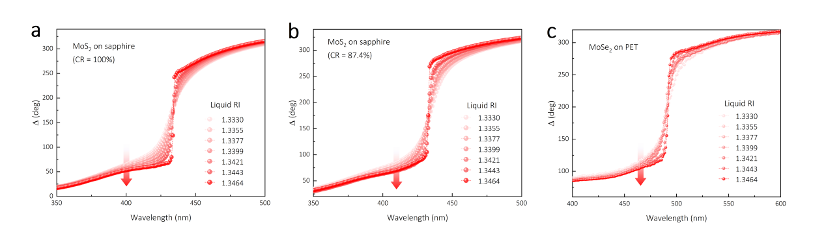
Figure S12. Additional experimental data for Fig. 5. Measured ellipsometric ∆ spectra depend on the refractive index (RI) of the investigated aqueous ethanol recorded at 47.22° (a, 100% MoS₂ on sapphire), 46.66° (b, 87.4% MoS₂ on sapphire), and 58.14° (c, 100% MoSe₂ on PET).

In Fig. 5, we analyzed the maximum and average phase sensitivities by using relative phase spectra referring to the spectra measured in pure water (n_{w} = 1.3330) with RI increment δn = 0.0023 ± 0.0002. This method is widely used in previous studies on the sensor demonstrations because the direct acquisition of phase is easy and intuitive. Optionally, spectral shift of the resonance position of Ψ spectra provides the spectral sensitivity of the biosensor. Fig. S13a shows the Ψ spectra of 100% MoS₂-sapphire stack corresponding to the ∆ spectra in Fig. S12a measured simultaneously. Clearly, the resonance position (minima, Ψ_{m}) of Ψ exhibits amplitude decrease and red shift with increasing medium RI, indicating the enhanced resonance closer to the singularity. Using δn as increment, the relative spectral shift of Ψ_{m} is shown in Fig. S13b, the spectral sensitivity is 360.0 nm/RIU in maxima and 117.6 nm/RIU in average. The maximum sensitivity appears closest to the condition of the PS. Besides, we used the figure of merit, FOM (introduced by V. G. Kravets et. al⁹) as an additional evaluation of the phase sensitivity. High FOM guarantees high phase sensitivity, FOM is approximated by the expression: FOM ~ 1/Ψ_{m}. The FOM of the MoS₂-sapphire based biosensor is ~1807, on par with those reported high performance sensors based on superstructures and high RI medium^{6,27}.
As extension, an alternatively evaluation method of phase sensitivity is presented by examining the slope of ∆ spectra. Due to the small local electron field induced by the monolayer, the phase at the wavelength point (λ_{s}) of the PSs are not significantly affected comparing to the bare substrate, the phase variation characteristic of absolute Brewster angle on nonabsorbent medium is largely preserved (strictly phase locked at 0 or π, shown in Fig. 1e). Except for the small adjacent area of ϕ_{s}, clusters of ∆ spectra measured at the same side of ϕ_{s} always exhibit a common intersection (0 or π) at the λ_{s}. Moreover, the ∆ spectra at the adjacent area of λ_{s} are approximately rotational symmetry around λ_{s} (Fig. S12). According to these features, the first derivatives of ∆ spectra appear a distinct single peak centered at λ_{s} shown as Fig. S13c using MoS₂-sapphire as example. These peaks are axisymmetric with respect to λ_{s} and tend to zero as spectral position moves away from λ_{s}. The maximum slope of ∆ can be easily obtained by searching the maxima of the derivative spectra, and the slope sensitivity of 1.96 ×10⁴ deg/(nm·RIU) in maxima and 5.64 ×10³ deg/(nm·RIU) in average are calculated in Fig. S13d using δn as increment. The slope sensitivity is close to the phase sensitivity (2.17 ×10⁴ deg/ RIU) in magnitude while the maxima of slope occur at λ_{s}, not in the neighborhood of λ_{s}. Despite the phase at λ_{s} is undefined and cannot be detected, high slope could be obtained by differential using a small spectral with as increment (δλ < 0.5 nm). The maximum slope sensitivity at the λ_{s} is beyond the upper limit of phase sensitivity (the phase is constrained by dielectric response) and theoretically approaches infinity. However, subject to the instrumental spectral resolution (1 nm), our measurement results do not exhibit a higher sensitivity. Furtherly, the full width at half maxima (FWHM) of the slope peaks show apparently narrowing with the increasing of RI, which could be used for calculating the spectral sensitivity. As a contrast, the spectral sensitivity of 2173 nm/deg in maxima and 860 nm/deg in average is much larger than that calculated by Ψ_{m}. This confirms the responding spectral width of phase in significantly larger than the spectral shift of resonance position.
However, we speculate that these sensitivity results could be further increased by change the detectors since the commercial ellipsometry (J.A. Woollam RC2-XI) based on rotating compensator used in this study are designed for fast optical characterizations but not for sensing. The detection system provides spectral resolution of 1 nm and phase sensitivity of 5×10⁻² deg. In contrast, ~ 10⁻³ deg could be realized by using advanced phase sensitive detectors. 1-2 orders of magnitude of phase sensitivity could be improved by replacing the detection scheme. On the other hand, high spectral resolution is also important to improve sensitivity, ~ 0.2 nm of δλ could be achieved using advanced spectrometer. The more refined spectra can show more phase information near the singularities, especially the large and rapid phase changes which are difficult to detect when the spectral neighborhood is less than 1 nm.
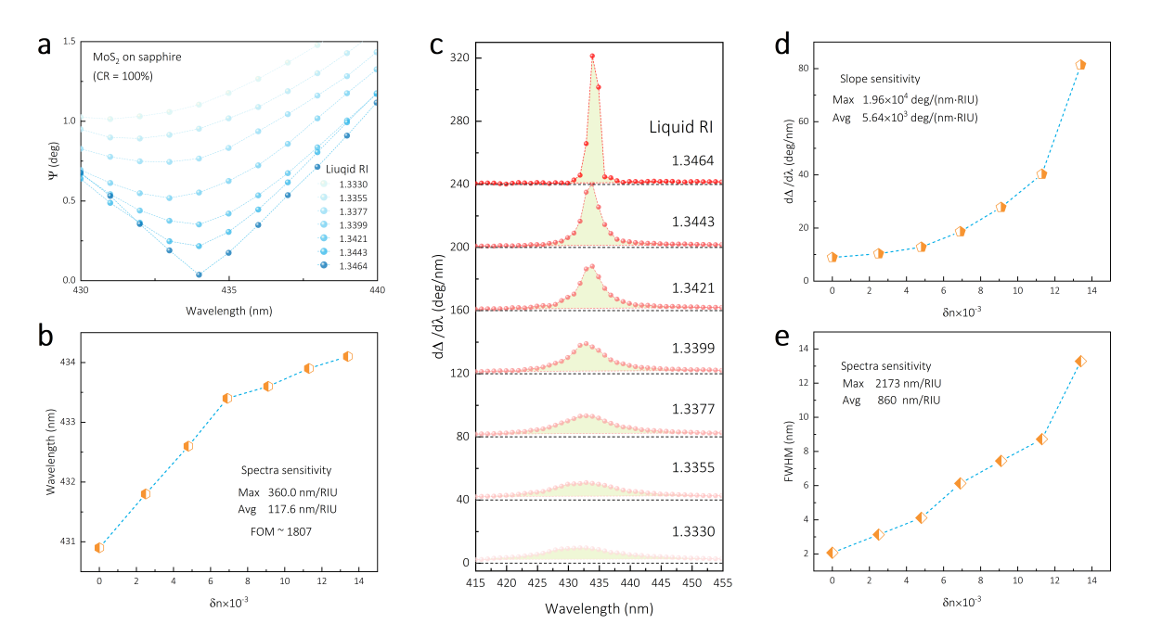
Figure S13. Spectral and slope sensitivity of biosensors. (a) Measured ellipsometric Ψ depend on the refractive index (RI) of the investigated aqueous ethanol recorded at 47.22°, corresponding to the PS. (b) Spectral shift of the resonance minimum position of Ψ spectra in (a) with the increment δn of medium liquid RI. (c) First derivative of measured ∆ spectra depend on the RI. The plots use 40° as cumulative increments for data presentation. (d, e) Maximum peak value and full width at half maxima (FWHM) of the peaks in (c) with the increment δn of medium liquid RI.

Supplementary Note 10. Theoretical calculations of gas sensor and sensitivity
A gas sensor is theoretically simulated using MoS₂-sapphire stack as demonstration. The RI of the ambient gaseous medium is weakly changed starting from 1.0000 (air) with increment δn = 5×10⁻⁴. The ideal simulated phase response near the PS and phase sensitivity are shown in Fig. S14. The ideal ∆ spectra are almost perfectly symmetric respect to (λ_{s}, π), and the measured results in Fig. S12a have the close properties. This proves that the proposed sensor design is stable and the phase response features near the PS will not be affected by the large change of the RI of ambient medium. In fact, the sensor can potentially be used in any range of RI by adjusting the parameter space of singularities. The maximum sensitivity of 4.38×10⁴ deg/RIU is nearly twice as large as the measured one in liquid medium. This result could be the upper limit under same spectral resolution of 1 nm based on our instrumental measurement.
As a remark, whatever the senor is used in gaseous or liquid medium, the detected targets should be able to change the equivalent RI of the medium, e. g., biomolecules in buffer solutions, nanoparticles in air. These effective targets tend to stick on the surface of sensor, resulting in uneven distribution of RI near the surface. However, considering the ultrathin thickness of monolayers, given that the distance of the measured light through the medium is much greater than the thickness, this influence could be easily ignored.

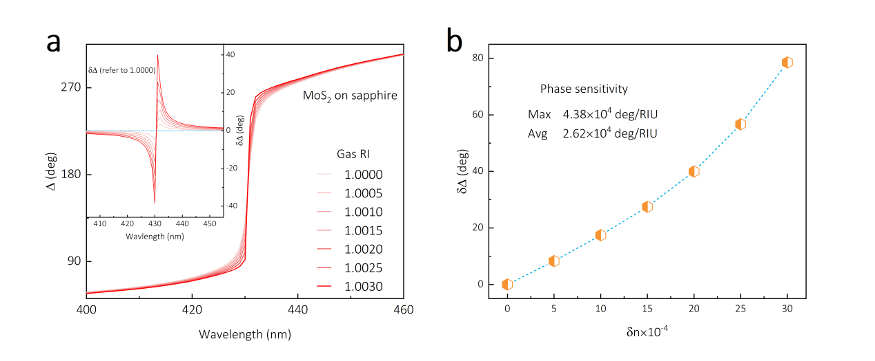
Figure S14. Theoretical sensitivity of gas sensors. (a) Simulated ∆ spectra depend on the refractive index (RI) of the investigated gaseous medium calculated at 65.42°, corresponding to the PS of MoS₂ monolayer on sapphire in air. The relative ∆ spectra shown in the inset is referenced to the spectra with RI = 1.0000. (b) The maximum phase shift of ∆ spectra in (a) with the increment δn of the gaseous medium RI.

Reference
1. Fujiwara, H. Spectroscopic Ellipsometry. (John Wiley & Sons Ltd, 2007).
2. Li, D. et al. Optical properties of thickness-controlled MoS 2 thin films studied by spectroscopic ellipsometry. Appl. Surf. Sci. 421, 884–890 (2017).
3. Hales, T. C. The Joran Curve Theorem, Formally and Informally. (The Mathematical association of America, 2007).
4. Kravets, V. G. et al. Singular phase nano-optics in plasmonic metamaterials for label-free single-molecule detection. Nat. Mater. 12, 304–309 (2013).
5. Sultanova, N., Kasarova, S. & Nikolov, I. Dispersion properties of optical polymers. Acta Phys. Pol. A 116, 585–587 (2009).
6. Ermolaev, G. et al. Topological phase singularities in atomically thin high-refractive-index materials. Nat. Commun. 13, 1–9 (2022).
7. Ouyang, Q. et al. Two-dimensional transition metal dichalcogenide enhanced phase-sensitive plasmonic biosensors: Theoretical insight. J. Phys. Chem. C 121, 6282–6289 (2017).
8. Yan, C., Raziman, T. V. & Martin, O. J. F. Phase Bifurcation and Zero Reflection in Planar Plasmonic Metasurfaces. ACS Photonics 4, 852–860 (2017).
9. Kravets, V. G., Schedin, F., Kabashin, A. V. & Grigorenko, A. N. Sensitivity of collective plasmon modes of gold nanoresonators to local environment. Opt. Lett. 35, 956 (2010).
10. Wang, S., Wang, X. & Warner, J. H. All Chemical Vapor Deposition Growth of MoS2:h-BN Vertical van der Waals Heterostructures. ACS Nano 9, 5246–5254 (2015).
11. Wang, S. et al. Shape evolution of monolayer MoS2 crystals grown by chemical vapor deposition. Chem. Mater. 26, 6371–6379 (2014).
12. Li, T. et al. Epitaxial growth of wafer-scale molybdenum disulfide semiconductor single crystals on sapphire. Nat. Nanotechnol. 16, 1201–1207 (2021).
13. Xu, X. et al. Growth of 2D Materials at the Wafer Scale. Adv. Mater. 34, 1–36 (2022).
14. Liu, H. L. et al. Optical properties of monolayer transition metal dichalcogenides probed by spectroscopic ellipsometry. Appl. Phys. Lett. 105, (2014).
15. Song, B. et al. Layer-Dependent Dielectric Function of Wafer-Scale 2D MoS 2. Adv. Opt. Mater. 7, 1801250 (2019).
16. Ermolaev, G. A. et al. Optical constants and structural properties of epitaxial MoS2 monolayers. Nanomaterials 11, 1–12 (2021).
17. Wang, Q. H., Kalantar-Zadeh, K., Kis, A., Coleman, J. N. & Strano, M. S. Electronics and optoelectronics of two-dimensional transition metal dichalcogenides. Nat. Nanotechnol. 7, 699–712 (2012).
18. Jellison, G. E. & Modine, F. A. Parameterization of the optical functions of amorphous materials in the interband region. Appl. Phys. Lett. 69, 371–373 (1996).
19. Komsa, H. P. & Krasheninnikov, A. V. Electronic structures and optical properties of realistic transition metal dichalcogenide heterostructures from first principles. Phys. Rev. B - Condens. Matter Mater. Phys. 88, 1–7 (2013).
20. Splendiani, A. et al. Emerging photoluminescence in monolayer MoS2. Nano Lett. 10, 1271–1275 (2010).
21. Gu, H. et al. Layer-dependent dielectric and optical properties of centimeter-scale 2D WSe2: Evolution from a single layer to few layers. Nanoscale 11, 22762–22771 (2019).
22. Luria, O., Kishore, P., Patsha, A., Kribus, A. & Ismach, A. Large-Scale characterization of Two-Dimensional Monolayer MoS 2 Island Domains Using Spectroscopic Ellipsometry and Re fl ectometry. Appl. Surf. Sci. 524, 146418 (2020).
23. Lee, C. et al. Anomalous lattice vibrations of single- and few-layer MoS2. ACS Nano 4, 2695–2700 (2010).
24. Yu, H. et al. Wafer-Scale Growth and Transfer of Highly-Oriented Monolayer MoS 2 Continuous Films. ACS Nano 11, 12001–12007 (2017).
25. Robertson, J., Liu, X., Yue, C., Escarra, M. & Wei, J. Wafer-scale synthesis of monolayer and few-layer MoS 2 via thermal vapor sulfurization. 2D Mater. 4, (2017).
26. Tang, A. et al. Toward Low-Temperature Solid-Source Synthesis of Monolayer MoS 2. ACS Appl. Mater. Interfaces 13, 41866–41874 (2021).
27. Wu, F. et al. Layered material platform for surface plasmon resonance biosensing. Sci. Rep. 9, 1–10 (2019).

