Table S1 Two-way ANOVA results (F and P) for the effects of land use, soil depth, and their interactions on the soil physical properties
Depth  (cm) | Land use | Upslope |  |  |  |  |  |  | Check dam
Depth  (cm) | Land use | clay | silt | sand | pH | BD | SM |  | clay | silt | sand | pH | BD | SM
0-10 | Cropland | 10±0.1 | 57.6±1.5 | 32.4±1.6 | 8.7±0.2 | 1.2±0 | 3.4±0.3 |  | 12.4±0.6 | 55.8±1 | 31.7±0.4 | 9.1±0.1 | 1.3±0 | 6.4±0.9
0-10 | Forest | 9.4±0.9 | 54±0.7 | 36.6±1.6 | 9.1±0.1 | 1.3±0 | 3.9±0.5 |  | 13.5±2.8 | 65.9±2.5 | 20.6±5 | 9±0.1 | 1.4±0 | 9.4±1.7
0-10 | Grassland | 8.3±1.2 | 61.8±0.6 | 29.9±1.8 | 9.1±0 | 1.4±0 | 4.2±0 |  | 19.2±0.2 | 69.7±0.4 | 11.1±0.6 | 9±0.1 | 1.3±0 | 8.8±1.3
10-20 | Cropland | 10.1±0.1 | 60.3±1.4 | 29.7±1.5 | 8.8±0.2 | 1.2±0 | 4.1±0.2 |  | 12.2±1.2 | 59.1±0.6 | 28.6±1.9 | 9.1±0.1 | 1.4±0 | 8.5±2.4
10-20 | Forest | 9.1±0.8 | 54.1±1.1 | 36.9±1.9 | 9.2±0.1 | 1.3±0 | 3.3±0.2 |  | 14.1±2.2 | 68.2±0.2 | 17.7±2 | 9±0 | 1.4±0 | 9.5±0.8
10-20 | Grassland | 8.3±1.2 | 61.8±0.6 | 29.9±1.8 | 9.1±0 | 1.4±0 | 4.2±0 |  | 19.2±0.2 | 69.7±0.4 | 11.1±0.6 | 9±0.1 | 1.3±0 | 8.8±1.3
60-80 | Cropland | 7.2±0.4 | 65.5±0.5 | 27.3±0.2 | 9.2±0 | 1.3±0 | 6.3±0.8 |  | 13.9±0.7 | 66.3±0.1 | 19.8±0.6 | 9.2±0.1 | 1.5±0.1 | 14.1±1.4
60-80 | Forest | 7.6±1.4 | 52.3±0.7 | 40±0.8 | 9.2±0.1 | 1.4±0 | 3.9±0.1 |  | 9.5±0.7 | 63±0.9 | 27.6±1.6 | 9.2±0 | 1.3±0 | 8.9±0.9
60-80 | Grassland | 10.6±1.2 | 63.7±1.1 | 25.7±2.3 | 9.1±0.1 | 1.3±0 | 5.8±1.9 |  | 12.1±0.5 | 65.9±0.1 | 22±0.6 | 9.3±0.1 | 1.3±0 | 11.9±2.6
180-200 | Cropland | 8.5±0.4 | 66.7±2.3 | 24.7±2.7 | 9.1±0.1 | 1.3±0 | 7.1±0.6 |  | 10.6±0.6 | 60.4±1.6 | 29±2.2 | 9.5±0.3 | 1.4±0 | 16.7±3.3
180-200 | Forest | 8±0.9 | 55.1±2 | 37±1.1 | 9.2±0.1 | 1.4±0 | 5.4±0.6 |  | 6.5±0.6 | 62.5±2.3 | 30.9±2.9 | 9.2±0 | 1.4±0 | 8.2±2.1
180-200 | Grassland | 8.5±1.3 | 64.6±1.1 | 26.8±2.4 | 9.1±0.1 | 1.3±0 | 7.7±2.7 |  | 10.2±1.7 | 55.3±2.8 | 34.5±4.5 | 9.3±0.2 | 1.3±0 | 23.7±0.2
Land use |  | 0.2ns | 61.7*** | 37.2*** | 4.4* | 8.9** | 2.3ns |  | 8.9** | 10.6*** | 6.5** | 0.6ns | 9.1** | 2.7ns
Depth |  | 0.6ns | 6.5** | 2.4ns | 2.8ns | 7.4** | 4.6* |  | 13.1*** | 8.9*** | 11.5*** | 3.7* | 0.7ns | 10.4***
Land use × Depth |  | 2.5* | 3.2* | 2ns | 0.8ns | 2.3ns | 0.4ns |  | 2.9* | 9.9*** | 6.9*** | 0.3ns | 3.4* | 4.8**
Note: BD: clay (%); silt (%); sand (%); BD: bulk density (g cm⁻³); SM: soil moisture (%); ***, **, * mean the significant differences at P < 0.001, < 0.01, and 0.05, respectively, and ns means no significant differences (P > 0.05).
Table S2 Two-way ANOVA results (F and P) for the effects of land use, soil depth, and their interactions on the soil total C, N, P and their stoichiometry.
Depth  (cm) | Land use | Upslope |  |  |  |  |  |  | Check dam
Depth  (cm) | Land use | OC | TN | TP | C/N | C/P | N/P |  | OC | TN | TP | C/N | C/P | N/P
0-10 | Cropland | 5±0.9 | 0.6±0.1 | 0.6±0 | 9.9±0.3 | 23±4.3 | 2.4±0.5 |  | 3.4±0.6 | 0.4±0.1 | 0.5±0 | 10.4±0.7 | 17.7±3.1 | 1.7±0.2
0-10 | Forest | 4.2±0.1 | 0.5±0 | 0.5±0 | 10.1±0.3 | 20±0.5 | 2±0 |  | 3.9±0.3 | 0.4±0.1 | 0.5±0 | 10.4±0.8 | 19.1±0.9 | 1.9±0.2
0-10 | Grassland | 4.1±0.1 | 0.4±0 | 0.6±0 | 11.1±0.4 | 18.7±0.7 | 1.7±0.1 |  | 4.6±0.8 | 0.5±0.1 | 0.6±0 | 10.9±0.3 | 20.8±2.3 | 1.9±0.2
10-20 | Cropland | 3.1±0.2 | 0.4±0 | 0.5±0 | 9.5±0.2 | 15±1.1 | 1.6±0.1 |  | 3.1±0.8 | 0.4±0.1 | 0.5±0 | 9.9±0.3 | 16.2±3.3 | 1.6±0.3
10-20 | Forest | 2.6±0.4 | 0.3±0 | 0.6±0 | 9.2±0.4 | 11.9±1.8 | 1.3±0.1 |  | 3.8±0.5 | 0.5±0 | 9.8±0.2 | 19.8±2.1 | 2±0.2 | 1.7±0
10-20 | Grassland | 4.1±0.1 | 0.4±0 | 0.6±0 | 11.1±0.4 | 18.7±0.7 | 1.7±0.1 |  | 4.6±0.8 | 0.5±0.1 | 0.6±0 | 10.9±0.3 | 20.8±2.3 | 1.9±0.2
60-80 | Cropland | 1.8±0.1 | 0.2±0 | 0.5±0 | 8.9±0.2 | 8.8±0.6 | 1±0.1 |  | 1.6±0.2 | 0.2±0 | 0.4±0 | 7.4±1.1 | 9.1±1.1 | 1.2±0
60-80 | Forest | 1.3±0.1 | 0.2±0 | 0.5±0 | 8.5±0.4 | 6.5±0.7 | 0.8±0.1 |  | 1.7±0 | 0.2±0 | 0.5±0 | 9.3±0.1 | 8.8±0.4 | 0.9±0
60-80 | Grassland | 2.2±0.2 | 0.2±0 | 0.5±0 | 10.6±0.8 | 10.3±0.8 | 1±0.1 |  | 1.7±0.1 | 0.2±0 | 0.5±0 | 9±0.1 | 9.4±0.7 | 1±0.1
180-200 | Cropland | 2.1±0.1 | 0.3±0 | 0.6±0 | 8.8±0.3 | 9.4±0.6 | 1.1±0.1 |  | 1.5±0.1 | 0.2±0 | 0.5±0 | 8.9±0.4 | 8.1±0.8 | 0.9±0.1
180-200 | Forest | 1.4±0 | 0.2±0 | 0.5±0 | 9±0.1 | 6.5±0.2 | 0.7±0 |  | 1.4±0.1 | 0.2±0 | 0.5±0 | 8.3±0.5 | 7.2±1 | 0.9±0.1
180-200 | Grassland | 2.3±0.1 | 0.2±0 | 0.6±0 | 11.6±1.4 | 10.3±0.4 | 0.9±0.1 |  | 1.5±0.3 | 0.2±0 | 0.5±0 | 9.6±0.8 | 7.3±1.4 | 0.8±0.2
Land use |  | 4.4* | 3.1ns | 3.6* | 12.6*** | 3.4ns | 2.6ns |  | 3.1ns | 1.5ns | 6.3** | 2.8ns | 1.7ns | 0.4ns
Depth |  | 28.1*** | 25.5*** | 2.7ns | 1.4ns | 26.3*** | 23.2*** |  | 27.4*** | 21.6*** | 4.3* | 8.6*** | 35.8*** | 28.9***
Land use × Depth |  | 1.1ns | 1ns | 0.7ns | 0.5ns | 1.1ns | 1ns |  | 0.9ns | 0.9ns | 0.7ns | 1ns | 0.9ns | 1.2ns
Note: OC: organic carbon (g kg⁻¹); TN: total nitrogen (g kg⁻¹); TP: total phosphorus (g kg⁻¹); ***, **, * mean the significant differences at P < 0.001, < 0.01, and 0.05, respectively, and ns means no significant differences (P > 0.05).
Table S3 Two-way ANOVA results (F and P) for the effects of land use, soil depth, and their interactions on the soil labile C, N, P and their stoichiometry.
Depth  (cm) | Land use | Upslope |  |  |  |  |  |  | Check dam
Depth  (cm) | Land use | DOC | Min-N | EP | C/N_{L} | C/P_{L} | N/P_{L} |  | DOC | Min-N | EP | C/N_{L} | C/P_{L} | N/P_{L}
0-10 | Cropland | 61.1±13 | 30.8±15.6 | 10.9±3.3 | 3.1±0.8 | 17.2±5 | 7.4±3.5 |  | 71.3±4.8 | 21.8±9.2 | 8.8±0.8 | 5.8±2.6 | 21±1.2 | 5.1±1.8
0-10 | Forest | 67.1±1 | 8±1.7 | 3.5±0.7 | 10.7±2.2 | 55.2±13 | 5.1±0.2 |  | 58.4±7.3 | 7.2±2.6 | 7.9±0.7 | 13±4.8 | 18.8±0.9 | 1.9±0.6
0-10 | Grassland | 59.6±2 | 5.6±1.4 | 2.2±0.8 | 13.9±3.4 | 123.2±68.9 | 7.7±2.5 |  | 52.4±3.6 | 4.3±0.3 | 9.8±1.3 | 14.5±1.8 | 14±1 | 1±0.2
10-20 | Cropland | 59.4±5 | 25.2±17.4 | 11.8±5.8 | 6±2.4 | 23.5±11.7 | 6.9±3.8 |  | 56.5±5.3 | 7.8±1.9 | 4.6±0.5 | 9.2±1.7 | 31.6±0.7 | 3.6±0.5
10-20 | Forest | 53.2±9.3 | 3.4±0.3 | 3±0.3 | 18.3±2.3 | 46.9±11.1 | 2.5±0.4 |  | 59.3±8.4 | 6.5±0.7 | 13.7±3 | 24.6±5.8 | 1.8±0.2 | 38.4±0.4
10-20 | Grassland | 59.6±2 | 5.6±1.4 | 2.2±0.8 | 13.9±3.4 | 123.2±68.9 | 7.7±2.5 |  | 52.4±3.6 | 4.3±0.3 | 9.8±1.3 | 14.5±1.8 | 14±1 | 1±0.2
60-80 | Cropland | 28.3±2 | 3±0.5 | 13±4.8 | 11.6±2.2 | 8.7±4.5 | 0.7±0.3 |  | 52.8±7.9 | 11.7±4.5 | 3.5±0.2 | 7.1±2.4 | 39.9±7.6 | 7.6±2.9
60-80 | Forest | 33.9±2.6 | 1.6±0.1 | 3.2±0.8 | 25.2±0.3 | 30.8±7.9 | 1.2±0.3 |  | 38.4±0.4 | 1.7±0.2 | 3.8±0.8 | 26.8±3 | 27.7±5 | 1.1±0.3
60-80 | Grassland | 36.2±3.1 | 1.6±0.2 | 2.1±1.1 | 26±1.2 | 138.1±99.6 | 5.1±3.5 |  | 29.6±2.2 | 1.8±0.2 | 5.9±0.6 | 19.9±2.7 | 13.1±0.8 | 0.7±0.1
180-200 | Cropland | 27±0.7 | 3.2±1.5 | 12.7±4.2 | 14.6±5.3 | 7.6±3.3 | 0.5±0.1 |  | 43±3.8 | 20.9±15.9 | 4.3±0.7 | 9.8±6.6 | 26.4±2 | 12.1±9.2
180-200 | Forest | 28.9±1.1 | 1.7±0.2 | 5.6±1.3 | 19.8±1.3 | 14.6±2.6 | 0.7±0.1 |  | 29.7±3 | 1.7±0.2 | 5.1±0.3 | 21.5±3.8 | 15±2 | 0.7±0
180-200 | Grassland | 36.7±2 | 1.7±0.1 | 5.1±1.7 | 24.8±0.5 | 22.3±5.7 | 0.9±0.2 |  | 29.5±5.1 | 2.2±0.2 | 5.6±1 | 15.3±1.1 | 13.6±0.2 | 0.9±0.1
Land use |  | 0.1ns | 4.1* | 13.2*** | 19.6*** | 4.3* | 1.4ns |  | 11.2*** | 6.3** | 6.2** | 10*** | 21*** | 5.9**
Depth |  | 22.6*** | 2.7ns | 0.4ns | 13.2*** | 1.1ns | 4.7* |  | 16.8*** | 0.7ns | 21.5*** | 2.1ns | 5.2** | 0.4ns
Land use × Depth |  | 1.1ns | 1.1ns | 0.1ns | 1ns | 0.6ns | 0.5ns |  | 0.8ns | 0.5ns | 0.8ns | 1ns | 1.8ns | 0.7ns
Note: DOC: dissolved organic matter (mg kg⁻¹); Min-N: mineral nitrogen (mg kg⁻¹); EP: Olsen phosphorus (mg kg⁻¹); C/N_{L}: carbon to nitrogen ratio of labile organic matter; C/P_{L}: carbon to phosphorus ratio of labile organic matter; N/P_{L}: nitrogen to phosphorus ratio of labile organic matter;***, **, * mean the significant differences at P < 0.001, < 0.01, and 0.05, respectively, and ns means no significant differences (P > 0.05).
Table S4 Two-way ANOVA results (F and P) for the effects of land use, soil depth, and their interactions on the soil microbial biomass C, N, P and their stoichiometry.
Depth  (cm) | Land use | Upslope |  |  |  |  |  |  | Check dam
Depth  (cm) | Land use | MBC | MBN | MBP | C/N_{B} | C/P_{B} | N/P_{B} |  | MBC | MBN | MBP | C/N_{B} | C/P_{B} | N/P_{B}
0-10 | Cropland | 39.6±8 | 4.9±1.5 | 13.1±3.5 | 10±1.5 | 9.2±2.8 | 0.9±0.2 |  | 42.9±10.9 | 4.9±1 | 13.3±1.9 | 10±0.9 | 8.1±1.1 | 0.8±0.1
0-10 | Forest | 89.2±27.5 | 8±2.5 | 21.4±7 | 13±0.4 | 10.9±0.3 | 0.8±0 |  | 86.2±22.2 | 9.6±2.2 | 26.4±6.3 | 10.3±0.4 | 8.3±0.3 | 0.8±0
0-10 | Grassland | 63.5±2.1 | 6.7±1 | 13.1±0.1 | 11.5±1.9 | 12.5±0.5 | 1.1±0.2 |  | 71.4±19.3 | 9.6±3.3 | 27.9±9.8 | 9.7±1.4 | 7.5±1.3 | 0.8±0
10-20 | Cropland | 39.8±11.9 | 4.3±1.4 | 12.1±3 | 11±0.3 | 8.3±0.7 | 0.8±0.1 |  | 48.6±8.5 | 7.4±1.7 | 18.4±3.9 | 8±0.7 | 7±0.4 | 0.9±0
10-20 | Forest | 85.1±13.3 | 8.9±1.2 | 25±0.6 | 11±0.5 | 8.8±1.4 | 0.8±0.1 |  | 62.8±8.9 | 20.7±1.2 | 8.5±0.7 | 7.8±1 | 0.9±0.2 | 54±0.6
10-20 | Grassland | 63.5±2.1 | 6.7±1 | 13.1±0.1 | 11.5±1.9 | 12.5±0.5 | 1.1±0.2 |  | 71.4±19.3 | 9.6±3.3 | 27.9±9.8 | 9.7±1.4 | 7.5±1.3 | 0.8±0
60-80 | Cropland | 30±2.1 | 3.3±0.2 | 7.5±0 | 10.7±0.3 | 10.3±0.7 | 1±0.1 |  | 58.7±8.7 | 4.2±0.1 | 11.4±0.4 | 16.3±2.5 | 13.2±1.6 | 0.8±0
60-80 | Forest | 38.1±3 | 3.5±0.2 | 7.2±0.3 | 12.7±0.7 | 13.8±1.5 | 1.1±0.1 |  | 54±0.6 | 7±0.1 | 19.3±0.6 | 9±0.1 | 7.2±0.3 | 0.8±0
60-80 | Grassland | 34.1±2.9 | 4.2±0.4 | 9.7±0.1 | 9.6±0.8 | 9.1±0.7 | 1±0.1 |  | 40.2±2.9 | 2.2±0.2 | 8.3±0.2 | 20.8±0.2 | 12.6±0.9 | 0.6±0
180-200 | Cropland | 31.4±0.8 | 4.2±0.2 | 11.6±0.5 | 8.8±0.3 | 7±0.5 | 0.8±0.1 |  | 46.6±4.1 | 4.9±0.2 | 12.3±0.1 | 11±0.5 | 9.8±1 | 0.9±0.1
180-200 | Forest | 21.3±0.8 | 2.1±0.1 | 4.2±0.1 | 11.8±0.1 | 13.2±0.4 | 1.1±0 |  | 32.9±3.4 | 3.9±0.2 | 10.9±0.6 | 9.7±0.6 | 7.9±1.1 | 0.8±0.1
180-200 | Grassland | 40.3±2.2 | 5.1±0.7 | 12.2±0.2 | 9.4±1.2 | 8.5±0.3 | 0.9±0.1 |  | 41±7.2 | 2.1±0.5 | 8.6±0.3 | 23.8±2.1 | 12.4±2.3 | 0.5±0.1
Land use |  | 4.6* | 3.8* | 4.4* | 6.9** | 6.8** | 1.1ns |  | 0.9ns | 2.6ns | 2.2ns | 32.5*** | 4.4* | 6.7**
Depth |  | 8.5*** | 8.9*** | 21.3*** | 1.5ns | 4.2* | 3.6* |  | 3.4* | 7.5** | 6.6** | 20.5*** | 5.2** | 2.3ns
Land use × Depth |  | 1.8ns | 2ns | 5.6*** | 0.9ns | 2.4ns | 1.5ns |  | 1.8ns | 1.7ns | 1.7ns | 10.4*** | 2.4ns | 1.1ns
Note: MBC: microbial biomass carbon (mg kg⁻¹); MBN: microbial biomass nitrogen (mg kg⁻¹); MBP: microbial biomass phosphorus (mg kg⁻¹); C/N_{B}: carbon to nitrogen ratio of microbial biomass; C/P_{B}: carbon to phosphorus ratio of microbial biomass; N/P_{B}: nitrogen to phosphorus ratio of microbial biomass;***, **, * mean the significant differences at P < 0.001, < 0.01, and 0.05, respectively, and ns means no significant differences (P > 0.05)
Table S5 Extracellular enzymes used in this study assessing ecoenzyme activities involve in soil C, N, P cycling.
Ecoenzymes | Abbreviation | ECª | Function
β-1, 4-Glucosidase | BG | 3.2.1.21 | Cellulose degradation: hydrolyses glucose from cellobiose
Cellobiohydrolase | CBH | 3.2.1.91 | Cellulose degradation: hydrolyses cellobiose dimers from non-reducing ends of cellulose molecules
β-1, 4-N-Acetylglucosaminidase | NAG | 3.2.1.14 | Chitin and peptidoglycan degradation: hydrolyses glucosamine from chitobiose
L-Leucine aminopeptidase | LAP | 3.4.11.1 | Proteolysis: hydrolyses leucine and other hydrophobic amino acids from the N terminus of polypeptides
Alkaline phosphatase | AP | 3.1.3.1 | Hydrolyses phosphate from phosphosaccharides and phospholipids
Note: ª Enzyme commission classification (Sinsabaugh et al., 2008, 2009).

Table S6 The intercepts and slopes of (EEA_{C}/(EEA_{C}+EEA_{P})) versus ΔTER1_{C:P} relationships for three land use types and three SOC levels using standardized major axis (Type Ⅱ) regression.
Regression | Database | Intercept | 97.5%CI |  | Slope | 97.5%CI |  | R² | P | n
 |  | Intercept | Lower | Upper | Slope | Lower | Upper | R² | P | n
(BG+CBH)/(BG+CBH+AP) vs. ∆TER1_{C:P} | This study | 0.21 | 0.20 | 0.23 | -0.01 | -0.01 | -0.01 | 0.27 | < 0.001 | 72
(BG+CBH)/(BG+CBH+AP) vs. ∆TER1_{C:P} | Croplandª | 0.19 | 0.18 | 0.21 | 0.00 | 0.00 | 0.00 | 0.25 | < 0.001 | 155
(BG+CBH)/(BG+CBH+AP) vs. ∆TER1_{C:P} | Forestª | 0.44 | 0.44 | 0.45 | 0.00 | 0.00 | 0.00 | 0.52 | < 0.001 | 106
(BG+CBH)/(BG+CBH+AP) vs. ∆TER1_{C:P} | Grasslandª | 0.23 | 0.21 | 0.24 | 0.00 | 0.00 | 0.00 | 0.57 | < 0.001 | 215
(BG+CBH)/(BG+CBH+NAG+LAP) vs. ∆TER1_{C:N} | This study | 0.48 | 0.44 | 0.53 | -0.02 | -0.02 | -0.01 | 0.20 | < 0.001 | 72
(BG+CBH)/(BG+CBH+NAG+LAP) vs. ∆TER1_{C:N} | Croplandª | 0.46 | 0.44 | 0.48 | -0.01 | -0.01 | -0.01 | 0.40 | < 0.001 | 155
(BG+CBH)/(BG+CBH+NAG+LAP) vs. ∆TER1_{C:N} | Forestª | 0.42 | 0.40 | 0.43 | -0.01 | -0.01 | -0.01 | 0.56 | < 0.001 | 106
(BG+CBH)/(BG+CBH+NAG+LAP) vs. ∆TER1_{C:N} | Grasslandª | 0.30 | 0.29 | 0.31 | 0.00 | 0.00 | 0.00 | 0.61 | < 0.001 | 215
Note: X₀ is the intercept of (BG+CBH)/(BG+CBH+AP) vs. ∆TER1_{C:P}, Y₀ is the intercept of (BG+CBH)/(BG+CBH+NAG+LAP) vs. ∆TER1_{C:N}. a is the value from Cui et al. (2021)

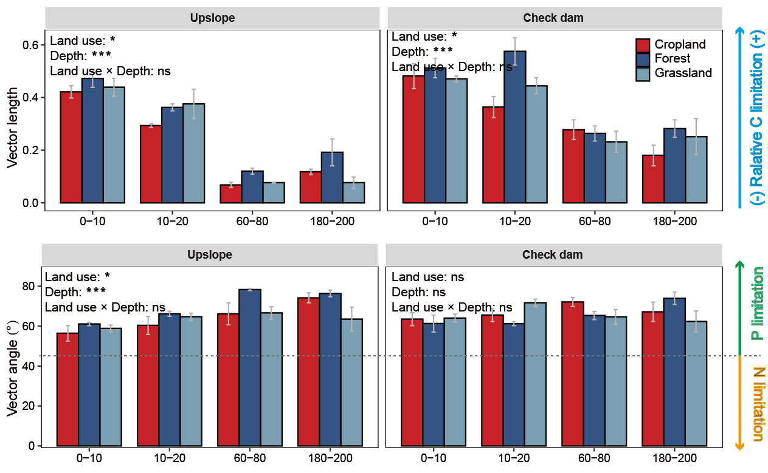
Fig.S1 The microbial C limitation (vector length) and microbial N/P limitation (vector) quantified by the traditional vector model for cropland and revegetated forest and grassland along 0-200 cm depth at upslope and check dam. The higher vector length the greater relative C limitation. Values of vector angle > 45° are P limited, while values < 45° are N limited. *, ***, and ns represents effects at P < 0.05, P < 0.001, and P > 0.05.

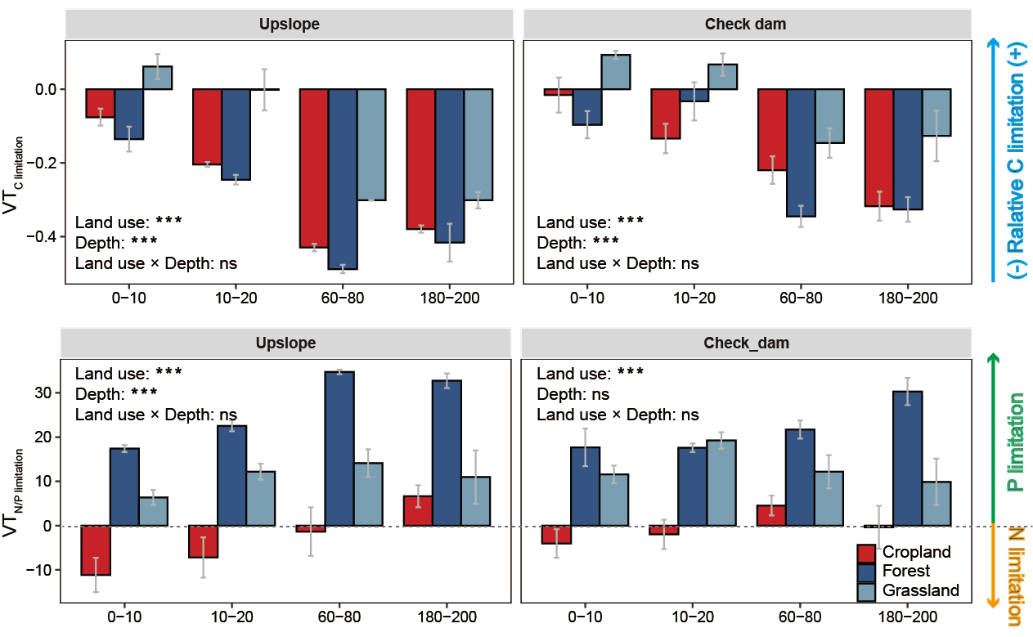
Fig. S2 The microbial C limitation (VT_{C limitation}) and microbial N/P limitation (VT_{N/P limitation}) quantified by the V-T model based on the balance point for cropland and revegetated forest and grassland along 0-200 cm depth at upslope and check dam. The balance point was derived from database in the study of Cui et al. (2021) (Fig.2; Table S2). Values of VT_{C limitation} > 0 indicate that microbial C limitation occurs no matter how much N and P are available. Values of VT_{N/P limitation} > 0 are P limited, while values < 0 are N limited. *, ***, and ns represents effects at P < 0.05, P < 0.001, and P > 0.05.

References:
Cui, Y., Moorhead, D.L., Guo, X., Peng, S., Wang, Y., Zhang, X., Fang, L., Xu, X., 2021. Stoichiometric models of microbial metabolic limitation in soil systems. Global Ecol. Biogeogr. 30, 2297–2311.
Sinsabaugh, R.L., Hill, B.H., Follstad Shah, J.J., 2009. Ecoenzymatic stoichiometry of microbial organic nutrient acquisition in soil and sediment. Nature 462, 795–798.
Sinsabaugh, R.L., Lauber, C.L., Weintraub, M.N., Ahmed, B., Allison, S.D., Crenshaw, C., Contosta, A.R., Cusack, D., Frey, S., Gallo, M.E., Gartner, T.B., Hobbie, S.E., Holland, K., Keeler, B.L., Powers, J.S., Stursova, M., Takacs-Vesbach, C., Waldrop, M.P., Wallenstein, M.D., Zak, D.R., Zeglin, L.H., 2008. Stoichiometry of soil enzyme activity at global scale. Ecol. Lett. 11, 1252–1264.

