Supplementary materials:
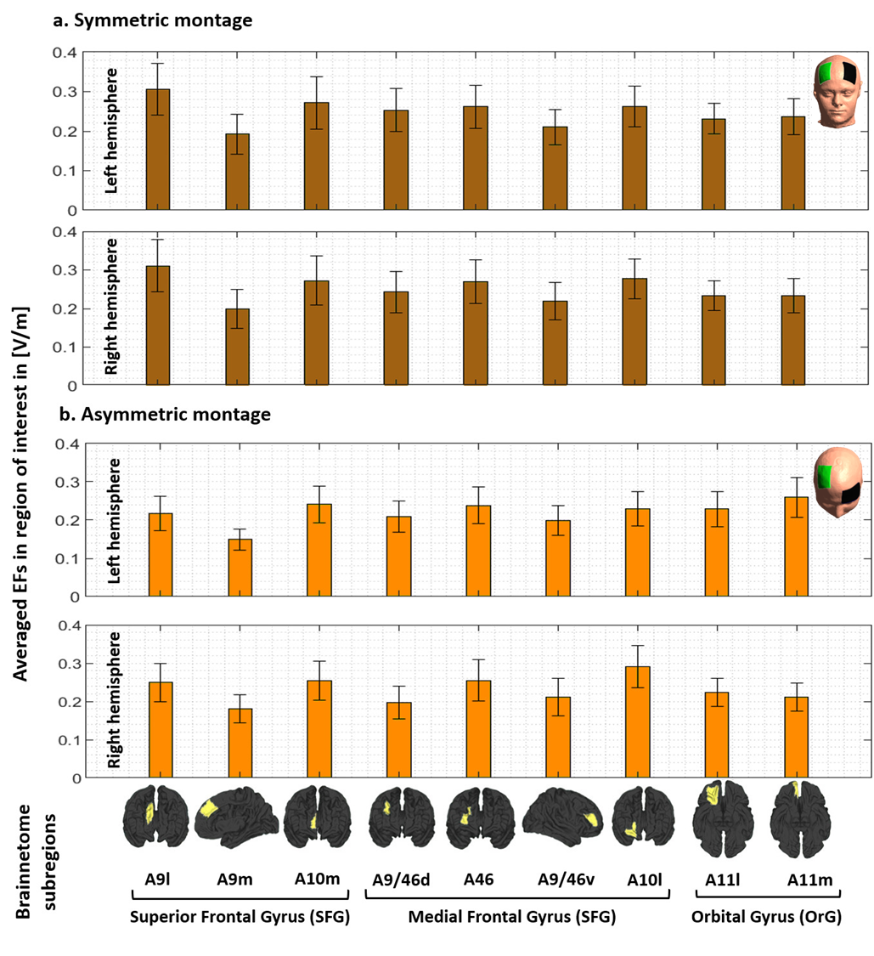
Figure S1. EF strength within the main subregions of the prefrontal cortex. Computational head models were generated for all participants and a Brainnetome atlas with 105 subregions in each hemisphere was used to extract tES-induced EFs in each cortical areas based on (a) symmetric (dark brown) and (b) asymmetric (light brown) montages. Bars show mean values and error bars show standard deviations (SD) of the EF strength in volt per meter ([V/m]) across 77 healthy subjects in 9 main subregions of the prefrontal cortex in the left (lines 1 and 3) and right (line 2 and 4) hemispheres. Labels below the horizontal axis determine the name of each subregion based on Brainnetome atlas parcellations and small brains next to the labels represent each region in fsaverage space. Atlas-based parcellation: Superior frontal gyrus: A9l, lateral area [13,48,40], A9m, medial area [6,38,35], A10m: medial area [8,58,13]. Middle frontal gyrus: A9/46d, dorsal area [30,37,36], A9/46v, ventral area [42,44,14], A46 [28,55,17], A10l, lateral area [25,61,-4]. Orbital gyrus: A11l, lateral area [23,36,-18], and A11m, medial area [6,57,-16]. Abbreviation: EF: electric field, SFG: superior frontal gyrus, MFG: medial frontal gyrus, OrG: orbital gurus.
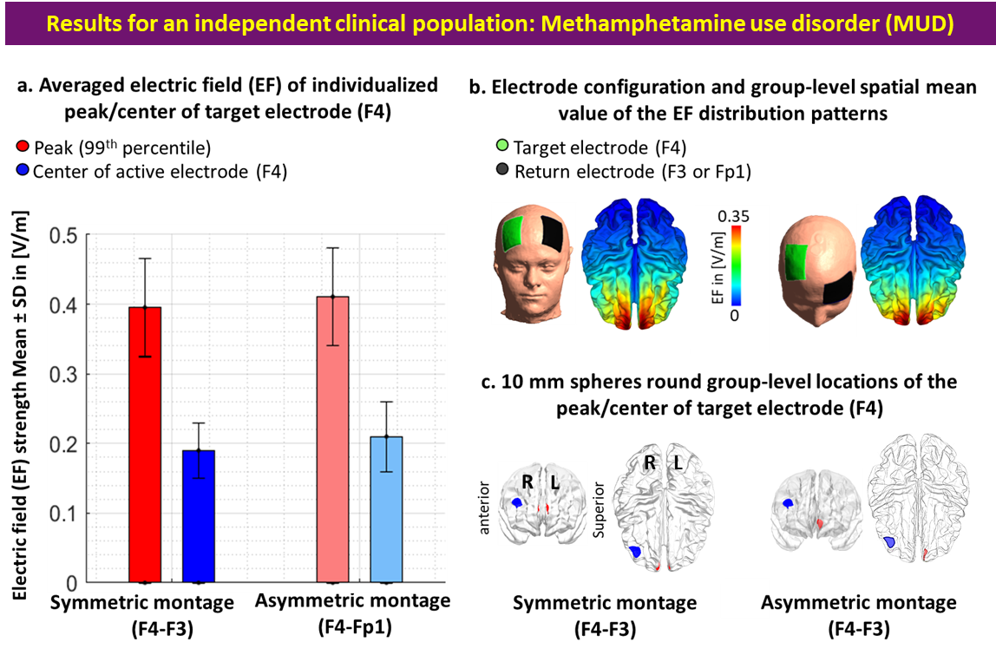
Figure S2. Comparing the center of the target electrode with EF peaks in an independent clinical population-people with methamphetamine use disorder (MUD). a. Bars show mean values and error bars show standard deviations (SD) of the EF strength in volt per meter ([V/m]) across 66 participants with MUD in individualized 99th percentile of the EF (peaks, in red) and center of the target electrode (F4, in blue) over the cortex across the population for symmetric (target/return over F4/F3 in dark colors) and asymmetric (target/return over F4/Fp1 in light colors) montages. Target electrodes over F4 are depicted in green, return electrodes over F3 in symmetric, and Fp1 in asymmetric montages are depicted in black. b. Electrode configurations over the scalp for DLPFC stimulation are visualized with the target (in green)/return (in black) electrodes over F4/F3 in symmetric and F4/Fp1 in asymmetric montages. EF distribution patterns at the group-level (spatial mean values across the population) are visualized over the cortex in superior view. c. Locations of the 10 mm spheres around F4 (in blue) and averaged location of the peaks across the population (in red) are visualized over the standard brain in fsaverage space. In each panel, the left side corresponds to symmetric montage (F4-F3) and right side corresponds to asymmetric (F4-Fp1) montages. Abbreviation: EF: electric field.

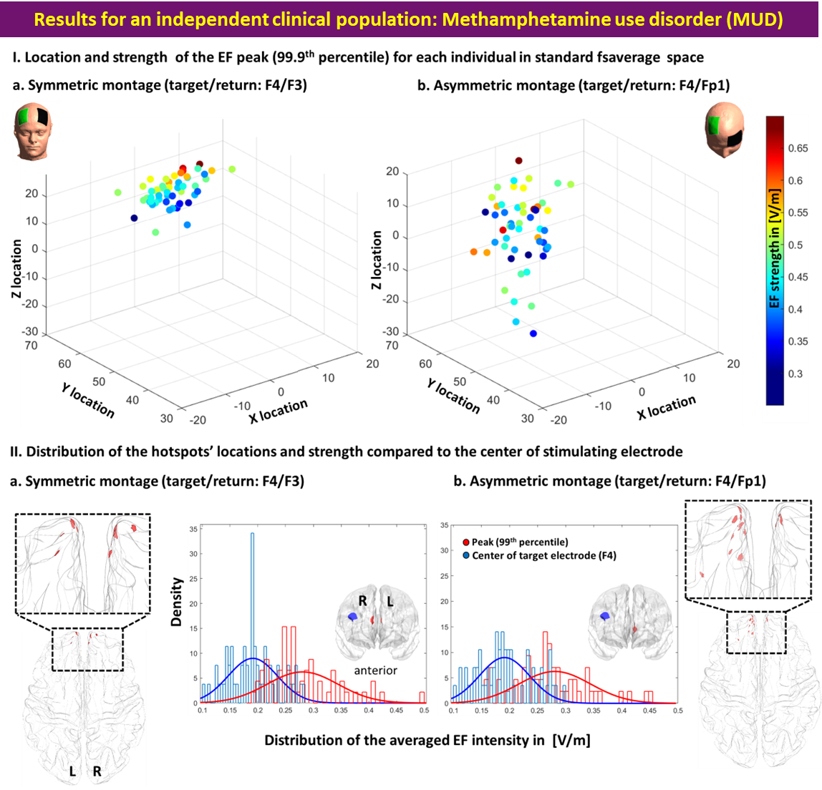
Figure S3. Inter-individual variability of peak EF location and strength in an independent clinical population-people with methamphetamine use disorder (MUD). I. Scatter plot (for location in MNI space) colored based on EF strength (hot colors represent strong EF strength) for visualizing inter-individual variability in the 99th percentile of the EFs in symmetric (a) and asymmetric (b) DLPFC montages. II. Visualizing the location of the 99th percentile of the EF over the standard fsaverage space (red dots over the cortex represent each individual). Distribution plots represent the distribution of the EF strength within the 10 mm spheres around F4 and 99th percentile (blue and red spheres over the cortex in anterior view) for symmetric (a) and asymmetric (b) montages. Abbreviation: EF: electric field.

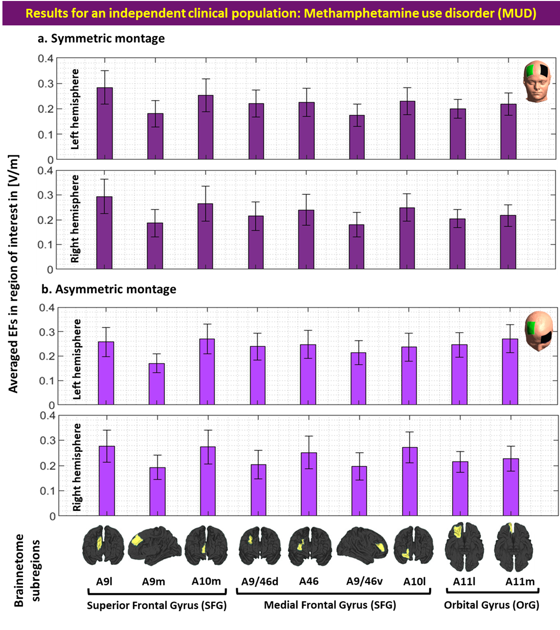
Figure S4. EF strength within the main subregions of the prefrontal cortex in an independent clinical population-people with methamphetamine use disorder (MUD). Computational head models were generated for all participants and a Brainnetome atlas with 105 subregions in each hemisphere was used to extract tES-induced EFs in each cortical areas based on (a) symmetric (dark green) and (b) asymmetric (light green) montages. Bars show mean values and error bars show standard deviations (SD) of the EF strength in volt per meter ([V/m]) across 66 participants with methamphetamine use disorder (MUD) in 9 main subregions of the prefrontal cortex in the left (line 1 and 3) and right (line 2 and 4) hemispheres. Labels below the horizontal axis determine the name of each subregion based on Brainnetome atlas parcellations and small brains next to the labels represent each region in fsaverage space. Atlas-based parcellation: Superior frontal gyrus: A9l, lateral area [13,48,40], A9m, medial area [6,38,35], A10m: medial area [8,58,13]. Middle frontal gyrus: A9/46d, dorsal area [30,37,36], A9/46v, ventral area [42,44,14], A46 [28,55,17], A10l, lateral area [25,61,-4]. Orbital gyrus: A11l, lateral area [23,36,-18], and A11m, medial area [6,57,-16]. Abbreviation: EF: electric field, SFG: superior frontal gyrus, MFG: medial frontal gyrus, OrG: orbital gurus.

