Supplementary data for
Single-cell profiling identifies a CD8^{bright} CD244^{bright} Natural Killer cell subset that reflects disease activity in HLA-A29-positive birdshot chorioretinopathy.

Pulak R. Nath¹*⎠, Mary Maclean^{1⎠⎠}, Vijay Nagarajan^{1,2}, Jung Wha Lee¹, Mehmet Yakin¹, Aman Kumar¹, Hadi Nadali¹, Brian Schmidt³, Koray D. Kaya⁴, Shilpa Kodati¹, Alice Young³, Rachel R. Caspi², Jonas J. W. Kuiper⁵*, H. Nida Sen^{1⎠⎠⎠}

¹ Clinical and Translational Immunology Unit, Laboratory of Immunology, NEI, NIH, Bethesda, USA.
² Immunoregulation Section, Laboratory of Immunology, NEI, NIH, Bethesda, USA.
³ NIH Intramural Sequencing Center, NIH, Rockville, USA.
⁴ Medical Genetics and Ophthalmic Genomics Unit, NEI, NIH, Bethesda, USA.
⁵ Department of Ophthalmology, University Medical Center Utrecht, University of Utrecht, Utrecht, Netherlands.

⎠Current affiliation: Lentigen Technology Inc, A Miltenyi Biotec Company, 910 Clopper Road, Gaithersburg, MD 20878, USA
⎠⎠Current affiliation: Translational Immunology Section, Office of Science and Technology, NIAMS, NIH, Bethesda, USA
⎠⎠⎠Current affiliation: Janssen Retina/Global Clinical Development at The Janssen Pharmaceutical, Companies of Johnson & Johnson.

* Correspondence to Pulak R. Nath (email: hellopran2000@gmail.com) and Jonas J.W. Kuiper (email: j.j.w.kuiper@umcutrecht.nl)

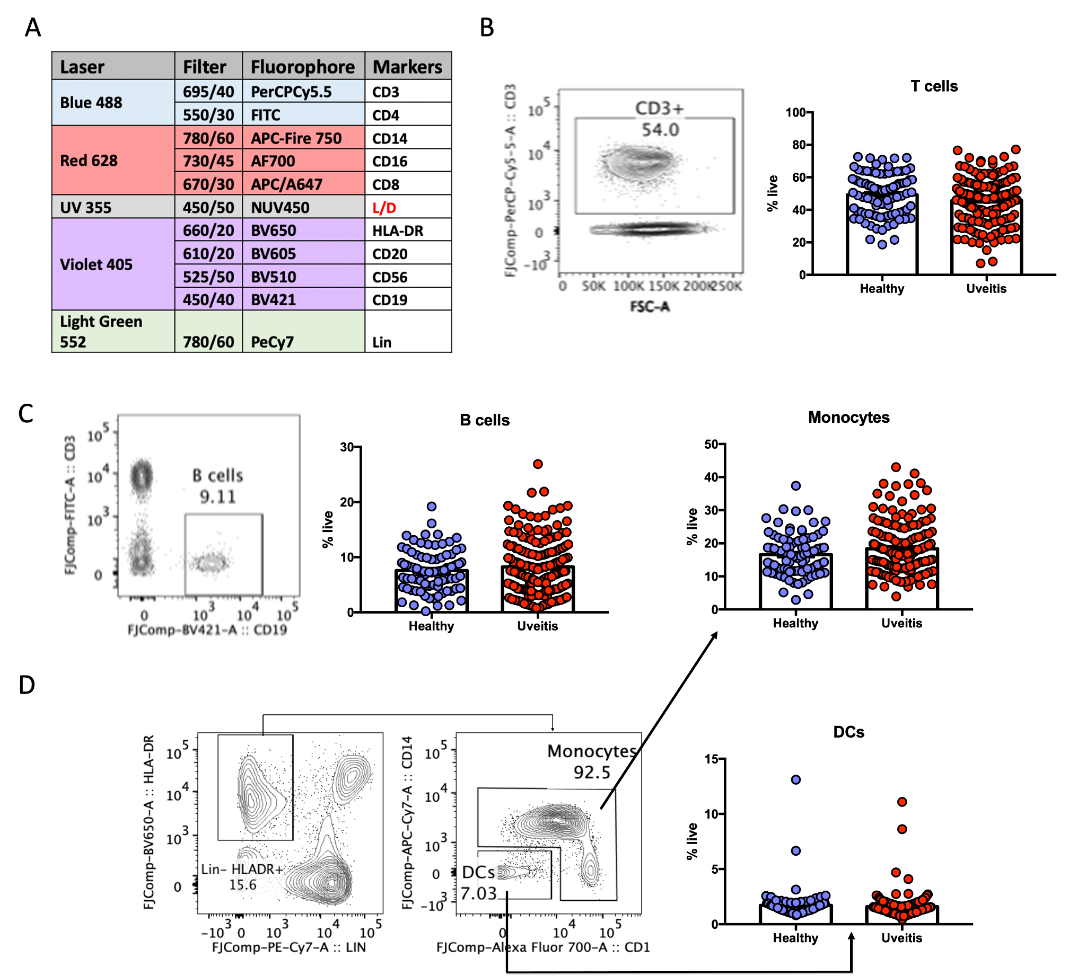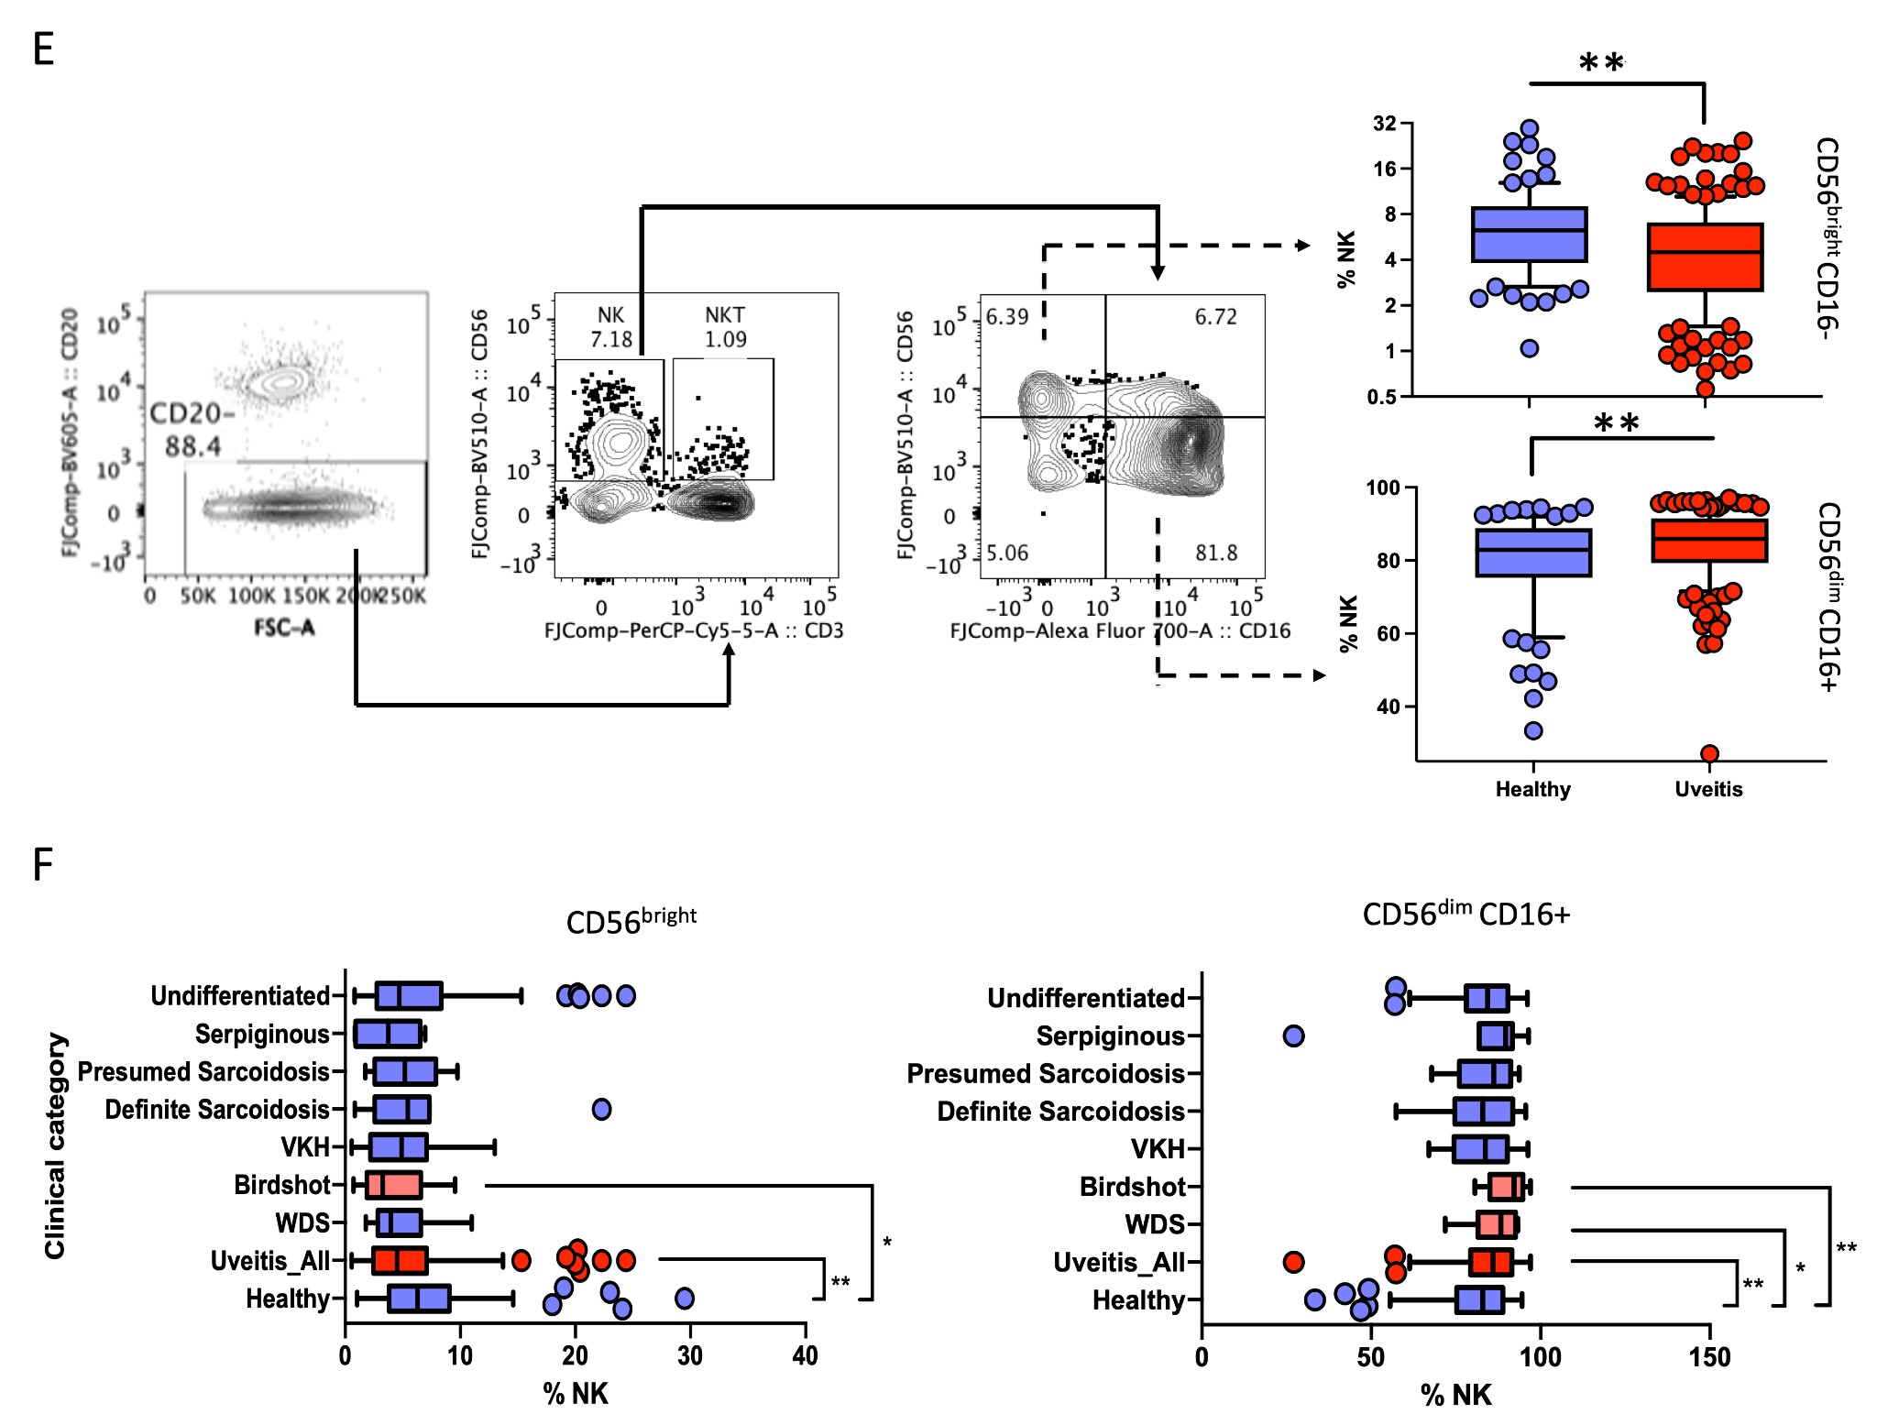Figure S1
A. List of markers for interrogating major lineages of immune cells (10 markers, 6 major immune subsets) in peripheral blood of patients and healthy controls using flow cytometry.
Representative plot and frequency of (B) T cells, (C) B cells, (D) monocyte and (DCs) and (E) NK cells and in the peripheral blood of uveitis patients (blue) and healthy controls are shown. There was no change in the frequency of T cells, B cells, DCs and monocytes, except the differences found in the NK cell subsets between the two groups. CD56highCD16- NK cells were significantly decreased while concomitantly CD56loCD16+ NK cells were significantly increased in uveitis cohort compared to the healthy controls.
F. Flow-cytometry analysis of NK1 (CD56dim CD16+) and NK2 (CD56bright) NK cells (CD3⁻CD19⁻CD56⁺) in the fresh blood of different uveitis subgroups.

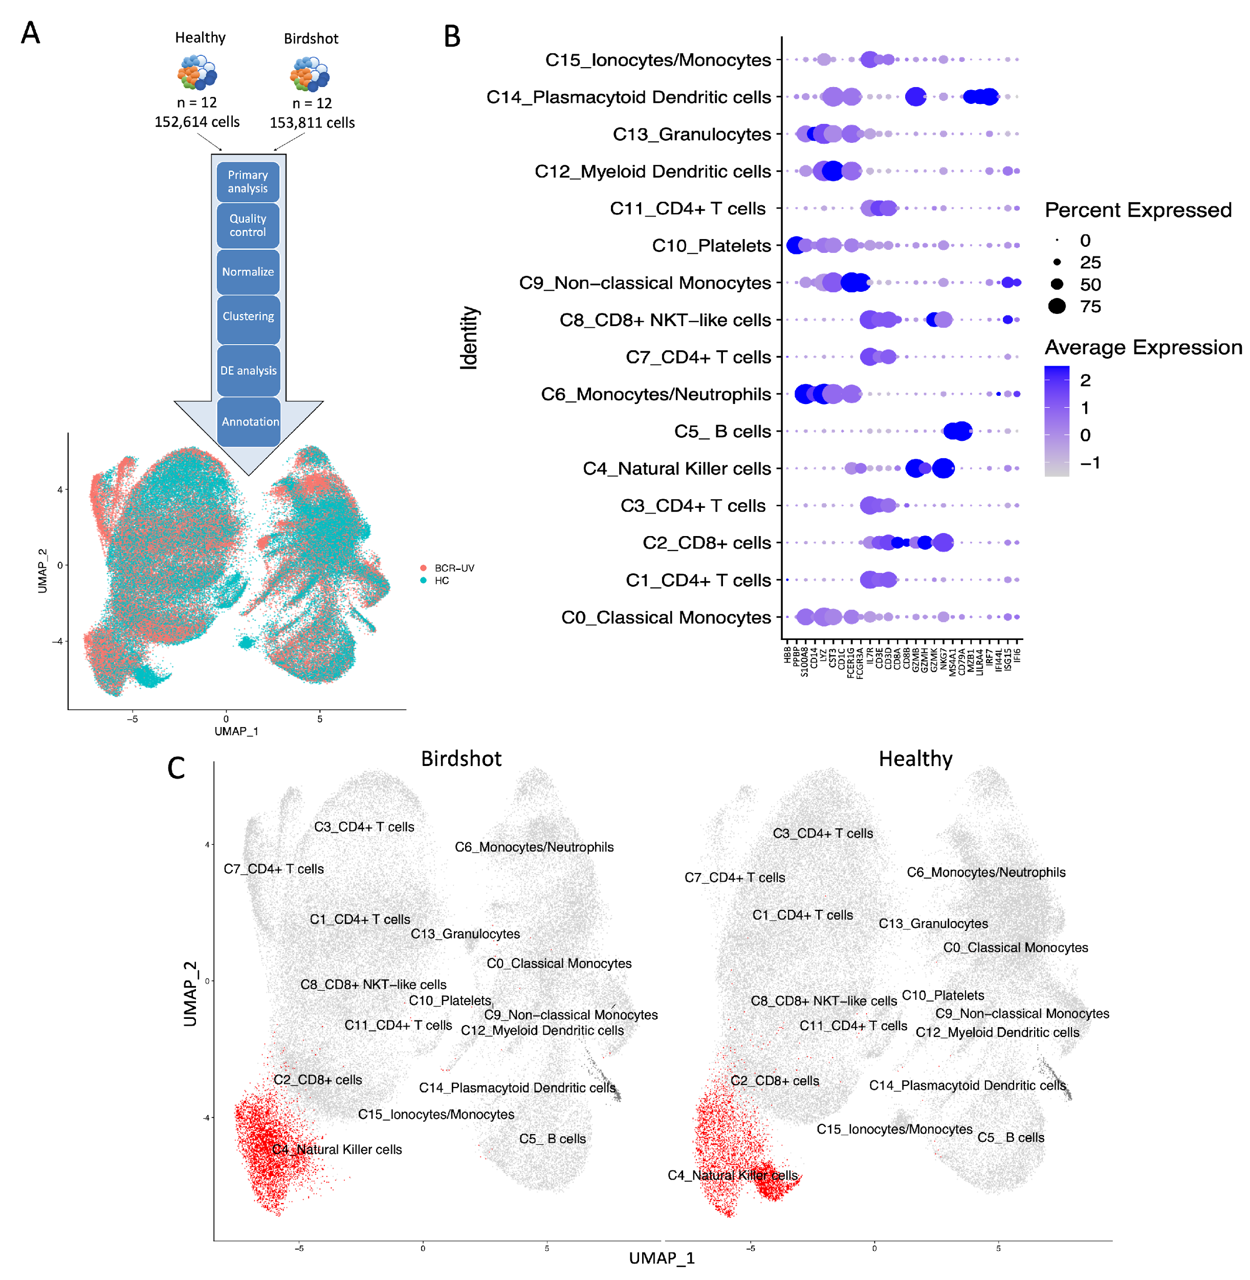
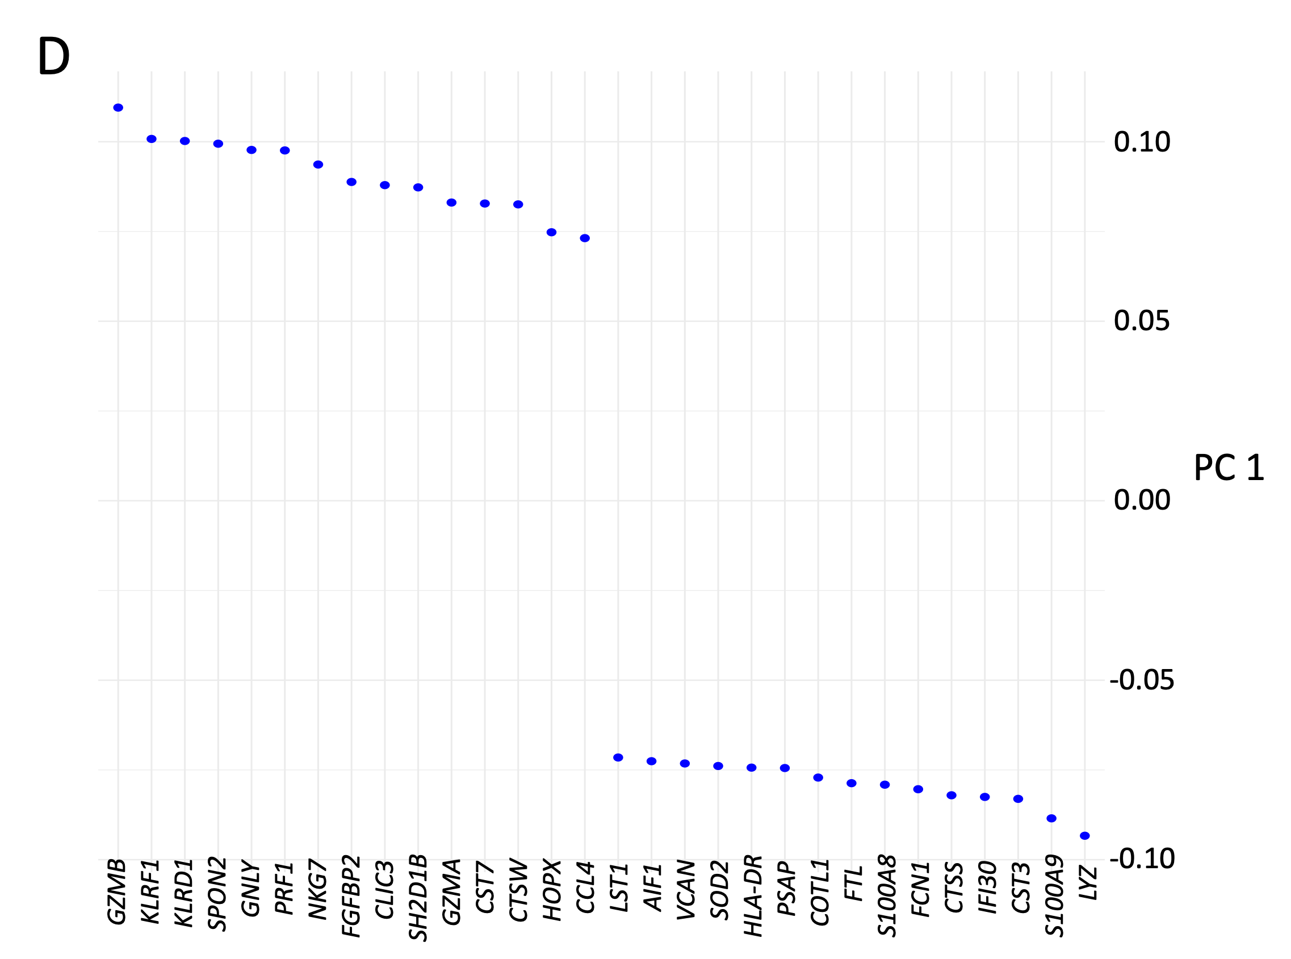
Figure S2
A. An overview of scRNAse analysis. A total of 306,425 cells from 12 Birdshot uveitis patients (Birdshot/BCR-UV) and 12 healthy controls (Healthy) were subjected to 10x Chromium single cell separation and sequencing and merged to a combined dataset. The bioinformatic analysis pipeline includes the Primary analysis, Quality control, Normalization, Clustering, Differential Expression (DE) analysis and Annotation of the combined dataset. The UMAP plot (top) shows the merged distribution of cells from Healthy (Green) and BCR-UV (Red). The UMAP plot (bottom) shows annotation of 16 clusters of cell lineages in the combined dataset. The putative identity of each cluster was manually annotated based on ‘scsa’ and ‘scType’ annotations and interrogating the top expressed genes in each cluster.
B. Dot plot showing the expression profile of lineage-specific genes in the annotated cell clusters.
C. The UMAP plot of single cell distribution is representing 16 clusters of cell lineages in the combined dataset of a total of 306,425 analyzed cells. The putative identity of each cluster was manually annotated. The NK cell clusters are identified in red color and the remaining cell clusters are presented in grey color. D. The top 30 most differentially expressed NK genes defined by principal component 1 in BCR-UV compared to HC.

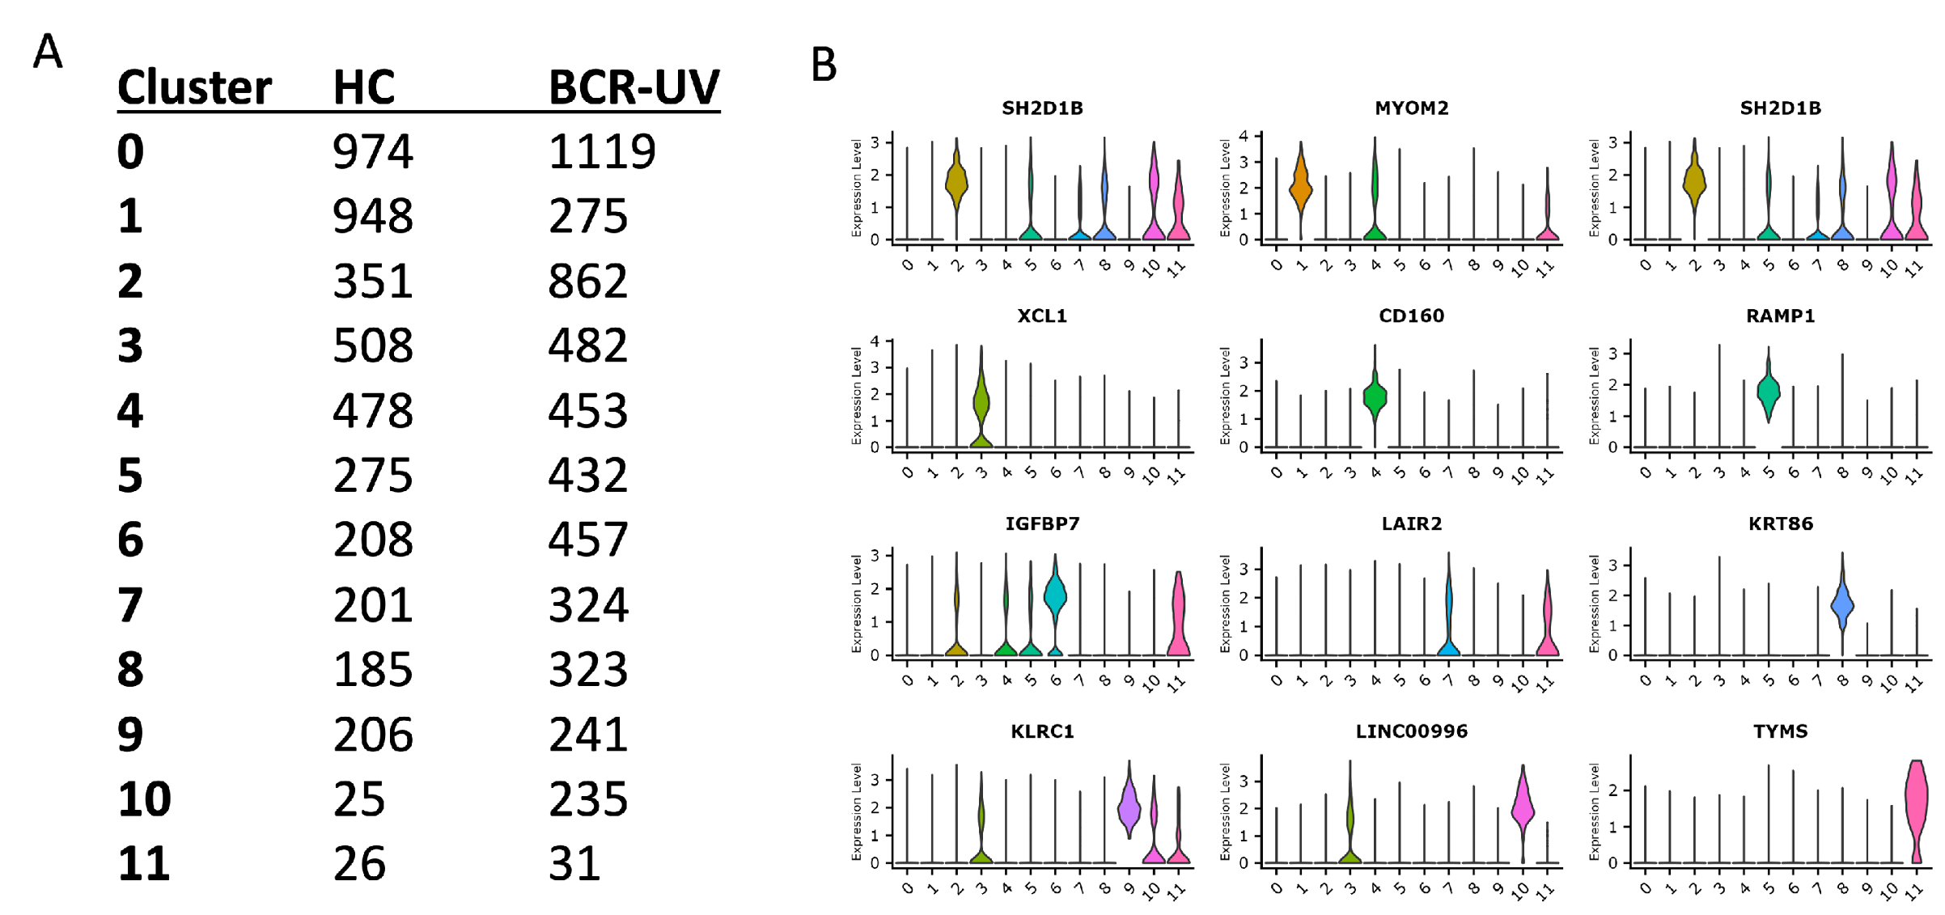
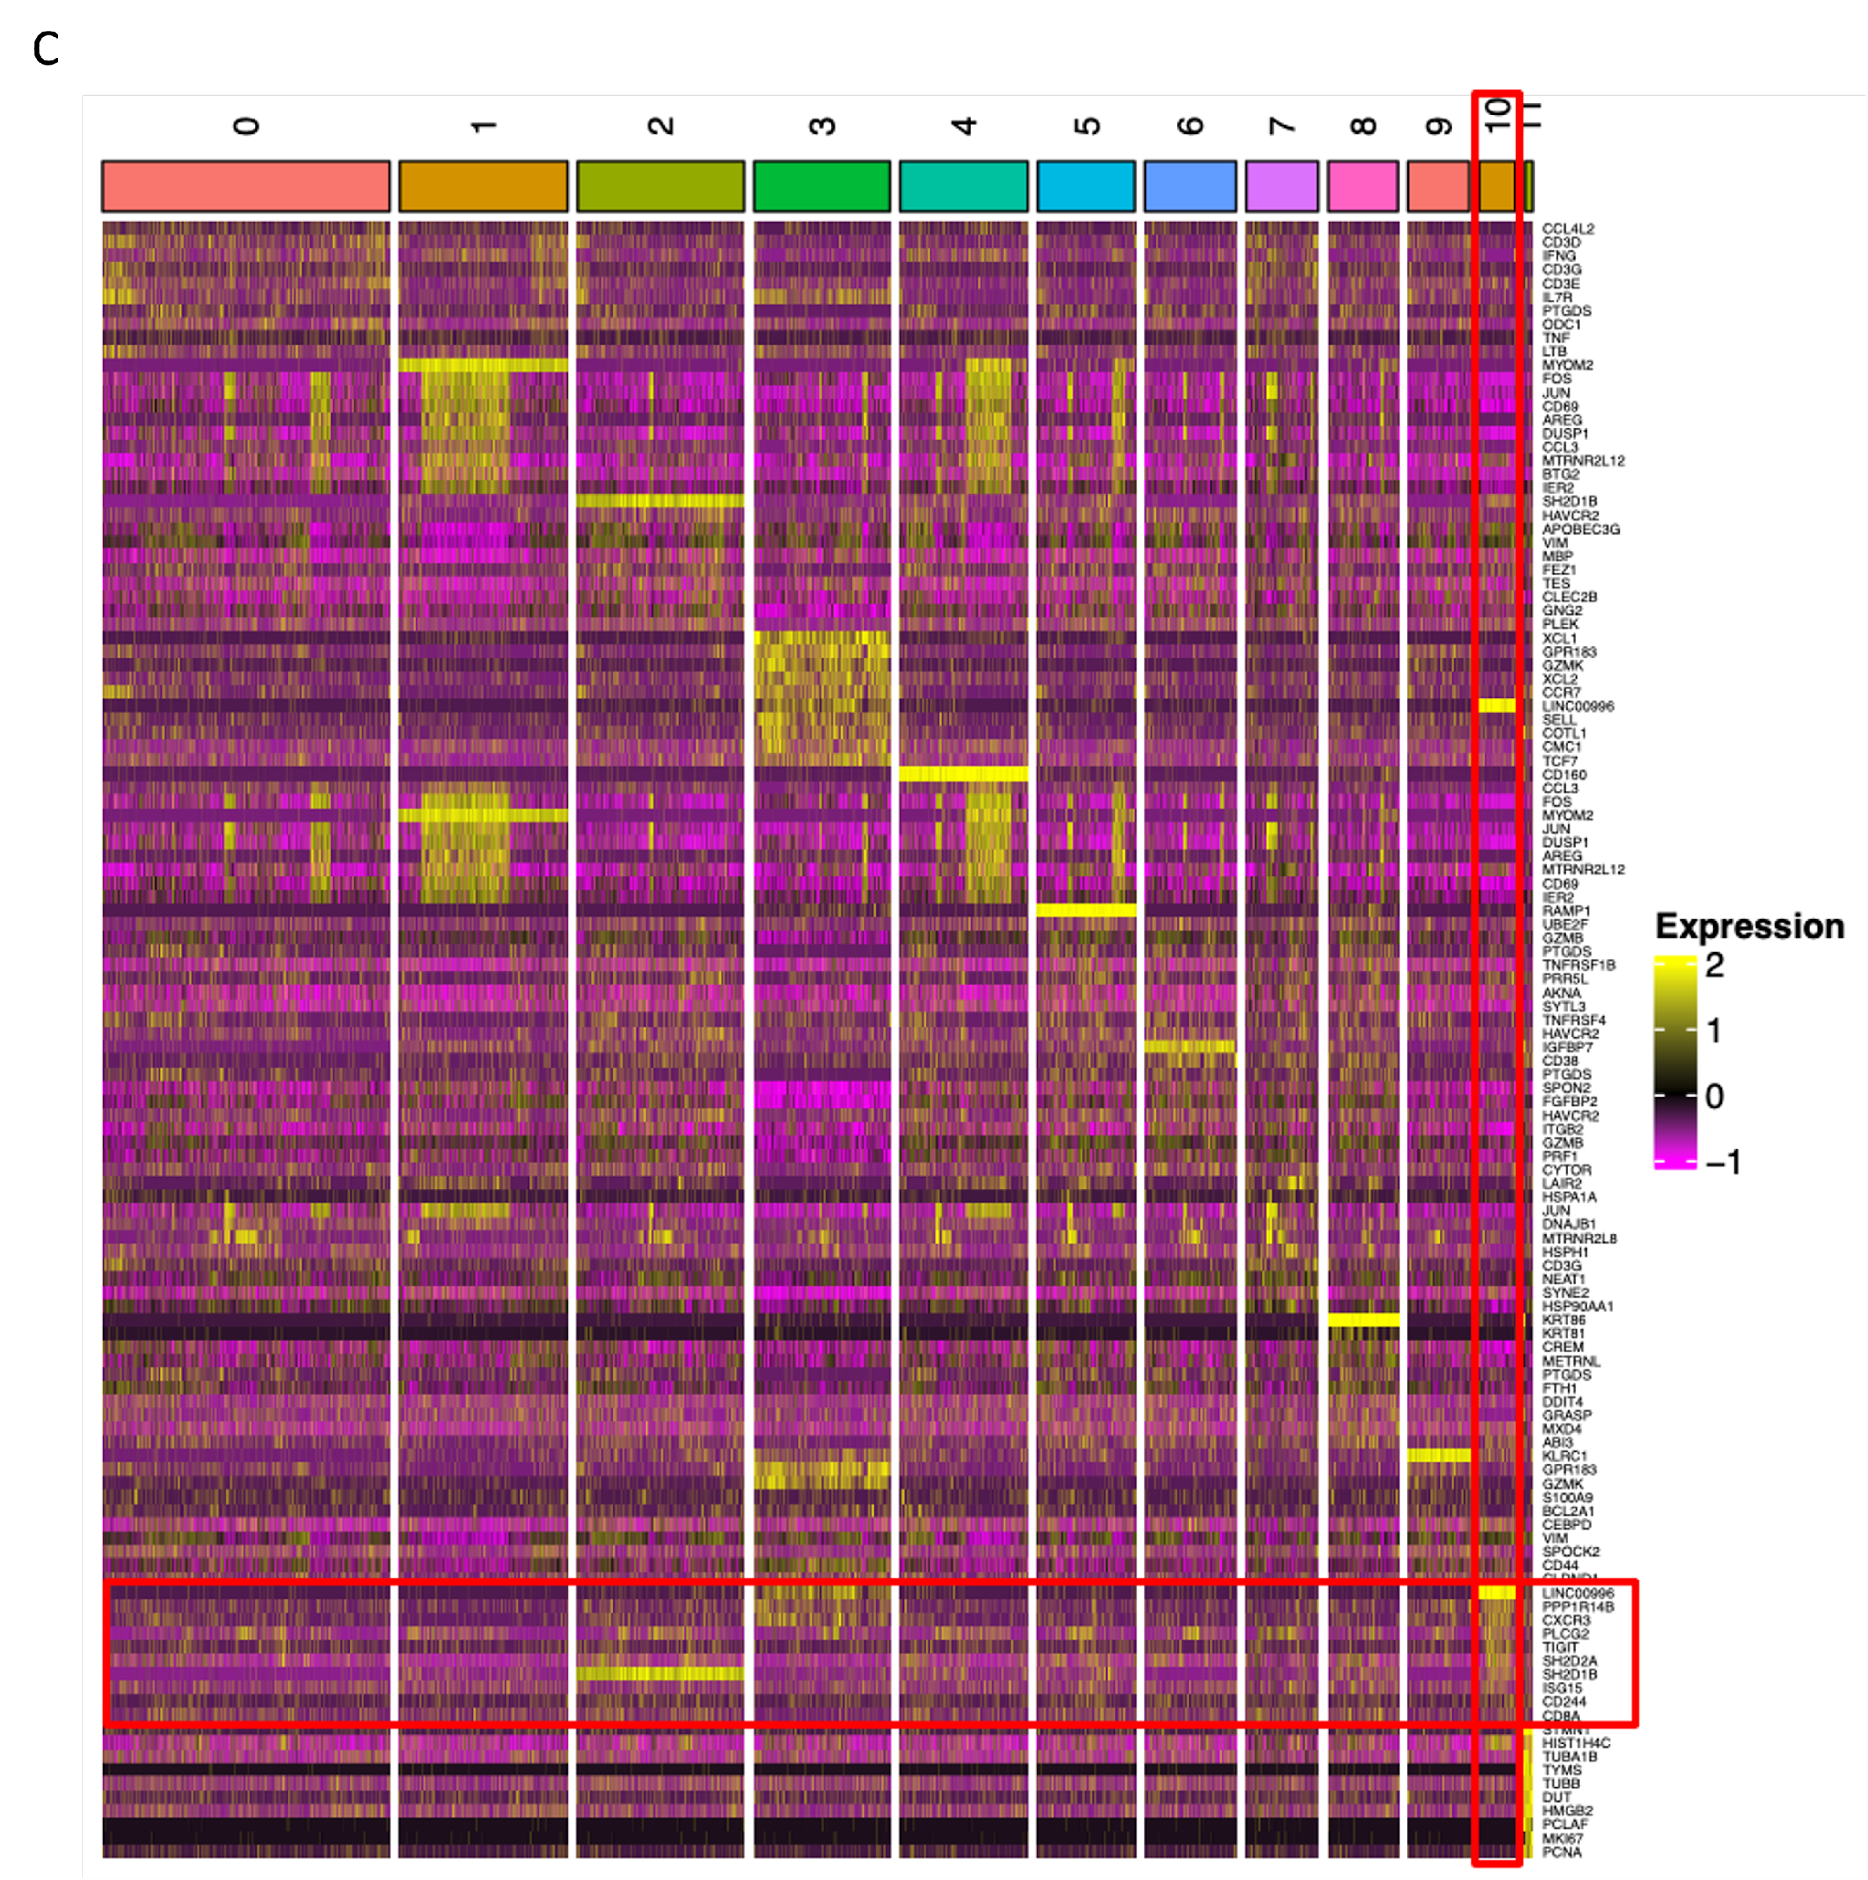
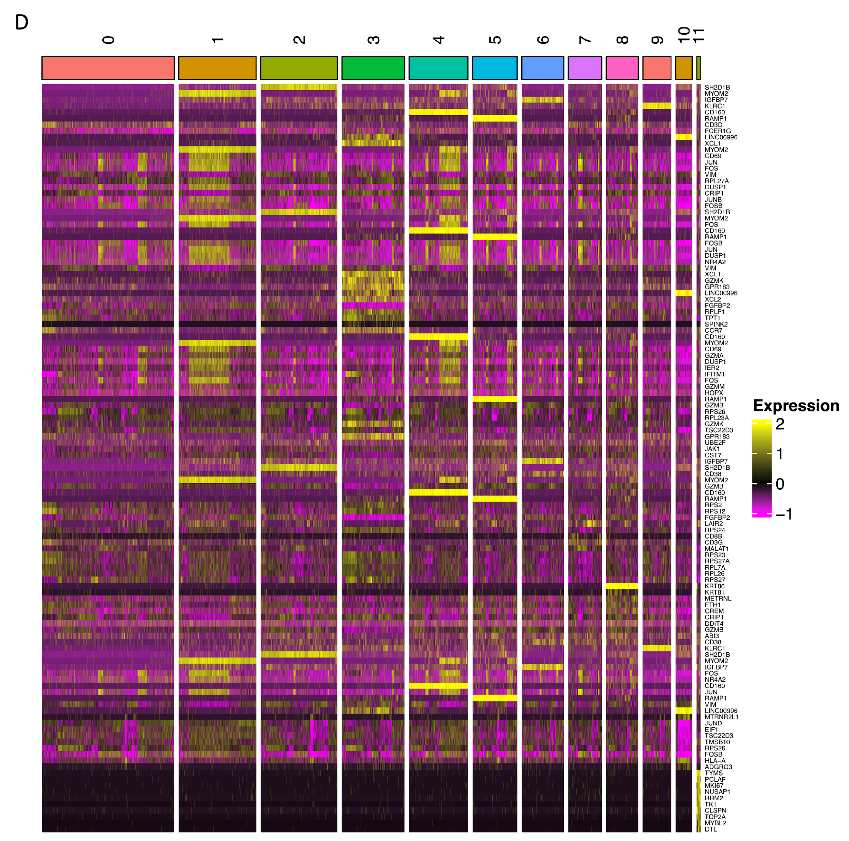

Figure S3
A. Tabular representation of total 12 NK-subclusters and associated cell count in 12 healthy controls (HC) and in 12 birdshot uveitis patients (BCR-UV).
B. Violin plots representing the list of genes that are uniquely expressed in each of the 12 clusters of NK cell-subclusters.
C. Heatmap representing the expression of top 10 highly expressed markers of each NK cluster.
D. Heatmap representing the expression of top 10 differentially expressed markers of each NK cluster.

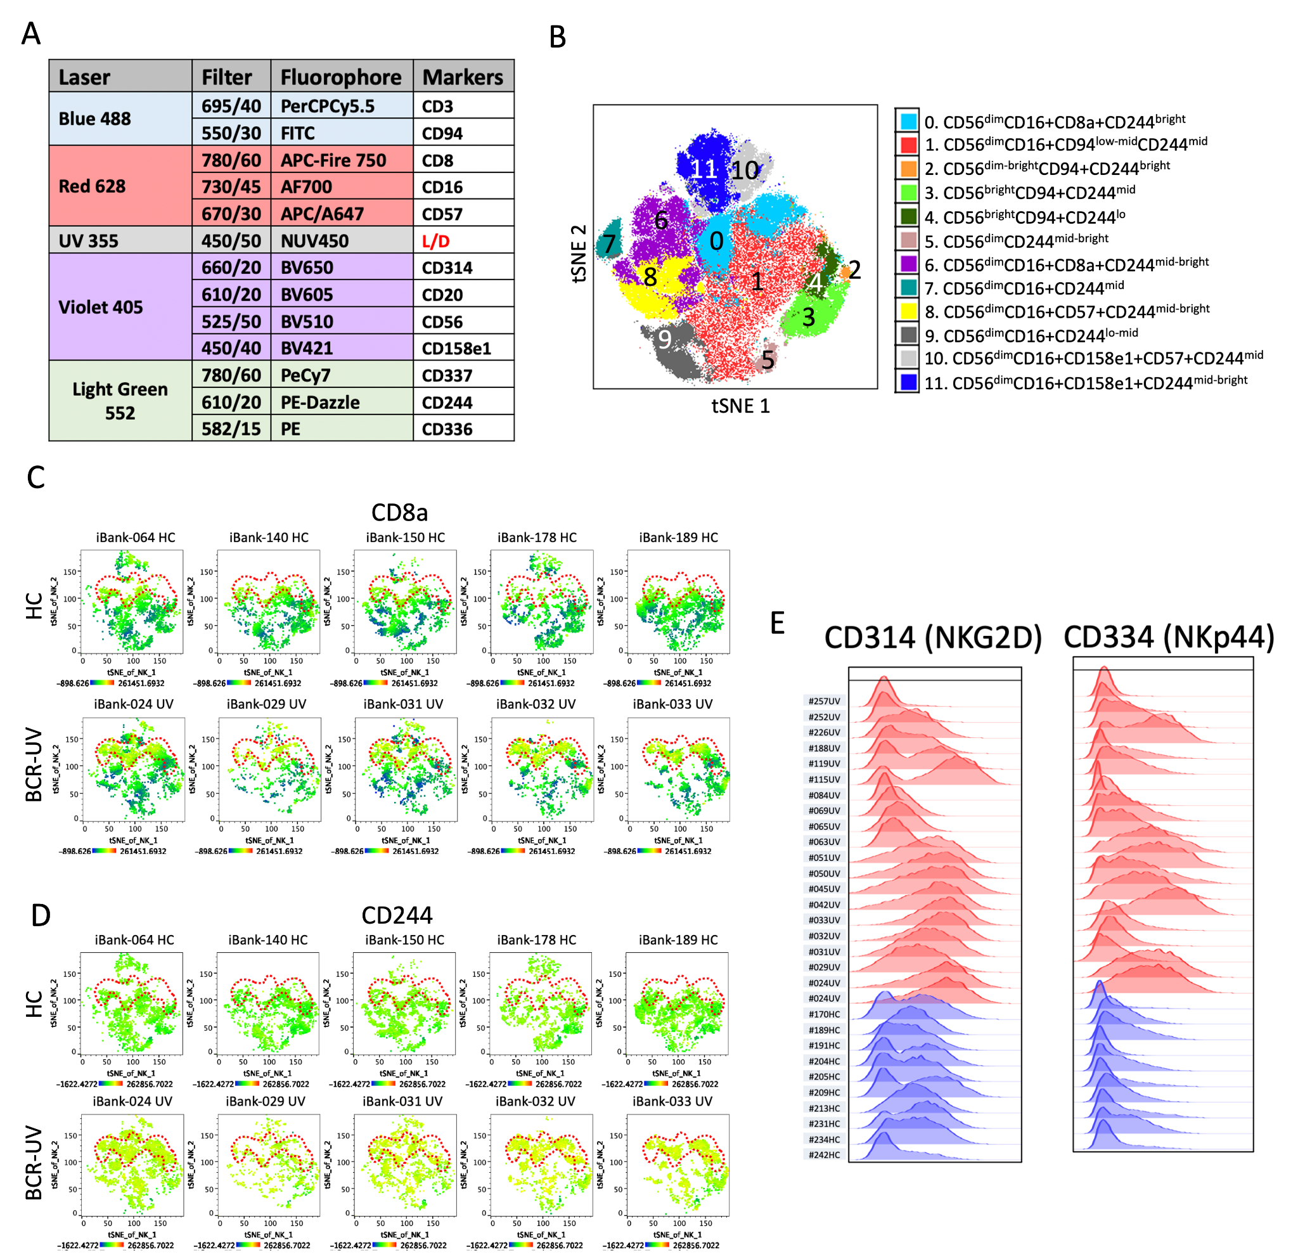

Figure S4
A. List of markers used to interrogate NK lineage cells in peripheral blood of BCR-UV patients and healthy controls using flow cytometry.
B. t-SNE plot represents the FlowJo-based FlowSOM analysis to identify clusters based on NK cell surface markers from a combined dataset of healthy controls and Birdshot patients. Cluster 0 (CD56dim CD16+ CD8+ and CD244bright) is one out of 12 NK clusters that was elevated in Birdshot. Phenotypes of all 12 NK clusters are color coded and described. Healthy n = 11, Birdshot n = 18.
C. Distribution of CD8a and D. CD244 surface protein expression is indicated in t-SNE plots of NK cells in five healthy controls (HC) and five birdshot uveitis (BCR-UV). Red dotted line captures the region where NK cells are present in BCR-UV but absent from HC.
E. Histograms showing expression of CD314 (NKG2D) and CD344 (NKp44) in 10 healthy controls (blue) and 20 birdshot uveitis (red).
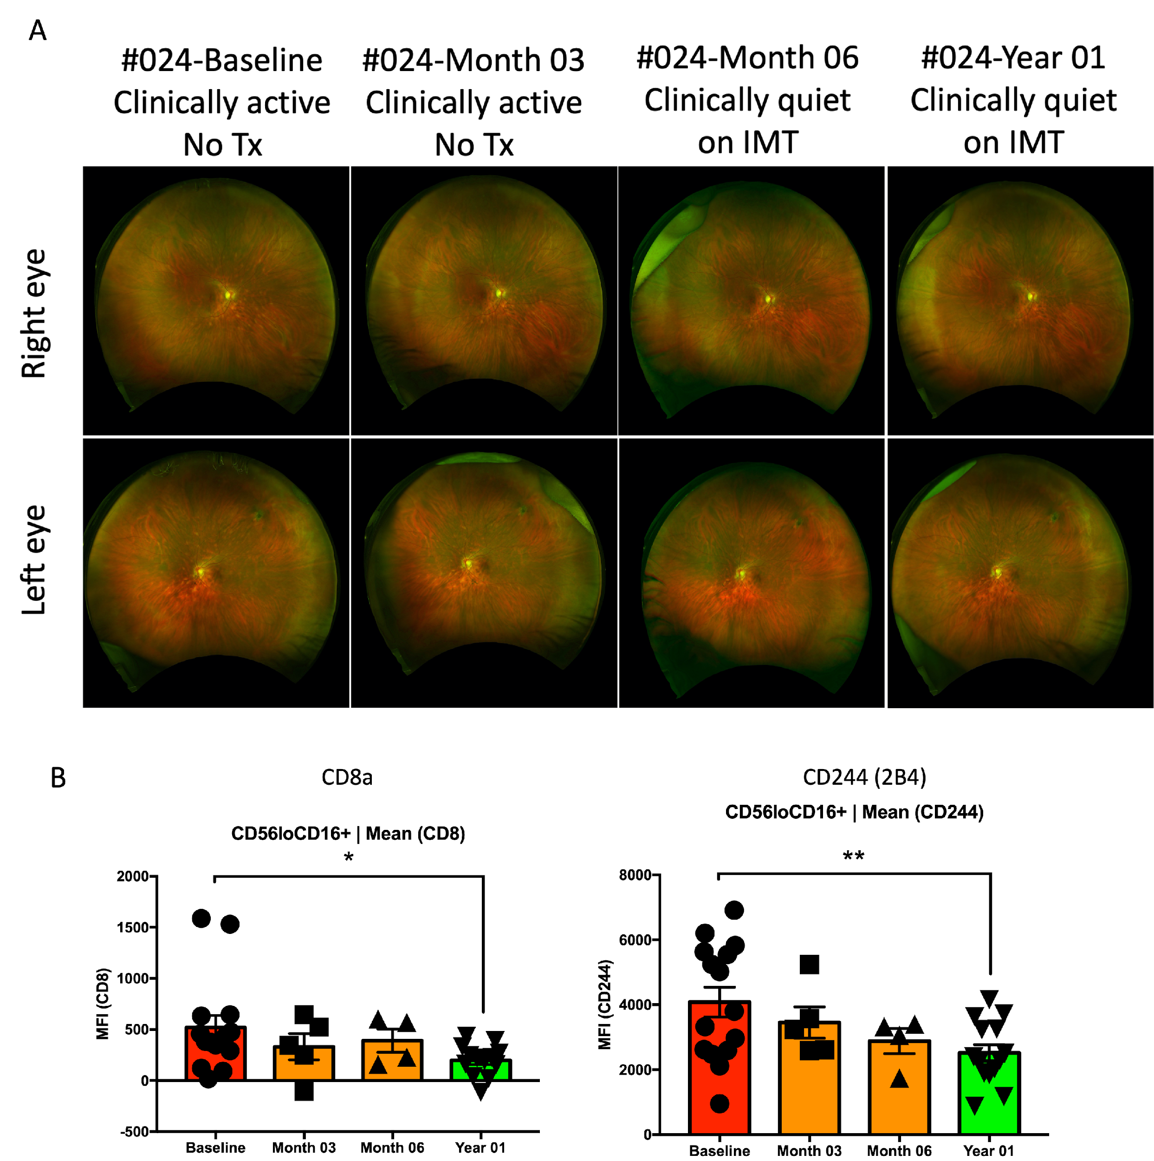

Figure S5
A. Fundoscopy examination of both eyes of a Birdshot uveitis patient (#024) at the Baseline, after Month 03, Month 06 and Year 01 of systemic immunomodulatory treatment (IMT).
B. Bar plots indicate statistical significance on changes of CD8a and CD244 MFI within CD56loCD16+ NK cells from 15 different Birdshot uveitis patients from baseline to year 1 after treatment.

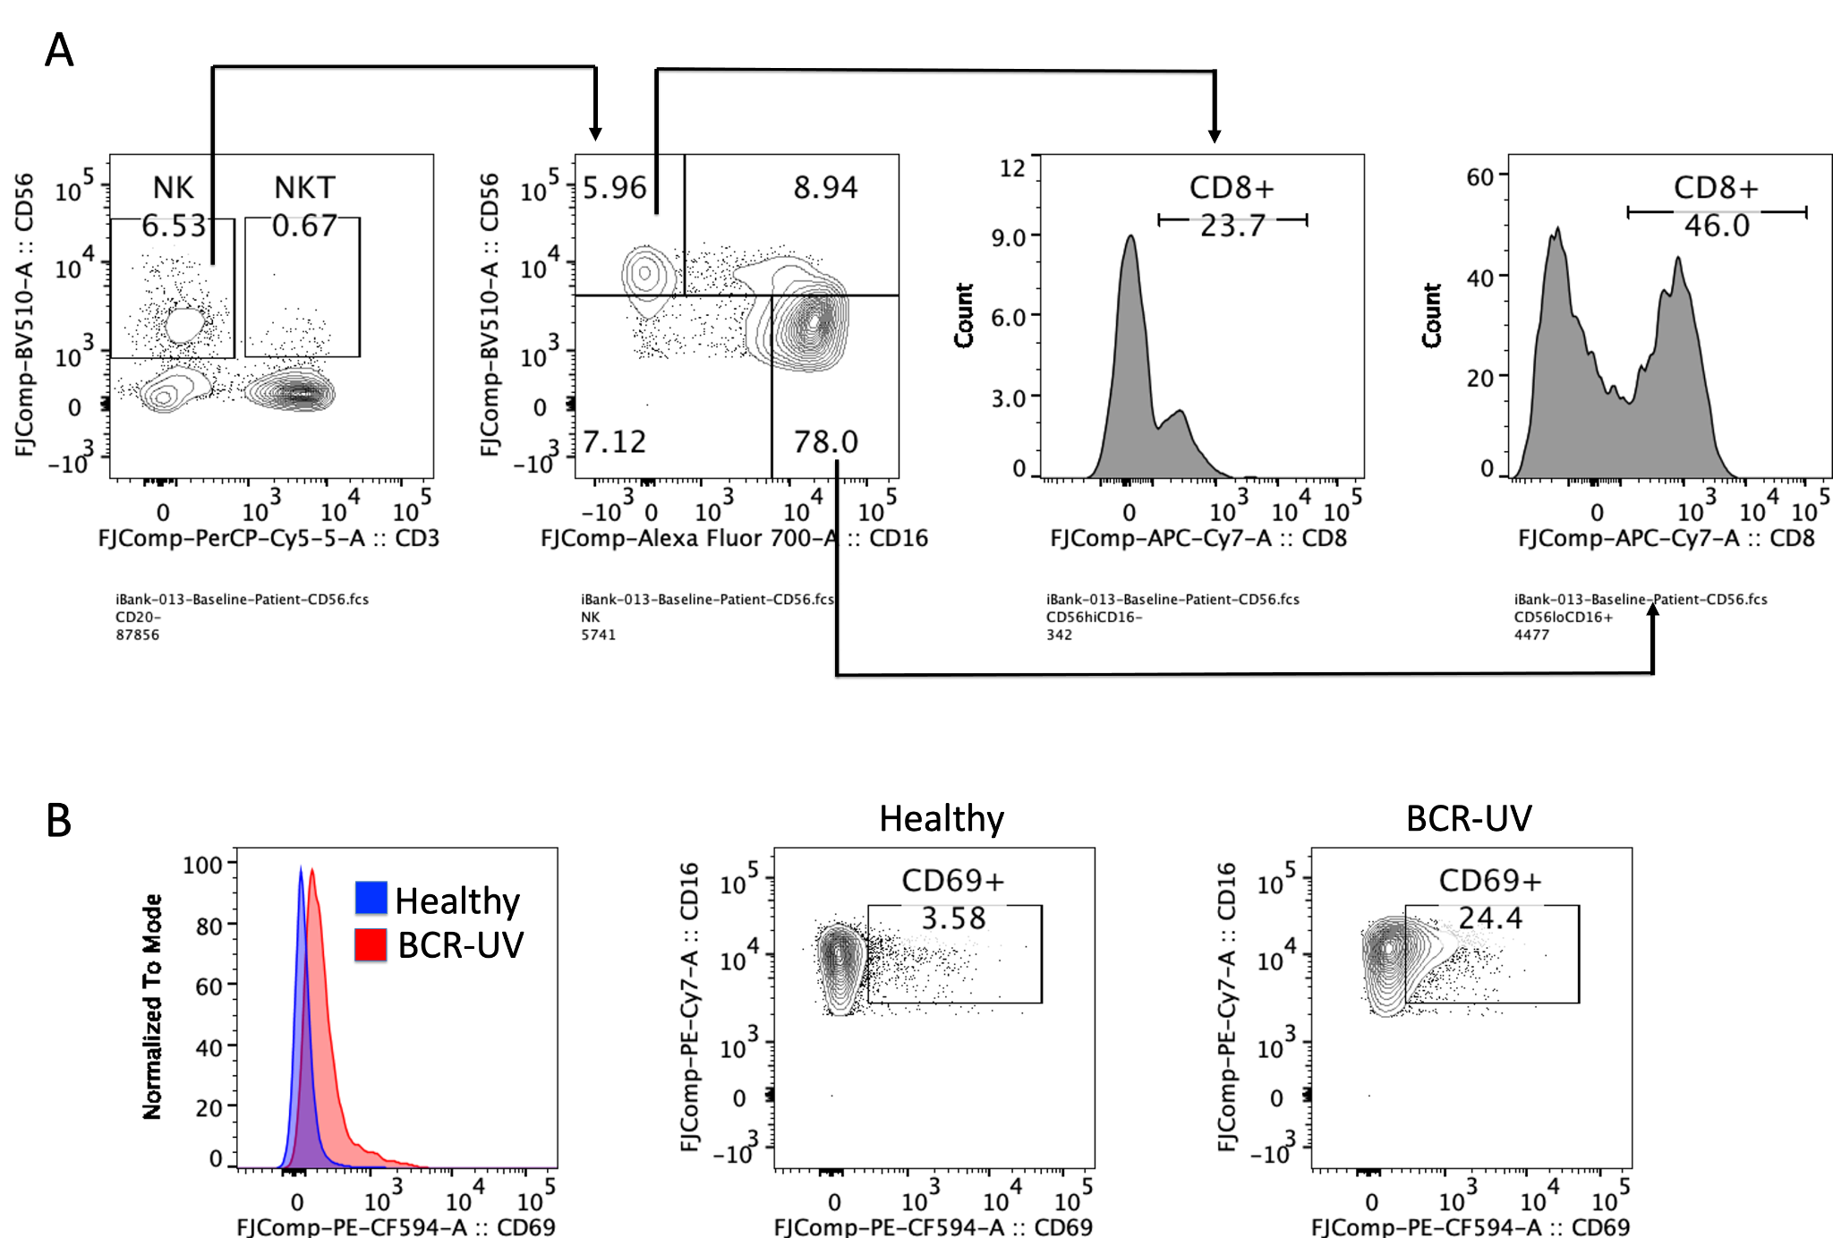
Figure S6
A. CD8 expression profiles in CD56bright and CD56dimCD16+ subsets of NK cells.
B. CD69 expression in CD56dim CD16+ NK cells of healthy vs BCR-UV patients.

