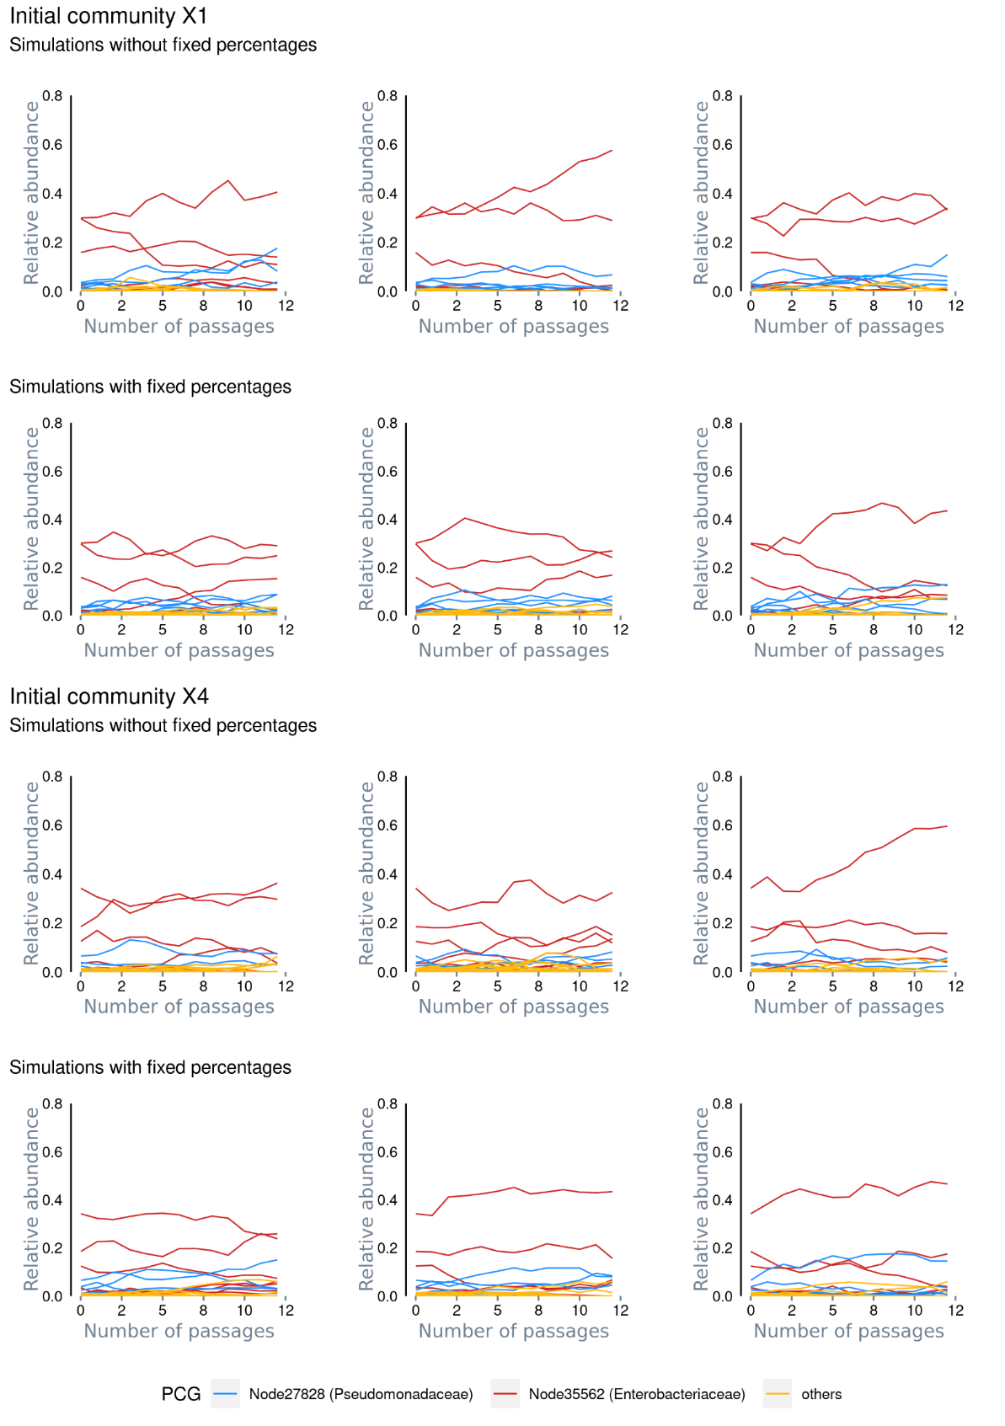
Supplementary Figure 1. Mechanistic drift modeling. The figure depicts example simulations starting with original samples X1 and X4. The approach simulates drift in communities undergoing dilution-growth cycles (passages). At each cycle, the community is first randomly subsampled to mimic experimental dilution. Then, the community grows by adding one new individual at each step until the pre-dilution community size is reached. At each growth step, the probability for each population to grow equals its actual relative abundance (“Simulations without percentages”). We also introduced a second scenario where the initial community populations are initially split into different groups, which then suffer the above dilution-growth cycles independently with different pre-set per group community sizes (“Simulations with fixed percentages”).
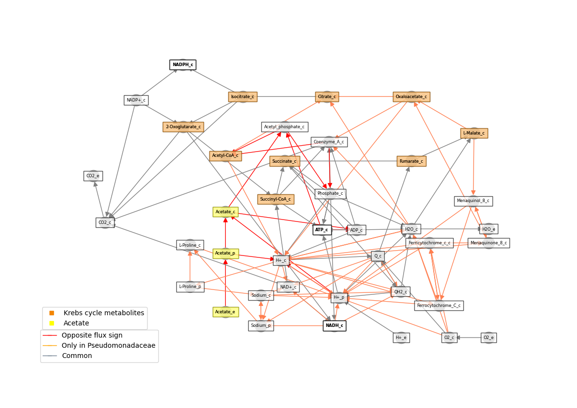Supplementary Figure 2. Simulated inter-PCG metabolism in citrate. The diagram depicts the simulation scenario where E grows on M9 + citrate media and P on the spent media of E. Edges represent reactions in the SBML models with absolute flux values >3.5. Red reactions present opposite flux signs in both models. Orange reactions are only active in P, and grey reaction are active and with same flux sign in both models. Metabolic compartments are designated with suffixes “_e”, “_p” and “_c” for extracellular, periplasm and cytoplasm, respectively. The diagram shows that P takes extracellular acetate produced by E, which can then be transformed into acetyl-CoA spending ATP or through a succinyl-CoA:acetyl-CoA transferase. Both acetyl-Coa and succinate can be fed into the Krebs cycle (orange compounds) generating reductive power and ATP (bold compounds).

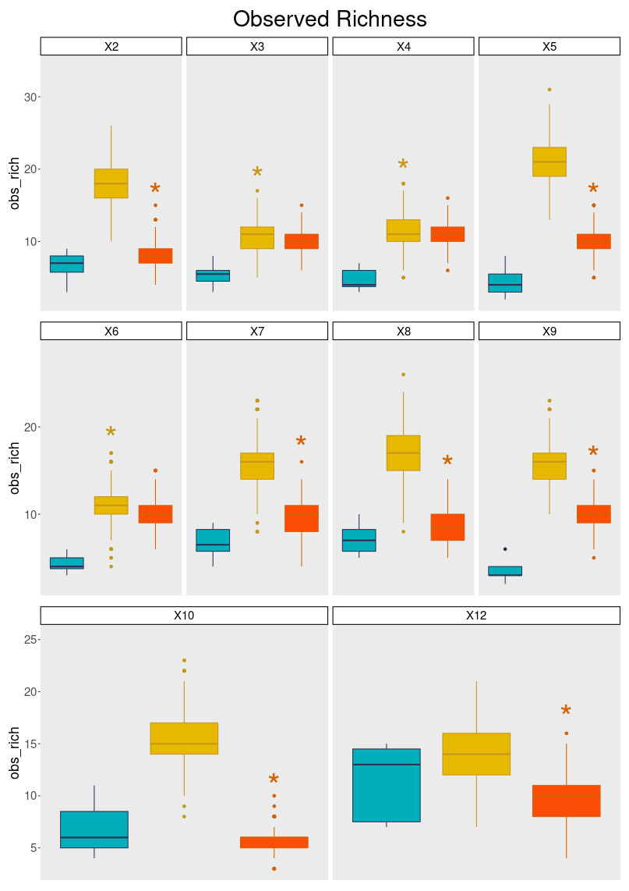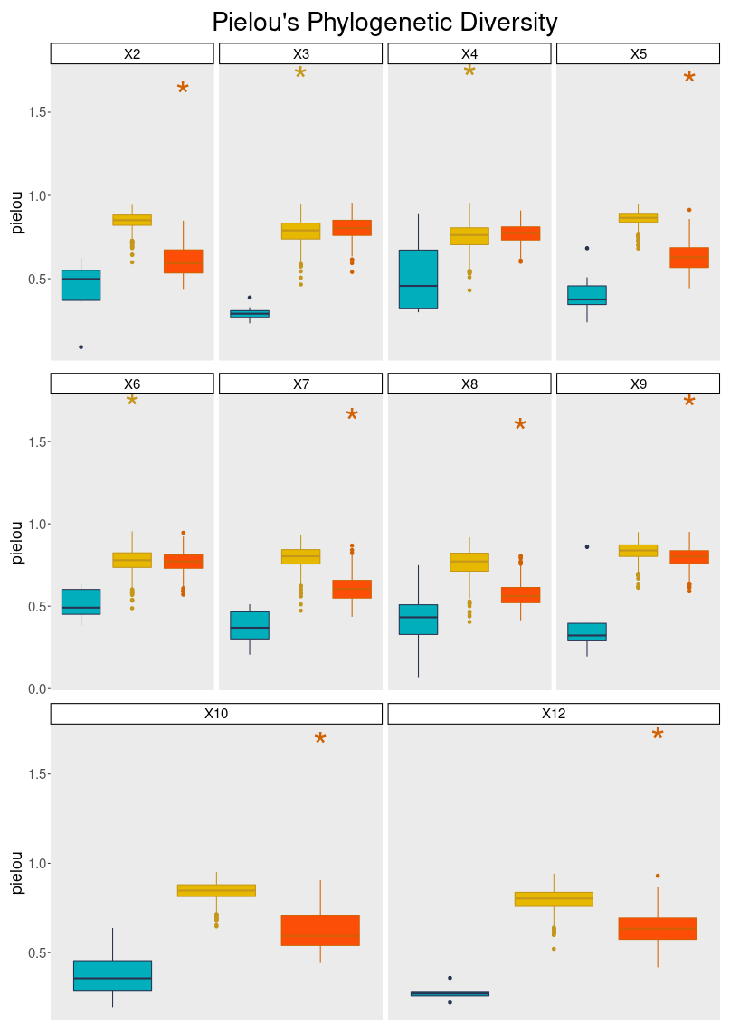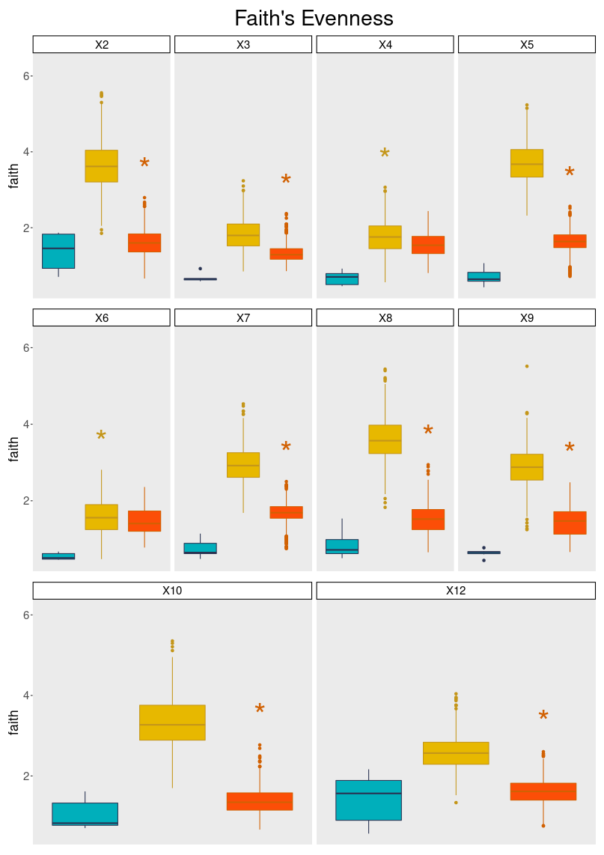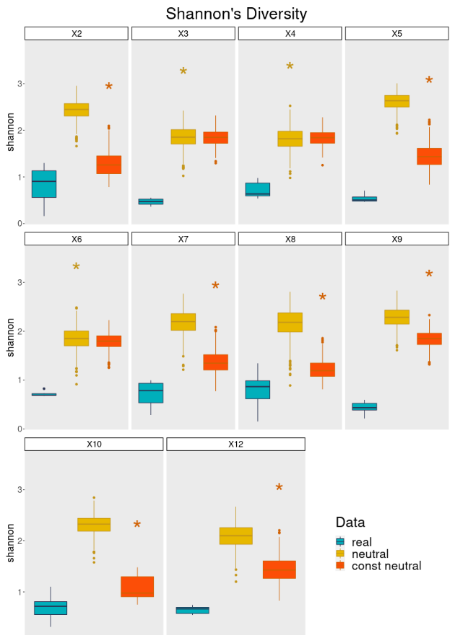
Supplementary Figure 3. Diversity metrics for experimental and simulated communities obtained for each original sample. Real; values for experimental endpoint communities. Neutral; values for 800 communities simulated under neutral drift. Const neutral; values for 800 communities simulated under within-group neutral drift and fixed per-group community sizes.

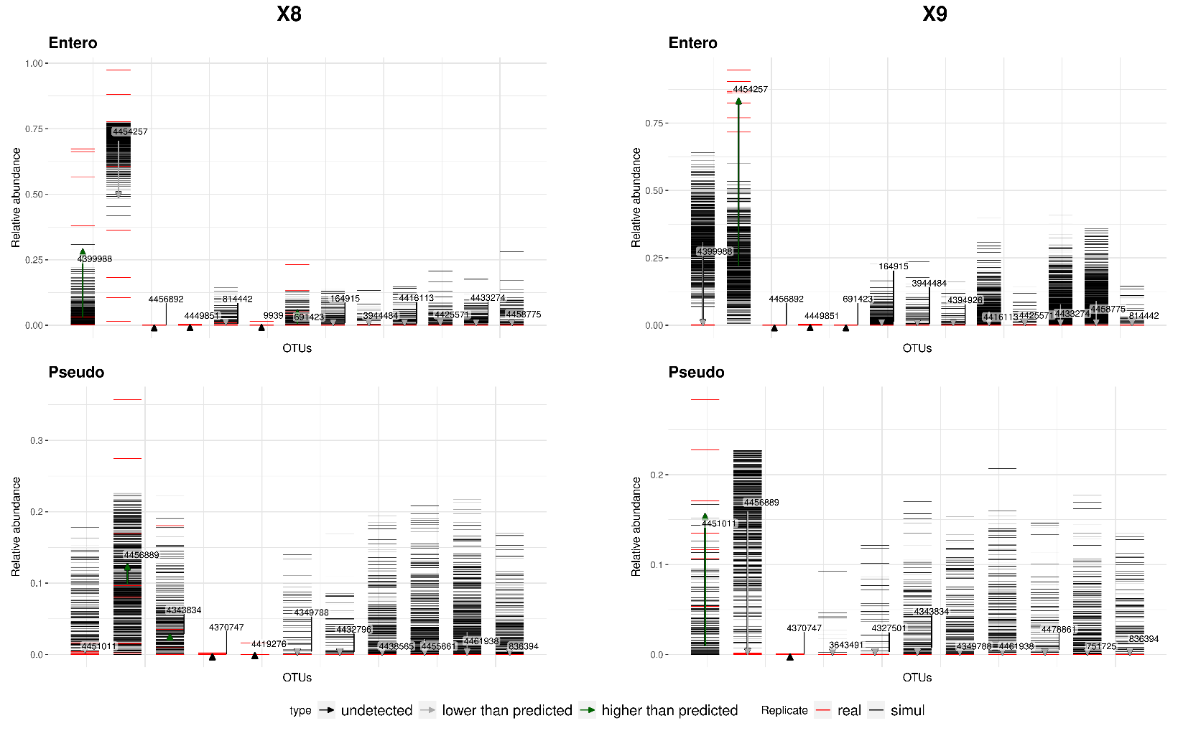
Supplementary Figure 4. Comparison of experimental vs. simulated population abundance distributions. Two representative examples are shown, corresponding to original samples X8 and X9 in the glucose dataset. Simulations were generated from the original samples abundance data under the constrained scenario. Each black line represents the final relative abundance of one simulation replicate, while red lines portray the relative abundance of the experimental replicates. Arrows indicate the differences between mean abundances (experimental vs. simulated). Black arrows represent cases where that OTU was not detected in the original sample.
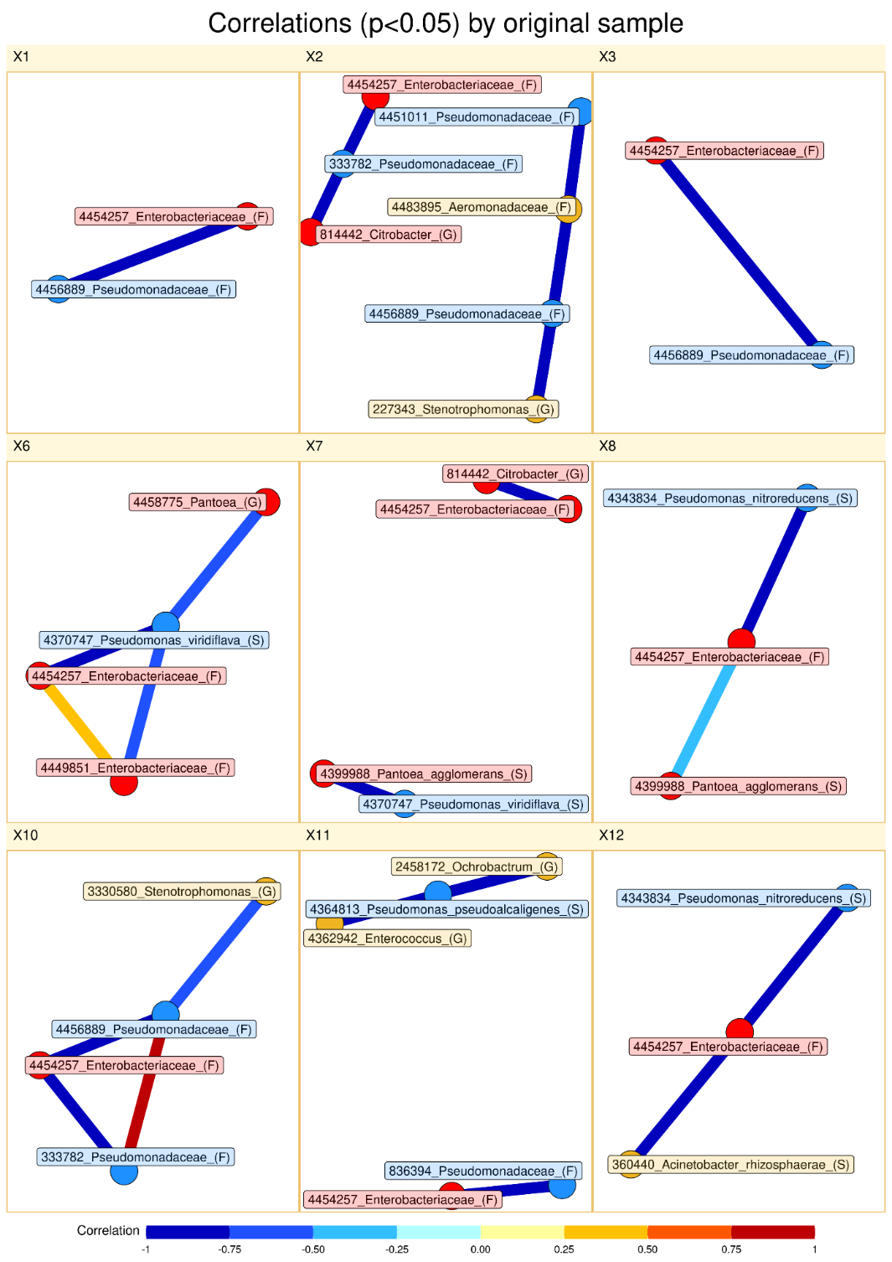
Supplementary Figure 5. Co-abundance correlations in experimental data. Panels represent correlation networks obtained from replicates arising from the same original sample. Only those correlations ranked within the 5% extreme values of the null correlation distribution are depicted. In a few instances there were no significant correlations and thus the network is not present. Red, blue and yellow labels represent populations belonging to E, P, and others, respectively.

