Supporting Information for
Hydrogen-controlled structural reconstruction of palladium-bismuth oxide cluster to single atom alloy for low temperature CO Oxidation
Bing Nan,^{1,4 #*} Lulu Li^{2 #}, Yunan Li,⁴ Lingling Guo,^{1, 4} Meng Du,^{1, 4} Zhengwu Liu,⁴ Xin Tao,⁴ Chen, Tian,⁴ Zhenye Liang,⁴ Yanxing Zhang,^{3*} Chao Ma,⁵ Lu Shen,⁶ Rui Si,^{4*} Lina Li,^{1,4*}
1 Shanghai Synchrotron Radiation Facility, Zhangjiang Laboratory, Shanghai Advanced Research Institute Shanghai, 201210, China
2 State Key Laboratory for Modification of Chemical Fibers and Polymer Materials, College of Environmental Science and Engineering, Donghua University, Shanghai 201620, China
3 School of Physics, Henan Normal University, Xinxiang, 453007, China
4 Shanghai Institute of Applied Physics, Chinese Academy of Sciences, Shanghai, 201204, China
5 Center for High Resolution Electron Microscopy, College of Materials Science and Engineering, Hunan University, Changsha 410082, China
6 Division of China, TILON Group Technology Limited, Shanghai 200090, China
# Bing Nan and Lulu Li contributed equally to this manuscript.

*E-mail: nanb@sari.ac.cn, lilina@sinap.ac.cn, sirui@mail.sysu.edu.cn, zhangyanxing@htu.edu.cn.
Table S1. Bulk Pd and Bi concentration, temperature of reduction peaks (T_{R}) and hydrogen consumption from H₂−TPR, BET specific surface areas (S_{BET}), BJH pore volume (V_{p}), average clusters size (D_{TEM}) for Pd/PdBi-SiO₂ samples.
Sample | Pd  (wt.%)ª | Bi  (wt.%)ª | T_{R} (°C) | H₂ (μmol g⁻¹)^{b} | S_{BET}  (m²/g)^{c} | V_{p}  (cm³/g)^{c} | D_{TEM}  (nm)^{d}
SiO₂ | — | — | — | — | 430 | 1.32 | —
1Pd-SiO₂ | 0.8 | — | 62 | 210^{α}, 194^{β} | 420 | 1.36 | 3.0±0.7  4.1±0.7e
1Pd2Bi-SiO₂ | 0.8 | 2.6 | 144, 366, 413 | 327^{α}, 280^{β} | 386 | 1.23 | 2.3±0.7  3.2±0.7e
1Pd5Bi-SiO₂ | 0.8 | 5.8 | 206, 395 | 829^{α}, 797^{β} | 355 | 1.17 | 2.1±0.5  3.1±0.5e
ª Determined by ICP-AES.; ^{b} Actual value of H₂ consumptions (α) and theoretical values (β) of H₂ consumption calculated according to Pd²⁺ → Pd⁰ and Bi³⁺ → Bi⁰; ^{c} From N₂ adsorption/desorption experiments; ^{d} Statistic data from over 100 clusters on the basis of TEM images, ^{e} after CO oxidation.

Table S2. Oxidation state of palladium (δ) and Pd K-edge EXAFS fitting results (R: distance; CN: coordination number; σ²: Debye-Waller factor ª; △E₀: inner potential correction ^{b}) of Pd/PdBi-SiO₂ samples.
Sample | δ | Pd-O |  | Pd-Pd (metallic) |  | Pd-Pd (Pd-O-Pd) |  | Pd-Bi (Pd-O-Bi)
Sample | δ | R (Å) | CN | R (Å) | CN | R (Å) | CN | R (Å) | CN
1Pd-SiO₂  (fresh) | 1.9 | 2.04±0.02 | 4.2±0.6 | — | — | 3.12±0.01 | 5.0±0.9 | — | —
1Pd2Bi-SiO₂  (fresh) | 1.8 | 2.04±0.01 | 5.0±0.1 | — | — | 3.07±0.01 | 1.2±0.5 | 3.36±0.03 | 3.1±0.8
1Pd5Bi-SiO₂  (fresh) | 1.8 | 2.04±0.01 | 4.4±0.4 | — | — | 3.08±0.02 | 2.1±0.9 | 3.37±0.04 | 2.6±1.1
1Pd-SiO₂  (used) | 0.5 | 1.98±0.01 | 1.4±0.3 | 2.73±0.01 | 7.0±0.3 | — | — | — | —
1Pd2Bi-SiO₂  (used) | 0.3 | 2.00±0.01 | 1.4±0.3 | 2.74±0.01 | 4.0±0.5 | — | — | 3.36±0.02 | 3.3±1.0
1Pd5Bi-SiO₂  (used) | 0.3 | 2.00±0.01 | 1.4±0.4 | 2.74±0.01 | 4.2±0.4 | — | — | — | —
ª D.W. = 0.003±0.001, 0.005±0.001 Å² for all the analyzed Pd−O, Pd−Pd/Bi shells, respectively; ^{b}△E₀ = 10.3 (set) eV and -8.9±1.1 eV for all fresh and used Pd/PdBi-SiO₂, respectively.

Table S3. Oxidation state of bismuth (δ) and Bi L₃-edge EXAFS fitting results (R: distance; CN: coordination number; σ²: Debye-Waller factor ª) of PdBi-SiO₂ samples.
Sample | δ | Bi-O |  | Metallic Bi-Pd |  | Bi-Bi
Sample | δ | R (Å) | CN | R (Å) | CN | R (Å) | CN
1Pd2Bi-SiO₂  (fresh) | 3.0 | 2.14±0.01 | 2.3±0.1 | — | — | — | —
1Pd5Bi-SiO₂  (fresh) | 3.0 | 2.14±0.01 | 2.4±0.1 | — | — | 3.90±0.03  (Bi−O−Bi) | 1.3±0.4
1Pd2Bi-SiO₂  (used) | 2.4 | 2.14±0.01 | 2.1±0.1 | 2.82±0.02 | 0.4±0.1 | 3.86±0.03  (Bi−O−Bi) | 1.1±0.4
1Pd5Bi-SiO₂  (used) | 2.3 | 2.15±0.01 | 1.7±0.1 | 2.82±0.01 | 0.5±0.1 | 2.99±0.02  (metallic Bi−Bi)  3.88±0.04  (Bi−O−Bi) | 0.6±0.2  0.9±0.4
ª D.W. = 0.003±0.001, 0.006±0.002 Å² for all the analyzed Bi−O, Bi−Pd and Bi−Bi shells, respectively.

Table S4. Testing conditions of Arrhenius plots (r_{w}) for Pd/PdBi-SiO₂ samples.
1Pd-SiO₂ | 60,000 mL·g_{cat}⁻¹·h⁻¹ |  | 1Pd2Bi-SiO₂ | 180,000 mL·g_{cat}⁻¹·h⁻¹
 | Conv.(%) | r_{w}(μmol_{CO}·g_{cat}⁻¹·s⁻¹) |  | Conv.(%) | r_{w}(μmol_{CO}·g_{cat}⁻¹·s⁻¹)
90°C | 3.8 | 0.3 | 90 | 9.1 | 2.1
100°C | 5.6 | 0.4 | 100 | 14.6 | 3.3
110°C | 6.3 | 0.5 | 110 | 21.3 | 4.9
1Pd5Bi-SiO₂ | 178,000 mL·g_{cat}⁻¹·h⁻¹
 | Conv.(%) | r_{w}(μmol_{CO}·g_{cat}⁻¹·s⁻¹)
90°C | 5.4 | 1.2
100°C | 6.7 | 1.5
110°C | 9.0 | 2.0

Table S5. Temperature of 50% (T_{50%}) and 90% (T_{90%}) CO conversion, rates normalized by catalyst weight (r₁), rates normalized by platinum or palladium amount (r₂) and apparent activation energies (E_{a}) for the carbon monoxide oxidation reaction over Pd/PdBi-SiO₂ samples.
Sample | T_{50%} | T_{90%} | r₁ (μmol_{CO}·g_{cat}⁻¹·s⁻¹) |  |  | r₂ (mmol_{CO}·mol_{Pd}⁻¹·s⁻¹) |  |  | E_{a} (kJ/mol)
Sample | T_{50%} | T_{90%} | 90°C | 100°C | 110°C | 90°C | 100°C | 110°C | E_{a} (kJ/mol)
1Pd-SiO₂ | 150 | 170 | 0.3 | 0.4 | 0.5 | 4.0 | 5.3 | 6.6 | 60±3
1Pd2Bi-SiO₂ | 107 | 122 | 2.1 | 3.3 | 4.9 | 27.8 | 43.7 | 64.9 | 35±1
1Pd5Bi-SiO₂ | 124 | 139 | 1.2 | 1.5 | 2.0 | 15.9 | 19.9 | 26.5 | 40±1

Table S6. The fraction of different valence for palladium and bismuth species according to the linear combination fitting of EXAFS results.

 | Pd²⁺ | Pd⁰ | Bi³⁺ | Bi⁰
1Pd-SiO₂ | 25% | 75% | − | −
1Pd2Bi-SiO₂ | 15% | 85% | 93% | 7%
1Pd5Bi-SiO₂ | 15% | 85% | 93% | 7%

Table S7. Oxidation state of bismuth (δ) and Bi L₃-edge EXAFS fitting results (R: distance; CN: coordination number; σ²: Debye-Waller factor ª) of 1Pd1Bi-SiO₂.
sample | δ | Bi-O |  | Metallic Bi-Pd
sample | δ | R | CN | R | CN
1Pd1Bi-fresh | 2.9 | 2.14±0.01 | 2.3±0.1 | − | −
1Pd1Bi-110H₂ | 2.4 | 2.14±0.01 | 1.4±0.1 | 2.82±0.02 | 0.4±0.1
1Pd1Bi-180H₂ | 2.0 | 2.14±0.03 | 1.0±0.4 | 2.83±0.03 | 1.2±0.2
1Pd1Bi-180H₂-used | 1.9 | 2.13±0.01 | 1.2±0.1 | 2.82±0.02 | 1.0±0.1
ª D.W. = 0.003±0.001, 0.006±0.002 Å² for all the analyzed Bi−O, Bi−Pd shells, respectively.

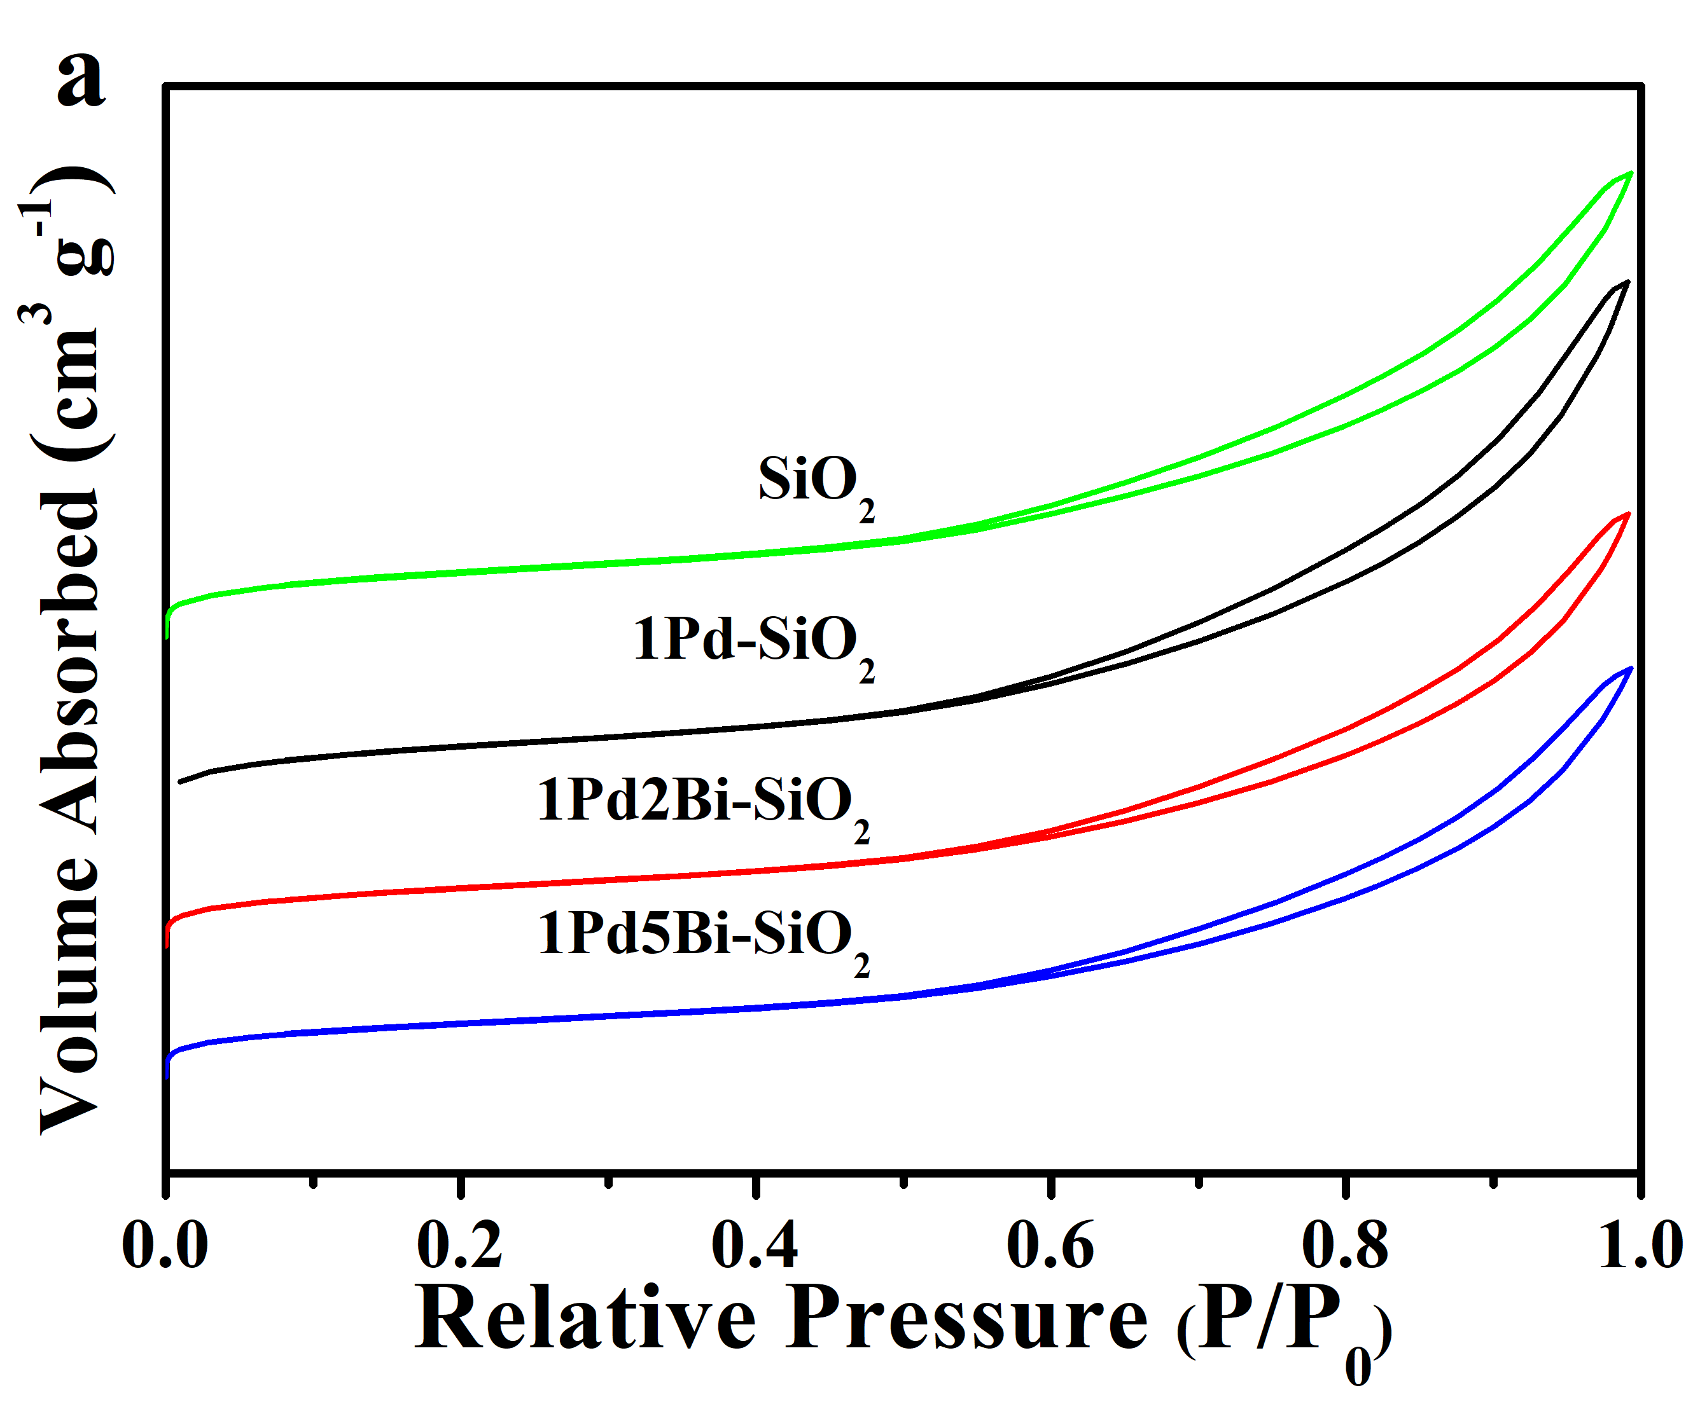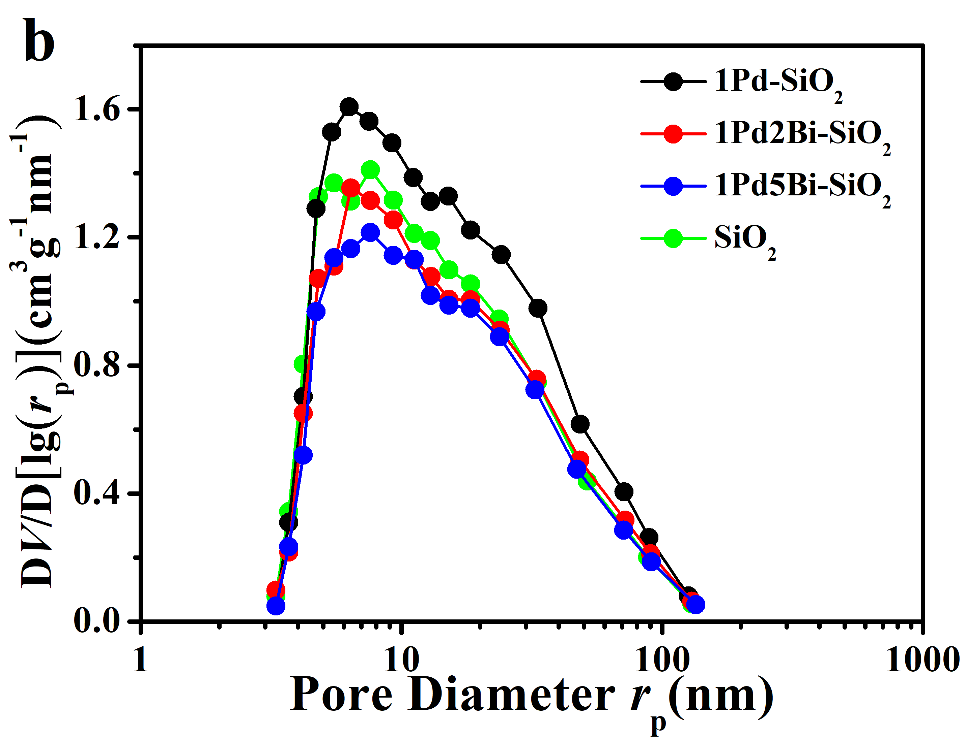
Figure S1. Nitrogen adsorption measurements of Pd/PdBi-SiO₂ and SiO₂ samples: (a) adsorption-desorption isotherm and (b) BJH pore size distribution.

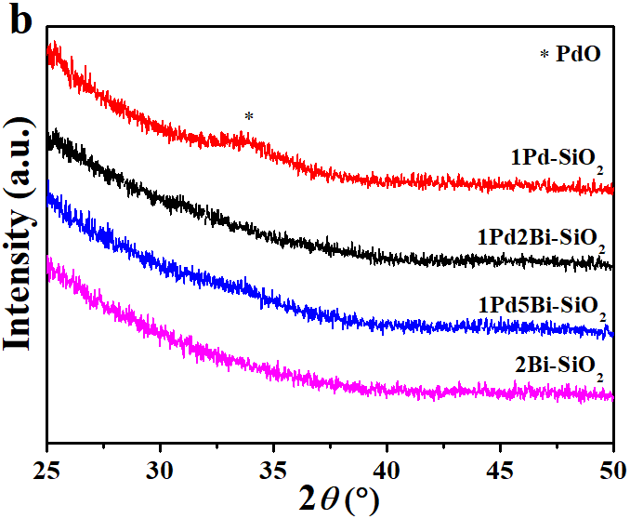
Figure S2. XRD patterns under “slow-scan” mode (scan rate: 1°/min) for Pd/PdBi-SiO₂ samples

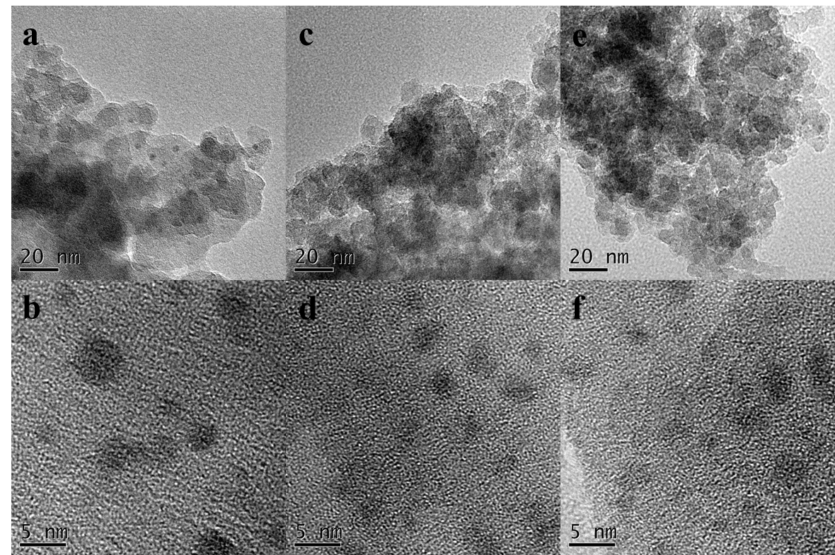
Figure S3. TEM (a,c,e) and HRTEM (b,d,f) images of fresh Pd/PdBi-SiO₂ samples: (a,b) 1Pd-SiO₂; (c,d) 1Pd2Bi-SiO₂; (e,f) 1Pd5Bi-SiO₂.

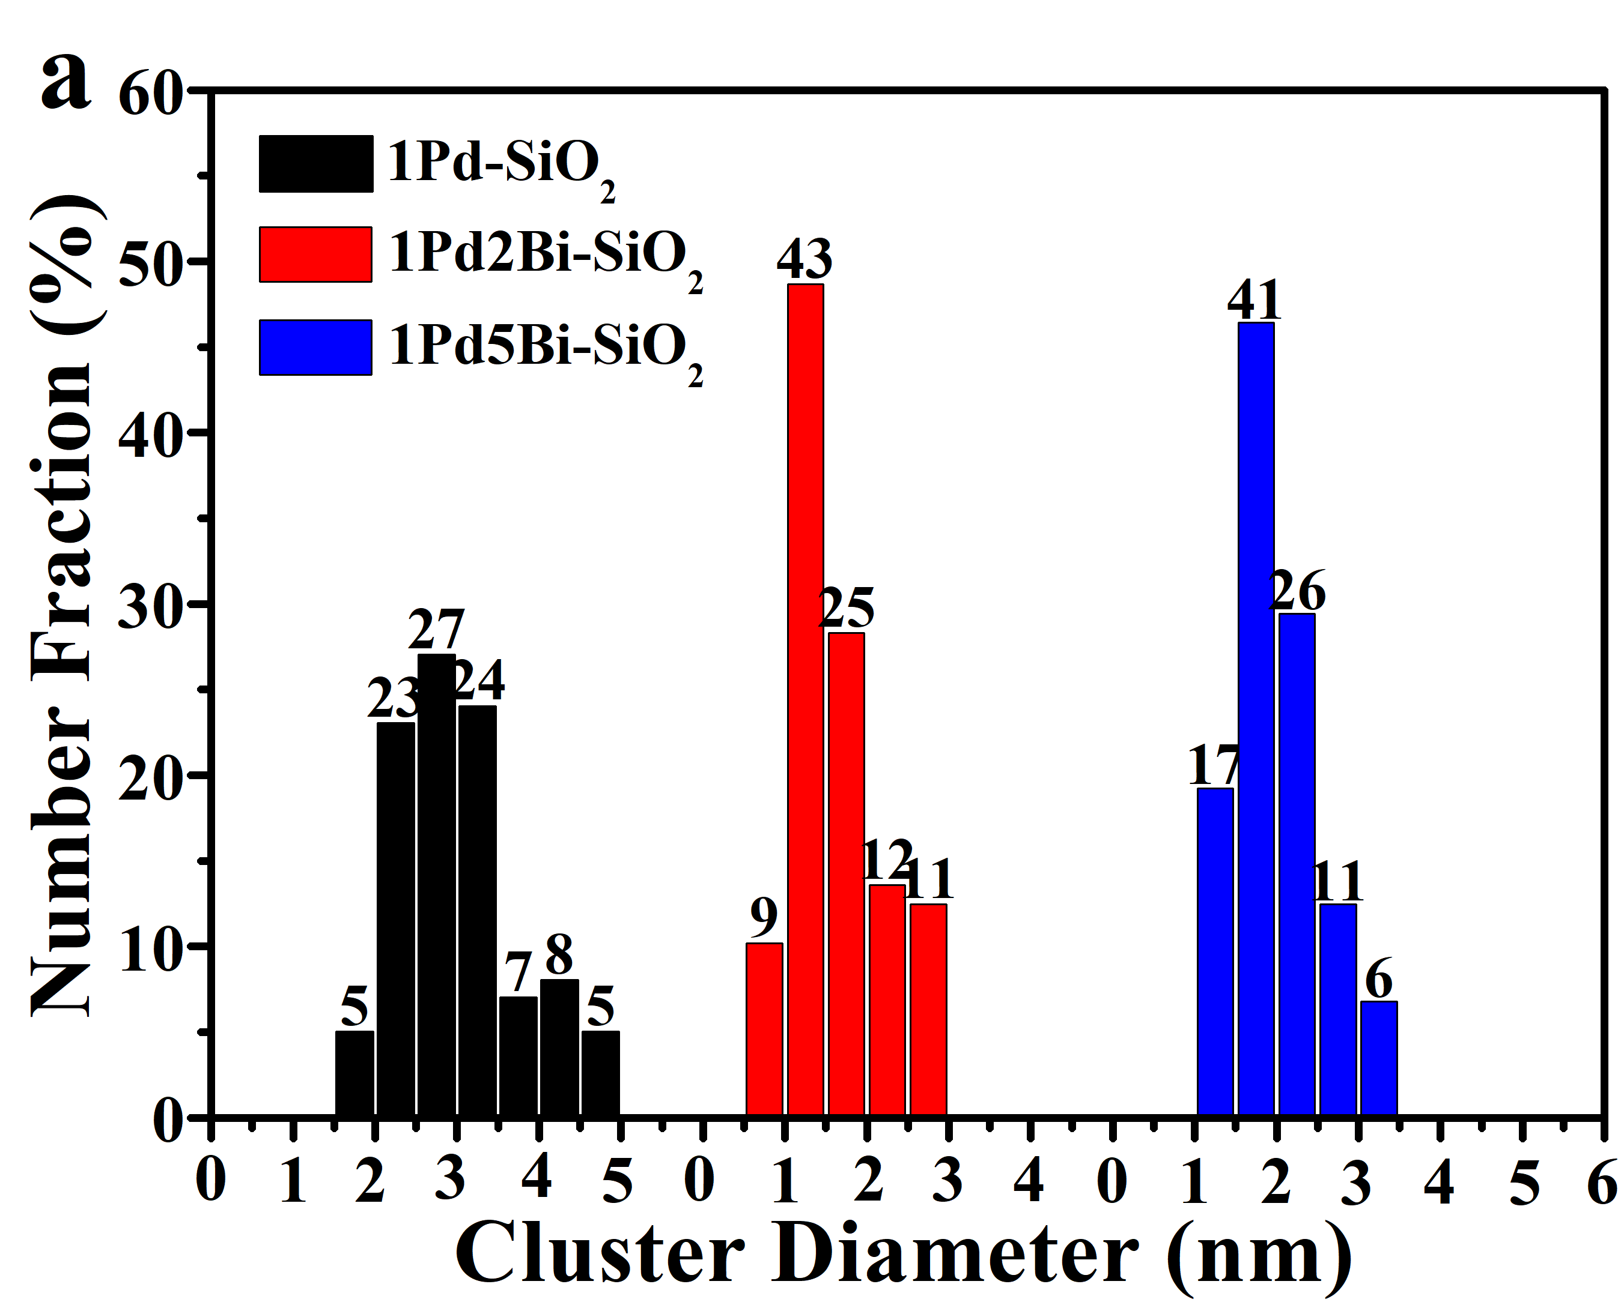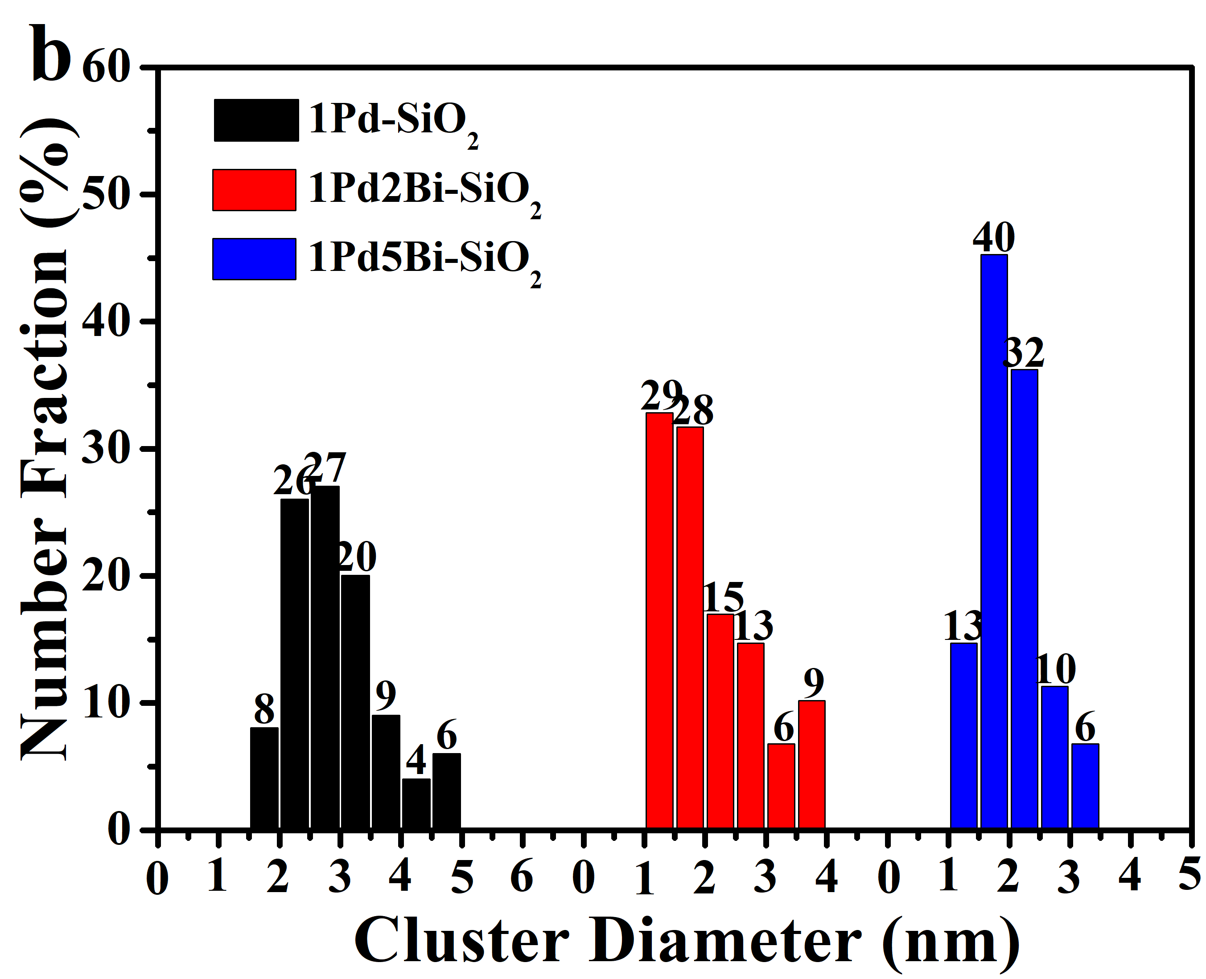
Figure S4. Diameter histograms on metal oxide clusters of fresh (a) and used (b) Pd/PdBi-SiO₂ samples on the basis of HAADF-STEM data.

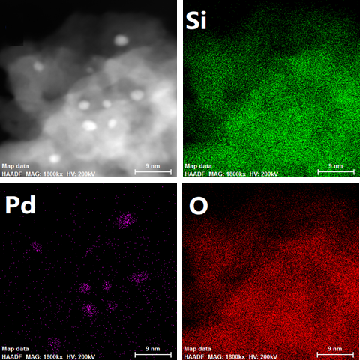
Figure S5. The EDS elemental mapping of 1Pd-SiO₂.

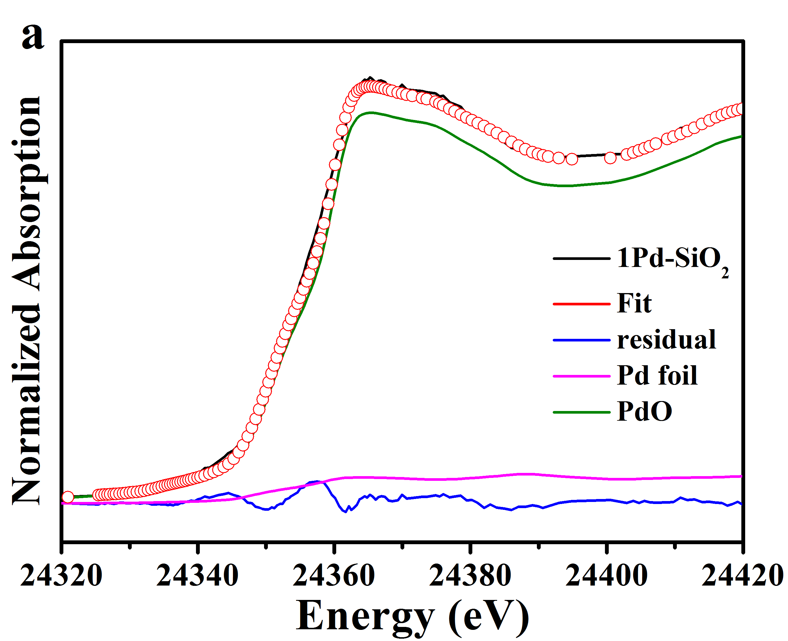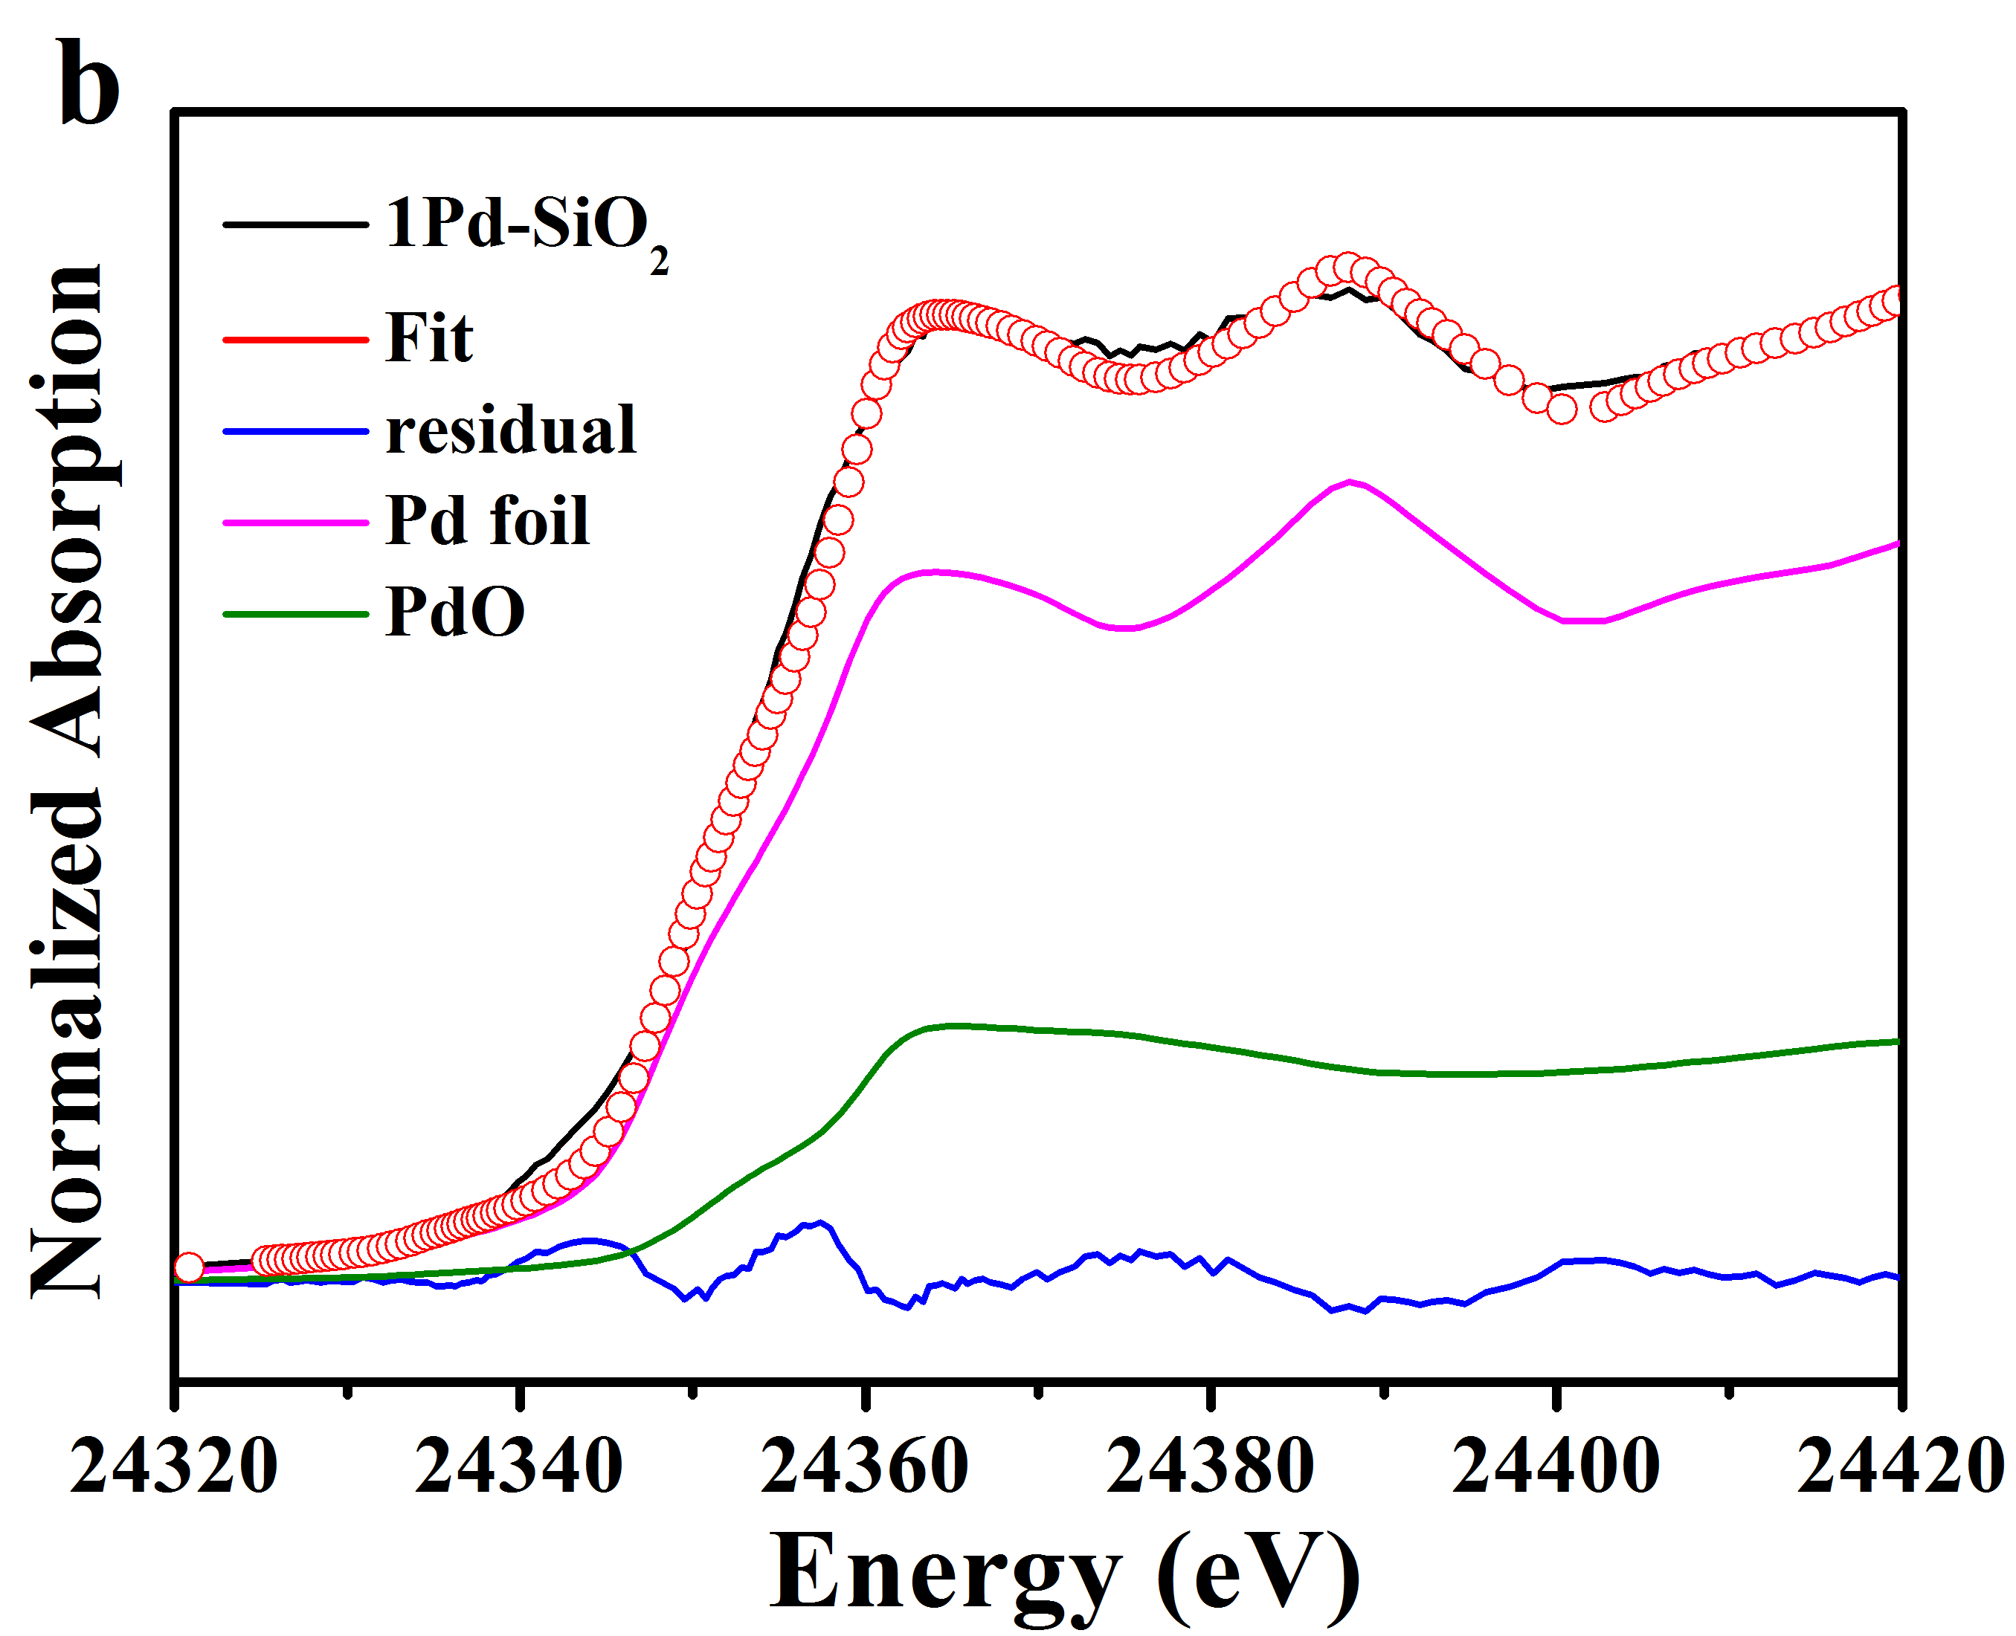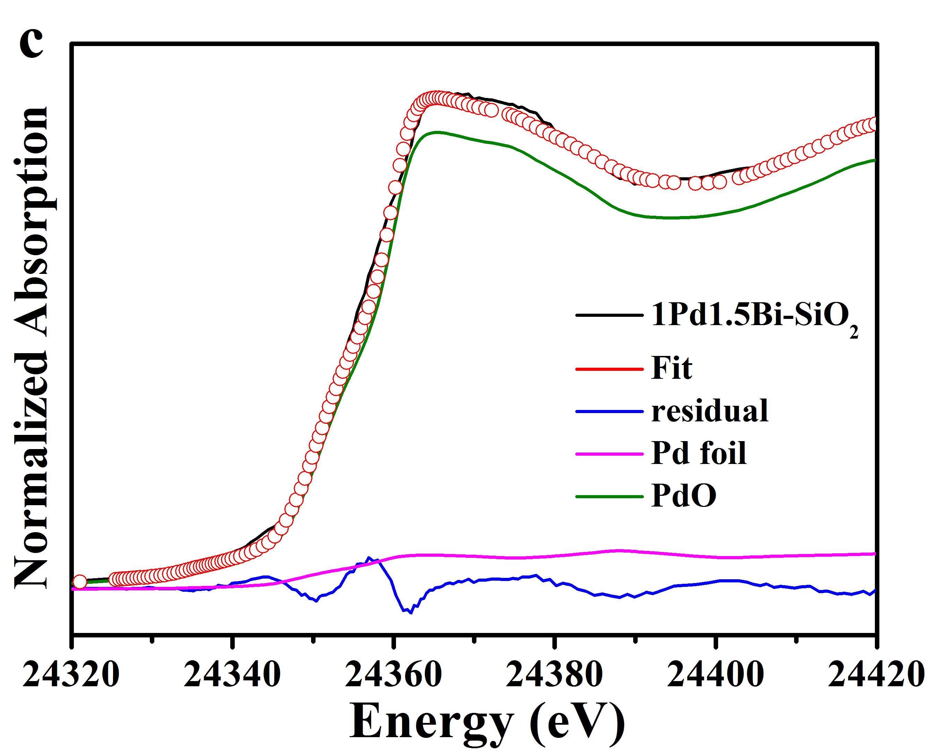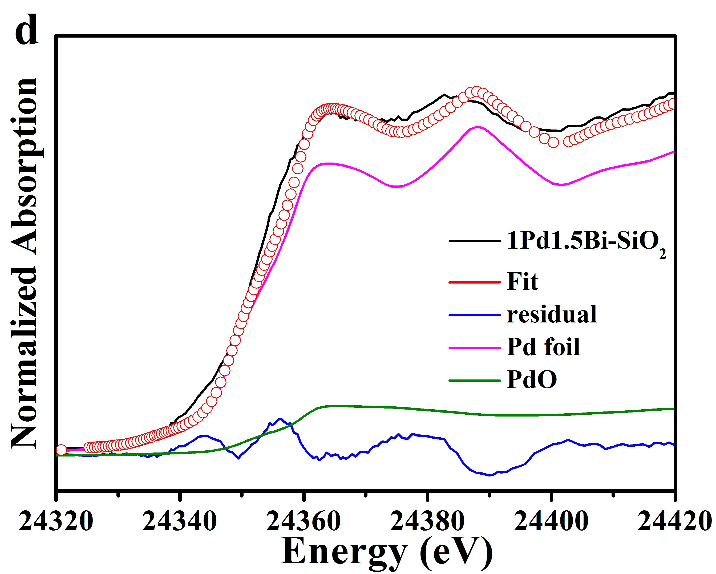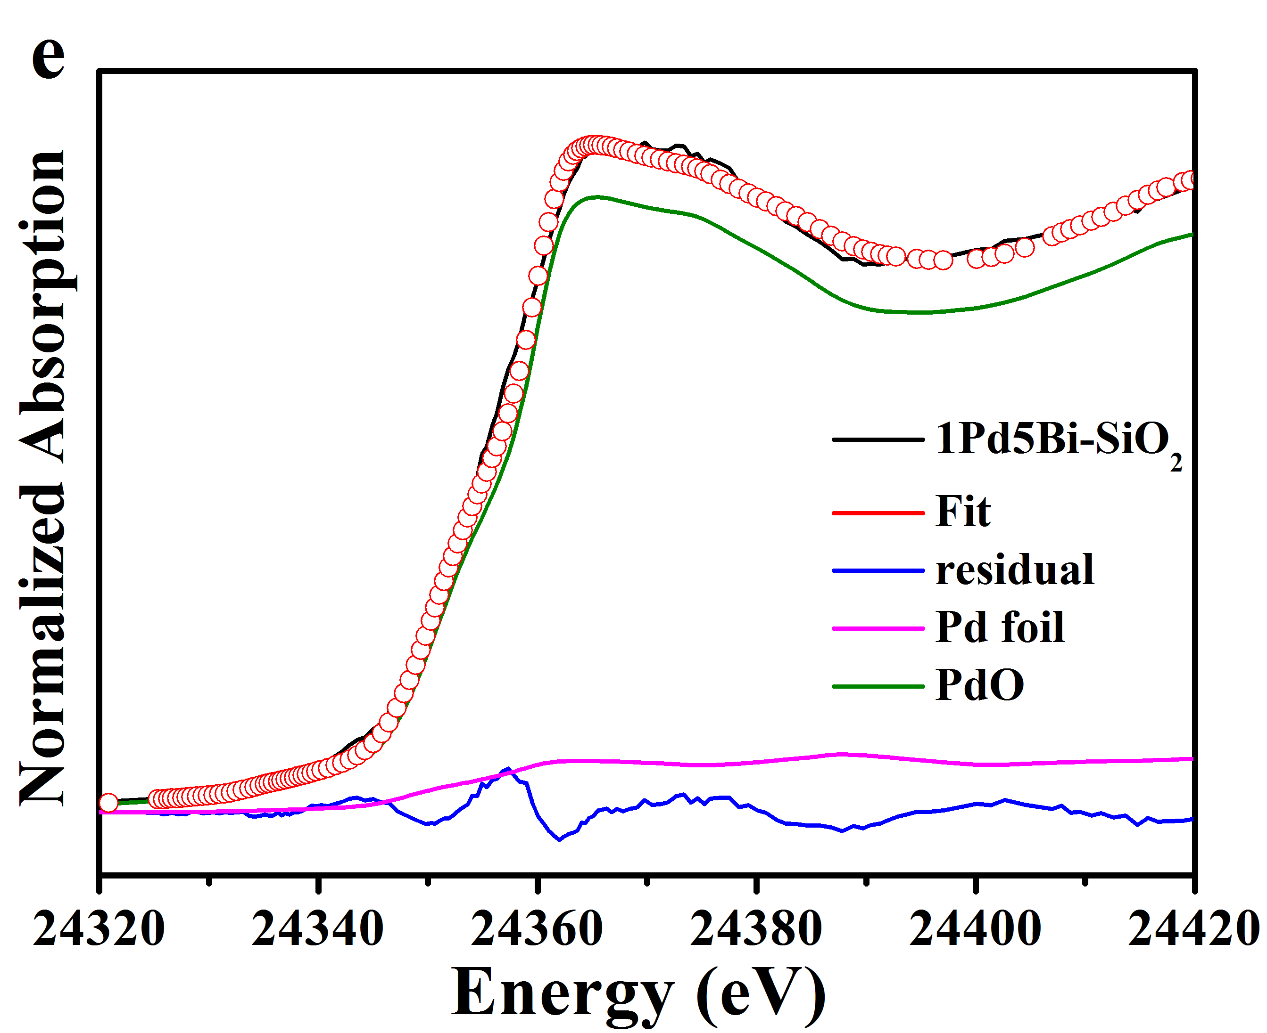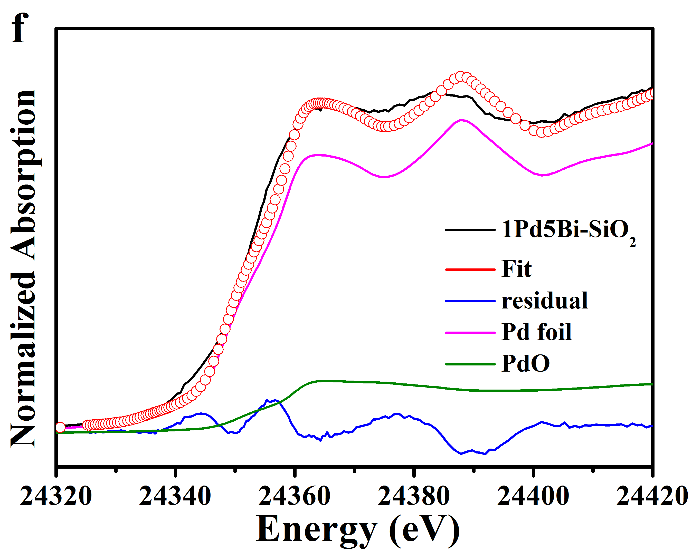
Figure S6. Linear combination fitting details on the Pd K edge XANES spectra of fresh (a,c,e) and used (b,d,f) PdBi-SiO₂ samples: (a,b) 1Pd-SiO₂, (c,d) 1Pd2Bi-SiO₂, (e,f) 1Pd5Bi-SiO₂.

sample | Pd₄O₄ | Pd₃BiO₄
 | 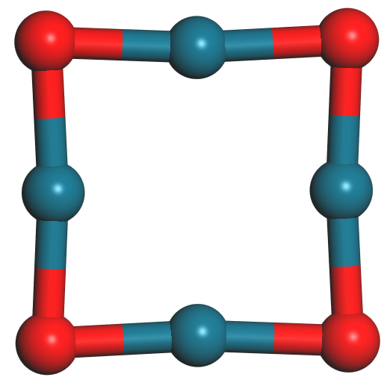 | 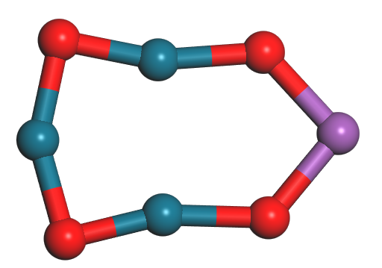
cohesive energy E (eV) | 23.65 | 24.08
Figure S7. The cohesive energy of P₄O₄ and Pd₃BiO₄.

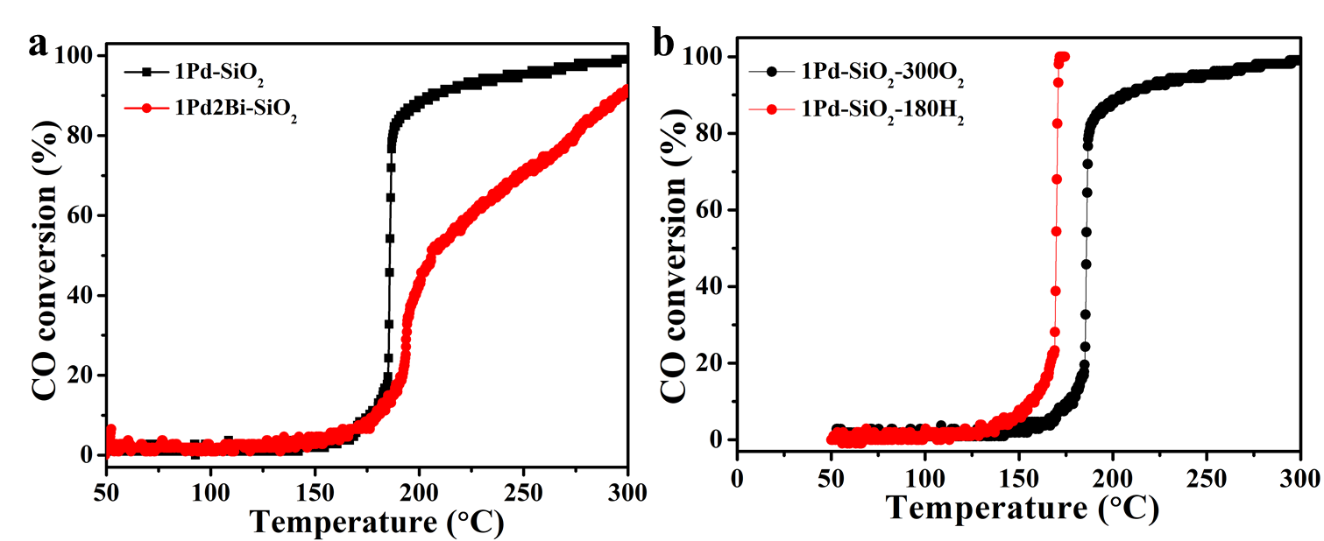
Figure S8. (a) The “light off” profiles of Pd/PdBi-SiO₂ catalysts with pretreatment at 300 °C under air and (b) CO oxidation of 1Pd-SiO₂ with oxidative and reductive pretreatments.

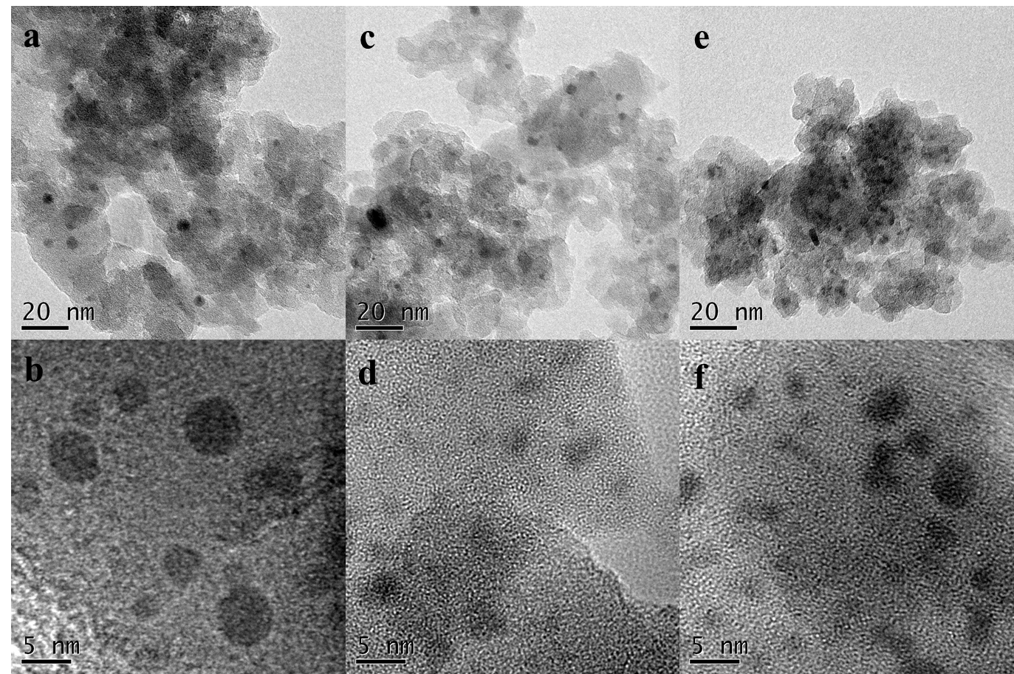
Figure S9. TEM (a,c,e) and HRTEM (b,d,f) images of used PdBi-SiO₂ samples: (a,b) 1Pd-SiO₂; (c,d) 1Pd2Bi-SiO₂; (e,f) 1Pd5Bi-SiO₂.

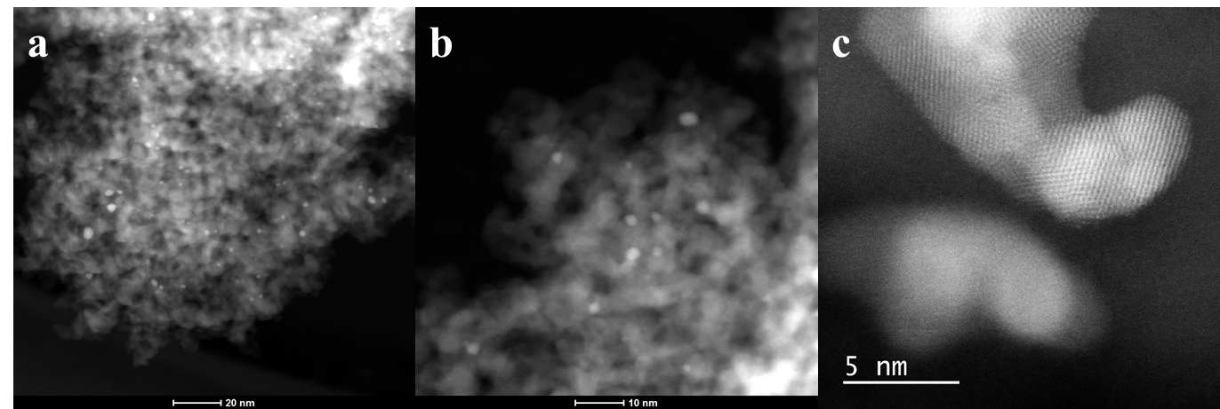
Figure S10. Aberration-corrected HAADF-STEM images of used 1Pd-SiO₂.

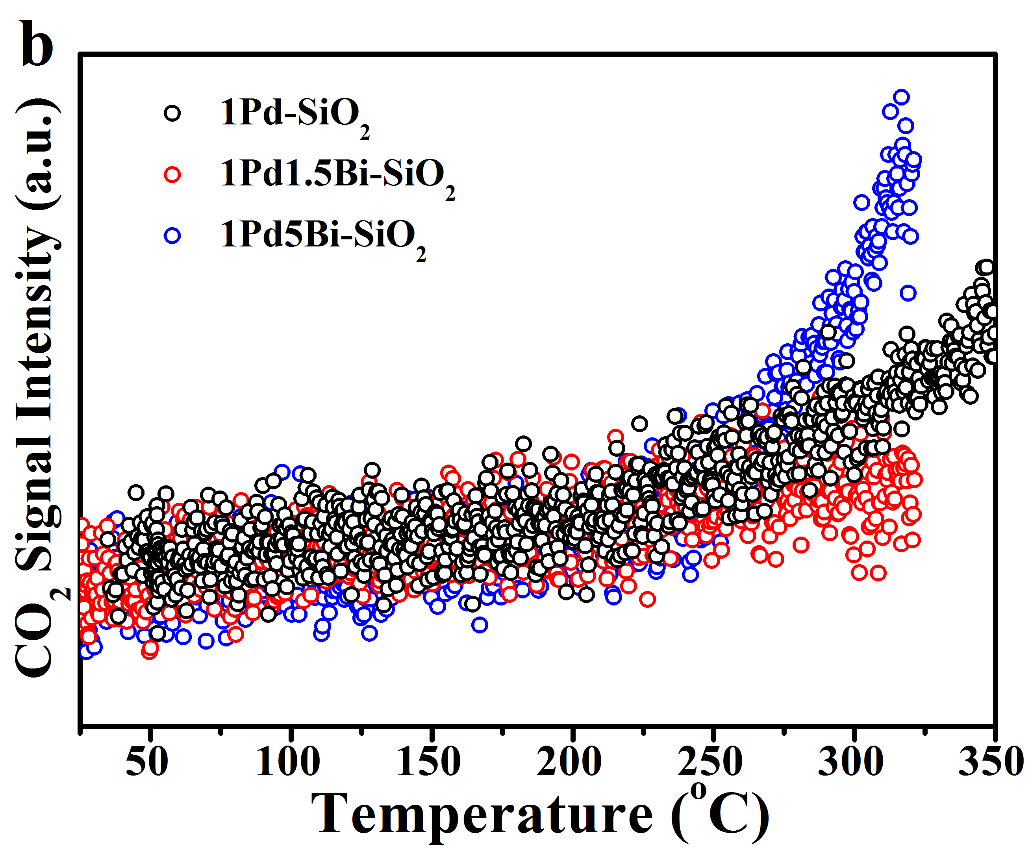
Figure S11. In-situ CO-TPR profiles of Pd/PdBi-SiO₂ samples with pretreatment condition at 180 ºC for 30 mins in 5%H₂/He.

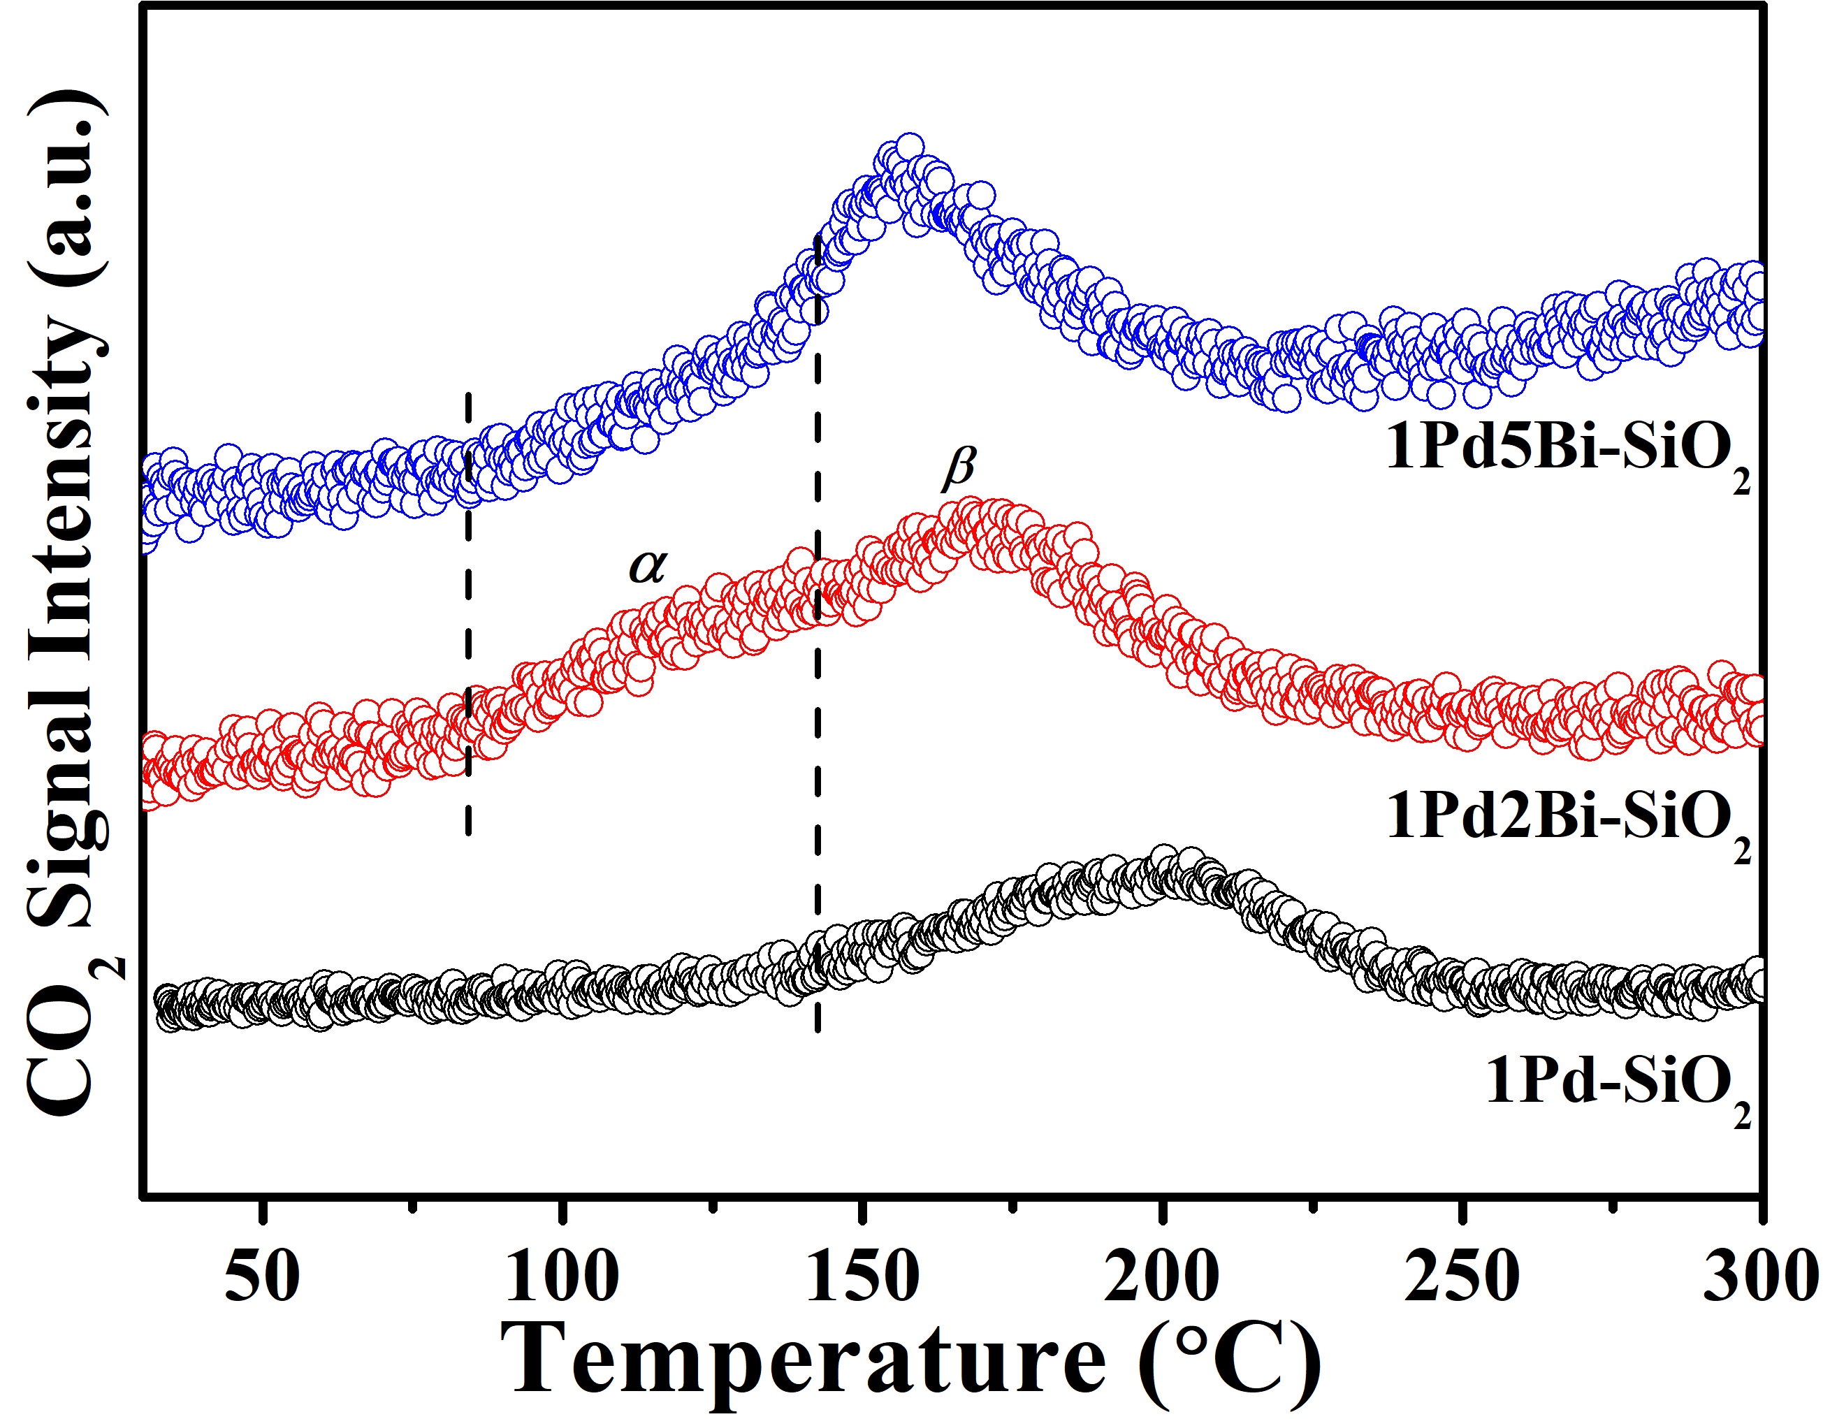
Figure S12. In-situ CO-TPR profiles of Pd/PdBi-SiO₂ samples after CO oxidation without air exposure.

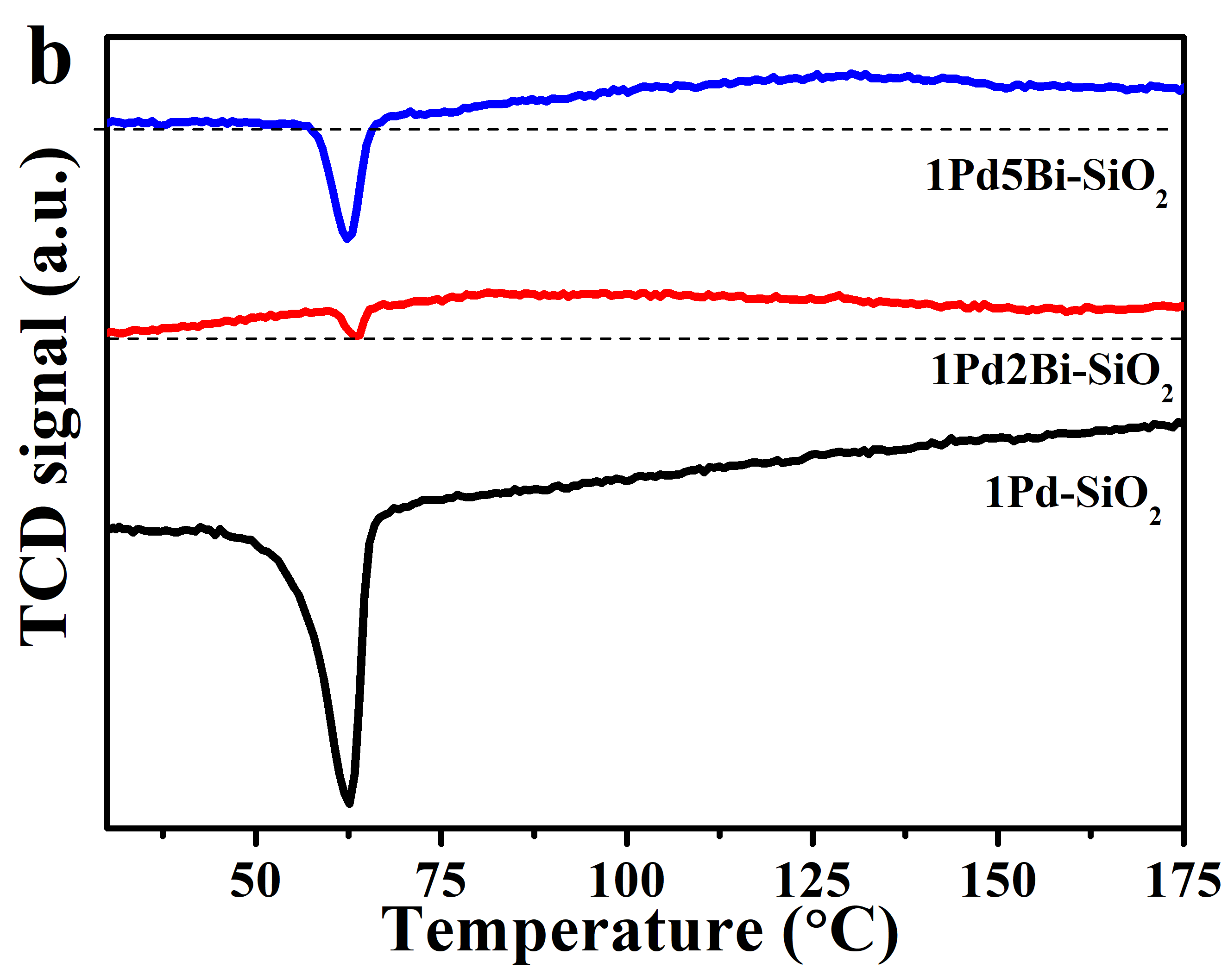
Figure S13. The H₂-TPR profiles of used Pd/PdBi-SiO₂ at low temperature.

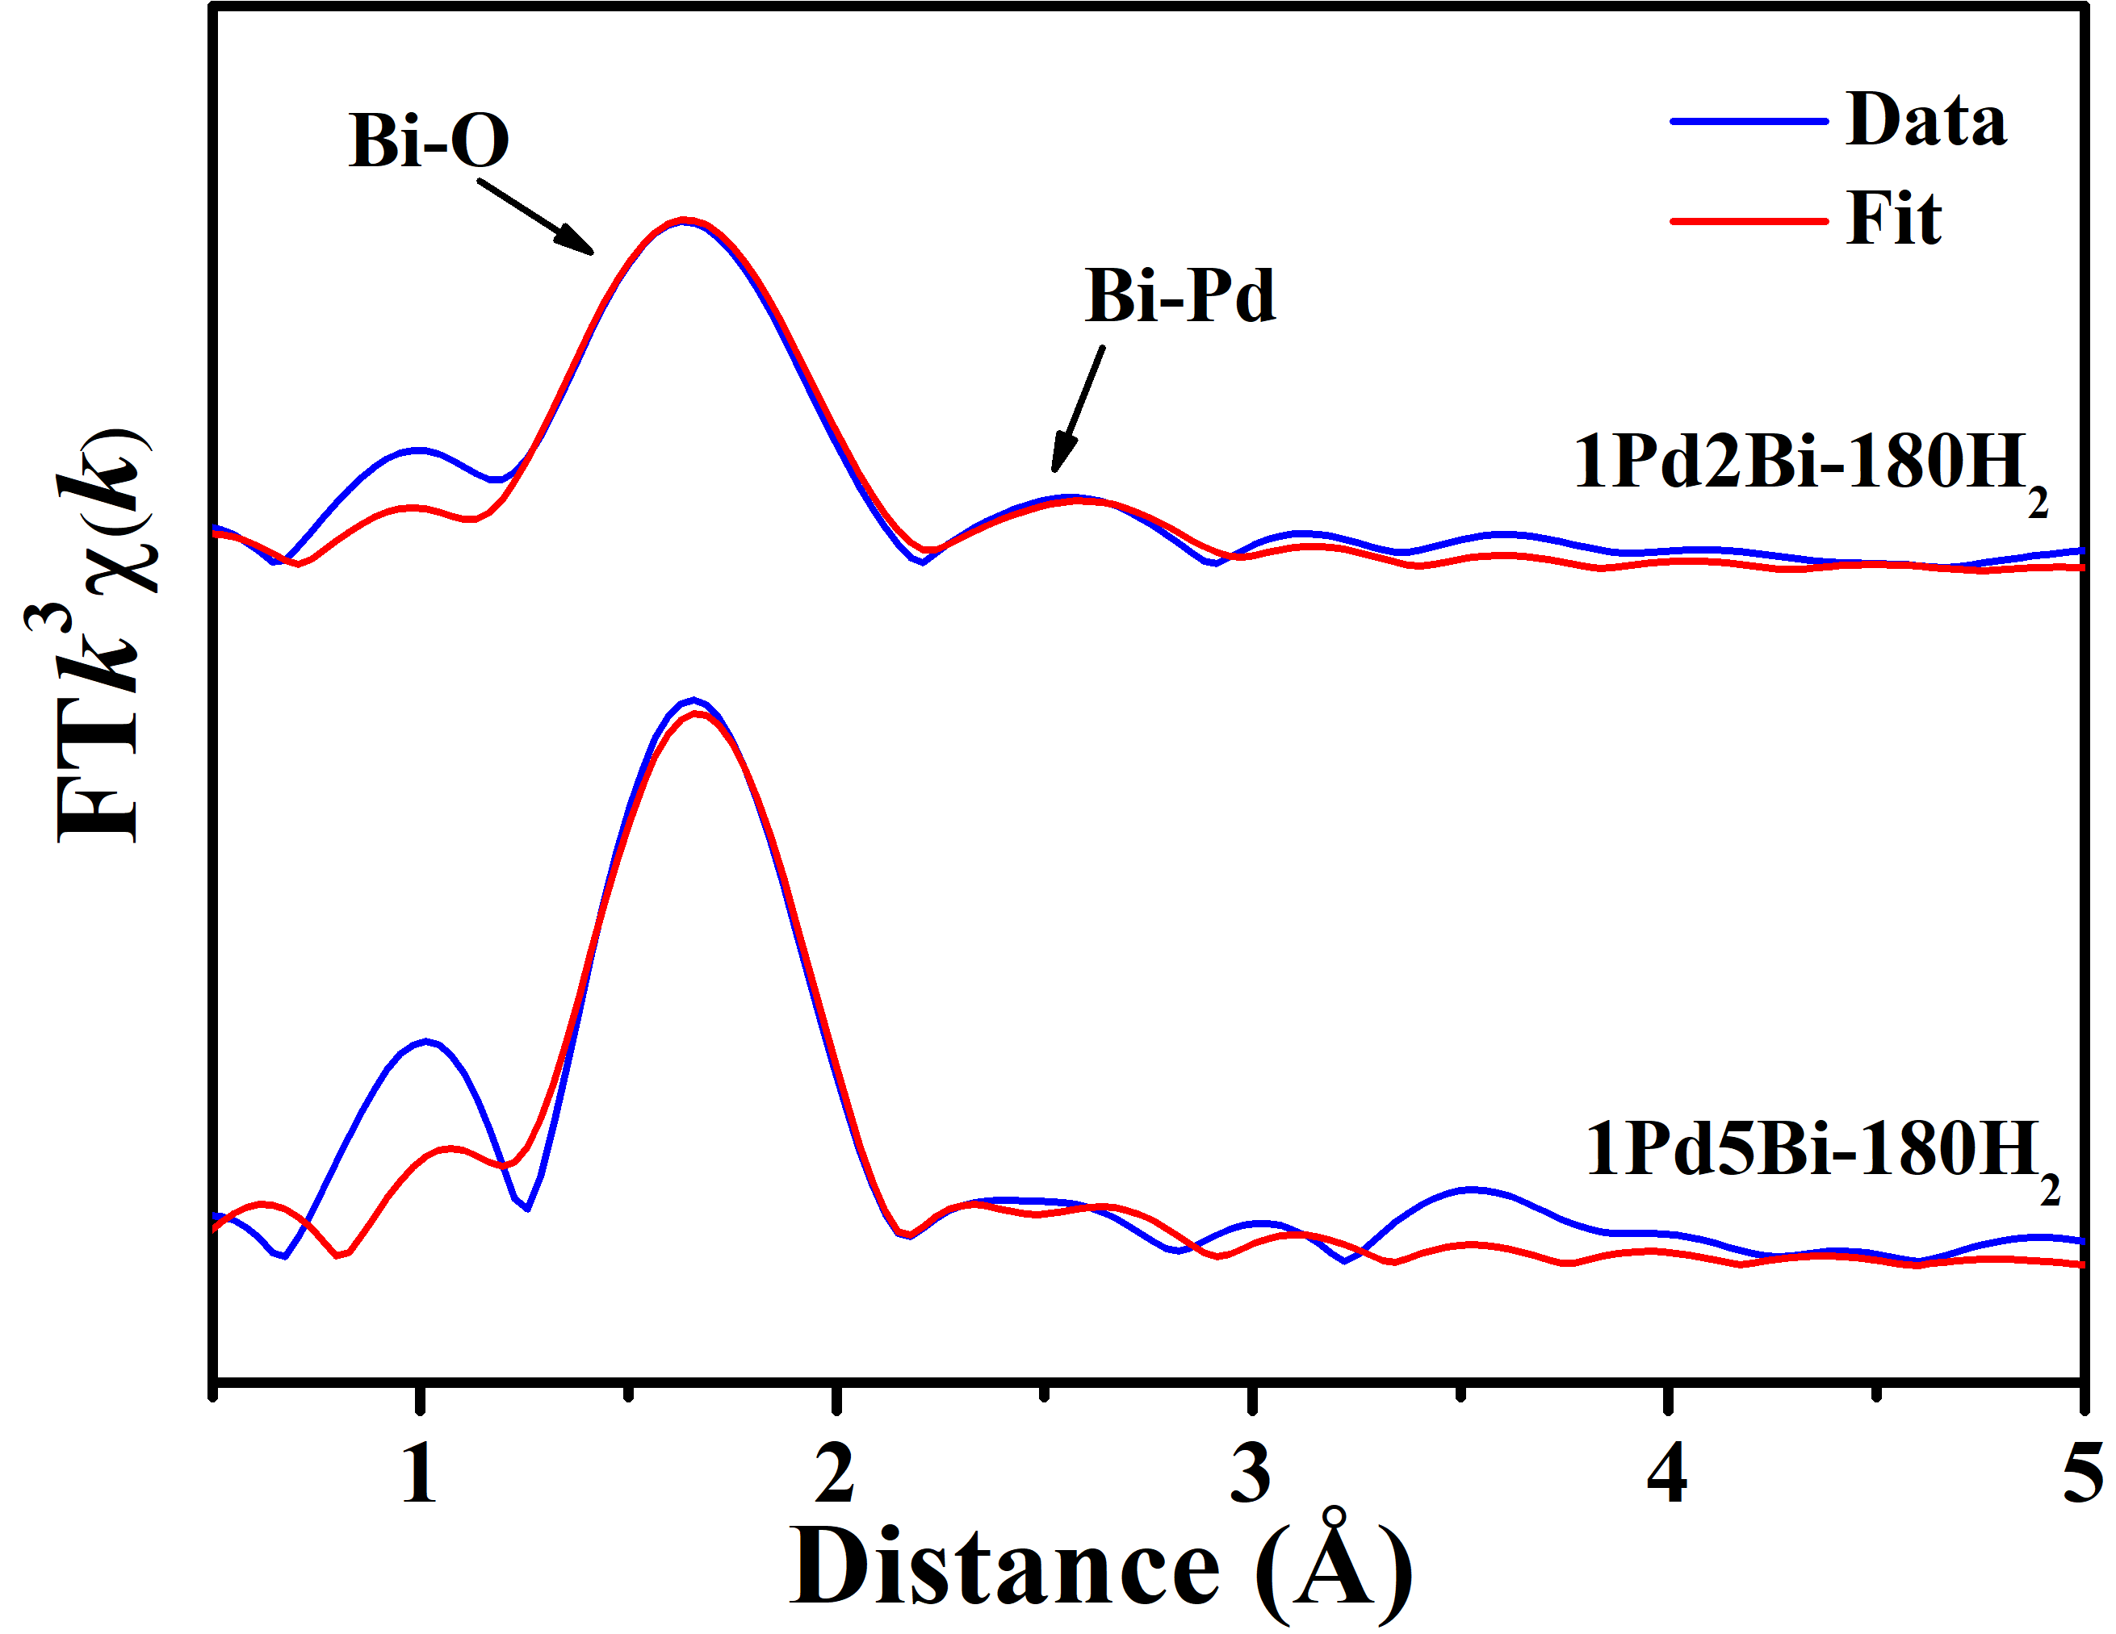
Figure S14. In-situ Bi L₃ edge EXAFS results over PdBi-SiO₂ samples at reduction temperature of 180 ºC

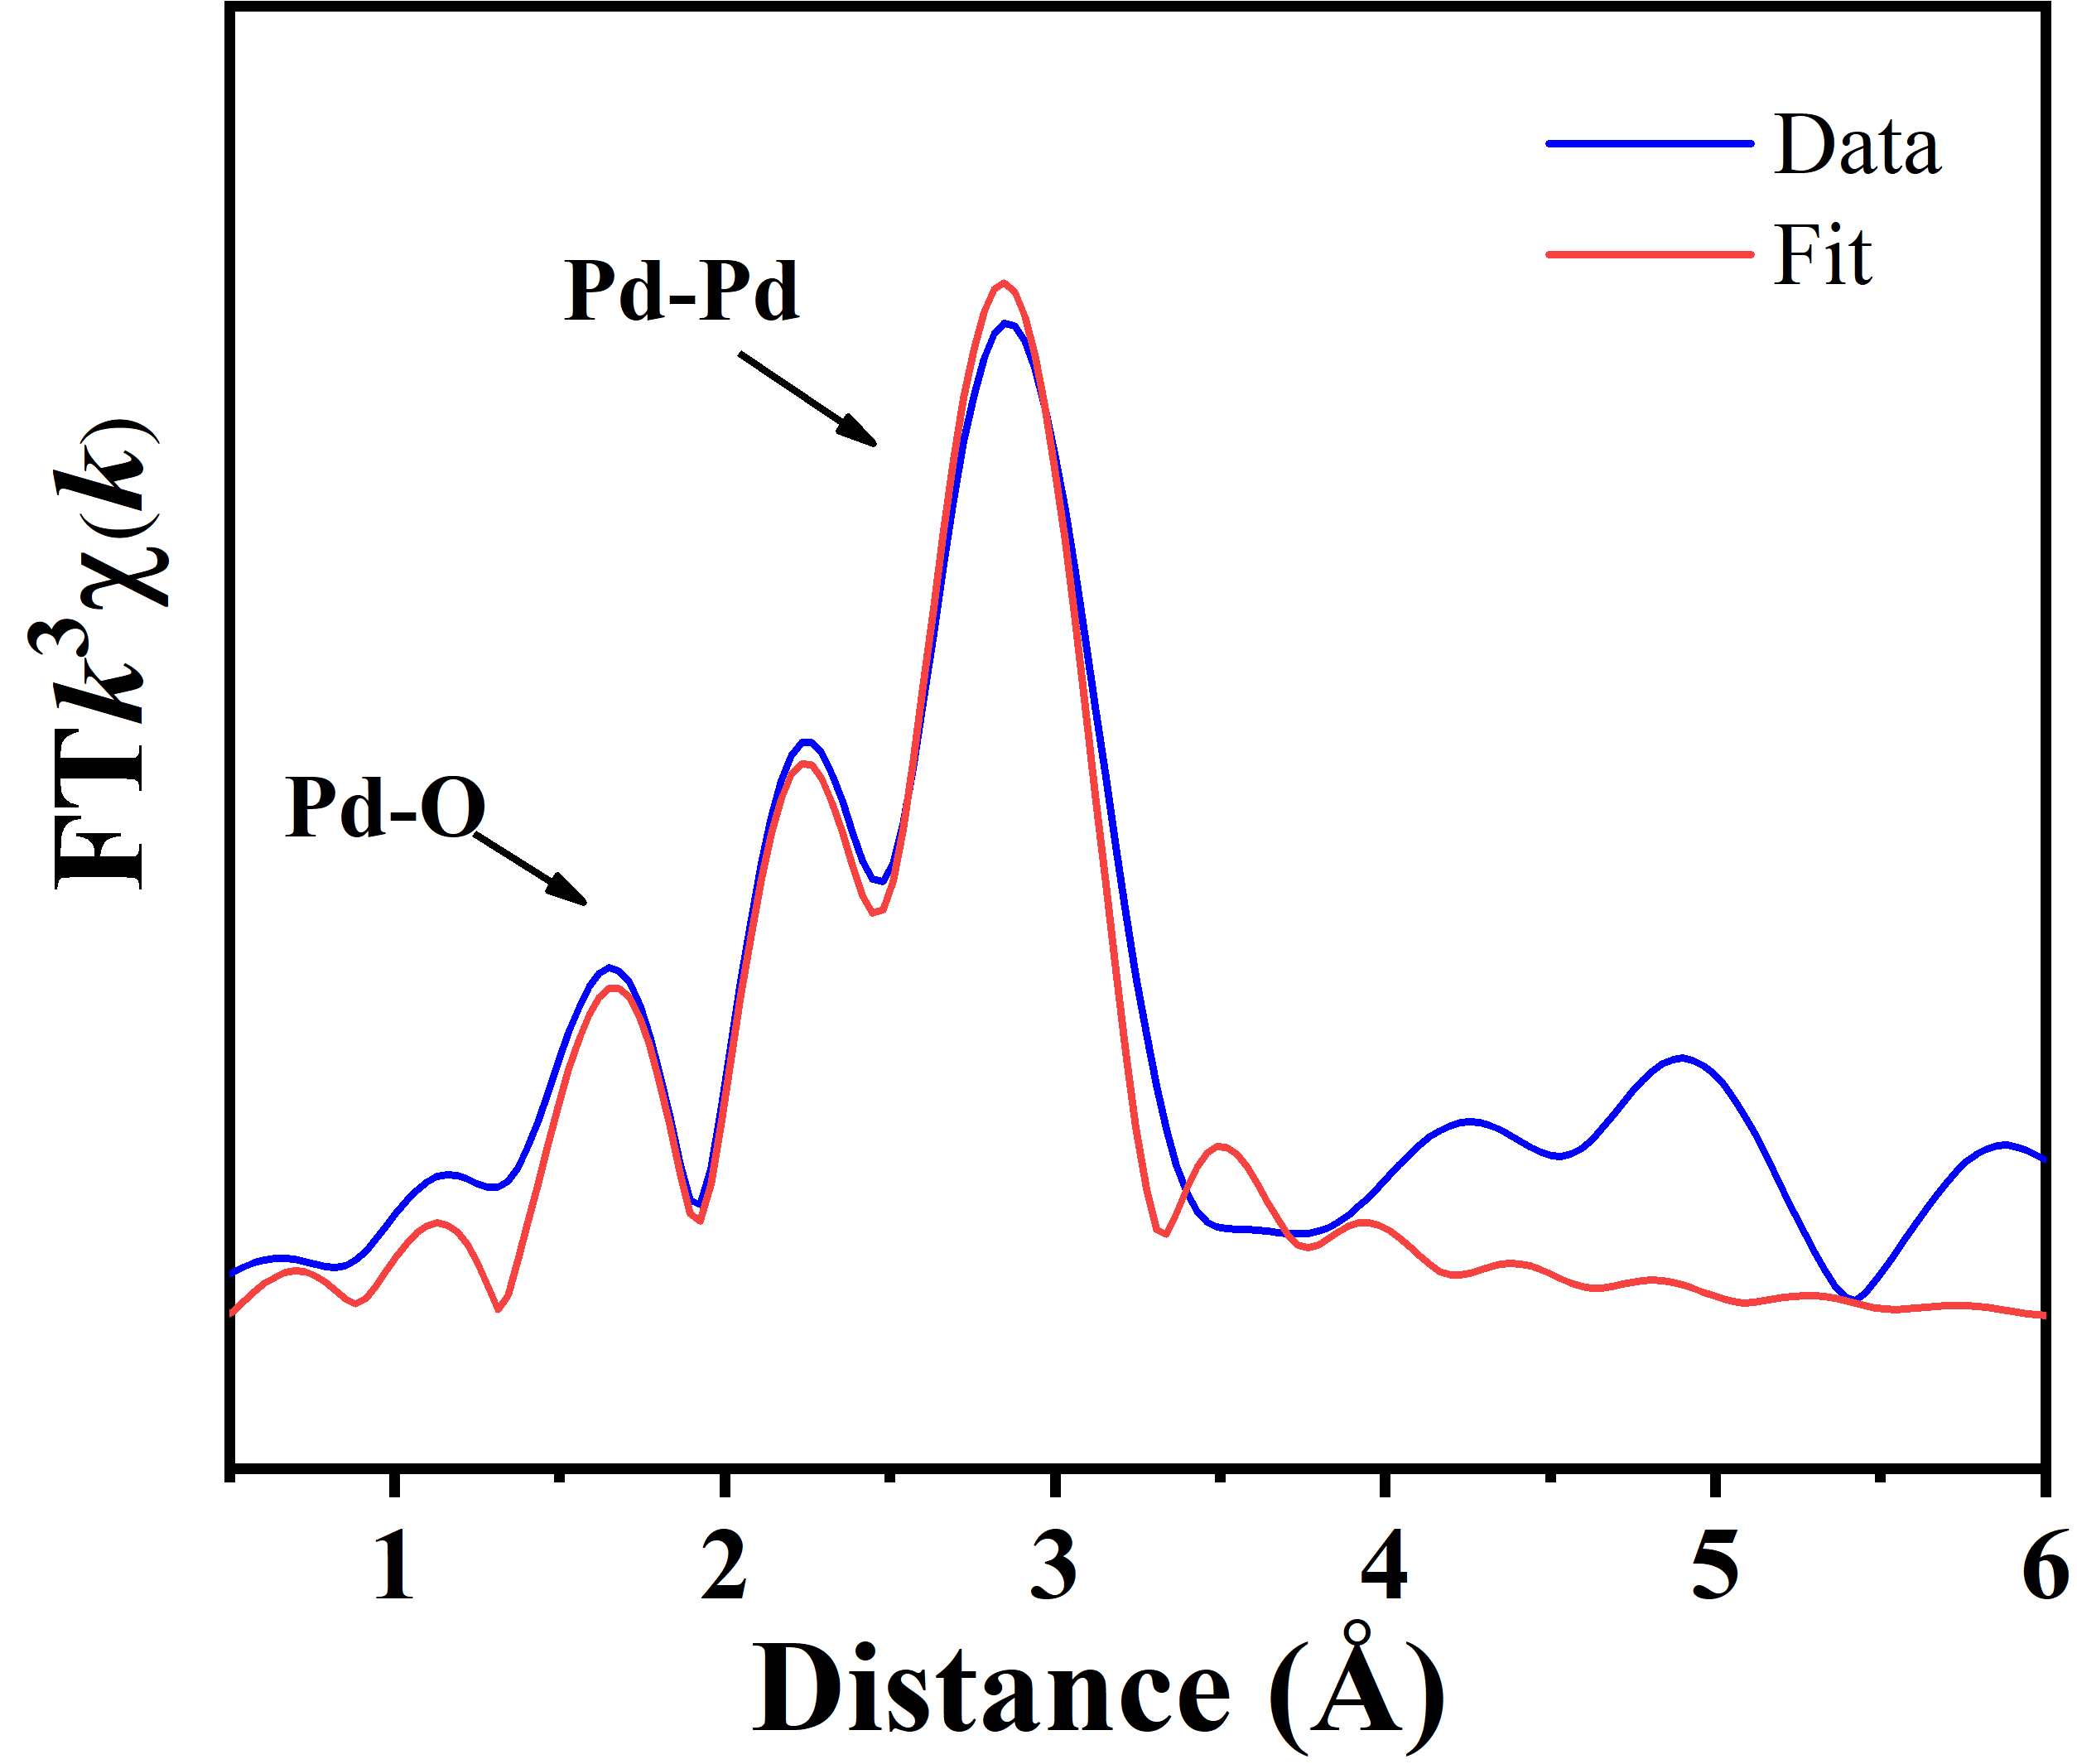
Figure S15. In-situ Pd K edge XAFS result over 1Pd1Bi-SiO₂ at reduction temperature of 180 ºC

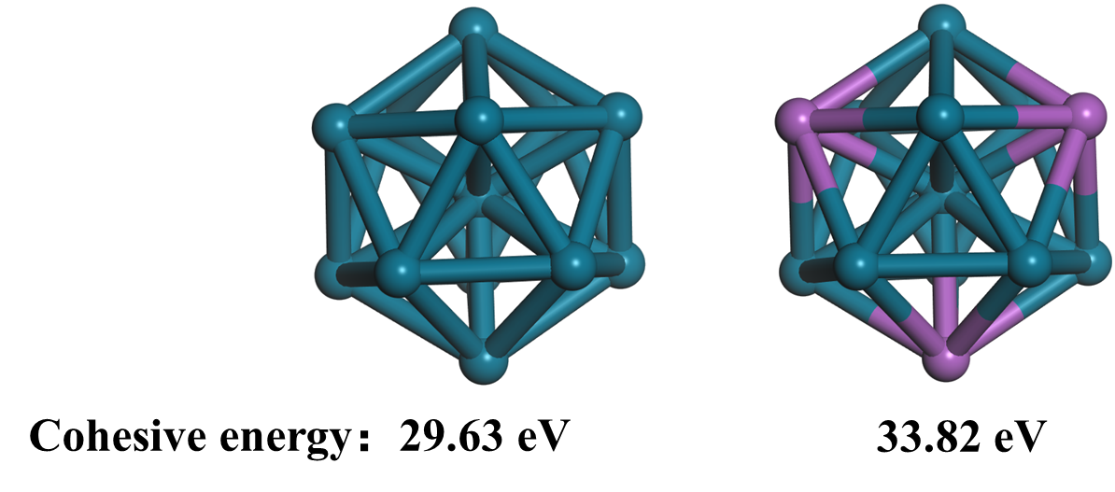
Figure S16. The cohesive energy of PdBi₁ single atom alloy and Pd nanoparticle.

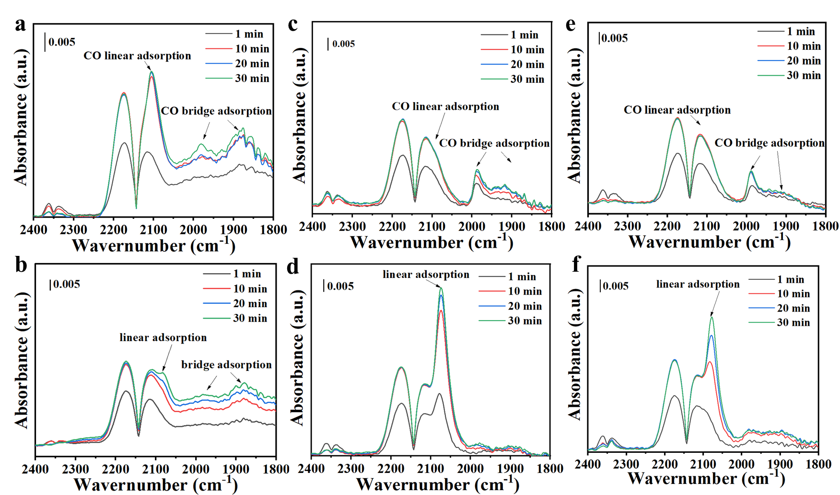
Figure S17. In-situ DRIFTS study of CO adsorption on 1Pd-SiO₂ and 1Pd2Bi-SiO₂ under different condition: (a,b) catalysts pretreated in situ at 300 °C under air, (c,d) catalysts at 180 °C under 5 vol.% H₂/N₂ flow, (e,f) after CO oxidation (CO flow rate: 30 mL min⁻¹; catalyst mass: 20 mg; temperature: 100 °C)

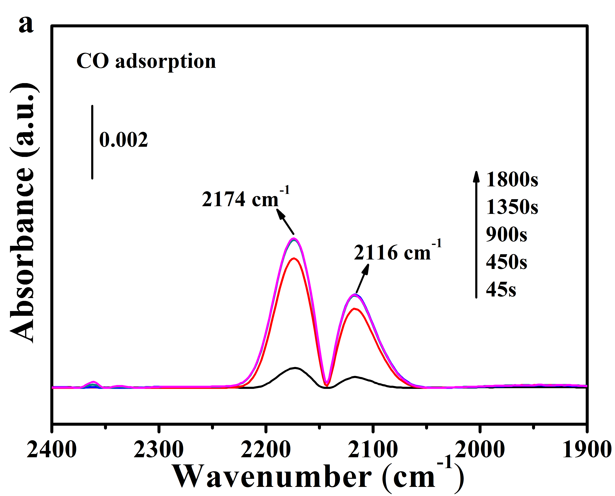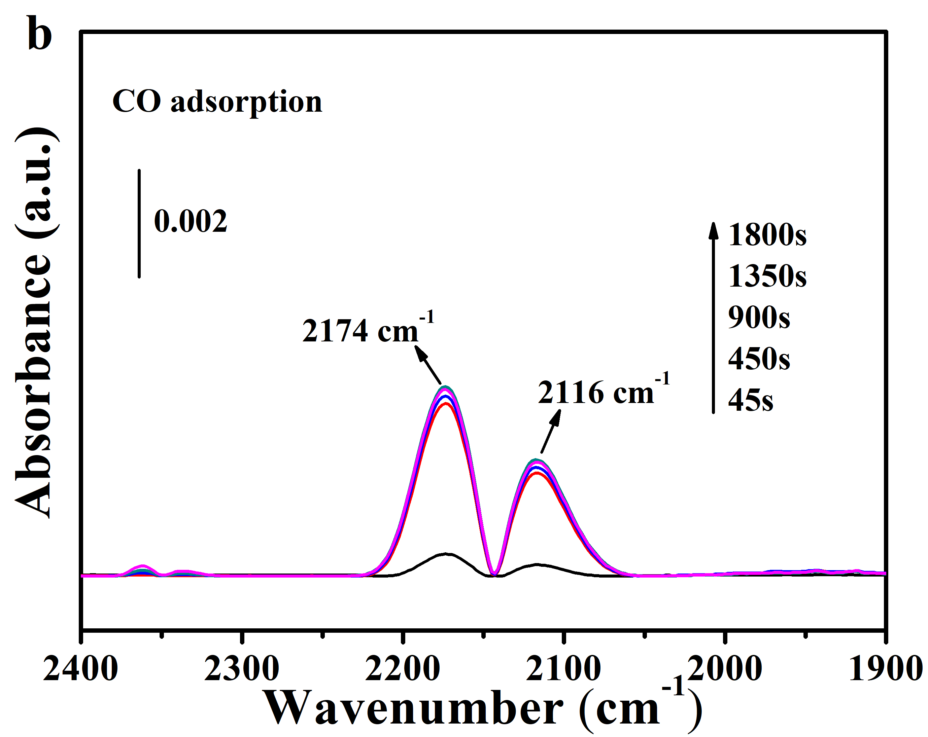
Figure S18. In-situ DRIFTS study of CO adsorption on 2Bi-SiO₂ with different pretreatment condition. The catalysts were pretreated in situ (a) at 300 °C under air and (b) at 180 °C under 5 vol.% H₂/N₂ flow in DRIFTS reaction cell before data collection (CO flow rate: 30 mL min⁻¹; catalyst mass: 20 mg; temperature: 100 °C)

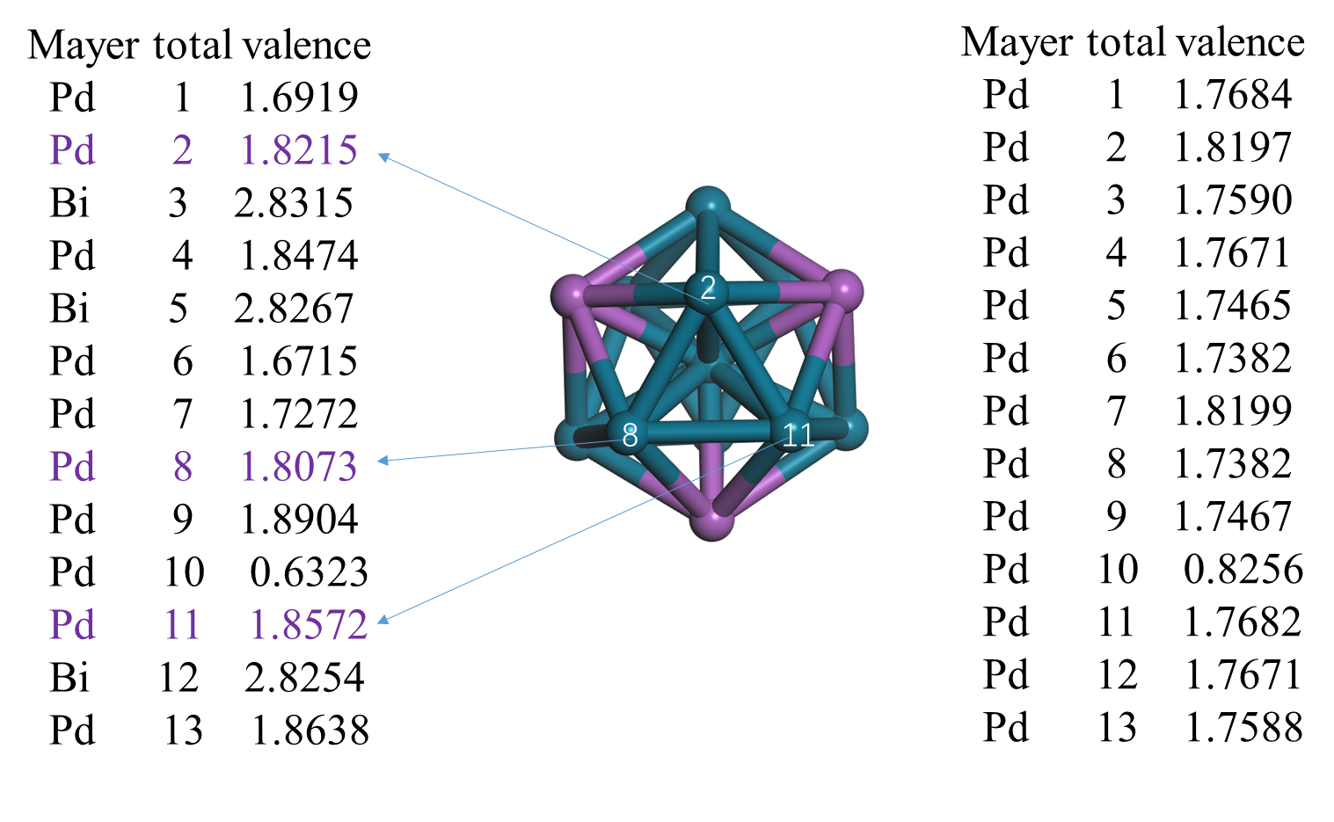
Figure S19. The total valence of palladium atom in PdBi₁ single atom alloy.

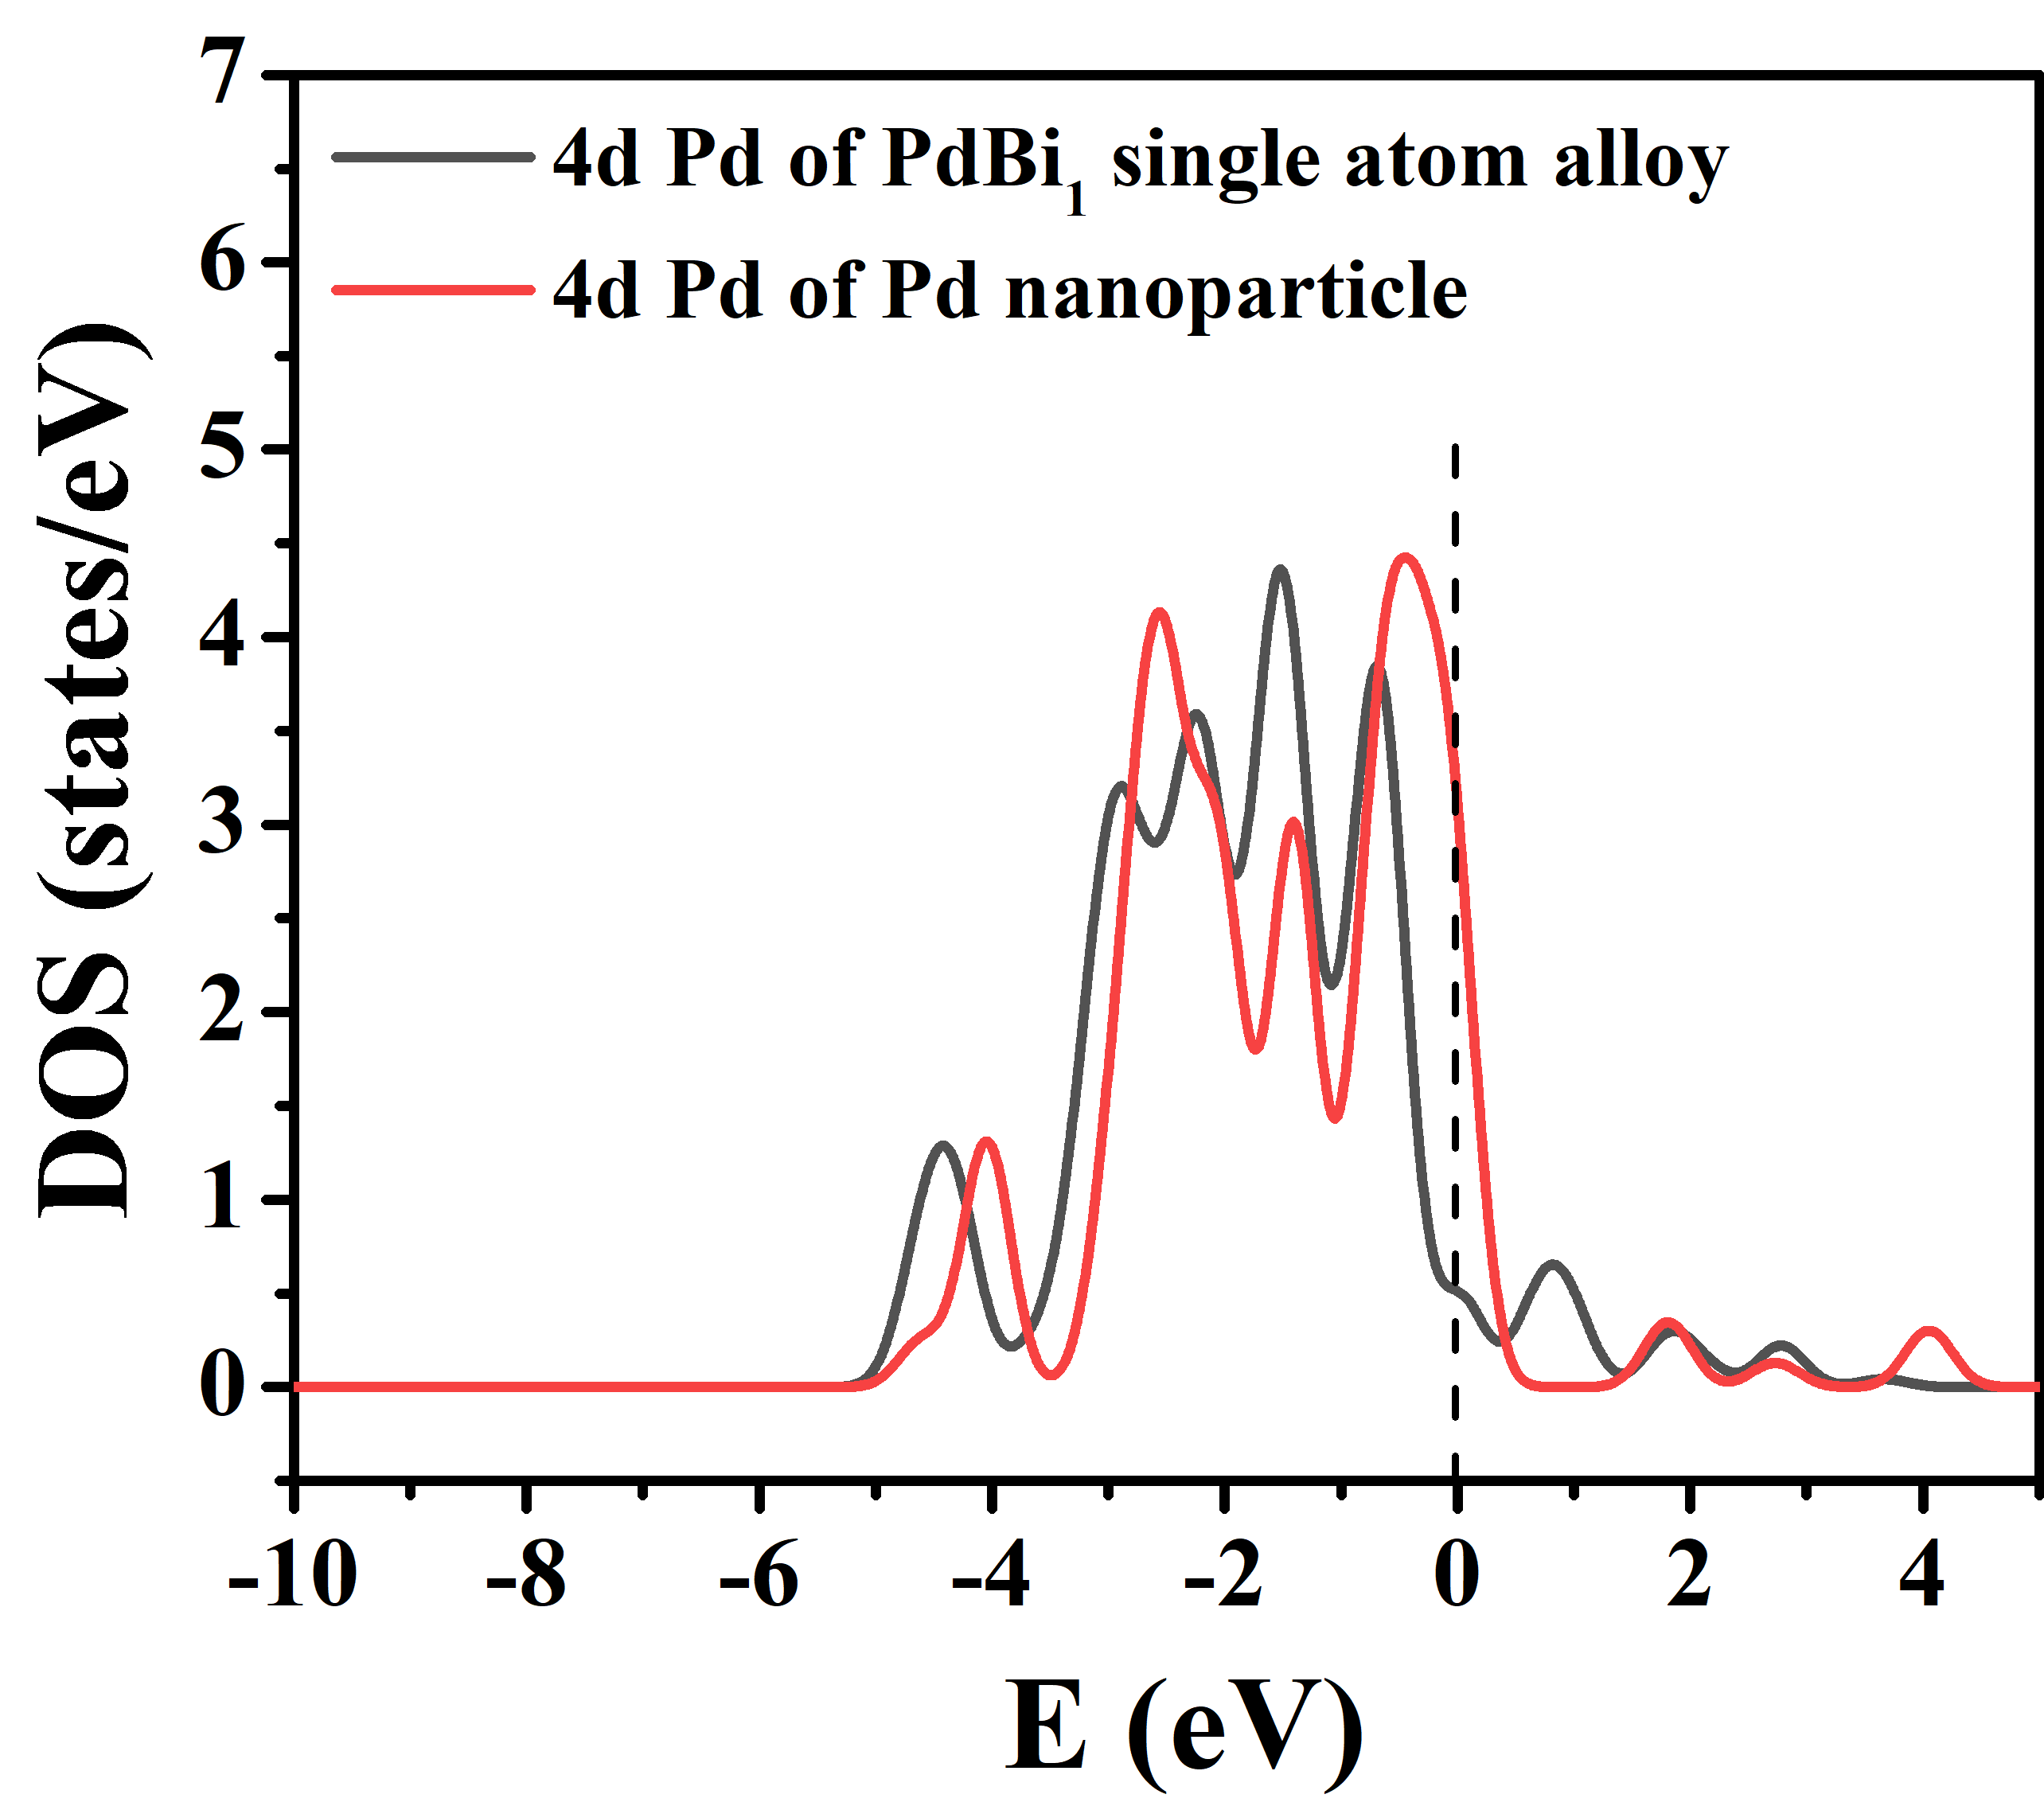
Figure S20. The density of state for Pd nanoparticle and PdBi₁ single atom alloy.

