Transition rules for eight eco-hydrological processes.
(1) Plant damage caused by ground deformation
Ground deformation not only causes changes in the elevation, slope, and aspect but also directly leads to the death of plants via stretching or pushing. Considering the difference in the resilience of plants to physical damages, the thresholds for the tolerance of herbs, shrubs and trees to ground deformation are set as 1.5 m, 1 m, and 0.5 m, respectively, which means that the herbs within the area with a subsidence depth of more than 1.5 m will die, while the shrubs and trees can only survive under subsidence depths of less than 1 m and 0.5 m, respectively. After this, all of the dead plants are converted to soil nutrients, and the conversion rules are consistent with the rule when the plants die naturally.
(2) Rainfall
The occurrence, duration, and amount of the rainfall are all random, and thus, a series of random numbers are applied to simulate the rainfall. The amount of rainfall obtained per cell per unit time is calculated as follows:
$rain=\frac{sumrain}{rainday*raintime}×prain,$ | (1)
where rain is the amount of rainfall in each cell per unit time, arain is the rainfall intensity, prain is the probability of rain falling within a cell, sumrain is the accumulated rainfall, rainday is the number of days of rainfall, and raintime is the duration of each rainfall event.
In this paper, the rainfall data for the study area over the past 50 years are used as a reference to determine the parameters of the rainfall, and the difference in the amount of rainfall in spring and summer are considered (Table S2), while the rainfall in autumn and winter are not included due to the low survival and germination rates of plants in these two seasons. Spring is defined as the 59th to the 151st days of the year; summer is defined as the 151st to the 243rd days; and the rest of the year is defined as autumn and winter.
(3) Infiltration
The differences in the infiltration rates of plant-covered and bare land are considered, as well as the slope and nutrition in each cell. The rate of infiltration is calculated using Equations (2) and (3). Based on sampling and testing of the soil in the study area, the saturated moisture content of the soil covered with vegetation and the soil without vegetation coverage are set as 0.35 and 0.3, respectively. In order to facilitate the conversion between variables with different dimensions such as rainfall, infiltration, and water content, the water content defined in this paper is unified as the proportion of the soil moisture per unit volume. Since the projected area of the surface water and surface soil formed by rainfall is 1 m², the soil water content is equal to the ratio of the depth of the accumulated infiltration to the depth of the surface soil (20 cm).
$${infilrate}_{plant}=cos{(s)}×\left(1.91+0.326×e^{-0.215infiltime}\right),$$ | (2)
$${infilrate}_{bare}=cos{(s)}×\left(0.3+0.621×e^{-0.25infiltime}\right)×\frac{nutrition}{ininutrition},$$ | (3)
where infilrate_{plant} and infilrate_{bare} are the infiltration rates of plant-covered and bare land, respectively, infil_{time} is the duration of the infiltration, nutrition is the soil nutrient content of each cell, and ininutrition is the initial soil nutrient content.
(4) Runoff
Runoff begins when the amount of rain exceeds the soil infiltration rate in each cell. The direction of the runoff is determined according to the elevation, and the runoff flows into the surrounding cell with the lowest elevation. The cell with the lowest elevation receives the rainfall from all of the surrounding cells until the runoff exceeds the maximum that it can collect, which is determined by the elevation drop between the surrounding cells with the lowest and highest elevations (Figure S1).
The runoff rate is calculated using the Manning–Strickler equation (Strohmeier et al., 2014):
$V=\frac{k}{n}{R_{h}}^{2/3}S^{1/2}$, | (4)
where k is the conversion coefficient, which is equal to 1 according to the international standard system; n is the Manning roughness coefficient, which is equal to 0.02 and 0.095 for bare and plant-covered land, respectively; R_{h} is the depth of the water passing through each cell; and S is the hydraulic slope line, which is equal to the tangent of the slope.
(5) Evaporation
Evaporation only occurs when the soil moisture is higher than the soil’s field capacity. The evaporation rates of the plant-covered and bare land are different, and they are also different in the different seasons, as well as in areas with various slope aspects, i.e., highest on sunny slope. Based on the meteorological data for the Yungang District over the past 50 years, after converting the annual evaporation rate into the daily evaporation rate, the evaporation rates of the plant-covered and bare land in the different seasons, as well as on slopes with various aspects are determined (Table S3).
(6) Accumulation and loss of soil nutrients
Two types of changes in soil nutrients are considered in this paper. The accumulation of soil nutrients mainly comes from the decomposition of plant litter and residual branches, while the loss of nutrients results from soil erosion caused by runoff. Based on previous research on the changes in soil nutrients, the accumulation law and loss rate of the soil nutrients are determined (Tables S4 and S5).
(7) Seed bank
The seed bank is also a perquisite for plant succession, which can be supplemented by plant litter and residual branches, as well as some accidents. In this paper, the number of seeds in each cell increases one by one when a plant dies or a neighboring plant wilt. In addition, there is a small probability (p = 0.04%) for each cell to obtain seeds via transport by wind, insects, or birds every day, and a random number is generated to describe this phenomenon.
(8) Plant growth and succession
There are certain differences in the soil moisture, nutrients, seed bank, and seed germination probability required for the growth of different plants, as well as the succession of communities. The soil nutrients, water, and seed bank conditions required by the different types of vegetation are based on previous research cases of the natural restoration of vegetation in the loess hilly area (Table S6).
Table S1. States of the cell in the plant community succession model
Categories | States
Rainfall | Total rainfall, rainfall days, rainfall intensity, probability of rainfall, unit rainfall
Terrain | Elevation, slope, and aspect
Infiltration | Cumulative amount of infiltration, unit amount of infiltration, infiltration rate, infiltration time, maximum infiltration amount
Runoff | Unit runoff, runoff duration, outflow amount, inflow amount, runoff rate, maximum runoff
Evaporation | Evaporation capacity
Soil | Soil moisture, soil nutrients, saturated moisture, field capacity, maximum nutrients, and soil seed bank
Plants | Coverage, herbs, shrubs, trees, litter, probability of death, probability of obtaining seeds, required moisture for seed germination, required nutrients for seed germination, neighboring plants
Table S2. Rainfall parameters in study area
 | Spring | Summer
Sumrain (mm) | 50–60 | 220–280
Rainday (day) | 10–20 | 20–40
Probability of rainfall occurring | 0.17 | 0.33
Raintime (min) | 60–600 | 60–720
Prain | 0.2–0.5 | 0.2–0.5
*prain is the probability of rain falling within a cell, sumrain is the accumulated rainfall, rainday is the number of days of rainfall, and raintime is the duration of each rainfall event.

Table S3. Angle ranges and evaporation rates for slopes with different aspects
Aspects | Angles | Evaporation rates (mm/day)
Aspects | Angles | Bare land |  |  | Plant-covered land
Aspects | Angles | Spring | Summer | Autumn and Winter | Spring | Summer | Autumn and Winter
North (shady slope) | (0,22.5)∪[337.5,360) | 0.01 | 0.02 | 0.015 | 0.005 | 0.01 | 0.0075
Northeast | [22.5,67.5) | 0.015 | 0.025 | 0.02 | 0.0075 | 0.0125 | 0.01
East | [67.5,112.5) | 0.02 | 0.03 | 0.025 | 0.01 | 0.015 | 0.0125
Southeast | [112.5,157.5) | 0.025 | 0.035 | 0.03 | 0.0125 | 0.0175 | 0.015
South (sunny slope) | [157.5,202.5) | 0.03 | 0.04 | 0.035 | 0.015 | 0.02 | 0.0175
Southwest | [202.5,247.5) | 0.025 | 0.035 | 0.03 | 0.0125 | 0.0175 | 0.015
West | [247.5,292.5) | 0.02 | 0.03 | 0.025 | 0.01 | 0.015 | 0.0125
Northwest | [292.5,337.5) | 0.015 | 0.025 | 0.02 | 0.0075 | 0.0125 | 0.01
Horizontal | 0 | 0.02 | 0.03 | 0.025 | 0.01 | 0.015 | 0.0125

Table S4. Accumulation of soil nutrients for different covered plant
Accumulation of soil nutrients (g/kg) | Trees | Shrubs | Herbs
Residual branches (in own cell) | 4.5 | 3 | 1.5
Residual branches (in neighboring cells) | 0.375 | 0.1875 | 0
Plant litter (in own cell) | 0.022 | 0.011 | 0
Plant litter (in neighboring cells) | 0.0014 | 0.0007 | 0

Table S5. Rates of soil nutrient change s
Categories | Plant-covered land | Bare land
Flowing out | $$\text{-}\text{0.8×}\frac{\text{arain}}{\text{2}}\text{×}\frac{\text{runoff}}{\text{50}}$$ | $$\text{-}\text{5.46×}\frac{\text{arain}}{\text{2}}\text{×}\frac{\text{runoff}}{\text{50}}$$
Flowing in | $$\text{5.46×}\frac{\text{arain}}{\text{2}}\text{×}\frac{\text{runoff}}{\text{50}}$$ | $$\text{0.8×}\frac{\text{arain}}{\text{2}}\text{×}\frac{\text{runoff}}{\text{50}}$$

Table S6. Seed germination conditions for different plants
 | Soil moisture (%) | Soil nutrients (g/kg) | Seed bank | Previous plants
Herbs | >=15 | >=10 | >=1 |  | Bare land
Shrubs | >=15 | >=18 | >=3 |  | Herbs
Trees | >=28 | >30 | >=6 |  | Herbs

Figure S1. Directions of runoff flowing out and flowing in. C(x,y) represents the cell in row x and column y; Drop is the difference between the elevations of the lowest (t_{min}) and highest (t_{max}) cells surrounding C(x,y).
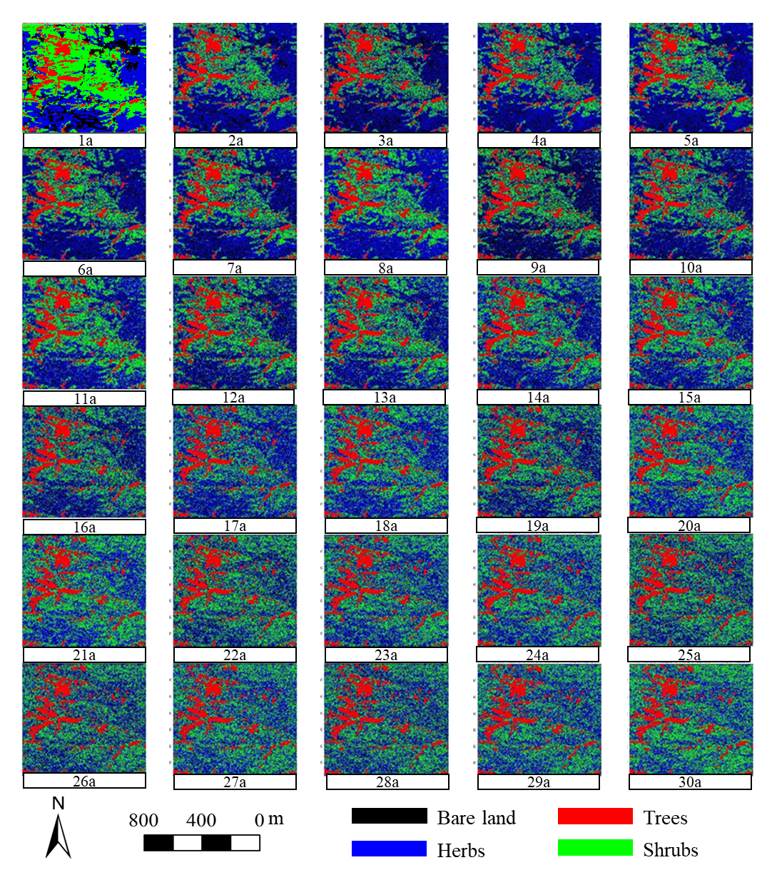
Figure S2. Dynamic changes in plant patterns in study area with initial plant communities during 30 years of plant succession in the non-mining scenario.
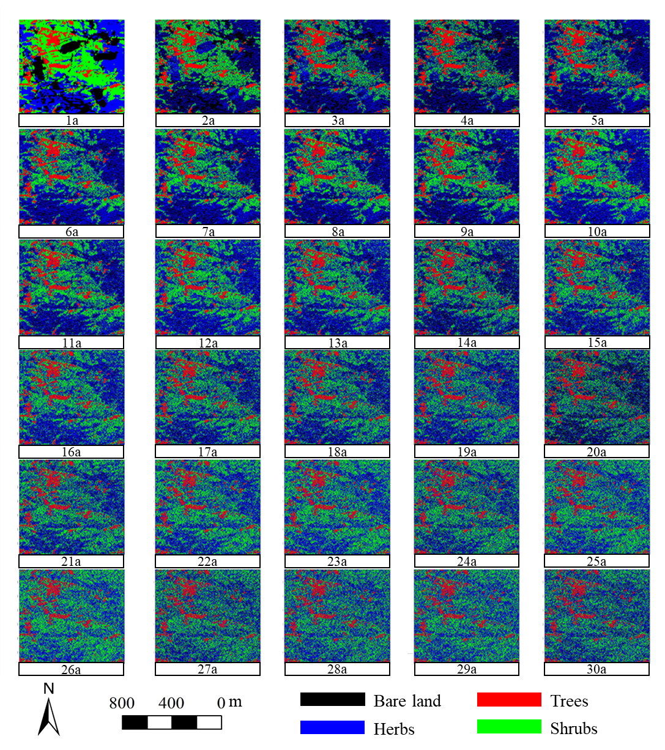
Figure S3. Dynamic changes in plant patterns in study area with initial plant communities during 30 years of plant succession in the mining scenario.

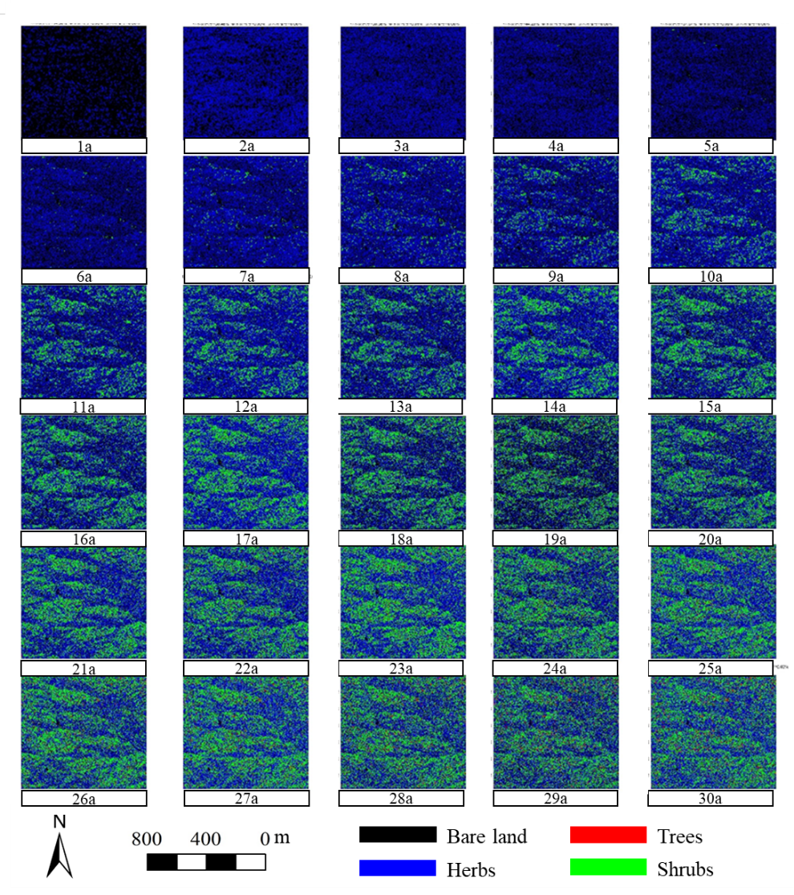
Figure S4. Dynamic changes in plant patterns in study area without initial plant communities during 30 years of plant succession in the non-mining scenario.
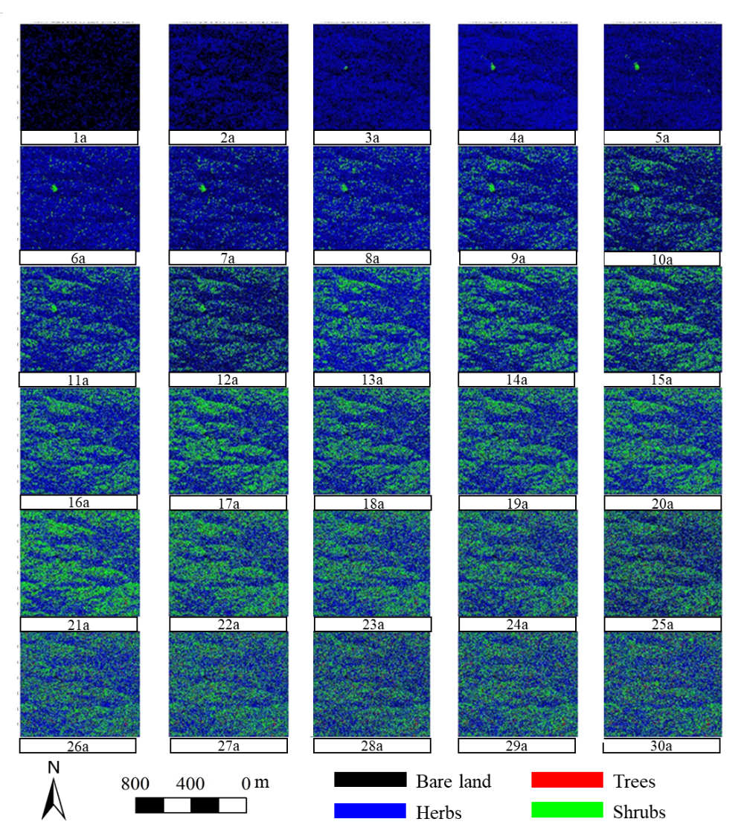
Figure S5. Dynamic changes in plant patterns in study area without initial plant communities during 30 years of plant succession in the mining scenario.

Reference:
Strohmeier, S. M., Nouwakpo, S. K., Huang, C.-H., & Klik, A. (2014). Flume experimental evaluation of the effect of rill flow path tortuosity on rill roughness based on the Manning–Strickler equation. CATENA, 118, 226-233. doi:https://doi.org/10.1016/j.catena.2014.01.011

