Supplementary Table 1: Primers pairs used for the detection of the DVCaV1 in HTS sequencing results.

Primer | Sequence (5′-3′) | Amplicon | Tm (℃)
DVCAV1 RT 1 F | AACATTGGACGCACAGGACA | nt 4,171-5,026 | 57.5
DVCAV1 RT 1 R | GGCCTTTCGGTCCTCTAAGT | nt 4,171-5,026 | 57.5
DVCAV1 RH1 1 F | TCCAATGGACCTGGACTCAAC | nt 5,144-5,816 | 58.0
DVCAV1 RH1 1 R | GCTCGTAAATATGCCGCTTGG | nt 5,144-5,816 | 58.0

Supplementary Fig. 1

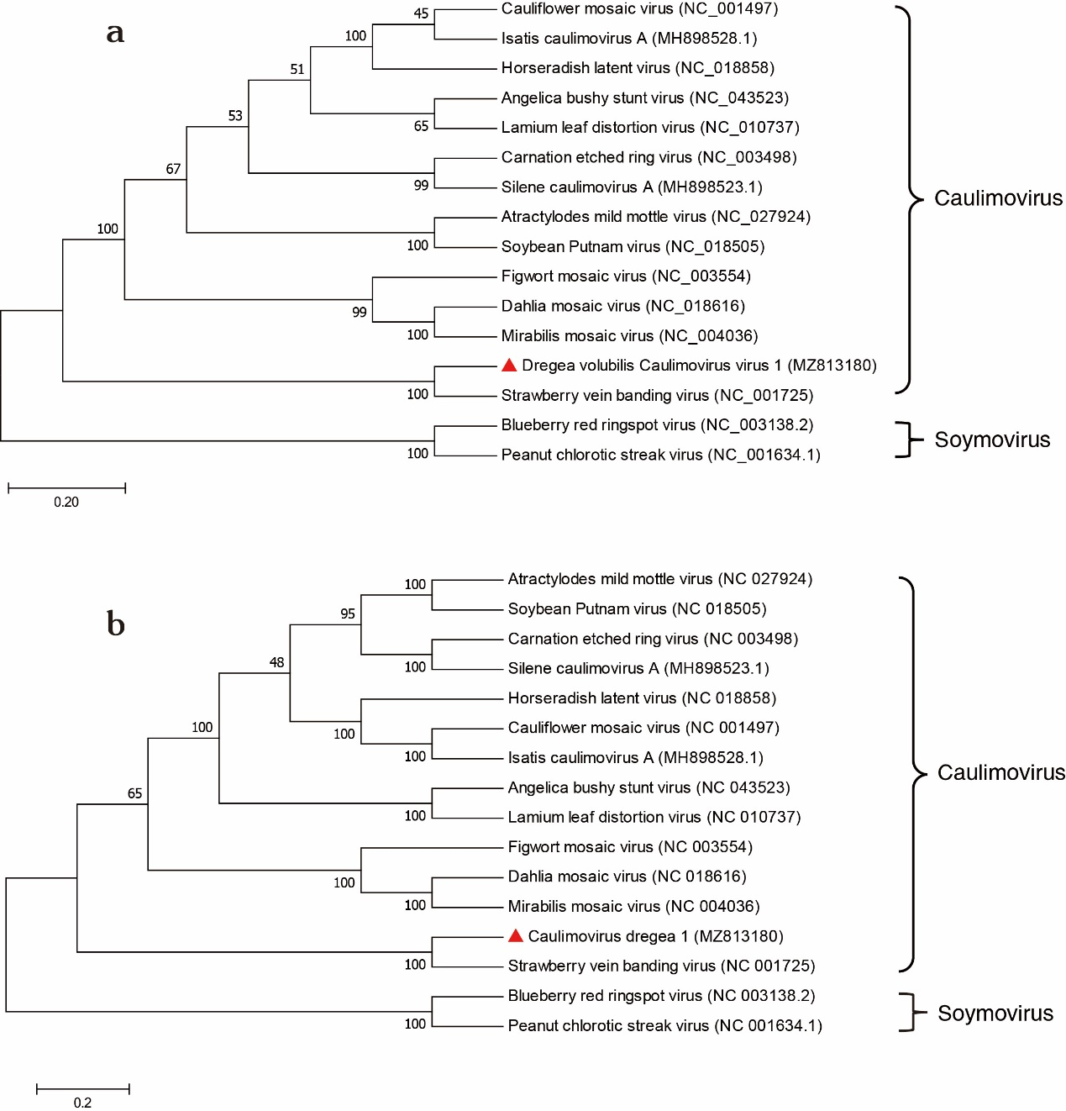
Phylogenetic trees based on alignments of DVCaV1 (GenBank accession no. MZ813180) and other caulimoviruses. The tree was constructed by the maximum likelihood method using MEGA7 software. The bootstrap values from 1,000 replicates are shown at the nodes. Blueberry red ringspot virus and peanut chlorotic streak virus were used as out group. a) The phylogenetic tree based on amino acid sequence alignment of the complete ORF5 of DVCaV1 and other caulimoviruses. b) The phylogenetic tree based on a complete nucleotide genome sequence alignment of DVCaV1 and other caulimoviruses.

