Review of Deep Learning Techniques for Neurological Disorders Detection

Akhilesh Kumar Tripathi¹*, Rafeeq Ahmed²† and Arvind Kumar Tiwari¹†

¹*CSE Department, Kamla Nehru Institute of Technology, Sultanpur, 228118, Uttar Pradesh, India.

²CSE Department, Koneru Lakshmaiah Education Foundation, Vaddeswaram, Guntur, 522502, Andhra Pradesh, India.
*Corresponding author(s). E-mail(s): akhileshtri@gmail.com;
Contributing authors: rafeeq.amu@gmail.com;
arvind@knit.ac.in;
†These authors contributed equally to this work.

Email Id: akhileshtri@gmail.com
Department of CSE, Kamla Nehru institute of technology, Sultanpur, UP, India.

Email Id: rafeeq.amu@gmail.com
Department of CSE, Koneru Lakshmaiah Education Foundation, Vaddeswaram, AP, India.

Email Id: arvind@knit.ac.in
Department of CSE, Kamla Nehru institute of technology, Sultanpur, UP, India

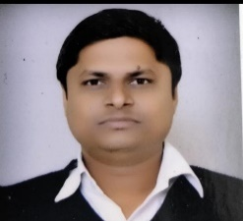 | Akhilesh Kumar Tripathi, Assistant Professor in MMMUT, Gorakhpur, has received M. Tech degree in CSE from MMM University of technology, Gorakhpur. He is currently pursuing Ph.D. from KNIT Sultanpur, UP, India. He has 8 years of teaching experience. His research interest includes deep learning, neurological disorder, image processing.
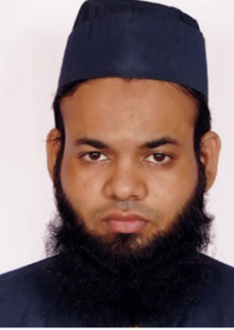 | Dr. Rafeeq Ahmed, Associate Professor of Department of Computer Science & Engineering, KL University, Guntur, Andhra Pradesh. He has done PhD from Jamia Millia Islamia (3rd Rank University in NIRF-22). He has done B.Tech and M.Tech from Aligarh Muslim University (11th Rank University in NIRF-22). He has been given gold medal in M.Tech. He has been awarded Maulana Azad National Fellowship (MANF). He has teaching experience of 10 years. He has published 20+ International Journal and Conferences papers. He has also got best paper award in international Conference SIGMA-2018 held at NSIT, New Delhi. Worked as an organizing member in International Conference and delivered expert lecture. His area of research is Deep Learning, IoT, Text Mining, Big Data.
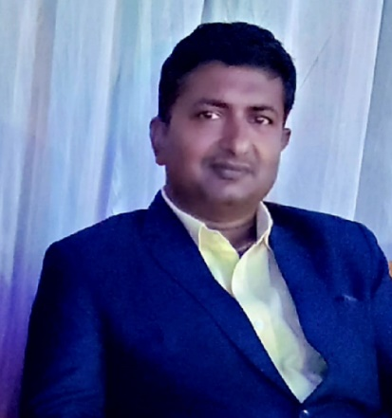 | Dr. Arvind Kumar Tiwari is an Associate Professor in the Department of Computer Science and Engineering at KNIT, Sultanpur, UP, India. He received the BE degree in Computer Science and Engineering from CCS university, Meerut, M.Tech. in Computer Science and Engineering from UPTU, Lucknow and Ph.D. in Computer Science and Engineering from IIT (BHU), Varanasi, India. He has more than 15 years of experience to guide UG and PG engineering students. He has more than 60 publications in journals of international repute including national journals, conferences and proceedings of the international conferences. He has also Published two books on Machine Learning, He is a professional member of various societies like ACM , Internet Society of India ISTE etc. He has an experience to organise two International Conferences and more than ten Faculty Development programs at KNIT Sultanpur. His research interests include Machine Learning, Computational Biology, Image Processing and Pattern Recognition.

