Cleaning testing of nineteenth-century plaster cast reconstructions with thin polyacrylamide-based surface attached gels
Charis Theodorakopoulos,^{1,*} Valentina Risdonne,² Silvia Freese,³ Samar Diraoui,³ Ulrich Jonas³

1 Department of Arts, Science in Conservation of Fine Art, Northumbria University,
Newcastle upon Tyne NE1 8ST, UK
2 Collection Care and Access, Victoria and Albert Museum, London SW7 2RL, UK
3 Department Chemistry - Biology, University of Siegen, Adolf-Reichwein-Strasse 2, D-57076 Siegen, Germany

Supporting information

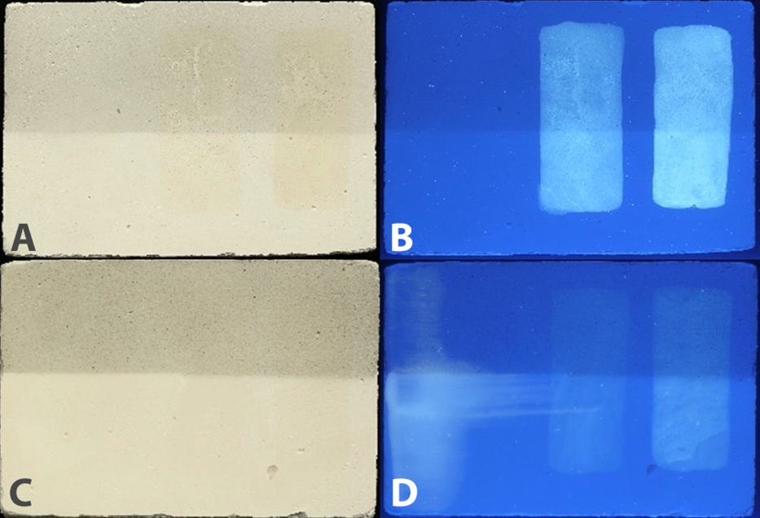
Figure 1s. Visible light (A, C) and UV fluorescence (B, D) of plaster plates that shows the coated plaster layout. In this example, the coatings are made of shellac 6wt% (middle) and 18wt% (at the right) in IMS. Plate C is coated with beeswax on top of the shellac coatings, whereas plate A does not have the beeswax coating. The upper half of the plates is soiled. A detailed database of the VR and UVf images is available [21]

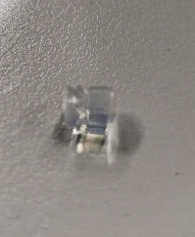
Figure 2s. Agarose plug on plaster substrate used to pH and conductivity on the surface of the plates

Table 1s Tested solutions according to the pH and conductivity of the soiled surface

 | Surface | pH | σ (mS/cm) | Solutions*
 | Surface | pH | σ (mS/cm) | Tested | Effective
 | Uncoated gypsum plaster | 5.95-6.34 | 0.04-0.22 | a, b, c, d, h | d
Coatings | Cold pressed linseed oil | 9.19 | 0.06 | g, h | h
Coatings | Boiled linseed oil | 6.71 | 0.03 | b | b
Coatings | Shellac6% | 5.25 | 0.04 | d, e | d
Coatings | Shellac18% | 5.27 | 0.08 | a, d, e | d
Coatings | Barite with Ca(OH)₂ | 9.00 | 0.12 | a, c, h | h
Coatings | Barite 60 °C | 8.54 | 0.04 | a, c, h | h
Coatings | Beeswax | 6.73-9.15 | 0.03-0.07 | IMS, i | i

Solutions
The solutions prepared were:
- 0.11M TEA buffered to pH 8 with 1M acetic acid
- 0.11M TEA buffered to pH 8.5 with 1M acetic acid
- 0.38M TEA buffered to pH 9 with 1M HCl
- 0.69M HCl buffered to pH 6 with TEA
- 0.09M HOAc buffered to pH 5.5 with 1M NaOH
- 0.09M HOAc buffered to pH 5 with 1M NaOH
- 2 wt% CA in DI water buffered to pH 8 with TEA
- 2 wt% EDTA in DI water buffered with 1M NaOH to pH 9
- 70% (v/v) IMS in DI water

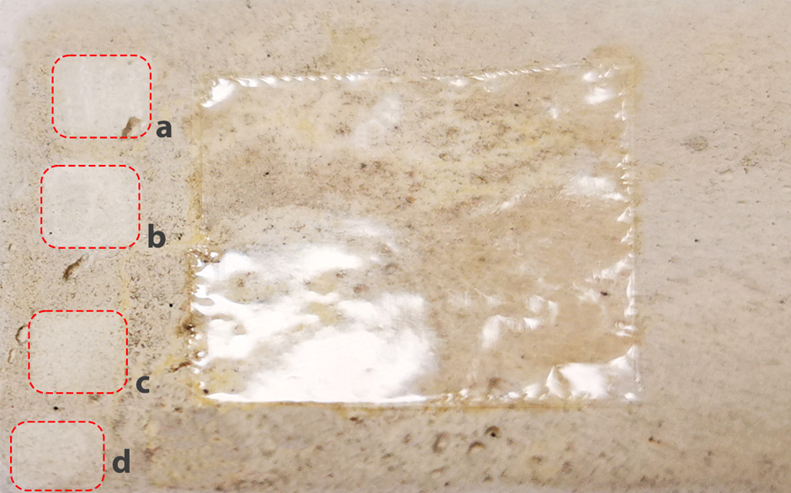
Figure 3s Preliminary tests on a soiled plaster plated coated with boiled linseed oil. The marked areas show the tests with: (a) PE-PAM₁₅, (b) PE-PAME₃₋₁₅ loaded with a pH 8.5 aqueous solution (TEA- HOAc) after 1 minute contact, showing the same cleaning capacity, (c) swab rolling that used to indicate the suitability of the solution. The area (d) shows the spot where pH and conductivity of the plate was measured. The central area shows a 2x2 cm PE-PAM₁₅ SAG foil on the plate.

Table 2s Roughness, Ra, and roughness depth, Rz
 | Uncoated plaster |  |  | Beeswax Coating
 | No soil | Soil | PE-PAM₁₅ | No soil | Soil | PE-PAM₁₅
Ra [μm] ± 0.3 μm | 5.35 | 5.30 | 2.80 | 1.23 | 3.16 | 3.34
Rz [μm] ± 0.05% | 39.91 ± 0.02 | 51.27 ± 0.03 | 20.46 ± 0.01 | 9.22 ± 0.005 | 44.72 ± 0.02 | 26.42 ± 0.01
 | Cold-pressed Linseed Oil |  |  | Boiled Linseed Oil
 | No soil | Soil | PE-PAM₁₅ | No soil | Soil | PE-PAM₁₅
Ra [μm] ± 0.3 μm | 3.48 | 4.45 | 1.52 | 3.15 | 4.40 | 4.14
Rz [μm] ± 0.05% | 28.52 ± 0.01 | 34.23 ± 0.02 | 9.98 ± 0.005 | 24.44 ± 0.01 | 45.45 ± 0.02 | 28.01 ± 0.01
 | 6 wt% Shellac in IMS |  |  | 18 wt% Shellac in IMS
 | No soil | Soil | PE-PAM₁₅ | No soil | Soil | PE-PAM₁₅
Ra [μm] ± 0.3 μm | 3.64 | 3.59 | 5.43 | 2.18 | 5.04 | 2.98
Rz [μm] ± 0.05% | 35.20 ± 0.02 | 22.81 ± 0.01 | 31.70 ± 0.02 | 19.68 ± 0.01 | 51.72 ± 0.03 | 16.04 ± 0.01
 | Barite with Ca(OH)₂ |  |  | Neat barite applied at 60 °C
 | No soil | Soil | PE-PAM₁₅ | No soil | Soil | PE-PAM₁₅
Ra [μm] ± 0.3 μm | 2.94 | 2.80 | 2.49 | 2.25 | 4.99 | 2.51
Rz [μm] ± 0.05% | 26.66 ± 0.01 | 29.72 ± 0.01 | 14.30 ± 0.01 | 16.67 ± 0.01 | 44.65 ± 0.02 | 16.63 ± 0.01

Table 3s Colourimetry and gloss data
 | Uncoated plaster |  |  | Beeswax Coating
 | No soil | Soil | PE-PAM₁₅ | No soil | Soil | PE-PAM₁₅
mean L* | 93.03 ± 0.05 | 82.15 ± 0.05 | 84.35 ± 1.29 | 91.74 ± 0.053 | 80.53 ± 0.05 | 85.73 ± 0.25
mean a* | 1.42 ± 0.001 | 1.12 ± 0.001 | 1.23 ± 0.05 | 1.61 ± 0.001 | 1.37 ± 0.00 | 1.57 ± 0.02
mean b* | 4.60 ± 0.001 | 4.67 ± 0.003 | 5.05 ± 0.22 | 6.42 ± 0.004 | 5.87 ± 0.00 | 6.11 ± 0.05
YI313 | 1.73 | 2.39 | 2.25 | 1.85 | 2.58 | 2.20
Gloss85° [GU] | 0.53 ± 0.18 | 0.48 ± 0.04 | 0.90 ± 0.01 | 1.42 ± 0.04 | 1.11 ± 0.17 | 12.65 ± 0.001
 | Cold-pressed Linseed Oil |  |  | Boiled Linseed Oil
 | No soil | Soil | PE-PAM₁₅ | No soil | Soil | PE-PAM₁₅
mean L* | 92.36 ± 0.05 | 79.65 ± 0.046 | 87.58 ± 0.449 | 88.91 ± 0.05 | 75.34 ± 0.04 | 76.68 ± 0.39
mean a* | 1.55 ± 0.001 | 1.24 ± 0.001 | 1.17 ± 0.005 | 1.54 ± 0.00 | 1.46 ± 0.001 | 1.16 ± 0.03
mean b* | 5.82 ± 0.003 | 5.63 ± 0.003 | 7.53 ± 0.132 | 10.27 ± 0.01 | 12.61 ± 0.007 | 12.55 ± 0.26
YI313 | 1.80 | 2.64 | 2.13 | 2.15 | 3.52 | 3.34
Gloss85° [GU] | 0.51 ± 0.09 | 0.05 ± 0.07 | 2.99 ± 0.01 | 0.49 ± 0.04 | 1.01 ± 0.04 | 3.56 ± 0.01
 | 6 wt% Shellac in IMS |  |  | 18 wt% Shellac in IMS
 | No soil | Soil | PE-PAM₁₅ | No soil | Soil | PE-PAM₁₅
mean L* | 92.97 ± 0.05 | 84.22 ± 0.05 | 87.03 ± 0.25 | 91.69 ± 0.053 | 80.49 ± 0.05 | 79.15 ± 1.21
mean a* | 1.21 ± 0.00 | 1.25 ± 0.00 | 1.21 ± 0.06 | 1.49 ± 0.001 | 1.28 ± 0.001 | 1.16 ± 0.03
mean b* | 5.76 ± 0.00 | 6.11 ± 0.00 | 7.52 ± 0.15 | 7.91 ± 0.005 | 7.13 ± 0.001 | 8.88 ± 0.13
YI313 | 1.77 | 2.30 | 2.17 | 1.90 | 2.64 | 2.17
Gloss85° [GU] | 0.73 ± 0.10 | 0.75 ± 0.14 | 2.65 ± 0.001 | 1.42 ± 0.23 | 0.62 ± 0.11 | 1.33 ± 0.91
 | Barite with Ca(OH)₂ |  |  | Neat barite applied at 60 °C
 | No soil | Soil | PE-PAM₁₅ | No soil | Soil | PE-PAM₁₅
Ra [μm] ± 0.3 μm | 94.72 ± 0.055 | 85.85 ± 0.05 | 86.58 ± 0.31 | 94.29 ± 0.054 | 88.09 ± 0.05 | 86.63 ± 1.51
 | 1.28 ± 0.001 | 1.15 ± 0.00 | 1.18 ± 0.02 | 1.16 ± 0.001 | 1.11 ± 0.00 | 1.19 ± 0.06
 | 2.93 ± 0.002 | 4.06 ± 0.00 | 4.40 ± 0.07 | 3.65 ± 0.002 | 3.89 ± 0.00 | 4.34 ± 0.07
 | 1.61 | 2.11 | 2.08 | 1.64 | 1.97 | 2.07
Rz [μm] ± 0.05% | 0.37 ± 0.12 | 0.19 ± 0.15 | 0.76 ± 0.01 | 1.05 ± 0.01 | 0.98 ± 0.00 | 1.64 ± 0.01

Table 4s FTIR bands and relevant assignments of the spectra acquired from unsoiled, soiled and cleaned uncoated and coated plaster plates

Frequencies (cm⁻¹) | Plaster (gypsum) plates [35] | Plaster plates with coatings |  |  |  |  | Assignments
Frequencies (cm⁻¹) | Plaster (gypsum) plates [35] | Linseed oil [39] | Shellac resin [40] | Barite-CaSO₄ [40, 41] | Barite (neat) [42] | Beeswax [43*] | Assignments
3520, 3400, 3233 |  |  |  |  |  | (weak) | ν_{O-H} (H₂O) stretching
2954 | – | – | – | – | – |  | v_{C-H} (C-H₃) symmetric stretching
2930 (weak) | – |  |  | – | – |  | v_{C-H} (C-H₃) symmetric stretching
2917 (strong) | – | – | – | – | – |  | v_{C-H} (C-H₂) asymmetric stretching
2857 (weak) | – | – |  | – | – | – | v_{C-H} (C-H₂) symmetric stretching
2849 (strong) | – | – | – | – | – |  | v_{C-H} (C-H₂) symmetric stretching
2248-2118 |  |  |  |  |  | – | ν_{O-S-O} (SO₄²⁻) stretching
2225 |  |  |  |  |  | – | O-H (H₂O) overtones
1740 (shoulder) | – |  | – | – | – | – | v_{C=O} stretching
1736 | – | – | – | – | – | (sharp) | v_{C=O} stretching
1722 (shoulder) | – | – |  | – | – | – | v_{C=O} stretching
1620, 1680 |  |  |  |  |  | – | δ_{O-H} (H₂O) bending
1458 – 1463 | – | – | (small) | – | – | (sharp) | δ_{C-H} (CH₂ and CH₃) scissor bending
1410 | – | – | – | (broad) | – | – | ν_{C-O} (CO₃²⁻) stretching
1399 | – | – | (small) | – | – | – | δ_{C-H} (CH₃) bending
1297 | – | – | (small) | – | – | – | ν_{C-O} stretching
1168 | – | – | – | – | – | (sharp) | ν_{C-O} stretching
1105 |  |  |  |  |  | – | ν_{O-S-O} (SO₄²) asymmetric stretching
1066 (strong) | – | – | – |  | – | – | ν_{C-O} (CO₃²⁻) stretching
1005 |  |  |  |  |  | – | ν_{O-S-O} (SO₄²) symmetric stretching
875 | – | – | – |  | – | – | δ_{C-O} (CO₃²⁻) out-of-plane bending in calcite
856 | – | – | – |  | – | – | δ_{C-O} (CO₃²⁻) out-of-plane bending in aragonite
713 | – | – | – |  | – | – | δ_{C-O} (CO₃²⁻) in-of-plane bending in calcite and aragonite
720 | – | – | – | – | – | (sharp) | C-H (CH₂) rocking
667, 597 |  |  |  |  |  | – | δ_{O-S-O} (SO₄²) bending
450-420 |  |  |  |  |  | – | ν_{O-S-O} (SO₄²) stretching

*Citation number refer to the Reference list in the paper

