Table 6: Patients’ adherence to lifestyle protocols
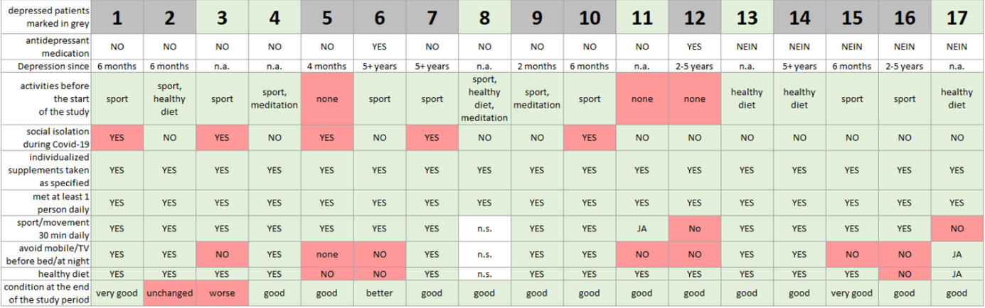
n.s. = not specified, n.a. = not applicable.

