Table 4: DASS-21 results in detail
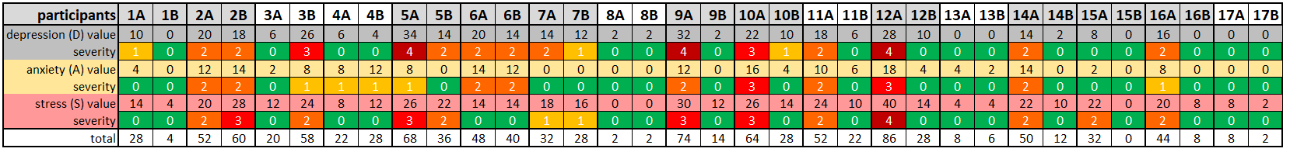
1A, 2A, … = patient number at the beginning of the study, 1B, 2B, … = patient number at the end of the study. Severity see Table 5.

