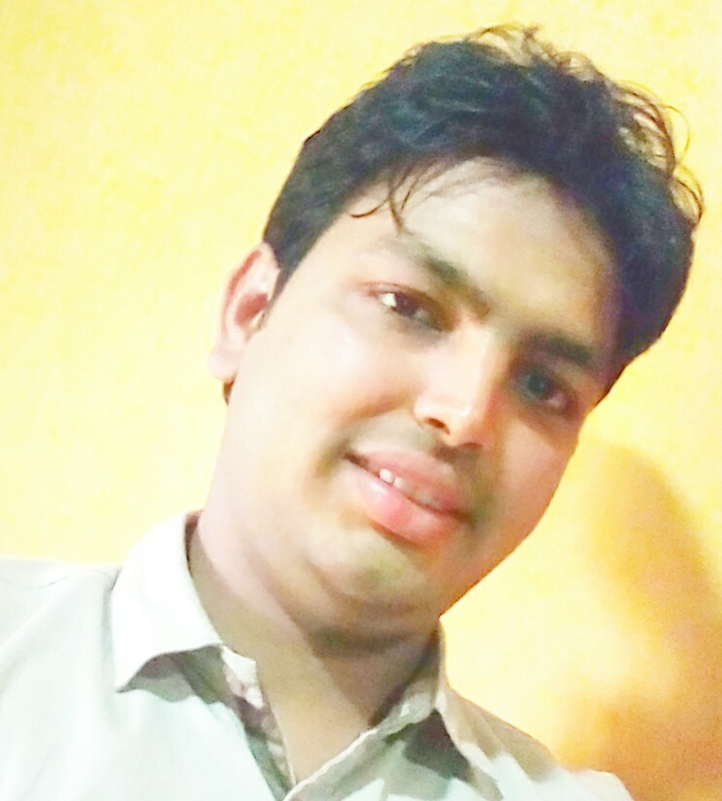
Photo of Mr.Md.Kamaruzzaman (First Author)

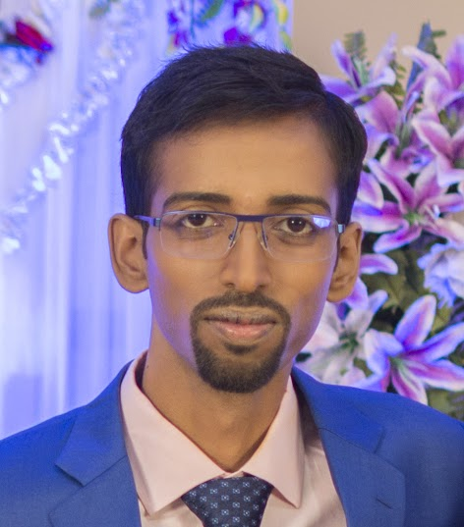
Photo of Dr.Abhijit Chandra (Second Author)

Biodata of Mr. Md. Kamaruzzaman (First Author)

Mr.Md.Kamaruzzaman is currently working as a faculty member at a deemed university in India. He has more than 7 years of teaching as well as more than 3 years of research experience. He has a dozen of research publications in some reputed International Journals, prestigious conference Proceedings and prominent research oriented Books. His research interests include wireless sensor network, Digital/Mobile Communication Systems. Mr. Zaman has served as a reviewer in a couple of reputed international journals. He has organized and participated in various Workshops, Seminars and Conferences. He is the member of I.E.E.E. and life member of International Association of Engineers. He is also the Honorary Rosalind Member of London Journal Press.
Biodata of Dr. Abhijit Chandra (Second Author)

Abhijit Chandra has obtained B.E. in Electronics and Telecommunication Engineering from Indian Institute of Engineering Science and Technology, Shibpur (Formerly, Bengal Engineering and Science University, Shibpur), India and M.E. Tel. E with specialization in Communication Engineering and Ph.D (Engineering) from Jadavpur University, India. Presently, he is working as Assistant Professor in the Department of Instrumentation and Electronics Engineering, Jadavpur University. His research area includes Digital Signal/Image Processing, Evolutionary Optimization Techniques, Digital/Mobile Communication Systems, Information and Coding Theory. He has published more than 70 research papers in International/National Conferences and Journals of good repute. Dr. Chandra has received President’s Gold Medal from Bengal Engineering and Science University, Shibpur for being First in the faculty of Engineering and Technology at B.E. examination. He has also received University Medal for standing First in order of merit at the M.E. Tel. E. examination from Jadavpur University. He has received “IEI Young Engineers Award 2015–2016” in Electronics and Telecommunication Engineering discipline from the Institution of Engineers (India) and Early Career Research Award from Science and Engineering Research Board, Department of Science and Technology, Govt. of India in 2017 in recognition of his achievement in engineering research. Recently, Dr. Chandra has been awarded with Young Faculty Research Fellowship of Visvesvaraya PhD Programme of Ministry of Electronics & Information Technology, Govt. of India.

