Supplementary Information

Multiple Adverse Events of anti-PD1/PDL1 Therapy: A Case-control Study using Japanese Prescription-diagnostics Database

Supportive Care in Cancer

Hirofumi Hamano PhD, Koji Miyata, Tomoyo Hara, Satoshi Sakaguchi, Masahiro Oura, Takahiro Niimura, Fuka Aizawa, Kenta Yagi, Naoto Okada, Hirokazu Miki, Mitsuhiro Goda, Yuki Ishizawa-Izawa, Yoshito Zamami, Hiroaki Yanagawa, Keisuke Ishizawa*

Correspondence should be addressed to Keisuke Ishizawa; ishizawa@tokushima-u.ac.jp
Department of Clinical Pharmacology and Therapeutics, Tokushima University Graduate School of Biomedical Sciences, Tokushima, Japan

Supplementary Methods – page 1
Online Resource 1 – Table S1 – page 3
Online Resource 2 – Table S2 – page 7
Online Resource 6 – Table S3 – page 9
Online Resource 3 – Figure S1 – page 11
Online Resource 4 – Figure S2 – page 12
Online Resource 5 – Figure S3 – page 13
Online Resource 7 – Figure S4 – page 14

Supplementary Methods

JMDC claims database
Data source and search
Using the Prescription-Diagnostics database of the JMDC claims database, anonymized information of patients using ICIs for the period between April 2014 and November 2020 was extracted and used for the analysis of the incidence of irAE. The supplementary analyses were the same as in the main article Methods. Lung (ICD-10: C30-C39), digestive organs (ICD-10: C15-C26), urinary tract (ICD-10: C64-C68), and skin (ICD-10: C43-C44) were used for carcinoma-specific classification analysis. In addition to nivolumab and pembrolizumab, PDL1 inhibitors (atezolizumab, durvalumab, and avelumab) were categorized in the drug-specific classification analysis.

VigiBase
Data source and search
The WHO database for spontaneous reports of adverse drug events, VigiBase (https://www.who-umc.org/vigibase/vigibase/), was used to analyze data up to March 2021. The drugs analyzed were atezolizumab, avelumab, cemiplimab, dostarlimab, durvalumab, nivolumab, pembrolizumab, and sintilimab. The number of days between ICI use and the occurrence of AEs was calculated using the Medical Dictionary for Regulatory Activities (MedDRA) Preferred Term (Table S2)10. The time to onset (TTO) was calculated as the number of days between ICI use and the onset of these AEs.

Online Resource 1 – Table S1. Use of International Classification of Diseases 10 (ICD-10) for JMDC claim database analysis
ICD-10 | Disease |  | ICD-10 | Disease
Adrenal |  |  | Neurological
E271 | Primary adrenocortical insufficiency |  | N009 | Acute nephritic syndrome: Unspecified
E272 | Addisonian crisis |  | N017 | Rapidly progressive nephritic syndrome: Diffuse crescentic glomerulonephritis
E274 | Other and unspecified adrenocortical insufficiency |  | N019 | Rapidly progressive nephritic syndrome: Unspecified
Colitis |  |  | N029 | Recurrent and persistent haematuria: Unspecified
K510 | Ulcerative (chronic) pancolitis |  | N049 | Nephrotic syndrome: Unspecified
K512 | Ulcerative (chronic) proctitis |  | N059 | Unspecified nephritic syndrome: Unspecified
K519 | Ulcerative colitis, unspecified |  | N10- | Acute tubulo-interstitial nephritis
K521 | Toxic gastroenteritis and colitis |  | N12- | Tubulo-interstitial nephritis, not specified as acute or chronic
K529 | Noninfective gastroenteritis and colitis, unspecified |  | N131 | Hydronephrosis with ureteral stricture, not elsewhere classified
K566 | Other and unspecified intestinal obstruction |  | N133 | Other and unspecified hydronephrosis
K579 | Diverticular disease of the intestine, part unspecified, without perforation or abscess |  | N142 | Nephropathy induced by an unspecified drug, medicament, or biological substance
K591 | Functional diarrhea |  | N170 | Acute renal failure with tubular necrosis
K599 | Functional intestinal disorder, unspecified |  | N178 | Other acute renal failure
K632 | Fistula of intestine |  | N179 | Acute renal failure, unspecified
K908 | Other intestinal malabsorption |  | N19- | Unspecified kidney failure
Type 1 diabetes |  |  | N259 | Disorder resulting from impaired renal tubular function, unspecified
E10- | Type 1 diabetes mellitus |  | N26- | Unspecified contracted kidney
E101 | Type 1 diabetes mellitus: With ketoacidosis |  | N288 | Other specified disorders of the kidney and ureter
E106 | Type 1 diabetes mellitus: With other specified complications |  | N289 | Disorder of kidney and ureter, unspecified
E109 | Type 1 diabetes mellitus: Without complications |  | Pancreatitis
Hematological |  |  | K858 | Other acute pancreatitis
D591 | Other autoimmune hemolytic anemias |  | K859 | Acute pancreatitis, unspecified
D592 | Drug-induced nonautoimmune hemolytic anemia |  | K861 | Other chronic pancreatitis
D595 | Paroxysmal nocturnal hemoglobinuria [Marchiafava-Micheli] |  | K868 | Other specified diseases of the pancreas
D599 | Acquired hemolytic anemia, unspecified |  | K869 | Disease of the pancreas, unspecified
D610 | Constitutional aplastic anaemia |  | Pneumonitis
D690 | Allergic purpura |  | J704 | Drug-induced interstitial lung disorders, unspecified
D692 | Other nonthrombocytopenic purpura |  | J841 | Other interstitial pulmonary diseases with fibrosis
D694 | Other primary thrombocytopenia |  | J849 | Interstitial pulmonary disease, unspecified
D695 | Secondary thrombocytopenia |  | Skin
D763 | Other histiocytosis syndromes |  | L100 | Pemphigus vulgaris
Hepatitis |  |  | L120 | Bullous pemphigoid
K710 | Toxic liver disease with cholestasis |  | L121 | Cicatricial pemphigoid
K711 | Toxic liver disease with hepatic necrosis |  | L129 | Pemphigoid, unspecified
K712 | Toxic liver disease with acute hepatitis |  | L139 | Bullous disorder, unspecified
K716 | Toxic liver disease with hepatitis, not elsewhere classified |  | L511 | Bullous erythema multiforme
K719 | Toxic liver disease, unspecified |  | Thyroiditis
K720 | Acute and subacute hepatic failure |  | E032 | Hypothyroidism due to medicaments and other exogenous substances
K754 | Autoimmune hepatitis |  | E038 | Other specified hypothyroidism
K759 | Inflammatory liver disease, unspecified |  | E039 | Hypothyroidism, unspecified
Hypophysitis |  |  | E050 | Thyrotoxicosis with diffuse goitre
E230 | Hypopituitarism |  | E055 | Thyroid crisis or storm
E231 | Drug-induced hypopituitarism |  | E059 | Thyrotoxicosis, unspecified
E232 | Diabetes insipidus |  | E063 | Autoimmune thyroiditis
E236 | Other disorders of the pituitary gland |  | E069 | Thyroiditis, unspecified
Myasthenia gravis |  |  | E078 | Other specified disorders of the thyroid
G700 | Myasthenia gravis |  | E079 | Disorder of the thyroid, unspecified
G709 | Myoneural disorder, unspecified |  | Tuberculosis
Myocarditis |  |  | A150 | Tuberculosis of the lung, confirmed by sputum microscopy with or without culture
I409 | Acute myocarditis, unspecified |  | A162 | Tuberculosis of the lung, without mention of bacteriological or histological confirmation
I514 | Myocarditis, unspecified |  | A165 | Tuberculous pleurisy, without mention of bacteriological or histological confirmation
Myositis |  |  | A169 | Respiratory tuberculosis, unspecified, without mention of bacteriological or histological confirmation
M609 | Myositis, unspecified |  | A182 | Tuberculous peripheral lymphadenopathy
M628 | Other specified disorders of muscle |  | A185 | Tuberculosis of eye
Nephritis |  |  | A188 | Tuberculosis of other specified organs
G049 | Encephalitis, myelitis, and encephalomyelitis, unspecified |  | Uveitis
G580 | Intercostal neuropathy |  | H200 | Acute and subacute iridocyclitis
G587 | Mononeuritis multiplex |  | H208 | Other iridocyclitis
G589 | Mononeuropathy, unspecified |  | H209 | Iridocyclitis, unspecified
G618 | Other inflammatory polyneuropathies |  | Venous thrombosis
G620 | Drug-induced polyneuropathy |  | I269 | Pulmonary embolism without mention of acute core pulmonale
G628 | Other specified polyneuropathies |  | I802 | Phlebitis and thrombophlebitis of other deep vessels of lower extremities
G629 | Polyneuropathy, unspecified |  | I808 | Phlebitis and thrombophlebitis of other sites
G819 | Hemiplegia, unspecified |  | I809 | Phlebitis and thrombophlebitis of unspecified site
G822 | Paraplegia, unspecified |  | I81- | Portal vein thrombosis
G825 | Tetraplegia, unspecified |  | I822 | Embolism and thrombosis of vena cava
G831 | Monoplegia of the lower limb |  | I823 | Embolism and thrombosis of renal vein
G838 | Other specified paralytic syndromes |  | I828 | Embolism and thrombosis of other specified veins
G839 | Paralytic syndrome, unspecified |  | I829 | Embolism and thrombosis of unspecified vein
G900 | Idiopathic peripheral autonomic neuropathy
G934 | Encephalopathy, unspecified
Japanese standard disease codes used to exclude inappropriate diseases in ICD-10
ICD-10 | Japanese standard disease code | Disease
Thyroiditis
E032 | 8847562 | Radiation hypothyroidism
E038 | 2449026 | Hypothalamic hypothyroidism
E039 | 2449014 | Low T3 syndrome
E039 | 8833505 | Anemia associated with hypothyroidism
E059 | 2429013 | Pseudohyperthyroidism
E059 | 8844716 | Thyroid eye disease
E063 | 8847898 | Hashimoto's encephalopathy
E078 | 2449035 | Resistance to thyroid hormone
E078 | 2468001 | Thyroxine-binding globulin deficiency
Hypophysitis
E230 | 8831248 | Anemia associated with hypopituitarism
E236 | 2273018 | Pituitary apoplexy
E236 | 2397002 | Pituitary mass
E236 | 8841346 | Rathke's cleft cyst
Adrenal
E274 | 8839683 | Adrenal hemorrhage
E274 | 8842095 | Hyporeninaemic hypoaldosteronism

Online Resource 2 – Table S2. Use of Medical Dictionary for Regulatory Activities (MedDRA) for World Health Organization VigiBase analysis
MedDRA ID | Preferred Term | MedDRA ID | Preferred Term
Adrenal |  | Nephritis
10001130 | Addison's disease | 10018364 | Glomerulonephritis
10001367 | Adrenal insufficiency | 10029117 | Nephritis
10001389 | Adrenocortical insufficiency acute | 10077087 | Autoimmune nephritis
10039807 | Secondary adrenocortical insufficiency | Neurological
10073179 | Adrenocorticotropic hormone deficiency | 10014581 | Encephalitis
Colitis |  | 10014625 | Encephalopathy
10009887 | Colitis | 10018767 | Guillain-Barre syndrome
10012735 | Diarrhea | 10027199 | Meningitis
10012741 | Diarrhea hemorrhagic | 10027201 | Meningitis aseptic
10013864 | Duodenitis | 10029331 | Neuropathy peripheral
10013865 | Duodenitis hemorrhagic | 10034580 | Peripheral motor neuropathy
10014866 | Enteritis | 10034620 | Peripheral sensory neuropathy
10014893 | Enterocolitis | 10049168 | Ocular myasthenia
10014896 | Enterocolitis hemorrhagic | 10056673 | Peripheral sensorimotor neuropathy
10056979 | Colitis microscopic | 10061811 | Demyelinating polyneuropathy
10075761 | Autoimmune colitis | 10070439 | Autoimmune neuropathy
10076599 | Ulcerative gastritis | 10072378 | Encephalitis autoimmune
10081456 | Autoimmune enteropathy | 10078012 | Limbic encephalitis
Type 1 diabetes |  | Pancreatitis
10012671 | Diabetic ketoacidosis | 10033645 | Pancreatitis
10023380 | Ketoacidosis (diabetic) | 10033647 | Pancreatitis acute
10067584 | Type 1 diabetes mellitus | 10069002 | Autoimmune pancreatitis
10072628 | Fulminant type 1 diabetes mellitus | Pneumonitis
Hematological |  | 10022611 | Interstitial lung disease
10018916 | Hemolytic anemia | 10035742 | Pneumonitis
10043561 | Thrombocytopenic purpura | 10067472 | Organizing pneumonia
10043648 | Thrombotic thrombocytopenic purpura | Skin
10055128 | Autoimmune neutropenia | 10014989 | Epidermolysis bullosa
10071583 | Haemophagocytic lymphohistiocytosis | 10034277 | Pemphigoid
10073785 | Autoimmune hemolytic anemia | 10034280 | Pemphigus
10074667 | Immune thrombocytopenic purpura | 10042033 | Stevens-Johnson syndrome
Hypophysitis |  | 10044223 | Toxic epidermal necrolysis
10021067 | Hypopituitarism | 10057970 | Toxic skin eruption
10021111 | Hypothalamo-pituitary disorder | 10059516 | Skin toxicity
10048675 | Pituitary enlargement | 10083961 | Autoimmune blistering disease
10062767 | Hypophysitis | Thyroiditis
10063685 | Lymphocytic hypophysitis | 10020850 | Hyperthyroidism
Hepatitis |  | 10021114 | Hypothyroidism
10000804 | Acute hepatic failure | 10043778 | Thyroiditis
10003827 | Autoimmune hepatitis | 10049046 | Autoimmune thyroiditis
10019663 | Hepatic failure | 10076644 | Autoimmune hypothyroidism
10019717 | Hepatitis | Tuberculosis
10019727 | Hepatitis acute | 10044755 | Tuberculosis
10019851 | Hepatotoxicity | Uveitis
10072268 | Drug-induced liver injury | 10022941 | Iridocyclitis
Myasthenia gravis |  | 10022955 | Iritis
10028417 | Myasthenia gravis | 10046851 | Uveitis
10028424 | Myasthenic syndrome | 10075690 | Autoimmune uveitis
10062758 | Myasthenia gravis crisis | 10082001 | Vogt-Koyanagi-Harada disease
Myocarditis |  | 10083069 | Immune-mediated uveitis
10028606 | Myocarditis | Venous thrombosis
10064539 | Autoimmune myocarditis | 10037377 | Pulmonary embolism
Myositis |  | 10037459 | Pulmonary venous thrombosis
10036102 | Polymyositis | 10047249 | Venous thrombosis
10074769 | Necrotizing myositis | 10051055 | Deep vein thrombosis
10039020 | Rhabdomyolysis

Online Resource 5 – Table S3. Patient characteristics associated with the cancer immunotherapy type
Patients population | Nivolumab (%)  n = 2482 | Pembrolizumab (%)  n = 2789 | PD-L1 inhibitor (%)  n = 1139
Time to onset of first irAE after initiation of ICI (days) | 79 (IQR, 29-169) | 72 (IQR, 29-155) | 75 (IQR, 29-150)
Type of irAE
Type 1 diabetes | 23 (0.9) | 27 (1) | 15 (1)
Tuberculosis | 16 (0.6) | 6 (0.2) | 6 (0.5)
Uveitis | 7 (0.3) | 4 (0.1) | 0
Hypophysitis | 41 (2) | 32 (1) | 6 (0.5)
Pneumonitis | 193 (8) | 264 (9) | 89 (8)
Hepatitis | 34 (1) | 36 (1) | 13 (1)
Thyroiditis | 404 (16) | 314 (11) | 131 (12)
Myositis | 6 (0.2) | 6 (0.2) | 2 (0.2)
Skin | 10 (0.4) | 17 (0.6) | 1 (0.1)
Neurological | 147 (6) | 186 (7) | 96 (8)
Nephritis | 186 (8) | 224 (8) | 46 (4)
Venous thrombosis | 70 (3) | 78 (3) | 45 (4)
Colitis | 76 (3) | 67 (2) | 19 (2)
Hematological | 10 (0.4) | 6 (0.2) | 3 (0.3)
Adrenal | 77 (3) | 73 (3) | 15 (1)
Myasthenia gravis | 8 (0.3) | 9 (0.3) | 0
Myocarditis | 3 (0.1) | 3 (0.1) | 2 (0.2)
Pancreatitis | 21 (0.8) | 14 (0.5) | 8 (0.7)
All-cause death | 664 (27) | 1053 (38) | 246 (22)
irAE-related death | 154 (6) | 131 (5) | 38 (3)
Type 1 diabetes | 1 (0.04 / 4ª) | 1 (0.04 / 4ª) | 1 (0.09 / 7ª)
Tuberculosis | 1 (0.04 / 6ª) | 1 (0.04 / 17ª) | 0
Uveitis | 0 | 0 | 0
Hypophysitis | 4 (0.2 / 10ª) | 1 (0.04 / 3ª) | 1 (0.09 / 17ª)
Pneumonitis | 40 (2 / 21ª) | 48 (2 / 18ª) | 10 (0.9 / 11ª)
Hepatitis | 3 (0.1 / 9ª) | 3 (0.1 / 8ª) | 1 (0.09 / 8ª)
Thyroiditis | 51 (2 / 13ª) | 25 (0.9 / 8ª) | 5 (0.4 / 4ª)
Myositis | 0 | 1 (0.04 / 17ª) | 0
Skin | 0 | 1 (0.04 / 6ª) | 0
Neurological | 25 (1 / 17ª) | 19 (0.7 / 10ª) | 9 (0.8 / 9ª)
Nephritis | 28 (1 / 15ª) | 31 (1 / 14ª) | 4 (0.4 / 9ª)
Venous thrombosis | 18 (0.7 / 26ª) | 13 (0.5 / 17ª) | 5 (0.4 / 11ª)
Colitis | 10 (0.4 / 13ª) | 6 (0.2 / 9ª) | 0
Hematological | 1 (0.04 / 10ª) | 0 | 0
Adrenal | 9 (0.4 / 12ª) | 7 (0.3 / 10ª) | 3 (0.3 / 20ª)
Myasthenia gravis | 0 | 1 (0.04 / 11ª) | 0
Myocarditis | 0 | 1 (0.04 / 33ª) | 1 (0.09 / 50ª)
Pancreatitis | 3 (0.1 / 14ª) | 3 (0.1 / 21ª) | 3 (0.3 / 38ª)
ªirAE-dependent mortality rate for each irAE. The mortality rate (%) was calculated as follows: number of deaths from various irAE / number of people with various irAE

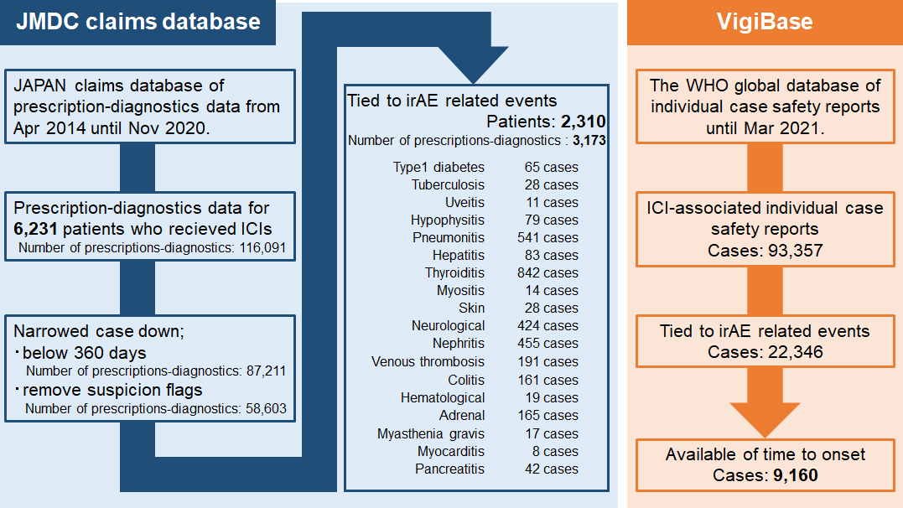
Figure legends
Online Resource 3 – Figure S1. Flow-chart in the JMDC claim database and VigiBase

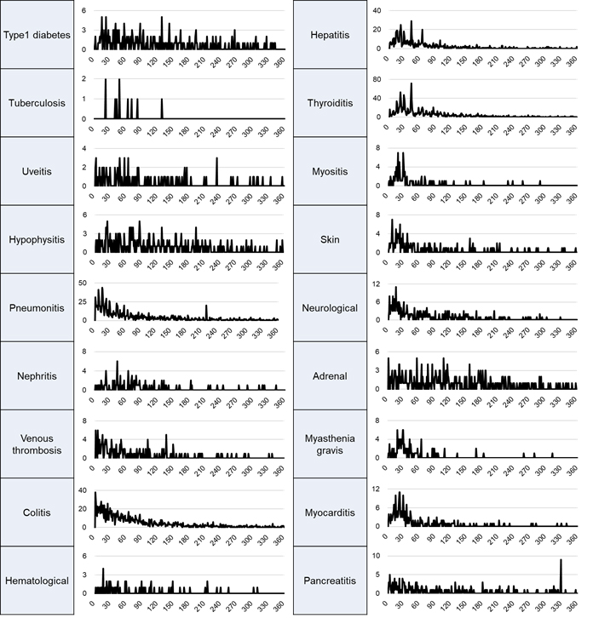
Online Resource 4 – Figure S2. Number of cases with each adverse event per period in the VigiBase The horizontal axis shows the number of each adverse event cases, and the vertical axis shows the number of days until onset.

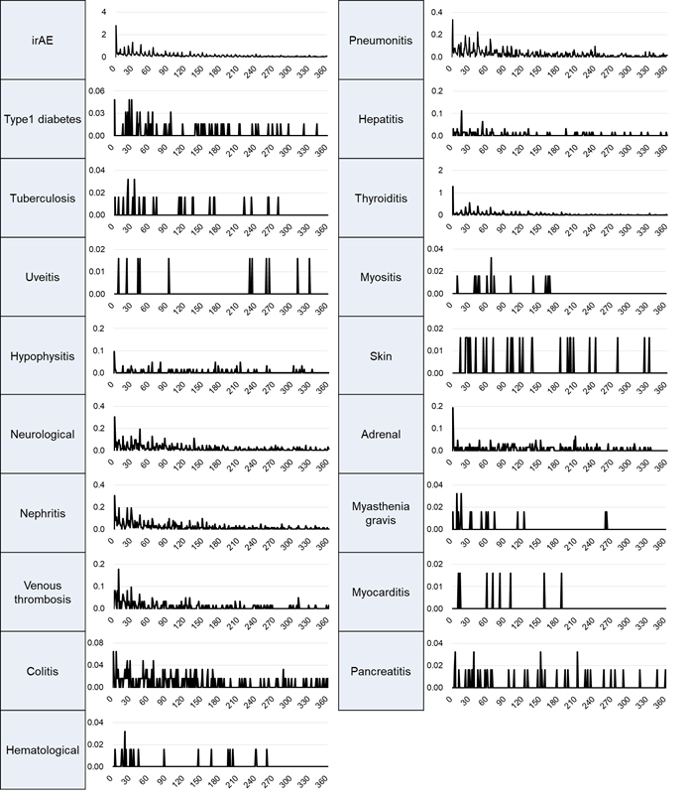
Online Resource 5 – Figure S3. Number of cases with each adverse event per period in the JMDC claims database. The horizontal axis shows the incidence rate of each adverse event, and the vertical axis shows the number of days until onset.

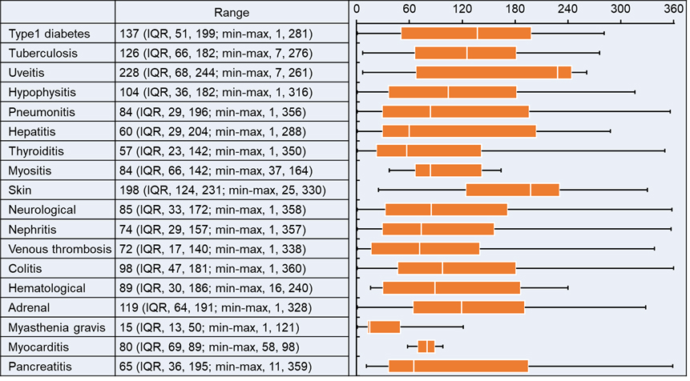
Online Resource 7 – Figure S4. Time to onset of cancer immunotherapy-related adverse events in JMDC claim database using nivolumab. Colored boxes indicate the interquartile range (IQR; Q1, Q3); the central vertical line indicates the median; outer vertical lines indicate the range (minimum to maximum [min-max]).

