GRAPHICAL DISPLAYS
The graphical displays below show the summary median values of the various EEG frequency bands for the whole of each of 4 labelled experimental sessions. The frequency values are given in the central vertical axis, and the amplitude values are given under the horizontal axis. (F) is the female participant. (M) is the male participant.

The first two displays, (display 1 and display 2) show a Mind Mirror summary display for F during, firstly, one of the sensing experiments, and secondly, during the consecutive paired imagination experiment. The difference between the two states is noticeable. It can be seen that the delta band is wider in the imagination experiment than in the mediumship experiment. Also it can be seen that the gamma band is wider in the mediumship experiment than in the imagination experiment.

Frequency (Hz)

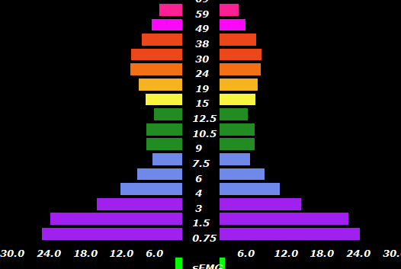

Median Amplitudes (microvolts)
Display 1. (from experiment 2)

ABOVE: (F) MEDIUMSHIP FREQUENCY BAND AMPLITUDES SPECTRUM (26/7/21)

Frequency (Hz)

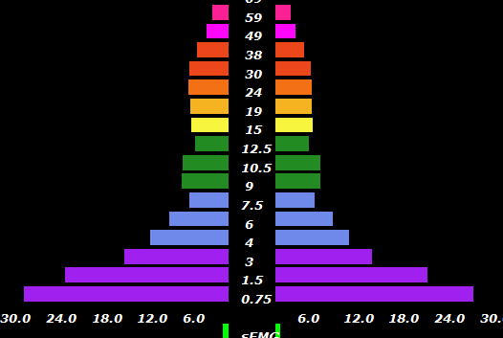

Median amplitudes in microvolts

Display 2. (from experiment 2)

ABOVE: (F) IMAGINATION (CONTROL) FREQUENCY BAND AMPLITUDES SPECTRUM (26/7/

The following two displays (display 3, and display 4) show a Mind Mirror summary display for M. Display 3 shows the median frequency amplitudes for a single mediumship experiment, and display 4 shows the median frequency amplitudes for the matching consecutive imagination experiment.

Frequency (Hz)

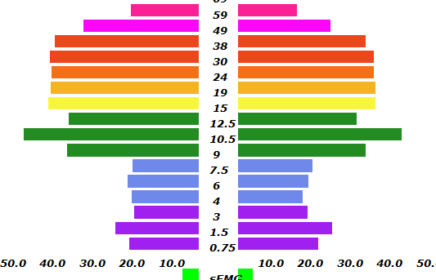

Amplitude (microvolts)

Display 3 (from Experiment 3).

ABOVE: (M) MEDIUMSHIP FREQUENCY BAND AMPLITUDES SPECTRUM (20/5/21)

Frequency (Hz)

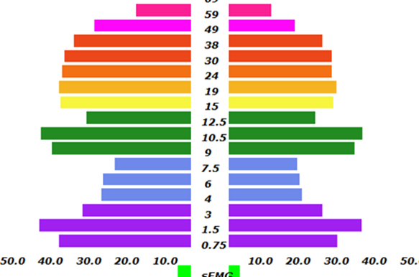

Amplitude (microvolts)
Display 4. (from experiment 3)

ABOVE: (M) IMAGINATION FREQUENCY BAND AMPLITUDES SPECTRUM (20/5/21)

It can be seen, from display 3 and 4, that the delta band is greater in amplitude in the imagination than in the mediumship experiment. It can also be seen that the gamma is slightly greater in amplitude in the mediumship than in the imagination session.

