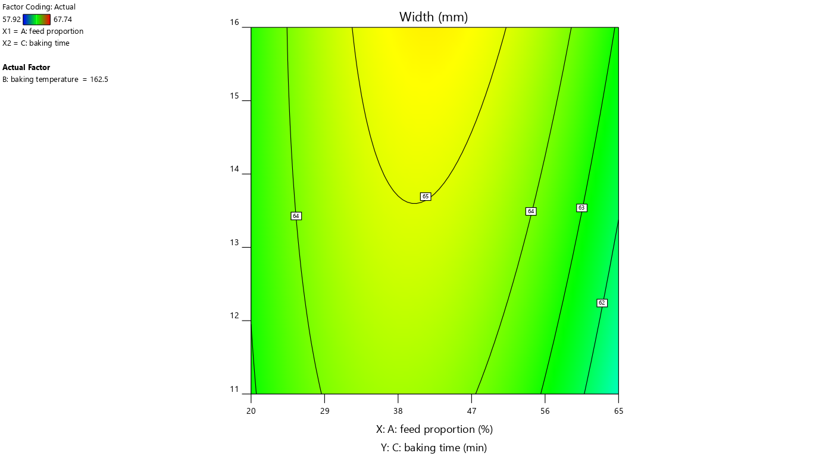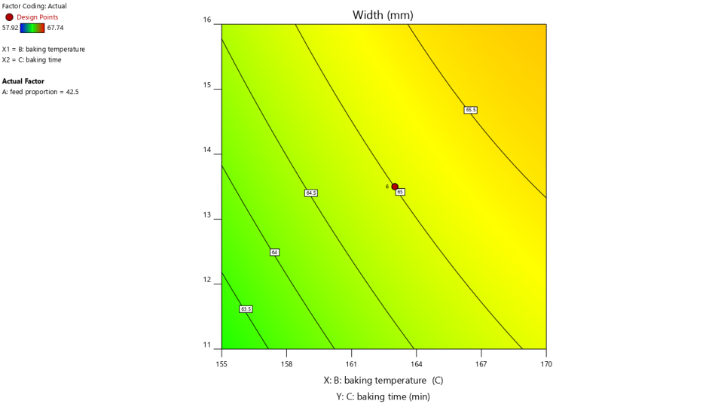
a) Effect of feed proportion and baking time on width b) Effect of baking temperature and baking time on width

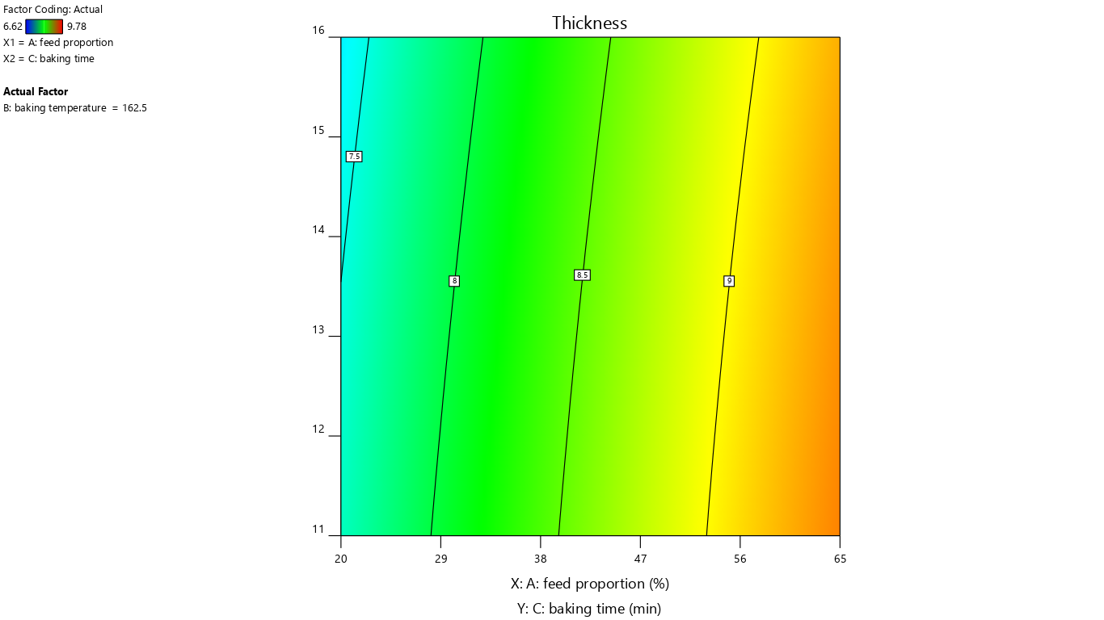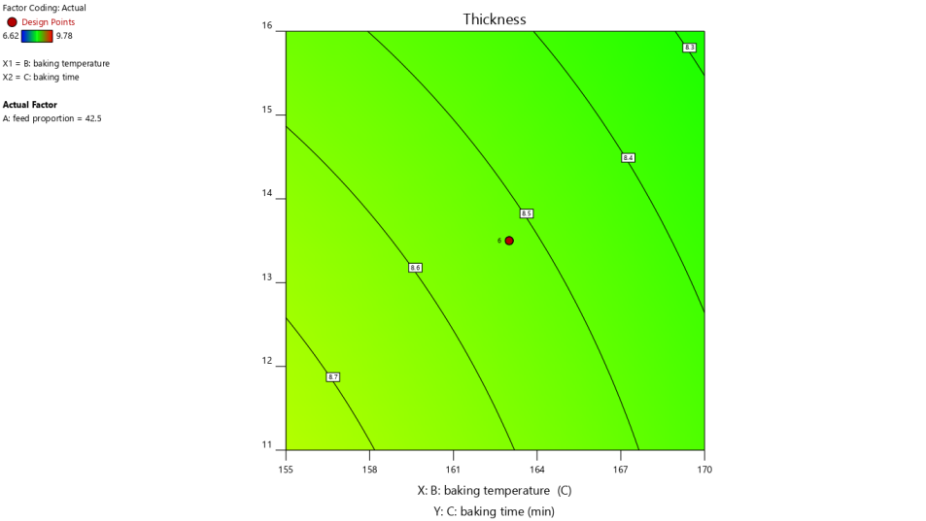
c) Effect of feed proportion and baking time on thickness d) Effect of baking temperature and baking time on thickness
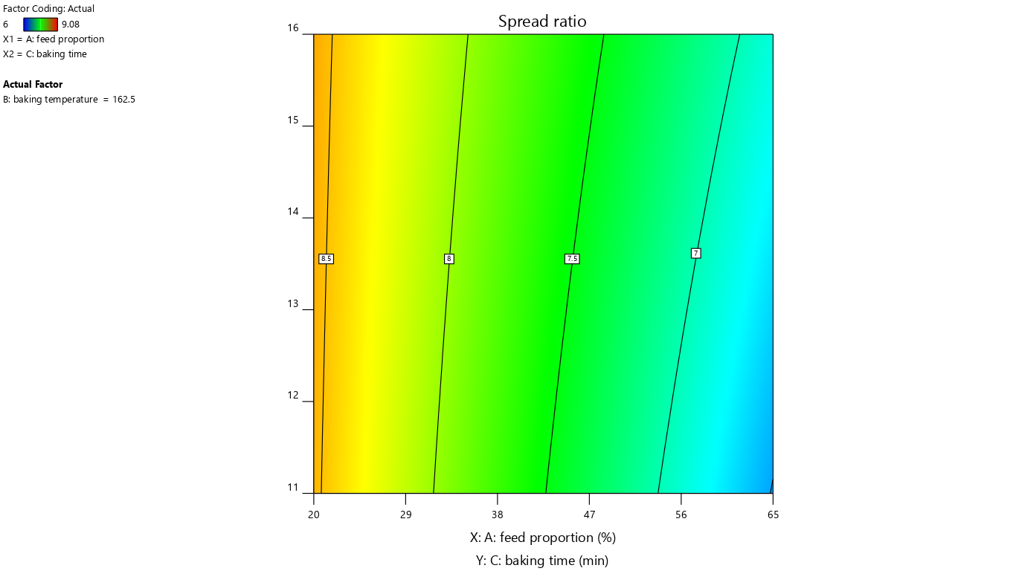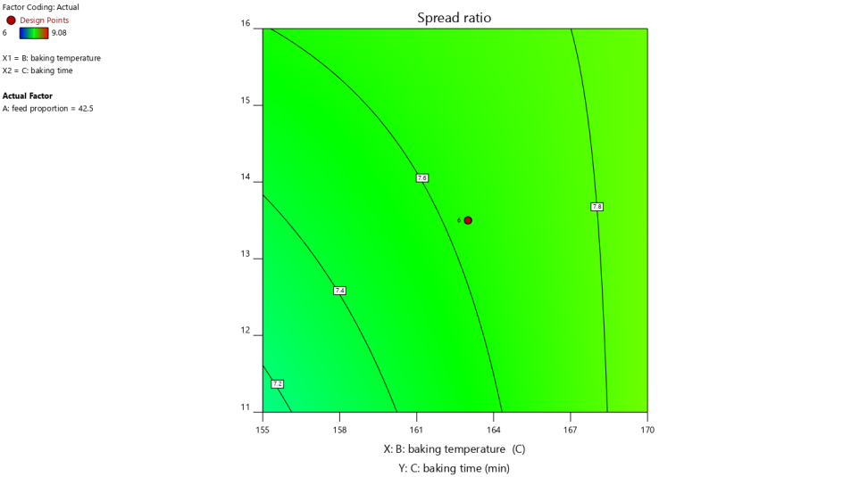
e) Effect of feed proportion and baking time on spread ratio f) Effect of baking temperature and baking time on spread ratio

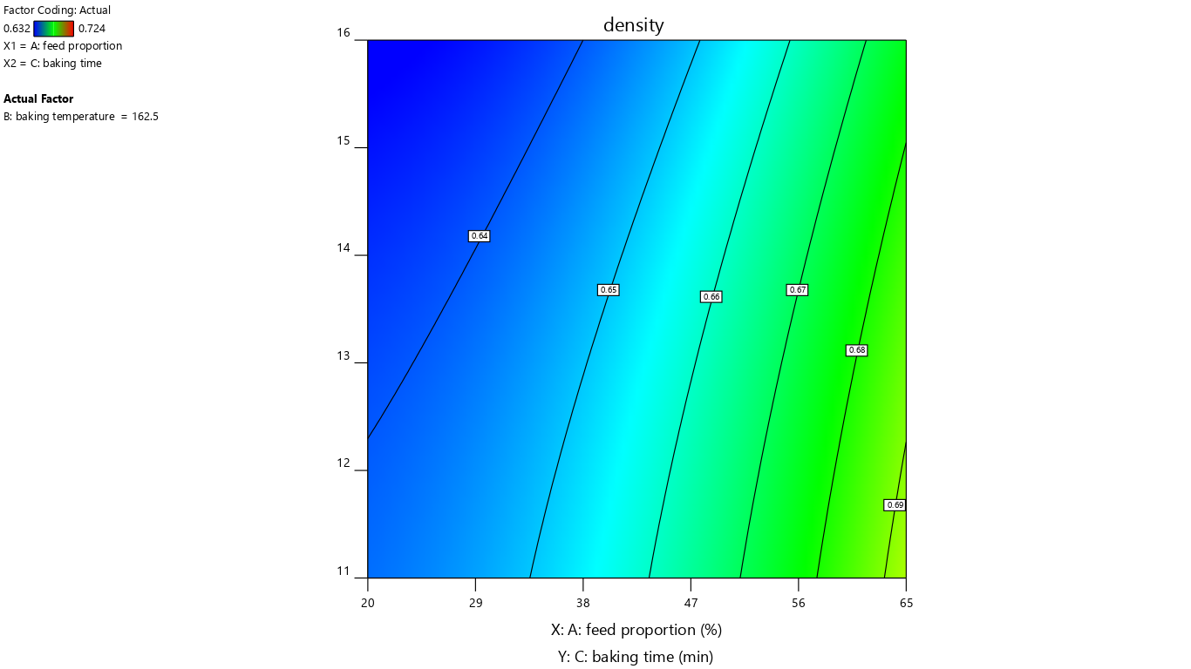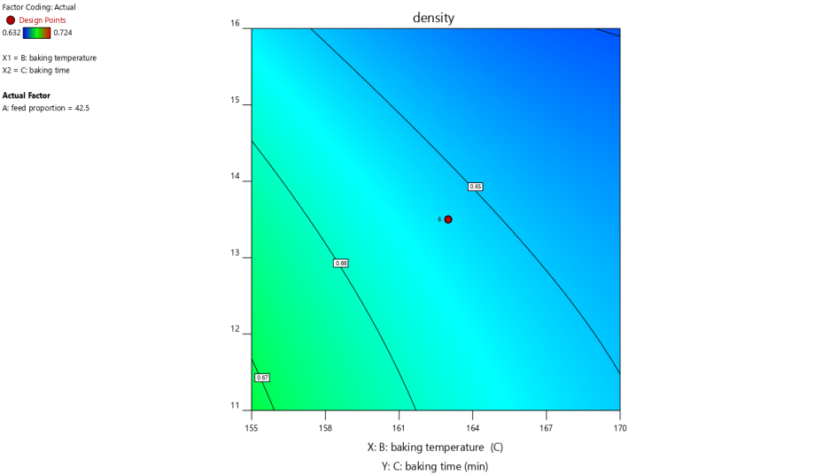
g) Effect of feed proportion and baking time on density h) Effect of baking temperature and baking time on density
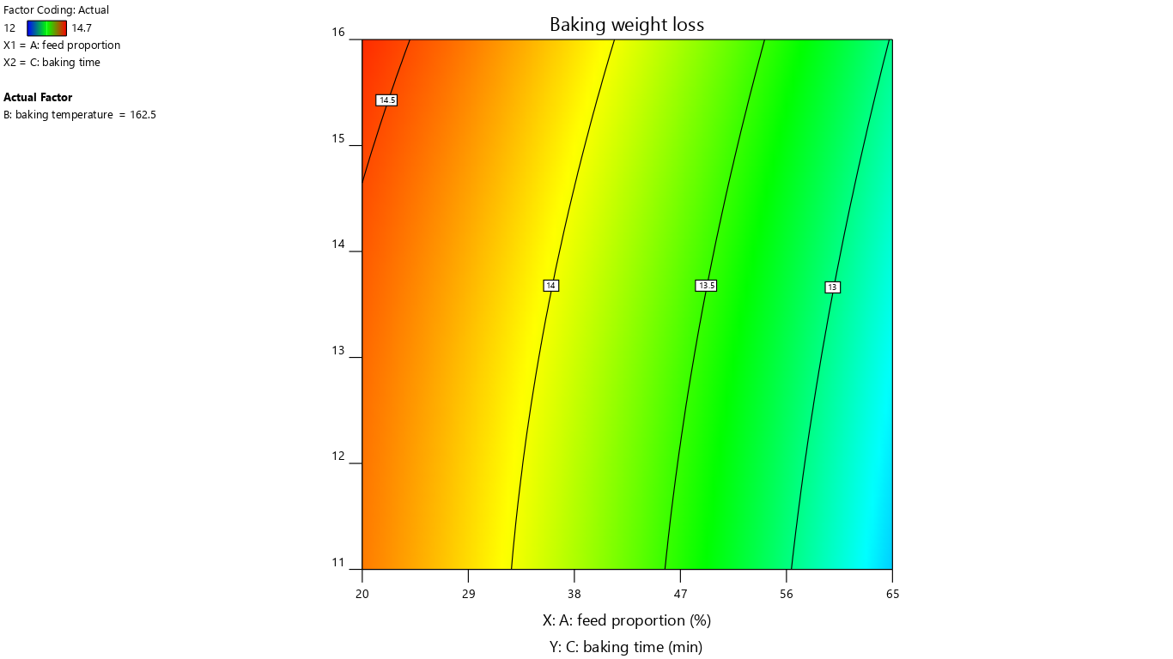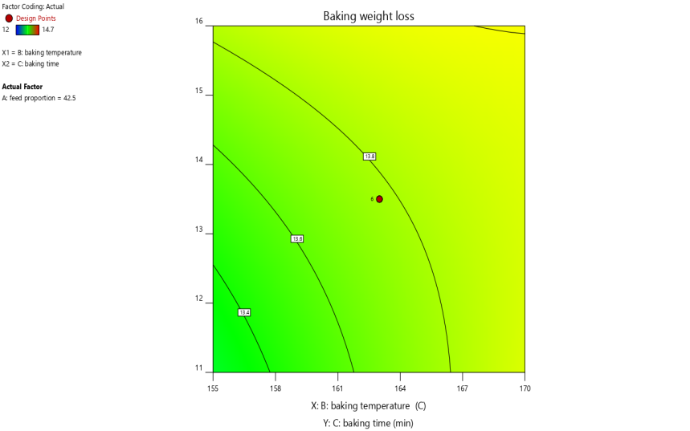
- Effect of feed proportion and baking time on baking weight loss j) Effect of baking temperature and baking time on baking weight loss

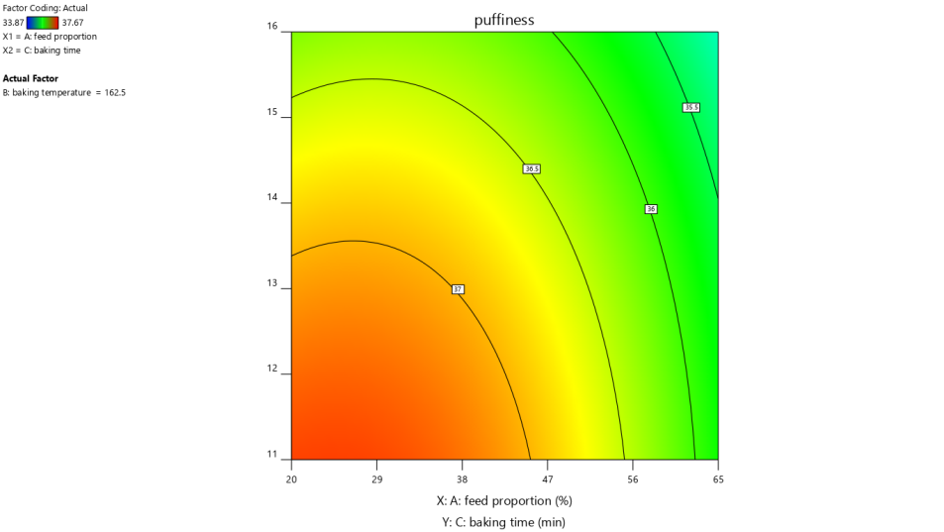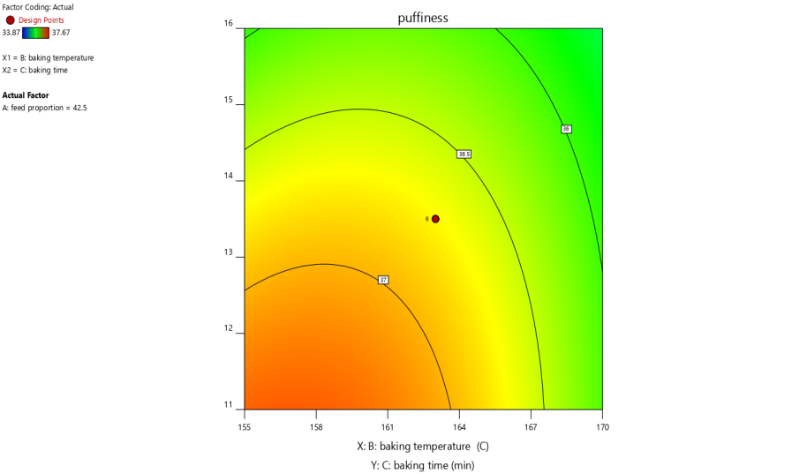
k) Effect of feed proportion and baking time on puffiness l) Effect of baking temperature and baking time on puffiness

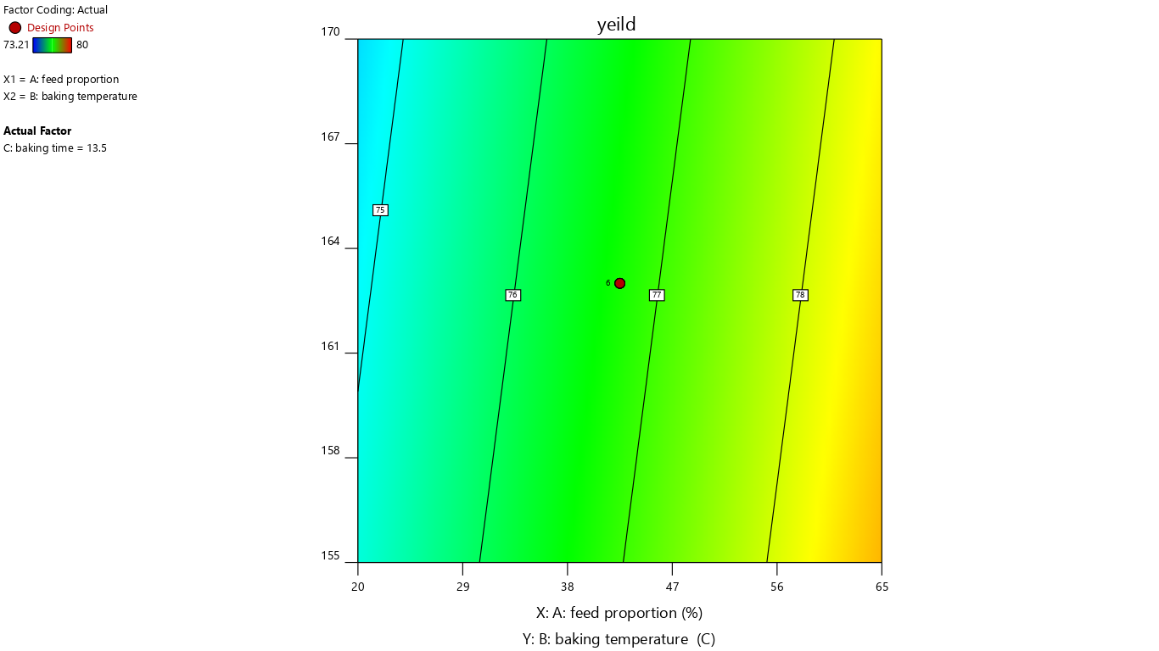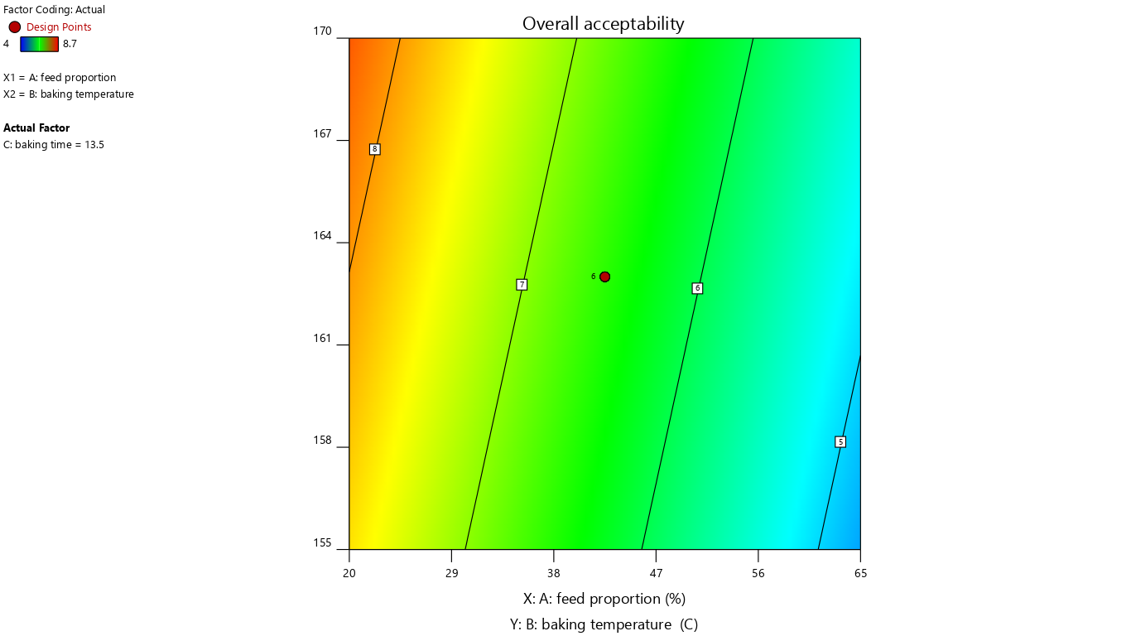
m) Effect of baking temperature and feed proportion on yield n) Effect of baking temperature and feed proportion on overall acceptability

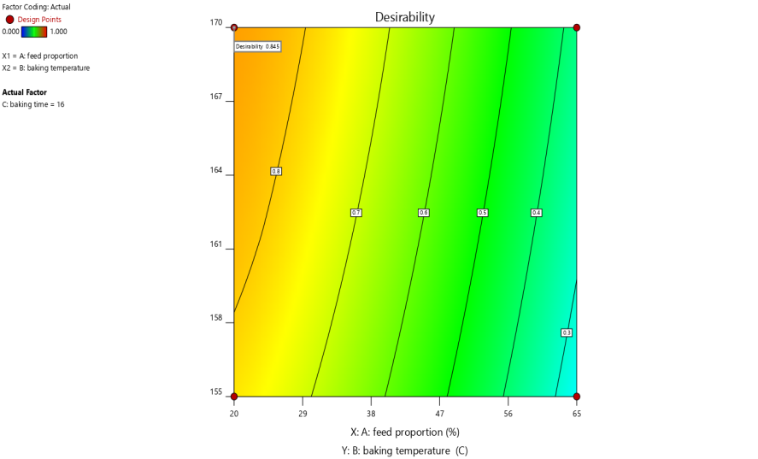
o) Desirability function plot
Fig.S1(a-n) Effect of baking conditions and feed proportion on physical attributes of chia seed flour incorporated cookies;(o) desirability function plot

