Supplementary Material

Molecular dynamics simulations of the interaction between graphene and lubricating oil molecules

Feng Qiu¹, Hui Song¹, Weimin Feng¹, Zhiquan Yang^{1,2}, Fei Zhang¹, and Xianguo Hu^{1,}*
¹Institute of Tribology, Hefei University of Technology, Hefei 230009, China
²State Key Laboratory of Solid Lubrication, Lanzhou Institute of Chemical Physics, Chinese Academy of Science, Lanzhou 730000, China

*Corresponding author. E-mail: xghu@hfut.edu.cn
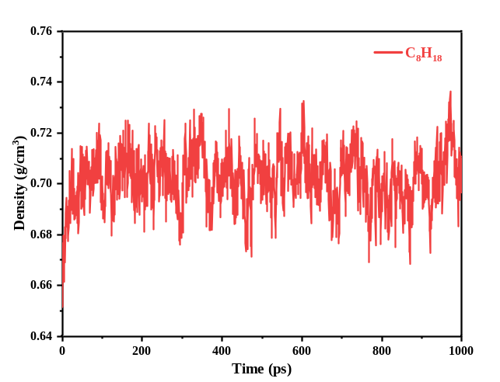
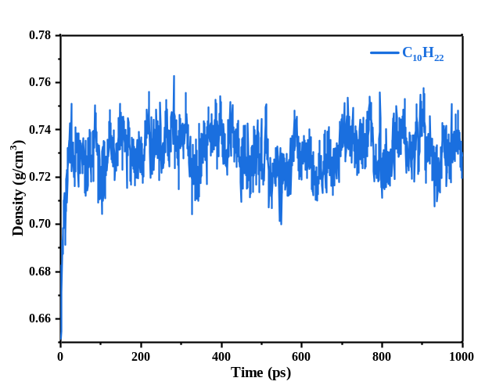
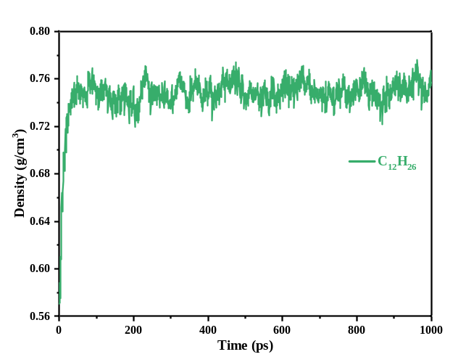
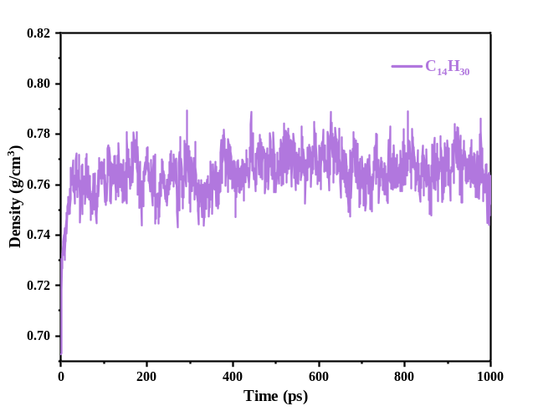
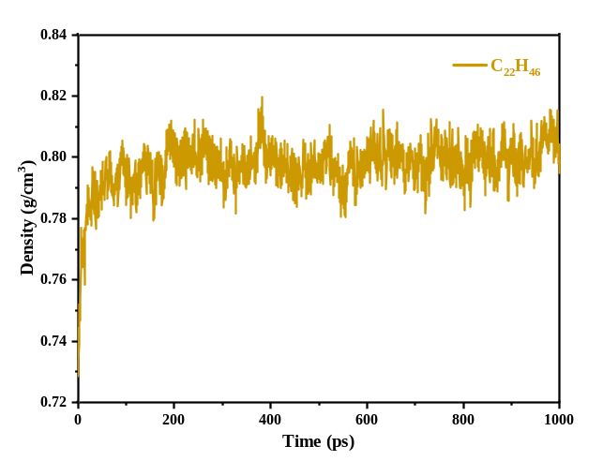
Fig S1 The density change curves of alkane system with different chain length

Table S1 Initial 200ps MSD linear fitting parameters and diffusion coefficient D
 |  | Y = a*x + b |  |  |  | D (Å²/ps)
Systems |  | a |  | b |  |  | a/6
Gra/C₆H₁₄ | 1.4011 ± 0.00282 |  | 40.5179 ± 0.37338 |  | 0.2335 ± 0.00047
Gra/C₈H₁₈ | 1.1612 ± 0.00212 |  | 20.3611 ± 0.28006 |  | 0.1935 ± 0.00035
Gra/C₁₀H₂₂ | 0.9816 ± 0.00102 |  | 13.1902± 0.13469 |  | 0.1636 ± 0.00017
Gra/C₁₂H₂₆ | 0.9047 ± 0.00065 |  | 7.8283 ± 0.08600 |  | 0.1508 ± 0.00011
Gra/C₁₄H₃₀ | 0.5345 ± 0.00074 |  | 13.6147 ± 0.09752 |  | 0.0891 ± 0.00012
Gra/C₂₂H₄₆ | 0.3741 ± 0.00035 |  | 8.4923 ± 0.04698 |  | 0.0624 ± 0.00006

Table S2 Subsequent 700ps MSD linear fitting parameters and diffusion coefficient D
 |  | Y=a*x + b |  |  |  | D (Å²/ps)
Systems |  | a |  | b |  | a/6
Gra/C₆H₁₄ | 0.8136 ± 0.00296 |  | 143.1404 ± 1.28886 |  | 0.1356 ± 0.00049
Gra/C₈H₁₈ | 0.7820 ±0.00028 |  | 22.2077 ± 0.12136 |  | 0.1303 ± 0.00046
Gra/C₁₀H₂₂ | 0.5906 ± 0.00037 |  | 11.1691 ± 0.16196 |  | 0.0984 ± 0.00062
Gra/C₁₂H₂₆ | 0.3942 ± 0.00072 |  | 8.0557 ± 0.31306 |  | 0.0657 ± 0.00012
Gra/C₁₄H₃₀ | 0.4253 ± 0.00031 |  | 4.6321 ± 0.13322 |  | 0.0708 ± 0.00005
Gra/C₂₂H₄₆ | 0.4608 ± 0.00172 |  | -27.2840 ± 0.75080 |  | 0.0768 ± 0.00029

Table S3 Final 900ps MSD linear fitting parameters and diffusion coefficient D
 |  | Y=a*x + b |  |  |  | D (Å²/ps)
Systems |  | a |  | b |  | a/6
Gra/C₆H₁₄ | 0.7538 ± 0.00300 |  | 171.4388 ± 1.70159 |  | 0.1256 ± 0.00050
Gra/C₈H₁₈ | 0.6722 ±0.00035 |  | 16.7412 ± 0.19940 |  | 0.1120 ± 0.00006
Gra/C₁₀H₂₂ | 0.3342 ± 0.00063 |  | 41.8532 ± 0.35764 |  | 0.0577 ± 0.00011
Gra/C₁₂H₂₆ | 0.2923 ± 0.00018 |  | 14.2847 ± 0.10375 |  | 0.0487 ± 0.00003
Gra/C₁₄H₃₀ | 0.1514 ± 0.00048 |  | 25.4764 ± 0.27237 |  | 0.0252 ± 0.00008
Gra/C₂₂H₄₆ | 0.0886 ± 0.00026 |  | 16.7211 ± 0.14853 |  | 0.0148 ± 0.00004

