Table S3.

A. r values of cross- correlation data using live neutralization assay NT50 values, MSD antigen binding and MSD ACE Inhibition binding data

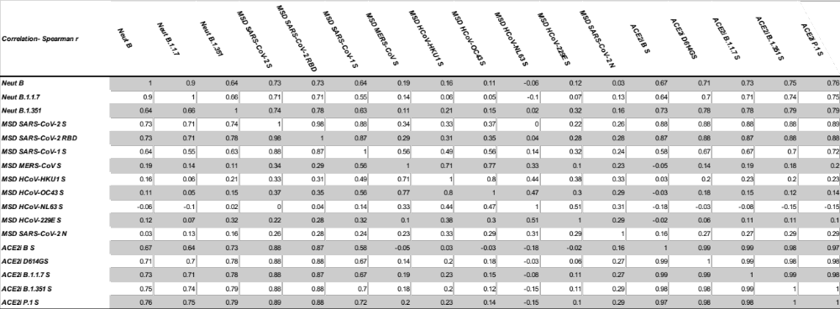

B. r values of cross- correlation data using live neutralization assay NT50 values and MSD antigen binding data

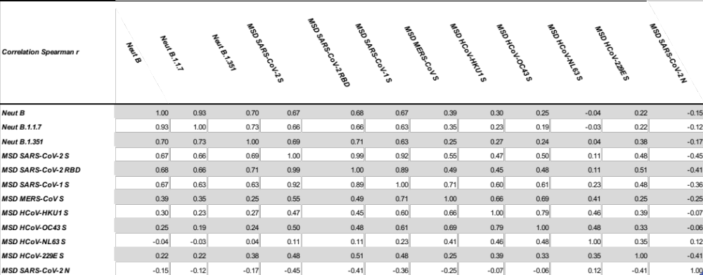

C. r values of cross- correlation data using live neutralization assay NT50 values, MSD antigen binding and MSD ACE Inhibition binding and Total Spike ELISpot data

