Plant Molecular Biology

Title: Functional investigation of five R2R3-MYB transcription factors associated with wood development in Eucalyptus using DAP-seq-ML

Lazarus T. Takawira¹*, Ines Hadj Bachir²*, Raphael Ployet¹, Jade Tulloch¹, Helene San Clemente², Nanette Christie¹, Nathalie Ladouce², Annabelle Dupas², Jacqueline Grima-Pettenati², Alexander A. Myburg¹, Eshchar Mizrachi¹, Fabien Mounet^{2†}, Steven G. Hussey^{1‡}
*These authors contributed equally to the study
†Corresponding author: fabien.mounet@univ-tlse3.fr
‡Corresponding author: steven.hussey@fabi.up.ac.za

¹Department of Biochemistry, Genetics and Microbiology, Forestry and Agricultural Biotechnology Institute (FABI), University of Pretoria, Pretoria 0002, South Africa
²Laboratoire de Recherche en Sciences Végétales, Université Toulouse, CNRS, INP, Castanet-Tolosan, France.

Supplementary information

Supplementary Tables

Table S1. Summary of clean paired-end reads and read mapping statistics for the DAP-seq libraries. E1-E4 represents four separately prepared E. grandis minimal adapter-ligated genomic DNA libraries.

Laboratory | Gene ID | Alias | Library | PCR cycles | Paired Clean Reads | Mapped reads | Mapping rate % | De-duplicated library size | % of deduplicated reads
1 | Eucgr.G01774 | EgrMYB1 | E1 | 20 | 8 459 247 | 3 508 050 | 41 | 297 560 | 8
1 | Eucgr.G01774 | EgrMYB1 | E2 | 20 | 47 796 194 | 37 515 233 | 78 | 2 477 731 | 7
1 | Eucgr.G01774 | EgrMYB1 | E2 | 15 | 565 560 | 441 193 | 78 | 244 483 | 55
1 | Eucgr.G01774 | EgrMYB1 | E1 | 15 | 59 960 | 48 400 | 81 | 31 309 | 65
2 | Eucgr.G01774 | EgrMYB1 | E3 | 20 | 1 424 006 | 1 205 706 | 85 | 998 508 | 83
2 | Eucgr.G01774 | EgrMYB1 | E3 | 20 | 2 202 568 | 1 854 783 | 84 | 1 166 856 | 63
2 | Eucgr.G01774 | EgrMYB1 | E3 | 20 | 1 823 308 | 1 534 861 | 84 | 669 680 | 44
1 | Eucgr.G03385 | EgrMYB2 | E1 | 20 | 19 703 924 | 15 995 646 | 81 | 741 068 | 5
1 | Eucgr.G03385 | EgrMYB2 | E2 | 15 | 4 997 588 | 3 643 242 | 73 | 1 300 865 | 36
1 | Eucgr.G03385 | EgrMYB2 | E1 | 15 | 157 543 | 125 719 | 80 | 69 945 | 56
1 | Eucgr.G03385 | EgrMYB2 | E2 | 20 | 10 198 661 | 7 988 611 | 78 | 4 225 914 | 53
2 | Eucgr.G03385 | EgrMYB2 | E3 | 20 | 942 046 | 759 006 | 81 | 671 512 | 88
 |  |  |  |  | 918 579 | 744 049 | 81 | 684 352 | 92
 |  |  |  |  | 836 500 | 679 824 | 81 | 608 468 | 90
1 | Eucgr.J01601 | EgrMYB122 | E1 | 20 | 7 427 557 | 6 141 847 | 83 | 438 956 | 7
 |  |  |  | 15 | 48 711 | 39 217 | 81 | 32877 | 84
1 | Eucgr.K02297 | EgrMYB135 | E1 | 20 | 11 332 350 | 9 494 243 | 84 | 505 472 | 5
1 | Eucgr.K02297 | EgrMYB135 | E1 | 15 | 97 244 | 78 126 | 80 | 43 284 | 55
1 | Eucgr.K02297 | EgrMYB135 | E2 | 15 | 4 246 804 | 3 329 494 | 78 | 1 218 500 | 37
1 | Eucgr.K02297 | EgrMYB135 | E2 | 20 | 12 609 139 | 10 142 791 | 80 | 2 638 144 | 26
2 | Eucgr.K02806 | EgrMYB137 | E4 | 20 | 22 077 608 | 17 662 086 | 80 | 3 142 078 | 18
 |  |  |  |  | 30 964 771 | 25 081 465 | 81 | 1 776 990 | 7
 |  |  |  |  | 22 390 144 | 17 912 115 | 80 | 2 678 441 | 15
2 | - | HaloTag | E3 | 20 | 3 362 527 | 2 413 678 | 72 | 1 495 756 | 62
 |  |  |  |  | 5 950 633 | 4 879 519 | 82 | 331 444 | 7
1 | - | HaloTag | E1 | 20 | 9 377 264 | 7 763 437 | 83 | 474 657 | 6
1 | - | HaloTag | E1 | 15 | 103 772 | 82 852 | 80 | 43 103 | 52
1 | - | HaloTag | E2 | 20 | 33 700 052 | 26 585 971 | 79 | 2 421 002 | 9
1 | - | HaloTag | E2 | 15 | 1 840 203 | 1 458 177 | 79 | 663 116 | 45

Table S2: Descriptions of machine learning features obtained for Arabidopsis thaliana

Feature | Range | Description
Peak score | [102,1000] | A normalized value indicating how dark the DAP-seq peak would be displayed in a genome browser (i.e., the degree of enrichment of the peak over background)
Peak signal value | [5,6925.3] | Measurement of average enrichment for the DAP-seq peak region
Peak q-value | [2,999] | Measurement of statistical significance of the DAP-seq peak, using false discovery rate (-log10)
Distance to TSS | [-5100,5095] bp | The bp distance between the middle of the DAP-seq peak (peak summit) and the gene TSS
Absolute distance to TSS | [0,5100] | The absolute bp distance between the middle of the DAP-seq peak and the gene TSS, regardless of orientation relative to the gene
Motif score | [0,47.18] | Log-likelihood ratio score for the occurrence of a TF binding motif in a DAP-seq peak for that TF, assuming a null model in which sequences are generated at random
Motif p-value | [4.31×10⁻¹⁷,1] | Measurement of statistical significance of the motif score
Motif E-value | [8.3×10⁻¹¹,18000] | The expected number of sequences generated at random, that would match the motif as well as the DAP-seq peak sequence does
Binding profile raw score  Binding profile raw score signal value  Binding profile Z score  Binding profile Z score signal value  Binding profile p- value score  Binding profile p-value signal value | [0.01,78.22]  [0.02,472.46]  [-1.22,19.31]  [-0.83,27.20]  [1.96×10⁻⁸³,0.89]  [2.89×10⁻¹⁶³,0.80] | Features relating to the regulatory “scores” or relationships between TFs and target genes, based on the binding profile of each TF.
CNS-DAP overlap (bp)  CNS-DAP overlap (proportion of peak length | [0,160] bp  [0,0.79] | Overlap of DAP-seq peak region with evolutionarily conserved noncoding sequences, measured in bp and as a proportion of the DAP-seq peak width
DHS-DAP overlap (bp)  DHS-DAP overlap (proportion of peak length) | [0,202] bp  [0,1] | Overlap of DAP-seq peak region with tissue-specific accessible chromatin regions, measured in bp and as a proportion of the DAP-seq peak width
CNS-DHS-DAP overlap (bp)  CNS-DHS-DAP overlap (proportion of peak length) | [0,202]  [0,1] | Overlap of DAP-seq peak region, evolutionarily conserved noncoding sequences and tissue-specific DNase-seq peak regions, measured in bp and as a proportion of the peak width
Pearson correlation coefficient  Spearman correlation coefficients | [-0.71,1.0]  [-0.70,1.0] | Measurements of the relationship between the TF-encoding and TF target gene expression levels. Pearson correlation measures the linear relationship between two genes’ expression levels, while a monotonic relationship is evaluated by the Spearman correlation. See Dataset S1.

Table S3: List of the primers used in this study
Gene name | Accession number | sequence primer forward (5' ->3') | sequence primer reverse (5' ->3')
Cloning
EgrMYB137 | Eucgr.K02806.1 | CACCTTTCCTGCGCAGTTCTCAAT | GAAGATGTTGAAATGTGCCTGTA
Expression analysis
PtVNS9 / PtrWND2A | Potri.014G104800 | ACAACTGGGCAACCCTTGATCG | GAGGTTTCAGTCTGGCCATTAAGC
PtVNS10 / PtrWND2B | Potri.002G178700 | TGGCCTTAACAACTGGGTTGCC | AGAGGTTTCAGCCTGGCCATTG
PtVNS11/ PtrWND1B | Potri.001G448400 | TGATGACAGCACCAACGACAC | TCCTGAACCAAGAATCTGATGAGC
PtVNS07 / PtrWND6A | Potri.013G113100 | ATGGGACATCCAAGCCAAGTGC | TGTTCCGGTCGGATACTTCCTATC
PtrMYB2 | Potri.001G258700 | TGCCAATGAACATGGATCCGTCAC | GCTTGCATGGAGGTTTCCAACG
PtrMYB21 | Potri.009G053900 | ACATGTATGGCGGTGCAAGTGG | AAGGACTCCAACTTGAGCCATGC
PtrMYB3 | Potri.001G267300 | AGGAATGCTGGCTTGCAAAGGT | GCCACGCTTGAGGTCAGGTC
PtrMYB20 | Potri.009G061500 | TCCATGCTCAACAACCGCTATG | ACCCACTTGTGTCAAGCATGTAG
PtrKNAT7 | Potri.001G112200 | CCAACTGAAGATGACAAAGCA | CTTGGACTTCAAGGATGTCA
PtrMYB156 | Potri.009G134000 | CCAGCCTGATCATCACCAGCCA | GTGCTGCCACTGCTCCCAACA
PtrMYB221 | Potri.004G174400 | TGCTTGCAGCTTGGGGCTACA | AGCCAGTTTTGGAGCCAGCACT
PtXND1 | Potri.005G064100 | CTGTTCCAGGAGTTTAAA | CACATGATTCATTAACATATAAGC
PtrMYB92 | Potri.001G118800 | GCATGGAATTGAGCGCACTTAGC | TCATCGCTCTAGCGTACACACG
PtrMYB125 | Potri.003G114100 | TGTAGTACCGAGGATTCGCTCTTG | CATCAACTAGCGGAGGCTCATC
PtrMYB10 | Potri.001G099800 | ACAGATGGGCTCACATAGCAAGC | TCGGTTCCGGTAGTTGCATTGG
PtrMYB128 | Potri.003G132000 | ACAGATGGGCTCATATTGCAAGTC | TTATTGTTGCAGGTGCTGAAGGC
PtrMYB216 | Potri.013G001000 | TTGTGGGAAATCCAGCGACGAAG | GTCTTCAACCGTCTCGTTTGCG
PtrMYB170 | Potri.005G001600 | AGCAACACCAATTTCTACGAGAGC | CGCCGGATTTCCCACAATTAGC
PtrCesA4 | Potri.002G257900 | GGTGCATCCATGCTCCTTTT | GAACCCACCTTCTAGCAAACTCA
PtrCesA7A | Potri.006G181900 | CATGTACATATTGCTTCTATGGG | GCATCTCCATTTTGTCGGTTAC
PtrCesA7B | Potri.018G103900 | GATACATGTGCATCCTGCTTCTAA | CATCTCCATCTTAGTCAGTTTATAC
PtrCesA8A | Potri.011G069600.1 | TTCGATCCAGATTCTACTTTCTCAT | CATCTCGCAGTTCATGTAACTC
PtrCesA8B | Potri.004G059600 | TTGCTGAGCTACCTCCAATAAG | AGGGAAACTACAACGAGGATCA
PdGATL1.1/PARVUS | Potri.014G040300.1 | GGAGTGGATGGAACTACAGA | GCAAGAGACTAACAGGACCA
PtrGAUT12.2 | Potri.011G132600 | CATTTCAATGGTCGAGCA AAGCCTTGGC | GACAGCCCGT AATGAACTTGTCAGA
PtrGXM1 | Potri.004g226800 | ACTGCCATATTTACAGCTGGAATG | CTACTCTGGGCAAAAGGGTCTGTC
PtrGXM2 | Potri.003g003800 | AGAATGACTGCCATATATACTGCC | CTACTCTGGGCAAAAAGGTCTGTC
PtrGXM3 | Potri.013g102200 | TGACGAGGCACCAGGGAGGATGAC | CTAAGGACAAAAAGGTCTGCCCGA
PtrGXM4 | Potri.019g076300 | TGATGAGGCTCCAGGGAGAATGAA | TGGACAAAAAGGTTTTCCCGAACT
PtrGT43A/IRX9 | Potri.006G131000 | GTCGCCCTTCATCTGTCC | TCCCTCATAGTTTTCTCCTGCT
PtrGT43B/IRX9 | Potri.016G086400 | GTCGCCCTTCTTCAGTCCAG | TTTTGTCTTCTTGATTTTCCTGA
PtrGT47c /FRA8 | Potri.009G006500 | CCACGTGGCAGGTGCTTTATG | CATGTCTCTTAGCTGGCAAAAGCG
PtrIRX10 | Potri.001G068100 | GGCTCGTAAGTTGCCGCAC | ACTTCTCTTACCAAGGTTTCAGGTCC
PtrRWA-A | Potri001G352300 | CCCACAAAAGACAATAAGCGG | ATGGAGGTTTTTTCTTCAACTTTG
PtrPAL1 | Potri.006G126800.1 | CCATCCAGGTCAAATTGAGGCTGCT | ACTTCTTAGCTGCCTTCATGTAAGCT
PtrPAL2 | Potri.008G038200.1 | CCTAGAAGCCATCACCAAGTTGCTC | GTTTCTCCATTGGGTCCCACG
PtrPAL3 | Potri.016G091100 | CATCCAGGTCAAATTGAGGCTGCA | ACTTCTTAGCTGCCTTCATGTAAGC
PtrC4H1 | Potri.013G157900 | AGTGCGCCATAGACCATATCCTC | ATTGCAGCGACGTTGATGTTCTCA
PtrC4H2 | Potri.019G130700 | GAAATGTGCAATTGATCATATTTTG | ATTGCAGCAACATTGATGTTCTCC
Ptr4CL3 | Potri.001G036900 | ACTAGCCCATCCAGAGATATCCGA | TCATCTTCGGTGGCCTGAGACTTT
Ptr4CL5 | Potri.003G188500 | GTGATCATGCTCATCCTGCCAAGT | TTGGCAGCAGTAGTAATGGCACCT
PtrHCT1 | Potri.003G183900 | ATCAGCATGTAAGGCACGCGG | TGCCAAAGTAACCAGGTGGAAGCGT
PtrC3H3 | Potri.006G033300 | GTATGACCTTAGTGAAGACACAATCAT | CCCTTGGGTTCTTGATTAGCTC
CSE1 | Potri.003G059200 | AGCGAGCCATACAAGAACTTGCC | ATCGTTGCTAGTCCGCCCATTG
CSE2 | Potri.001G175000 | GGTATACGTTGCTACATGGGTGAC | TGGTAAGCCCTTGTATGGTTCGC
PtrCCoAOMT1 | Potri.009G099800 | CAGTAATTCAGAAAGCTGGTGTTGC | GCATCCACAAAGATGAAATCAAAAC
PtrCCoAOMT2 | Potri.001G304800 | CCTTCCAACGCCAGGAAAGAGAGTA | GTGGCCAACTTCTTGATGCCTTCCG
PtrCCR2 | Potri.003G181400 | CGGTGATTCAGAAAGCTGGTCTGGA | GCATCCACAAAGATGAAGTCATAAG
PtrCAld5H2 | Potri.007G016400 | AAGCCAATATAGGCAAGCCTGTGAATC | ATTTTTAGCCCCGAAAGCTGCTCTG
PtrCOMT1 | Potri.015G003100 | AGCACAATCGTCTCCAAGTACCCT | AACATTCTCCACACCAGGGAAAGC
PtrCOMT2 | Potri.012G006400 | TCTTGAAGAATTGCTATGACGCCT | GAATGCACTCAACAAGTATCACCTTG
PtrCAD1 | Potri.009G095800 | GGCAAGCTGATCTTGATGGGTGTT | TCCCGGTGATTGACTTTCTCCCAA
PtrCAD5 | Potri.009G062800 | CTCCAGGAGGTCTACAGGAGAGAAT | GTCTGAGTGACATATTCCACAAAAC
HK1 | Potri.005G101200 | TCAACAAGAGTGGGCGGTTCAC | ACCTGCATAGGTCCAGCAAAGAC
HK3 | Potri.009G037800 | CGAGTTCGTGATCCACAAGGAAGC | TCCCTGGAGAAGTGAGCATGTTG
HK11 | Potri.006G275300 | TAGCAGCAGCTATGTGGCTGAG | TCAGCAGTGTTGGCCATGTCAC
UBQ | Potri.001G418500 | GTTGATTTTTGCTGGGAAGC | GATCTTGGCCTTCACGTTGT
CDC2/ACT1 | Potri.001G309500 | GGTAACATTGTGCTCAGTGG | CTCGGCCTTGGAGATCCACA

Table S4. A comparison of EgrMYB DAP-seq peak sets called using GEM and MACS2 peak callers. T denotes technical replicates analysed under identical conditions, while E1-E4 represent the four separately prepared E. grandis minimal adapter-ligated genomic DNA and FRiP stands for Fraction of Reads in Peaks.
TF Candidate | Library | PCR Cycles | HaloTag Control |  |  |  | Final Peak Set
 |  |  | GEM | FRiP % | MACS2 | FRiP % | GEM
EgrMYB1-T2 | E3 | 20 | 1,912 | 6.88 | 1,869 | 8.15 | 1,912
EgrMYB2 | E2 | 15 | 16,795 | 34.10 | 6,480 | 30.08 | 17,467
EgrMYB2 | E2 | 20 | 37,138 | 39.16 | 15,137 | 30.37 | 17,467
EgrMYB2-T1 | E3 | 20 | 5,420 | 26.31 | 6,170 | 31.02 | 17,467
EgrMYB2-T2 | E3 | 20 | 6,026 | 25.11 | 6,915 | 29.61 | 17,467
EgrMYB2-T3 | E3 | 20 | 4,626 | 23.08 | 6,451 | 28.73 | 17,467
EgrMYB122 | E1 | 20 | 1,778 | 13.15 | 3,409 | 19.23 | 1,778
EgrMYB135 | E2 | 15 | 5,269 | 16.31 | 2,337 | 16.27 | 13,967
EgrMYB135 | E2 | 20 | 10,724 | 19.46 | 6,411 | 19.82 | 13,967
EgrMYB137-T1 | E4 | 20 | 23,443 | 24.03 | 896 | 9.38 | 27,941
EgrMYB137-T2 | E4 | 20 | 6,838 | 10.55 | 447 | 4.28 | 27,941
EgrMYB137-T3 | E4 | 20 | 21,964 | 20.84 | 689 | 7.12 | 27,941

Table S5. Enriched motifs for EgrMYB1, EgrMYB2, EgrMYB122 & EgrMYB135 DAP-seq binding sites. The EgrMYB135 motif is from the two technical replicates that passed the QC and filtering threshold and likewise, the EgrMYB2 represents the 5 technical replicates from the two labs that passed the QC and filtering thresholds. Motifs of close orthologs in Arabidopsis are also included in the table.
MYB TF | E. grandis motif | Arabidopsis motif¹
EgrMYB1 | 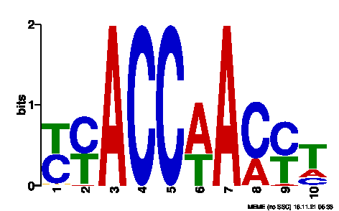  EgrMYB1-T2 | 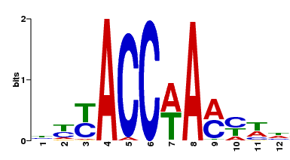  AtMYB4
EgrMYB2 | 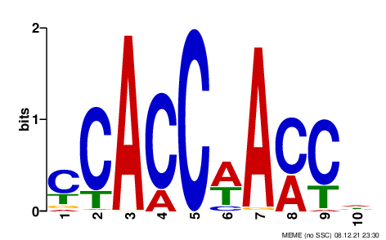  EgrMYB2 | 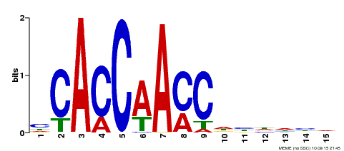  AtMYB83
EgrMYB122 | 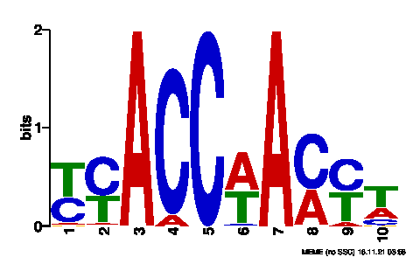  EgrMYB122_E1_20 | 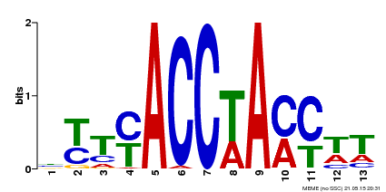  AtMYB43
EgrMYB135 | 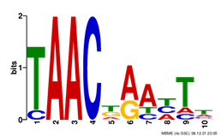  EgrMYB135 | 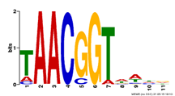  AtMYB52
EgrMYB137 | 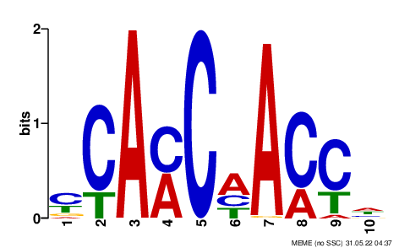  EgrMYB137 | 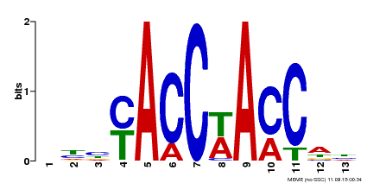  AtMYB61
¹ (O’Malley et al. 2016)

Table S6. Pairwise comparison of peak quality matrices and enriched motifs for EgrMYB2 using GEM. Overlapping peaks are indicate on the bottom left of the diagonal, which the significance of the overlap (P-value) is indicated at the top right. *FRiP – Fraction of Reads in Peaks.

 | Top enriched motif | Library E2  15-cycles | Library E2  20-cycles | Library E1  15-cycles | Library E1  20-cycles | Library E3  20-cycles R1 | Library E3  20 cycles R2 | Library E3  20 cycles R3
Library E2  15 cycles | 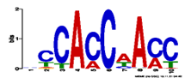 |  | 2.84x10⁻¹ | 1.07x10⁻³ | 4.18x10⁻² | 2.34x10⁻¹ | 2.5x10⁻¹ | 2.04x10⁻¹
Library E2  20 cycles | 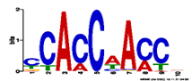 | 15,263 |  | 4.85x10⁻⁴ | 2x10⁻² | 1.2x10⁻¹ | 1.37x10⁻¹ | 1.05x10⁻¹
Library E1  15 cycles | 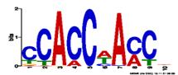 | 22 | 23 |  | 8.06x10⁻³ | 3.32x10⁻³ | 2.99x10⁻³ | 3.89x10⁻³
Library E1  20 cycles | 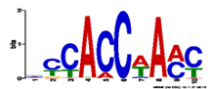 | 840 | 907 | 8 |  | 1.1x10⁻¹ | 1.02x10⁻¹ | 1.11x10⁻¹
Library E3  20 cycles R1 | 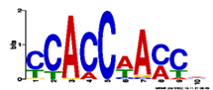 | 5,399 | 6,272 | 23 | 729 |  | 4.51x10⁻¹ | 4.51x10⁻¹
Library E3  20 cycles R2 | 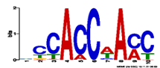 | 5,674 | 6,871 | 24 | 733 | 4,289 |  | 4.33x10⁻¹
Library E3  20 cycles R3 | 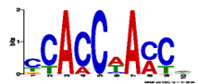 | 4,603 | 5,365 | 26 | 706 | 3,823 | 3,845
Peaks  (FRiP) |  | n = 16789  (FRiP = 34,1%) | n = 37121  (FRiP = 39,2%) | n = 19  (FRiP = 1,8%) | n = 856  (FRiP = 3,9%) | n = 5422  (FRiP = 26,3%) | n = 6026  (FRiP = 25,1%) | n = 4626  (FRiP = 23,1%)

Table S7: Confusion matrix statistics for each base model considered

 | Base model  (nearest) | Base model (5 kb  binding region)
Correctly predicted functional TF-gene associations | 8 776 | 13 620
Correctly predicted non-functional TF-gene associations | 270 026 | 219 334
Incorrectly predicted functional TF-gene associations | 74 680 | 125 372
Incorrectly predicted non-functional TF-gene associations | 27 402 | 22 558

Table S8. Independent Arabidopsis training/testing data splits that were considered when exploring the robustness of the random forest classifier.
Independent test no. | Samples in test set | Percentage of samples in UDGs test matrix | Percentage of samples in LEGs test matrix | Percentage of samples in RANDOMs test  matrix
1 | NAC4, RAV1 | 18.36% | 18.06% | 20.50%
2 | HHO2, HHO3, VRN1 | 19.52% | 20.15% | 19.63%
3 | RAV1, NAP | 21.16% | 20.01% | 21.40%
4 | RAV1, VRN1 | 20.98% | 19.19% | 19.19%
5 | HB6, MYB61 | 19.79% | 19.65% | 17.99%

Table S9: Biological process gene ontology enrichment results and enrichment analysis for EgrMYB2
EgrMYB2 | pre-ML |  | post-ML
EgrMYB2 | Baseline model |  | no cut-off |  | Pr ≥ 0.5 |  | Pr ≥ 0.7
GO Description | corrected p-val | Enrichment | corrected p-val | Enrichment | corrected p-val | Enrichment | corrected p-val | Enrichment
phenylpropanoid metabolic process | <0.001 | 1.88 | <0.001 | 2.0 | <0.001 | 2.8 | <0.001 | 4.2
phenylpropanoid biosynthetic process | <0.001 | 1.90 | <0.001 | 2.0 | <0.001 | 3.2 | <0.001 | 4.7
secondary metabolic process | <0.001 | 1.53 | <0.001 | 1.6 | <0.026 | 1.7 | 0.001 | 2.4
flavonoid biosynthetic process | <0.001 | 2.05 | <0.001 | 2.1 | 0.046 | 2.7 | - | -
cellular aromatic compound metabolic process | 0.001 | 1.37 | <0.001 | 1.4 | <0.001 | 2.0 | <0.001 | 3.0
flavonoid metabolic process | <0.001 | 1.95 | <0.001 | 2.0 | - | - | - | -
cellular amino acid derivative metabolic process | 0.001 | 1.41 | 0.001 | 1.5 | 0.001 | 2.0 | <0.001 | 2.9
aromatic compound biosynthetic process | 0.002 | 1.44 | 0.004 | 1.5 | <0,001 | 2.3 | <0,001 | 3.6
cellular amino acid derivative biosynthetic process | 0.004 | 1.43 | 0.005 | 1.5 | <0.001 | 2.4 | <0.001 | 3.2
lignin metabolic process | 0.005 | 1.81 | 0.005 | 1.9 | 0.012 | 3.1 | 0.003 | 5.1
cellular amino acid and derivative metabolic process | 0.030 | 1.22 | 0.007 | 1.3 | - | - | 0.006 | 2.0
small molecule biosynthetic process | 0.045 | 1.18 | 0.007 | 1.2 | - | - | - | -
response to stimulus | 0.007 | 1.09 | 0.014 | 1.1 | - | - | - | -
response to biotic stimulus | 0.003 | 1.24 | 0.014 | 1.2 | - | - | - | -
response to other organism | 0.004 | 1.24 | 0.028 | 1.2 | - | - | - | -
localization | - | - | 0.037 | 1.1 | 0.008 | 1.3 | - | -
regulation of RNA metabolic process | 0.001 | 1.26 | 0.040 | 1.2 | - | - | - | -
regulation of transcription, DNA-dependent | 0.001 | 1.25 | 0.050 | 1.2 | - | - | - | -
cell wall organization or biogenesis | - | - | - | - | <0.001 | 2.9 | <0.001 | 3.7
plant-type cell wall organization or biogenesis | - | - | - | - | <0.001 | 2.9 | <0.001 | 4.4
plant-type cell wall biogenesis | - | - | - | - | <0.001 | 3.5 | <0.001 | 4.9
cell wall biogenesis | - | - | - | - | <0.001 | 3.2 | <0.001 | 4.7
cellular cell wall organization or biogenesis | - | - | - | - | <0.001 | 3.1 | <0.001 | 4.3
vesicle-mediated transport | - | - | - | - | <0.001 | 2.3 | <0.001 | 3.3
cellular localization | - | - | - | - | <0.001 | 1.8 | - | -
secondary cell wall biogenesis | - | - | - | - | 0.001 | 4.7 | <0.001 | 8.2
establishment of localization in cell | - | - | - | - | 0.001 | 1.7 | - | -
lignin biosynthetic process | - | - | - | - | 0.003 | 4.2 | 0.003 | 6.4
intracellular transport | - | - | - | - | 0.003 | 1.8 | - | -
regulation of actin cytoskeleton organization | - | - | - | - | 0.003 | 8.0 | - | -
regulation of actin filament-based process | - | - | - | - | 0.003 | 8.0 | - | -
cellular carbohydrate metabolic process | - | - | - | - | 0.004 | 1.7 | 0.016 | 1.9
cellular macromolecule localization | - | - | - | - | 0.008 | 1.8 | - | -
cellular cell wall macromolecule metabolic process | - | - | - | - | 0.008 | 5.1 | 0.001 | 9.5
carbohydrate biosynthetic process | - | - | - | - | 0.008 | 1.9 | 0.035 | 2.2
microtubule-based process | - | - | - | - | 0.009 | 2.3 | 0.003 | 3.4
carbohydrate metabolic process | - | - | - | - | 0.010 | 1.5 | - | -
establishment of protein localization | - | - | - | - | 0.010 | 1.7 | - | -
protein transport | - | - | - | - | 0.010 | 1.7 | - | -
establishment of localization | - | - | - | - | 0.011 | 1.3 | - | -
cell wall polysaccharide metabolic process | - | - | - | - | 0.016 | 4.0 | 0.008 | 6.5
intracellular protein transport | - | - | - | - | 0.016 | 1.8 | - | -
protein localization | - | - | - | - | 0.016 | 1.6 | - | -
transport | - | - | - | - | 0.016 | 1.3 | - | -
cell wall organization | - | - | - | - | 0.016 | 2.3 | <0.001 | 4.2
plant-type cell wall organization | - | - | - | - | 0.016 | 2.8 | <0.001 | 5.2
cellular protein localization | - | - | - | - | 0.016 | 1.7 | - | -
cellular component macromolecule biosynthetic process | - | - | - | - | 0.022 | 4.8 | 0.006 | 8.7
cell wall polysaccharide biosynthetic process | - | - | - | - | 0.022 | 4.8 | 0.006 | 8.7
cell wall macromolecule biosynthetic process | - | - | - | - | 0.022 | 4.8 | 0.006 | 8.7
cell wall macromolecule metabolic process | - | - | - | - | 0.026 | 2.9 | 0.001 | 9.5
actin cytoskeleton organization | - | - | - | - | 0.035 | 2.8 | - | -
microtubule-based movement | - | - | - | - | 0.035 | 2.8 | 0.047 | 3.9
cytoskeleton organization | - | - | - | - | 0.035 | 2.1 | - | -
xylan metabolic process | - | - | - | - | 0.036 | 4.3 | - | -
hemicellulose metabolic process | - | - | - | - | 0.036 | 4.3 | - | -
vacuole organization | - | - | - | - | 0.036 | 4.3 | - | -
cellular carbohydrate biosynthetic process | - | - | - | - | 0.036 | 1.9 | 0.029 | 2.5
actin filament-based process | - | - | - | - | 0.036 | 2.5 | - | -
extracellular matrix organization | - | - | - | - | 0.036 | 6.4 | 0.050 | 10.5
extracellular structure organization | - | - | - | - | 0.036 | 6.4 | 0.050 | 10.5
pentose metabolic process | - | - | - | - | 0.036 | 3.7 | - | -
xylan biosynthetic process | - | - | - | - | 0.036 | 5.0 | 0.023 | 8.7
glucuronoxylan metabolic process | - | - | - | - | 0.036 | 5.0 | 0.023 | 8.7
glucuronoxylan biosynthetic process | - | - | - | - | 0.036 | 5.0 | 0.023 | 8.7
regulation of cytoskeleton organization | - | - | - | - | 0.036 | 5.0 | - | -
polysaccharide metabolic process | - | - | - | - | 0.036 | 1.8 | - | -
macromolecule localization | - | - | - | - | 0.044 | 1.5 | - | -
cell wall modification | - | - | - | - | - | - | 0.006 | 3.8
rhamnose metabolic process | - | - | - | - | - | - | 0.008 | 17.5
rhamnose biosynthetic process | - | - | - | - | - | - | 0.008 | 17.5
cell wall assembly | - | - | - | - | - | - | 0.024 | 13.1
cellulose microfibril organization | - | - | - | - | - | - | 0.024 | 13.1
plant-type cell wall assembly | - | - | - | - | - | - | 0.024 | 13.1
nucleotide-sugar metabolic process | - | - | - | - | - | - | 0.026 | 6.2
regulation of transcription | 0.001 | 1.18 | - | - | - | - | - | -
regulation of biosynthetic process | 0.001 | 1.17 | - | - | - | - | - | -
regulation of cellular biosynthetic process | 0.001 | 1.17 | - | - | - | - | - | -
regulation of macromolecule biosynthetic process | 0.002 | 1.17 | - | - | - | - | - | -
regulation of cellular metabolic process | 0.003 | 1.15 | - | - | - | - | - | -
regulation of primary metabolic process | 0.003 | 1.15 | - | - | - | - | - | -
regulation of nucleobase, nucleoside, nucleotide and nucleic acid metabolic process | 0.003 | 1.16 | - | - | - | - | - | -
response to chemical stimulus | 0.004 | 1.13 | - | - | - | - | - | -
regulation of nitrogen compound metabolic process | 0.006 | 1.15 | - | - | - | - | - | -
regulation of gene expression | 0.038 | 1.13 | - | - | - | - | - | -
response to organic substance | 0.045 | 1.14 | - | - | - | - | - | -

Table S10: Biological process gene ontology enrichment results and enrichment analysis for EgrMYB1

EgrMYB1 | pre-ML |  | post-ML
EgrMYB1 | Baseline model |  | No cut-off |  | Pr ≥ 0.5 |  | Pr ≥ 0.7
GO Description | Corrected p-val | Enrichment | Corrected p-val | Enrichment | Corrected p-val | Enrichment | Corrected p-val | Enrichment
secondary metabolic process | <0.001 | 2.9 | <0.001 | 3.1 | 0.001 | 3.3 | 0.018 | 3.7
phenylpropanoid metabolic process | <0.001 | 4.0 | 0.001 | 4.0 | 0.001 | 4.7 | 0.001 | 7.2
small molecule biosynthetic process | 0.001 | 2.0 | 0.002 | 2.1 | 0.003 | 2.2 | - | -
phenylpropanoid biosynthetic process | <0.001 | 4.5 | 0.002 | 4.2 | 0.002 | 4.8 | 0.001 | 8.4
cellular amino acid derivative metabolic process | <0.001 | 2.9 | 0.002 | 3.0 | 0.002 | 3.4 | 0.014 | 4.3
aromatic compound biosynthetic process | <0.001 | 3.2 | 0.004 | 3.2 | 0.002 | 3.8 | 0.006 | 5.4
cellular aromatic compound metabolic process | 0.002 | 2.4 | 0.006 | 2.5 | 0.001 | 3.1 | 0.012 | 3.9
small molecule metabolic process | 0.028 | 1.5 | 0.006 | 1.7 | 0.002 | 1.9 | - | -
cellular amino acid and derivative metabolic process | 0.008 | 2.0 | 0.006 | 2.2 | 0.002 | 2.6 | 0.004 | 3.5
cellular amino acid derivative biosynthetic process | 0.001 | 3.1 | 0.013 | 3.0 | 0.007 | 3.5 | 0.012 | 5.2
response to wounding | 0.010 | 3.0 | 0.015 | 3.2 | - | - | - | -
carboxylic acid biosynthetic process | 0.032 | 2.1 | 0.015 | 2.3 | 0.032 | 2.4 | - | -
organic acid biosynthetic process | 0.032 | 2.1 | 0.015 | 2.3 | 0.032 | 2.4 | - | -
indole derivative catabolic process | 0.032 | 13.8 | 0.024 | 17.0 | 0.011 | 23.0 | - | -
cellular ketone metabolic process | 0.032 | 1.7 | 0.024 | 1.8 | 0.034 | 1.9 | - | -
oxoacid metabolic process | 0.037 | 1.7 | 0.030 | 1.8 | 0.040 | 1.9 | - | -
carboxylic acid metabolic process | 0.037 | 1.7 | 0.030 | 1.8 | 0.040 | 1.9 | - | -
organic acid metabolic process | 0.037 | 1.7 | 0.030 | 1.8 | 0.040 | 1.9 | - | -
lignin metabolic process | 0.050 | 4.2 | - | - | 0.029 | 5.9 | - | -
defense response by cell wall thickening | - | - | - | - | 0.029 | 10.2 | - | -
defense response by callose deposition in cell wall | - | - | - | - | 0.029 | 10.2 | - | -
aromatic compound catabolic process | - | - | - | - | 0.032 | 9.4 | - | -
callose deposition in cell wall | - | - | - | - | 0.032 | 9.4 | - | -
cell wall thickening | - | - | - | - | 0.034 | 8.8 | - | -
defense response by callose deposition | - | - | - | - | 0.034 | 8.8 | - | -
regulation of transcription in response to stress | - | - | - | - | 0.034 | 30.6 | - | -
glycosinolate catabolic process | - | - | - | - | 0.034 | 30.6 | - | -
glucosinolate catabolic process | - | - | - | - | 0.034 | 30.6 | - | -
indole glucosinolate catabolic process | - | - | - | - | 0.034 | 30.6 | - | -
coumarin metabolic process | - | - | - | - | 0.034 | 30.6 | 0.012 | 73.2
coumarin biosynthetic process | - | - | - | - | 0.034 | 30.6 | 0.012 | 73.2
S-glycoside catabolic process | - | - | - | - | 0.034 | 30.6 | - | -
callose localization | - | - | - | - | 0.036 | 8.2 | - | -
polysaccharide localization | - | - | - | - | 0.040 | 7.7 | - | -
defense response to virus | - | - | - | - | 0.040 | 7.7 | - | -
response to UV-B | - | - | - | - | 0.049 | 5.5 | - | -
vesicle-mediated transport | - | - | - | - | - | - | 0.022 | 4.4
monocarboxylic acid metabolic process | 0.031 | 2.1 | - | - | - | - | - | -
fatty acid metabolic process | 0.032 | 2.4 | - | - | - | - | - | -
regulation of transcription, DNA-dependent | 0.006 | 1.9 | - | - | - | - | - | -
regulation of RNA metabolic process | 0.006 | 1.9 | - | - | - | - | - | -
regulation of transcription | 0.032 | 1.5 | - | - | - | - | - | -

Table S11: Biological process gene ontology enrichment results and enrichment analysis for EgrMYB137

EgrMYB137 | pre-ML |  | post-ML
EgrMYB137 | Baseline model |  | no cut-off |  | Pr ≥ 0.5 |  | Pr ≥ 0.7
GO Description | corrected p-val | Enrichment | corrected p-val | Enrichment | corrected p-val | Enrichment | corrected p-val | Enrichment
response to nematode | 0.023 | 1.5 | 0.008 | 1.6 | - | - | - | -
flavonoid biosynthetic process | 0.034 | 1.5 | 0.025 | 1.6 | - | - | - | -
phenylpropanoid biosynthetic process | 0.003 | 1.4 | 0.001 | 1.5 | 0.003 | 2.3 | 0.047 | 2.8
phenylpropanoid metabolic process | 0.001 | 1.4 | <0.001 | 1.5 | 0.021 | 1.9 | - | -
cellular amino acid derivative biosynthetic process | 0.027 | 1.3 | 0.009 | 1.3 | - | - | - | -
secondary metabolic process | 0.003 | 1.2 | 0.001 | 1.3 | - | - | - | -
cellular amino acid derivative metabolic process | 0.027 | 1.2 | 0.008 | 1.3 | - | - | - | -
cellular aromatic compound metabolic process | - | - | 0.030 | 1.2 | 0.011 | 1.6 | - | -
monocarboxylic acid metabolic process | - | - | 0.040 | 1.2 | - | - | - | -
response to osmotic stress | - | - | 0.037 | 1.2 | - | - | - | -
response to biotic stimulus | 0.023 | 1.2 | 0.007 | 1.2 | - | - | - | -
response to other organism | 0.027 | 1.2 | 0.008 | 1.2 | - | - | - | -
cellular amino acid and derivative metabolic process | - | - | 0.037 | 1.2 | - | - | - | -
regulation of biological quality | - | - | 0.026 | 1.2 | 0.014 | 1.4 | - | -
small molecule biosynthetic process | - | - | 0.019 | 1.2 | - | - | - | -
multi-organism process |  | - | 0.025 | 1.2 | - | - | - | -
response to chemical stimulus | 0.036 | 1.1 | 0.013 | 1.1 | - | - | - | -
cell wall biogenesis | - | - | - | - | <0.001 | 3.3 | 0.002 | 4.1
plant-type cell wall biogenesis | - | - | - | - | <0.001 | 3.5 | 0.002 | 4.3
vesicle-mediated transport | - | - | - | - | <0.001 | 2.3 | 0.002 | 2.8
cellular cell wall organization or biogenesis | - | - | - | - | <0.001 | 3.0 | 0.004 | 3.8
cell wall organization or biogenesis | - | - | - | - | <0.001 | 2.3 | 0.004 | 2.7
plant-type cell wall organization or biogenesis | - | - | - | - | <0.001 | 2.7 | 0.041 | 2.8
microtubule-based process | - | - | - | - | <0.001 | 2.5 | 0.028 | 3.0
cellular localization | - | - | - | - | <0.001 | 1.7 | - | -
intracellular transport | - | - | - | - | <0.001 | 1.8 | - | -
establishment of localization in cell | - | - | - | - | 0.001 | 1.7 | - | -
cellular macromolecule localization | - | - | - | - | 0.001 | 1.8 | - | -
cellular protein localization | - | - | - | - | 0.001 | 1.9 | - | -
intracellular protein transport | - | - | - | - | 0.001 | 1.9 | - | -
establishment of protein localization | - | - | - | - | 0.001 | 1.7 | - | -
protein transport | - | - | - | - | 0.001 | 1.7 | - | -
protein localization | - | - | - | - | .002 | 1.7 | - | -
regulation of cellular component size | - | - | - | - | 0.003 | 1.8 | - | -
regulation of anatomical structure size | - | - | - | - | 0.003 | .8 | - | -
cytoskeleton organization | - | - | - | - | 0.003 | 2.3 | - | -
secondary cell wall biogenesis | - | - | - | - | 0.004 | 3.8 | 0.047 | 5.4
regulation of cell size | - | - | - | - | 0.004 | 1.8 | - | -
localization | - | - | - | - | 0.006 | 1.3 | - | -
microtubule-based movement | - | - | - | - | 0.006 | 2.9 | - | -
regulation of actin cytoskeleton organization | - | - | - | - | 0.006 | 6.4 | - | -
regulation of actin filament-based process | - | - | - | - | 0.006 | .4 | - | -
establishment of localization | - | - | - | - | 0.006 | 1.3 | - | -
transport | - | - | - | - | 0.006 | 1.3 | - | -
polysaccharide metabolic process | - | - | - | - | 0.008 | 1.9 | - | -
carbohydrate biosynthetic process | - | - | - | - | 0.009 | 1.8 | - | -
cell growth | - | - | - | - | 0.010 | 1.7 | - | -
cellular carbohydrate biosynthetic process | - | - | - | - | 0.011 | 1.9 | - | -
growth | - | - | - | - | 0.013 | 1.6 | - | -
carbohydrate metabolic process | - | - | - | - | 0.014 | 1.4 | - | -
pectin metabolic process | - | - | - | - | 0.018 | 4.1 | - | -
cellular cell wall macromolecule metabolic process | - | - | - | - | 0.018 | 4.1 | .041 | 7.0
multidimensional cell growth | - | - | - | - | 0.022 | 2.8 | - | -
S-adenosylmethionine biosynthetic process | - | - | - | - | 0.025 | 6.4 | - | -
macromolecule localization | - | - | - | - | 0.027 | 1.4 | - | -
polysaccharide biosynthetic process | - | - | - | - | 0.027 | 2.0 | - | -
aromatic compound biosynthetic process | - | - | - | - | 0.030 | 1.7 | - | -
actin filament-based process | - | - | - | - | 0.032 | 2.3 | - | -
cellular carbohydrate metabolic process | - | - | - | - | 0.033 | 1.5 | 0.041 | 1.9
cellular polysaccharide biosynthetic process | - | - | - | - | 0.033 | 2.0 | - | -
phosphate metabolic process | - | - | - | - | 0.036 | 1.3 | - | -
phosphorus metabolic process | - | - | - | - | 0.037 | 1.3 | - | -
cell wall macromolecule metabolic process | - | - | - | - | 0.037 | 2.6 | - | -
lignin biosynthetic process | - | - | - | - | 0.037 | 3.0 | - | -
cell wall polysaccharide metabolic process | - | - | - | - | 0.045 | 3.2 | - | -
cellular polysaccharide metabolic process | - | - | - | - | 0.046 | 1.8 | - | -
L-ascorbic acid metabolic process | - | - | - | - | 0.046 | 4.6 | - | -
L-ascorbic acid biosynthetic process | - | - | - | - | 0.046 | 4.6 | - | -
actin cytoskeleton organization | - | - | - | - | 0.047 | 2.5 | - | -
cellular component macromolecule biosynthetic process | - | - | - | - | 0.049 | 3.9 | - | -
cell wall polysaccharide biosynthetic process | - | - | - | - | 0.049 | 3.9 | - | -
cell wall macromolecule biosynthetic process | - | - | - | - | 0.049 | 3.9 | - | -
extracellular structure organization | - | - | - | - | - | - | 0.014 | 12.3
regulation of transcription | 0.027 | 1.1 | - | - | - | - | - | -
regulation of macromolecule biosynthetic process | 0.027 | 1.1 | - | - | - | - | - | -
regulation of biosynthetic process | 0.027 | 1.1 | - | - | - | - | - | -
regulation of cellular biosynthetic process | 0.027 | 1.1 | - | - | - | - | - | -
regulation of RNA metabolic process | 0.034 | 1.1 | - | - | - | - | - | -
regulation of transcription, DNA-dependent | 0.034 | 1.1 | - | - | - | - | - | -
response to organic substance | 0.039 | 1.1 | - | - | - | - | - | -
regulation of primary metabolic process | 0..044 | 1.1 | - | - | - | - | - | -

Table S12: Biological process gene ontology enrichment results and enrichment analysis for EgrMYB122

EgrMYB122 | pre-ML |  | post-ML
EgrMYB122 | Baseline model |  | no cut-off |  | Pr ≥ 0.5 |  | Pr ≥ 0.7
GO Description | corrected p-val | Enrichment | corrected p-val | Enrichment | corrected p-val | Enrichment | corrected p-val | Enrichment
secondary metabolic process | - | - | 0.013 | 2.9 | 0.009 | 3.3 | 0.047 | 3.8
phenylpropanoid metabolic process | - | - | - | - | 0.015 | 4.3 | 0.008 | 7.2
response to wounding | - | - | - | - | 0.015 | 4.3 | - | -
phenylpropanoid biosynthetic process | - | - | - | - | 0.030 | 4.6 | 0.008 | 8.0
cellular aromatic compound metabolic process | - | - | - | - | 0.039 | 2.8 | 0.006 | 5.0
cellular amino acid and derivative metabolic process | - | - | - | - | - | - | 0.008 | 3.6
cellular amino acid derivative biosynthetic process | - | - | - | - | - | - | 0.012 | 5.8
cellular amino acid derivative metabolic process | - | - | - | - | - | - | 0.012 | 4.9
aromatic compound biosynthetic process | - | - | - | - | - | - | 0.015 | 5.3
small molecule biosynthetic process | - | - | - | - | - | - | 0.032 | 2.8

Table S13: Biological process gene ontology enrichment results and enrichment analysis for EgrMYB135

EgrMYB135 | pre-ML |  | post-ML
EgrMYB135 | Baseline model |  | No cut-off |  | Pr ≥ 0.5 |  | Pr ≥ 0.7
GO Description | corrected p-val | Enrichment | corrected p-val | Enrichment | corrected p-val | Enrichment | corrected p-val | Enrichment
response to other organism | <0.001 | 1.4 | 0.001 | 1.4 | - | - | - | -
response to biotic stimulus | <0.001 | 1.4 | 0.001 | 1.3 | - | - | - | -
multi-organism process | 0.001 | 1.3 | 0.004 | 1.3 | - | - | - | -
response to salicylic acid stimulus | 0.001 | 1.6 | 0.011 | 1.6 | - | - | - | -
response to stimulus | 0.006 | 1.1 | 0.018 | 1.1 | - | - | - | -
phenylpropanoid metabolic process | 0.001 | 1.6 | 0.031 | 1.5 | - | - | - | -
phenylpropanoid biosynthetic process | 0.001 | 1.7 | 0.031 | 1.6 | - | - | - | -
carbohydrate metabolic process | - | - | 0.040 | 1.2 | - | - | - | -
response to salt stress | - | - | 0.042 | 1.3 | - | - | - | -
response to chemical stimulus | 0.026 | 1.1 | 0.043 | 1.1 | - | - | - | -
response to osmotic stress | - | - | 0.048 | 1.3 | - | - | - | -
post-translational protein modification | - | - | 0.048 | 1.2 | - | - | - | -
response to abscisic acid stimulus | - | - | 0.048 | 1.3 | - | - | - | -
defense response | 0.003 | 1.3 | 0.048 | 1.2 | - | - | - | -
cellular response to endogenous stimulus | 0.012 | 1.3 | 0.048 | 1.3 | - | - | - | -
response to jasmonic acid stimulus | 0.006 | 1.5 | 0.048 | 1.5 | - | - | - | -
protein amino acid phosphorylation | 0.038 | 1.2 | 0.048 | 1.2 | - | - | - | -
response to arsenic | - | - | 0.050 | 2.7 | - | - | - | -
regulation of biosynthetic process | 0.001 | 1.2 | - | - | - | - | - | -
regulation of cellular biosynthetic process | 0.001 | 1.2 | - | - | - | - | - | -
regulation of nitrogen compound metabolic process | 0.001 | 1.2 | - | - | - | - | - | -
regulation of primary metabolic process | 0.001 | 1.2 | - | - | - | - | - | -
regulation of macromolecule biosynthetic process | 0.001 | 1.2 | - | - | - | - | - | -
regulation of cellular metabolic process | 0.002 | 1.2 | - | - | - | - | - | -
regulation of nucleobase, nucleoside, nucleotide and nucleic acid metabolic process | 0.002 | 1.2 | - | - | - | - | - | -
regulation of transcription | 0.002 | 1.2 | - | - | - | - | - | -
cellular amino acid derivative biosynthetic process | 0.003 | 1.5 | - | - | - | - | - | -
response to bacterium | 0.006 | 1.4 | - | - | - | - | - | -
regulation of metabolic process | 0.006 | 1.1 | - | - | - | - | - | -
regulation of macromolecule metabolic process | 0.006 | 1.2 | - | - | - | - | - | -
secondary metabolic process | 0.006 | 1.3 | - | - | - | - | - | -
aromatic compound biosynthetic process | 0.007 | 1.4 | - | - | - | - | - | -
cellular amino acid derivative metabolic process | 0.012 | 1.4 | - | - | - | - | - | -
regulation of gene expression | 0.017 | 1.1 | - | - | - | - | - | -
response to endogenous stimulus | 0.027 | 1.2 | - | - | - | - | - | -
response to hormone stimulus | 0.032 | 1.2 | - | - | - | - | - | -
cellular response to hormone stimulus | 0.034 | 1.3 | - | - | - | - | - | -
regulation of flavonoid biosynthetic process | 0.034 | 2.4 | - | - | - | - | - | -
defense response to bacterium | 0.036 | 1.3 | - | - | - | - | - | -
regulation of cellular process | 0.048 | 1.1 | - | - | - | - | - | -

Table S14. Most discriminant FT-IR wavenumbers associated with CW compounds from literature data. 13 wavenumbers related to CW compounds were identified from Sparse-PLS-DA loadings contribution to PC1 axis and PC2 explaining samples separation (see Figure 7)

Peak number | Contribution on | Associated WN in the literature | Associated CW compound | References
1 | PC2 | 1948 | lignin | (Salim et al. 2021)
2 | PC2 | 1730-1742 | lignin/hemicelluloses | (Faix 1991; Chang et al. 2014)
3 | PC1 | 1596-1600 | lignin | (Stark et al. 2016)
4 | PC1 | 1510 | lignin | (Faix 1991; Sammons et al. 2013; Largo-Gosens et al. 2014; Stark et al. 2016; Salim et al. 2021)
5 | PC1 | 1447 | lignin | (Salim et al. 2021)
6 | PC1 | 1365-1372 | lignin/cellulose/  hemicelluloses | (Chang et al. 2014)
7 | PC1 | 1330 | lignin | (Largo-Gosens et al. 2014; Stark et al. 2016)
8 | PC1 | 1265-1275 | lignin | (Sammons et al. 2013)
9 | PC2 | 1047 | pectin | (Largo-Gosens et al. 2014)
10 | PC1 | 1030-1035 | lignin | (Sammons et al. 2013)
11 | PC2 | 966-990 | lignin | (Sammons et al. 2013)
12 | PC2 | 915-930 | lignin | (Sammons et al. 2013)
13 | PC2 | 863 | lignin | (Stark et al. 2016)

Supplementary Figures
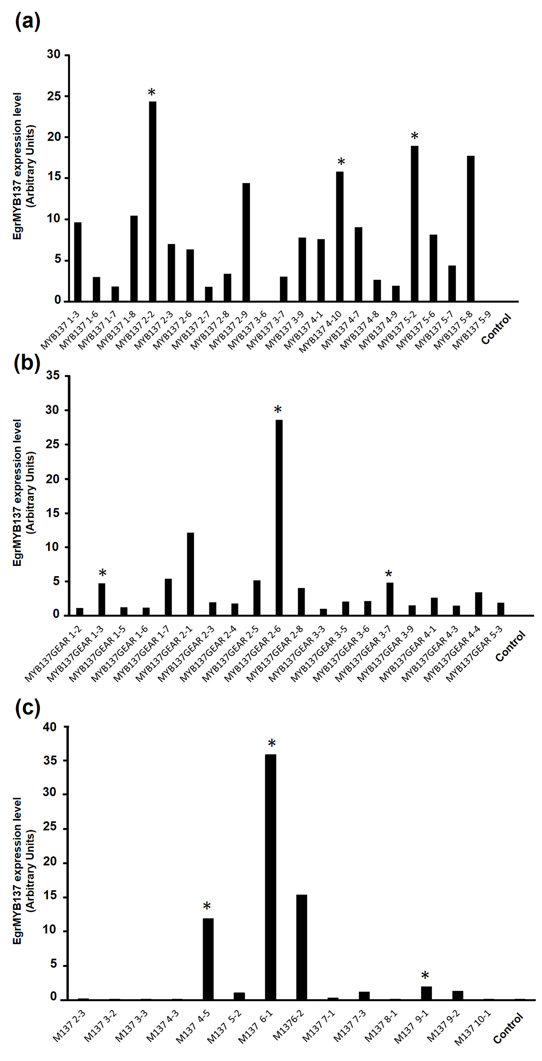

Figure S1: Transgene expression level in EgrMYB137 transgenic lines. A and B EgrMYB137 expression level in Arabidopsis Pro35S:EgrMYB137-EAR dominant-repressive lines and Pro35S:EgrMYB137 overexpressing lines, respectively. C EgrMYB137 expression level in Populus Pro35S:EgrMYB137-EAR dominant-repressive lines. EgrMYB137 expression was measured in control lines (WT Col-0 Arabidopsis and Populus transformed with empty vector). Stars represent the 3 independent lines per construct chosen for functional characterization.

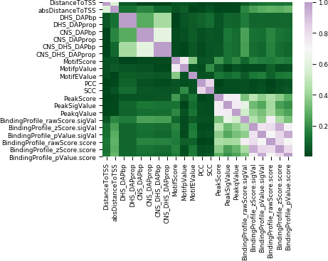

Figure S2. Evaluation of the absolute pairwise correlations between 22 machine learning features. The heatmap represents the absolute values of the Pearson correlation coefficients between each feature pair for the positive sample data. Each of the feature names are represented on the x- and y-axes. Highly correlated features were identified as those with an absolute pairwise correlation ≥ 0.7.

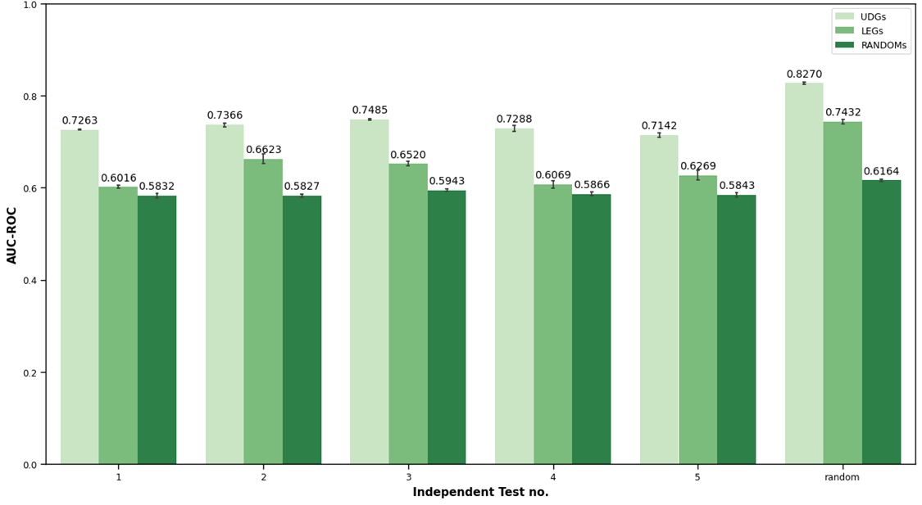Figure S3. Evaluation of the random forest classifier performance (AUC-ROC) on independent training and testing subsets of Arabidopsis data. UDGs: undetected genes, LEGs: lowly expressed genes, RANDOMs: randomly selected genes. Lower case letters on each bar represent AUC-ROC scores that are statistically significantly different from each other for models trained on each of the different negative sample sets, based on post-hoc testing (Tukey HSD test, p-value < 0.05). Error bars represent one standard deviation and show variability in the AUC-ROC across the best-performing models for each of 5 cross-validation folds. For each of the feature matrices differing in negative samples, AUC-ROC was statistically significantly lower when the model is trained and tested on independent subsets of data, rather than randomly split training and testing sets (‘random split’).

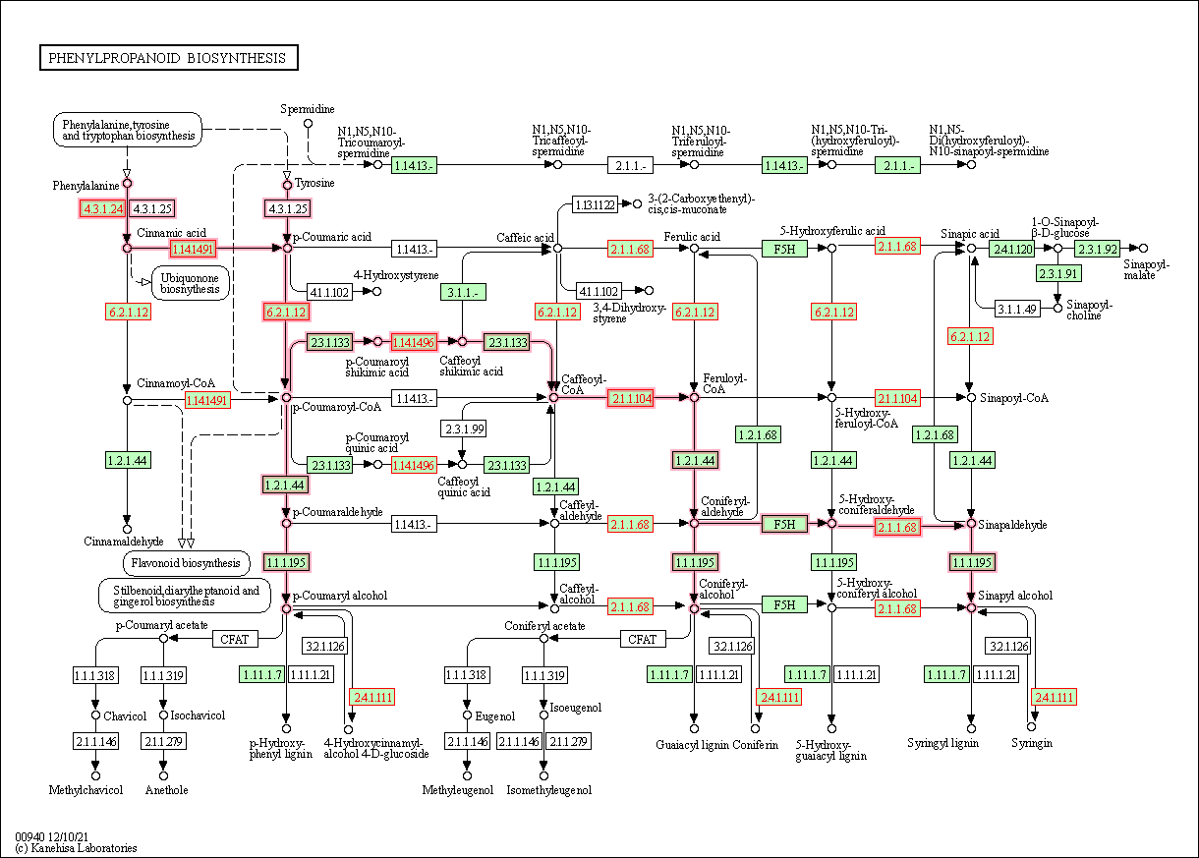

Figure S4: KEGG pathway analysis of the phenylpropanoid biosynthesis pathway showing predicted targets of EgrMYB122. EgrMYB122 gene targets selected at Pr ≥ 0.5 cut-off using the machine learning classifier.

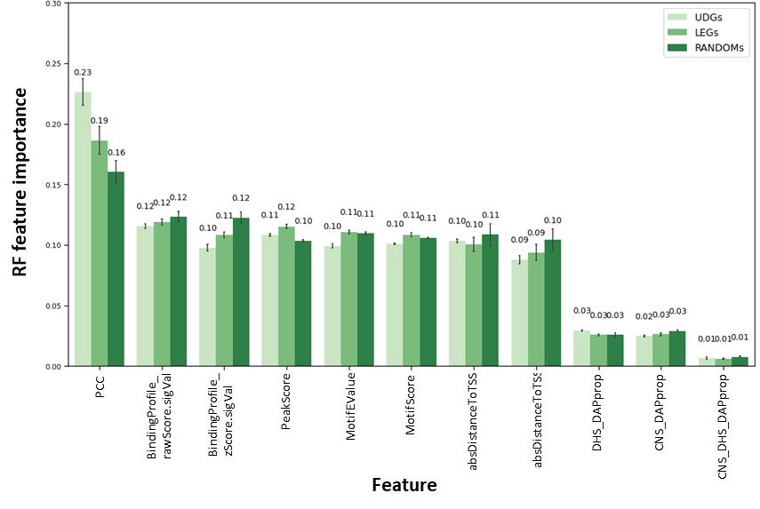

Figure S5. Evaluation of non-redundant feature importance for the random forest classifier and different negative training sample sets. UDGs: undetected genes, LEGs: lowly expressed genes, RANDOMs: randomly selected non-differentially expressed genes, RF: random forest. Error bars represent one standard deviation for cross-validation iterations (n = 5). Feature labels are described in Supplementary Table S2.

References
Chang S-S, Salmén L, Olsson A-M, Clair B (2014) Deposition and organisation of cell wall polymers during maturation of poplar tension wood by FTIR microspectroscopy. Planta 239:243–254. https://doi.org/10.1007/s00425-013-1980-3
Faix O (1991) Classification of Lignins from Different Botanical Origins by FT-IR Spectroscopy. Holzforschung 45:21–28. https://doi.org/10.1515/hfsg.1991.45.s1.21
Largo-Gosens A, Hernández-Altamirano M, García-Calvo L, Alonso-Simón A, Álvarez J, Acebes JL (2014) Fourier transform mid infrared spectroscopy applications for monitoring the structural plasticity of plant cell walls. Front Plant Sci 5. https://doi.org/10.3389/fpls.2014.00303
O’Malley RC, Huang SSC, Song L, Lewsey MG, Bartlett A, Nery JR, Galli M, Gallavotti A, Ecker JR (2016) Cistrome and Epicistrome Features Shape the Regulatory DNA Landscape. Cell 165:1280–1292. https://doi.org/10.1016/j.cell.2016.04.038
Salim RM, Asik J, Sarjadi MS (2021) Chemical functional groups of extractives, cellulose and lignin extracted from native Leucaena leucocephala bark. Wood Sci Technol 55:295–313. https://doi.org/10.1007/s00226-020-01258-2
Sammons RJ, Harper DP, Labbé N, Bozell JJ, Elder T, Rials TG (2013) Characterization of Organosolv Lignins using Thermal and FT-IR Spectroscopic Analysis. Bioresources 8. https://doi.org/10.15376/biores.8.2.2752-2767
Stark NM, Yelle DJ, Agarwal UP (2016) Techniques for Characterizing Lignin. In: Lignin in Polymer Composites. Elsevier, pp 49–66

