Supplementary Materials

ExposomeX: Integrative Exposomic Platform Expediates Discovery of “Exposure-Biology-Disease” Nexus

Bin Wang^{1,2}, Changxin Lan^{1,2}, Guohuan Zhang^{1,2}, Mengyuan Ren^{1,2}, Yanqiu Feng^{1,2}, Ning Gao^{1,2}, Weinan Lin^{1,2}, Bahabake Jiangtulu^{1,2}, Zhijian Liu³, Xuqiang Shao⁴, Shu Su^{1,2}, Yuting Wang^{1,2}, Han Wang^{1,2}, Fanrong Zhao⁵, Bo Peng⁵, Xiaotong Ji⁶, Xiaojia Chen⁶, Min Nian⁶, and Mingliang Fang^{5,6*}

¹ Institute of Reproductive and Child Health, Peking University/Key Laboratory of Reproductive Health, National Health Commission of the People’s Republic of China, Beijing 100191, China
² Department of Epidemiology and Biostatistics, School of Public Health, Peking University, Beijing 100191, China
³ Department of Power Engineering, North China Electric Power University, Baoding, 071003 China.
⁴ School of Control and Computer Engineering, North China Electric Power University, Baoding, Hebei, China.
⁵ School of Civil and Environmental Engineering, Nanyang Technological University, 639798 Singapore.
⁶ Department of Environmental Science and Engineering, Fudan University, Shanghai, 200433，China.

*Correspondence and requests for materials should be addressed to MF (E-mail: mlfang@ntu.edu.sg).

List of supplementary materials
- Table
Table S1. Typical characteristics of the databases used for ExposomeX platform

- Figure
Figure S1. Databases used for ExposomeX platform development and five functions of ExpoDB module

- Code
Supplementary Code_Fig3A-G_Stat
Supplementary Code_Fig3H-K_Viz
Supplementary Code_Fig4B_Cros
Supplementary Code_Fig4C_Surv
Supplementary Code_Fig4D_Panel
Supplementary Code_Fig4EF_NTA
Supplementary Code_Fig4G_Cros
Supplementary Code_Fig4H_MO
Supplementary Code_Fig4I_Mix
Supplementary Code_Fig4J_Medt
Supplementary Code_Fig5ABC_StatLink
Supplementary Code_Fig5DEF_Meta
Supplementary Code_Fig5GH_BioLink
Supplementary Code_Fig6ABC_Medt
Supplementary Code_Fig6D_Mix
Supplementary Code_Fig6E_BioLink
Supplementary Code_Fig6F_StatLink
Supplementary Code_Fig6G_Meta
Supplementary Code_Fig7A_MO
Supplementary Code_Fig7B_Viz
Supplementary Code_Fig7C_StatLink
Supplementary Code_Fig7D_Medt
Supplementary Code_Fig7E_Mix
Supplementary Code_Fig7F_NTA

*All the above files can be downloaded at the website:
https://github.com/ExposomeX/Data-and-Code-for-ExposomeX-Manuscript.git

- Data
Supplementary Data_Fig3A-G_Stat
Supplementary Data_Fig3H-K_Viz
Supplementary Data_Fig4B_Cros
Supplementary Data_Fig4C_Surv
Supplementary Data_Fig4D_Panel
Supplementary Data_Fig4EF_NTA
Supplementary Data_Fig4G_Cros
Supplementary Data_Fig4H_MO
Supplementary Data_Fig4I_Mix
Supplementary Data_Fig4J_Medt
Supplementary Data_Fig5ABC_StatLink
Supplementary Data_Fig5DEF_Meta
Supplementary Data_Fig5GH_BioLink
Supplementary Data_Fig6ABC_Medt
Supplementary Data_Fig6D_Mix
Supplementary Data_Fig6E_BioLink
Supplementary Data_Fig6F_StatLink
Supplementary Data_Fig6G_Meta
Supplementary Data_Fig7A_MO
Supplementary Data_Fig7B_Viz
Supplementary Data_Fig7C_StatLink
Supplementary Data_Fig7D_Medt
Supplementary Data_Fig7E_Mix
Supplementary Data_Fig7F_NTA

*All the above files can be downloaded at the website:
https://github.com/ExposomeX/Data-and-Code-for-ExposomeX-Manuscript.git

- Tutorials
- Web modules
- Description: describe the data
- Visualization: visualize the data
- Database: support the ExposomeX platform
- Cross-sectional data: analyze the cross-sectional data
- Multi-omics data: analyze the data of multi-omics
- Nontarget data: analyze the non-targeted from HRMS
- Panel data: analyze the data of panel study
- Survival data: analyze the censored data
- Mediation effect: screening the mediation pathway
- Mixture effect: analyzing the effect of mixture exposure
- Statistical: explore the statistical explanation
- Biological: explore the biological explanation
- Meta-analysis: provide the summary of the previous publications
- R packages
- ExpoStatistics: describe the data
- ExpoViz: visualize the data
- ExpoDB: support the ExposomeX platform
- ExpoCros: analyze the cross-sectional data
- ExpoMultiomics: analyze the data of multi-omics
- ExpoNontarget: analyze the non-targeted from HRMS
- ExpoPanel: analyze the data of panel study
- ExpoSurvival: analyze the censored data
- ExpoMediation: screening the mediation pathway
- ExpoMixEffect: analyzing the effect of mixture exposure
- ExpoStatLink: explore the statistical explanation
- ExpoBioLink: explore the biological explanation
- ExpoMeta: provide the summary of the previous publications
* All the above up-to-date tutorial files can be downloaded at the website:
http://www.exposomex.cn/#/toturial

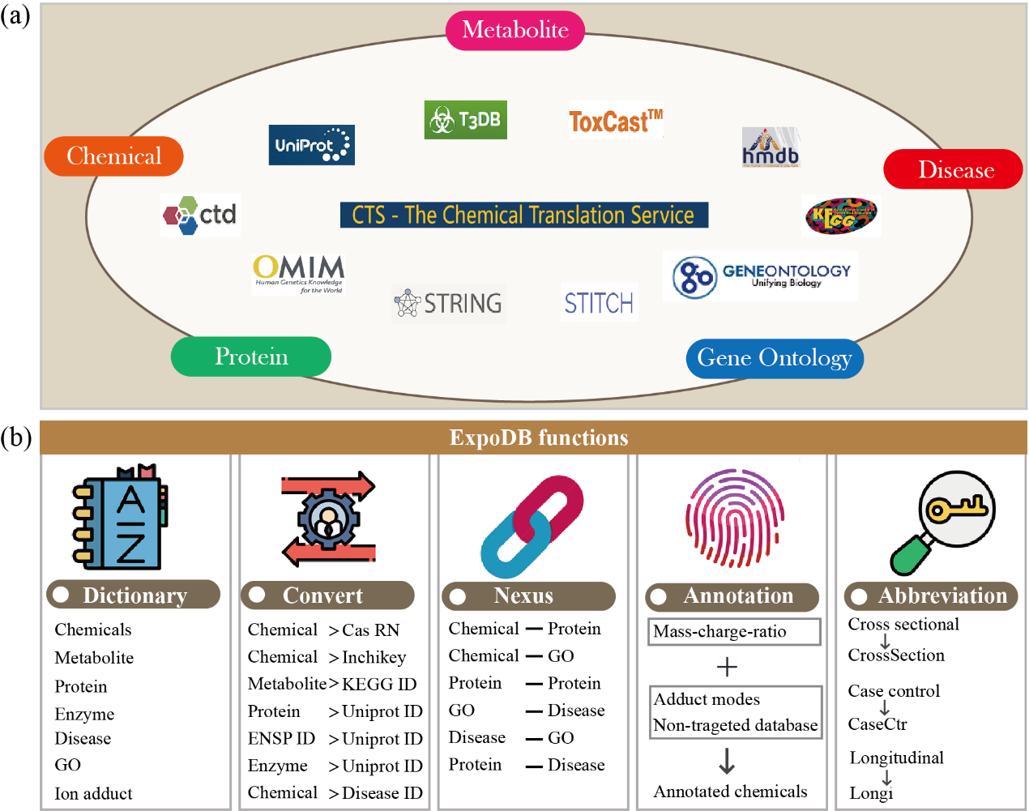
Figure S1. Databases used for ExposomeX platform development and five functions of ExpoDB module. (a) The databases used to develop ExposomeX platform; (b) The five functions of ExpoDB module. Of them, “Dictionary” is used for searching the related information about the databases, “Convert” for converting the names or IDs between different databases or nomenclatures, “Nexus” for exploring the potential nexuses between exposure, protein, phenotype, and disease, “Annotation” for annotating the non-target features from high-resolution mass spectrometry, “Abbreviation” for learning the nomenclature of "ExposomeX" platform.

Table S1. Typical characteristics of the databases used for ExposomeX platform
Classes ª | Count | Descriptions of main sources ^{b}
Exposure | 94,355 | STITCH, CTD, ToxCast, and T3DB. The chemical information are mainly from Chemical Translation Service (CTS).
Metabolite | 18,905 | KEGG for the human species.
Protein | 167,654 | UniprotKB in Uniprot consortium, STRING, and STITCH, and CTD for the human species.
Enzyme | 5,223 | KEGG for the human species.
Disease | 16,400 | Uniprot consortium, CTD and OMIM.
Chemical-protein | 2,053,899 | TTD, T3DB, CTD, ToxCast, and STITCH.
Protein-protein | 59,714 | STRING for the human species.
Protein-disease | 4,554 | Uniprot consortium for the human species
Chemical-GO | 25,096 | CTD
GO-Disease | 2,779,411 | CTD
Meta-analysis publications | 19,781 | CTD and Exposome-Explorer
ª The related databases can be downloaded from the ExposomeX platform at the website:
http://www.exposomex.cn/#/download;
^{b} The related databases can be obtained through the following websites:
HMDB: Human Metabolome Database (https://hmdb.ca/)
OMIM: Online Mendelian Inheritance in Man (https://omim.org/)
STICH: Chemical-Protein Interaction Networks (http://stitch.embl.de/)
UniProt consortium (https://www.uniprot.org/)
STRING: Functional Protein Association Networks (https://cn.string-db.org/)
CTD: Comparative Toxicogenomics Database (http://ctdbase.org/)
T3DB: Toxin and Toxin Target Database (http://www.t3db.ca/)
GO: Geneontology (http://geneontology.org/)
KEGG: Kyoto Encyclopedia of Genes and Genomes (https://www.genome.jp/kegg/)
CTS: Chemical Translation Service (http://cts.fiehnlab.ucdavis.edu/)
ToxCast: Toxicity ForeCaster (https://www.epa.gov/chemical-research)
TTD: Therapeutic Target Database (http://db.idrblab.net/ttd/)
Exposome-Explorer: (http://exposome-explorer.iarc.fr/)

