Supplementary Materials for

High sensitivity of photodetection via fermion to boson condensation
Tuntan Wu^{1,2,3}, Qinxi Qiu^{1,3}, Yongzhen Li^{1,3}, Qiangguo Zhou^{1,3}, Wanli Ma^{1,3}, Jingbo Li^{1,3}, Lin Jiang¹, Wei Zhou¹, Zhiming Huang^{1,2,3,4}*
1. State Key Laboratory of Infrared Physics, Shanghai Institute of Technical Physics, Chinese Academy of Sciences, 500 Yu Tian Road, Shanghai 200083, China
2. Hangzhou Institute for Advanced Study, University of Chinese Academy of Sciences, 1 Sub-Lane Xiangshan, Hangzhou 310024, China
3. University of Chinese Academy of Sciences, 19 Yu Quan Road, Beijing 100049, China
4. Institute of Optoelectronics, Fudan University, 2005 Songhu Road, Shanghai 200438, China
*Corresponding author. Email: zmhuang@mail.sitp.ac.cn

This file includes:
Figures S1 to S10
Note 1，2, 3

Figure S1. Crystal structure of 1T-TiSe₂.
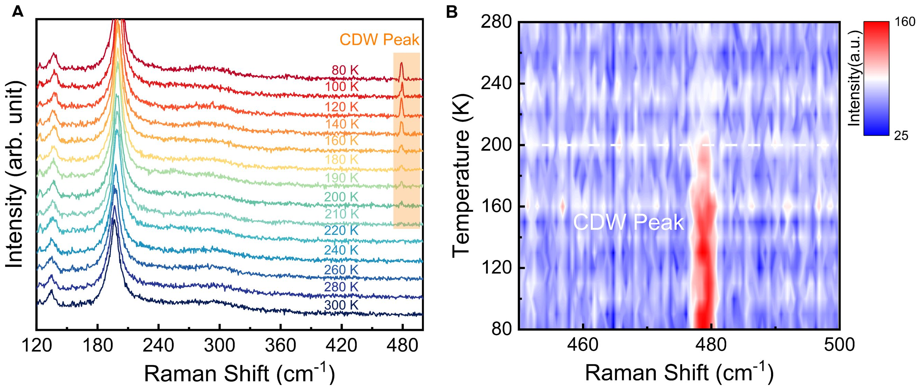
Figure S2. Raman characterization (A) Variable temperature Raman spectra of 1T-TiSe₂ film under rapid cooling procedure. (B) Raman mapping of new CDW peak at 477 cm⁻¹.

Figure S3. Cycled variable temperature resistance measurement on different devices.

Figure S4. Variable temperature electrical and optoelectronic characteristics of #1 terahertz photodetector under the procedure of warming after rapid cooling. (A) AFM image of the #1 device. (B) Temperature-dependent resistance of the #1 device. (C) Overview of variable temperature responsivities at the frequency ranges from 0.22 to 0.33 THz. (D) Temperature-dependent responsivities at 0.254THz. (E) Detailed comparison of responsivity spectra around T_{C}=180 K.

Figure S5. Variable temperature electrical and optoelectronic characteristics of #1 terahertz photodetector under the procedure of slow cooling. (A) Comparison of temperature-dependent resistance under two procedures. (B) Comparison of temperature-dependent responsivities at 0.254 THz under two procedures. (C) Overview of variable temperature responsivities at the frequency ranges from 0.22 to 0.33 THz during the processes of slow cooling. (D) Comparison of responsivity spectra under two procedures around T_{C}=180 K.

Figure S6. Variable temperature electrical and optoelectronic characteristics of #2 terahertz photodetector under the procedure of warming after rapid cooling. (A) AFM image of the #2 device. (B) Temperature-dependent resistance of the #2 device. (C) Overview of variable temperature responsivities at the frequency ranges from 0.22 to 0.33 THz. (D) Temperature-dependent responsivities at 0.266THz. (E) Detailed comparison of responsivity spectra around T_{C}=170 K.

Figure S7. Variable temperature electrical and optoelectronic characteristics of #2 terahertz photodetector under the procedure of slow cooling. (A) Comparison of temperature-dependent resistance under two procedures. (B) Comparison of temperature-dependent responsivities at 0.266 THz under two procedures. (C) Overview of variable temperature responsivities at the frequency ranges from 0.22 to 0.33 THz during the processes of slow cooling. (D) Comparison of responsivity spectra under two procedures around T_{C}=170 K.

Figure S8. Variable temperature electrical and optoelectronic characteristics of #3 terahertz photodetector under the procedure of warming after rapid cooling. (A) AFM image of the #3 device. (B) Temperature-dependent resistance of the #3 device. (C) Overview of variable temperature responsivities at the frequency ranges from 0.22 to 0.33 THz. (D) Temperature-dependent responsivities at 0.268THz. (E) Detailed comparison of responsivity spectra around T_{C}=160 K.

Figure S9. Variable temperature performances under 1550 nm laser illumination. (A) Variable temperature waveforms under 3 KHz modulation. (B) Comparison of rising time at 280 K and 80 K. (C) Comparison of falling time at 280 K and 80 K.

Figure S10. Schematic of the setup of the THz imaging system

Supplementary Note 1. The analysis in temperature-dependent resistance
Considering the metallic transport processes based on electron scattering, using relaxation time τ to generalize the effect of electron collisions on statistical distribution, $ρ∝\frac{1}{τ}=\frac{1}{τ_{L}}+\frac{1}{τ_{I}}$ (T >$Θ$_{D}), where $ρ$ is resistivity, T is temperature, $Θ$_{D} is Debye Temperature, $τ_{L}$ and $τ_{I}$ are the lattice scattering and impurity contributed relaxation time, respectively. Additionally, $\frac{1}{τ_{L}}∝T$ and $τ_{I}$ is temperature-independent, therefore, resistivity is linearly proportional to temperature¹.
For the temperature-dependent resistance of TiSe₂, the resistance curve above T_{C} can be fitted as $αT+β$, where α and β are constants, revealing its metallicity. The curve below T_{C} with slow cooling rate can be fitted as $α'T+β'$, while the curve with rapid cooling rates is fitted as $γT^{2}+α_{1}T+β_{1}$, losing its linearity with temperature below T_{C}.

Reference
1. N. W. Ashcroft, N. D. Mermin, Solid State Physics, Holt, Rinehart and Winston Inc., NY, USA 1976.

Supplementary Note 2. Brief description of EIW effect
When photons with energy much smaller than the bandgap are incident on the designed sub-wavelength size MSM structure, an electromagnetic induced well will be generated in the semiconductor. The physical process for the EIW contributing the long wavelength photo-response is as follows: the antisymmetric electric field of THz and MMW radiation can be utilized in the MSM structure when radiations propagate onto it. In the one-half period when the antisymmetric electric field appears parallel to the surface of the device, the electrons in the metals are emitted into the semiconductor from two metallic electrodes driven by Lorentz force. In the following half period when the antisymmetric electric field appears, the injected electrons in the semiconductor are decelerated but further move forward the center along the trajectory. In other words, the electrons are trapped in the well located at the semiconductor and therefore change the conductivity of the semiconductor. With the applying of the bias voltage on electrodes, the photovoltage signal can be collected.
For the above physical process, the concentration of the trapped electrons Δn in the well can be expressed as:
$∆n=\frac{4ε_{0}ηPτ_{e}μ}{π^{3}q^{2}dc\sqrt{ε_{r}}}\sqrt{{\left(\frac{π}{a}\right)}^{2}-k_{0}^{2}}×\left[1-exp⁡(-d\sqrt{ε_{r}}\sqrt{{\left(\frac{π}{a}\right)}^{2}-k_{0}^{2}})\right]$ ……(1)
where ε₀ is the permittivity in vacuum, $η=\left|\frac{ε\left(ω\right)\sqrt{ε_{0}μ_{0}k_{0}^{2}-{\left(π/a\right)}^{2}}}{\sqrt{ε\left(ω\right)ε_{0}μ_{0}k_{0}^{2}-{\left(π/a\right)}^{2}}}\right|$ is the optical gain, $ε\left(ω\right)$ is the relative permittivity of the metal, $μ_{0}$ is the magnetic permeability in vacuum, $k_{0}$ is the free space wave vector, P is the power of incident light, τ_{e} is the lifetime of the carriers, μ is the mobility of carriers, q is the unit electric charge, ε_{r} is the relative permittivity of semiconductor, d is the thickness of the film and $c$ is the velocity of light in vacuum. Therefore, we can get the responsivity expression as below:
$R_{v}=\frac{4ε_{0}ηV_{b}τ_{e}μ}{π^{3}q^{2}dc\sqrt{ε_{r}}n}\sqrt{{\left(\frac{π}{a}\right)}^{2}-{k_{0}}^{2}}×\left[1-\exp\left(-d\sqrt{ε_{r}}\sqrt{{\left(\frac{π}{a}\right)}^{2}-{k_{0}}^{2}}\right)\right]$ ……(2) where n is the intrinsic carrier concentration, V_{b} is the bias voltage of the device.

Supplementary Note 3. Derivations of temperature-dependent intrinsic carrier concentration and mobility.
Regarding the EIW responsivity formula:
$$R_{v}=\frac{4ε_{0}ηV_{b}τ_{e}μ}{π^{3}q^{2}dc\sqrt{ε_{r}}n}\sqrt{{\left(\frac{π}{a}\right)}^{2}-k_{0}^{2}}×\left[1-exp⁡(-d\sqrt{ε_{r}}\sqrt{{\left(\frac{π}{a}\right)}^{2}-k_{0}^{2}})\right]$$
Regarding the resistance:
$$R=ρ\frac{l}{S}=ρ\frac{a}{dw}$$
$$ρ=\frac{1}{σ}=\frac{1}{nqμ}$$
where a is the length of the channel and w is the width of the channel.
Considering the influence of temperature:
$$\frac{n(T)}{μ(T)}=\frac{4ε_{0}ηV_{b}τ_{e}}{π^{3}q^{2}dc\sqrt{ε_{r}}R_{v}(T)}\sqrt{{\left(\frac{π}{a}\right)}^{2}-k_{0}^{2}}×\left[1-exp⁡(-d\sqrt{ε_{r}}\sqrt{{\left(\frac{π}{a}\right)}^{2}-k_{0}^{2}})\right]$$
$$n\left(T\right)μ\left(T\right)=\frac{a}{qdwR(T)}$$
Combining the two formulae:
$$n\left(T\right)=\sqrt{\frac{4ε_{0}aηV_{b}τ_{e}}{π^{3}q^{3}d^{2}wc\sqrt{ε_{r}}R_{v}(T)R(T)}\sqrt{{\left(\frac{π}{a}\right)}^{2}-k_{0}^{2}}×\left[1-exp⁡(-d\sqrt{ε_{r}}\sqrt{{\left(\frac{π}{a}\right)}^{2}-k_{0}^{2}})\right]}$$
$$μ\left(T\right)=\sqrt{\frac{π^{3}qac\sqrt{ε_{r}}R_{v}(T)}{4ε_{0}ηwV_{b}τ_{e}R(T)\sqrt{{\left(\frac{π}{a}\right)}^{2}-k_{0}^{2}}×\left[1-exp⁡(-d\sqrt{ε_{r}}\sqrt{{\left(\frac{π}{a}\right)}^{2}-k_{0}^{2}})\right]}}$$

