Rhizosphere functioning and rhizo-microbiome of two contrasting genotypes of rice under drought-induced conditions

Supplementary data:
Data sheet on metagenome analysis of rice rhizosphere

Experimental setup
The experiment was carried out under wetland conditions in cement tanks (1 m x 45 cm x 45 cm) with rice landrace Norungan and high-yielding cultivar Co51. The soils collected from Tamil Nadu Agricultural University wetland farm, where no chemical fertilizers have been applied, were used for this experiment. The soil was characterized as clay loam textured with pH 7.97 (slightly alkaline), an electrical conductivity of 0.71 dS/m (non-saline), with available nitrogen 213 kg/ha; available phosphorus 31 kg/ha; available potassium 617 kg/ha, and soil organic carbon – 4.8 mg/g. The soil was filled in a cement tank, puddled with water, and paddy seeds were dibbled directly. After 15 days, two seedlings per hill were maintained.
No exogenous chemicals, organic amendments, or chemical fertilizers were applied throughout the experimentation. The moisture stress was initiated on the 30th day by maintaining 50% field capacity for 25 days. The depletion of soil moisture on imposition of drought stress was determined by computing the moisture percentage of the soil randomly to maintain 50% field capacity. Hydration and dehydration were followed to maintain 50% soil moisture throughout the experiment. After 55 days of culturing, rice plants were uprooted randomly, the adhered soil was considered rhizosphere soil, and soil apart from roots was treated as bulk soil. The rhizosphere and bulk soil samples with three biological replications were collected on the 56th day. The samples were divided into two parts. One part was shade dried, powdered, and sieved using 2 mm for further soil analysis. The remaining part was packed in airtight sampling vials (HiMedia, India) and stored at -20°C for metagenomic analysis.
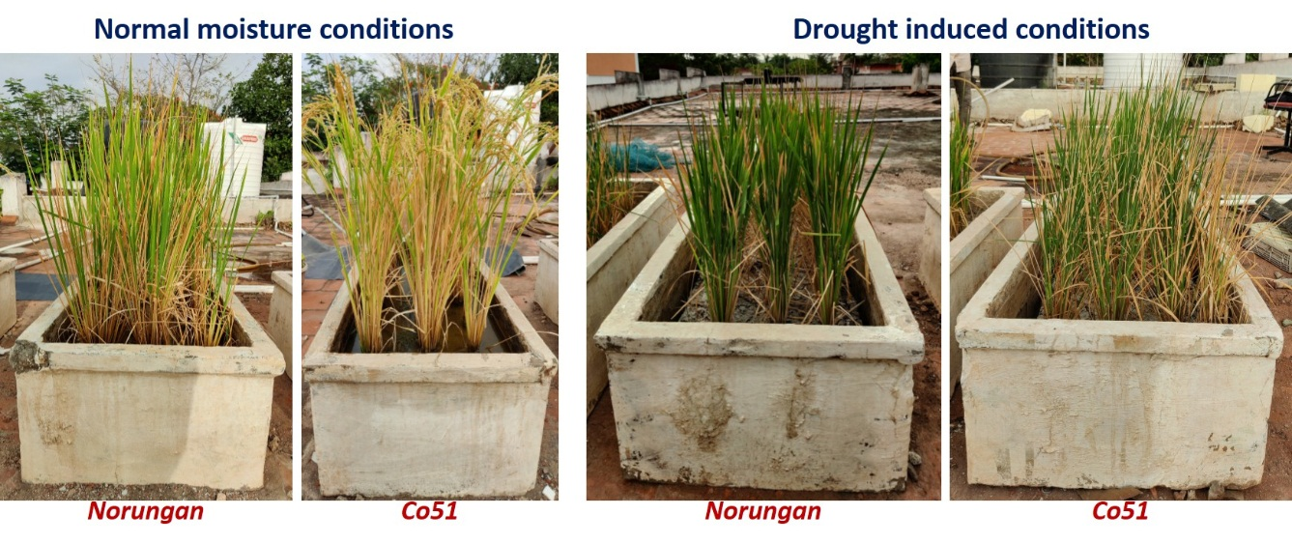
Fig. 1. Two contrasting rice genotypes were grown in cement tanks for microbiome analysis

Soil sample IDs
CDB1 – Co51 drought-induced bulk soil - 1
CDB2 – Co51 drought-induced bulk soil - 2
CDR1 – Co51 drought-induced rhizosphere soil - 1
CDR2 – Co51 drought-induced rhizosphere soil - 2
CNB1 – Co51 normal moisture bulk soil - 1
CNB2 – Co51 normal moisture bulk soil - 2
CNR1 – Co51 normal moisture rhizosphere soil - 1
CNR2 – Co51 normal moisture rhizosphere soil - 2
NDB1 – Norungan drought-induced bulk soil - 1
NDB2 – Norungan drought-induced bulk soil - 2
NDR1 – Norungan drought-induced rhizosphere soil - 1
NDR2 – Norungan drought-induced rhizosphere soil - 2
NNB1 – Norungan normal moisture bulk soil - 1
NNB2 – Norungan normal moisture bulk soil - 2
NNR1 – Norungan normal moisture rhizosphere soil -1
NNR2 – Norungan normal moisture rhizosphere soil - 2

Soil DNA extraction
Five hundred milligrams of homogenized soil stored at -20°C was used for high molecular weight metagenomic DNA extraction. The soil DNA was extracted using the Fast DNA spin kit for soil (MP biomedicals, Qbiogen, Cat. No. 6560-200) following the manufacturer's protocol. The extracted DNA was qualitatively and quantitatively quantified by gel electrophoresis (0.8% agarose gel), and the purity was checked spectrophotometrically (Nanodrop™ spectrophotometer, USA).

Table 1. Soil metagenomic DNA extracted from the samples
Sample ID | DNA (ng/µl) | A260/280 | Sample ID | DNA (ng/µl) | A260/280
CDB1 | 51.2 | 1.77 | NDB1 | 80.6 | 1.72
CDB2 | 57.6 | 1.77 | NDB2 | 76.2 | 1.72
CDR1 | 103.8 | 1.80 | NDR1 | 126.2 | 1.69
CDR2 | 146.0 | 1.78 | NDR2 | 103.6 | 1.80
CNB1 | 243.4 | 1.79 | NNB1 | 159.0 | 1.79
CNB2 | 113.2 | 1.76 | NNB2 | 198.6 | 1.80
CNR1 | 335.0 | 1.76 | NNR1 | 283.1 | 1.82
CNR2 | 315.3 | 1.74 | NNR2 | 280.5 | 1.82

Amplification of 16S r RNA gene sequence (Check)
The full-length 16S rRNA gene from soil metagenomics DNA was amplified using forward primer 338F and reverse primer 518R (Weisburg et al., 1991) (Primer details in Table 3A). The 30 µl PCR reaction mixture contains DNA template 50 ng, 10x Taq buffer, 2.5mM of each deoxyribonucleotide triphosphate (dNTP) mixture, 2.5 mM of MgCl₂, 1% Bovine serum albumin, 20 picomoles of each primer, and 2 U of Taq DNA polymerase (all from Bioserve, India). PCR amplification was performed in a thermocycler (Applied Biosystems, USA) using the following conditions: initial denaturation at 95°C for 10 min, 35 cycles of denaturation at 94°C for 1 min, annealing at 55°C for 1 min, extension at 72°C for 1 min, and final elongation at 72°C for 10 min. PCR products were separated by electrophoresis on 1.5 % agarose gels stained with the ethidium bromide and documented in the gel documentation and analysis system (Syngene bioimaging, Cambridge, UK).
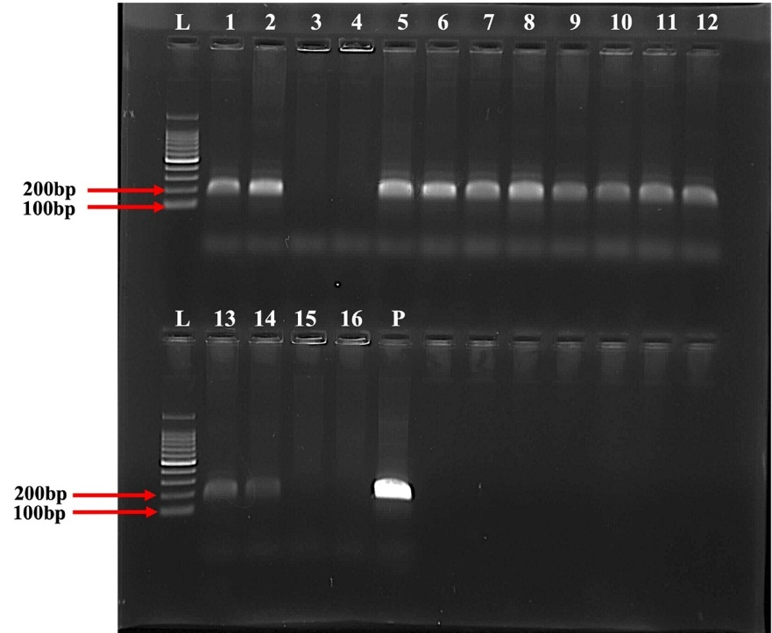
Fig. 2. PCR amplification of V3 region of 16S rRNA gene from soil metagenomic DNA using 338F-518R universal primers. An amplicon size of 180 pb indicates positive amplification. P – E. coli DNA as the positive control.

Next-generation sequencing
The microbiome of soil samples was assessed by the Illumina sequencing platform (Oneomics Private Limited, Bharathidasan University Technology Park, Khajamalai Campus, Tiruchirappalli 620 023, Tamil Nadu, India).

Amplicon generation
The V3+V4 region of the 16S rRNA gene was amplified using a specific primer with a barcode. All PCR reactions were carried out with Phusion® High-Fidelity PCR Master Mix (New England Biolabs).

Library preparation and sequencing
From the raw DNA samples to the final data, each step, including sample test, PCR, library preparation, and sequencing, influences the quality of the data, and data quality directly impacts the analysis results. Quality control is performed at each step of the procedure to keep the data reliability.
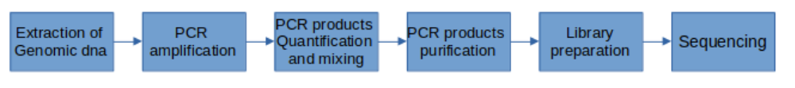
Fig. 3. Workflow of Illumina sequencing of soil samples.

Data analysis procedures
For the veracity of sequencing data analysis, raw data would be merged and filtered to get clean data. The effective data are used to do OTU cluster and species annotation for the respective sequence of each OTU. Furthermore, OTU picking, and taxonomic assignment construction of phylogenetic trees through downstream statistical analysis explain the community construction differences between samples or among groups.

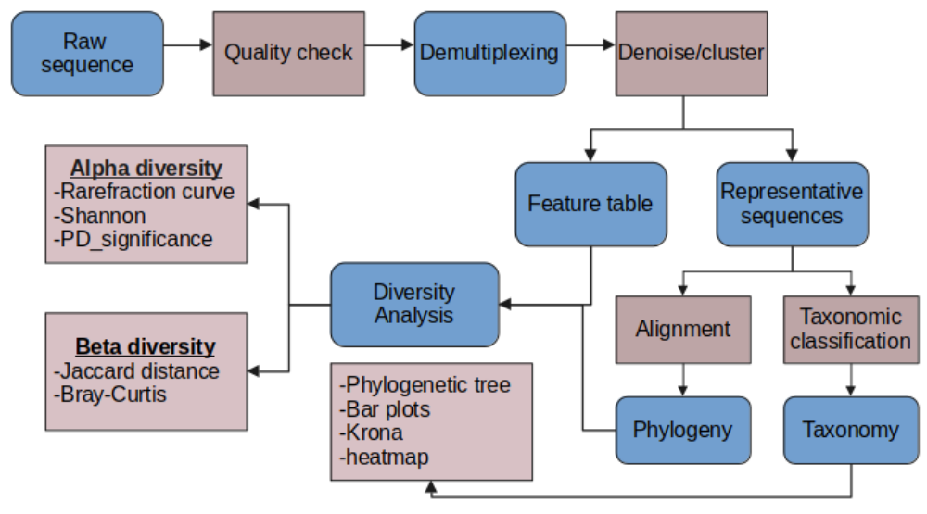
Fig. 4. Flowchart on the workflow of data analysis in Illumina sequencing of a soil metagenome

Table 2. Quality sequence reads obtained from different soil samples
Sample ID | Reads (bp) | GC % | Unique reads (bp) | Duplicate reads (bp)
CDB1 | 255710 | 56% | 20168 | 235542
CDB2 | 242986 | 57% | 19056 | 223930
CDR1 | 217714 | 55% | 17788 | 199926
CDR2 | 220716 | 56% | 18616 | 202100
CNB1 | 202818 | 57% | 19180 | 183638
CNB2 | 237592 | 57% | 21403 | 216189
CNR1 | 254802 | 57% | 22572 | 232230
CNR2 | 206422 | 57% | 18630 | 187792
NDB1 | 207106 | 57% | 19114 | 187992
NDB2 | 233648 | 57% | 20358 | 213290
NDR1 | 244062 | 57% | 21312 | 222750
NDR2 | 243870 | 57% | 22519 | 221351
NNB1 | 275928 | 57% | 24317 | 251611
NNB2 | 247674 | 57% | 21517 | 226157
NNR1 | 214616 | 57% | 18772 | 195844
NNR2 | 227270 | 57% | 18591 | 208679

Rarefaction Curve
The rarefaction Curve was created by randomly selecting a certain amount of sequencing data from the samples, then counting the number of the species they represent. If the curve is steep, many species remain to be discovered. If the curve becomes flatter, a credible number of samples have been taken, which means only the scarce species remain to be sampled. The rarefaction curve of all the samples was presented in Fig. 5.

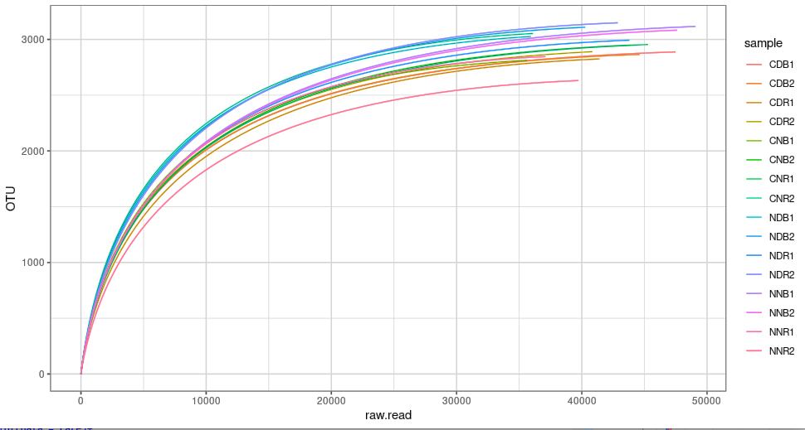
Fig. 6. Rarefaction curve sequences showing the microbial community complexities in all the samples.
Output files
After sequencing, fastq files containing the nucleotide information were used in the QIIME2 program. The following output files were obtained from QIIME2.
- Feature table - a matrix containing the abundances of detected microbial features (OTUs) [table.qza].
- Taxonomy table - an array indicating the taxonomic assignment of features, which can be integrated with biom format. [taxonomy.qza].
- Phylogenetic tree - a phylogenetic tree indicating the evolutional similarity of microbial features, potentially used when calculating phylogenetic diversity metrics [rooted-tree.qza].
- Metadata - a data frame containing the grouping information, including genotype (Norungan/Co51), stress conditions (Normal/drought), and niche (rhizosphere/bulk) [sample-metadata.tsv].
These four output files obtained from QUIMME2 were further processed for alpha and beta diversity, phylum and genus level relative abundance, and differential abundance analysis in R (Version 4.1.1) (R Core Team, Vienna, Austria).

References
Caporaso, J. Gregory, et al. QIIME allows analysis of high-throughput community sequencing data. Nature methods 7.5 (2010): 335-336.
Edgar, Robert C. UPARSE: highly accurate OTU sequences from microbial amplicon reads. Nature methods 10.10 (2013): 996-998.
Edgar, Robert C., et al. UCHIME improves sensitivity and speed of chimera detection. Bioinformatics 27.16 (2011): 2194-2200.
Haas, Brian J., et al. Chimeric 16S rRNA sequence formation and detection in Sanger and 454- pyro-sequenced PCR amplicons. Genome Research 21.3 (2011): 494-504.
Quast C, Pruesse E, et al. The SILVA ribosomal RNA gene database project: improved data processing and web-based tools. Nucleic Acids Research (2013): D590-D596.
Weisburg, W. G., Barns, S. M., Pelletier, D. A. and Lane, D. J. 16S ribosomal DNA amplification for phylogenetic study. J Bacteriol. (1991): 173:697-703.

