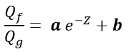 (1)
Where:
Q_{f}/Q_{g}: ratio of the absorbed mass of toluene per gram of rubber;
z: ratio of load mass per unit mass of rubber;
a: constant angular coefficient of the straight;
b: constant linear coefficient of straight.

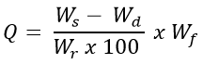 (2)
Where:
Q: mass of toluene absorbed per gram of rubber;
W_{s}: mass of the swollen composite, after equilibrium reached (g);
W_{d}: dry composite mass (g);
W_{r}: mass of rubber in the dry composite (g);
W_{f}: total formulation mass (g);

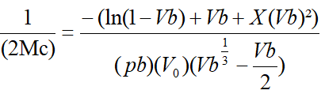 (3)

