Mechanism of kinetin-induced death of Vicia faba ssp. minor cortex cells

Andrzej Kaźmierczak^{1*}, Anita Kunikowska¹, Magdalena Doniak¹, Andrzej Kornaś²

¹Andrzej Kaźmierczak
University of Łódź, Faculty of Biology and Environmental Protection, Institute of Experimental Biology, Department of Cytophysiology, Pomorska 141/143, 90-236 Łódź, Poland

¹ Anita Kunikowska

E-mail: anitkunikowska@gmail.com

¹ Magdalena Doniak
E-mail: magdadoniak@o2.pl

²Andrzej Kornaś
Institute of Biology, The Pedagogical University of Cracow, Podchorążych 2, 30-084 Kraków, Poland
andrzej.kornas@up.krakow.pl

(* Corresponding author)
E-mail: andrzej.kazmierczak@biol.uni.lodz.pl
Fax: +48 +42 635-45-12
Tel: +48 +42 635-42-03
http://orcid.org/0000-0001-6446-7337
PBN: 3936870

Supplementary Figures

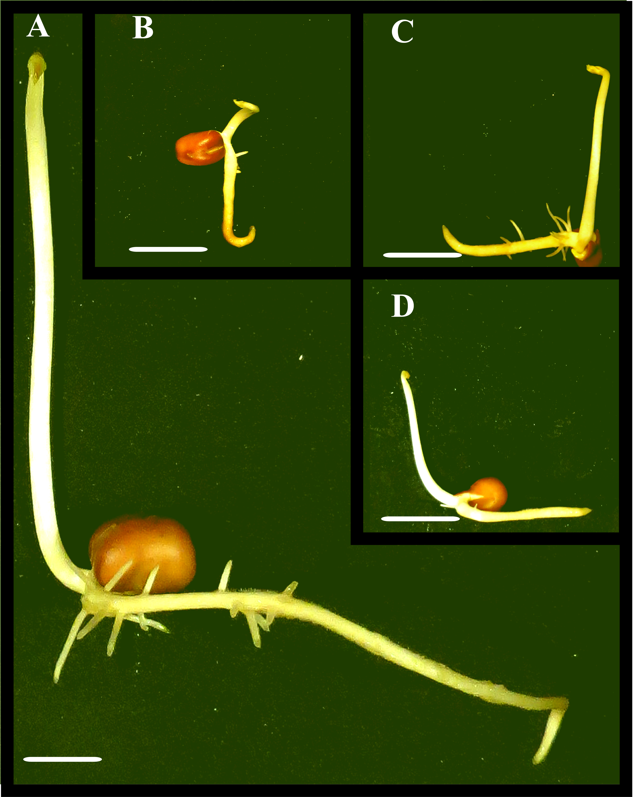

Figure 1Sǀ Vicia faba ssp. minor seedlings and after Sorafenib treatment. Ctrl (A); Kin (B); Sorafenib (C’) and Kin/Sorafenib (D). a, nuclei of alive cells, d, nuclei of dying cells. Scale bars = 20 mm.

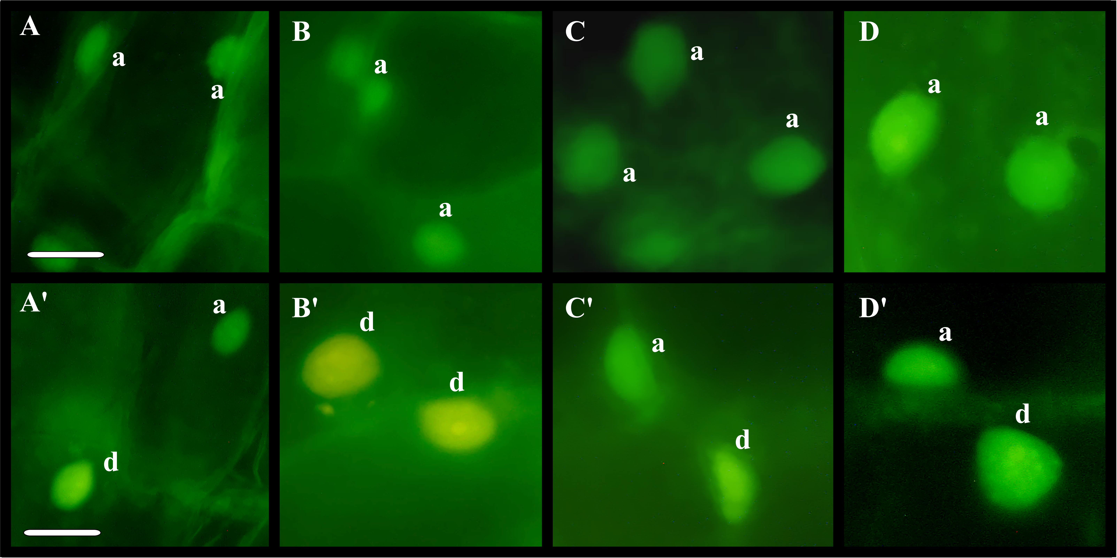

Figure 2Sǀ Images of nuclei of cortex cells of Vicia faba ssp. minor seedling roots stained with Acridine orange and Ethidium bromide after Sorafenib treatment. Ctrl (A,A’); Kin (B,B’); Sorafenib (C,C’) and Kin/Sorafenib (D,D’). a, nuclei of alive cells, d, nuclei of dying cells. Scale bars in A,A’ = 20 µm, are applied to all figures.

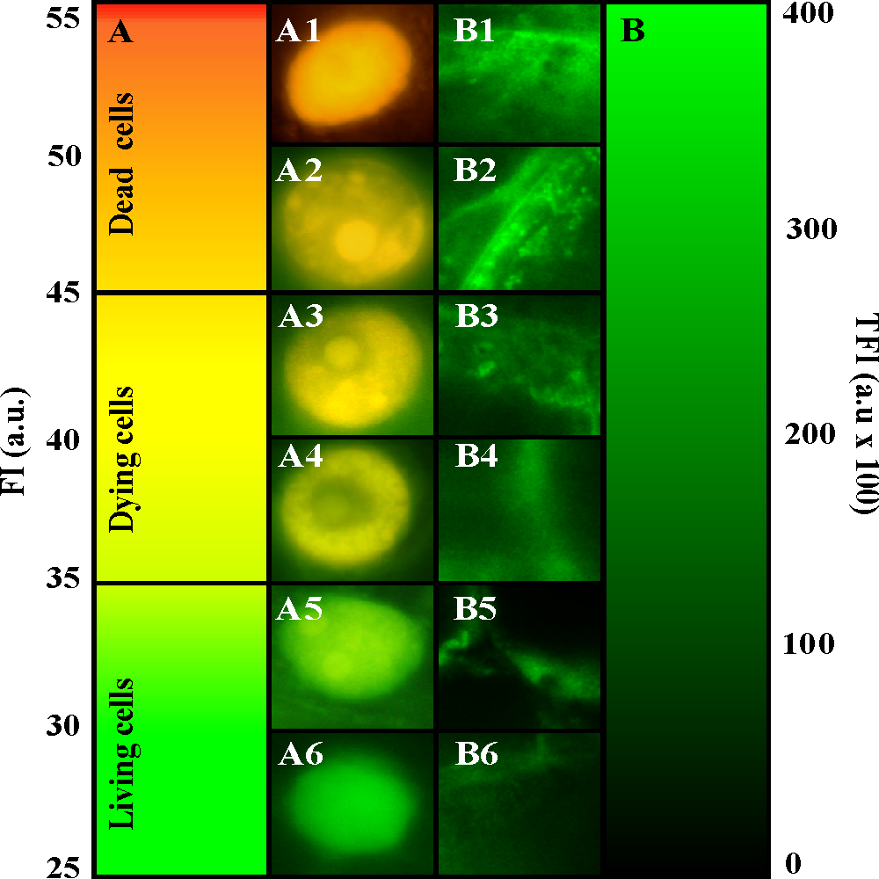

Figure 3Sǀ Graph (A) and panels with the green (A6), green-yellow (A5), yellow (A4), yellow-orange (A3), bright-orange (A2) and orange-red (A1) colour and nuclei respectively, used to calculate the number of living (A6,A5; FI values 10–35 a.u.), dying (A4,A3; FI values 34–55 a.u) and dead (A2,A1) cells after Acridine orange and Ethidium bromide staining as well as graph (B) with the dark to green (B6-B1; FI values 0 and 400 a.u.) panels used to estimate calcium ion (Ca ²⁺) amount. Scale bars in A1 and B1 = 10 µm, are applied to all figures.

