Supplementary Information

Automatic Surface Dispersion, Defect, Curing and Thermal Characteristics Determination of Polymer Composites using Infrared Thermography and Machine Learning Algorithm
Md Ashiqur Rahman¹, Mirza Masfiqur Rahman², Ali Ashraf^{1,*}
¹Department of Mechanical Engineering, University of Texas Rio Grande Valley, Edinburg, TX-78539, USA.
²Department of Computer Sciences, Purdue University, West Lafayette, IN-47907, USA.
*Corresponding Author: Ali Ashraf (Email: ali.ashraf@utrgv.edu)

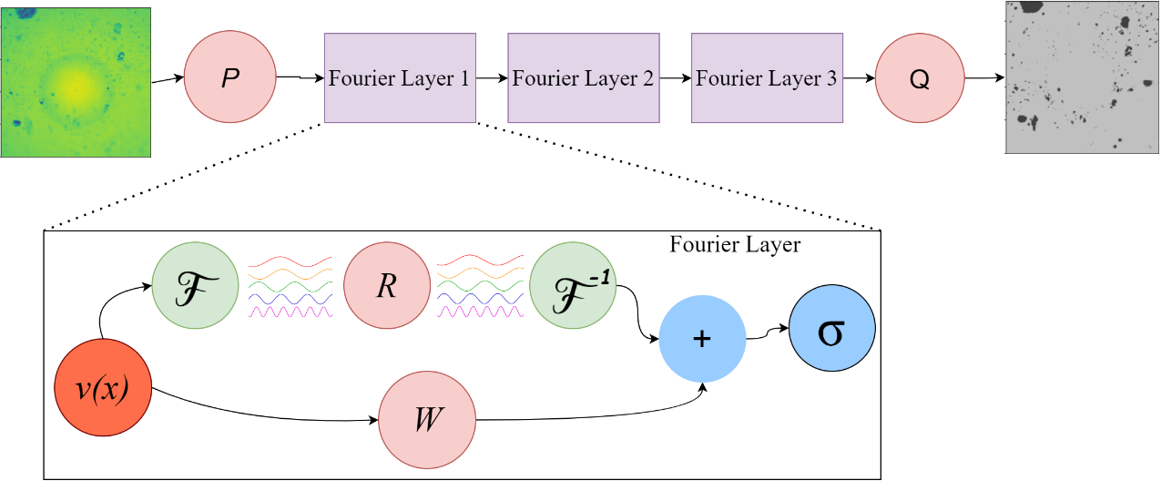
Figure S1: Schematic of SDFN architecture.

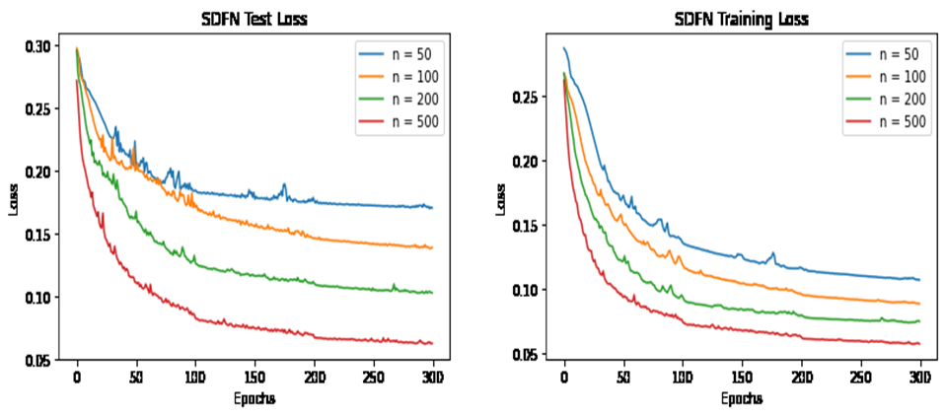
Figure S2: Test loss and training loss of SDFN model with varying number of runs.

(a)
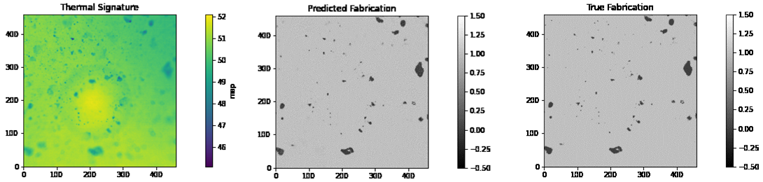
(b)
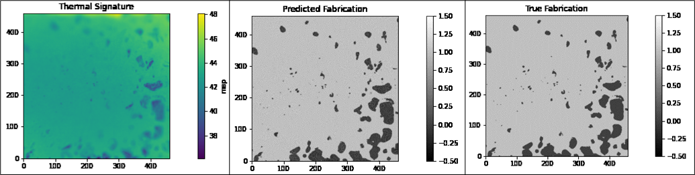
(c)
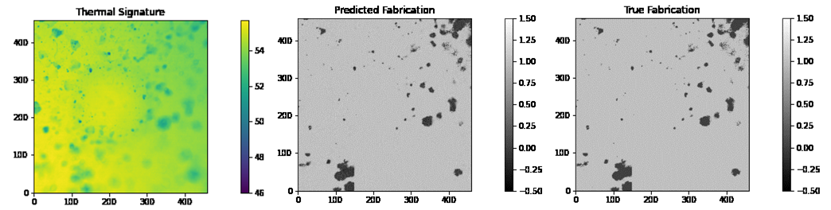
(d)
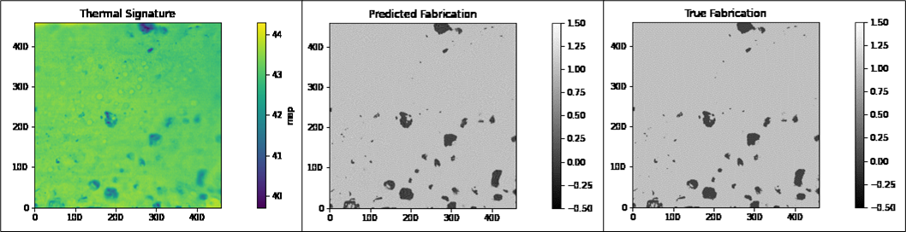
Figure S3: Thermal signature, predicted and true image of (a) 5% G Planetary, (b) 5% G Hand, (c) 7.5% G Hand, (d) 7.5% G Planetary.
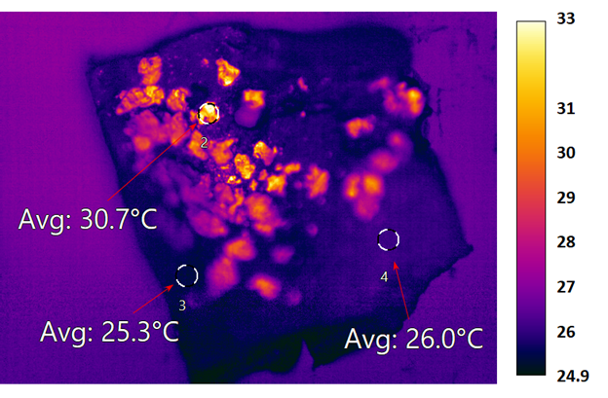
Figure S4: Filler identification (tramp material analysis) of polymer composites using MoS₂, graphite, and ecoflex elastomer. The average temperature of each region was distinct due to emissivity.
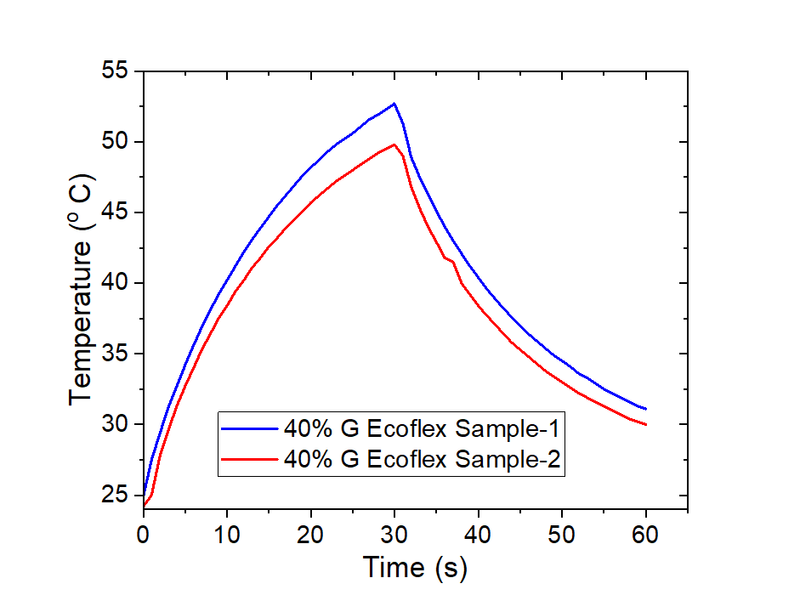Figure S5: Thermal characteristics curve of 40% G Batch mixing samples.

