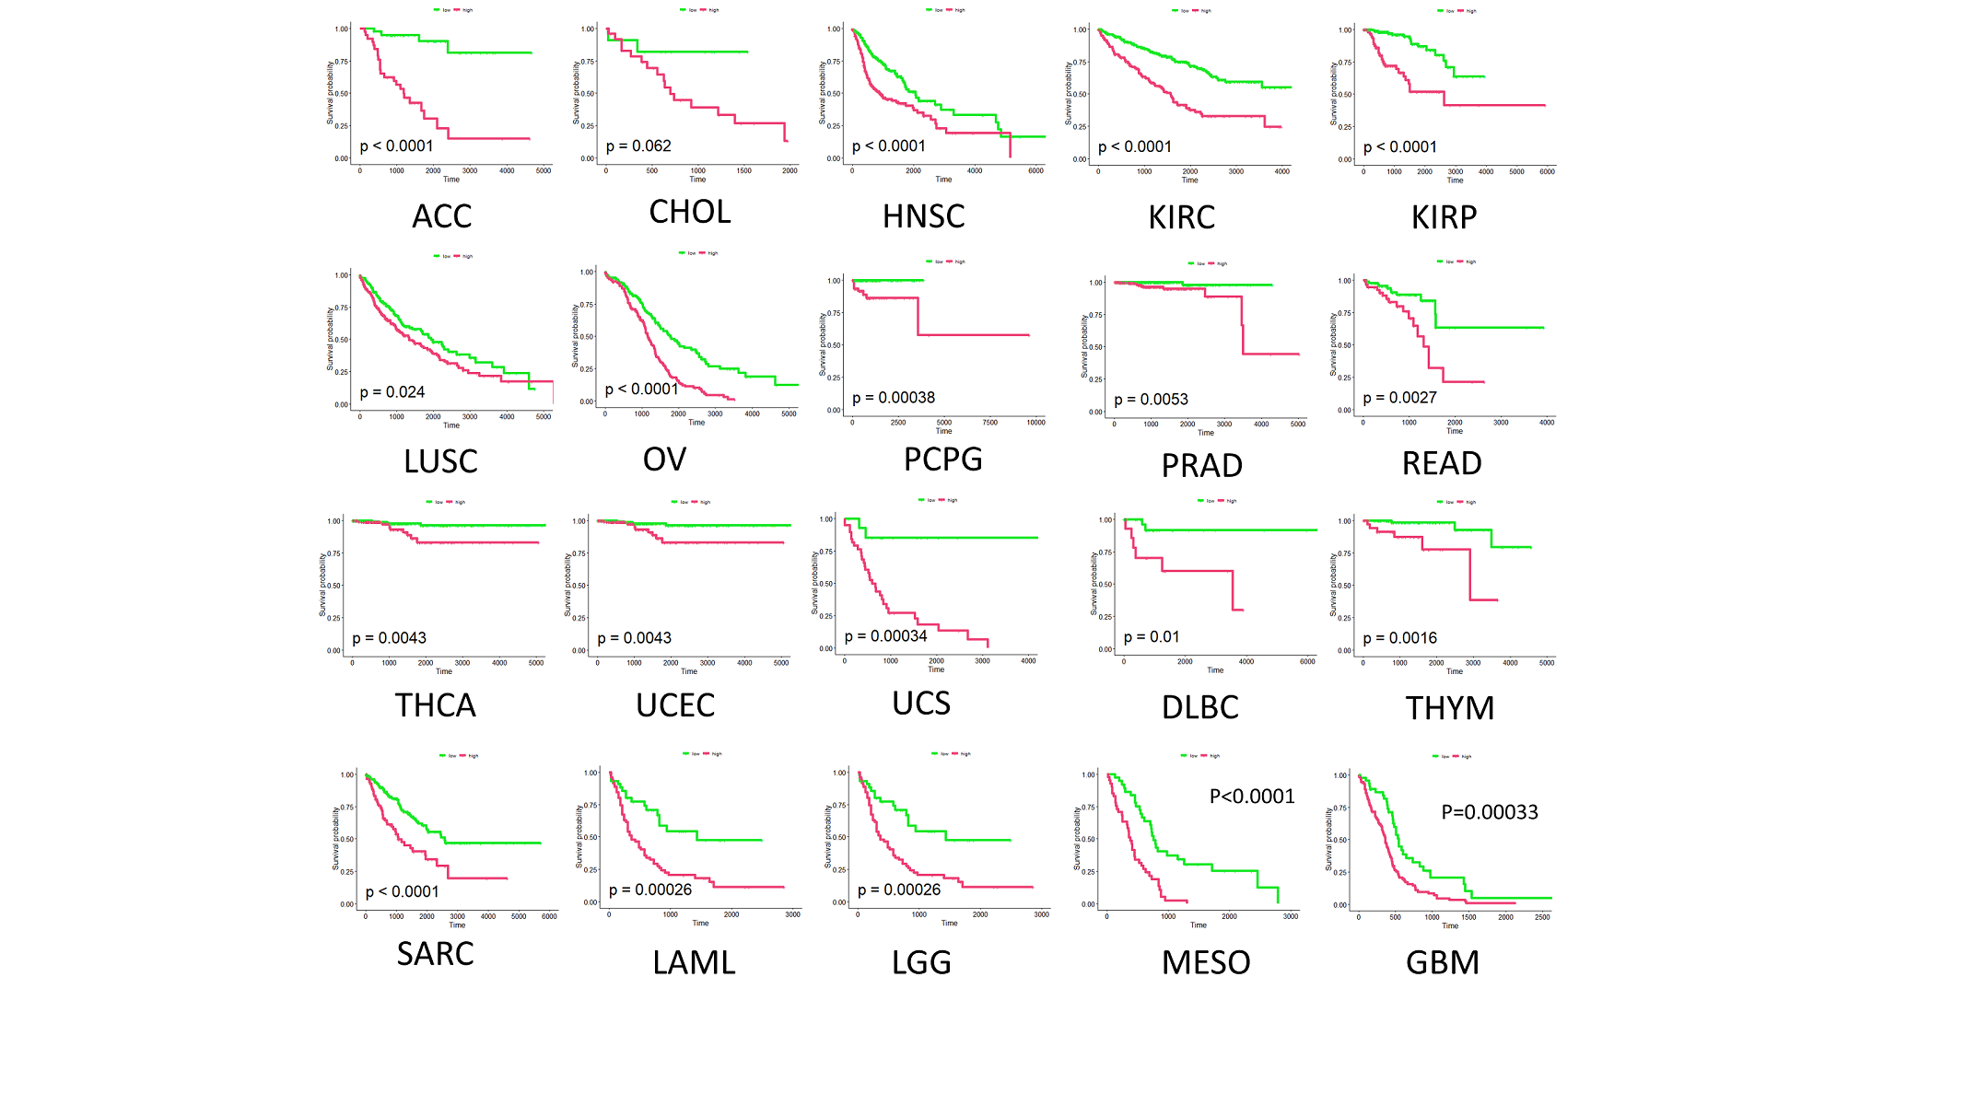
Figure S1. The overall survival (OS) curves of AP^{low} and AP^{high} patients.

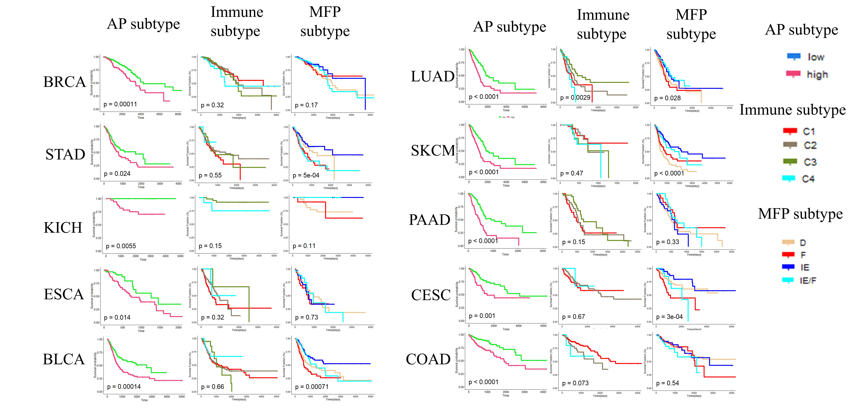
Figure S2. The overall survival (OS) curves based on AP model, immune subtype, MFP subtype classification.

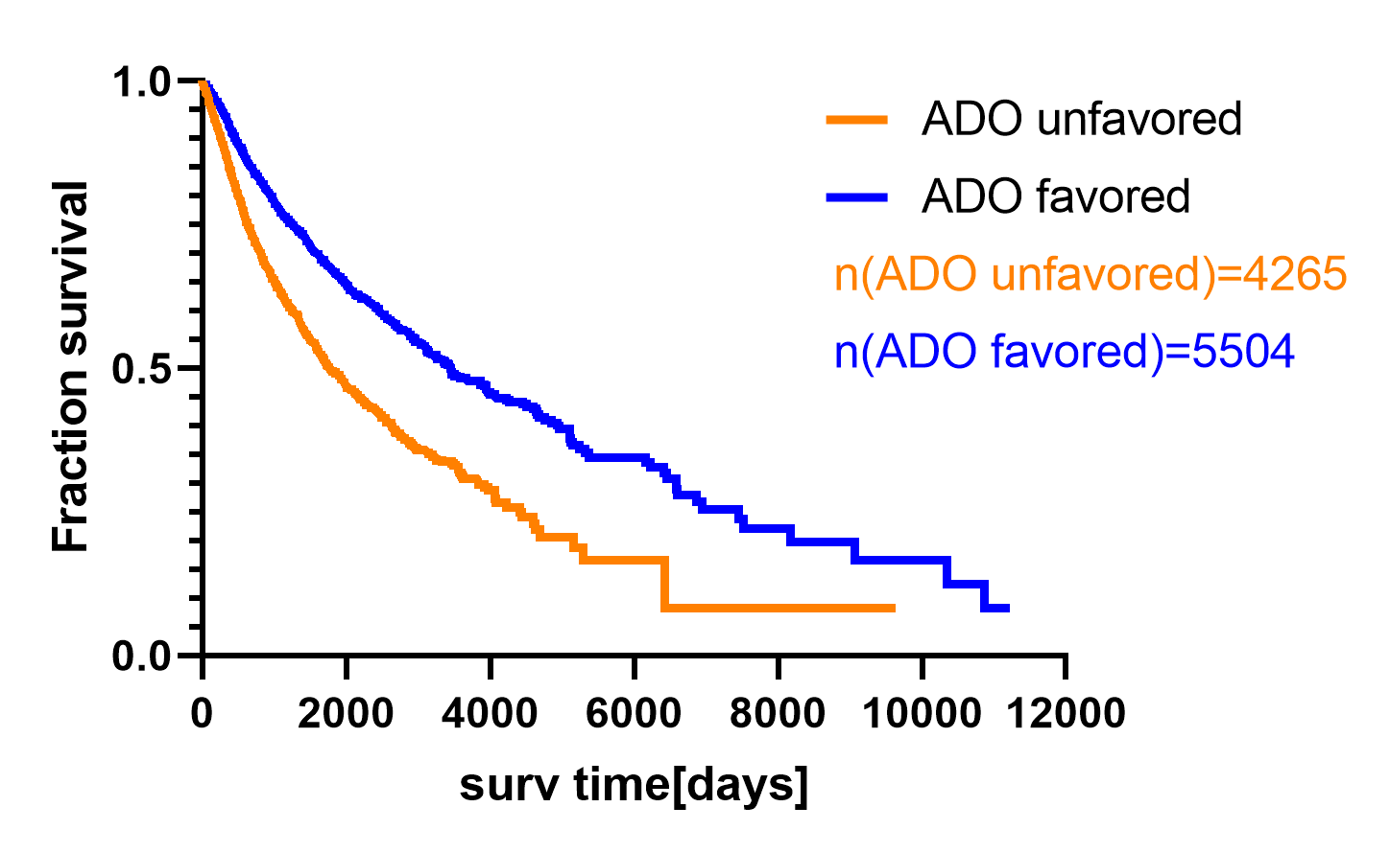
Figure S3. The overall survival (OS) curves of ADO unfavored (n=4265) and ADO favored (n=5504) tumors. The data were retrieved from TCGA database.

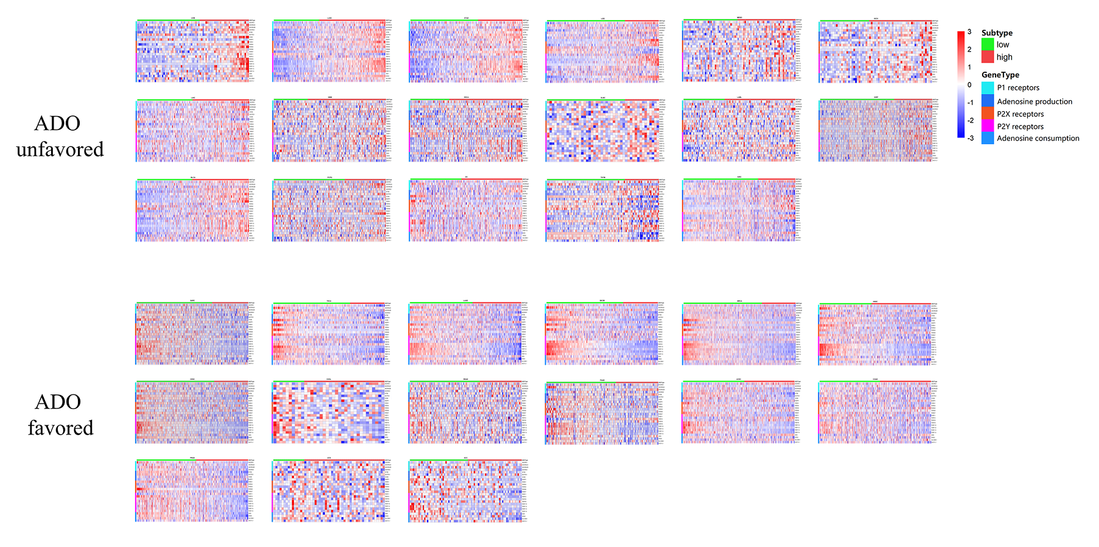
Figure S4. Gene expression patterns of ADO unfavored and ADO favored tumors. The data were retrieved from TCGA database.

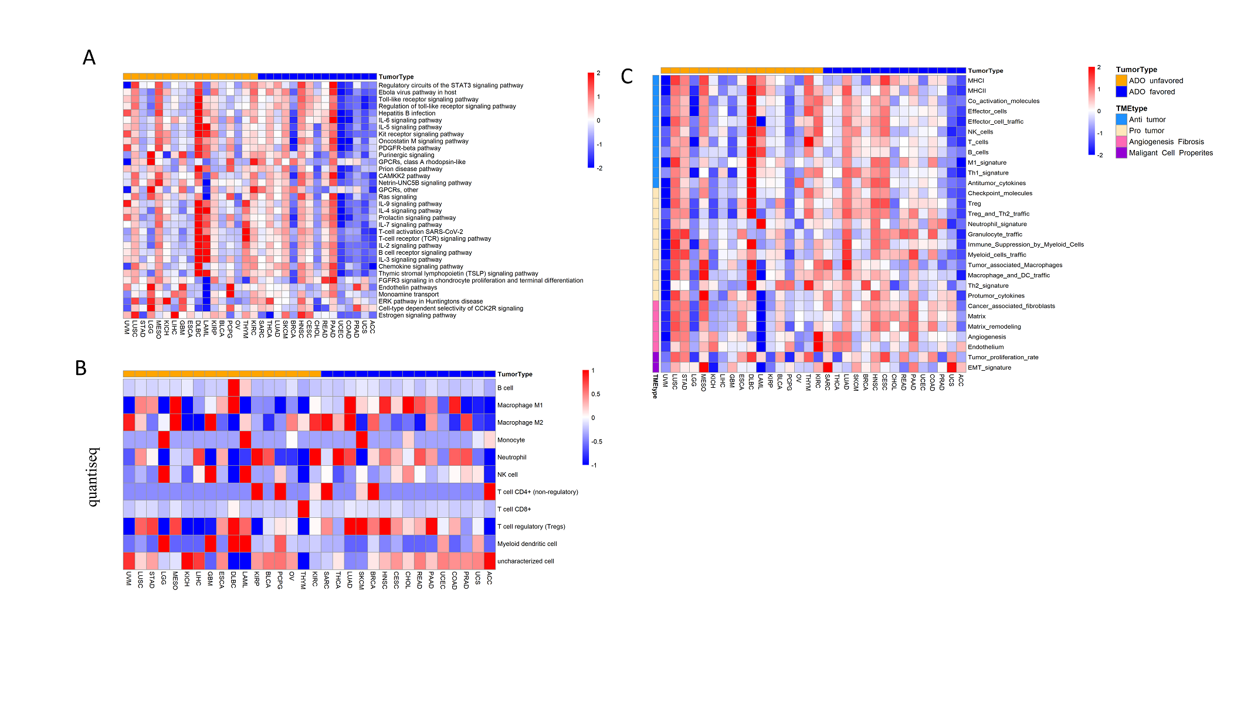
Figure S5. Heatmap of cell components and microenvironment of AP^{low} and AP^{high} patients. The properties between AP^{low} and AP^{high} patients were compared, such as signaling pathway (A), cell components (B), microenvironment characteristics (C).

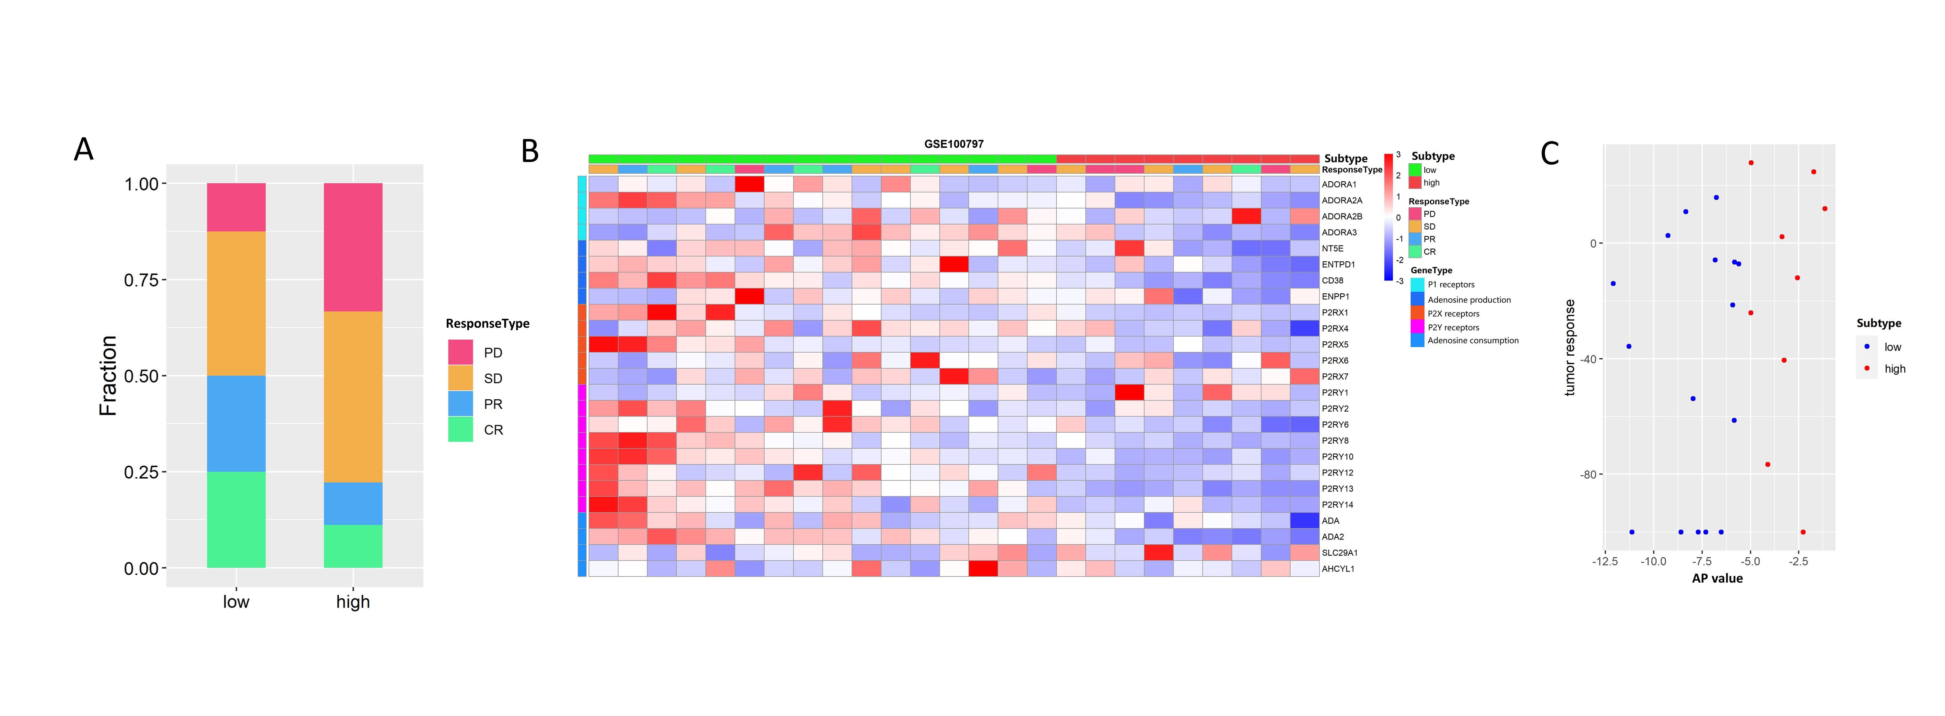
Figure S6. AP^{low} and AP^{high} patients responded to adoptive T-cell therapy (ACT). (A) the ratio of ACT response for AP^{low} and AP^{high} melanoma patients. Dataset ID was GSE100797, with a total 25 patients (AP^{low} =16, AP^{high}=9). (B) gene expression of the AP related genes before ACT therapy. (C) Correlation between AP values and tumor response.

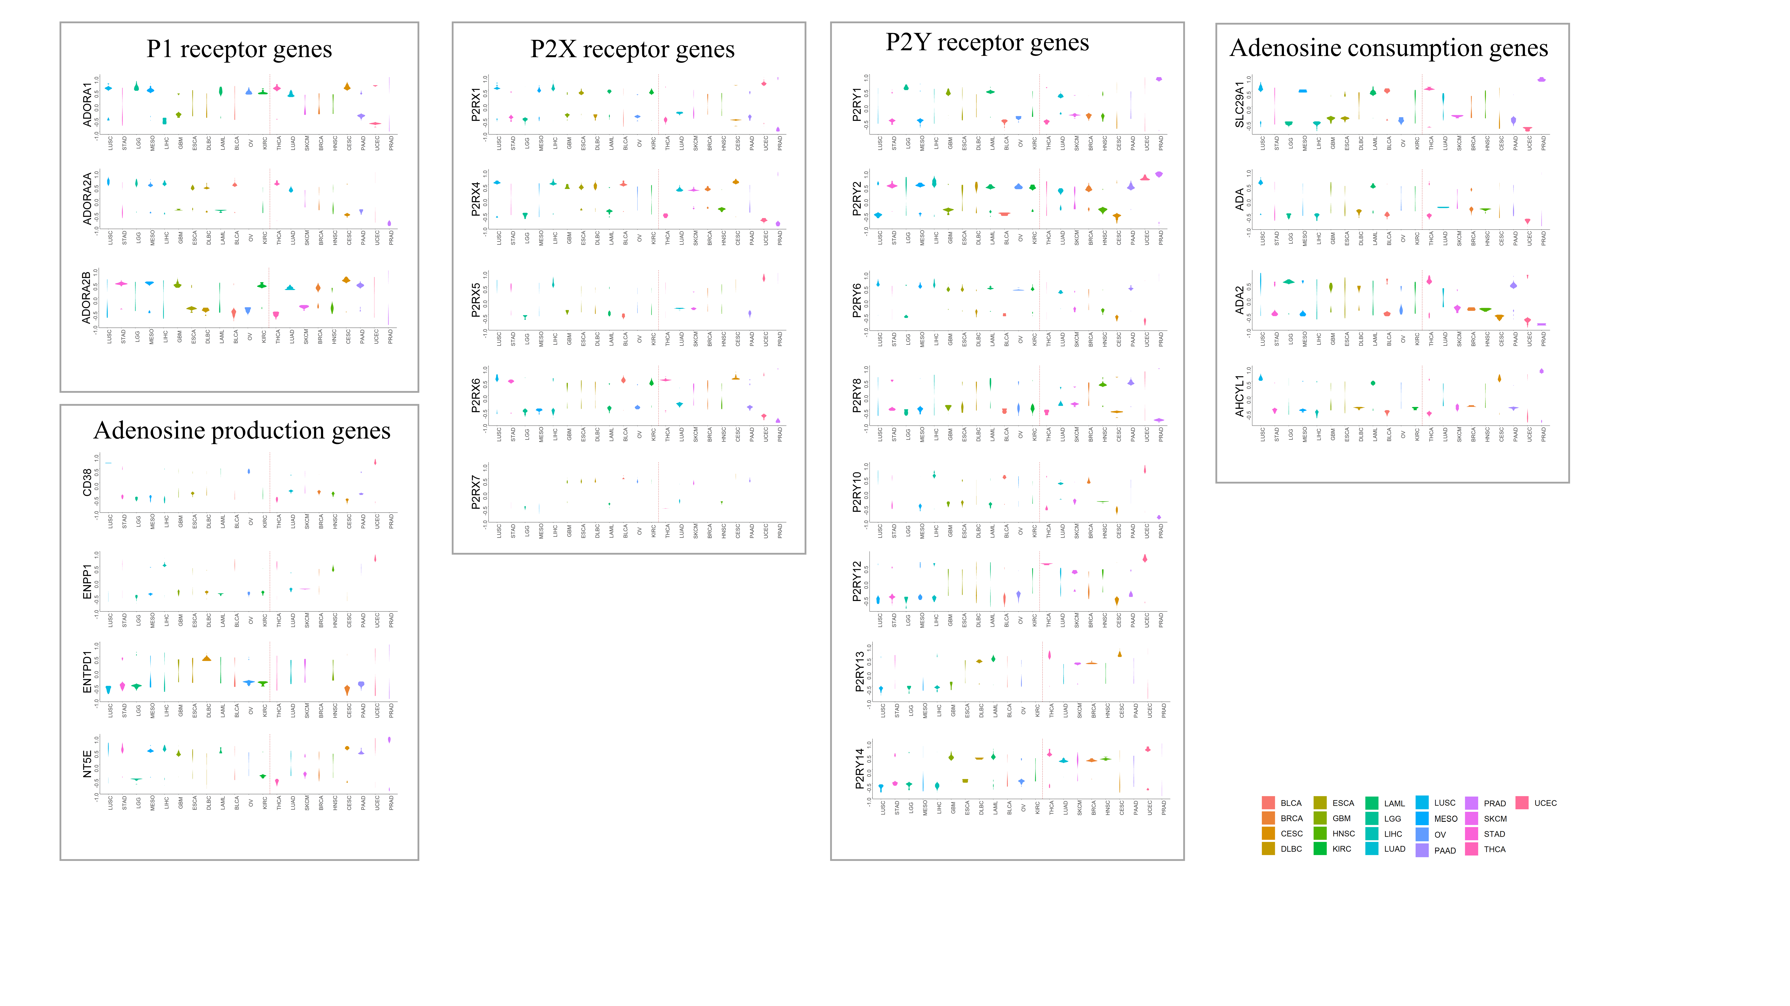
Figure S7. Correlation values of each gene on drug sensitivity in different tumors.

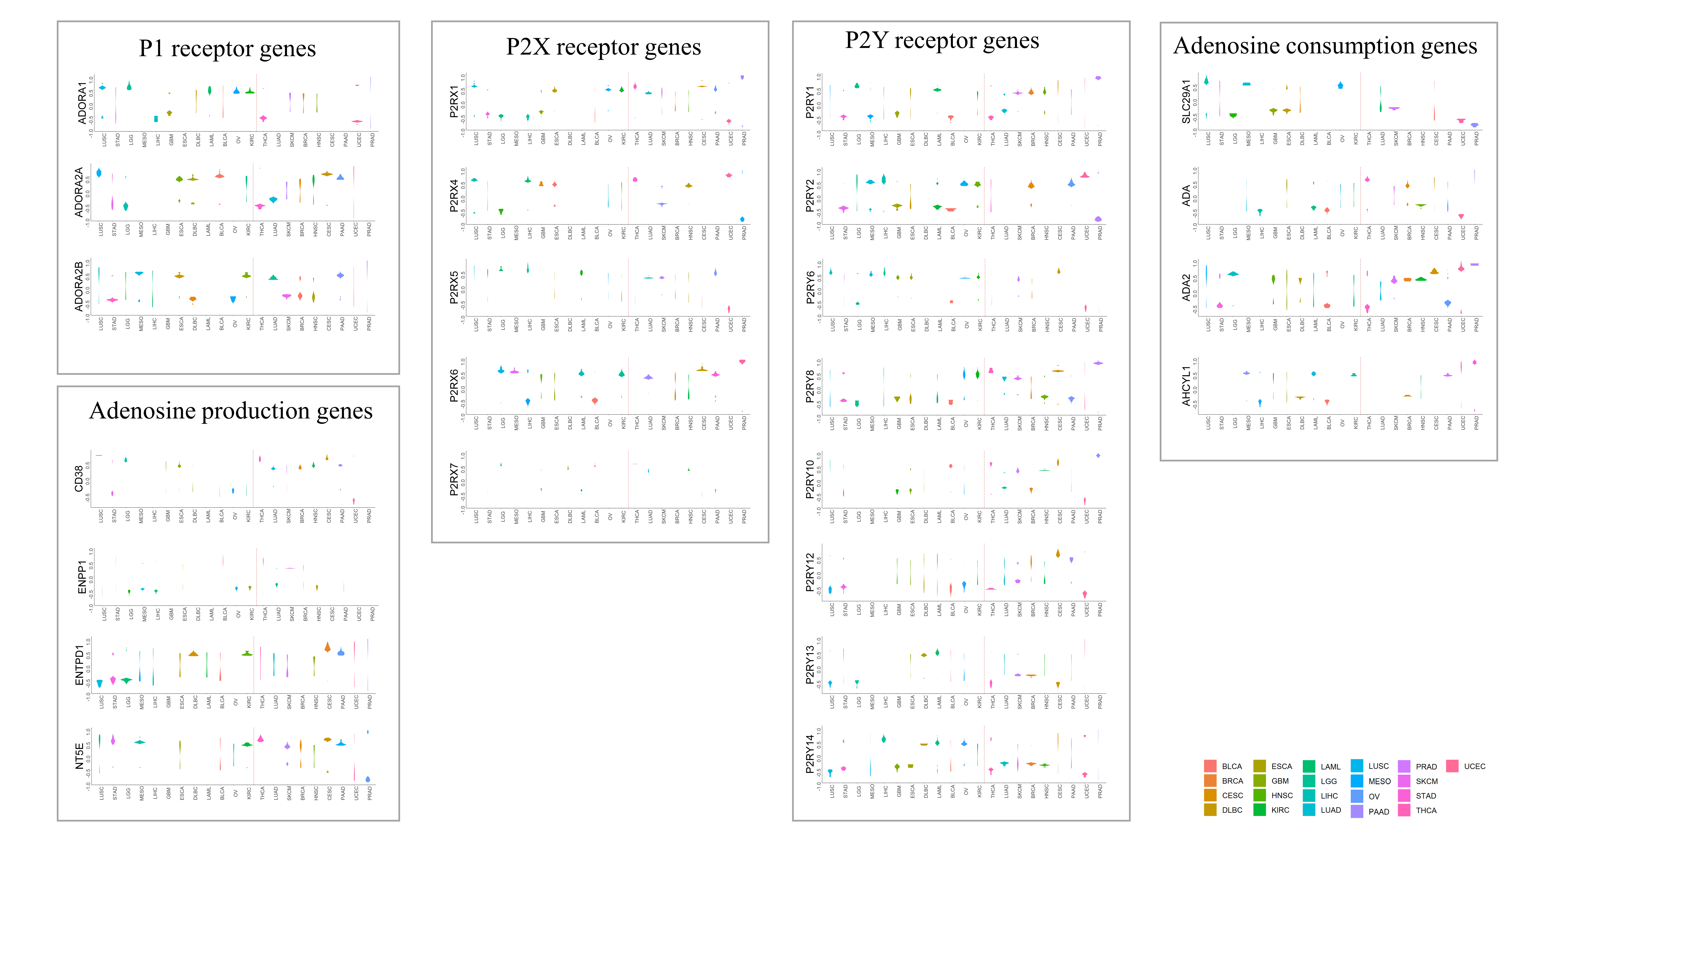
Figure S8. Correlation values of each gene of AP^{high} patients on drug sensitivity in different tumors.

