Relationships between weather parameters and foraging daily activity of Oecophylla smaragdina (Hymenoptera: Formicidae) in oil palm plantations
Exélis Moïse Pierre*^{1, 2}, Rosli Ramli¹, Azarae Hj. Idris¹, Samshul Amry Abdul Latif³

Supplementary information
Supplemental Table 1. Selected surveyed oil palm plantations for trunk foraging activity
Year | Name – Locations (Malaysia) | Ownership | Area ha | Coordinates
2010-2016 & 2020- 2021 | Teluk Intan Perak Northern | MPOB | 600 | 3°49’07”N 100°58’59”E
2020-2022 | Felda Gunung Besout Perak Northern | FELDA | 21345 | 03°50’04”N 101°17’48”E  03°53’41”N 101°20’45”
2022 | Felda Keratong Pahang East | FELDA | 18460 | 02°571’54”N 102°562’52”
2012-2013 & 2019 | Lahad Datu Sabah Borneo | MPOB | 1000 | 5°01'48"N 118°25'05"E
2012 | Sessang Saratok Sarawak Borneo | MPOB | 1500 | 1°45'13"N 111°20'05"E
2012-2016 & 2019 | UM plantations Sdn.Bhd Johor | Universiti Malaya | 400 | 2°02’03”N 103°51’50”E
2012 & 2019 | Felcra Kota Tinggi Johor South | Felcra | 1000 | 2°00”40”N 103°51’38”E
2012 | Boustead Kota Tinggi Johor South | Boustead | 1500 | 1°59’52”N 103°52’02”E

Table 2. Rule of Thumb for Interpreting the Size of a Correlation Coefficient. The value of Correlation Coefficient (r) range from -1, when there is an inverse perfect relationship through 0, when there no relationship to 1, when there is a perfect positive relationship.
.90 to 1.00 (- .90 to -1.00) | Very high positive (negative) correlation
.70 to .90 (-.70 to -.90) | High positive (negative) correlation
.50 to .70 (-.50 to -.70) | Moderate positive (negative) correlation
.30 to .50 (-.30 to -.50) | Low positive (negative) correlation
.00 to .30 (.00 to -.30) | Negligible correlation

Supplemental table 3. Test of Homogeneity of Variances: study 1
Test of Homogeneity of Variances
 |  |  |  |  |  | Levene Statistic |  | df1 | df2 | Sig.
Colonies Mean Trunk Foragers |  |  | Based on Mean |  |  | 117.882 |  | 7 | 1792 | .000
 |  |  | Based on Median |  |  | 14.256 |  | 7 | 1792 | .000
 |  |  | Based on Median and with adjusted df |  |  | 14.256 |  | 7 | 1368.014 | .000
 |  |  | Based on trimmed mean |  |  | 102.770 |  | 7 | 1792 | .000
Supplemental table 4. Robust Tests of Equality of Means: study 1.
Colonies Mean Trunk Foragers
 | Statisticª | df1 |  | df2 | Sig.
Welch | 23.696 | 7 |  | 755.478 | .000
ªAsymptotically F distributed.

Supplemental table 5. Major workers forager day phase activity period in relation to weather parameters.
Daily Phase period | Time h | AT ˚C | RH % | AP hPa | RI mm/h | Average foraging ants*
Nocturnal | 2100  2200  2300  2400  0100  0200  0300  0400  0500  0600 | 25  25  24.8  24.4  24  23.5  22  21  20  21 | 92  92  92.5  93  93  93  93  93.5  94  93.5  93 | 1004  1002  1002  1003  1003.5  1003.5  1003  1001  1001  1001  1004.2 | 0  0  0  0  1.2  0.9  0.9  2  0  0  0 | 0  0  0  0  0  0  0  0  0  0  0
Scotophase | 0700 | 23 | 93 | 1004.2 | 0 | 0
Photophase | 0800  0900  1000  1100  1200  1300  1400  1500  1600  1700  1800 | 23  23  25  26  33  33  33  32  30  30.5  31 | 92  92  90  88  75  75  75  76  77  76.5  77.5 | 1004.2  1004.3  1004.5  1012  1012  1012  1011  1010  1010  1010  1005 | 0  0  0  0  0  2  2  2  2  2  2 | 1  5 (0930- 9-12 foragers)  12  20  25  25  25  25  20 (1620-only 12)  25  25
Crepuscular | 1900 | 26 | 90 | 1004 | 2 | 25
Dusk | 2000 | 25.5 | 91 | 1004 | 0.4 | 5
Note: * average mean active major workers ±2 ants
Supplemental table 6
Tests of Normality
 | Kolmogorov-Smirnovª |  |  | Shapiro-Wilk
 | Statistic | df | Sig. | Statistic | df | Sig.
Unstandardized Residual | .106 | 67 | .060 | .964 | 67 | .048
Standardized Residual | .106 | 67 | .060 | .964 | 67 | .048
ªLilliefors Significance Correction
Supplemental figure sup 1. The figure sup 1 is describing the average annual AT in Malaysia according to the meteorological department records and on site weather station.
Supplemental figure sup 2. The figure sup 1 is describing the average annual RH in Malaysia according to the meteorological department records and on site weather station.
Supplemental figures 1 A-H

Figure 1 A-H. Mean Foraging Activity (Y axis) in function of day time (X axis) according to each colony in 8 plantations

Supplementary Figures 2 A-H. The Figures 2 A-H show the mean active trunk foragers of each colony over time for nine consecutive days.

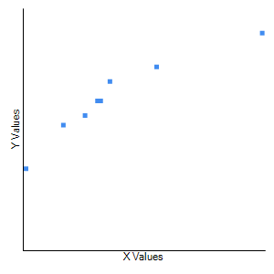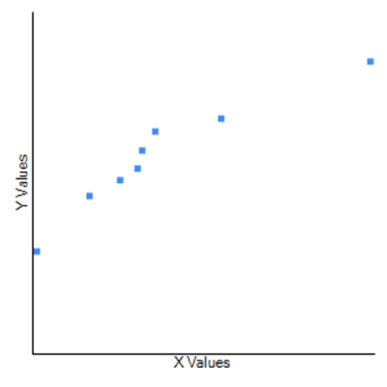
A
B
Supplementary figure Sup 2 A-B. Relation between foraging peaks, average trunk foragers with colonies nest abundance: Study 1.
Y values: Foraging peaks – X values: Number of nest per colony (A) and Y values: Mean trunk foragers – X values: Number of nest per colony (B). The Pearson Correlation Coefficient values r = .9446, r = .95 with the coefficient of determination (R² = .8923 and R² = .9025), is a strong positive correlation between the mean foraging peaks and the mean trunk foragers with each colony nest abundance, respectively. The P-Value is < .00001. The result is significant at p < .01.
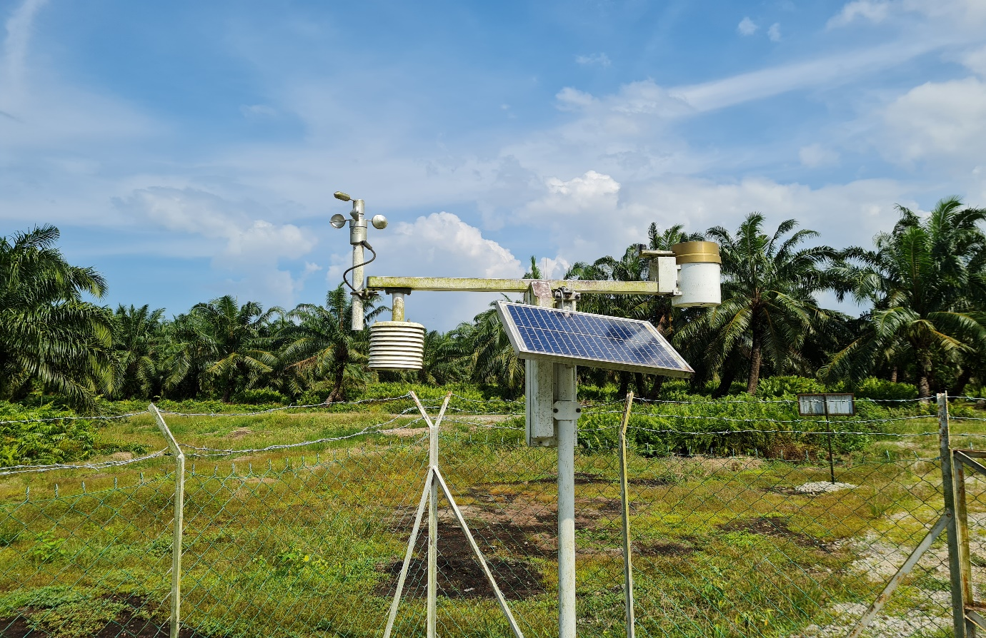
Supplemental figure 3. On site weather station monitoring AT, RH, AP and RI
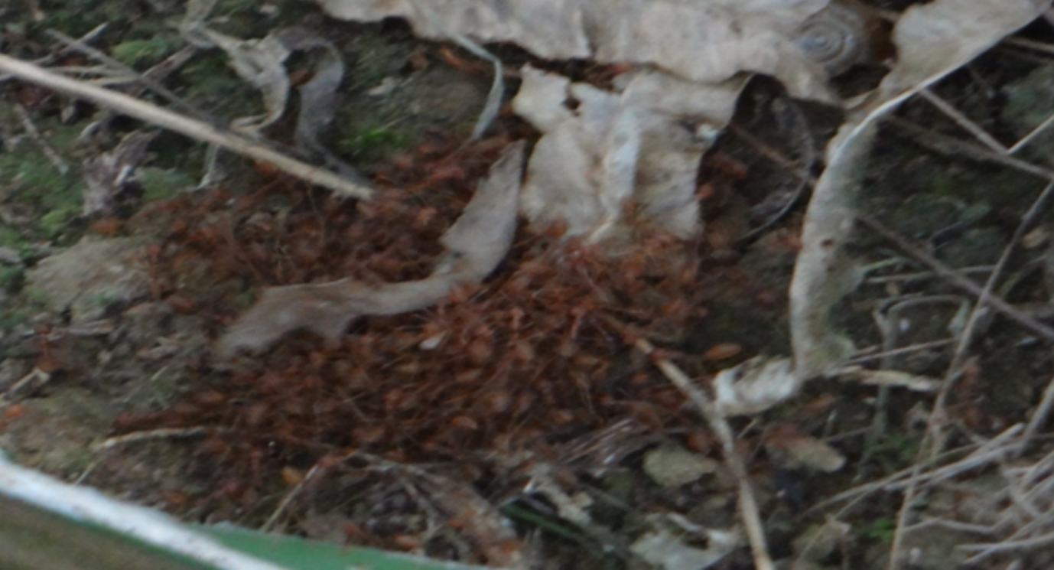
Supplemental figure 4. Massive emergency responses of major workers protecting the gravid queen.
During surveys and censuses in Lahad Datu, Sabah an exceptional event occurred in consequence to an invasive sampling of a dealate queen nest. The sight of a massive emergency response from extremely aggressive major workers protecting the colony gravid queen by performing an evacuation exhibiting a fast moving compacted aggregation on ground, was astonishing. The response shown by major workers during an emergency defense of their gravid queen is exceptional. The colony queen’s protection protocol is unknown. It is called an operation of evacuation by retinue (Van Itterbeeck et al., 2015). The queen is at the center of that fast moving ball type surrounded by a plethora of highly aggressive veteran soldiers bigger in size than others and supported by smaller workers (intermediate size). Being too heavy with less developed arolia, a queen is not able to move on a vertical orientation and need workers assistance (Van Itterbeeck, 2014). This safety protocol prevent a queen from exploding her fragile gaster upon falling (Van Itterbeeck et al., 2015).

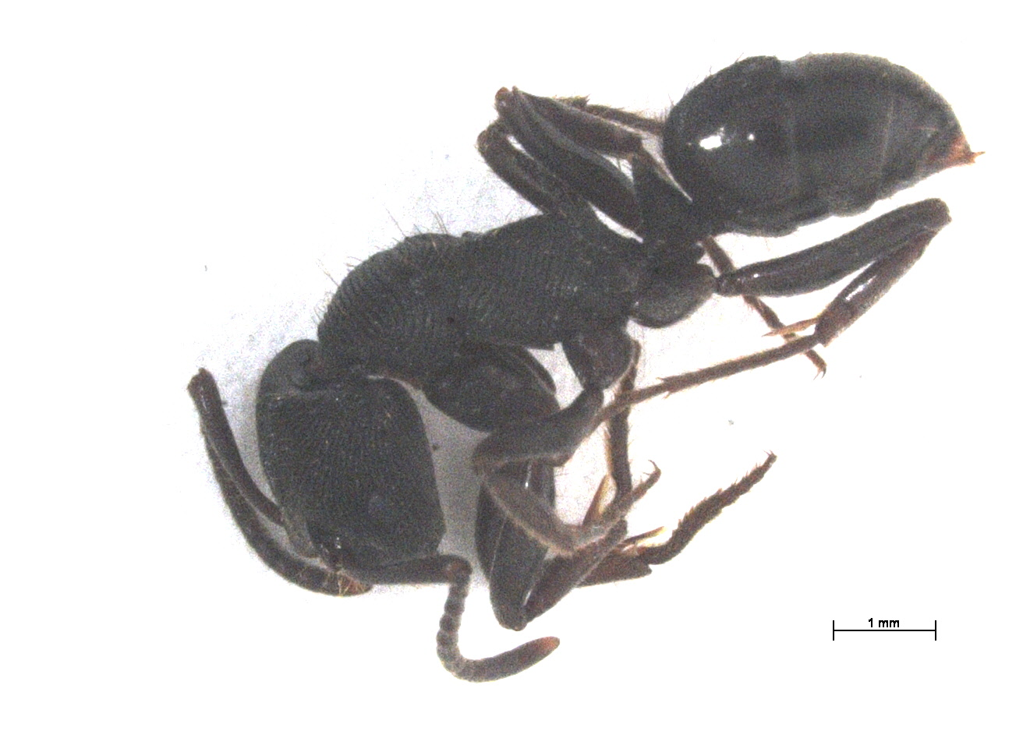
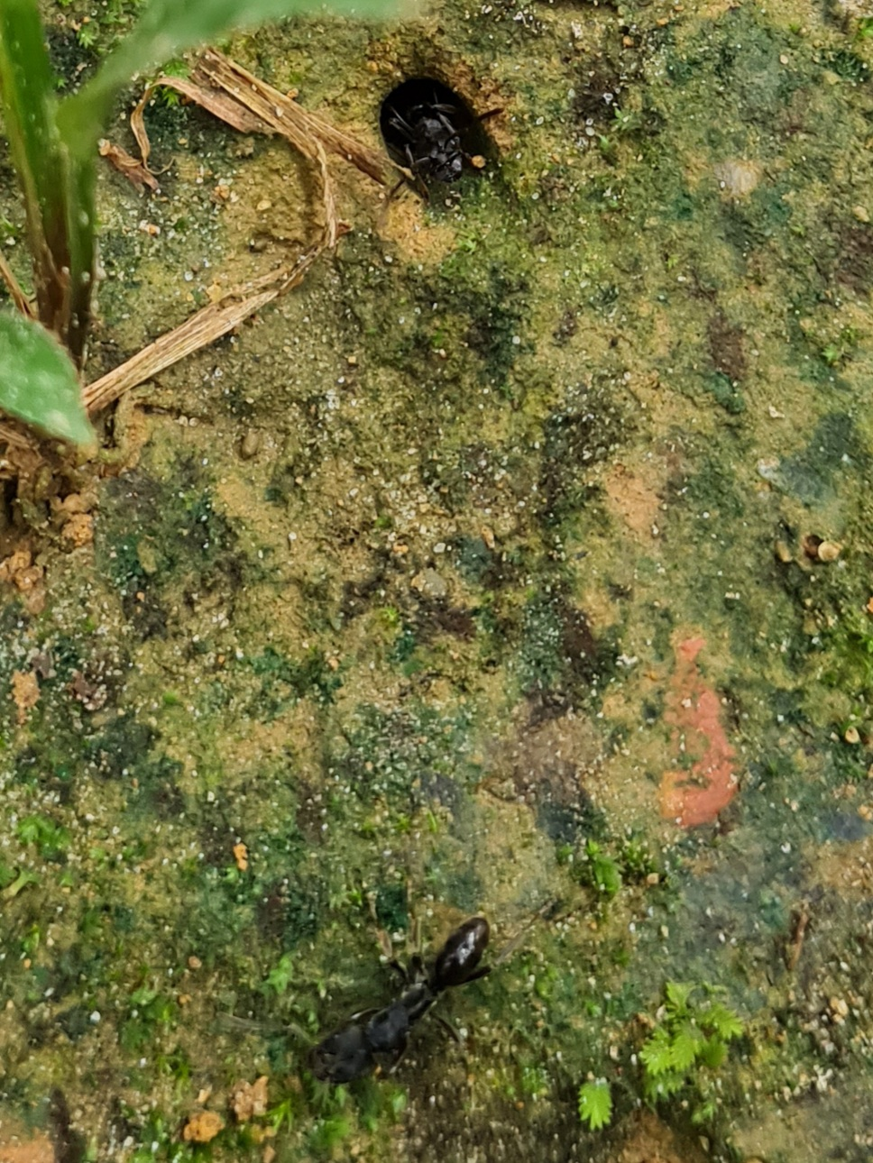
B
A

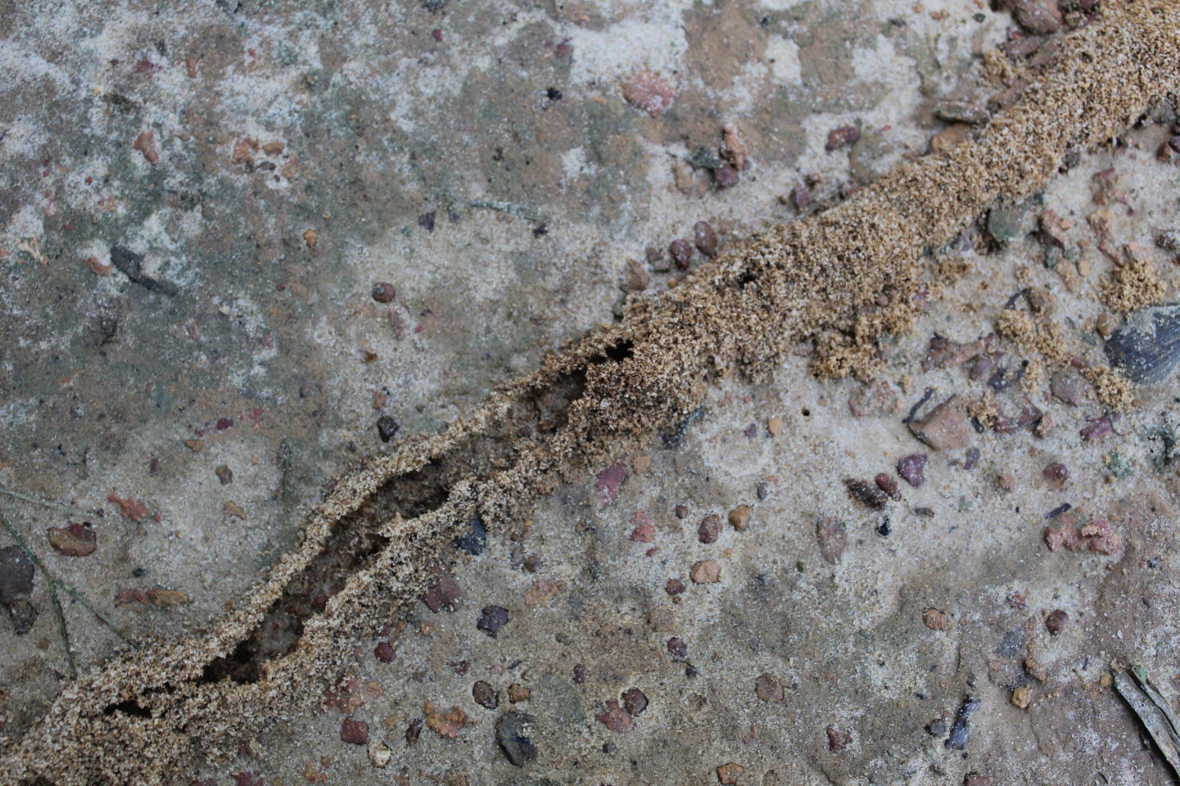
C
Supplemental Figure 5: (A-C). Antagonistic ant species presence interference.
Supplemental Figure 5 A-B shows Odontoponera denticulate photo taken with a ZEISS Stereo Discovery V20 microscope mounted by AxioCam MRc software image analyser. Figure 5C shows the invasive Solenopsis spp.

