SUPPLEMENTARY MATERIAL
for
Global profiling of antibiotic resistomes in maize rhizospheres
Dung Ngoc Pham, Qiong Wu, and Mengyan Li*
Department of Chemistry and Environmental Science, New Jersey Institute of Technology, Newark, New Jersey 07102, United States

*Address correspondence to Dr. Mengyan Li (mengyan.li@njit.edu)
Phone: +1-973-642-7095
Fax: +1-973-596-3586

Results and Discussion
S1. Dominant mechanism of AMR in maize rhizosphere
The main mechanisms of antibiotic resistance across the 4 regions were target alternation (37.4~78.6%) and target protection (9.2~21.3%) (Figure S8). The dominance of target alternation and target protection found in our study was also observed in the previous metagenomic study on paddy soil and soil–mangrove root continuum.^{1, 2} ARGs acted by these two mechanisms typically resulted from spontaneous mutation of bacterial genes in the presence of antibiotic selective pressure which naturally exist in soil or is introduced through anthropogenic activities.³ In Michigan rhizosphere metagenomes, 31.4% of ARGs were acted by the mechanism of antibiotic inactivation, significantly higher than those detected in California, South Africa, and the Netherland (8.7, 0.0, and 5.0%, respectively), partly due to the high abundance of genes inactivating beta-lactam (i.e bla genes) and fosfomycin (i.e. FosA genes) (Figures 2 and S8). In fact, antibiotic inactivation is often associated with genes that confer resistance to common anthropogenic antibiotics, such as beta-lactam and fosfomycin,^{1, 4} which cause antibiotic selective pressure on microbial communities. Furthermore, a higher fraction of antibiotic inactivation was often detected in human-impacted samples, such as estuary sediment (20–25%),⁵ rice and wheat phyllosphere under pig manure fertilization (42%).⁶ Thus, these lines of evidence corroborate that Michigan rhizosphere resistomes are heavily affected by human activities, such as the previous manure applications.
S2. Taxonomic analysis of ARB in maize rhizosphere
Antibiotic-resistant bacteria across maize rhizosphere samples mainly belong to the phylum Actinobacteria, including unclassified Actinobacterium (3.1~10.7%), Mycobacterium (10.8~19.5%), Mycolicibacterium (5.8~23.1%), and Streptomyces (2.9~7.8%) (Figure S9). The phylum Actinobacteria is well known for producing most antibiotics used today, including glycopeptides and rifamycin, and also serving as hubs of antibiotic resistomes.^{7, 8} Interestingly, the genera Enterobacter and Ralstonia within the phylum Proteobacteria showed at high abundance in the Michigan rhizosphere (20.5% and 4.6%, respectively), but were not detected in the other three regions (Figure S9). The genus Enterobacter is often found in a variety of environmental habitats such as water, soil, and plants, and also includes natural commensals of gut microbiomes in animals and humans.⁹ A recent study found Enterobacter cloacae was only detected in cow-manured soil samples with a relative abundance of 10⁻⁵~10⁻⁴ but mostly not in control samples and chemical-fertilized soil samples.¹⁰ Ralstonia spp. are commonly found in water, soil, and plants; some of their members were reported as plant pathogens (e.g. Ralstonia solanacearum) and human pathogens (e.g. Ralstonia pickettii, and Ralstonia mannitolilytica), which are becoming more prevalent in cases of infection, mainly bacteremia and pneumonia.¹¹ The abundance of these two genera was also reported to be associated with manure application in soil.^{10, 12, 13}

Table S1. A summary of 52 metagenomic datasets.
GOLD Analysis Project ID | Country | Region | Sampling time | Assembly-based dataset size (Gb) | Total reads number | ARG-containing contig number
Ga0105239 | USA | Michigan | October, 2015 | 5.5 | 4.28E+08 | 29
Ga0157369 | USA | Michigan | August, 2016 | 4.2 | 4.11E+08 | 30
Ga0157370 | USA | Michigan | August, 2016 | 3.4 | 3.51E+08 | 56
Ga0157371 | USA | Michigan | August, 2016 | 2.6 | 3.71E+08 | 58
Ga0157372 | USA | Michigan | August, 2016 | 5.2 | 3.93E+08 | 25
Ga0157373 | USA | Michigan | August, 2016 | 2.4 | 3.21E+08 | 32
Ga0207639 | USA | Michigan | October, 2014 | 4.1 | 3.92E+08 | 15
Ga0207640 | USA | Michigan | October, 2014 | 4.0 | 3.96E+08 | 18
Ga0207656 | USA | Michigan | October, 2014 | 1.3 | 2.01E+08 | 21
Ga0207667 | USA | Michigan | October, 2014 | 4.2 | 4.14E+08 | 18
Ga0207671 | USA | Michigan | October, 2015 | 2.9 | 3.26E+08 | 24
Ga0207674 | USA | Michigan | October, 2014 | 4.7 | 4.00E+08 | 35
Ga0207694 | USA | Michigan | October, 2014 | 3.4 | 3.71E+08 | 8
Ga0207698 | USA | Michigan | October, 2014 | 4.8 | 4.29E+08 | 16
Ga0207702 | USA | Michigan | October, 2014 | 4.6 | 4.34E+08 | 21
Ga0307405 | USA | California | October, 2016 | 4.3 | 4.40E+08 | 10
Ga0307406 | USA | California | October, 2016 | 4.2 | 4.18E+08 | 19
Ga0307407 | USA | California | October, 2016 | 3.4 | 3.53E+08 | 16
Ga0307408 | USA | California | October, 2016 | 5.1 | 5.39E+08 | 12
Ga0307409 | USA | California | October, 2016 | 5.6 | 5.33E+08 | 28
Ga0307410 | USA | California | October, 2016 | 4.2 | 4.31E+08 | 15
Ga0307411 | USA | California | October, 2016 | 4.6 | 4.48E+08 | 13
Ga0307412 | USA | California | October, 2016 | 4.7 | 5.01E+08 | 11
Ga0307413 | USA | California | October, 2016 | 4.4 | 4.44E+08 | 17
Ga0307414 | USA | California | October, 2016 | 4.4 | 4.58E+08 | 12
Ga0307415 | USA | California | October, 2016 | 5.2 | 5.27E+08 | 24
Ga0307416 | USA | California | October, 2016 | 7.6 | 6.90E+08 | 37
Table S1. A summary of 52 metagenomic datasets (continue).
NCBI SRA Accession number | Country | Region | Sampling time | Assembly-dataset size (Gb) | Total reads number | ARG-containing contig
SRR12192801 | South Africa | Lichtenburg | June,2019 | 0.6 | 1.28E+07 | 0
SRR12192802 | South Africa | Lichtenburg | June,2019 | 0.7 |  | 0
SRR12192803 | South Africa | Lichtenburg | June,2019 | 0.5 | 2.76E+09 | 0
SRR12192804 | South Africa | Lichtenburg | June,2019 | 0.8 | 1.69E+07 | 1
SRR12192805 | South Africa | Lichtenburg | June,2019 | 0.5 | 1.10E+07 | 1
SRR12192848 | South Africa | Randfontein | June,2019 | 0.4 |  | 0
SRR12192849 | South Africa | Randfontein | June,2019 | 0.4 |  | 0
SRR12192850 | South Africa | Randfontein | June,2019 | 0.5 | 1.19E+07 | 2
SRR12192851 | South Africa | Randfontein | June,2019 | 0.5 | 1.10E+07 | 1
SRR12192852 | South Africa | Randfontein | June,2019 | 0.5 | 1.11E+07 | 0
SRR12285194 | South Africa | Mafikeng | June, 2019 | 0.5 | 1.02E+07 | 2
SRR12285195 | South Africa | Mafikeng | June, 2019 | 0.7 | 1.34E+07 | 2
SRR12285196 | South Africa | Mafikeng | June, 2019 | 0.6 |  | 0
SRR12285197 | South Africa | Mafikeng | June, 2019 | 0.5 | 1.01E+07 | 1
SRR12288316 | South Africa | NA | NA | 0.4 |  | 0
SRR12288317 | South Africa | NA | NA | 0.4 |  | 0
SRR12288318 | South Africa | NA | NA | 0.6 |  | 0
SRR12288319 | South Africa | NA | NA | 0.5 | 1.17E+07 | 0
SRR12403548 | South Africa | NA | NA | 0.4 |  | 0
SRR12403549 | South Africa | NA | NA | 0.7 |  | 0
SRR12403551 | South Africa | NA | NA | 0.6 |  | 0
SRR8197392 | Netherland | Wageningen | August, 2018 | 1.6 | 4.81E+07 | 6
SRR8197393 | Netherland | Wageningen | August, 2018 | 1.9 | 4.72E+07 | 8
SRR8197394 | Netherland | Wageningen | August, 2018 | 2.1 | 4.13E+07 | 4
SRR8197395 | Netherland | Wageningen | August, 2018 | 2.6 | 4.93E+07 | 5

Table S2. A summary of soil managements at four regions.
Regions | Soil | Growth time | Maize type | Growing condition | Reference
Michigan, USA | - Kellogg Biological Station (KBS) was established since 2008 on land previously used for row crop agriculture for many decades.  Fertilized with manure or composted manure for >10 years before  - The antibiotics such as ceftiofur (a beta-lactam antibiotic) and oxytetracycline (a tetracycline antibiotic) were used primarily in KBS dairy production. | 3-4 months | NA | 158-173 kg ha⁻¹ nitrogen fertilizer (2009-2015) | ¹⁴⁻¹⁶
California, USA | Two type of soils: one was ammended with inorganic N fertilizer, and the other was ammended with cover crops and composted poultry manure, both continously since 1993 | 35 days |  | No fertilization | ¹⁷
Lichtenburg,  South Africa | Semi-arid, low soil fertility soil | NA | Genetically modified-white and yellow maize seeds | NA | ¹⁸
Randfontein,  South Africa | Semi-arid, low soil fertility soil | NA | Genetically modified-white and yellow maize seeds | NA | ¹⁸
Mafikeng,  South Africa | Farm soil |  | NA
Wageningen,  the Netherland | Moistened loamy sand soil collected from a biological Lolium perenne grass field | 38 days | Zea mays L. cv ‘Yukon Chief’ | Chemical fertilizer (Hoagland’s solution)  30 mg per pot | ¹⁹

Table S3. Pairwise perMANOVA analysis of Bray–Curtis distance to assess the significant differences between different resistomes.
Factor | Sample size | Pseudo-F | p | FDR corrected p
Michigan vs California | 27 | 8.05 | 0.001 | 0.006
Michigan vs South Africa | 22 | 3.86 | 0.004 | 0.008
Michigan vs the Netherland | 19 | 2.95 | 0.025 | 0.031
California vs South Africa | 19 | 3.11 | 0.032 | 0.032
California vs the Netherland | 16 | 12.35 | 0.003 | 0.008
South Africa vs the Netherland | 11 | 4.50 | 0.026 | 0.031
All p and FDR corrected p values were based on 999 permutations.

Table S4. ARGs detected in Michigan maize rhizosphere metagenomes with >99% identity to isolates with human and animal sources.
ARG type | ARG subtype | Length (nt) | Contigs of isolates from human and animal sources | Identity (%) | Flanked MGE
Beta-lactam | blaACT-4 | 735 | E. asburiae (CP066278) | 99.1 | No
 | blaACT-4 | 1145 | E. asburiae (NZ_AP019632) | 99.0 | No
 | blaACT-6 | 1145 | E. asburiae (LZCS01000012) | 99.7 | No
 | blaTEM-116 | 860 | S. aureus (BEAF01000016), S. enterica (AAMBKO010000036), and A. baumannii (WJWT01000094) | 100.0 | Fragment of Tn3 originated from Salmonella enterica  (Bit score: >2137, E-value: 0.0)
Fosfomycin | FosA2 | 425 | E. ludwigii (JXWL01000868), E. asburiae (LZCS01000012, JAERJE010000003) | 99.5-100 | No

Table S5. A summary of 9 drug-resistant MAGs.
Bin ID | Bin Lineage | Bin completeness | Bin contamination | Genome size (bp) | Bin quality | ARGs
3300013102_17 | Ralstonia sp. | 97.08 | 1.59 | 5,713,483 | 89.13 | blaOXA-22, blaOXA-60
3300013102_20 | Rahnella | 98.69 | 0.57 | 5,124,623 | 95.84 | blaRAHN-1
3300013102_26 | Acinetobacter guillouiae | 62.41 | 1.72 | 3,567,078 | 53.81 | blaOXA-275
3300013104_22 | Ralstonia sp. | 97.26 | 5.03 | 5,652,537 | 72.11 | blaOXA-22, blaOXA-60
3300013105_20 | Flavobacterium johnsoniae | 94.7 | 3.03 | 5,396,267 | 79.55 | blaJOHN-1
3300013105_23 | Ralstonia sp. | 88.21 | 1.59 | 4,862,288 | 80.26 | blaOXA-22, blaOXA-60
3300013105_29 | Klebsiella cf. planticola B43 | 94.27 | 0.87 | 4,290,385 | 89.92 | CRP, H-NS, Ptsl, EF-Tu,soxS, fabI, marA
3300013307_24 | Ralstonia sp. | 97.22 | 0.8 | 5,317,922 | 93.22 | blaOXA-22, blaOXA-60
3300026116_28 | Enterobacter sp. | 96.77 | 0.87 | 4,251,676 | 92.42 | arcA, blaACT-6, cpxA, CPR, emrR, fabI, FosA2, gyrA, H-NS, marA, oqxB, parE, Ptsl, ramA, UhpA

Table S6. A summary of the network topological properties.
Network property | Co-occurrence network of ARGs
Total nodes | 17
Total links | 50
Average degree | 5.88
Average shortest path length | 1.67
Maximum degree | 10
Average clustering coefficient | 0.71
Centralization of betweenness | 4.35
Density | 0.37
Modularity degree | 0.19
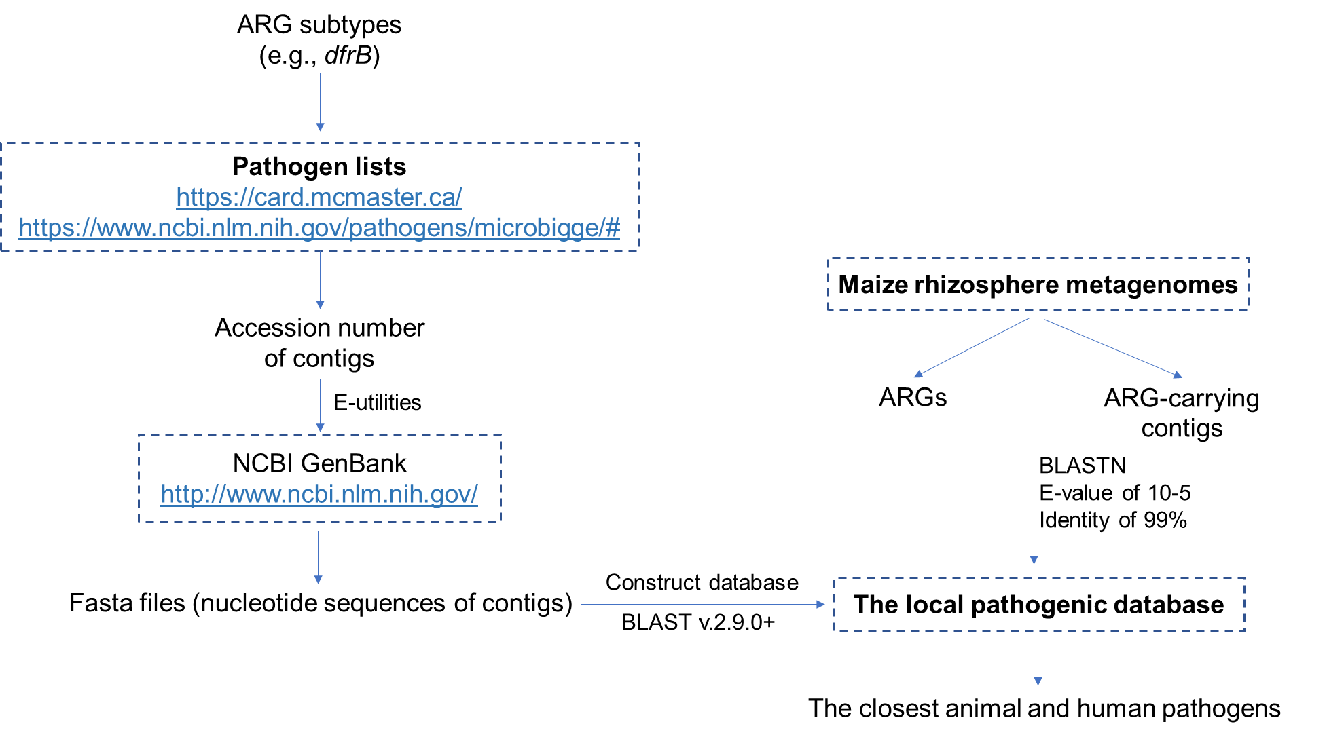
Figure S1. Flowchat for determining the closest animal and human pathogens of ACCs recovered from metagenomic data of maize rhizosphere.
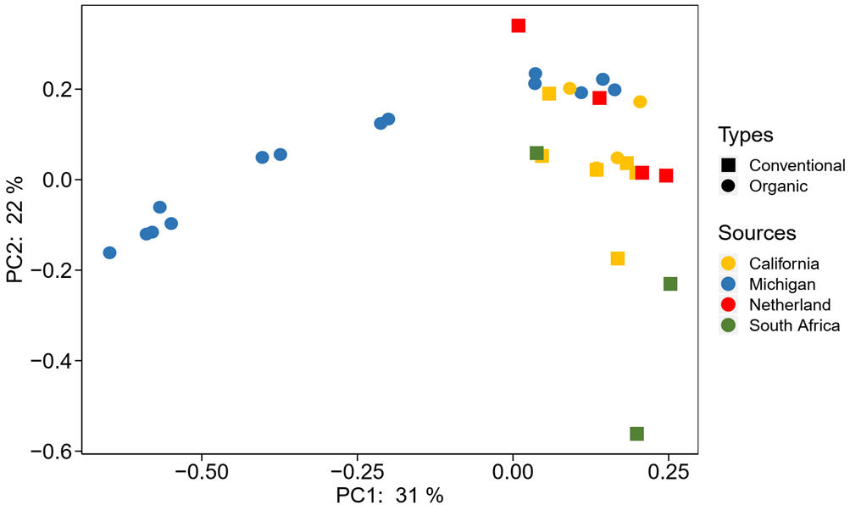
Figure S2. PCoA of resistomes from the 4 different regions based on the Bray-Curtis distance.
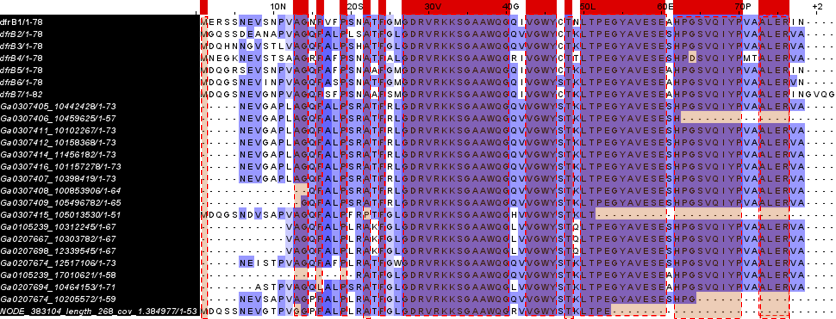
Figure S3. Alignment of DfrB proteins annotated from Group-1 dfrB genes detected in maize rhizosphere metagenomes (Figure 3) and reference genes from CARD.
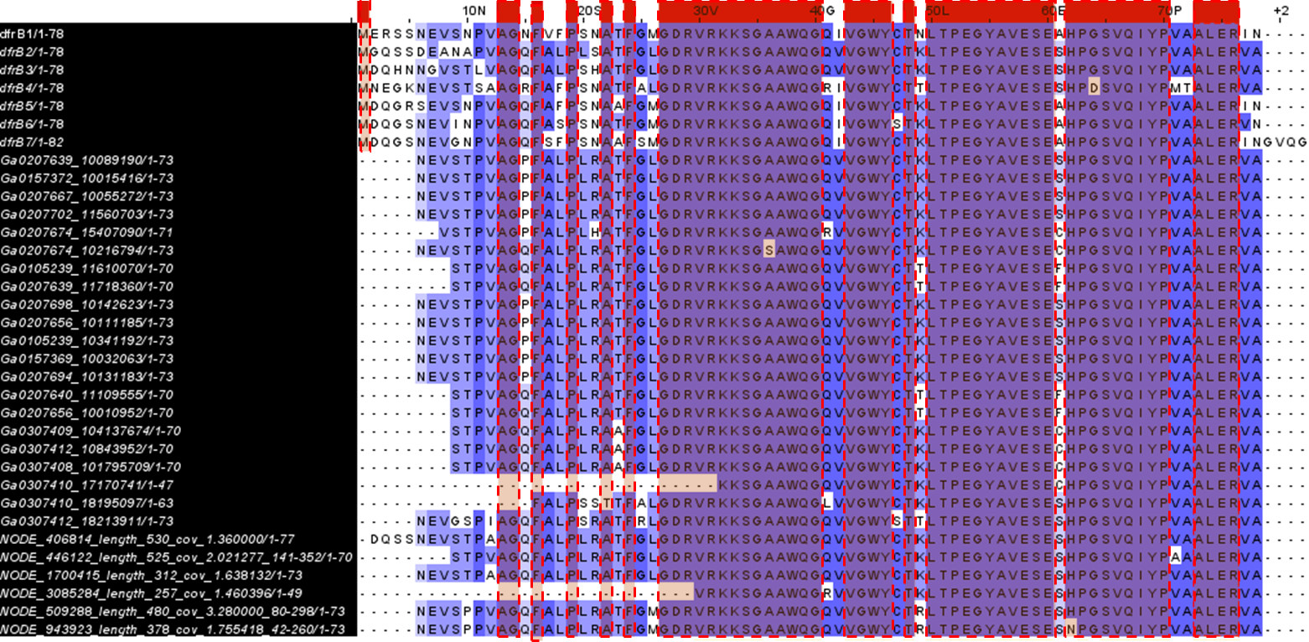
Figure S4. Alignment of DfrB proteins annotated from Group-2 dfrB genes detected in maize rhizosphere metagenomes (Figure 3) and reference genes from CARD.
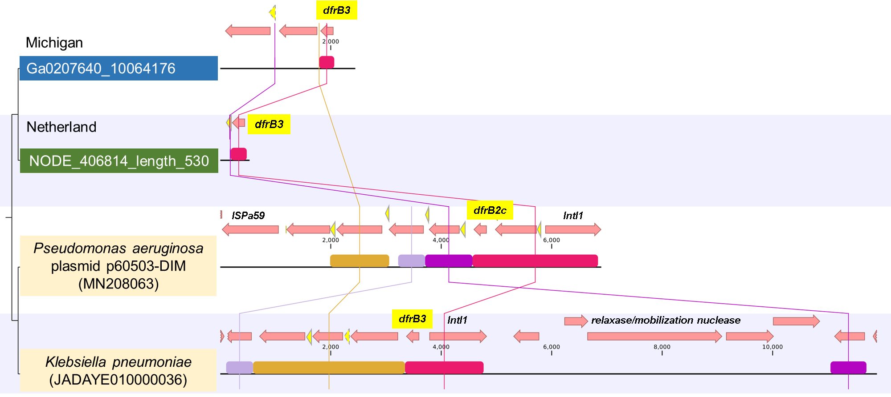
Figure S5. Comparison of two representative contigs containing dfrB genes in Michigan and Netherland maize rhizosphere metagenomes to the partial genomes of Pseudomonas aeruginosa strain 60503 plasmid p60503-DIM (accession number MN208063) and human pathogen Klebsiella pneumoniae (JADAYE010000036). Yellow arrows depict attC sites, in which the solid ones indicate similar regions covering full attC sequences while the dash ones indicate similar regions covering partial attC sequences. Bars of the same color indicate the regions that share high similarity among the contigs.
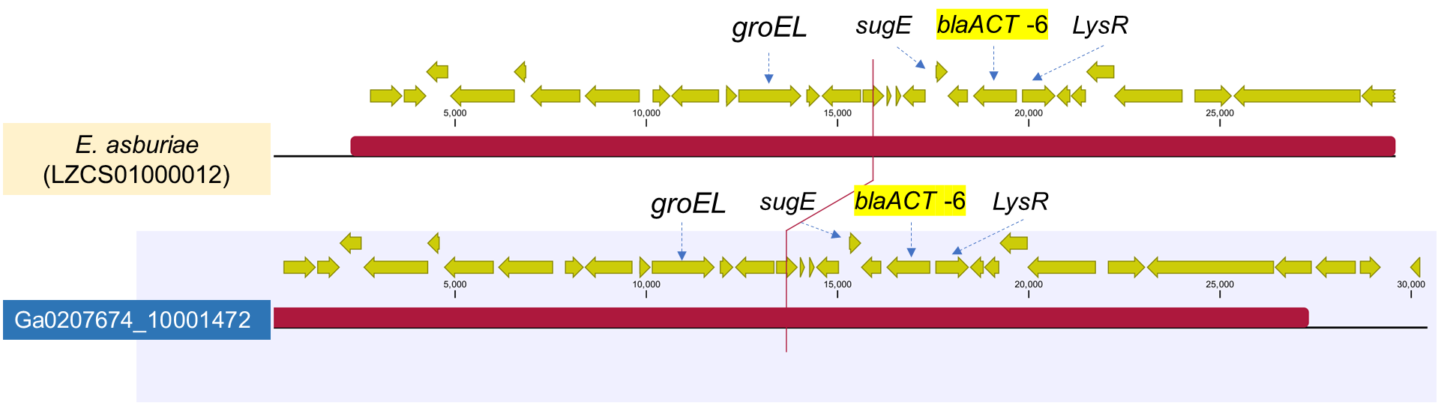
Figure S6. Comparison of a representative contig containing the blaACT-6 genes in the Michigan maize rhizosphere metagenomes to the closet human pathogenic isolate E. asburiae (LZCS01000012). Red bar indicate similar regions between the two contigs. groEL: a heat shock protein involved in intestinal colonization. LysR: a family transcriptional regulator of beta-lactamase. sugE: a quaternary ammonium compound-resistance protein.
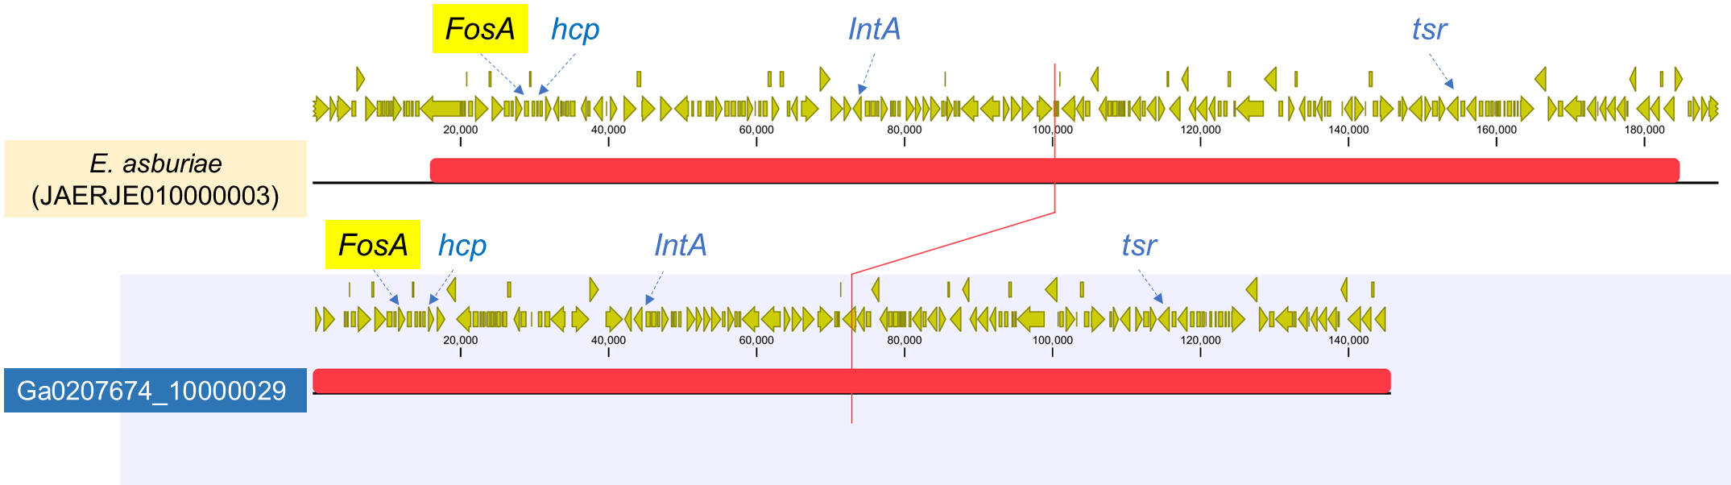
Figure S7. Comparison of one representative contig containing the FosA2 in the Michigan maize rhizosphere metagenomes to the closet human pathogenic isolate E. asburiae (JAERJE010000003). Red bars indicate similar regions between the contigs. Other relevant genes include IntA (a prophage integrase), virulent factors, such as hcp (a type VI secretion system tube protein) and tsr (a methyl-accepting chemotaxis protein).

Figure S8. AMR mechanisms in maize rhizospheres across the 4 different regions.
Figure S9. Composition and relative abundance of microbial hosts of ARGs in maize rhizospheres across the 4 different regions.

References
1. Xiao, K.-Q.; Li, B.; Ma, L.; Bao, P.; Zhou, X.; Zhang, T.; Zhu, Y.-G., Metagenomic profiles of antibiotic resistance genes in paddy soils from South China. FEMS microbiology ecology 2016, 92 (3), fiw023.
2. Wang, C.; Hu, R.; Strong, P.; Zhuang, W.; Huang, W.; Luo, Z.; Yan, Q.; He, Z.; Shu, L., Prevalence of antibiotic resistance genes and bacterial pathogens along the soil–mangrove root continuum. Journal of Hazardous Materials 2021, 408, 124985.
3. Lambert, P. A., Bacterial resistance to antibiotics: modified target sites. Advanced drug delivery reviews 2005, 57 (10), 1471-1485.
4. Pérez, D. S.; Tapia, M. O.; Soraci, A. L., Fosfomycin: uses and potentialities in veterinary medicine. Open veterinary journal 2014, 4 (1), 26-43.
5. Chen, B.; Yang, Y.; Liang, X.; Yu, K.; Zhang, T.; Li, X., Metagenomic profiles of antibiotic resistance genes (ARGs) between human impacted estuary and deep ocean sediments. Environmental science & technology 2013, 47 (22), 12753-12760.
6. Zhu, D.; Giles, M.; Yang, X.-R.; Daniell, T.; Neilson, R.; Zhu, Y.-G., Phyllosphere of staple crops under pig manure fertilization, a reservoir of antibiotic resistance genes. Environmental pollution 2019, 252, 227-235.
7. Peterson, E.; Kaur, P., Antibiotic resistance mechanisms in bacteria: relationships between resistance determinants of antibiotic producers, environmental bacteria, and clinical pathogens. Frontiers in microbiology 2018, 9, 2928.
8. Forsberg, K. J.; Patel, S.; Gibson, M. K.; Lauber, C. L.; Knight, R.; Fierer, N.; Dantas, G., Bacterial phylogeny structures soil resistomes across habitats. Nature 2014, 509 (7502), 612-616.
9. Davin-Regli, A.; Lavigne, J.-P.; Pagès, J.-M., Enterobacter spp.: update on taxonomy, clinical aspects, and emerging antimicrobial resistance. Clinical microbiology reviews 2019, 32 (4).
10. Peng, S.; Feng, Y.; Wang, Y.; Guo, X.; Chu, H.; Lin, X., Prevalence of antibiotic resistance genes in soils after continually applied with different manure for 30 years. Journal of hazardous materials 2017, 340, 16-25.
11. Ryan, M. P.; Adley, C. C., Ralstonia spp.: emerging global opportunistic pathogens. European journal of clinical microbiology & infectious diseases 2014, 33 (3), 291-304.
12. Zhang, H.; Zhang, Q.; Song, J.; Zhang, Z.; Chen, S.; Long, Z.; Wang, M.; Yu, Y.; Fang, H., Tracking resistomes, virulence genes, and bacterial pathogens in long-term manure-amended greenhouse soils. Journal of hazardous materials 2020, 396, 122618.
13. Tang, X.; Zou, L.; Su, S.; Lu, Y.; Zhai, W.; Manzoor, M.; Liao, Y.; Nie, J.; Shi, J.; Ma, L. Q., Long-Term Manure Application Changes Bacterial Communities in Rice Rhizosphere and Arsenic Speciation in Rice Grains. Environmental Science & Technology 2021, 55 (3), 1555-1565.
14. Hussain, M. Z.; Robertson, G. P.; Basso, B.; Hamilton, S. K., Leaching losses of dissolved organic carbon and nitrogen from agricultural soils in the upper US Midwest. Science of the Total Environment 2020, 734, 139379.
15. Munir, M.; Xagoraraki, I., Levels of antibiotic resistance genes in manure, biosolids, and fertilized soil. Journal of environmental quality 2011, 40 (1), 248-255.
16. Guo, X.; Akram, S.; Stedtfeld, R.; Johnson, M.; Chabrelie, A.; Yin, D.; Mitchell, J., Distribution of antimicrobial resistance across the overall environment of dairy farms–A case study. Science of The Total Environment 2021, 788, 147489.
17. Schmidt, J. E.; Rodrigues, J. L. M.; Brisson, V. L.; Kent, A.; Gaudin, A. C., Impacts of directed evolution and soil management legacy on the maize rhizobiome. Soil Biology and Biochemistry 2020, 145, 107794.
18. Akinola, S. A.; Ayangbenro, A. S.; Babalola, O. O., The Immense Functional Attributes of Maize Rhizosphere Microbiome: A Shotgun Sequencing Approach. Agriculture 2021, 11 (2), 118.
19. Li, Z.; Yao, Q.; Guo, X.; Crits-Christoph, A.; Mayes, M. A.; Lebeis, S. L.; Banfield, J. F.; Hurst, G. B.; Hettich, R. L.; Pan, C., Genome-resolved proteomic stable isotope probing of soil microbial communities using 13CO2 and 13C-methanol. Frontiers in microbiology 2019, 10, 2706.

