SUPPLEMENT
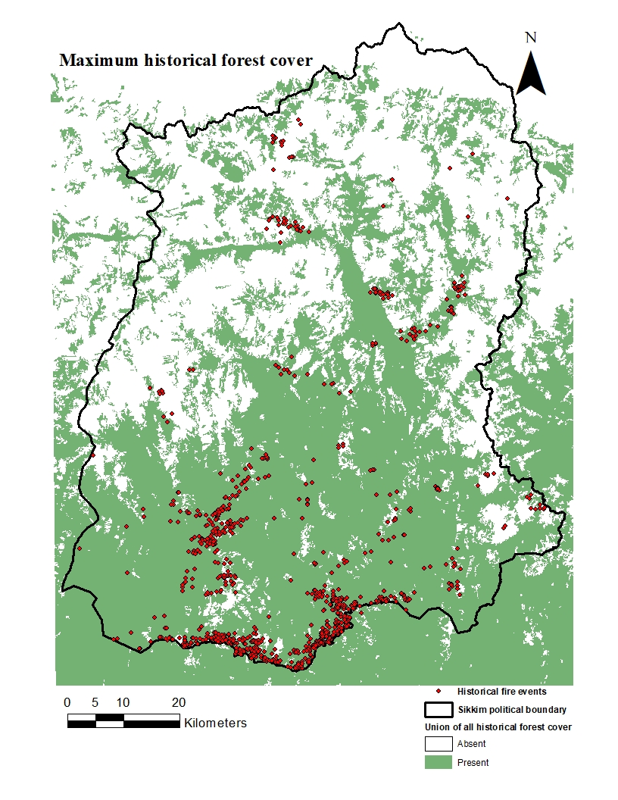
Figure S1: Maximum historical forest cover constructed by the union of all raster images (2007-2010) accessed from ALOS PALSAR (Shimada et al., 2014) and converted into binary maps of forest/ non-forest areas.

Environmental feature maps
Figure S2: Environmental features for the training of MaxEnt, (a) Aspect (in degree) (Cont.)
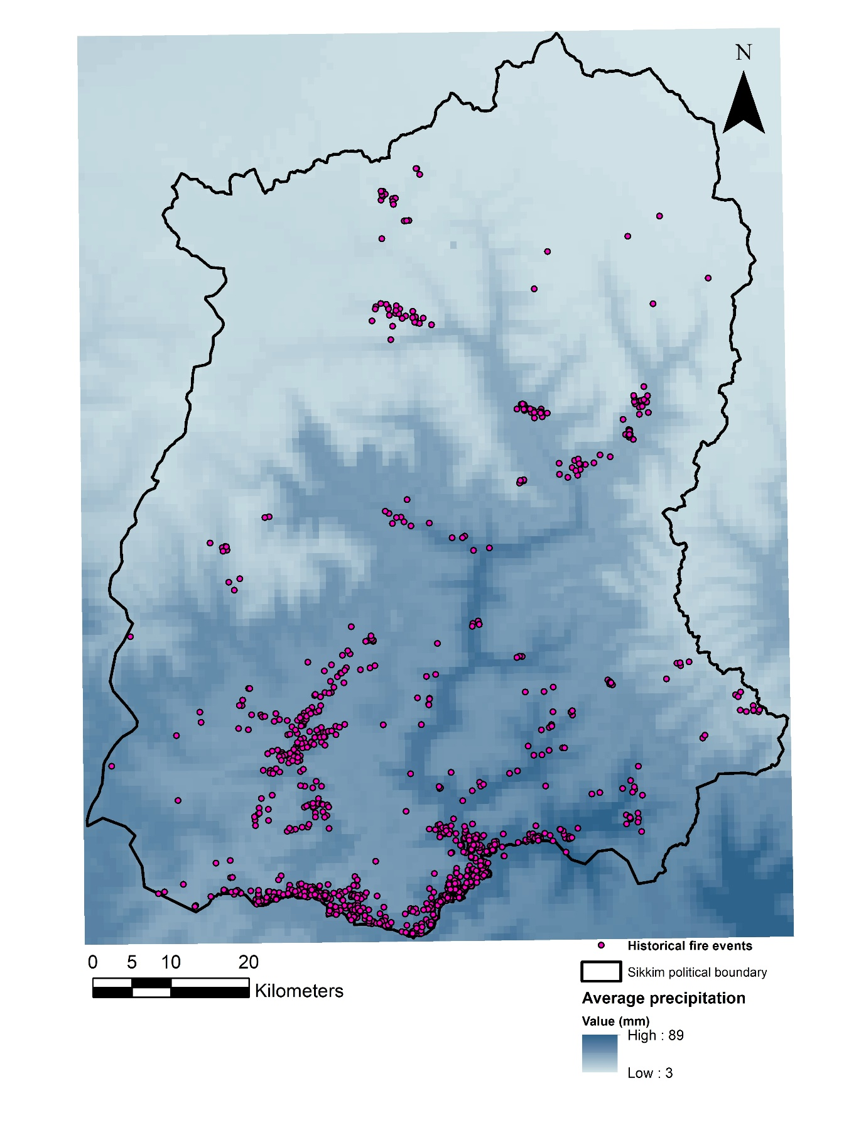
Figure S2: (b) Average precipitation (in mm)

Figure S2: (c) Average ambient temperature (in ºC). (Cont.)
Figure S2: (d) Average wind speed (in m/s) (Cont.)

Figure S2: (e) NDVI (a nondimensional value) (Cont.)

Figure S2: (f) Plan curvature (in radians/ m) (Cont.)

Figure S2: (g) Profile curvature (in radians/ m) (Cont.)

Figure S2: (h) Proximity to human habitations (in m) (Cont.)

Figure S2: (i) Proximity to roadways (in m) (Cont.)

Figure S2: (j) Proximity to waterbodies (in m) (Cont.)
Figure S2: (k) Soil surface carbon content (in ×5g/kg of soil) (Cont.)

Figure S2: (l) Soil surface water content (in volumetric %) (Cont.)
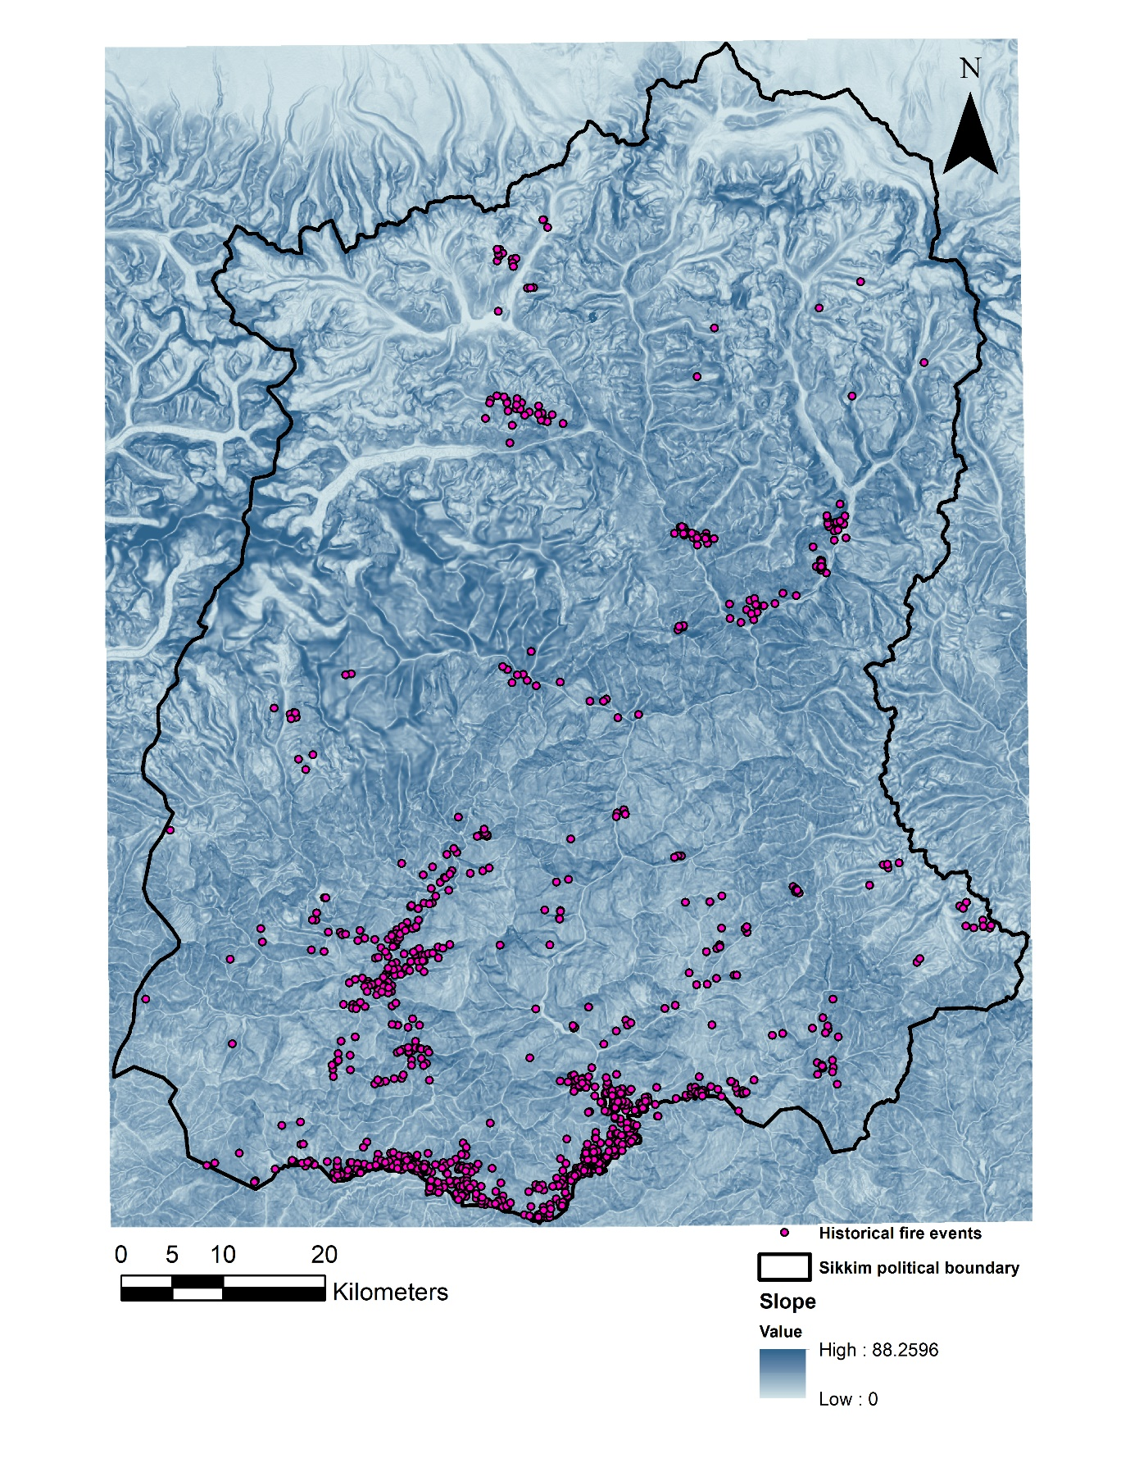
Figure S2: (m) Slope (in degree) (Cont.)
Figure S2: (n) Tree cover (in %) (Cont.)

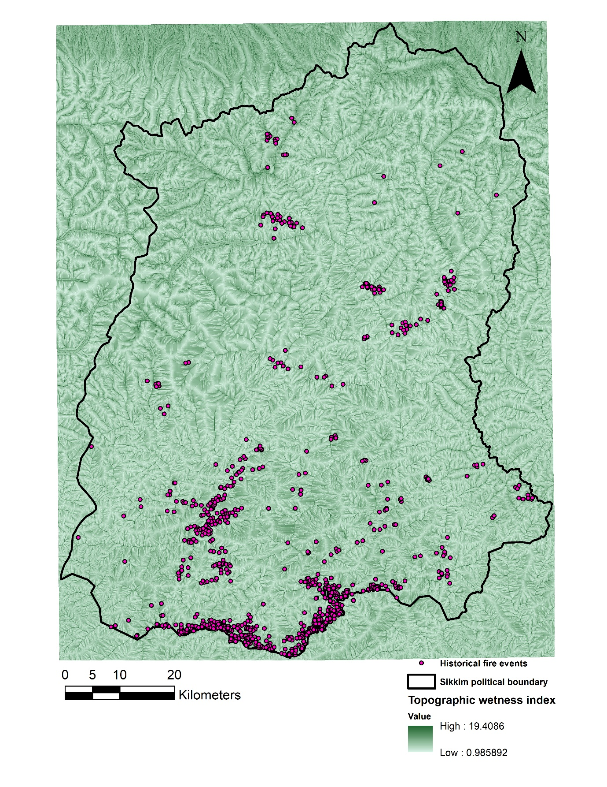
Figure S2: (Cont.) (o) TWI (a nondimensional value)

