SUPPLEMENT FIGURES: DISTRIUTION OF FOREST FIRE EVENTS OVER ENVIRONMENTAL FEATURES
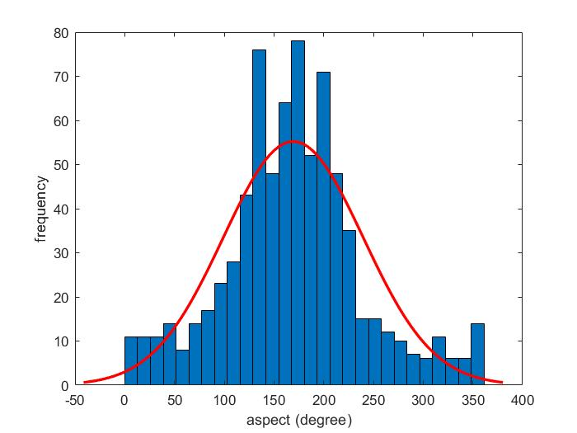
Figure S1: (a) Aspect (cont.)
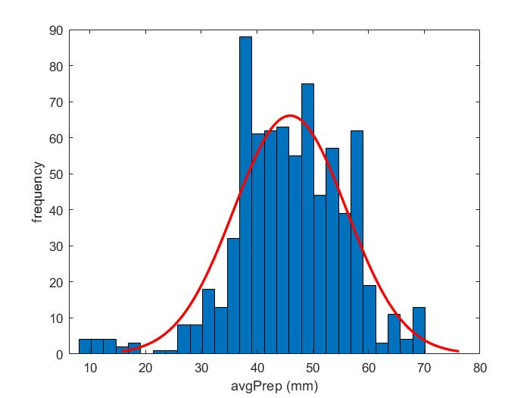
Figure S1: (b) Average precipitation (cont.)

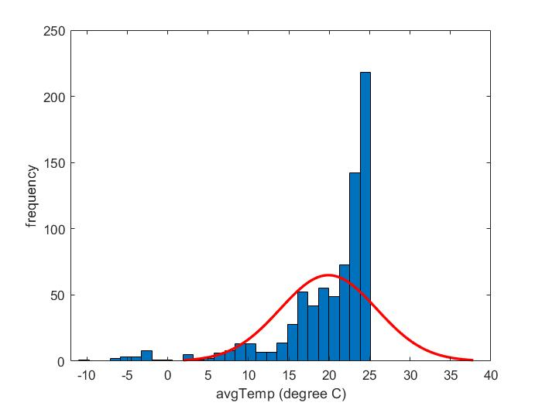
Figure S1: (c) Average ambient temperature (cont.)

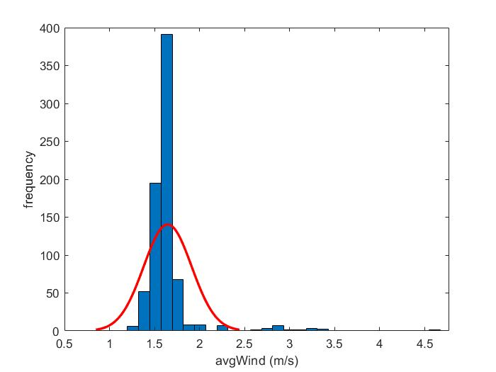
Figure S1: (d) Average wind speed (cont.)

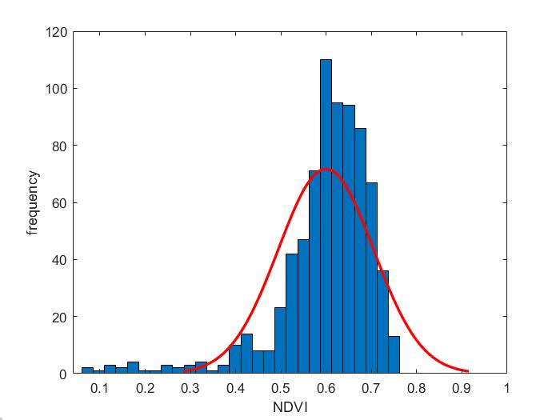
Figure S1: (e) NDVI (cont.)

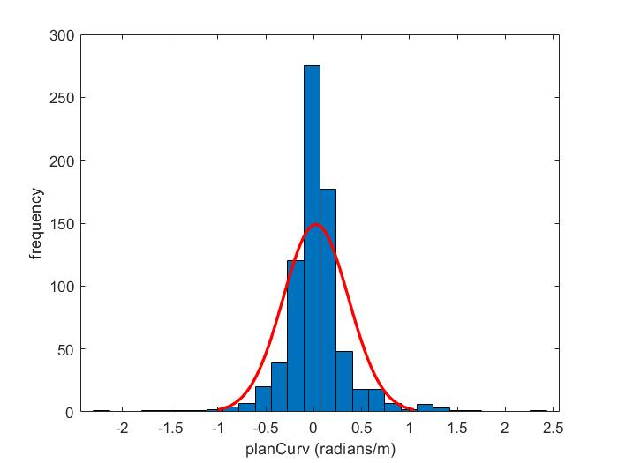
Figure S1: (f) Plan Curvature (cont.)

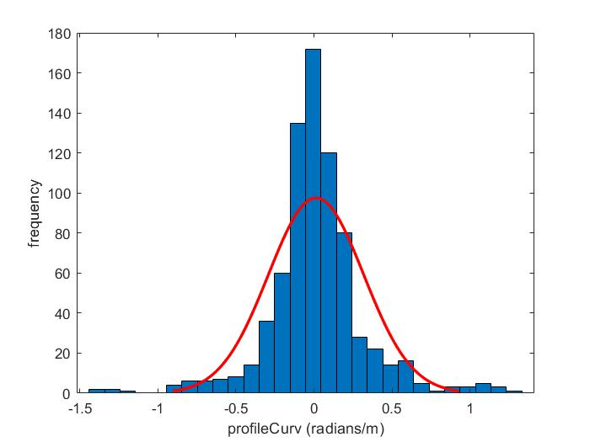
Figure S1: (g) Profile curvature (cont.)

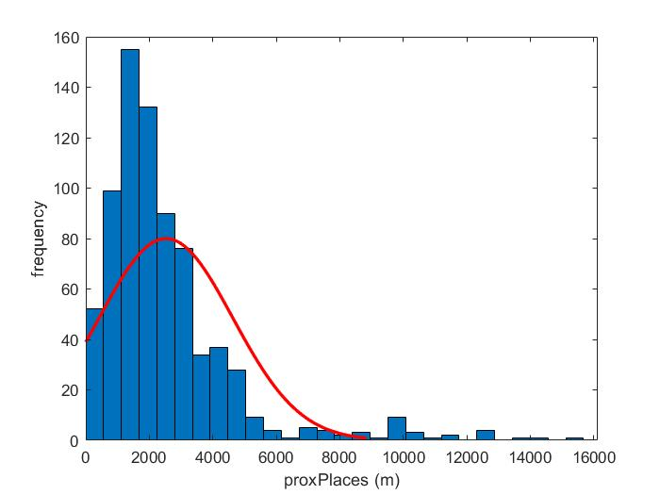
Figure S1: (h) Proximity to human habitations (cont.)

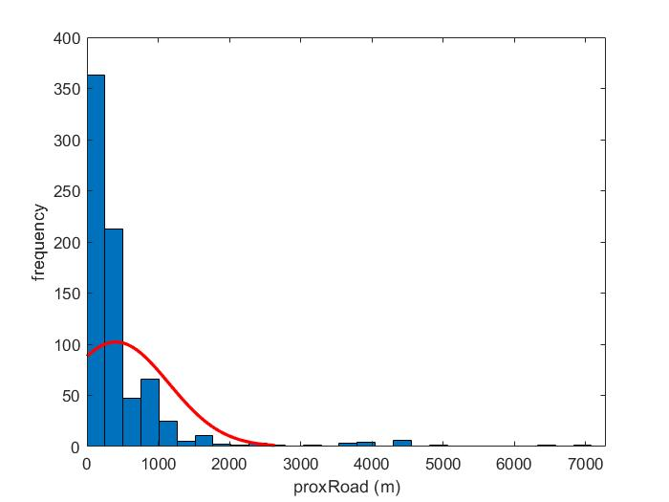
Figure S1: (i) Proximity to roadways (cont.)

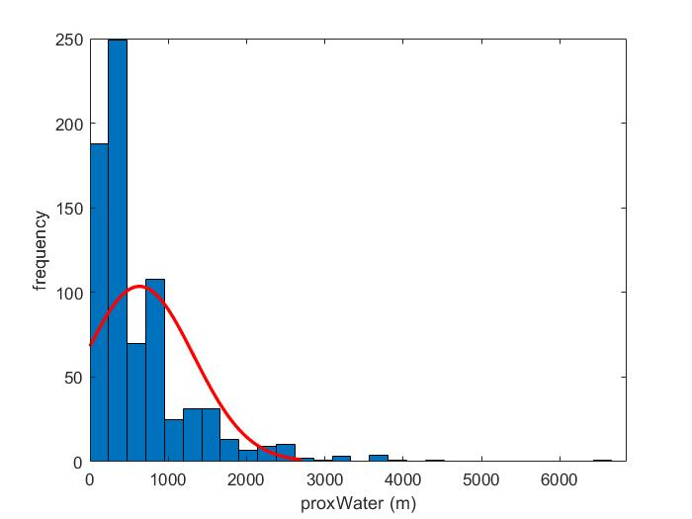
Figure S1: (j) Proximity to water bodies (cont.)

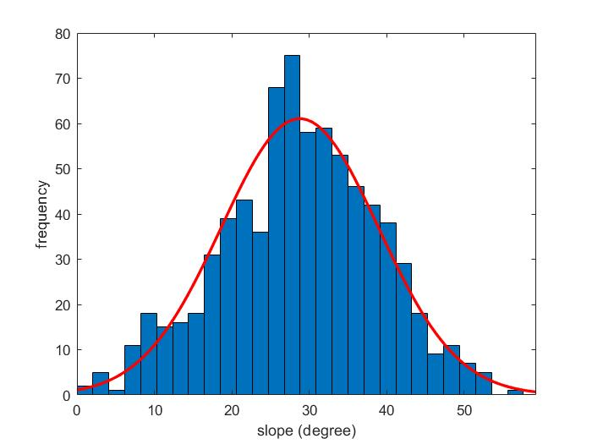
Figure S1: (k) Slope (cont.)

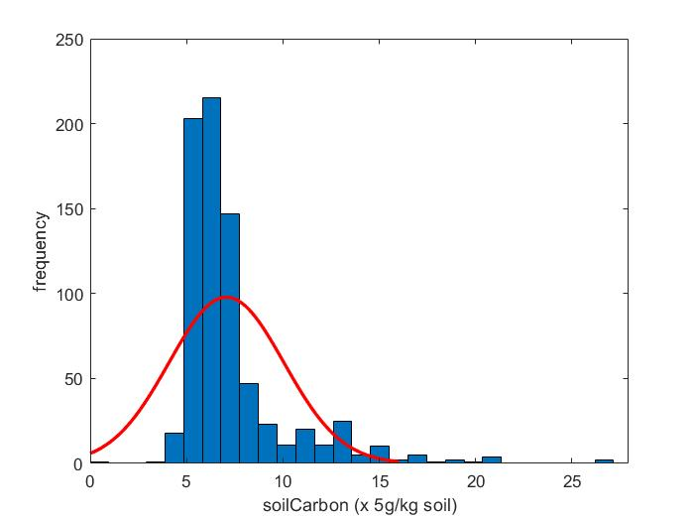
Figure S1: (l) Soil surface carbon content (cont.)

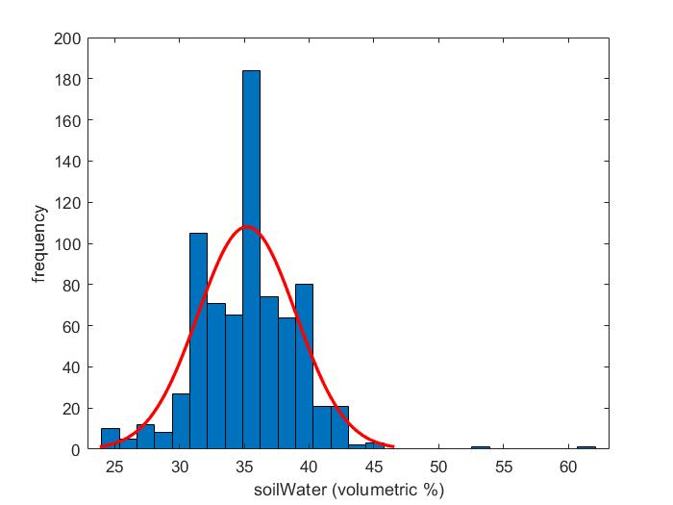
Figure S1: (m) Soil surface water content (cont.)

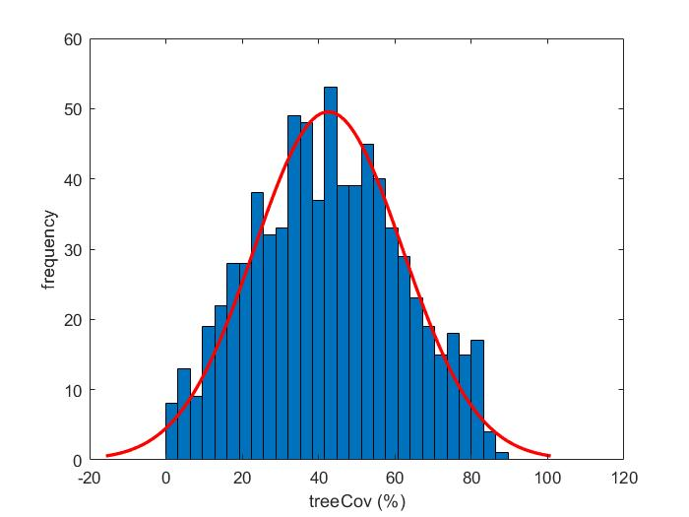
Figure S1: (n) Tree cover (cont.)

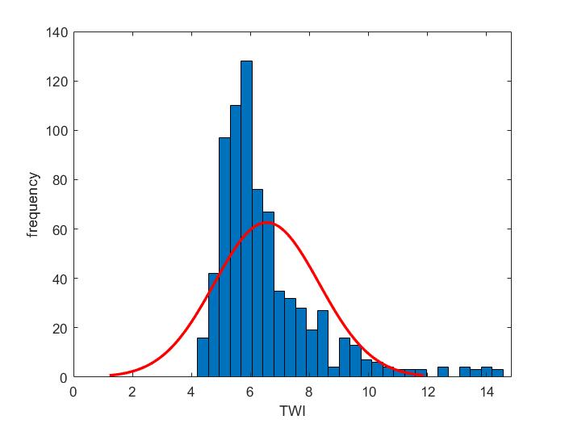
Figure S1: (cont.) (o) TWI.

