Supplementary figure 1
GFP expression in transfected cells.
Several clones of transfected cells (clone and passage number in title) from separate cultures were assessed for stability of transfection by measuring GFP using flow cytometry (Acquisition and graphical representation of fluorescence using BD FACS Aria).

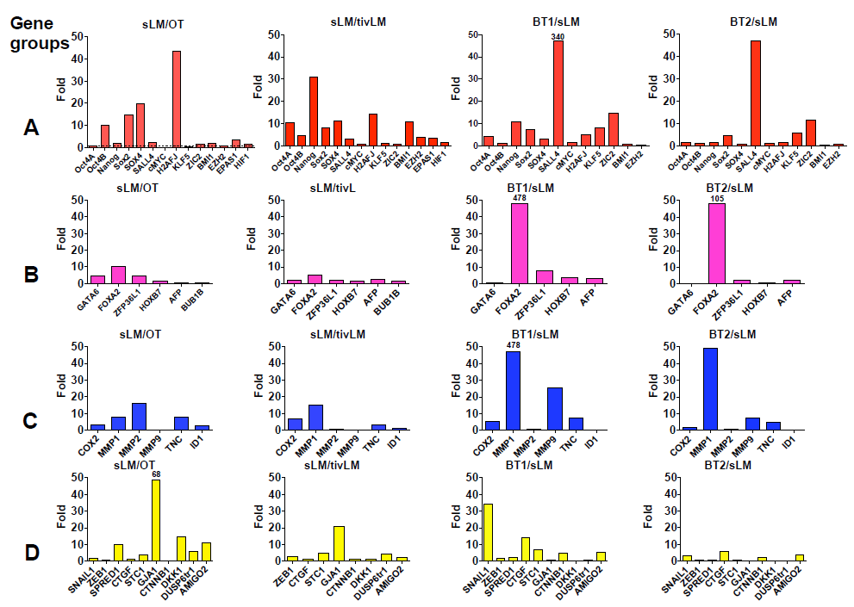
Supplementary figure 2
Heterogeneous expression of PTFs and other genes of Oct3/4 network in different tissues and based on modes of implantation.
qRT-PCR analysis of differentially expressed genes regulated by the OCT3/4 network tumors established in different tissues. Fold changes with respect to the house keeping genes presented as a ratio of spontaneous lung metastasis (SpLM), Orthotopic mammary fat pad tumor (OT), Lung tumors from tail vein injection of cells (tivLM) and Brain (BT1, BT2). Representative result of 3 independent cultures conducted in triplicate. Significantly upregulated genes with preferential upregulation in certain tissues is presented as figure 4 in the manuscript.

