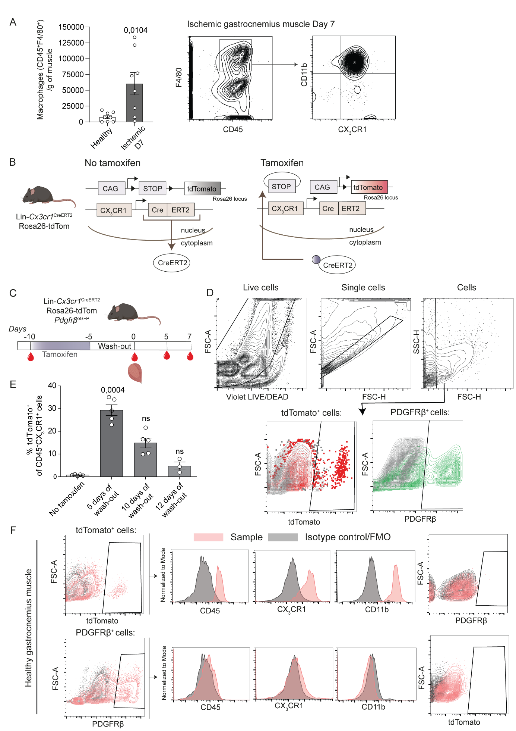Extended Data Figure 1. A) Number of macrophages (CD45⁺ F4/80⁺) at day 7 after induction of ischemia. Most CD45⁺ F4/80⁺macrophages are CD11b and CX₃CR1 positive. B) Experimental layout: tdTomato expression by macrophages is induced by tamoxifen treatment for 5 consecutive days and is followed by a 5-day wash-out period to remove tamoxifen from the system. C) Schematic representation of the experimental layout. D) Gating strategy for macrophages in lineage tracing experiments. E) Recombination efficiency in blood. F) Representative flow cytometry plots for the characterization of tdTomato⁺ cells and of PDGFRβ⁺ cells in relation to their expression of leukocyte markers demonstrate that recombined cells are macrophages and that PDGFRβ⁺ cells do not express macrophage markers in healthy muscle. Mann-Whitney U test (A); Kruskal-Wallis followed by Dunn’s post-hoc test, mean rank of each column was compared with the mean rank of “No tamoxifen” group (E). Data shown as average ± SEM.

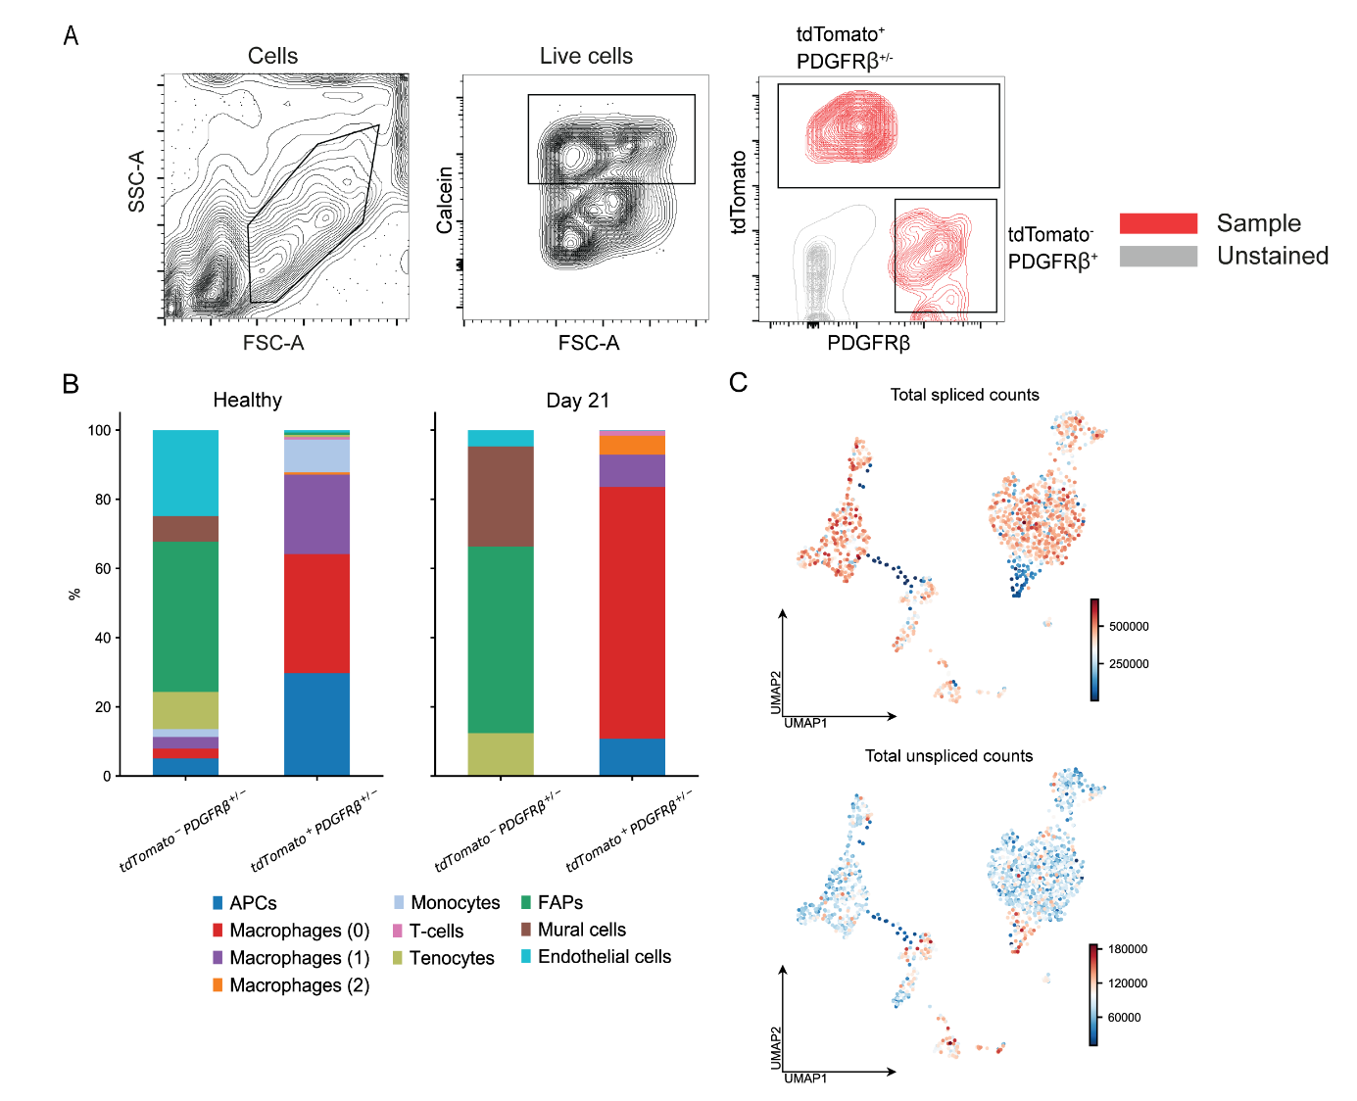
Extended Data Figure 2. A) Sorting strategy used for FACS for the scRNA-seq experiments B) Relative proportions of cell types in healthy and ischemic muscle, demonstrating shifts in cell type composition after 3 weeks of ischemia. C) UMAP embedding of scRNA-seq data colored by number of total spliced and unspliced counts.

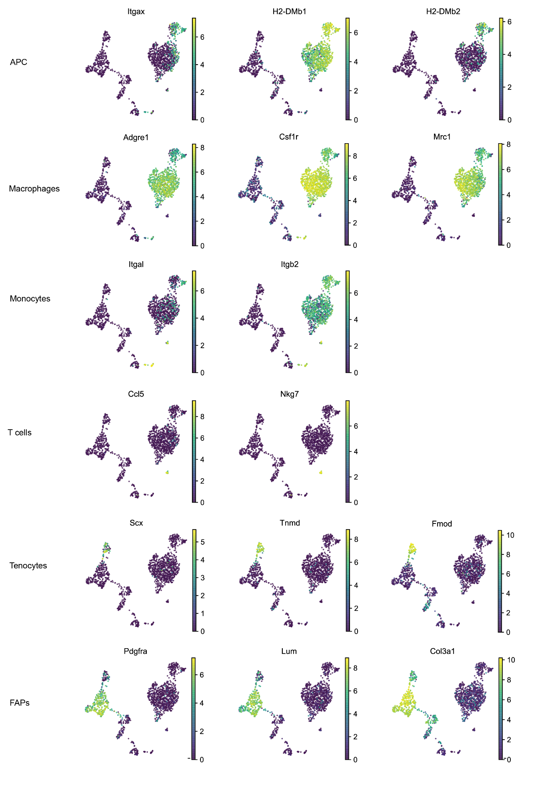

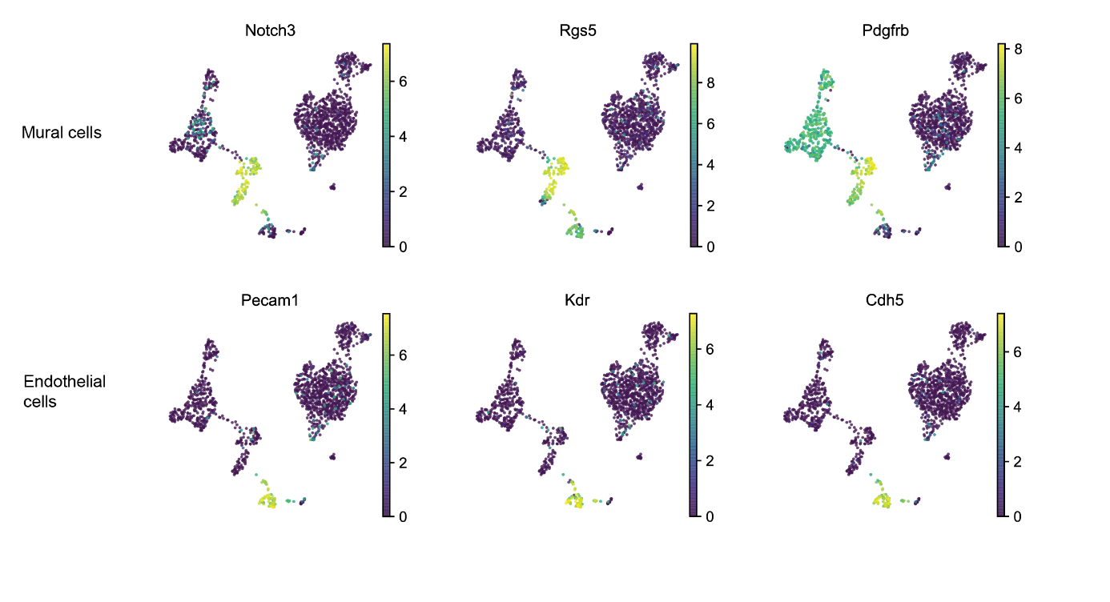
Extended Data Figure 3. Related to Supplemental Figure 2C, UMAP visualization of selected genes enriched in clusters identified in the scRNA-seq experiments.

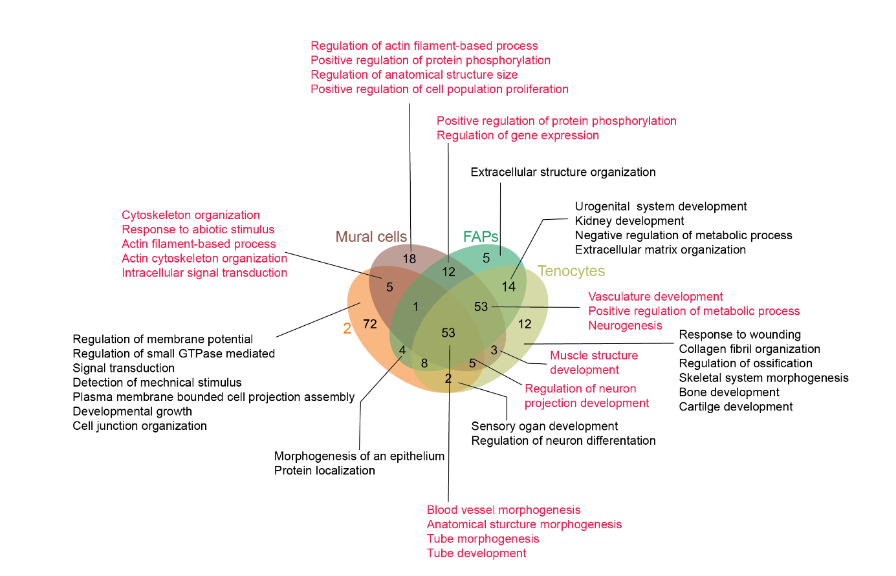
Extended Data Figure 4. Venn Diagram of Top 150 GO terms enriched in clusters 2, tenocytes, FAPs and mural cells when comparing to cluster 0, with a selection of pathways shown. Pathways identified as enriched in mural cell cluster are marked red.

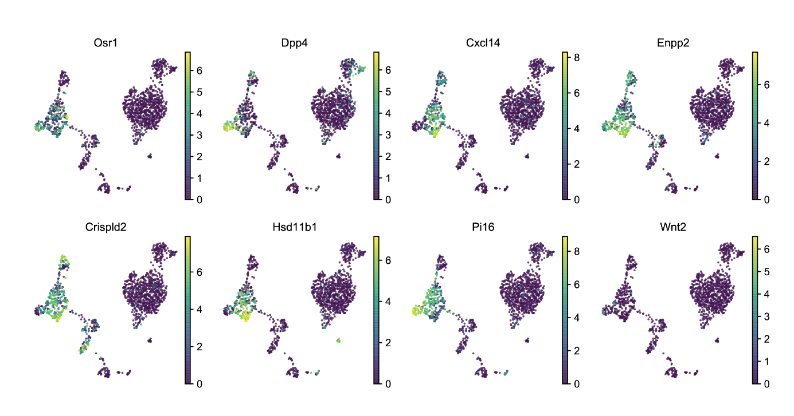
Extended Data Figure 5. UMAP plots with color-coded expression of the genes characteristic of FAPs as described by Oprescu et al.

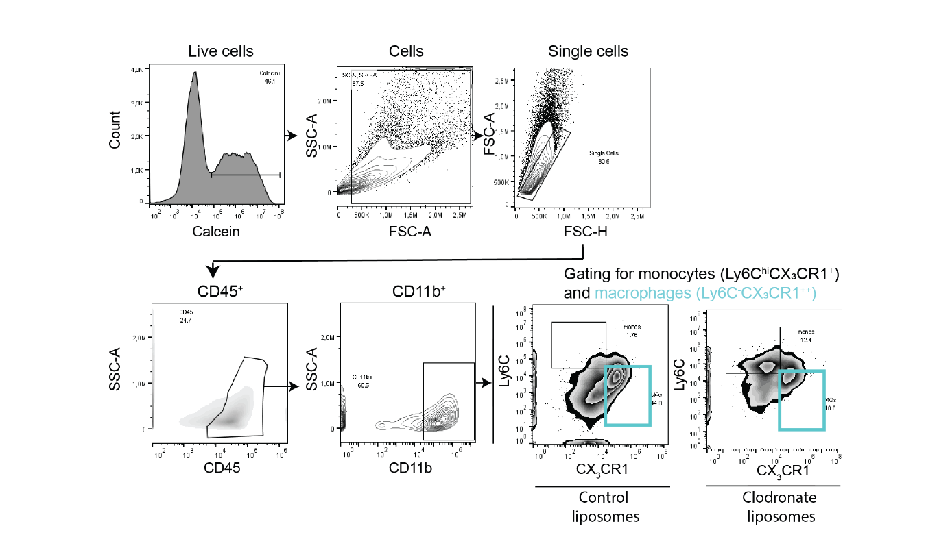
Extended Data Figure 6. Gating strategy for macrophages in macrophage depletion experiments (related to Fig. 6).

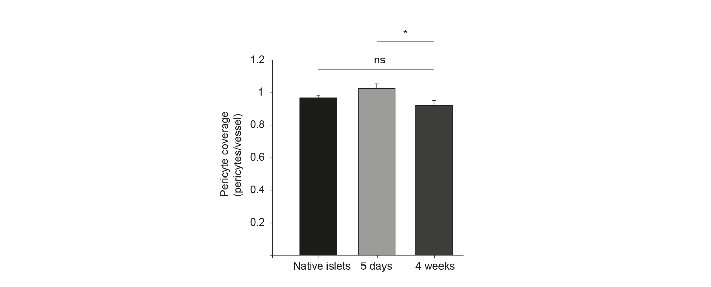
Extended Data Figure 7. Pericytes are recruited to the transplanted islet early in the revascularization process. There is no difference between the degree of pericyte coverage (pericytes/vessels) in islets in the healthy pancreas (n=6) or islets that have engrafted in mouse muscle for 4 weeks (n=4). At 5 days post-transplantation, the number of pericytes over vessels exceed the amount 4 weeks later (n=6). *Indicates statistically significant differences (p<0.05); One-Way ANOVA followed by Bonferroni’s post-hoc test. Data shown as average ± SEM.

