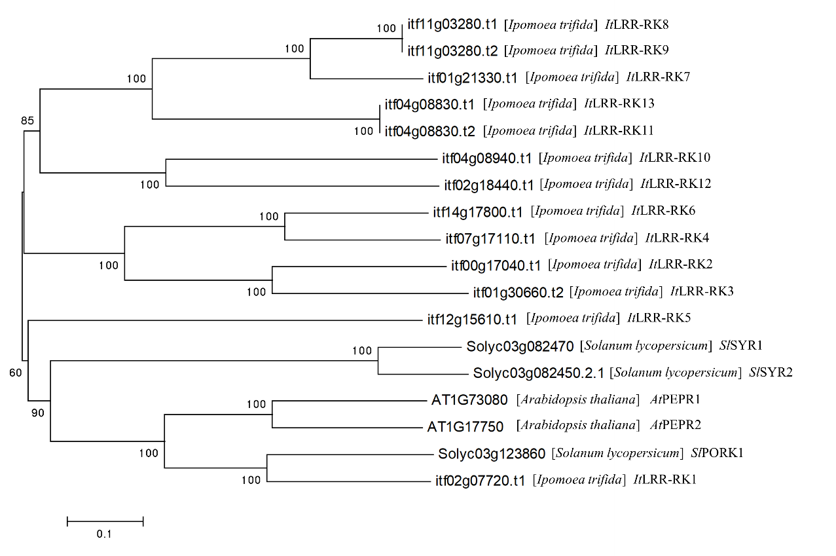
Supplementary Figure 1.
Phylogenetic tree (Neighbor-joining) established with Ipomoea trifida receptor-like genes. Sequences were obtained by BLASTx searches with AtPEPR1/2 and SlSYR1/2 from Ipomoea trifida database (http://sweetpotato.plantbiology.msu.edu/index.shtml).

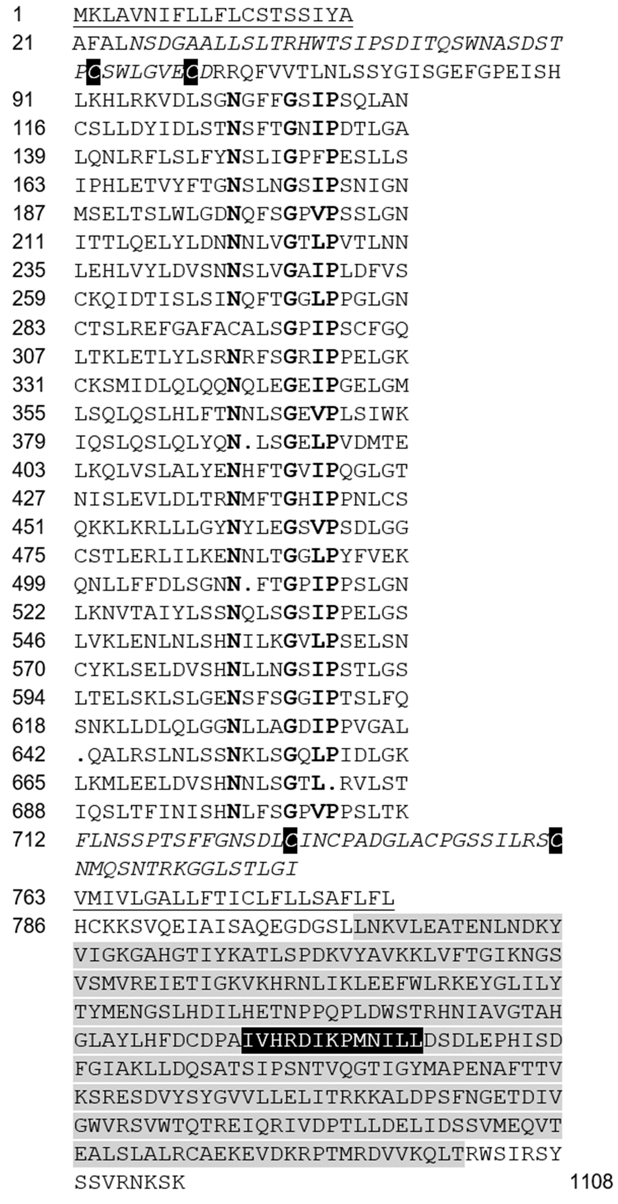
Supplementary Figure 2
Primary structure of the LRR receptor kinase IbLRR-RK1 from sweet potato. The coding sequence of IbLRR-RK1 encodes a signal peptide (aa 1-20, underlined), the N-terminal cap region (italic) containing two conserved cystein residues (white on black) embedded in the N-terminus (aa 21-90), 26 repetitions of the LRR motif (aa 91-711, highly conserved residues of the consensus sequence of plant LRRs (see ¹) are shown in bold letters), the outer juxtamembrane region (aa 712-762) containing two conserved cystein residues (white on black), a transmembrane domain (aa 763-785, underlined), and the cytoplasmic domain (aa 786-1108) including a serine/threonine kinase domain (shaded light gray) with a conserved active site (shaded in black).

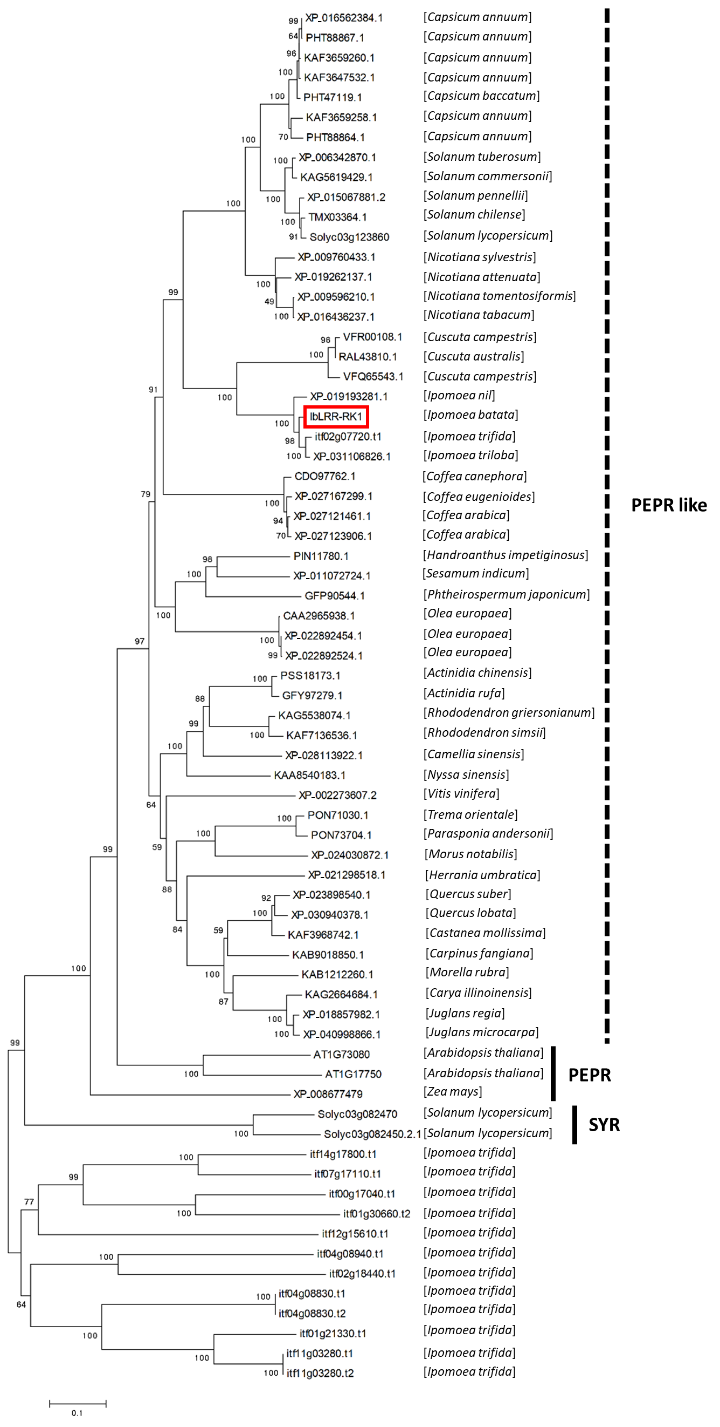
Supplementary Figure 3
Phylogenetic tree (Neighbor-joining) established with sequences related to IbLRR-RK1 in different plant species. Sequences were obtained by BLASTx searches with IbLRR-RK1 in public databases (PubMed/NCBI/Sweetpotato Genomics Resource database).

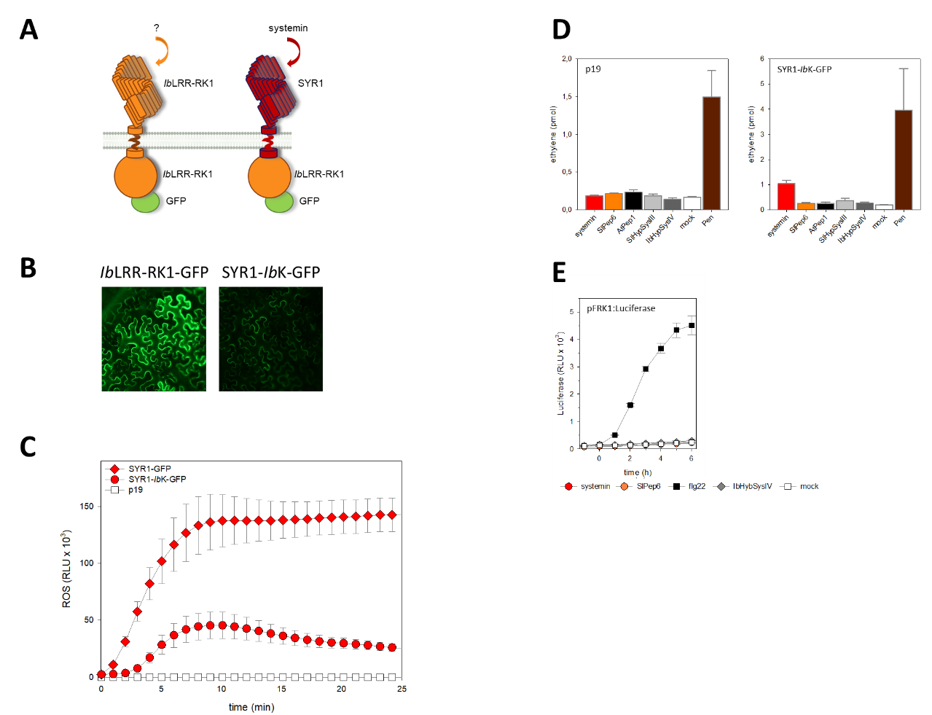
Supplementary Figure 4
Generation of a chimeric receptor version to test for functionality. The core kinase domain of SYR1 was replaced with the one from IbLRR-RK1 (A) and the resulting chimeric protein was transiently expressed in Nicotiana benthamiana (B, C). Reporter assays (C) showed that the kinase of IbLRR-RK1 in combination with the SYR1 ectodomain (SYR1-IbK) was able to induce the generation of ROS in the leaf disc assay when treted with 10 nM systemin (red circles), similar to SYR1 (red diamonds). Control leaf pieces (expressing p19 only) did not react with a ROS burst to systemin treatment (open squares). Data are depicted as means ± s.e. of n = 4. (D) Controls and additional data to Figure 2C: Induced ethylene production in N. benthamiana leaf pieces, transiently transformed with p19 only or with p19 and SYR1-IbK-GFP, treated with 1 µM of the listed peptides or 90 ng/ml Pen as a positive control. Values and error bars represent mean ± s.d. of n = 3. (E) Control for Figure 2D and E: Mesophyll protoplasts from A. thaliana Col-0 were transformed with the reporter construct pFRK1:luciferase only and luminescence was monitored after treatment with either 10 nM flg22 (black squares, positive control), systemin (red circles), SlPep6 (orange circles), or IbHypSysIV (dark gray diamonds) at time point 0, mock control is shown with open squares. Values and error bars represent mean ± s.d. of n = 2.

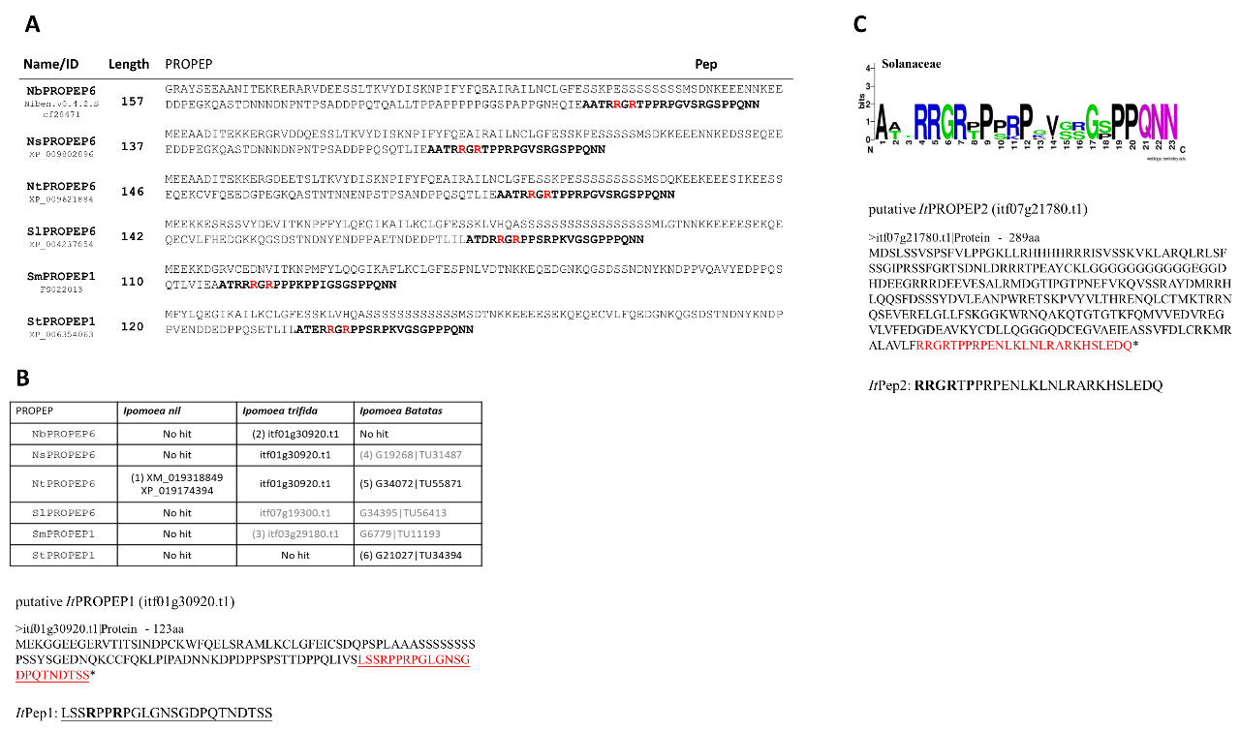
Supplementary Figure 5
Different approaches to identify putative Peps and PROPEPs in sweet potato. Sweet potato belongs into the morning glory family (Convolvulaceae), a sister family of the Solanaceae, from which genes encoding PROPEPs have been published ², including also SlPROPEP6. (A) We retrieved the six PROPEPs (Nb, Nicotiana benthamiana; Ns, Nicotiana sylvestris; Nt, Nicotiana tomentosiformis; Sl, Solanum lycopersicum; Sm; Solanum melongena; St, Solanum tuberosum; putative mature Peps, representing the last 23 residues of the precursor proteins, are highlighted in bold) and used them for tBlastn queries of the sweet potato databases (http://sweetpotato.plantbiology.msu.edu/index.shtml). (B) One gene from I. trifida (itf01g30920.t1, putative ItPROPEP1) was retrieved multiple times. (C) A scanning sequence patterns strategy starting with the the consensus sequences of the Solanaceae Pep sequences (as visualized by the WebLogo tool, ³ identified another I. trifida gene (itf07g21780.t1, putative ItPROPEP2).

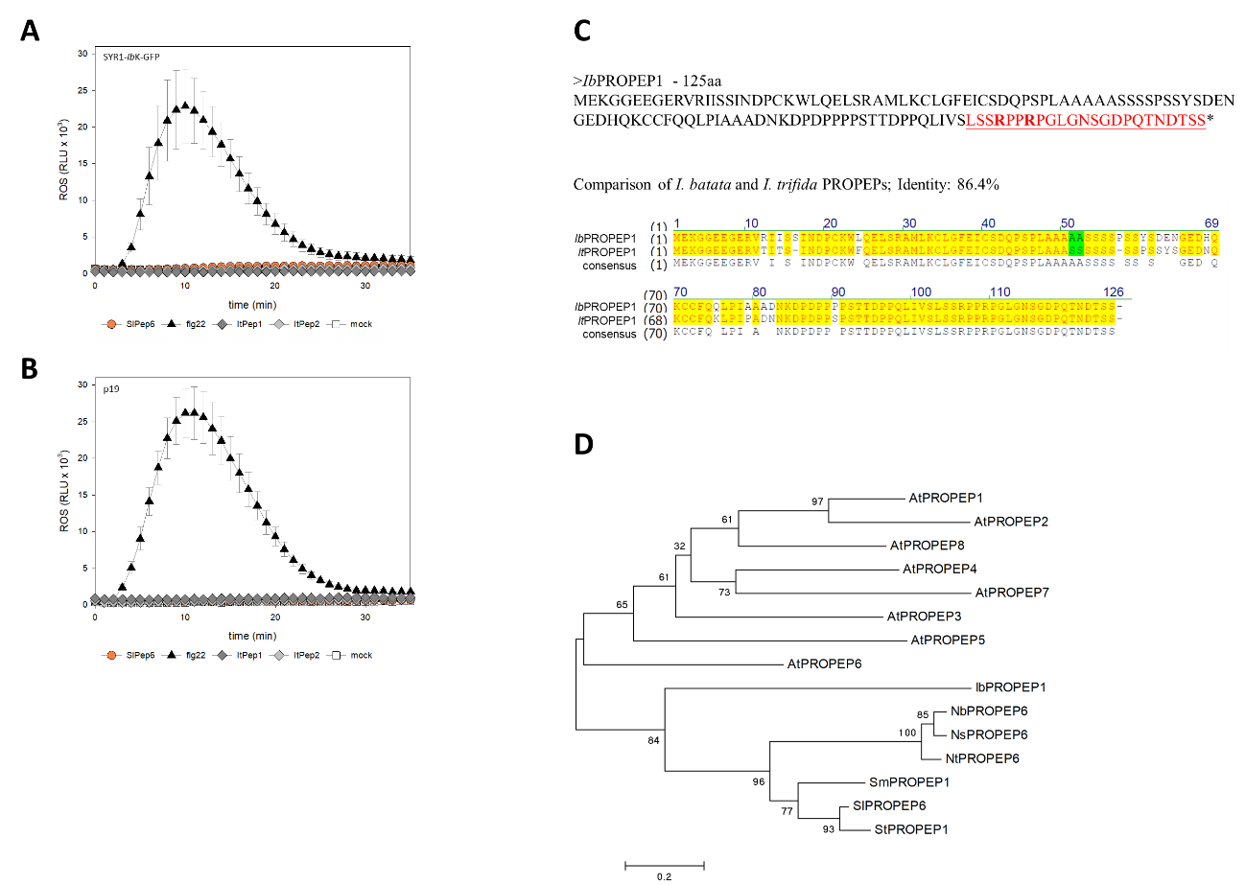
Supplementary Figure 6
Identification of an endogenous ligand for IbLRR-RK. Control for Figure 3A: ROS assays with N. benthamiana leaf discs from plants which were transformed with the construct encoding the chimeric receptor SYR1-IbK-GFP and p19 (A), or with p19 only (B). Data are means ± s.e. of n = 4 after treatment with 1 µM of the respective peptides, or BSA/NaCl-treatment (mock). (C) The deduced amino acid sequence of IbPROPEP1 and its derived peptide, IbPep1 (highlighted in red). The comparison of the PROPEP amino acid sequences from I. trifida and I. batata reveals an identity of 86,4%, the putative mature 23-mer peptides at the C-terminus are 100% identical. (D) Phylogenetic tree (Neighbor-joining) comparing IbPROPEP1 with PROPEPs from different plant species; for the abbreviations see Table S2.
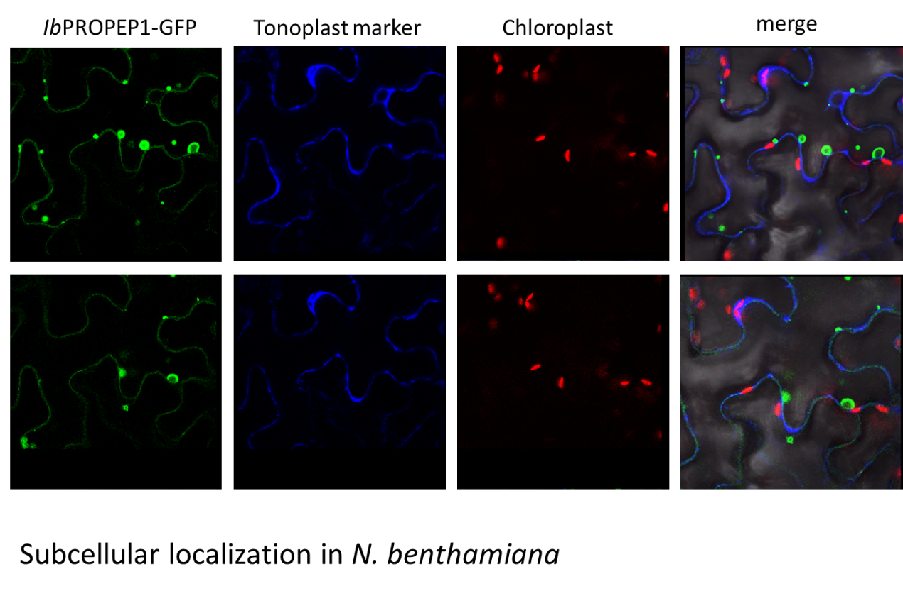
Supplementary Figure 7
Subcellular localization of IbPROPEP1 in transgenic N. benthamiana leaves. N. benthamiana leaves were transiently transformed with IbPROPEP1-GFP and observed 3 dpi to check the subcellular localization of the expressed protein by confocal microscopy (TCS SP5 Confocal; Leica), in comparison to the tonoplast marker γ-Tip-mCherry ⁴.

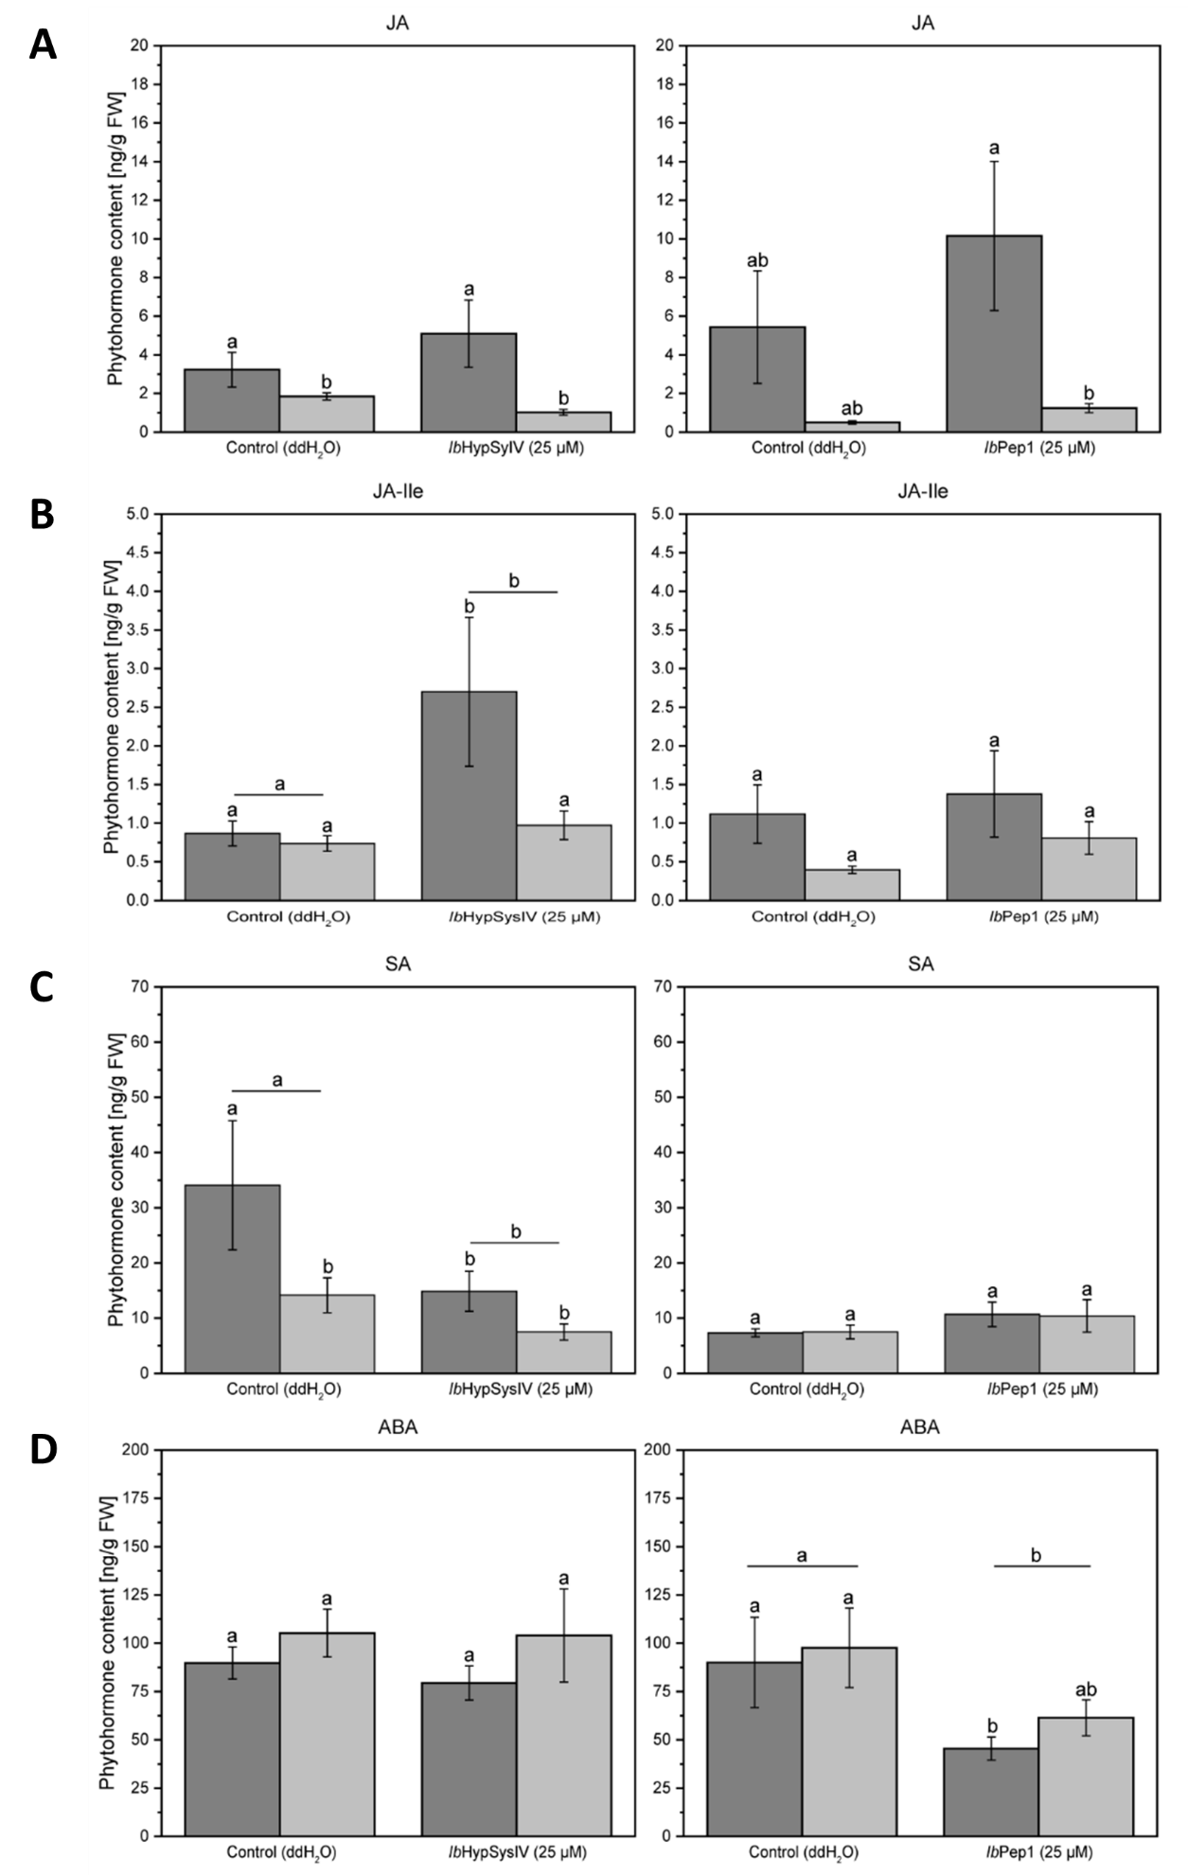
Supplementary Figure 8
Opposing phytohormone accumulation patterns in I. batatas after treatment with IbHypSysIV and IbPep1. Jasmonates (JA, JA-Ile, (A, B)), salicylic acid (SA, (C)), and abscisic acid (ABA, (D)) levels after treatment with 25 µM IbHypSysIV (left) and IbPep1 (right), respectively, measured in I. batatas TN57 after 1 h. Phytohormone contents were analyzed in the locally treated 3rd leaf (dark gray bars) and the adjacent untreated 4th systemic leaf (light gray bars). Leaves from ddH₂O-sprayed plants served as controls. Statistically significant differences between groups were analyzed using a two-way ANOVA with initial normality and equal variance tests. Different letters indicate significant differences among groups for p<0.05, determined by the Holm-Sidak method. For all analyses, phytohormone content was set as the dependent variable with treatment and leaf type as independent variables. Data are presented as mean ± s.e. of n = 8.

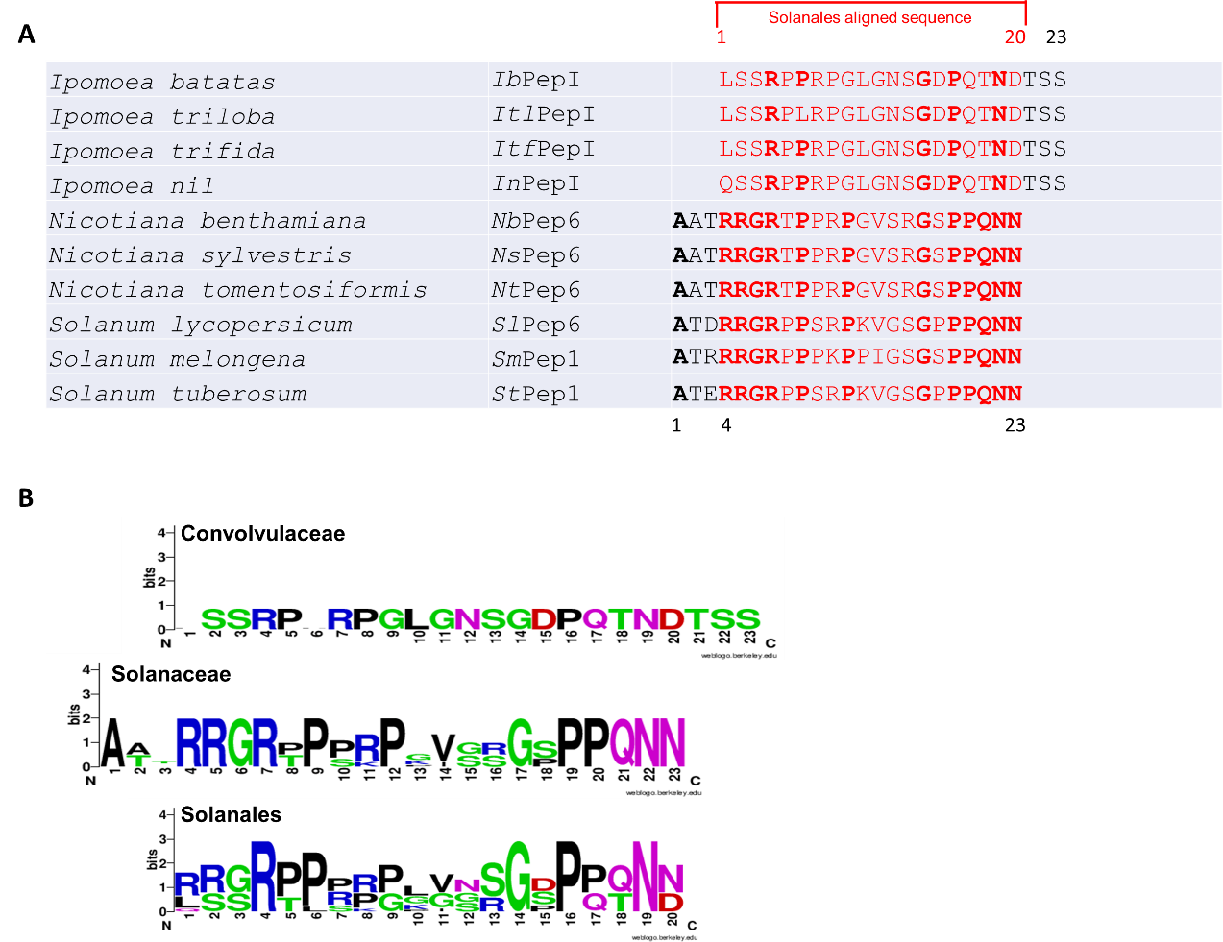
Supplementary Figure 9
Comparison of Peps from Solanaceae and Convolvulaceae. (A) Pep sequences from Solanales which were used for the analysis of the consensus sequences. (B) The consensus sequences of Convolvulaceae (IbPep1, ItlPep1, ItfPep1, InPep1) and Solanaceae (NbPep6, NsPep6, NtPep6, SlPep6, SmPep6, StPep6) Peps are compared to the combined consensus (for which only the overlapping 20 residues were used) by generating WebLogos ³.

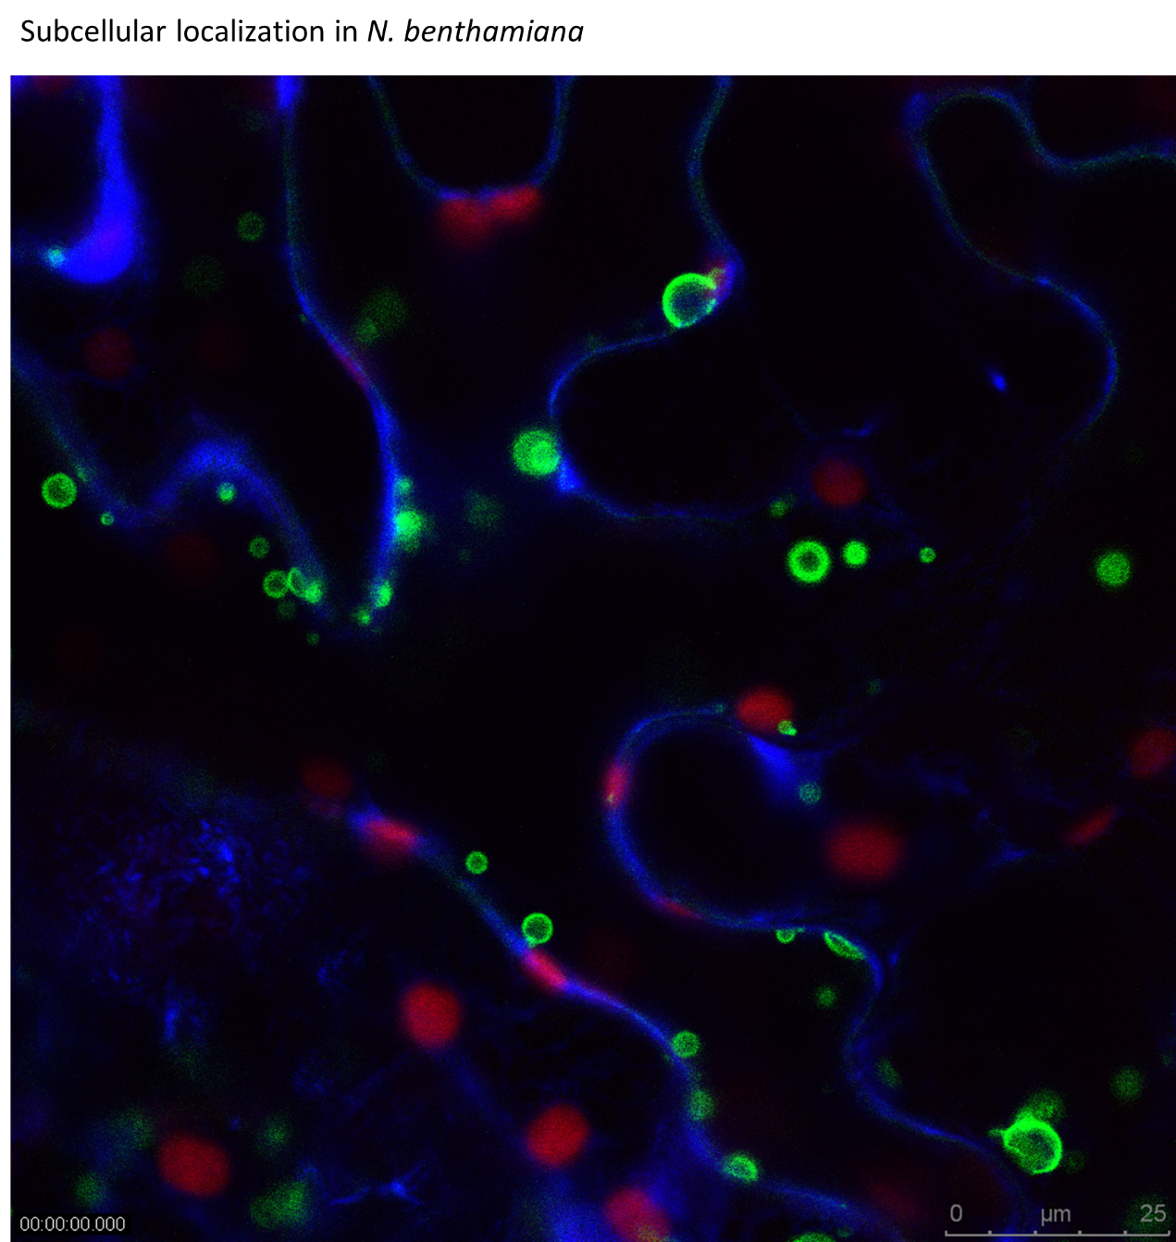
Supplementary Movie 1
GFP-tagged IbPROPEP1 moves in vesicles.
N. benthamiana leaves were transiently transformed with IbPROPEP1-GFP. A leaf sample was observed to check the subcellular localization and movement of the IbPROPEP1 by confocal microscopy (TCS SP5 Confocal; Leica). Tonoplast was visualized by co-transformation with the tonoplast marker γ-Tip-mCherry ⁴.

Supplementary Table 1. List of peptides used for signaling activity experiments.

Name | Sequence
systemin | AVQSKPPSKRDPPKMQTD
IbHypSysIV | REEKPOOOAOETDDPNRP
C-IbHypSysIV | CREEKPOOOAOETDDPNRP
IbPep1 | LSSRPPRPGLGNSGDPQTNDTSS
SlPep6 | ATDRRGRPPSRPKVGSGPPPQNN
SlHypSysIII | GRHDSVLPPPSPKTD
AtPep1 | ATKVKAKQRGKEKVSSGRPGQHN
Scrambled peptide | PEROEDDNEOPKORPC

Supplementary Table 2. Identity table of IbPep1 and other Peps by Vector NTI.
 | AtPep1 | AtPep2 | AtPep8 | AtPep6 | IbPepI | NbPep6 | NsPep6 | NtPep6 | SlPep6 | StPep1 | SmPep1 | AtPep3 | AtPep5 | AtPep4 | AtPep7
AtPep1 |  | 65 | 43 | 43 | 10 | 30 | 30 | 30 | 39 | 39 | 35 | 39 | 39 | 35 | 35
AtPep2 |  |  | 52 | 35 | 21 | 22 | 22 | 22 | 26 | 26 | 26 | 43 | 30 | 39 | 30
AtPep8 |  |  |  | 30 | 16 | 22 | 22 | 22 | 22 | 22 | 17 | 35 | 35 | 39 | 26
AtPep6 |  |  |  |  | 32 | 39 | 39 | 39 | 43 | 43 | 48 | 26 | 39 | 26 | 26
IbPepI |  |  |  |  |  | 42 | 42 | 42 | 37 | 37 | 37 | 10 | 5 | 10 | 16
NbPep6 |  |  |  |  |  |  | 100 | 100 | 65 | 65 | 65 | 26 | 17 | 17 | 13
NsPep6 |  |  |  |  |  |  |  | 100 | 65 | 65 | 65 | 26 | 17 | 17 | 13
NtPep6 |  |  |  |  |  |  |  |  | 65 | 65 | 65 | 26 | 17 | 17 | 13
SlPep6 |  |  |  |  |  |  |  |  |  | 96 | 74 | 26 | 17 | 17 | 13
StPep1 |  |  |  |  |  |  |  |  |  |  | 74 | 26 | 17 | 17 | 13
SmPep1 |  |  |  |  |  |  |  |  |  |  |  | 30 | 22 | 22 | 17
AtPep3 |  |  |  |  |  |  |  |  |  |  |  |  | 35 | 30 | 39
AtPep5 |  |  |  |  |  |  |  |  |  |  |  |  |  | 39 | 39
AtPep4 |  |  |  |  |  |  |  |  |  |  |  |  |  |  | 39
AtPep7
At, Arabidopsis thaliana; Ib, Ipomoea batatas; Nb, Nicotiana benthamiana; Ns, Nicotiana sylvestris; Nt, Nicotiana tomentosiformis; Sl, Solanum lycopersicum; Sm; Solanum melongena; St, Solanum tuberosum.
Supplementary Table 3. List of oligonucleotides used for this study.
Name | Sequence | Amplification of
IbLRR-RK1_RT_F | TGGCCCATTTCCTGAGTCTTTAC | real-time PCR
IbLRR-RK1_RT_R | GACAGGCAAGGTTCCAACAAGATT | real-time PCR
IbLRR-RK2_RT_F | GATATGGTTTACAAGGTACGCTCG | real-time PCR
IbLRR-RK2_RT_R | CTGTGGCGAAGATACAACCCTTT | real-time PCR
IbLRR-RK3_RT_F | ACTTTCAGGCCACATCCCTC | real-time PCR
IbLRR-RK3_RT_R | GTGGCCTGAAAGTTGGTTATTGAG | real-time PCR
IbLRR-RK4_RT_F | ACAGCCTTAATGGGTCAATTCC | real-time PCR
IbLRR-RK4_RT_R | CCAGACAAGTCTAAGCTCTGAAGA | real-time PCR
IbLRR-RK5_RT_F | GCATTGTGGGTAGTGTTCCATCC | real-time PCR
IbLRR-RK5_RT_R | CACCTGCCCTGAGAACCTCAA | real-time PCR
IbActin_RT_F | GACTACCATGTTCCCCGGTA | real-time PCR
IbActin_RT_R | TTGTATGCCACGAGCATCTT | real-time PCR
sporamin_RT_F | ATGTCCAAATGCGCCAGCG | real-time PCR
sporamin_RT_R | TTTCAGGAAATACTGCCCGGA | real-time PCR
IbWIPK_RT_F | ACATCACCATGGTGGGCG | real-time PCR
IbWIPK_RT_R | CGTTCAAAGCCGAACAGACGATT | real-time PCR
IbNAC1_RT_F | CGGCCGGGGATACAAATTTGTAAGCTT | real-time PCR
IbNAC1_RT_R | GAATCGGAATCCCGGCGGCATCTC | real-time PCR
IbCML_RT_F | AAGTGGAGAAGGTGTTCAGGAAG | real-time PCR
IbCML_RT_R | CCTTGTCCTCAGAGTCGGATC | real-time PCR
IbPROPEP1_FL_F | ATGGAGAAGGGTGGAGAGGA | IbPROPEP1 CDS
IbPROPEP1_FL_R | TTAAGAAGAGGTGTCGTTAGTCTGA | IbPROPEP1 CDS
IbLRR-RK1_FL_F | ATGAAGGTTGCTGTGATCACATTCT | IbLRR-RK CDS
IbLRR-RK1_FL_R | CTACTTAGACTTGTTTCTAACACTCGA | IbLRR-RK CDS
SlPEPR_FL_F | ATGAAGATAGCTGTTCATAATTTGATCT | SlPEPR CDS
SlPEPR_FL_R | CTAGTACTTGCTTCGTATACTCGAA | SlPEPR CDS
B-5*_IbRK1_fw | tatggtctcaTCTGaacaATGAAGCTTGCTGTGAACATATTC | IbLRR-RK ectodomain  (for GoldenGate)
B-5*_IbRK1_rev | ttaggtctcCCgATAACATACTTATCATTTAGGTTC | IbLRR-RK ectodomain  (for GoldenGate)
5*-D_IbRK1_fw | ataggtctcTATcGGGAAGGGAGCACATG | IbLRR-RK kinase  (for GoldenGate)
5*-D_IbRK1_rev | attggtctcTcCTTAGATTTGTTTCTAACACTCGAG | IbLRR-RK kinase  (for GoldenGate)
B-5*_SYR1_fw | atggtctcATctgaacaATGTTCTTGTTTGATGTTGTTCAT | SYR1 ectodomain  (for GoldenGate)
B-5*_SYR1_rev | tatggTCTcCCgATAACATAGTTTTCACTCCAGC | SYR1 ectodomain  (for GoldenGate)

REFERENCES
1 Liu, P. L., Du, L., Huang, Y., Gao, S. M. & Yu, M. Origin and diversification of leucine-rich repeat receptor-like protein kinase (LRR-RLK) genes in plants. BMC Evol. Biol. 17, 16, doi:10.1186/s12862-017-0891-5 (2017).
2 Lori, M. et al. Evolutionary divergence of the plant elicitor peptides (Peps) and their receptors: interfamily incompatibility of perception but compatibility of downstream signalling. J. Exp. Bot. 66, 5315-5325, doi:10.1093/jxb/erv236 (2015).
3 Crooks, G. E., Hon, G., Chandonia, J. M. & Brenner, S. E. WebLogo: A sequence logo generator. Genome Res 14, 1188-1190, doi:10.1101/gr.849004 (2004).
4 Nelson, B. K., Cai, X. & Nebenfuhr, A. A multicolored set of in vivo organelle markers for co-localization studies in Arabidopsis and other plants. Plant Journal 51, 1126-1136, doi:10.1111/j.1365-313X.2007.03212.x (2007).

