Insights of under-water trophic interaction: A scenario in Chilika through the lens of Ecopath

Prajna Rithambhara Swain#, Pranaya Kumar Parida#, Basanta Kumar Das*, Bijay Kumar Behera

ICAR-Central Inland Fisheries Research Institute, Barrackpore, Kolkata, India – 700120

*Basanta Kumar Das
Barrackpore, Kolkata, India – 700120
E-mail: basantakumard@gmail.com

#equally contributed

Table S1: Basic Estimates of Chilika ecopath Model

 | Group name | Trophic level | Biomass in habitat area (t/km²) | Biomass (t/km²) | Production / biomass (/year) | Consumption / biomass (/year) | Ecotrophic Efficiency | Production / consumption (/year)
1 | Irrawaddy Dolphin | 3.802595 | 0.0126 | 0.0126 | 0.2 | 12.75 | 0 | 0.01568628
2 | Crabs | 2.676449 | 0.53 | 0.53 | 2.9 | 14 | 0.3895117 | 0.2071429
3 | Prawns | 2.290802 | 2.92 | 2.92 | 5.14 | 20.58 | 0.2379662 | 0.249757
4 | Ciprinids | 2.322169 | 0.253638 | 0.253638 | 3.1 | 20 | 0.8018541 | 0.155
5 | Tripod Fish | 2.240298 | 0.116901 | 0.116901 | 1.38 | 5.5 | 0.2752946 | 0.2509091
6 | Elopiformes | 3.472628 | 0.0038 | 0.0038 | 2.1 | 13.5 | 0.7178457 | 0.1555555
7 | Eels | 3.367437 | 0.044969 | 0.044969 | 1.5 | 7.9 | 0.3625624 | 0.1898734
8 | Featherbacks | 2.726079 | 0.211654 | 0.211654 | 1.51 | 9.9 | 0.09147189 | 0.1525253
9 | Snakeheads | 3.07363 | 0.088735 | 0.088735 | 1.99 | 7.6 | 0.2452017 | 0.2618421
10 | Cichlids | 2.546468 | 0.252122 | 0.252122 | 2.26 | 15.8 | 0.2082728 | 0.143038
11 | Catfish | 2.884749 | 0.867631 | 0.867631 | 1.34 | 7.9 | 0.4287312 | 0.1696203
12 | Croakers | 3.193563 | 0.422219 | 0.422219 | 1.45 | 10.6 | 0.05320816 | 0.1367925
13 | Gerridae | 2.718717 | 0.233 | 0.233 | 3.49 | 36 | 0.795509 | 0.09694444
14 | Belonids | 3.38976 | 0.088 | 0.088 | 1.85 | 12.2 | 0.4351014 | 0.1516393
15 | Threadfins | 3.330708 | 0.202 | 0.202 | 1.03 | 4.5 | 0.3533027 | 0.2288889
16 | Perches | 3.205816 | 0.76 | 0.76 | 1.5 | 7.1 | 0.05076382 | 0.2112676
17 | Clupeoids | 2.543328 | 1.857695 | 1.857695 | 3.1 | 15 | 0.3431189 | 0.2066667
18 | Mullets | 2.394258 | 1.4995 | 1.4995 | 2.8 | 20 | 0.2274858 | 0.14
19 | Benthos | 2.201488 | 10.94 | 10.94 | 9 | 60 | 0.7146652 | 0.15
20 | Zoo plankton | 2.010101 | 2.9 | 2.9 | 48 | 133 | 0.8598639 | 0.3609022
21 | Sea grass with other macrophytes | 1 | 95.67 | 95.67 | 12.5 |  | 0.05362874
22 | P. karka | 1 | 254.41 | 254.41 | 12.5 |  | 0.003276915
23 | Phytoplankton | 1 | 7.83 | 7.83 | 134.27 |  | 0.4209001
24 | Detritus | 1 | 308.217 | 308.217 |  |  | 0.09403238

Table S2: Diet Matrix of Chilika Ecopath
 | Prey \ predator | 1 | 2 | 3 | 4 | 5 | 6 | 7 | 8 | 9 | 10 | 11 | 12 | 13 | 14 | 15 | 16 | 17 | 18 | 19 | 20
1 | Irrawaddy Dolphin
2 | Crabs | 0.025 | 0.01 |  |  |  | 0.05 | 0.05 |  | 0.005 | 0.005 | 0.005 | 0.005 | 0.005 | 0.0005 |  | 0.07
3 | Prawns | 0.055 | 0.076 |  |  |  | 0.1 | 0.21 | 0.08 | 0.005 | 0.005 | 0.01 | 0.2 | 0.005 | 0.094 | 0.3 | 0.25
4 | Ciprinids | 0.05 |  |  |  |  |  | 0.05 | 0.07 | 0.56 |  | 0.01 |  |  | 0.011
5 | Tripod Fish | 0.025 |  |  |  |  | 0.01 | 0.005 | 0.01 | 0.01 |  |  | 0.001 |  | 0.0005 |  | 0.001
6 | Elopiformes | 0.03 |  |  |  |  |  |  |  |  |  |  |  |  |  | 0.001
7 | Eels | 0.025 |  |  |  |  |  |  |  | 0.01 |  | 0.001 |  |  | 0.0005 | 0.001 | 0.001
8 | Featherbacks | 0.025 |  |  |  |  |  | 0.005 |  | 0.01 |  | 0.001 | 0.001 |  | 0.005
9 | Snakeheads | 0.025 |  |  |  |  |  | 0.003 | 0.01 |  |  | 0.001 | 0.001 |  | 0.0005 |  | 0.001
10 | Cichlids | 0.07 |  |  |  |  | 0.1 | 0.005 | 0.01 | 0.01 |  |  | 0.002 |  | 0.005 | 0.005 | 0.01
11 | Catfish | 0.07 |  |  |  |  | 0.02 | 0.005 |  | 0.01 |  |  |  |  | 0.0005 | 0.05 | 0.08
12 | Croakers | 0.07 |  |  |  |  | 0.02 | 0.005 |  |  |  | 0.001 |  |  | 0.005 | 0.001 | 0.001
13 | Gerridae | 0.1 |  |  |  |  | 0.25 | 0.05 |  |  |  | 0.005 | 0.1 |  | 0.0005 | 0.1 | 0.005
14 | Belonids | 0.07 |  |  |  |  | 0.01 |  |  |  |  |  |  |  | 0.05 |  | 0.001
15 | Threadfins | 0.06 |  |  |  |  | 0.01 | 0.005 |  |  |  | 0.001 | 0.005 |  | 0.005 |  | 0.005
16 | Perches | 0.07 |  |  |  |  | 0.02 | 0.05 |  |  |  |  | 0.005 |  | 0.005 | 0.0001
17 | Clupeoids | 0.11 |  |  |  |  | 0.05 | 0.1 |  |  |  | 0.01 | 0.135 |  | 0.2 | 0.127 | 0.17
18 | Mullets | 0.12 |  |  |  |  | 0.21 | 0.002 |  |  |  | 0.035 | 0.025 |  | 0.15 | 0.15 | 0.051
19 | Benthos |  | 0.459 | 0.2 | 0.1 | 0.2 | 0.1 | 0.443 | 0.3 | 0.15 | 0.35 | 0.47 | 0.35 | 0.3 | 0.467 | 0.21 | 0.154 | 0.2 | 0.16 | 0.05
20 | Zoo plankton |  | 0.01 | 0.05 | 0.2 |  |  |  | 0.12 | 0.05 | 0.11 | 0.2 | 0.06 | 0.34 |  | 0.005 | 0.05 | 0.3 | 0.2 | 0.14 | 0.01
21 | Sea grass with other macrophytes |  | 0.055 | 0.05 | 0.15 | 0.2 |  | 0.001 | 0.15 |  | 0.2 | 0.005 | 0.03 | 0.05 |  |  | 0.025 | 0.05 | 0.15 | 0.05 | 0.05
22 | P. karka |  |  |  |  |  |  |  |  |  |  |  |  |  |  |  |  |  |  | 0.01 | 0.01
23 | Phytoplankton |  | 0 | 0.3 | 0.3 | 0.55 |  |  | 0.05 |  | 0.23 | 0.045 | 0.01 | 0.1 |  |  | 0.025 | 0.4 | 0.39 | 0.2 | 0.69
24 | Detritus |  | 0.39 | 0.4 | 0.25 | 0.05 | 0.05 | 0.011 | 0.2 | 0.18 | 0.1 | 0.2 | 0.07 | 0.2 |  | 0.05 | 0.1 | 0.05 | 0.1 | 0.55 | 0.24
 | Sum | 1 | 1 | 1 | 1 | 1 | 1 | 1 | 1 | 1 | 1 | 1 | 1 | 1 | 1 | 1 | 1 | 1 | 1 | 1 | 1

Table S3: Ecological Indicators of the Chilika Ecopath Model

Parameter | Value | Units
Sum of all consumption | 1207.602 | t/km²/year
Sum of all exports | 4731.606 | t/km²/year
Sum of all respiratory flows | 695.7275 | t/km²/year
Sum of all flows into detritus | 5222.71 | t/km²/year
Total system throughput | 11857.65 | t/km²/year
Sum of all production | 5697.688 | t/km²/year
Calculated total net primary production | 5427.334 | t/km²/year
Net system production | 4731.606 | t/km²/year
Total biomass/total throughput | 0.032225 | t/km²/year
Total primary production/total respiration | 7.800948
Total primary production/total biomass | 14.20343
Total biomass (excluding detritus) | 382.1144 | t/km²
Connectance Index | 0.385633
System Omnivory Index | 0.231064
Ecopath pedigree | 0.476744
Measure of fit, t* | 2.485337
Transfer efficiency of the system | 7.298 | %
Transfer efficiency from producers | 8.126 | %
Transfer efficiency From detritus | 6.155 | %
Ascendency | 14206 | flowbits
Overhead | 19016 | flowbits
Redundancy | 16585 | flowbits
Average Mutual Information (AMI) | 1.198 | bits
System Robustness | 0.157
Finn’s cycling Index | 1.67 | % of total throughput
Finn’s cycling path length | 2.185
Predator Cycling Index | 2.6 | % of total throughput without detritus

The Ecopath Model
Theory
Ecopath with Ecosim models is one of the widely recognized ecosystem models used for ecosystem-based fisheries management strategy. The ecopath models are mass balanced models and based on two basic equations.
Equation 1: Production = catch + predation + net migration + biomass accumulation + other mortality
Equation 2: Consumption = production + respiration + unassimilated food
Input parameter and Pedigree
The major input parameters for ecopath models are biomass, production/biomass, consumption/biomass and diet of each functional group. Biomass of each group are expressed in t/km²/year. The biomass, production/biomass and consumption/biomass of fish groups, phytoplankton, zoo plankton, sea grass and other macrophytes, Phragmites karka and detritus biomass were adopted from Swain et al., (2022) and Behera et al., (2020). For the Irrawaddy dolphin the biomass was calculated manually and the production/biomass and consumption/biomass were adopted from Mukherjee et al., 2019. The diet matrix was adopted from some basic knowledge of food and feeding of functional groups, fish base, Swain et al., 2022, Behera et al., 2020, Mukherjee et al., 2019. The pedigree analysis was carried out to check the data authenticity and the calculated pedigree was 0.477 indicating the robust data structure.
Glossary
Trophic Level: Position of the organism in a food web or chain
Ecotrophic Efficiency: The fraction of the production utilized in the system and also well known as the mass balanced indicator
Total system throughput: Sum of all flows (inputs and outputs) occurring in the system
Total primary production/total respiration: Maturity indicator, ratio value 1 indicates the system is mature
Connectance Index: Ratio between the number of actual links in a food web to its possible number of linkage in a food web
System Omnivory Index : the variance of the trophic level of a consumer's prey groups
Transfer efficiency: Ratio between the sum of exports between two adjacent trophic level and throughput at the former trophic level
Average mutual Information: Indicator of flow of energy between two adjacent levels
Ascendency: Characterise the growth and development and the product of average mutual information and total throughput of the system
Overhead: System reserve of the system to counter the external perturbations
Redundancy: Indicator of system reserve and it is the part of the overhead in internal flow
System Robustness Stands for the sustainability of the system
Finn’s cycling Index: fraction of total system throughput utilised in the system
Predator cycling Index: Fraction of system throughput cycled within the system without considering the detritus

Supplementary figure
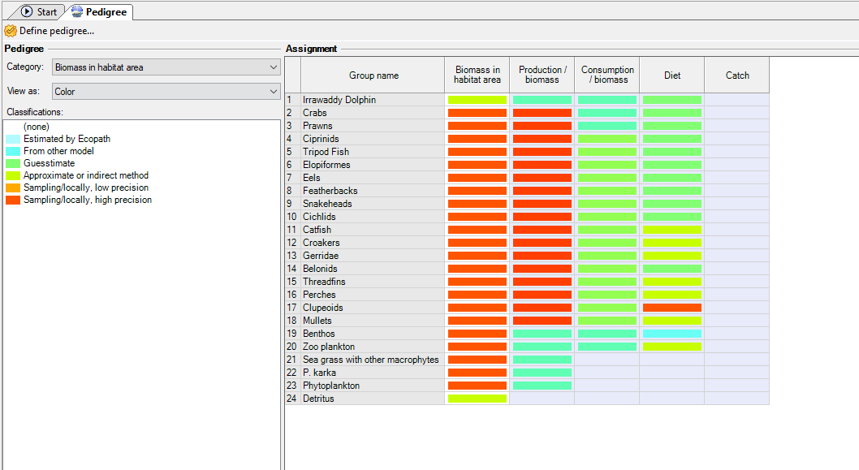
Figure S1: Pedigree Defining

